**Name: - Aditya Devidas Jadhav**

Documentation: -

First, we created a login.JS file and here signup.JS file then we imported both of them in the app.JS using the route facility provided by React.

Then also added validation for the login page in which year if the user didn’t enter proper mail and address then the error message will be shown to the user.

Also added validation for the registration page where the user has to enter his first name, last name a proper 10-digit phone number, proper email address and a proper password which must contain an uppercase and a lower character and a number.

The detail validation can be seen in the code.

1. Signup Page

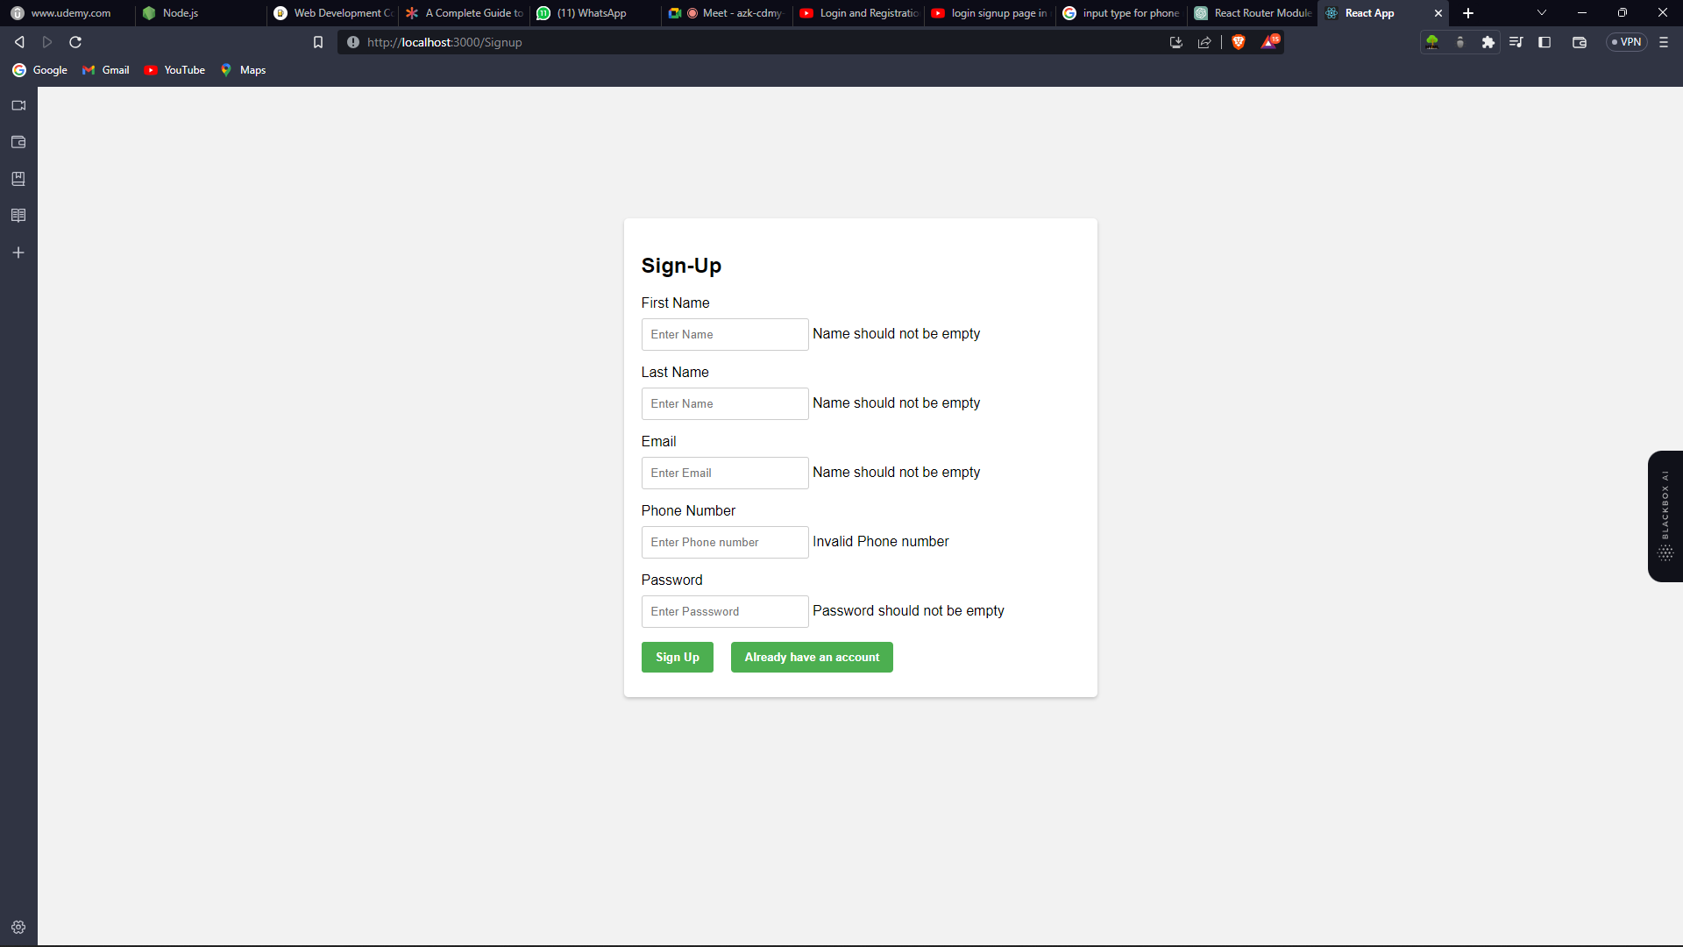

1. Login Page

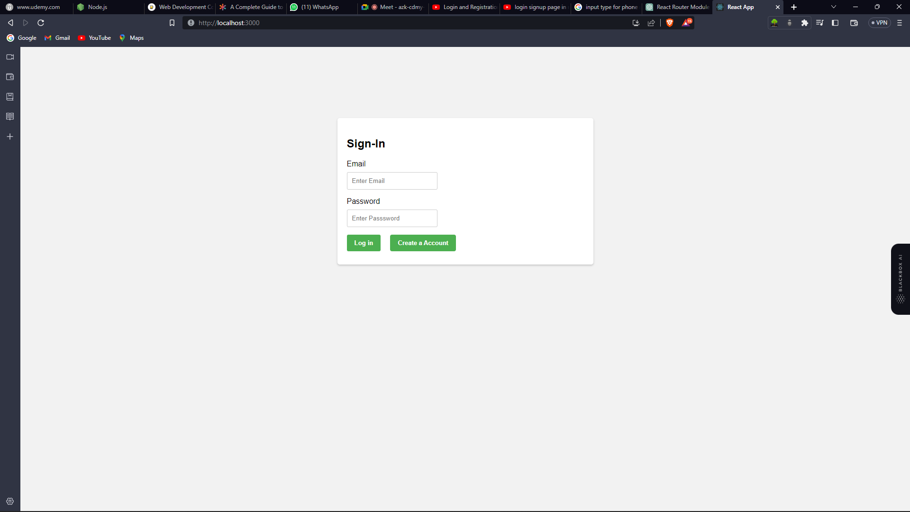

Backend development will require us to connect to a database by using the mysql.connection.

Make API so that we will store the user’s data in database.

We will use MySQL database to store the data in database.