
Fabrication Process

Photodiode

Type  Process Flow |  | Version  v1 |  | Exported by  Adish Gupta |  | Exported on  Oct 30, 2026, 1:57 PM

Last saved Oct 30, 2026, 10:28 AM

Open in FabuBlox https://www.fabublox.com/designer/2cbbc24f-813f-4e72-a331-79439cbee9c8

Substrate
p-Si(100) with 300 nm Thermal SiO2  p-Si(100), 4", 1-10 ohm.cm, 300 nm thermal SiO2 (MTI), cleaved to ~2x2 cm dies  Wafer Sizes 100mm - 4"  Vendor MTI | 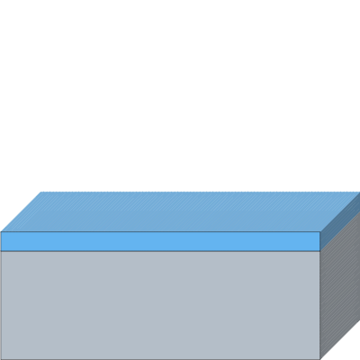

Layer | Material | Thickness | Doping | Crystal Structure | Crystal Orientation
1 | Silicon | 525 µm | p-type (B - Boron) | Single Crystal | <100>
2 | SiO₂ | 300 nm | — | — | —

Process Flow
Section 1

[A] PREP
[A] PREP

1 Solvent clean
Capability Type Chemical Clean
Tool Name Wet Bench: Solvents
Recipe Name -
Process Parameters
Cleaning Bath Composition: Acetone
Ultra-Sonication: No
Dry Method: N₂ blow dry
Advanced Settings
Keep Floating Structures: No

Notes
Process Intent: Cleans organic residues from the wafer surface prior to processing.
Rationale: Sequential solvent clean: acetone > IPA > DI water rinse > N2 dry.

[A] PREP

2 RCA clean
Capability Type RCA Clean
Tool Name Wet Bench: RCA
Recipe Name -
Process Parameters
SC 1 Constituents: SC-1
SC 2 Constituents: SC-2
Tool Parameters
Dry
Dry Method: N2 blow dry
Advanced Settings
Floating Structures
Keep Floating Structures: No

Notes
Process Intent: Standard high-grade clean to remove trace organics, native oxide, and ionic/metallic contamination.
Rationale: Per lab RCA references prior to photolithography and high-temperature processing.

Section 2

[B] MASK 1: ACTIVE WINDOWS
[B] MASK 1: ACTIVE WINDOWS

3 Dehydration bake
Capability Type Bake
Tool Name Hot Plate
Recipe Name -
Process Parameters
Bake Temperature: 120 °C
Bake Time: 300 secs
Advanced Settings
Hard-Bake All Resists: No
Resist Image Reversal: No

Notes
Process Intent: Dehydrates the wafer surface to promote resist adhesion.
Rationale: ~120 °C for 5 min; HMDS primed if available.

[B] MASK 1: ACTIVE WINDOWS  4 Spin S1813  Capability Type Spin-Coat  Tool Name Spin Coater  Recipe Name -  Process Parameters  Material Type: Positive  Material: S1813  Film Thickness: 1.35 µm  Spin Speed: 4000 rpm  Spin Time: 50 secs  Advanced Settings  Fill Gaps: Yes  Notes  Process Intent: Coats positive photoresist S1813 for patterning active windows.  Rationale: 4000 rpm for 50 s yields ~1.35 µm nominal thickness. | 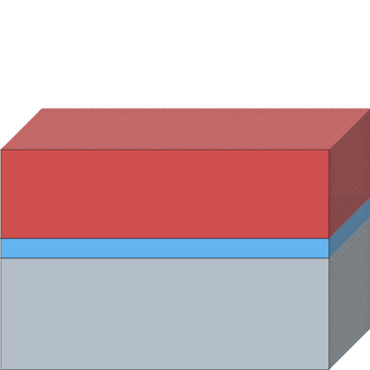

[B] MASK 1: ACTIVE WINDOWS

5 Pre-exposure bake
Capability Type Bake
Tool Name Hot Plate
Recipe Name -
Process Parameters
Bake Temperature: 115 °C
Bake Time: 60 secs
Advanced Settings
Hard-Bake All Resists: No
Resist Image Reversal: No

Notes
Process Intent: Soft-bakes S1813 resist to remove casting solvents.
Rationale: Hotplate pre-exposure bake at ~115 °C for 60 s.

[B] MASK 1: ACTIVE WINDOWS  6 Expose Mask 1  Capability Type Direct-Write Lithography  Tool Name litho-v1  Recipe Name -  Process Parameters  Laser Wavelength: 405 nm (h-line)  Layer(s) to Expose: S1813  Pattern source: Manual  Define Pattern: 1,4,1  Toggle start exposure region: Yes  Advanced Settings  Exposure Sidewall Angle: 5 °  Notes  Process Intent: Exposes Mask 1 to define 500x500 µm active window, 200x200 µm pad area, marks, van der Pauw cross, and test diodes.  Rationale: Patterned on litho-v1 DLP projector (405 nm LED) at 140 mJ/cm². | 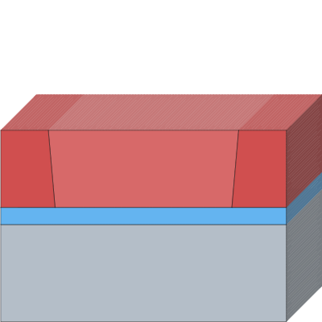

[B] MASK 1: ACTIVE WINDOWS  7 Develop  Capability Type Develop  Tool Name Wet Bench: MF-319  Recipe Name -  Process Parameters  Layer(s) to Develop: S1813  Developer: MF-319  Develop Time: 25 secs  Advanced Settings  Custom Undercut: No  Notes  Process Intent: Develops exposed S1813 photoresist.  Rationale: MF-319 developer for 15-40 s (~30 s), followed by DI water rinse and N2 dry. | 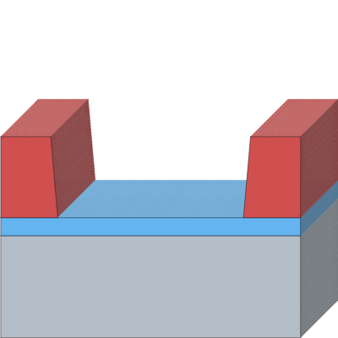

[B] MASK 1: ACTIVE WINDOWS

8 Hard bake
Capability Type Bake
Tool Name Hot Plate
Recipe Name -
Process Parameters
Bake Temperature: 120 °C
Bake Time: 600 secs
Advanced Settings
Hard-Bake All Resists: Yes
Resist Image Reversal: No

Notes
Process Intent: Hardens resist mask prior to wet chemical oxide etching.
Rationale: Hard bake at ~120 °C for 10 min.

[B] MASK 1: ACTIVE WINDOWS  9 Etch oxide to Si  Capability Type Chemical Etch  Tool Name Wet Bench: BOE/DHF  Recipe Name -  Process Parameters  Layer(s) to Etch: SiO₂  Two-Sided Etch: Yes  Etch Bath Composition: BOE 6:1  Etch Depth: 300 nm  Etch Time: 240 secs  Advanced Settings  Etch Mode: Isotropic Etch  Define Etch Selectivity: No  Out-of-plane Etch Buried Layers: No  Keep Floating Structures: No  Notes  Process Intent: Etches 300 nm SiO2 thermally grown oxide down to bare silicon in opened active windows.  Rationale: BOE wet etch for ~3-5 min (~4 min); visual endpoint indicated when bare silicon dewets. Leave backside uncoated by resist so the backside oxide is stripped simultaneously in this step for subsequent backside metallization. | 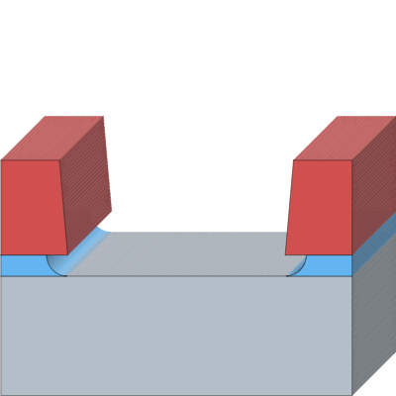

[B] MASK 1: ACTIVE WINDOWS  10 Strip Resist  Capability Type Chemical Clean  Tool Name Wet Bench: PG Remover  Recipe Name -  Process Parameters  Layer(s) to Remove: S1813  Cleaning Bath Composition: NMP  Cleaning Time: 5 mins  Cleaning Temperature: 60 °C  Ultra-Sonication: No  Dry Method: N2 blow dry  Advanced Settings  Keep Floating Structures: No | 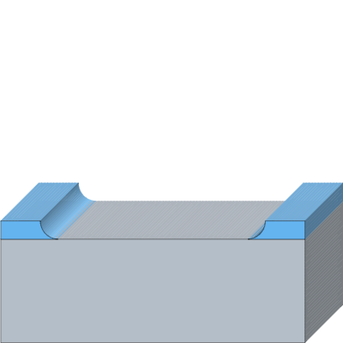

Section 3

[C] n+ EMITTER
[C] n+ EMITTER  11 Dilute HF dip  Capability Type Chemical Etch  Tool Name Wet Bench: BOE/DHF  Recipe Name -  Process Parameters  Layer(s) to Etch: SiO₂  Two-Sided Etch: No  Etch Bath Composition: DHF 50:1  Etch Depth: 2 nm  Etch Time: 10 secs  Advanced Settings  Etch Mode: Isotropic Etch  Define Etch Selectivity: No  Out-of-plane Etch Buried Layers: No  Keep Floating Structures: No  Notes  Process Intent: Removes native oxide from active silicon windows prior to dopant application.  Rationale: 10 s dilute HF (DHF 50:1) dip. | 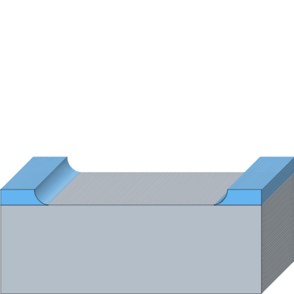

[C] n+ EMITTER  12 Spin P spin-on dopant  Capability Type Spin-Coat  Tool Name Spin Coater  Recipe Name -  Process Parameters  Material Type: Dopant  Dopant Species: P  Material: Phosphorus Spin-On Dopant  Film Thickness: 200 nm  Spin Speed: 3000 rpm  Spin Time: 45 secs  Advanced Settings  Fill Gaps: Yes  Notes  Process Intent: Applies phosphorus spin-on dopant to form shallow n+ emitter layer.  Rationale: Spun per dopant recipe parameters. | 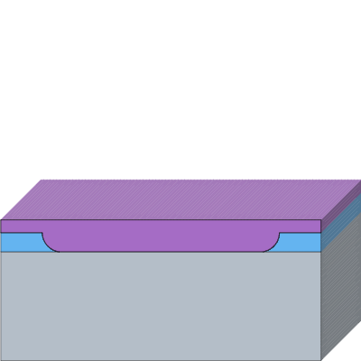

[C] n+ EMITTER

13 Bake
Capability Type Bake
Tool Name Hot Plate
Recipe Name -
Process Parameters
Bake Temperature: 165 °C
Bake Time: 300 secs
Advanced Settings
Hard-Bake All Resists: No
Resist Image Reversal: No

Notes
Process Intent: Soft-bakes and dries spin-on dopant layer.
Rationale: Hotplate bake at 150-175 °C (~165 °C).

[C] n+ EMITTER  14 Predeposition  Capability Type Dopant Diffusion  Tool Name Tube Furnace  Recipe Name -  Process Parameters  Diffusion Target Layer(s): Silicon  Gas-Source Diffusion: No  Diffusion Distance: 300 nm  Diffusion Temperature: 1100 °C  Diffusion Time: 8 mins  Advanced Settings  Grow Thermal Surface Layer: No  Notes  Process Intent: Drives phosphorus dopant into exposed silicon active areas to form n+ emitter junction.  Rationale: Tube furnace predeposition at 1100 °C for 5-10 min (~8 min). | 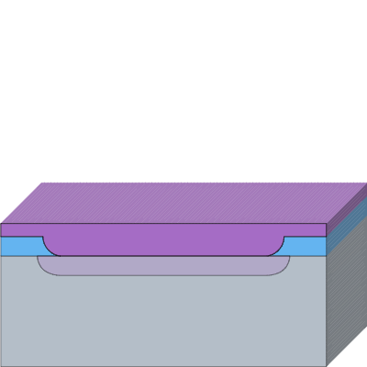

[C] n+ EMITTER  15 Strip dopant glass  Capability Type Chemical Etch  Tool Name Wet Bench: BOE/DHF  Recipe Name -  Process Parameters  Layer(s) to Etch: Phosphorus Spin-On Dopant  Two-Sided Etch: No  Etch Bath Composition: BOE 6:1  Etch Depth: 500 nm  Etch Time: 60 secs  Advanced Settings  Etch Mode: Isotropic Etch  Define Etch Selectivity: No  Out-of-plane Etch Buried Layers: No  Keep Floating Structures: No  Notes  Process Intent: Strips residual phosphosilicate dopant glass down to bare Si.  Rationale: Brief BOE etch (60 s) to hydrophobic bare silicon surface. Note: This blanket dip also thins the field oxide from ~300 nm to ~200 nm, which remains sufficiently thick for subsequent Mask 2 and Mask 3 patterning. | 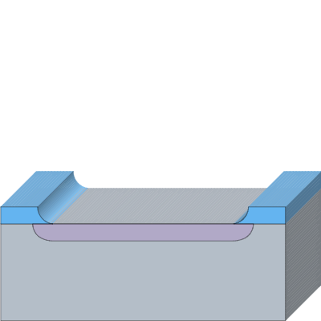

[C] n+ EMITTER

M1 Measure R_sheet <GATE G1>
Capability Type Metrology
Tool Name Probe Station
Recipe Name -

Notes
Process Intent: Measures sheet resistance (R_sheet) on van der Pauw cross structures as quality gate G1.
Rationale: Confirms dopant drive-in and active layer sheet resistance before oxidation split.

Section 4

[D] AR-OXIDE SPLIT
[D] AR-OXIDE SPLIT  16 Dry O2 oxidation  Capability Type Thermal Oxidation  Tool Name Tube Furnace  Recipe Name -  Process Parameters  Layer(s) to Consume: Silicon  Two-Sided Growth: No  Process Gases: O₂  Thermally Grown Material: SiO₂  Layer Thickness: 70 nm  Growth Time: 20 mins  Growth Temperature: 1100 °C  Advanced Settings  Consumption Ratio: 46 %  Notes  Process Intent: Thermally grows passivating anti-reflection (AR) oxide layer.  Rationale: Dry O2 oxidation in furnace at 1100 °C; dies pulled at ~7 min (~40 nm), ~20 min (~70 nm), ~38 min (~100 nm), plus one bare-Si witness. | 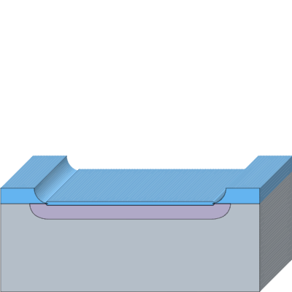

[D] AR-OXIDE SPLIT

M2 Measure oxide
Capability Type Metrology
Tool Name Ellipsometer
Recipe Name -

Notes
Process Intent: Ellipsometer metrology of AR oxide thickness across split dies.
Rationale: Confirms targets of ~40 nm / ~70 nm / ~100 nm AR oxide.

Section 5

[E] MASK 2: CONTACT STRIPES
[E] MASK 2: CONTACT STRIPES

17 Dehydration bake
Capability Type Bake
Tool Name Hot Plate
Recipe Name -
Process Parameters
Bake Temperature: 120 °C
Bake Time: 300 secs
Advanced Settings
Hard-Bake All Resists: No
Resist Image Reversal: No

Notes
Process Intent: Dehydration bake before resist application.
Rationale: 120 °C for 5 min.

[E] MASK 2: CONTACT STRIPES  18 Spin S1813  Capability Type Spin-Coat  Tool Name Spin Coater  Recipe Name -  Process Parameters  Material Type: Positive  Material: S1813  Film Thickness: 1.35 µm  Spin Speed: 4000 rpm  Spin Time: 50 secs  Advanced Settings  Fill Gaps: Yes  Notes  Process Intent: Coats S1813 positive resist for contact stripe mask.  Rationale: 4000 rpm for 50 s. | 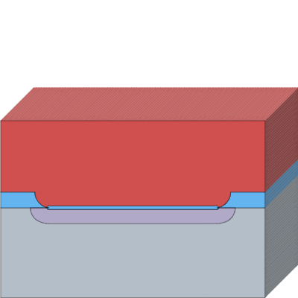

[E] MASK 2: CONTACT STRIPES

19 Pre-exposure bake
Capability Type Bake
Tool Name Hot Plate
Recipe Name -
Process Parameters
Bake Temperature: 115 °C
Bake Time: 60 secs
Advanced Settings
Hard-Bake All Resists: No
Resist Image Reversal: No

Notes
Process Intent: Soft-bakes S1813 resist.
Rationale: 115 °C for 60 s.

[E] MASK 2: CONTACT STRIPES  20 Expose Mask 2  Capability Type Direct-Write Lithography  Tool Name litho-v1  Recipe Name -  Process Parameters  Laser Wavelength: 405 nm (h-line)  Layer(s) to Expose: S1813  Pattern source: Manual  Define Pattern: 2,1,2  Toggle start exposure region: Yes  Advanced Settings  Exposure Sidewall Angle: 5 °  Notes  Process Intent: Exposes Mask 2 defining 10 µm contact opening stripes inside 30 µm fingers.  Rationale: Patterned on litho-v1 DLP projector (405 nm LED), aligned to Mask 1 marks using XY + theta stage. | 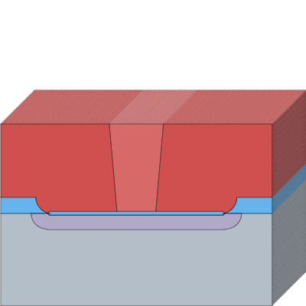

[E] MASK 2: CONTACT STRIPES  21 Develop  Capability Type Develop  Tool Name Wet Bench: MF-319  Recipe Name -  Process Parameters  Layer(s) to Develop: S1813  Developer: MF-319  Develop Time: 25 secs  Advanced Settings  Custom Undercut: No  Notes  Process Intent: Develops exposed contact opening stripes in S1813 resist.  Rationale: MF-319 developer for 15-40 s (~30 s), DI rinse, and N2 dry. | 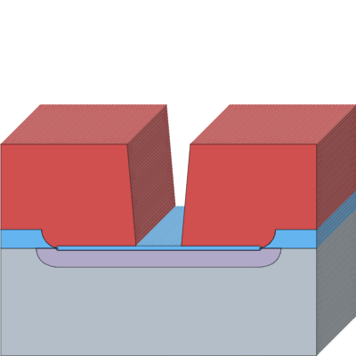

[E] MASK 2: CONTACT STRIPES

22 Hard bake
Capability Type Bake
Tool Name Hot Plate
Recipe Name -
Process Parameters
Bake Temperature: 120 °C
Bake Time: 600 secs
Advanced Settings
Hard-Bake All Resists: Yes
Resist Image Reversal: No

Notes
Process Intent: Hardens resist mask prior to wet etching of contact stripes.
Rationale: 120 °C for 10 min.

[E] MASK 2: CONTACT STRIPES  23 Etch AR oxide  Capability Type Chemical Etch  Tool Name Wet Bench: BOE/DHF  Recipe Name -  Process Parameters  Layer(s) to Etch: SiO₂  Two-Sided Etch: Yes  Etch Bath Composition: BOE 6:1  Etch Depth: 100 nm  Etch Time: 45 secs  Advanced Settings  Etch Mode: Isotropic Etch  Define Etch Selectivity: No  Out-of-plane Etch Buried Layers: No  Keep Floating Structures: No  Notes  Process Intent: Etches opened contact stripes through AR oxide down to n+ emitter.  Rationale: BOE etch time scaled by AR oxide thickness: ~25 s for 40 nm die, ~45 s for 70 nm die, and ~70 s for 100 nm die. Visual endpoint indicated when bare silicon contact stripes dewet. | 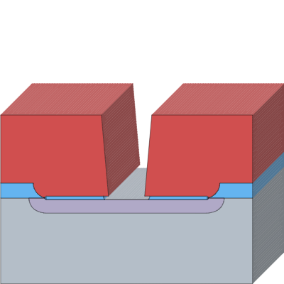

[E] MASK 2: CONTACT STRIPES  24 Strip Resist  Capability Type Chemical Clean  Tool Name Wet Bench: PG Remover  Recipe Name -  Process Parameters  Layer(s) to Remove: S1813  Cleaning Bath Composition: NMP  Cleaning Time: 5 mins  Cleaning Temperature: 60 °C  Ultra-Sonication: No  Dry Method: N2 blow dry  Advanced Settings  Keep Floating Structures: No | 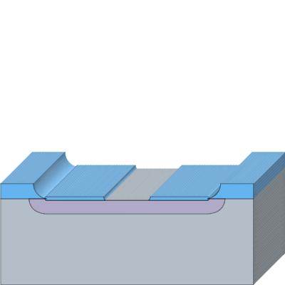

Section 6

[F] MASK 3: METAL BY SPUTTER + ETCH
[F] MASK 3: METAL BY SPUTTER + ETCH  25 Sputter Al  Capability Type Sputter  Tool Name sputter-v2  Recipe Name -  Process Parameters  Material: Aluminum  Sputter Targets: Aluminum  Process Gases: Argon  Film Thickness: 300 nm  Deposition Time: 1800 secs  Tool Parameters  Pumpdown  Shutter Open: No  Gas Stabilization  Shutter Open: No  Plasma Ignition  Shutter Open: No  Power Ramp-Up  Shutter Open: No  Target Conditioning  Shutter Open: No  Deposition  Shutter Open: No  Power Ramp-Down  Shutter Open: No  Purge  Shutter Open: No  Advanced Settings  Conformal Deposition Controls  Conformal Deposition: No  Isotropy Ratio: 5%  Maximum Deposition Angle: 85 °  Deposition Step Size: 0 nm  Surface Interpolation: 0 nm  Target Angle: 0 °  Maximum Gap to Fill: 0 nm  Shadow Mask  Shadow Mask: No  Notes  Process Intent: Blanket aluminium over the whole die for the contact fingers and pads.  Rationale: DC magnetron sputtering in argon at about 0.001-0.01 mbar, 115 W, following the lab's sputter time. Sputtering gives good step coverage over the field-oxide step. 300 nm is a design target; the true rate is not documented and will be calibrated with a profilometer. Pre-sputter a few minutes behind a shutter or dummy piece to clean the target. | 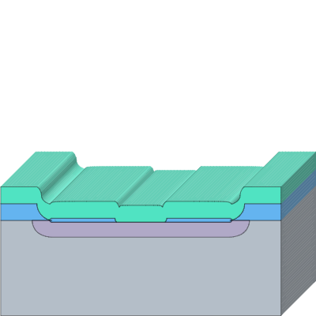

[F] MASK 3: METAL BY SPUTTER + ETCH

26 Dehydration bake
Capability Type Bake
Tool Name Hot Plate
Recipe Name -
Process Parameters
Bake Temperature: 120 °C
Bake Time: 300 secs
Advanced Settings
Hard-Bake All Resists: No
Resist Image Reversal: No

Notes
Process Intent: Removes adsorbed water from the Al surface before the resist.
Rationale: 120 °C for 5 min, then cool to room temperature.

[F] MASK 3: METAL BY SPUTTER + ETCH  27 Spin S1813  Capability Type Spin-Coat  Tool Name Spin Coater  Recipe Name -  Process Parameters  Material Type: Positive  Material: S1813  Film Thickness: 1.35 µm  Spin Speed: 4000 rpm  Spin Time: 50 secs  Advanced Settings  Fill Gaps: Yes  Notes  Process Intent: Coats S1813 positive photoresist as etch mask for Aluminum patterning.  Rationale: About 1.35 µm positive photoresist as the etch mask (4000 rpm, 50 s). | 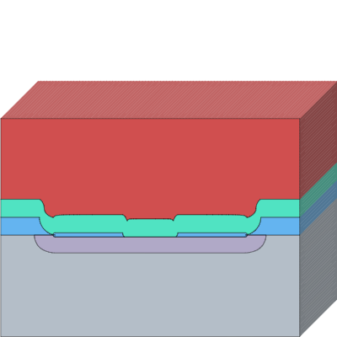

[F] MASK 3: METAL BY SPUTTER + ETCH

28 Pre-exposure bake
Capability Type Bake
Tool Name Hot Plate
Recipe Name -
Process Parameters
Bake Temperature: 115 °C
Bake Time: 60 secs
Advanced Settings
Hard-Bake All Resists: No
Resist Image Reversal: No

Notes
Process Intent: Soft-bakes S1813 photoresist before exposure.
Rationale: 115 °C for 60 s.

[F] MASK 3: METAL BY SPUTTER + ETCH  29 Expose Mask 3  Capability Type Direct-Write Lithography  Tool Name litho-v1  Recipe Name -  Process Parameters  Laser Wavelength: 405 nm (h-line)  Layer(s) to Expose: S1813  Pattern source: Manual  Define Pattern: 2,1,2  Toggle start exposure region: No  Advanced Settings  Exposure Sidewall Angle: 5 °  Notes  Process Intent: Define the Al fingers, bus bar and pads, aligned to Mask 2.  Rationale: S1813 is a positive resist, so the Al to keep must stay unexposed. Dose may need a small trim because Al is reflective. Tool is a DLP projector with a 405 nm LED, not a laser. | 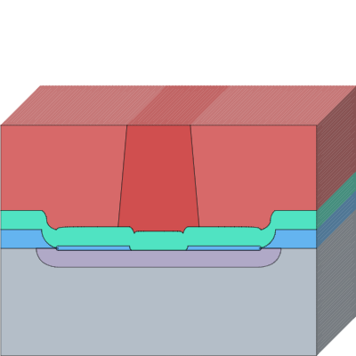

[F] MASK 3: METAL BY SPUTTER + ETCH  30 Develop  Capability Type Develop  Tool Name Wet Bench: MF-319  Recipe Name -  Process Parameters  Layer(s) to Develop: S1813  Developer: MF-319  Develop Time: 30 secs  Advanced Settings  Custom Undercut: No  Notes  Process Intent: Develops exposed S1813 photoresist.  Rationale: MF-319 for 30 s. Then DI water rinse and N2 dry. | 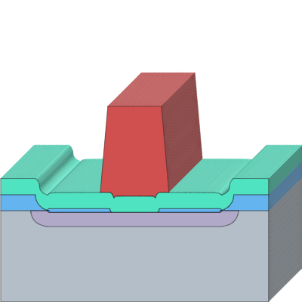

[F] MASK 3: METAL BY SPUTTER + ETCH

31 Hard bake
Capability Type Bake
Tool Name Hot Plate
Recipe Name -
Process Parameters
Bake Temperature: 120 °C
Bake Time: 120 secs
Advanced Settings
Hard-Bake All Resists: Yes
Resist Image Reversal: No

Notes
Process Intent: Hardens the resist so the aqueous acid etch does not lift it.
Rationale: 120 °C for 2 min.

[F] MASK 3: METAL BY SPUTTER + ETCH  32 Etch Al  Capability Type Chemical Etch  Tool Name Wet Bench: Al etchant  Recipe Name -  Process Parameters  Layer(s) to Etch: Aluminum  Two-Sided Etch: No  Etch Bath Composition: Al etchant (H3PO4 : HNO3 : H2O = 40 : 7 : 7 by volume)  Etch Depth: 300 nm  Etch Time: 300 secs  Advanced Settings  Etch Mode: Isotropic Etch  Define Etch Selectivity: No  Out-of-plane Etch Buried Layers: No  Keep Floating Structures: No  Notes  Process Intent: Remove the Al outside the finger, bus-bar and pad pattern.  Rationale: Phosphoric/nitric acid mix, endpoint by eye plus about 30 s over-etch; time and temperature are calibrated on a dummy die. Isotropic undercut is about the film thickness (0.3 um), small compared with the 30 um fingers. Keep nitric acid away from acetone, IPA and organic solvents; fume hood, acid gloves. | 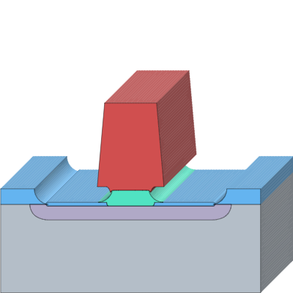

[F] MASK 3: METAL BY SPUTTER + ETCH  33 Strip resist  Capability Type Chemical Clean  Tool Name Wet Bench: NMP  Recipe Name -  Process Parameters  Layer(s) to Remove: S1813  Cleaning Bath Composition: NMP  Cleaning Time: 5 mins  Cleaning Temperature: 60 °C  Ultra-Sonication: No  Dry Method: N₂ blow dry  Advanced Settings  Keep Floating Structures: No  Notes  Process Intent: Completely removes S1813 etch mask resist.  Rationale: NMP bath at 60 °C for 5 min. Then IPA rinse, DI water rinse, N2 dry. | 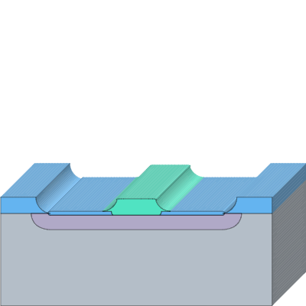

Section 7

[G] BACKSIDE + SINTER
[G] BACKSIDE + SINTER

34 Backside contact
Capability Type Custom Step
Tool Name -
Recipe Name -
Process Parameters
Comment: Apply ~200 nm evaporated Al, silver epoxy, or indium paste (backside oxide stripped earlier during Steps 9 and 23 BOE etches).

Notes
Scratch the backside lightly with a diamond scribe before applying silver epoxy or indium, because phosphorus vapour during predeposition (step 14) can form a thin n-type skin there.
Process Intent: Applies ohmic backside contact metallization.
Rationale: Backside oxide was stripped earlier during Steps 9 and 23 BOE etches. Apply ~200 nm evaporated Al, silver epoxy, or indium paste to form backside substrate contact without exposing front-side Al to BOE.

[G] BACKSIDE + SINTER

35 Sinter
Capability Type Bake
Tool Name Hot Plate
Recipe Name -
Process Parameters
Bake Temperature: 380 °C
Bake Time: 10 mins
Advanced Settings
Hard-Bake All Resists: No
Resist Image Reversal: No

Notes
Process Intent: Sinters the Al contacts to form low-resistance ohmic contacts.
Rationale: 380 °C, 10 min on a hotplate in air. Kept at or below 400 °C to avoid Al spiking through the shallow junction.

Section 8

[H] TEST
[H] TEST

M3 Dark I-V <GATE G2>
Capability Type Metrology
Tool Name Probe Station
Recipe Name -

Notes
Process Intent: Measures dark I-V characteristics as quality gate G2.
Rationale: Confirms diode rectification >= 10^3 between +/-1 V.

[H] TEST

M4 Photocurrent <GATE G3/G4>
Capability Type Metrology
Tool Name Probe Station
Recipe Name -

Notes
Process Intent: Measures photocurrent response on litho-v1 stage under 405 nm LED illumination as quality gate G3/G4.
Rationale: Quantifies on/off response difference vs AR oxide thickness split (40/70/100 nm) and vs finger pitch.

[H] TEST

M5 Linearity
Capability Type Metrology
Tool Name Probe Station
Recipe Name -

Notes
Process Intent: Evaluates photocurrent linearity over optical power.
Rationale: Measures photocurrent (I_ph) versus LED driving current.

[H] TEST

M6 Calibration
Capability Type Metrology
Tool Name Probe Station
Recipe Name -

Notes
Process Intent: Calibrates photodiode responsivity and external quantum efficiency (EQE).
Rationale: Benchmarks against a calibrated commercial silicon photodiode standard.

