Real-Time Intrusion Detection System (RIDS) Report

R Keerthana Prasad, 1RVU23CSE363, B.Tech (H)
Adishree Kartikeyan, 1RVU22BSC001, B.Sc (H)

Problem Statement:
To develop and analyze a Real-Time Intrusion Detection System (RIDS) using machine learning techniques to detect abnormal network activities and potential security breaches.

Introduction:
Intrusion Detection Systems (IDS) are essential for maintaining network security by monitoring and analyzing network traffic for suspicious activities. The objective of this project is to create a real-time IDS using the CIC-IDS2017 dataset, which includes various types of network attacks. The goal is to build a robust model that can classify network traffic as either normal or abnormal.

Dataset:
The CIC-IDS2017 dataset is used for this analysis. It consists of multiple features capturing network traffic information, including 'protocol_type,' 'service,' 'flag,' and other numerical features. The dataset has been preprocessed to convert categorical features to numerical values and to create a binary classification target for attacks.

Observations and Analysis:
Statistical Analysis:
The dataset was examined for outliers using box plots for all numerical features, ensuring the robustness of the model by identifying and potentially handling outliers.
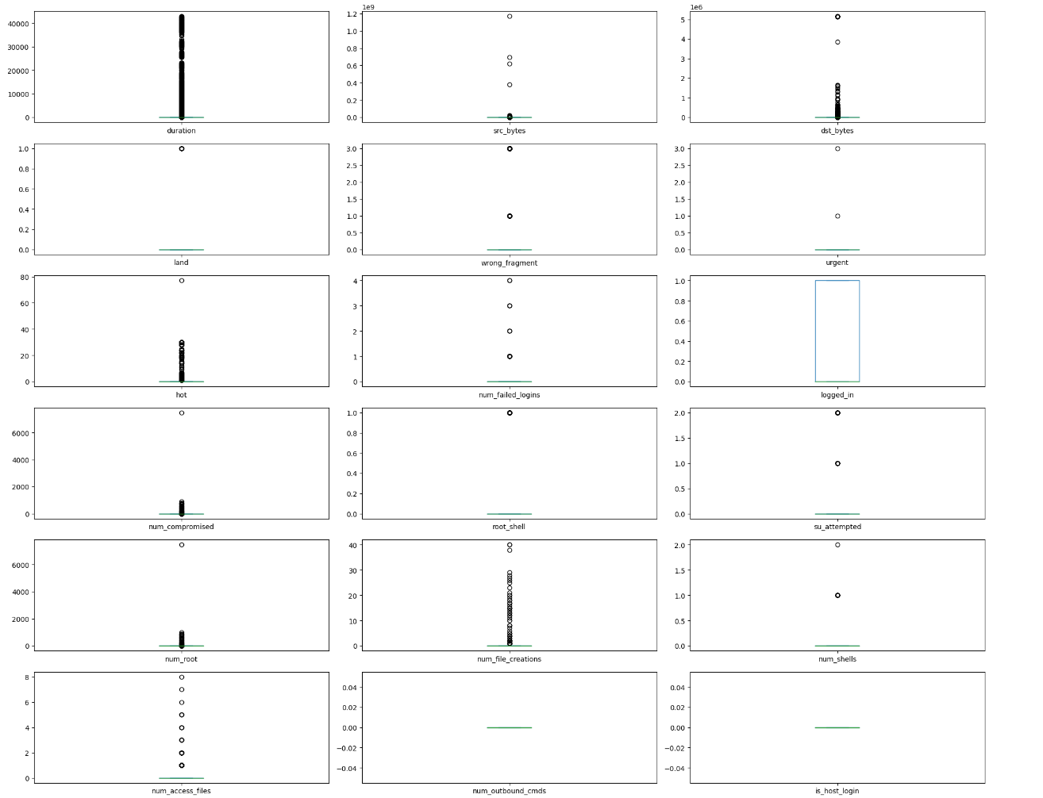
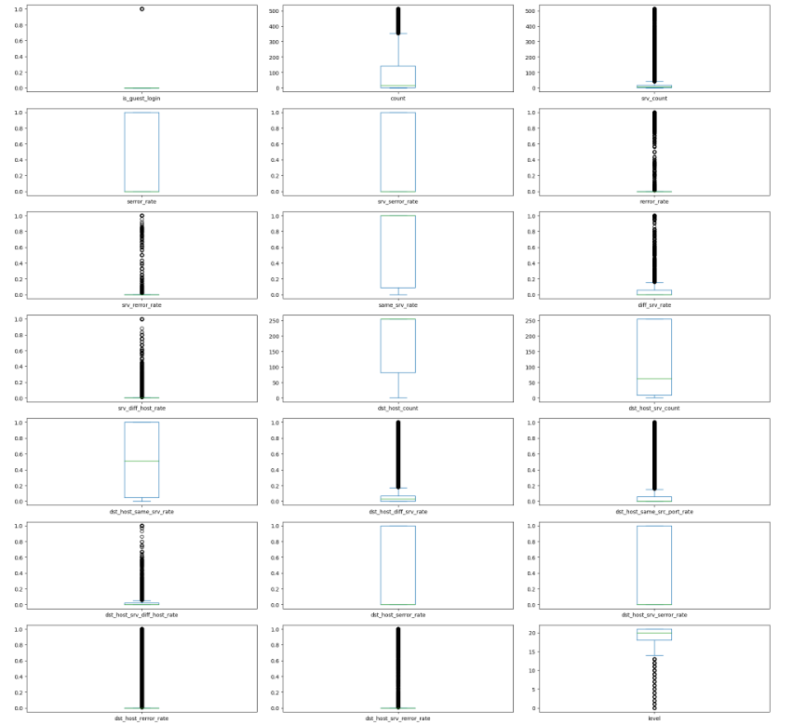
Table 1. Statistical Analysis

Key Findings:
- The dataset was successfully converted into a binary classification problem, with the 'attack' column mapped to 'normal' and 'abnormal' labels.
- The categorical features were encoded using label encoding, allowing the machine learning models to process them effectively.
- The mutual information between features and the target variable was calculated to understand the importance of each feature in predicting attacks.

Data Visualization:

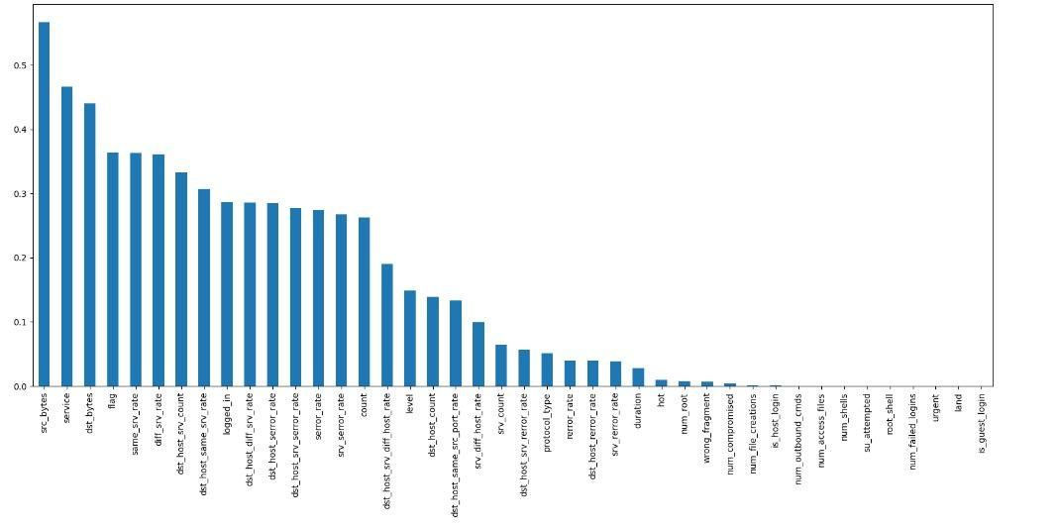
Figure 1: Distribution of Columns

Analysis of Feature Importance in Intrusion Detection
The graph shows the mutual information scores for various features, with 'src_bytes', 'service', 'dst_bytes', and 'flag' having the highest importance for the classification task, while features like 'land' and 'is_guest_login' have the lowest importance.

Heat Analysis:
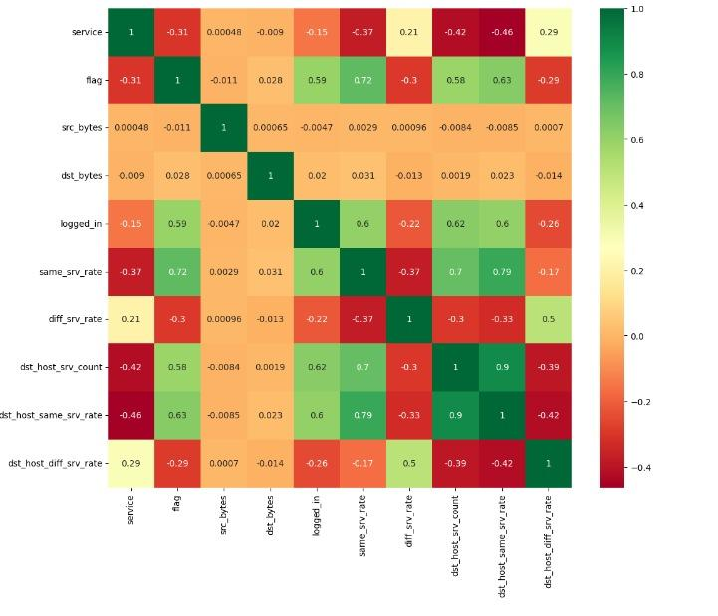

Figure 2: Correlation Heatmap

Analysis of Correlation Heatmap:
The above heat map visualizes the correlation matrix of the features in the dataset, highlighting both positive (green) and negative (red) correlations, with strong correlations seen between 'flag' and 'same_srv_rate' (0.72), and 'dst_host_srv_count' and 'dst_host_same_srv_rate' (0.9), indicating these pairs of features are highly related.

Conclusion:

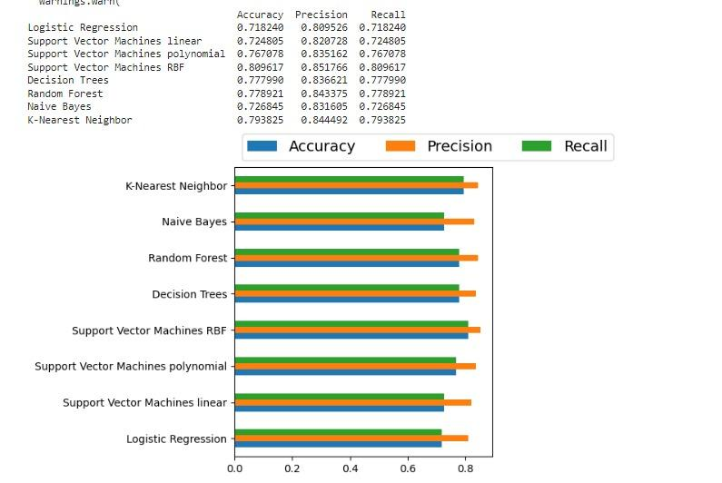

The analysis and preprocessing steps outlined here are crucial for building an effective real-time IDS. By converting categorical features to numerical values, handling outliers, and scaling the data, we prepare the dataset for robust model training. The mutual information analysis helps in feature selection, ensuring the model focuses on the most relevant features.Thus according to the data, Support Vector Machines RBF is the best classifier achieving the highest accuracy, precision, and recall.

References:
1.https://www.kaggle.com/datasets/sampadab17/network-intrusion-detection
2.https://www.kaggle.com/code/mohamedkhaledelsafty/intrusion-detection-system-with-binary-classifiers/input

