Digital Nurture 4.0 – Deep Skilling Program

Java Full Stack Engineer (FSE)

Week 1 – Mandatory Exercises Submission

Name: Adishree Devoor

GitHub Profile: https://github.com/Adishree16

Email: adishreedevoor18@gmail.com

Skills Covered:

* Data Structures and Algorithms

**Data Structures and Algorithms**

**Exercise 2: E-commerce Platform Search Function**

**Program:**

import java.util.Arrays;

class Product {

int id;

String name;

String category;

Product(int id, String name, String category) {

this.id = id;

this.name = name;

this.category = category;

}

}

public class SearchFunction {

public static void main(String[] args) {

Product[] products = {

new Product(1, "Mobile", "Electronics"),

new Product(2, "Laptop", "Electronics"),

new Product(3, "Shirt", "Clothing"),

new Product(4, "Book", "Education")

};

String search = "Laptop";

// Linear Search

System.out.println("Linear Search:");

for (Product p : products) {

if (p.name.equalsIgnoreCase(search)) {

System.out.println("Found: " + p.name + " in category " + p.category);

break;

}

}

// Binary Search

Arrays.sort(products, (a, b) -> a.name.compareToIgnoreCase(b.name));

System.out.println("\nBinary Search:");

int low = 0, high = products.length - 1;

while (low <= high) {

int mid = (low + high) / 2;

int cmp = products[mid].name.compareToIgnoreCase(search);

if (cmp == 0) {

System.out.println("Found: " + products[mid].name + " in category " + products[mid].category);

break;

} else if (cmp < 0) {

low = mid + 1;

} else {

high = mid - 1;

}

}

}

}

**Output:**

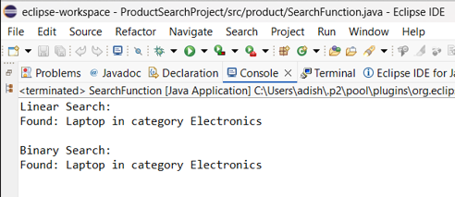

**Exercise 7: Financial Forecasting**

**Program:**

public class FinancialForecast {

public static double predictValue(double currentValue, double rate, int years) {

// Base condition

if (years == 0) return currentValue;

// Recursive call

return predictValue(currentValue * (1 + rate), rate, years - 1);

}

public static void main(String[] args) {

double currentValue = 10000; // Starting amount

double growthRate = 0.1; // 10% annual growth

int years = 5;

double futureValue = predictValue(currentValue, growthRate, years);

System.out.printf("Predicted value after %d years: %.2f", years, futureValue);

}

}

**Output:**

