Digital Nurture 4.0 – Deep Skilling Program

Java Full Stack Engineer (FSE)

Week 1 – Mandatory Exercises Submission

Name: Adishree Devoor

GitHub Profile: https://github.com/Adishree16

Email: adishreedevoor18@gmail.com

Skills Covered:

* Design Patterns and Principles

**Design Patterns and Principles**

**Exercise 1: Implementing the Singleton Pattern**

**Program:**

// Logger.java

public class Logger {

private static Logger instance;

private Logger() {}

public static Logger getInstance() {

if (instance == null) {

instance = new Logger();

}

return instance;

}

public void log(String msg) {

System.out.println("Log: " + msg);

}

}

// Main.java

public class Main {

public static void main(String[] args) {

Logger logger1 = Logger.getInstance();

Logger logger2 = Logger.getInstance();

logger1.log("First message");

logger2.log("Second message");

System.out.println("Are both instances same? " + (logger1 == logger2));

}

}

**Output:**

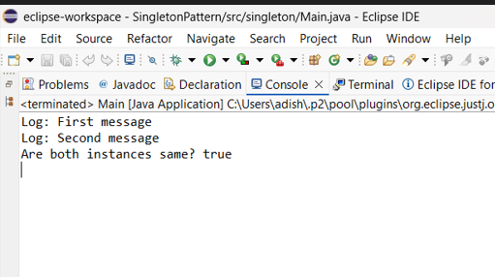

**Exercise 2: Implementing the Factory Method Pattern**

**Program:**

// Document.java

interface Document {

void open();

}

class WordDocument implements Document {

public void open() {

System.out.println("Opening Word Document");

}

}

class PdfDocument implements Document {

public void open() {

System.out.println("Opening PDF Document");

}

}

class ExcelDocument implements Document {

public void open() {

System.out.println("Opening Excel Document");

}

}

// DocumentFactory.java

abstract class DocumentFactory {

public abstract Document createDocument();

}

class WordFactory extends DocumentFactory {

public Document createDocument() {

return new WordDocument();

}

}

class PdfFactory extends DocumentFactory {

public Document createDocument() {

return new PdfDocument();

}

}

class ExcelFactory extends DocumentFactory {

public Document createDocument() {

return new ExcelDocument();

}

}

// Main.java

public class Main {

public static void main(String[] args) {

DocumentFactory factory = new WordFactory();

Document doc = factory.createDocument();

doc.open();

factory = new PdfFactory();

doc = factory.createDocument();

doc.open();

factory = new ExcelFactory();

doc = factory.createDocument();

doc.open();

}

}

**Output:**

