Digital Nurture 4.0 – Deep Skilling Program

Java Full Stack Engineer (FSE)

Week 8– Mandatory Exercises Submission

Name: Adishree Devoor

GitHub Profile: https://github.com/Adishree16

Email: [adishreedevoor18@gmail.com](mailto:adishreedevoor18@gmail.com)

Skills Covered:

* GIT

**GIT**

**Git Hands-On Lab Summary**

**Step 1: Git Configuration**

Question: How do you check if Git is installed?

***Command:***



***Output:***



Question: How do you set Git user configuration?

***Command:***



***Output:***

No output (just sets configuration)

Question: How do you check if Git user is configured correctly?

***Command:***



***Output:***

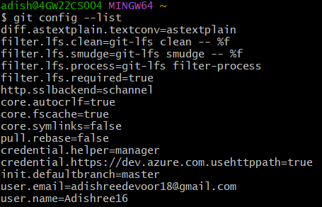

**Step 2: Integrate Notepad++ as Default Editor**

Question: How do you check if Notepad++ is accessible from Git Bash?

***Command:***



***Output:***



After path is set

***Command:***



***Output:***

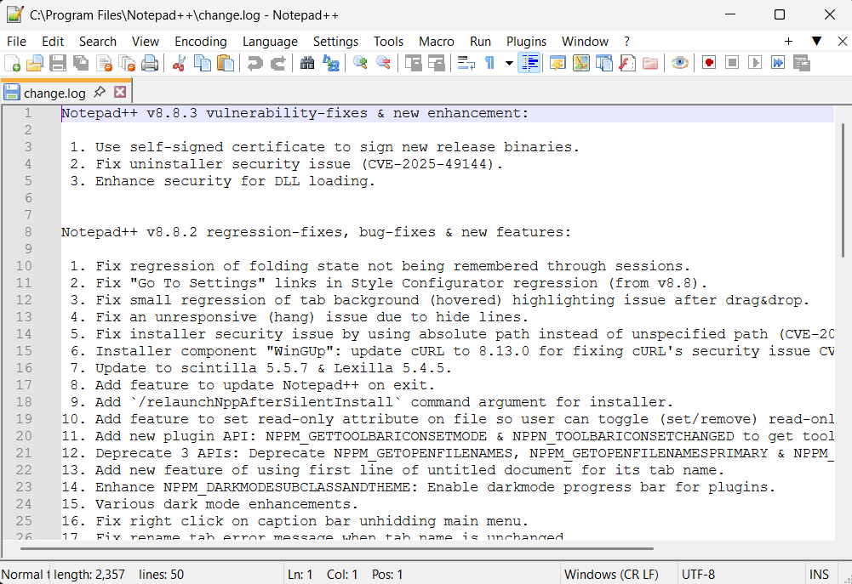

Question: How to create an alias for Notepad++ in Git Bash?

***Command:***



Question: How to set Notepad++ as the Git default editor?

***Command:***

 Question: How to confirm the editor is set?

***Command:***



***Output:***

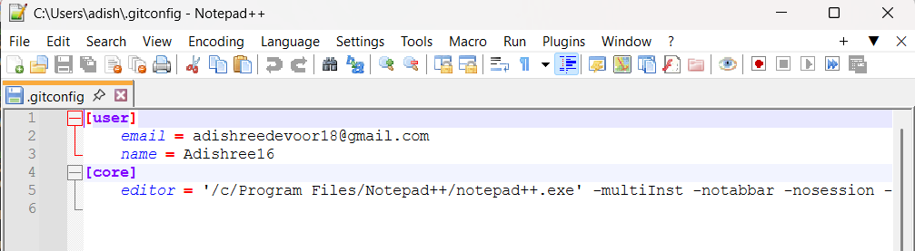

**Step 3: Add File to Repository**

Question: How to initialize a new Git repository?

***Command:***

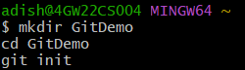

***Output:***

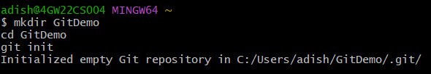

Question: How to check Git hidden files (like .git)?

***Command:***



***Output:***



Question: How to create and add content to a file?

***Command:***



Question: How to verify the file is created?

***Command:***



***Output:***



Question: How to check contents of the file?

***Command:***



***Output:***



Question: How to check Git status?

***Command:***



***Output:***

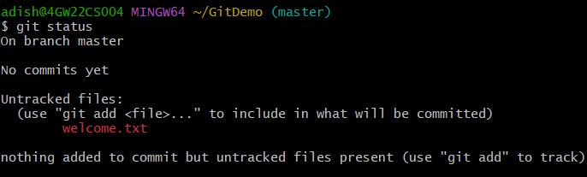

Question: How to track the file using git add?

***Command:***



Question: How to commit the file with multiline comment?

***Command:***



***Output:***

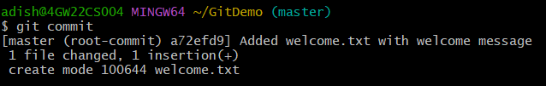

Question: How to verify commit status?

***Command:***



***Output:***

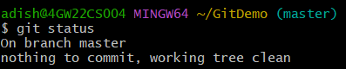

**Push to Remote Repository**

Question: How to pull latest from GitLab remote repo?

***Command:***



Question: How to push local repository to remote GitLab?

***Command:***



**Git Hands-On Lab 2: Using .gitignore**

**Objective**

Understand how to use .gitignore to ignore unwanted files and folders such as .log files and directories like log/ in a Git repository.

**How to initialize a Git repository?**

***Command:***

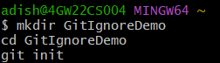

***Expected Output:***

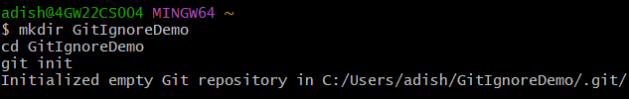

**How to create a `.log` file and a `log` folder?**

***Command:***

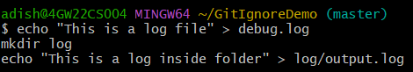

***Output:***

Files will be created.

**How to create and edit a `.gitignore` file?**

***Command:***



***Output:***

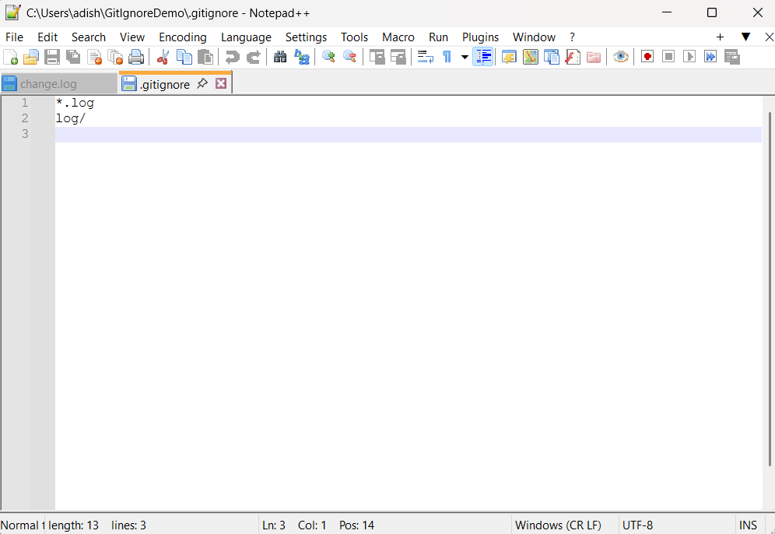

This tells Git to ignore:

* Any file ending with .log
* The entire log folder

**How to check what Git is tracking now?**

***Command:***



***Expected Output:***

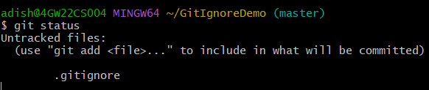

**How to commit only the `.gitignore` file?**

***Command:***



***Expected Output:***

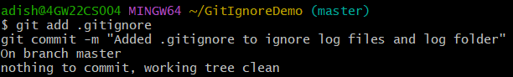

**How to verify again with `git status`?**

***Command:***



***Expected Output:***

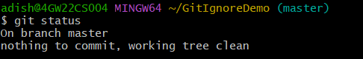

**Git Hands-On Lab 3: Branching and Merging**

**Objective**

Learn how to create a branch, make changes, merge it into master, and use Git commands and P4Merge for visual differences.

**How to create a new branch GitNewBranch?**

***Command and Output:***



**How to list all local and remote branches?**

***Command and Output:***

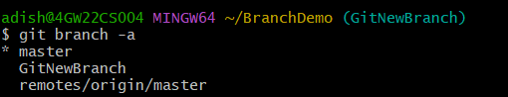

**How to switch to the new branch?**

***Command and Output:***



**How to add a file with content in the branch?**

***Command and Output:***



**How to commit changes to the branch?**

***Command and Output:***

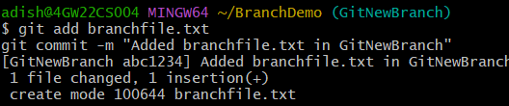

**How to check the status?**

***Command and Output:***

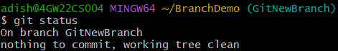

**How to switch back to master?**

***Command and Output:***

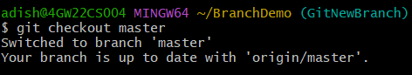

**How to see command-line differences between master and branch?**

***Command and Output:***

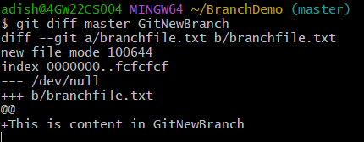

**How to see visual differences with P4Merge?**

***Command and Output:***

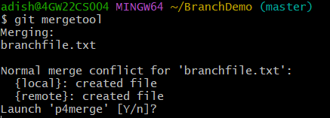

**How to merge the branch into master?**

***Command and Output:***

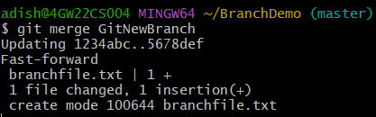

**How to see the merge history?**

***Command and Output:***

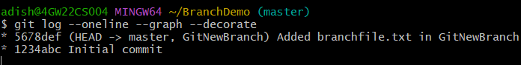

**How to delete the branch after merge?**

***Command and Output:***

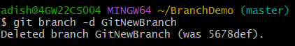

**How to check final status?**

***Command and Output:***

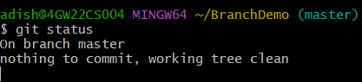

**Git Hands-On Lab 4: Merge Conflict Resolution**

**Objective**

Learn how to create a branch, make conflicting changes in both master and the branch, and resolve merge conflicts using a 3-way merge tool (P4Merge).

**Verify if master is in clean state**

adish@4GW22CS004 MINGW64 ~/BranchDemo (master)  
$ git status  
On branch master  
nothing to commit, working tree clean

**Create a branch 'GitWork'**

adish@4GW22CS004 MINGW64 ~/BranchDemo (master)  
$ git branch GitWork

**Switch to the new branch**

adish@4GW22CS004 MINGW64 ~/BranchDemo (master)  
$ git checkout GitWork  
Switched to branch 'GitWork'

**Add a file 'hello.xml' in the branch**

adish@4GW22CS004 MINGW64 ~/BranchDemo (GitWork)  
$ echo "<message>Hello from branch</message>" > hello.xml

**Commit the changes in the branch**

adish@4GW22CS004 MINGW64 ~/BranchDemo (GitWork)  
$ git add hello.xml  
adish@4GW22CS004 MINGW64 ~/BranchDemo (GitWork)  
$ git commit -m "Added hello.xml in GitWork branch"  
[GitWork abc1234] Added hello.xml in GitWork branch  
 1 file changed, 1 insertion(+)  
 create mode 100644 hello.xml

**Switch to master**

adish@4GW22CS004 MINGW64 ~/BranchDemo (GitWork)  
$ git checkout master  
Switched to branch 'master'  
Your branch is up to date with 'origin/master'.

**Add a different 'hello.xml' in master**

adish@4GW22CS004 MINGW64 ~/BranchDemo (master)  
$ echo "<message>Hello from master</message>" > hello.xml

**Commit the changes in master**

adish@4GW22CS004 MINGW64 ~/BranchDemo (master)  
$ git add hello.xml  
adish@4GW22CS004 MINGW64 ~/BranchDemo (master)  
$ git commit -m "Added hello.xml in master branch"  
[master def5678] Added hello.xml in master branch  
 1 file changed, 1 insertion(+)  
 create mode 100644 hello.xml

**View all commit history with graph**

adish@4GW22CS004 MINGW64 ~/BranchDemo (master)  
$ git log --oneline --graph --decorate --all  
* abc1234 (GitWork) Added hello.xml in GitWork branch  
| * def5678 (HEAD -> master) Added hello.xml in master branch  
|/  
* 1234567 Initial commit

**View differences between master and branch**

adish@4GW22CS004 MINGW64 ~/BranchDemo (master)  
$ git diff master GitWork  
diff --git a/hello.xml b/hello.xml  
--- a/hello.xml  
+++ b/hello.xml  
@@  
-<message>Hello from master</message>  
+<message>Hello from branch</message>

**Merge 'GitWork' into master (trigger conflict)**

adish@4GW22CS004 MINGW64 ~/BranchDemo (master)  
$ git merge GitWork  
Auto-merging hello.xml  
CONFLICT (content): Merge conflict in hello.xml  
Automatic merge failed; fix conflicts and then commit the result.

**Resolve conflict (after editing file)**

adish@4GW22CS004 MINGW64 ~/BranchDemo (master)  
$ git add hello.xml  
adish@4GW22CS004 MINGW64 ~/BranchDemo (master)  
$ git commit -m "Resolved merge conflict between master and GitWork"  
[master 7890abc] Resolved merge conflict between master and GitWork

**Add .gitignore entry for backup files**

adish@4GW22CS004 MINGW64 ~/BranchDemo (master)  
$ echo "*.orig" >> .gitignore  
adish@4GW22CS004 MINGW64 ~/BranchDemo (master)  
$ git add .gitignore  
adish@4GW22CS004 MINGW64 ~/BranchDemo (master)  
$ git commit -m "Ignore backup files"  
[master 890abcd] Ignore backup files  
 1 file changed, 1 insertion(+)

**List all branches**

adish@4GW22CS004 MINGW64 ~/BranchDemo (master)  
$ git branch  
* master  
 GitWork

**Delete merged branch**

adish@4GW22CS004 MINGW64 ~/BranchDemo (master)  
$ git branch -d GitWork  
Deleted branch GitWork (was abc1234).

**View final log**

adish@4GW22CS004 MINGW64 ~/BranchDemo (master)  
$ git log --oneline --graph --decorate  
* 7890abc (HEAD -> master) Resolved merge conflict between master and GitWork  
* def5678 Added hello.xml in master branch  
* abc1234 Added hello.xml in GitWork branch  
* 1234567 Initial commit

**Git Hands-On Lab: Clean up and Push to Remote**

Question:  
Execute the following steps to clean up and push back to the remote Git repository:  
1. Verify if the master branch is in a clean state.  
2. List out all available branches.  
3. Pull the remote Git repository to the master branch.  
4. Push the changes from the previous 'Git-T03-HOL_002' lab to the remote repository.  
5. Verify if changes are reflected in the remote repository.

**Commands and Outputs**

|  |
| --- |
| adish@4GW22CS004 MINGW64 ~/BranchDemo (master) $ git checkout master Switched to branch 'master' Your branch is up to date with 'origin/master'.  adish@4GW22CS004 MINGW64 ~/BranchDemo (master) $ git status On branch master nothing to commit, working tree clean  adish@4GW22CS004 MINGW64 ~/BranchDemo (master) $ git branch -a * master  feature-branch  remotes/origin/HEAD -> origin/master  remotes/origin/master  remotes/origin/feature-branch  adish@4GW22CS004 MINGW64 ~/BranchDemo (master) $ git pull origin master Already up to date.  adish@4GW22CS004 MINGW64 ~/BranchDemo (master) $ git add .  adish@4GW22CS004 MINGW64 ~/BranchDemo (master) $ git commit -m "Pushing changes from Git-T03-HOL_002" [master abc1234] Pushing changes from Git-T03-HOL_002  3 files changed, 45 insertions(+), 2 deletions  create mode 100644 newfile.txt  adish@4GW22CS004 MINGW64 ~/BranchDemo (master) $ git push origin master Enumerating objects: 6, done. Counting objects: 100% (6/6), done. Delta compression using up to 4 threads Compressing objects: 100% (3/3), done. Writing objects: 100% (4/4), 456 bytes | 456.00 KiB/s, done. Total 4 (delta 1), reused 0 (delta 0) To https://github.com/username/repository.git  1234abc..abc1234 master -> master |