**A Data Infrastructure for Empowerment of Unorganised Sector's Workers: Towards Achieving Skill India Mission.**

**INTRODUCTION:**

Before the commencement of the discussion we must address a very important question: **What is Skill?**

A skill is the ability to carry out a task with pre-determined results often within a given amount of [time](https://en.wikipedia.org/wiki/Time), [energy](https://en.wikipedia.org/wiki/Energy), or both. Skills can often be divided into [domain](https://en.wikipedia.org/wiki/Departmentalization) general and domain-specific skills. For example, in the domain of work, some general skills would include [time management](https://en.wikipedia.org/wiki/Time_management), [teamwork](https://en.wikipedia.org/wiki/Teamwork) and [leadership](https://en.wikipedia.org/wiki/Leadership), [self](https://en.wikipedia.org/wiki/Self)-[motivation](https://en.wikipedia.org/wiki/Motivation) and others, whereas domain-specific skills would be useful only for a certain [job](https://en.wikipedia.org/wiki/Job_(role)). Skill usually requires certain environmental stimuli and situations to assess the level of skill being shown and used.

People need a broad range of skills in order to contribute to a modern [economy](https://en.wikipedia.org/wiki/Economy). A broad classification of such skills would be:

* Labor skills
* Life skills
* People skills
* Social skills
* Soft skills
* Hard skills

Having defined skills we move on to the **Indian Scenario in respect of Skill for unorganised sector.**

The Indian economy is characterised by the existence of a vast majority of informal or unorganised labour employment. As per a survey carried out by the National Sample Survey Organisation (NSSO) in 2009–10[1], the total employment in the country was of 46.5 crore comprising around 2.8 crore in the organised and the remaining 43.7 crore workers in the unorganised sector. Out of these workers in the unorganised sector, there are 24.6 crore workers employed in agricultural sector, about 4.4 crore in construction work and remaining in manufacturing and service. In 2012, there were around 487 million workers in India, the second largest after China. Of these over 94 percent work in unincorporated, unorganised enterprises ranging from pushcart vendors to home-based diamond and gem polishing operations.

The term unorganised sector refers to the firms whose activities are not governed by any legal provision or any collective agreements between workers and employers. This includes home-based jobs, self-employment, agricultural work, construction work and a lot of other temporary occupations. The unorganised sector does not give any benefit to the workers in terms of various laws like Minimum Wages Act, Factories Act, etc. The workers have to forego the benefits such as provident fund, gratuity, maternity welfare, etc. The term ‘informal’ is often used in the place of ‘unorganised’. Informality does not imply a particular mode or location of labour use; informal labour can be in self-employment, in casual wage employment, and in regular wage employment, just as it can be in urban as well as in rural areas.

While it is understood that unorganised industries will employ informal or unorganised labour, organised sectors can also engage informal labour. Recently, there is an increasing trend of employing informal labours in the organised sectors.

We do not need to assume that informal labour is unskilled; only need to recognize that its skills are acquired outside the formal education system. All the more in the context of the neo-liberal economic policies of hire and fire where the organized sector itself is getting informalised through outsourcing of labour, there are workers who are equally or even more educated and skilled, work better and even longer in so many of the organized sectors; but for no labour rights, wage, job or social security protection and for very dismal wages. The casual and contract labourers are under the working and living conditions that prevailed in the nineteenth century Europe.

The Ministry of Labour, Government of India, has categorized the unorganized labour force under four groups in terms of Occupation, nature of employment, especially distressed categories and service categories.

1. In terms of Occupation:

Small and marginal farmers, landless agricultural labourers, share croppers, fishermen, those engaged in animal husbandry, labelling and packing, building and construction workers, leather workers, weavers, artisans, salt workers, workers in brick kilns and stone quarries, workers in saw mills, oil mills etc. come under this category.

1. In terms of Nature of Employment:

Attached agricultural labourers, bonded labourers, migrant workers, contract and casual labourers come under this.

1. In terms of Specially distressed categories:

Toddy tappers, Scavengers, Carriers of head loads, Drivers of animal driven vehicles, Loaders and unloaders come under this category.

1. In terms of Service categories:

Midwives, Domestic workers, Fishermen and women, Barbers, Vegetable and fruit vendors, News paper vendors etc. belong to this category.

In addition to these four categories, there exists a large section of unorganized labour force such as cobblers, Handicraft artisans, Handloom weavers, tailors, and physically handicapped self employed persons, Rickshaw pullers, Auto drivers, Sericulture workers, Carpenters, Tannery workers, Power loom workers and urban poor. All India Democratic Women’s Association (AIDWA) has conducted a survey in 1989 in Pune city which reveals that women are involved in different types of home-based work as much as 150 occupations. It includes works like making flower garlands, folding paper for the printing industry, supplying chapattis to caterers, making incense sticks, weaving plastic seats for chairs, deseeding tamarind and packaging sweets.

Though the availability of statistical information on intensity and accuracy vary significantly, the extent of unorganized workers is significantly high among agricultural workers, building and other construction workers and among home based workers.

**The Socio-Economic condition or status of unorganised sector’s workers:**

The unorganised sector is plagued by low wages that are inadequate to meet the basic needs, long working hours, unsafe working conditions and lack of basic amenities at worksite. This can be found commonly in several work types like agricultural, construction, brick-kiln, transport and courier. ‘Home-based work’ employs large number of people to do piecework where they are paid on a ‘per item’ basis. This work is done commonly from the worker’s own premises. Formal and informal surveys reveal that the workers in unorganised sector normally earn in the range of Rs 80 to 100 per day[2]. Few of them would earn more in seasonal employments but the total earning would be around the same. To meet their needs, they are forced to work longer and harder. This scenario exists particularly, with the self-employed jobs like vendors, rag pickers and petty traders.

They start their work in the early hours of morning to late in the night irrespective of the difficult working conditions. Due to insufficient earnings in the family, parents make their children work to supplement their income which is also the primary reason for existence of child labour in the unorganised sector.

Women are paid low compared to men and they encounter sexual abuse which is not escalated to law enforcement due to the fear of job loss. Options like paid leaves or maternity benefits are non-existent in this industry. The main reason behind significant profit for the unorganised sector is because of the use of cheap workforce. The workers are exploited as they lack the collective bargaining power and trade unions. Though the population of unorganised labourers is significant in numbers and their contribution to economic growth is substantial, they are the poorest section among the society. Most of the workers in unorganised sector hardly manage their survival. There is no feasibility of savings and it is hard to manage during the time they are not able to work. They do not have pension or any such benefits. There is no backup option in emergencies like major illness, death of an earning member, disability due to hazardous working condition as they lack savings and support system. Private healthcare is not affordable due to high costs and deterioration of public health system due to liberalisation.

The need of the hour is to improve their living standard and it is the responsibility of policymakers to implement the required steps and monitor them. The main concerns for the workers in unorganised sectors that need focus are regulation of their working condition, maximum working hours, minimum wages, retirement benefits and healthcare benefits for major illnesses. In this scenario, the interests of the workers have to be taken care in particular, by providing them training, skill upgrade training and various measures that will enable them to find new jobs, productivity improvement in the current field of work, quality and cost-wise enhancement of their product to be competitive in the market which would improve their income thus their socio-economic status.

The Government of India has launched several projects that aim at providing vocational training and employment to the less fortunate people like,

1. National Skill Development Mission

2. Deen Dayal Upadhyay Grameen Kaushalya Yojana (Skill Development for Inclusive Growth)

3. Make In India (A Lion’s Step to boost manufacturing sector)

4. Pradhan Mantri Kaushal Vikas Yojana

5. Financial Assistance for Skill Training of Persons with Disabilities.

6. [National Policy on Skill Development and Entrepreneurship 2015](http://vikaspedia.in/social-welfare/skill-development/national-policy-on-skill-development-and-entrepreneurship-2015)

7. [National Apprenticeship Promotion Scheme](http://vikaspedia.in/social-welfare/skill-development/national-apprenticeship-promotion-scheme)

8. [Craftsmen Training Scheme](http://vikaspedia.in/social-welfare/skill-development/craftsmen-training-scheme)

9. [Apprenticeship training](http://vikaspedia.in/social-welfare/skill-development/apprenticeship-training)

10. [World Youth Skills Day](http://vikaspedia.in/social-welfare/skill-development/world-youth-skills-day)

Of these our area of interest is focused on the **Skill India programme[3].**

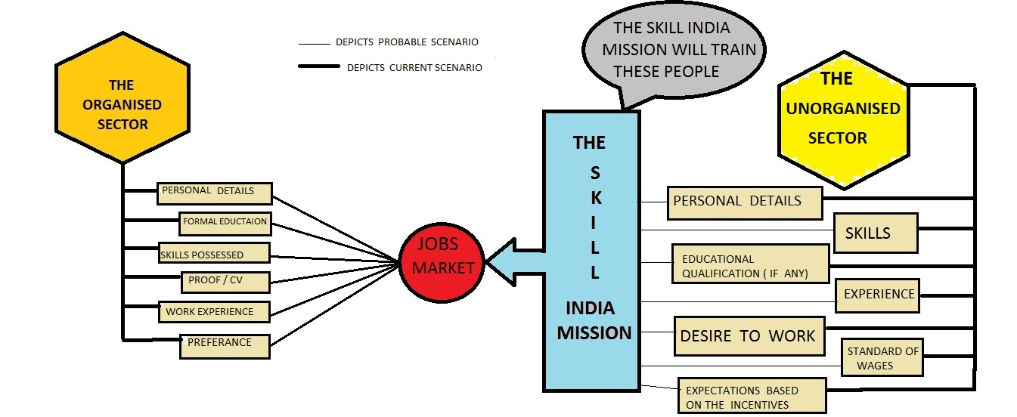

The Skill India is a revised version of programs launched earlier under the skill development policy. This new program is a multi-skill program. It was launched in March 2015. Like all other programs, ‘Skill India’ too is a dream project of Narendra Modi, the Indian Prime Minister.

**Objectives of ‘Skill India’:**

The main goal is to create opportunities, space and scope for the development of the talents of the Indian youth and to develop more of those sectors which have already been put under skill development for the last so many years and also to identify new sectors for skill development. The new programme aims at providing training and skill development to 500 million youth of our country by 2020, covering each and every village. Various schemes are also proposed to achieve this objective.

**Features of ‘Skill India ‘:**

The emphasis is to skill the youths in such a way so that they get employment and also improve entrepreneurship. It provides training, support and guidance for all occupations that were of traditional type like carpenters, cobblers, welders, blacksmiths, masons, nurses, tailors, weavers etc.

More emphasis is given on new areas like real estate, construction, transportation, textile, gem industry, jewellery designing, banking, tourism and various other sectors, where skill development is inadequate or nil.

The training programmes is on the lines of international level so that the youths of our country can not only meet the domestic demands but also of other countries like the US, Japan, China, Germany, Russia and those in the West Asia.

Another remarkable feature of the ‘Skill India’ programme is to create a hallmark called ‘Rural India Skill’, so as to standardise and certify the training process.

Tailor-made, need-based programmes is initiated for specific age groups which are like language and communication skills, life and positive thinking skills, personality development skills, management skills, behavioural skills, including job and employability skills.

The course methodology of ‘Skill India’ is innovative, which includes games, group discussions, brainstorming sessions, practical experiences, case studies etc.

**How is it different from the previous skill development policies?**

The Government of India has always considered skill development as a national priority. It is just that since the ministry is new, the approach taken for skill development is also new.

Earlier, the emphasis was on traditional jobs. However this time, all kinds of jobs are given equal emphasis. Earlier, the responsibility was divided among various ministries, but this time, these are being clubbed together. The ministry of skill development and entrepreneurship will be the principal ministry coordinates with other ministries and organisations.

According to Modi, Skill India isn’t just a programme but a movement. Here, youth who are jobless, college and school dropouts, along with the educated ones, from rural and urban areas, all will be given value addition. The new ministry itself is the certifying agency. Certificates will be issued to those who complete a particular skill or programme and this certificate is to be recognized by all public and private agencies and entities, including overseas organisations. Skill India is a programme for the entire nation.

**Advantages of Skill India:**

The idea is to raise confidence, improve productivity and give direction through proper skill development. Skill development enables the youths to get blue-collar jobs. Development of skills, at a young age, right at the school level, is very essential to channel them for proper job opportunities. There should be a balanced growth in all the sectors and all jobs should be given equal importance. Every job aspirant is given training in soft skills to lead a proper and decent life. Skill development would reach the rural and remote areas also. Corporate educational institutions, non-government organizations, Government, academic institutions, and society would help in the development of skills of the youths so that better results are achieved in the shortest time possible.

It is also high time now measures are taken to improve the physical and mental development of the youths of the country so that none of them remain unemployed and the country’s unemployment problem also gets reduced. It is time to open up avenues by which the youth accepts responsibility and no one remains idle because an idle youth is a burden to the economy. The economy should concentrate on job creation and social security schemes. With this new approach towards skill development, India can definitely move forward towards its targeted results.

**RELATED WORK:**

There has been a lot of related work in the fields of job recruitments online. From a brief discussion of each of these works we can find the scope of further work from our behalf.

We shall begin by referring to the SEEMP (Single European Employment Market-Place).[4]

They use an ontology based approach to facilitate the job matching and recruitment process. The different countries of the European Union have different languages and dialects which makes it difficult for a job seeker to get employment beyond their location. Now, what SEEMP aims to do is, it has local ontologies for every employment services (public and private) in the EU and a reference ontology that acts as a template for the local ones. When a CV is posted to any one of the ES it is passed through the local ontology and forwarded to every other ES’s local ontology via the reference ontology. If a match is found at any of the ES’s it is sent back to the original ES as a job offer from the respective ES. The SEEMP connector goes through the job offers and ranks them in accordance with the details provided by the job seeker. As a result, the job seeker not only gets job offers from the ES he has originally applied at but also at other ES’s all over the EU. SEEMP heavily relies on the Web Service Language and the concept of semantic web. However we see that SEEMP will not be able to offer jobs to the people of the unorganized sector as they have no criterion for any kind of informal education. It will work as per the CV submitted to it only disregarding the people who may belong to the unorganized sector.

We see in[5] Ontology for Modeling HRM the presentation of the methodological approach they followed for reusing existing human resources management standards in the SEEMP project, in order to build a common “language” called Reference Ontology. They have reused some existing ontologies like NACE, FOET and ISCO-88(COM). They have specified using competency questions the necessities that the ontology has to satisfy and have selected the standards that cover most of these necessities. The Reference Ontology was developed using engineering tool Web ODE.

There has also been plenty of work on semantic matchmaking for job recruitment such as[6]. We know that currently for human resource recruitment the Internet is mainly being used to place online job advertisements, resume searches and acquisition of information about skills and competencies of individuals. To assist this process the paper promotes the development of automated techniques. The effective matching of the job offer and job seeker it is important to use semantic technologies. They have used an OWL-DL ontology called SkillOnt and have used DL for their matching process. The ranking is done using similarity based ranking model. In addition to satisfying advertised job requirements, other factors such as job seekers’ and recruiters’ preferences, cultural fit, ability to adapt to the company’s marketplace and ability to grow with the organization play an important part in selecting employees. Furthermore, when considering individuals for teams, complexities arise when considering the fitness between an individual and other team members.

Furthermore there has been a skill ontology-based model for quality assurance in crowd sourcing[7]. For our work crowd sourcing is of prime importance for the development of our ontologies. The model maintains a dynamically evolving ontology of skills, with libraries of standardized and personalized assessments because checking every single submitted response is costly, time consuming and threatens to invalidate most of the crowd sourcing gains. It has an ontology merger that transfers a new skill defined by a requester from the temporary ontology to the skill ontology once it has been proved popular and verified. However uncertainty is inevitable when dealing with crowd sourcing results.

In another paper we see some work done on the reasoning about skills and competency[8]. In almost all the existing systems and approaches, the focus has been either on building and maintaining ontology-based skill catalogs, or searching for individuals that match certain requirements. As such, the reasoning has been limited. Furthermore, existing approaches have mainly focused on binary matching and do not take into account the cases where skills do not completely match existing requirements. They have used FOL (First Order Logic) as the basis of their skill ontology which is an extension of the Process Specification Language. However they did not evaluate the ontology according to knowledge representation criteria such as consistency and completeness, as well as systems performance criteria like efficiency and scalability.

For Skill and competency management we refer to this paper[9] where they have used the ontology design and evaluation methodology of Gruninger and Fox, 1995. Similar to the previous reference FOL and PSL have been used for representation and ontology extension respectively. To stay competitive within the market, organizations need to accurately grasp the competency of their human resources. This is particularly important for organizations that engage with multiple and changing clients such as consulting firms and software development

Companies since these organizations need to be able to flexibly respond to internal and external demands for skills and competencies. The bottleneck of this work lies in the fact that they have designed no system to verify the information received from external sources, the trust-belief factor is a given in this situation.

The scenario that we want to present forward as scope of our work is depicted as follows.

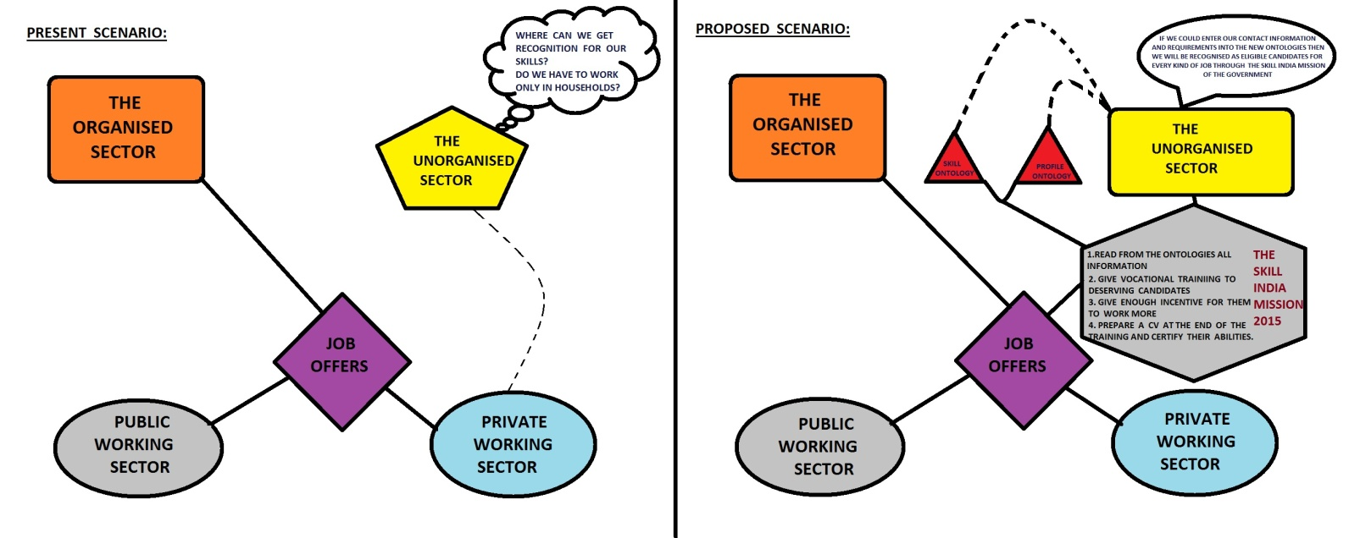

Although several works have already been done in this field, our uniqueness lies in the targeted group of people. No work as of yet has been done for the unorganised sector that exists in a country like India. The people of this sector don not possess a formal CV or a honed set of skills; however the workforce can be made to use in private and public firms alike. The difference between the formal and informal sector lies in the following points:

1. The job seekers can apply for a job based on the company’s demands and can expect a salary as per previous experience. However the people of the unorganised sector do not get a fixed salary and cannot expect one either not having the necessary qualifications. They get paid on a per-job basis which is not always sufficient for them to run their homes.
2. The job seekers of the organised sector are not confined to any one of the type of firms, they can apply to both public and private ESs. The people of the unorganised sector are often self-employed, freelancing or work in private firms, their reach is very limited.
3. A person who is eligible for jobs other than those he applied for may never get to know about these jobs which lead to a gap between an employer and a job seeker.

To address these issues we aim to develop a database which will store every detail of the people of the unorganised sector. This way an employer could easily query into the database and get a person suitable for his task. For this we choose to develop skill ontology alongside profile ontology. But why use ontology?

A skills management system can be seen as part of an organizational memory information system, which gives it the ability to store dispersed and unorganized corporate knowledge.

Three objectives have to be satisfied:

1. It has to support the complete and systematic acquisition of knowledge about skills of members of an enterprise.

2. It has to provide the knowledge of the skills and the skill owners.

3. It has to apply the available knowledge to serve the purpose.

Usually Skill management systems concentrate on manual definition of skills by employees in the form of a simple tree hierarchy of relations. This can hardly satisfy basic business demands because if we focus only on managing the existing skills the strategic human resource development is not supported and the management system may not be integrated in the existing information technology structure. The users must essentially gain a high actuality of the administered knowledge about skills so that the users can rely on the statement the system provides. The management system must therefore continuously modify and update its knowledge base.

The user of an ontology based skill management system gets a more valuable answer than he would get using a common database query.

Semantic web opened a new paradigm to design adaptive e-learning systems. By using the capabilities of semantic web approach, World Wide Web led the interchange of information about data (i.e., metadata) as well as documents.

Such capabilities also indicated a new kind of challenge for e-learning providers to design a common framework that allows learning objects to be shared and reused within and across applications.

Furthermore, applications of our skill ontology are not limited only to the producer-consumer searching and listing.

Using this platform, we can empower people who belong to the unorganized sector, by providing them a job profile for prospective employers. So it can act as “LinkedIn” for the unorganized sector and hiring companies.

This ontology can be grown dynamically which enables us to not only document but also develop Human Resource management system. This dynamical development of the ontology is required because different people have different skill sets which cannot be defined by a single database.

This ontology allows us to document the different levels of proficiency and experience a person has. Their service can also be rated by their employers for future recommendations.

The Government of India has launched several projects that aim at providing vocational training and employment to the less fortunate people. However noble the objective maybe, it does not necessarily reach the right people. For example, a person who is not enthusiastic about repairing mechanical parts may enroll into a mechanic vocation training simply drawn by the lucrative internship money offered as incentive. Whereas a person who really deserves to be trained may not even know about such programs. Hence the communication gap that has been established between the technologically backward people and the Government has to be bridged through this ontology.

1. http://vikaspedia.in/social-welfare/unorganised-sector-1/categories-of-unorganised-labour-force
2. http://www.efymag.com/admin/issuepdf/13-16_Unorganised%20Sectors%20in%20India_FFY%20Dec%2013.pdf
3. http://www.mapsofindia.com/my-india/society/skill-india-a-new-programme-to-be-launched-in-march-2015
4. SEEMP
5. HRMontology
6. Semantic matchmaking for job recruitment…
7. Skill ontology…crowd sourcing
8. Reasoning skills
9. Skill and competency management