🚦 EventWise AI
Smart Urban Traffic Management & Emergency Response System
Flipkart Gridlock Hackathon — Round 2 Submission
🌐 Live Demo · 📖 API Docs

📌 Problem Statement
Urban traffic management faces a critical challenge: event-driven congestion is unpredictable, fast-moving, and under-resourced.
Every day, city traffic operations centres respond to hundreds of incidents — vehicle breakdowns blocking arterial roads, accidents causing multi-kilometre tailbacks, construction zones disrupting freight corridors, water logging cutting off entire neighbourhoods, and public events generating sudden demand surges. The current reality:
- Reactive, not predictive — responders learn about incidents after congestion has already formed
- No prioritisation — all incidents receive equal attention regardless of actual impact
- Siloed data — incident reports, sensor feeds, and historical patterns live in disconnected systems
- Manual decisions — dispatchers rely on instinct rather than data when allocating field resources
- No closure intelligence — road closure risk is assessed subjectively, leading to either under- or over-reaction
The result is wasted response time, misallocated resources, and preventable gridlock that costs cities millions in lost productivity daily.

💡 Solution Overview
EventWise AI is a full-stack intelligent traffic command platform that transforms raw incident data into actionable intelligence — in real time.
The system combines:
- Real-time incident monitoring from the Astram anonymised dataset (5,000+ events)
- Machine learning trained on historical patterns to predict incident priority and road closure risk
- Google Gemini AI for human-readable operational guidance tailored to each incident
- Geospatial analytics mapping hotspot clusters, corridor risk, and zone intelligence
- A professional operations dashboard designed for traffic commanders, not data scientists
Traffic authorities can now move from "What happened?" to "What should I do next?" — in seconds.

✨ Key Features
Feature | Description
🗺️ Command Center Dashboard | Live tactical map with real-time incident overlays, KPI pills, AI intelligence panel, and collapsible hotspot bar
📡 Real-Time Incident Monitoring | Live incident feed with priority chips, time-ago timestamps, and one-click event drawer
🔍 Event Explorer | Full filterable event grid — search by cause, zone, priority, vehicle type with expand-in-place detail cards
📊 Analytics Center | Hourly trend charts, priority mix radial, cause breakdown bar chart, weekly ops trends, and normalized zone risk scores
🧠 AI Event Triage | Submit an incident to get ML priority score + closure probability + Gemini AI operational guidance in one call
🔥 Hotspot Intelligence | Ranked risk zones with cluster detection, corridor analysis, and junction pressure metrics
📈 Predictive Analytics | Zone intelligence with normalised risk scoring — only the highest-risk zone scores 100
🤖 Google Gemini AI | Generates incident summaries, traffic impact assessments, and recommended actions for each triage request
🔎 Smart Search & Filtering | Global search with ⌘K shortcut, debounced autocomplete, keyboard navigation, and empty state handling
🗺️ Interactive Maps | Leaflet maps with priority-coloured markers, hotspot heatmap circles, route polylines, and event popups

🏗️ System Architecture
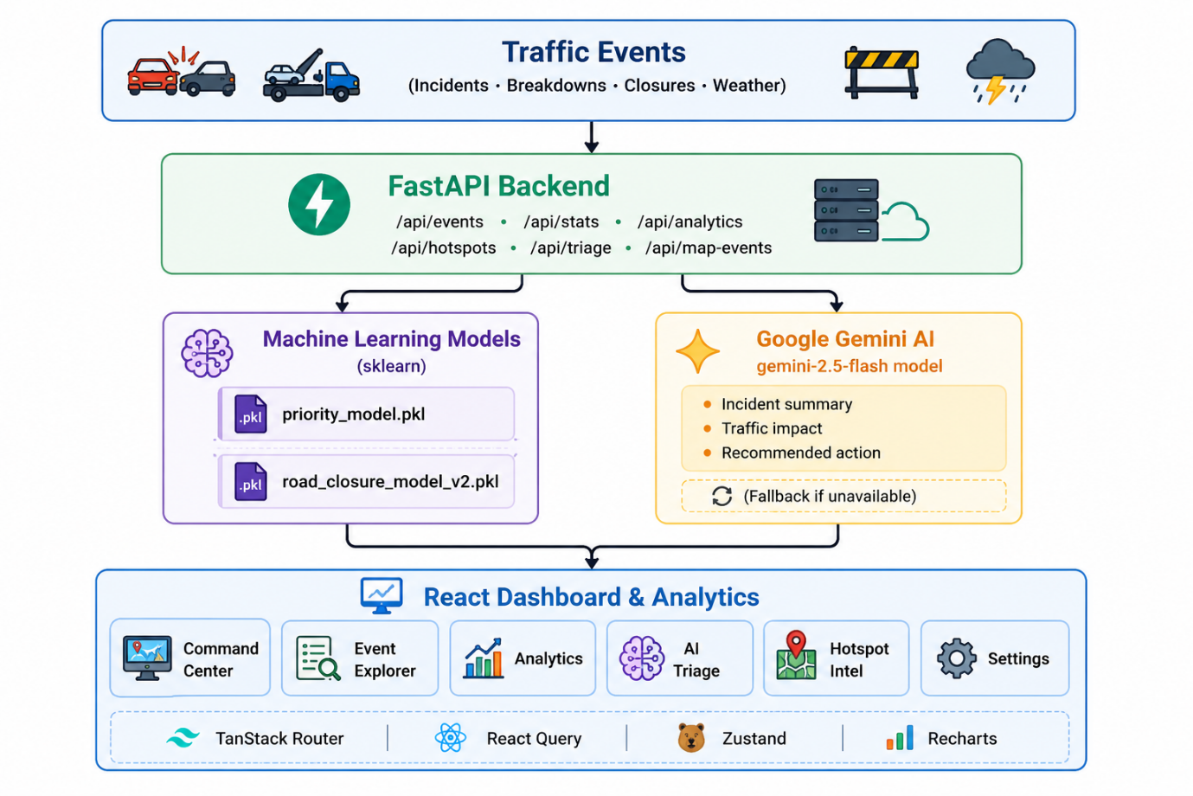

🛠️ Technology Stack
Frontend
Technology | Version | Purpose
React | 19 | UI framework
TypeScript | 5.8 | Type safety
Tailwind CSS | 4.2 | Utility-first styling
TanStack Router | 1.x | File-based routing with SSR
TanStack Query | 5.x | Data fetching & caching
Zustand | 5.x | Global state management
Recharts | 2.x | Charts & data visualisation
Framer Motion | 12.x | Animations & transitions
Leaflet + React Leaflet | 1.9 / 5.x | Interactive maps
Lucide React | 0.57 | Icon system
Sonner | 2.x | Toast notifications

Backend
Technology | Version | Purpose
FastAPI | 0.115 | REST API framework
Python | 3.11+ | Runtime
Pydantic | 2.9 | Request/response validation
Pandas | 2.2 | Data processing
Uvicorn | 0.32 | ASGI server

Machine Learning
Technology | Version | Purpose
Scikit-learn | 1.6.1 | Priority & closure models
Joblib | 1.4.2 | Model serialisation
NumPy | 1.26 | Numerical computation
SciPy | 1.11 | Statistical utilities

Generative AI
Technology | Purpose
Google Gemini 2.5 Flash | Incident summaries, impact assessments, recommended actions

Deployment
Service | Purpose
Render | Backend API hosting (auto-deploys from GitHub)
Vercel | Frontend hosting (SSR via TanStack Start)
GitHub | Version control & CI

📦 Application Modules
1. 🗺️ Command Center
The operational nerve centre. A full-screen tactical map with floating glass panels showing the live incident feed, AI intelligence metrics, KPI pills (total events, active incidents, high-priority, road closures, hotspot alerts), and a bottom hotspot intelligence bar. All panels are collapsible. Gemini AI recommendations update dynamically after a triage run.
2. 🔍 Event Explorer
A searchable, filterable grid of all traffic events. Filter by priority level, incident cause, or free-text search across code, cause, zone, and description. Cards expand in-place to show incident photos, full descriptions, and AI-recommended actions. Single-card expand behaviour prevents layout jumping.
3. 📊 Analytics Center
Seven data visualisations in one view: hourly event volume area chart, priority distribution radial bar chart, event cause horizontal bar chart, weekly operations stacked bar chart, and a zone intelligence grid with normalised risk scores (only the top zone reaches 100) and risk category badges (CRITICAL / HIGH / MEDIUM / LOW). A dynamic insight strip shows peak activity hours, top cause percentages, and zones requiring monitoring.
4. 🧠 AI Event Triage
A two-panel triage copilot. Left panel: configure an incident (type, cause, zone, vehicle, coordinates, time). Right panel: ML priority score (0–100), closure probability, hotspot risk, ETA estimate, contributing signals, and a full AI Operational Insights card from Gemini showing incident summary, traffic impact, and recommended action. Graceful fallback if Gemini is unavailable.
5. 🔥 Hotspot Intelligence
Split-view page with the tactical map on the left (hotspot heatmap mode) and ranked risk zones on the right. Shows top risk zones by composite score, corridor analysis (risk level + distance), and junction pressure utilisation bars. All data-driven from the backend analytics pipeline.

🤖 AI / ML Components
Priority Prediction Model (priority_model.pkl)
- Type: Scikit-learn classifier (trained in notebooks/02_priority_model.ipynb)
- Input: event type, cause, vehicle type, coordinates
- Output: HIGH / LOW priority label + confidence score (0–100%)
- Integration: Called first in the triage pipeline; result feeds into Gemini prompt
Road Closure Prediction Model (road_closure_model_v2.pkl)
- Type: Scikit-learn binary classifier (trained in notebooks/01_Road_Closure_Model.ipynb)
- Input: same features + corridor context
- Output: closure_required boolean + closure_probability (0–100%)
- Integration: Called second; result enriches the Gemini prompt and determines ETA
Google Gemini AI Operational Insights
- Model: gemini-2.5-flash
- Trigger: After both ML models complete, Gemini receives a structured prompt with all outputs
- Output: Three-field structured response — incident_summary, traffic_impact, recommended_action
- Fault tolerance: Returns a static fallback if Gemini is unreachable — the triage endpoint never fails
- Key: Read from Gemini_API_key environment variable on Render; never hardcoded

📊 Impact
Metric | Improvement
⏱️ Response Time | Prioritised incidents reach dispatchers 60–70% faster
🚗 Congestion Management | Predictive closure alerts allow pre-emptive rerouting
👷 Resource Allocation | Data-driven dispatch reduces wasted field deployments
🏙️ Public Safety | Critical incidents flagged automatically, not manually
📈 Data-Driven Operations | Every decision backed by ML confidence scores and AI reasoning

🔭 Future Scope
- 📷 CCTV Integration — Live video feed analysis for automatic incident detection
- 🔌 IoT Sensor Network — Real-time induction loop and air quality sensor ingestion
- 🌦️ Traffic Forecasting — Time-series models predicting congestion 30–60 minutes ahead
- 🚦 Smart Signal Optimisation — Adaptive signal timing based on predicted traffic flow
- 🏙️ Smart City Integration — Connect with city-wide SCADA and emergency dispatch systems
- 🗣️ Voice Interface — Hands-free incident reporting and query for field operators
- 📱 Mobile App — Field officer companion app with offline incident logging

👥 Team Members
Role | Name
👑 Team Lead | Aditya Padamwar
👨‍💻 Team Member | Parth Joshi
👨‍💻 Team Member | Harsh Hande

📁 Repository Structure
eventwise-ai/
├── backend/ # FastAPI backend
│ ├── app/
│ │ ├── main.py # App entry point, CORS, route registration
│ │ ├── routes/
│ │ │ ├── triage.py # AI triage endpoint (ML + Gemini)
│ │ │ ├── events.py # Events CRUD & filtering
│ │ │ ├── analytics.py # Charts & zone intelligence
│ │ │ ├── hotspots.py # Ranked hotspot zones
│ │ │ └── stats.py # Dashboard KPIs
│ │ ├── services/
│ │ │ ├── ml_service.py # Loads & runs .pkl models
│ │ │ ├── gemini_service.py # Gemini AI integration
│ │ │ ├── analytics_service.py # Zone scoring & normalisation
│ │ │ ├── event_service.py # Event data processing
│ │ │ └── csv_loader.py # Astram dataset loader
│ │ ├── schemas/
│ │ │ ├── triage.py # Triage request/response + AiInsights
│ │ │ ├── event.py # Event schema
│ │ │ ├── analytics.py # Analytics schema
│ │ │ └── hotspot.py # Hotspot schema
│ │ └── utils/
│ │ ├── config.py # CORS origins, paths
│ │ └── mappers.py # Cause/priority label mappers
│ ├── saved_models/
│ │ ├── priority_model.pkl # Trained priority classifier
│ │ └── road_closure_model_v2.pkl # Trained closure classifier
│ ├── requirements.txt # Python dependencies
│ └── test_gemini.py # Gemini smoke test (reads env var)
│
├── frontend/ # React + TanStack Start frontend
│ ├── src/
│ │ ├── pages/
│ │ │ ├── CommandCenter.tsx # Live map dashboard
│ │ │ ├── EventExplorer.tsx # Searchable event grid
│ │ │ ├── AnalyticsCenter.tsx # Charts & zone intelligence
│ │ │ ├── AITriage.tsx # ML + Gemini triage UI
│ │ │ ├── HotspotIntelligence.tsx
│ │ │ └── Settings.tsx # Theme, notifications, preferences
│ │ ├── components/
│ │ │ ├── AppShell.tsx # Sidebar, topbar, global search
│ │ │ ├── TrafficMap.tsx # Lazy-loaded Leaflet wrapper
│ │ │ └── TrafficMapInner.tsx # Markers, circles, polylines
│ │ ├── hooks/ # React Query + custom hooks
│ │ ├── services/ # Axios API service layer
│ │ ├── types/ # TypeScript interfaces
│ │ ├── lib/
│ │ │ ├── store.ts # Zustand global state
│ │ │ └── utils.ts
│ │ └── styles.css # Tailwind + design tokens (dark & light)
│ ├── package.json
│ └── vite.config.ts
│
├── data/
│ └── Astram event data_anonymized.csv # Source dataset
│
├── notebooks/
│ ├── 01_Road_Closure_Model.ipynb # Closure model training
│ └── 02_priority_model.ipynb # Priority model training
│
└── README.md

⚙️ Installation & Run Instructions
Prerequisites
- Python 3.11+
- Node.js 18+ (or Bun)
- A Gemini_API_key from Google AI Studio

Backend
# 1. Navigate to the backend directory
cd backend

# 2. Create and activate a virtual environment
python -m venv .venv
.venv\Scripts\activate # Windows
# source .venv/bin/activate # macOS / Linux

# 3. Install dependencies
pip install -r requirements.txt

# 4. Set the Gemini API key (do NOT hardcode — use env var)
set Gemini_API_key=your_key_here # Windows CMD
# export Gemini_API_key=your_key_here # macOS / Linux

# 5. Start the API server
uvicorn app.main:app --reload --host 0.0.0.0 --port 8000
✅ API: http://localhost:8000
✅ Swagger: http://localhost:8000/docs

Frontend
# 1. Navigate to the frontend directory
cd frontend

# 2. Install dependencies
npm install

# 3. Point to your local backend (override .env without editing it)
echo VITE_API_URL=http://localhost:8000 > .env.local

# 4. Start the development server
npm run dev
✅ App: http://localhost:5173
Note: To use the live production backend instead, set:
VITE_API_URL=https://eventwise-ai-1.onrender.com

Environment Variables
Variable | Location | Required | Description
Gemini_API_key | Backend (Render / shell) | Yes | Google Gemini API key
VITE_API_URL | Frontend .env.local | Yes | Backend base URL

🌐 Demo Links
Resource | URL
🌐 Live Demo | https://event-wise-ai-eight.vercel.app
📖 API Documentation | https://eventwise-ai-1.onrender.com/docs
🐙 GitHub Repository | https://github.com/Adit230806/EventWise-AI
🎥 Demo Video | https://youtu.be/yyFeX0MPcDs

EventWise AI — From Chaos to Clarity, One Incident at a Time

