**Capstone Project**

**Determining Ideal Location to Open a Coffee Shop in Mumbai**

**By- Adit Bangera**

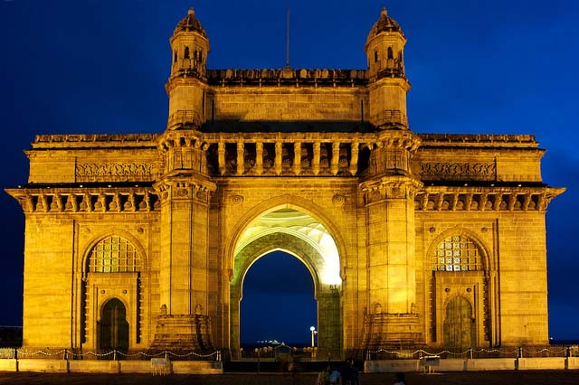

**Introduction**

Mumbai is the most populated city in India and one of the most densely populated city in the world. Mumbai is known for its diversity and people with different tastes and lifestyle live here. There is large assortment of restaurants and fast food joints for people to choose from and apart from that there are many street vendors as well. Due to this there is intense competition amongst these various entities and it gets difficult for a business to stay profitable if the location is packed with competitors as well as other alternatives. Even though there are many restaurants there is still a lack of speciality coffee shops where people can have a relaxing cup of coffee and some snacks while working or talking to their friends. If by using data science we would be able to determine areas within Mumbai with less competition it would benefit anyone opening a new shop to know such areas within Mumbai.

**Business Problem**

The business problem is to determine suburbs within Mumbai with coffee shops and cluster them within groups to be able to determine groups of suburbs which have lower frequency of shops and hence it become a better option to build a coffee shop at that particular. It would be better to even visualize these spots in a map to have a clearer picture. Since even restaurants can have impact on sales it would be better to consider even that data in decision making process.

**Target Audience**

Restaurants and other small outlets are a major source of income for many residents in Mumbai and as said before in order to be profitable lower number of competitors in an important factor. Also, large commercial chains like Starbucks already use such data science to plan their strategy of expansion and moving into new locations. This type of evaluation will hence help middle level businessmen to plan their ventures in order to provide a good service and also be profitable at the same time. This can also help people who plan on opening new restaurants.

**Data Requirements**

1. List of suburbs in Mumbai
2. Corresponding latitude and longitudinal data of the suburbs.
3. Data on the coffee shops and restaurants in each suburb.