DROWSINESS DETECTION SYSTEM

Bathala vishal  
*Department of Computating Technologies*  
SRM Institute of Science and Technology, Chennai, India Mrs. J. Jayapradha(Associate Professor)   
*Department of Computating Technologies*  
SRM Institute of Science and Technology, Chennai, India Adit Mahajan  
*Department of Computating Technologies*  
SRM Institute of Science and Technology, Chennai, India

***Abstract* — Nowadays the driver safety in the car is one of the most wanted system to avoid accidents. The project's goal is to guarantee the safety system. We track the driver's eye blinks to increase safety by determining the driver's status and controlling the vehicle accordingly.The major goal of this research is to create a non-intrusive technology that can quickly alert users whenever a human exhibits signs of weariness. Drivers who do not take regular breaks when driving long distances run a high risk of becoming drowsy a state that they often fail to recognize early enough.The technology will use a camera to track the driver's eyes, and by creating an algorithm, we can identify signs of driver fatigue early enough to prevent the individual from falling asleep. Therefore, this project will be helpful in detecting driver drowsiness in advance and will give warning output in form of alarm sound**

I. INTRODUCTION

Drowsiness Detection System (DDS) is an efficient system, which is capable of detecting the state of the person sitting in vehicles.

A automobile safety feature called Drowsiness Detection system works to stop accidents from happening when a driver becomes drowsy. According to numerous studies, weariness may be factor in upto 50% of certain types of roads and up to 20% of all accidents involving vehicles.

*A.Problem Statement*

To develop a real-time based detection model, which based on image captured determines the state of condition of driver.

*B.Motivation*

To increase driving safety, it can be crucial to monitor the drivers' behaviour while behind the wheel by looking at how the car is manoeuvred. The major factor to be identified will be how to distinguish between unintended and intentional car steering wheel inputs. For example, a sudden significant steering input may reflect the driver's level of attention. It is widely acknowledged that driver drowsiness contributes significantly to the rising number of accidents on today's highways. [2]. Many researchers that have demonstrated ties between driver drowsiness and road accidents have verified this proof. Although it is hard to decide the exact number of accidents due to drowsiness, it is much likely to be underestimated. The aforementioned statement highlights the importance of doing research to lessen the risks of accidents caused by tiredness. Until now, researchers have attempted to simulate the behaviour by establishing associations between tiredness and specific signs pertaining to the car and the driver.

The relevant behaviour is predominantly assumed in earlier methods of tiredness detection, which mainly focus on blink rate, eye closure, and yawning [29,30]. Although the

auto industry has attempted to develop technologies that can foresee driver fatigue, there are currently very few commercially accessible solutions [31]. The systems ignore the ability and traits of the driver as well as driver performance. Naturally, the majority of individuals would concur that every driver is unique. The system being developed is adaptable to the changes of the driver’s behavior.

1. *Proposed system*
2. We are dividing the project into two phases namely model building and real time face detection
3. For model building, we use keras and implement transfer learning (a deep learning method).
4. In real time face detection, we use OpenCV and alert the driver using alarm sound.

II. RELATED WORKS

Feng you, xiaolong li, unbo gong, haiwei wang, hongyi li in their research paper “A Real-time Driving Drowsiness Detection Algorithm with Individual Differences Consideration" suggests a real-time driving drowsiness detection algorithm that takes the driver's unique characteristics into account. A deep-cascaded convolutional neural network was constructed to detect the face region; they used Dlib toolkit - for detecting the face region. They only worked for daytime that effected the accuracy at nighttime.

Mohammad Amin Assari , Mohammad Rahmati in their paper “Driver Drowsiness Detection Using Face Expression Recognition” they used capacitive sensors but it involves lot of hardware and it is uncomfortable to driver due to sensors the accuracy is very high.

Jongmin yu, sangwoo park, sangwook lee and moongu jeon in their paper “Driver Drowsiness Detection Using Condition-Adaptive Representation Learning Framework” they used Representation learning, adaptive learning, convolutional neural network the accuracy they got is low.

Anirban Dasgupta, daleef Rahman and aurobinda routray in their paper “A Smartphone-Based Drowsiness Detection and Warning System for Automotive Drivers” they used perclos and computation algorithm and verification but it takes lot of time to run.

Dian artanto, prayadi sulistyanto, deradjad pranowo and ervan erry pramesta in their paper “Drowsiness Detection System based on Eye-closure using A Low-Cost EMG and ESP8266” they used Low-cost EMG

ESP8266 the accuracy of this model is good but it cannot run in realtime.

Shinfeng D lin, jia-jen lin and chih-yao chung in their paper “Sleepy Eye's Recognition for Drowsiness Detection”

they used A cascaded Adaboost classifier with the Haar-like features and Active Shape Model (ASM) there is no training is done in this model so the accuracy is not good.

Anilkumar c, mansoor ahmed, sahana R, thejashwini R and Anisha p.s in their paper “ Design of Drowsiness, Heart Beat Detection System and Alertness Indicator for Driver Safety” They used MATLAB, R-peak detection algorithm, Image processing toolbox, Computer vision cascade

Toolbox it also detects heartbeat but the hardware is huge makes the driver uncomfortable.

Petchara Inthanon and surasak mungsing in their paper “ Detection of Drowsiness from Facial Images in Real-Time Video Media using Nvidia Jetson Nano ” they used Nvidia Jetson Nano is a tool that accurately evaluates image by

Tracking closing eye motions more than 35 FPS or 1.5 seconds

To detect faces infrared camera is must but it is difficult to get.

Ghulam hyder, bhawanui shankar Chowdary and khuhed memon in their paper “ THE SMART AUTOMOBILE (SAM): An Application Based on Drowsiness Detection, Alcohol Detection, Vital Sign Monitoring and Lane based Auto Drive to avoid Accidents” they used Raspbian Operating System

OpenCV, Python, Dlib library and it also detects vitals.

Deepu Kurian, johnson joseph p, krishnaja Radhakrishnan, arun

A.balakrishnan in their paper “ Drowsiness Detection using Photoplethysmography Signal” they used Acquisition of signal using DAQ and PPG technique they got peak detection algorithm works with an accuracy of almost 100% but It becomes hard to carry and maintain physical things like ppg and electrodes

DATA PREPARATION

We have gathered a dataset of 84898 images, from mrleyedataset which contains images of eyes of 37 people, each individual has images with and without spectacles and open and closed eyes. Every image of the dataset is annotated to specify whether person has open or closed eyes.

An image from dataset which contains annotations

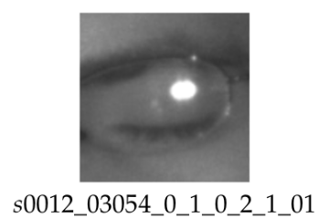

**subject ID**; in the dataset, we have the data of 37 different persons (33 men and 4 women)

**image ID;** there are 84,898 images in the dataset.

**gender** [0 - man, 1 - woman]; each image's gender is indicated in the dataset (man, woman)

**glasses** [0 - no, 1 - yes]; the information is also provided for each image whether the eye image contains spectacles (with and without the glasses)

**eye state** [0 - closed, 1 - open]; information regarding two eye states is contained in this attribute (open, close)

We marked three reflection states based on the size of the reflections (0 = none, 1 = small, and 2 = enormous) (none, small, and big reflections)

**lighting circumstances** [0 - bad, 1 - good]; each image has two states (bad, good) depending on how much light was present when the videos were being taken.

**Sensor ID** Currently, the collection includes the images taken by three separate sensors with the sensor IDs [01 - RealSense, 02 - IDS, and 03 - Aptina]; (Intel RealSense RS 300 sensor with 640 x 480 resolution, IDS Imaging sensor with 1280 x 1024 resolution, and Aptina sensor with 752 x 480 resolution)

IMPLEMENTATION

We have used transfer learning method for training our model and openCv for the real time implementation.

Modules used in this project are

OS:- The Python OS module gives the user the ability to communicate with the operating system by providing the facilities necessary to do so. It provides a large number of helpful OS functions that may be used to carry out OS-based activities and get information about the operating system that is connected to those actions. Python's operating system is covered by its basic utility modules.

SHUTIL:- The Python module known as shutil offers a wide variety of high-level functions for performing operations on files and groups of files. It is part of Python's standard collection of utility modules. This module contributes to the automation of the process of copying files and directories as well as removing them.

The data set consits of data images in single folder, to create different set of folders for open eyes and closed eyes based on annotations on the image we use shutil to split the data into different folders.

GLOB:- glob, which stands for global, is a command that returns all of the file paths that correspond to a given pattern. Using glob, we may search for a certain file pattern, or perhaps more effectively, we can search for files where the filename fits a given pattern by using wildcard characters. Both of these options are possible.

RANDOM:- The Python Random module is an integral part of the Python programming language and may be used to produce random numbers. The fact that these numbers are just "pseudo-random" indicates that they are not actually random. This module may be used to carry out arbitrary tasks like as the generation of random numbers, the printing of a random value for a list or string, and other similar activities.

TQDM:- Python's tqdm library is responsible for the creation of progress metres and bars, and it may also be called a progress metre. The word "progress" comes from the Arabic word "taqaddum," which is where the term "tqdm" originated from.

In this whole project we used this module in different parts to show the status of process(eg- downloading and coping files).

TRANSFER LEARNING

A model created for one task is used as the basis for another using the machine learning technique known as transfer learning.

Pre-trained models are frequently utilised as the foundation for deep learning tasks in computer vision and natural language processing because they save both time and money compared to developing neural network models from scratch and because they perform vastly better on related tasks.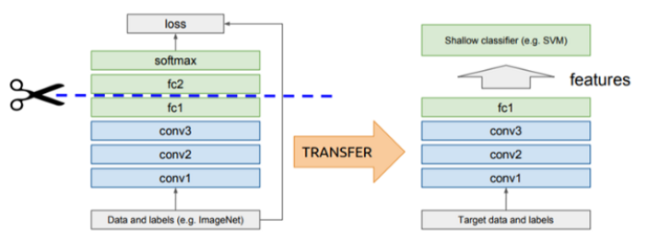

We used insceptionv3 model as a base model

Firstly we removed the head of the inceptionV3 model and flattened the model and applied relu activation and dropped out a layer and applied softmax function to the model.

OpenCV

A set of programming tools called OpenCV is primarily focused on real-time computer vision. It was initially created by Intel and then backed by Willow Garage and Itseez. The library is cross-platform and free for use

We have used OpenCV module for detecting the users face and eyes for real time implementation and for detection of face in a frame we used face cascade from cv2.cascadeclassifier

(haarcascade_frontalface_default.xml),similarly eye detection in a frame from the face we used eye cascade from cv2.cascadeclassifier ( haarcascade_eye.xml).

After receiving the input from openCV the model will predict the state of an eye (i.e closed or open) then triggers the alarm accordingly.(alarm has a timer of 5 sec i.e if the users eye is found closed for 5 sec).

ARCHITECTURE DIAGRAM

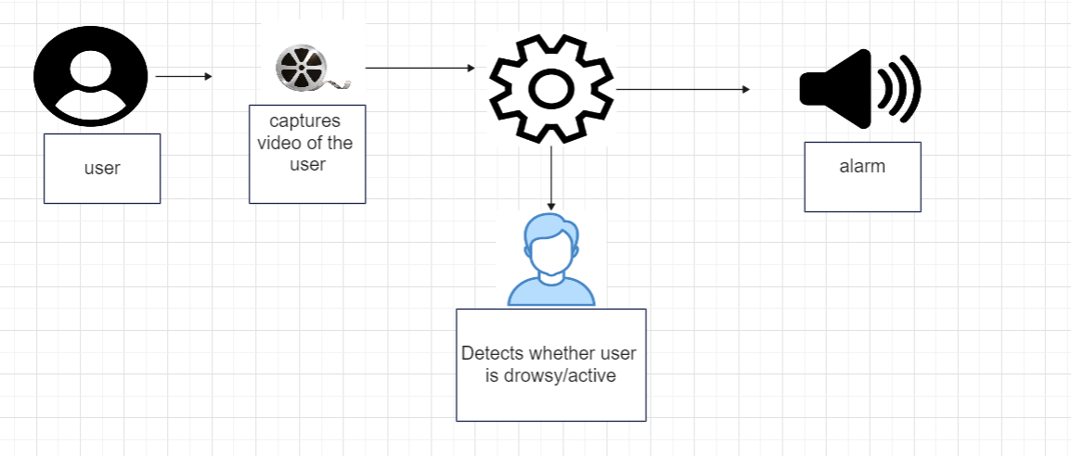

When this occurs, first a video of the user is collected, then it is determined whether or not the user is tired, and finally, if it is determined that the user is asleep, an alarm is activated in accordance with that finding.

FLOWCHART DIAGRAM:

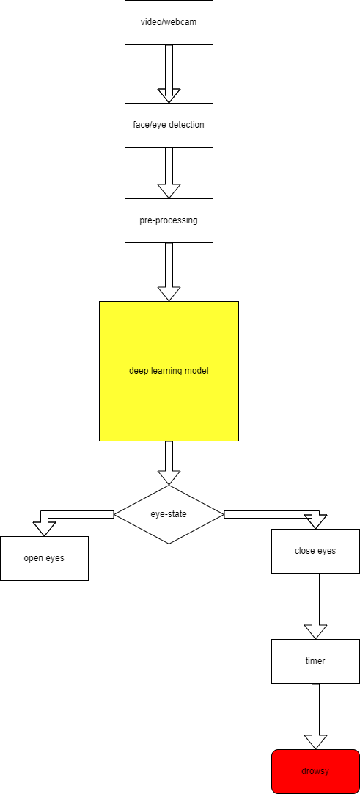

EXPERIMENTAL ANALYSIS:

A.EXPERIMENTAL SETUP:

For the purpose of our testing, we utilised Windows 11 on a computer that had 16 GB of RAM and a hard drive that was 1 TB in size.

The data for this set came from 37 individuals who were observed either with their eyes open or closed and under a variety of lighting situations. The total number of photos is 84000, including both photographs with closed and open eyes. where each picture is between three and five kilobytes in size.

B.RESULTS:

The predictions we got from the model are accurate compared to many models came previously. Main advantages of this model is very compatable and not irriatatable to driver compared to the models which composes of conductric materials throughout the driver’s body

The outputs we got from the model are

Person1

Open eyes: close eyes: 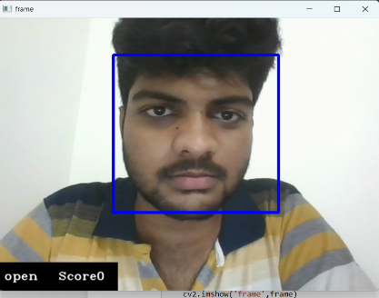

Here in the first picture the person has open eyes so the model detected it and gave a score of 0 upon closing eyes in the second picture the model detected the closed eyes with a score of 6.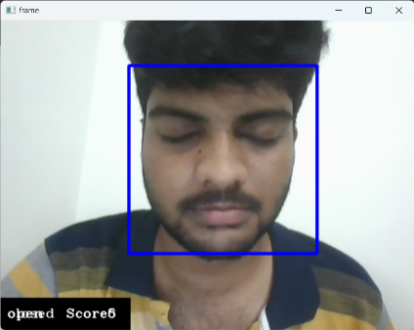

Here Score is the amount of time the person is closing his eye.

Person2

Open eyes: close eyes:

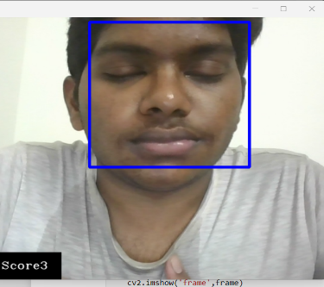

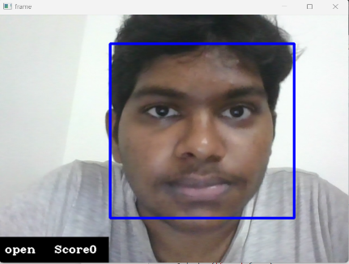

With glasses:

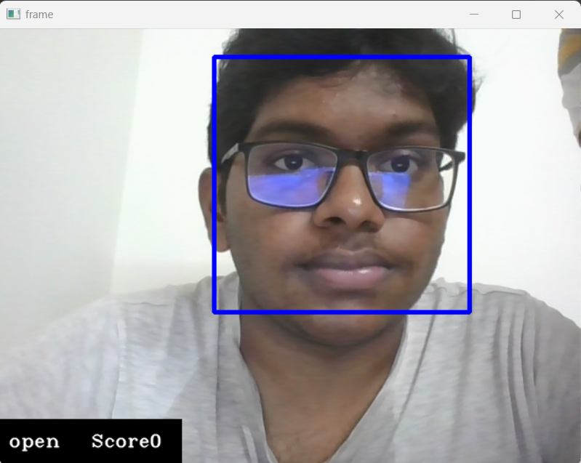

Here in this picture , the model detected even when the person was wearing glasses.and gave the output as open eyes with a score of 0.

The accuracy obtained for this model

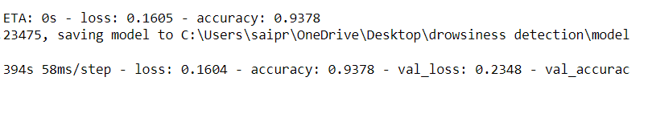

C.CONCLUSION:

Research on an algorithm that is able to recognise drowsy driving is one of the most important things that can be done to reduce the number of people who are injured or killed in automobile accidents.

It is general known that individuals may be recognised from one another in significant ways, notably in terms of the size of their eyes. One of these ways is that people can be distinguished from one another in substantial ways. When doing research on an algorithm that is based on computer vision, it is important to take into consideration the differences that might be found between different people. In this article, we provide an algorithm for reducing the amount of accidents that are brought about by drivers who are sleepy.

We were successful in attaining an accuracy score of 93.7%, which is higher than the majority of the other models. While previous models were either constructed on hardware or based on some other models with less accuracy, we were able to attain this level of accuracy by using the ideas of deep learning. Because the hardware is mounted to the driver itself, using capacitive sensors may be exceedingly unpleasant and aggravating for the user. Earlier versions, on the other hand, were constructed using resistive sensors. In addition, several of the models were unsuccessful in a variety of situations, such as poor lighting.

FUTURE WORK:

via the implementation of additional functionalities such as facial recognition for the purpose of driver identification or the use of a phone while driving with the intention of reducing the likelihood of unintentional dangers on the road.

REFERENCES

[1] You, F., Li, X., Gong, Y., Wang, H., & Li, H. (2019). A real-time driving drowsiness detection algorithm with individual differences consideration. Ieee Access, 7, 179396-179408.

[2] Assari, M. A., & Rahmati, M. (2011, November). Driver drowsiness detection using face expression recognition. In 2011 IEEE international conference on signal and image processing applications (ICSIPA) (pp. 337-341). IEEE.

[3] Yu, J., Park, S., Lee, S., & Jeon, M. (2018). Driver drowsiness detection using condition-adaptive representation learning framework. IEEE transactions on intelligent transportation systems, 20(11), 4206-4218.

[4] Dasgupta, A., Rahman, D., & Routray, A. (2018). A smartphone-based drowsiness detection and warning system for automotive drivers. IEEE transactions on intelligent transportation systems, 20(11), 4045-4054.

[5] Artanto, D., Sulistyanto, M. P., Pranowo, I. D., & Pramesta, E. E. (2017, November). Drowsiness detection system based on eye-closure using a low-cost EMG and ESP8266. In 2017 2nd International conferences on Information Technology, Information Systems and Electrical Engineering (ICITISEE) (pp. 235-238). IEEE.

[6] Lin, S. D., Lin, J. J., & Chung, C. Y. (2013, July). Sleepy eye's recognition for drowsiness detection. In 2013 International Symposium on Biometrics and Security Technologies (pp. 176-179). IEEE.

[7] Anilkumar, C. V., Ahmed, M., Sahana, R., Thejashwini, R., & Anisha, P. S. (2016, May). Design of drowsiness, heart beat detection system and alertness indicator for driver safety. In *2016 IEEE International Conference on Recent Trends in Electronics, Information & Communication Technology (RTEICT)* (pp. 937-941). IEEE.

[8] Inthanon, P., & Mungsing, S. (2020, June). Detection of drowsiness from facial images in real-time video media using nvidia Jetson Nano. In 2020 17th International Conference on Electrical Engineering/Electronics, Computer, Telecommunications and Information Technology (ECTI-CON) (pp. 246-249). IEEE.

[9] Hyder, G., Chowdhry, B. S., Memon, K., & Ahmed, A. (2020, October). The Smart Automobile (SAM): An Application Based on Drowsiness Detection, Alcohol Detection, Vital Sign Monitoring and Lane based Auto Drive to avoid Accidents. In 2020 Global Conference on Wireless and Optical Technologies (GCWOT) (pp. 1-10). IEEE.

[10] Kurian, D., Joseph, P. J., Radhakrishnan, K., & Balakrishnan, A. A. (2014, August). Drowsiness detection using photoplethysmography signal. In 2014 Fourth international conference on advances in computing and communications (pp. 73-76). IEEE.

[11] Cueva, L. D. S., & Cordero, J. (2020, June). Advanced Driver Assistance System for the drowsiness detection using facial landmarks. In 2020 15th Iberian Conference on Information Systems and Technologies (CISTI) (pp. 1-4). IEEE.

[12] Suryawanshi, Y., & Agrawal, S. (2020, October). Driver drowsiness detection system based on lbp and haar algorithm. In 2020 Fourth International Conference on I-SMAC (IoT in Social, Mobile, Analytics and Cloud)(I-SMAC) (pp. 778-783). IEEE.

[13] Yang, C. M., Wu, C. C., Chou, C. M., & Yang, T. L. (2009, November). Vehicle driver's ECG and sitting posture monitoring system. In 2009 9th International Conference on Information Technology and Applications in Biomedicine (pp. 1-4). IEEE.