|  |  |  |
| --- | --- | --- |
| **Guide Name** | | **Panel Head** |
|  | Dr.A.Pandian | Dr.A.Pandian |
|  |  |  |
|  | **Faculty Advisor** | **Project Domain** |
|  | **Dr. Karthikeyan U** |  |
| M |  |  |
|  | **Student(s) Details: Name** | **Passport size photo(s)** |
|  | 1. Carlin Fernandes 2. Adit Mahajan |  |
|  |  |  |

Registration Number(s)

1. RA1911003010129

2. RA1911003010497

**Email ID(s)&Mobile Number(s)**

|  |  |
| --- | --- |
| 1: cs6311@srmist.edu.in | 2: am6504@srmist.edu.in |
| 7506491142 | 8925614488 |

**Abstract Architecture Diagram**

One of the most fundamental and challenging issues in computer vision is object recognition, which aims to identify instances of objects from the vast categories of already defined and easily accessible natural images. To accomplish machine vision understanding, the object detection approach tries to identify all the objects or entities in the provided image and determine the categories and location in formation. It is a fundamental problem that identifies objects within images and videos and determining its precise location. The goal of object recognition is to enable machines to automatically understand and interpret the visual world in a similar manner to that of humans. It also has many practical applications such as autonomous driving, surveillance systems and medical imaging. It also does involve processing an input image or video stream and extracting features that can be used to distinguish between different objects. These features are used to train the ML models like SVM, CNN and DNNs. In this project, we build a system that is able to detect weapons in surveillance systems using YOLOv3 algorithm, it’s a new state-of-the-art for real-time object detectors released in 2022. The aim of this project is to investigate the effect of training YOLOv3 with two classes “Weapons” and “Shotgun” on detecting weapons in Realtime.

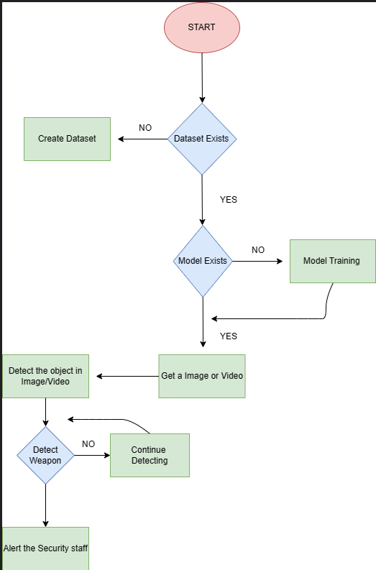

**Significance of the Project Conclusion**

### A Weapon detection system can provide advance detection of dangerous situations that is important for public wellbeing. The way stops it from happening is to detect harmful objects like example shotguns and other weapons in CCTV videos. In order to train the object detector, we need to supervise the learning with box annotations. We draw a box around each object that we want the detector to see and label it with a class that the detector would predict. There are various tools available to do the labelling eg: LabelImg or we can collect the dataset along with their labelled boxes and train the model. The primary objective of an object detection model is to accurately identify the location and class of objects within an image or video stream. Object detection models are trained to detect objects within images and videos by analyzing the input data and identifying specific patterns and features associated with objects of interest. The main goal of object detection models is to achieve high detection accuracy. The specific objectives of an object detection model can vary depending on the application. For example, in autonomous driving systems, the objective may be to detect vehicles, and other objects on roads to avoid collisions. In medical imaging, the objective may be to detect tumors or other abnormalities in medical images to aid in diagnosis. In surveillance systems, the objective may be to detect and track people, vehicles, or other objects of interest. Overall, the primary objective of an object detection model is to accurately and efficiently detect objects within images and video streams, with the ultimate goal of enabling machines to understand and interpret the visual world in a manner similar to humans. The YOLO model is then installed for object detection and the images are then inputted for the detection and the output is produced.

The intent of the project was to implement the YOLOV3 in detecting various harmful objects like weapons after doing a comparison of it in other state of the art models. Since they are existing datasets but no model was built hence, we implemented this model. The images that are used for training will be annotated based on its classes and it will be uploaded to the model for testing.

It is well known that people can distinguish one another from one another in important ways, particularly if they are carrying a weapon. People can be distinguishable from one another in significant ways, which is one of these ways. The disparities that may exist between individuals should be taken into account when conducting research on an algorithm based on computer vision. In this paper, we present an algorithm for lowering the number of accidents and injuries brought on by criminals carrying ammunition.

We were able to beat out most of the other models in terms of accuracy ratings because to our success. We were able to achieve this degree of precision by utilising the concepts of deep learning, whereas earlier models were either built on hardware or based on other models with lower accuracy. Using physical sensors may be quite unpleasant and upsetting for the many other innocent individuals because the gear is affixed to the surveillance itself. On the other hand, earlier models were built employing metal detector sensors.

**Conference/Journal Publication Details (If Any)**

