Cyber Security Tasks — CodeAlpha
Task-1 Basic Network sniffer
● Build a Python program to capture network traffic packets.
● Analyze captured packets to understand their structure and content.
● Learn how data flows through the network and the basics of protocols.
● Use libraries like `scapy` or `socket` for packet capturing.
● Display useful information such as source/destination IPs, protocols and payloads.

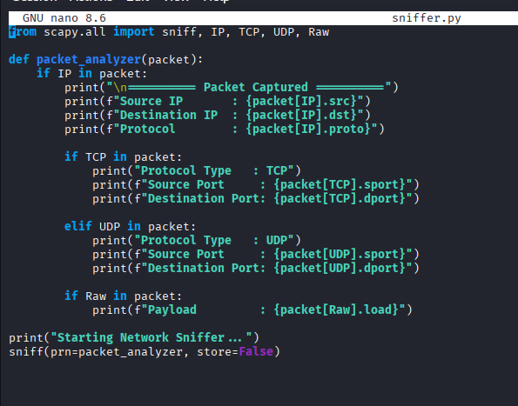
To develop a Python-based network sniffer using Scapy that captures live network packets and analyzes their source, destination, protocol, and payload to understand how data flows across a network.
