Documentation

1.Desing

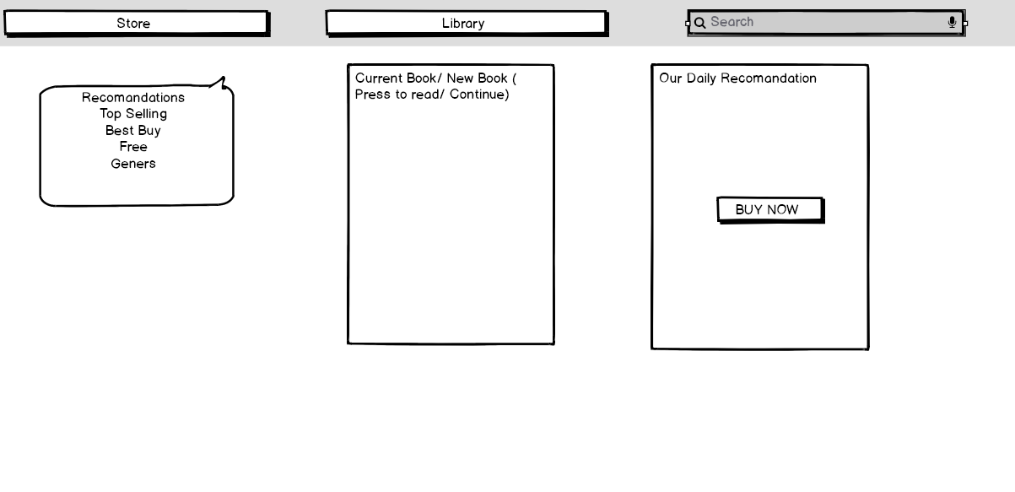

2. IDENTIFY COMPONENTS

**-Store List**

**-Library List**

**-Search bar**

**-Current book**

**-Buy now**

**-Daily recomandation**

3. API CALLS

**-GET Recomandations**

**-GET Geners**

**-GET Top Selling**

**-GET FREE**

**-PUT BUYNOW**

**-POST DAILY RECOMANDATiON**

**4. USERS ACTION**

-**BUY BOOKS**

**-READ CURRENT BOOK**

**-SEARCH BOOK BY TITLE**

**-BUY NOW THE DAILY RECOMANDATION**