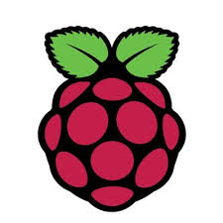

Raspberry Pi Board

* 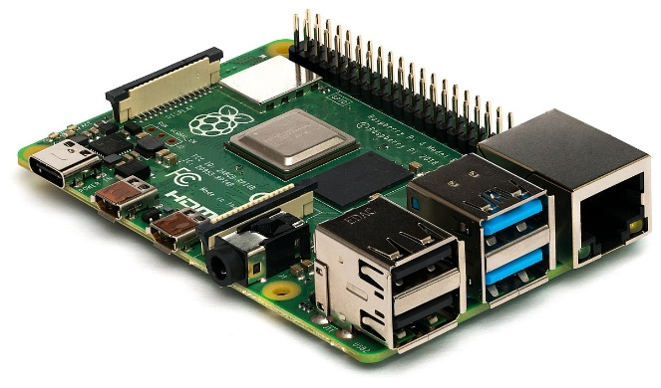The Raspberry Pi is a low cost, credit-card sized computer.
* It is a capable little device that enables people of all ages to explore computing.
* Raspberry Pi OS is the recommended operating system for normal use on a Raspberry Pi.
* Raspberry Pi OS is a free operating system based on Debian, optimised for the Raspberry Pi hardware.
* Raspberry Pi have developed a graphical SD card writing tool that works on Mac OS, Ubuntu 18.04, and Windows

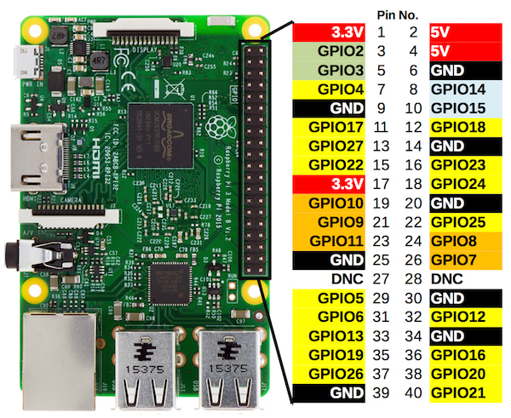

**There are various benefits to the Raspberry Pi:**

* Low cost
* Huge processing power in a compact board.
* Many interfaces (HDMI, multiple USB, Ethernet, onboard Wi-Fi, and Bluetooth, many GPIOs, USB powered, etc.)
* Supports Linux, Python (making it easy to build applications)

***“The raspberry pi boards are used in many applications like Media streamer, Arcade machine, Tablet computer, Home automation, Carputer, Internet radio, controlling robots, Cosmic Computer, Hunting for meteorites, Coffee and also in raspberry pi-based projects.”***

Raspberry Pi Detailed Documentation: https://www.raspberrypi.org/documentation/

Link to download Raspberry Pi Operating system: https://downloads.raspberrypi.org/imager/imager_1.6.exe