
DISSERTATION REPORT
2025-26
Project Report On
“Customer Lifetime Value in Indian Consumer Market”
By
Adith Naren Kadadi
1RUB24MBA0003
FOR FULFILLMENT OF THE REQUIREMENT FOR THE
AWARD OF THE DEGREE
OF
MASTER OF BUSINESS ADMINISTRATION
UNDER THE GUIDANCE OF
Ms. Suma MN
Assistant Professor
RV UNIVERSITY

DECLARATION BY THE STUDENT
Date:

DECLARATION

I Adith Naren Kadadi, {USN NUMBER:}1RUB24MBA0003, fourth semester student of MBA declare that the Dissertation Report titled, “Customer Lifetime Value in Indian Consumer Market “submitted for the degree of Master of Business Administration to the RV University, is my original work, conducted under the supervision of my guide Ms. Suma MN. I also wish to inform you that no part of the project work has been submitted for a degree or examination at any University. I am aware of and understand the university’s policy on plagiarism and I certify that this report is my work, except were indicated by reference.

Student Name: Adith Naren Kadadi

Signature:

CERTIFICATE FROM THE SUPERVISOR

CERTIFICATE

This is to certify that Mr. Adith Naren Kadadi bearing USN:1RUB24MBA0003, is a Bonafide student of Master of Business Administration of the RV University (Batch 2024-26), Bengaluru. We confirm that the Dissertation Report titled “Customer Lifetime Value in Indian Consumer Markets” is authored by him/her under the guidance of (Ms. Suma MN), in partial fulfillment of the requirements for the award of the Master of Business Administration of RV University, Bengaluru, Karnataka. I, further certify that this work has not formed the basis for the award of any Degree, Diploma, Associateship, Fellowship, or other Titles in this University or any other University or institution of Higher Learning.

Signature
Name of the Supervisor: Ms. Suma MN
Designation: Assistant Professor

Acknowledgement
I would like to thank Ms. Suma MN and RV University, for helping and displaying profound understanding which assisted in deciphering the convoluted and dense Household Consumer Expenditure Survey (HCES) datasets, minimizing raw figures into useful information. I would like to express my gratitude towards the academic environment created by RV University and the mentoring provided by Ms. Suma MN. Both were crucial to the success of this research.
Advanced clustering and classification models were one of the technical breakthroughs on this project. Under her direction, I was able to work on various classification techniques to group the certain types of consumer behavior into different categories based on long term value and retention trends. This methodology enabled a finer understanding of the Indian consumer market, ensuring that the outputs are statistically relevant and applicable to present markets. I am very thankful for the technical support and more grateful for the unwavering guidance I had throughout the dissertation. The resources and facilities at RV University benefitted greatly for managing the extensive data gathering required for such a comprehensive research study. The project journey has actually made a turning point in my academic career.
This study showcases the application and impact of making data driven decisions to understand the dynamics of Indian Consumer Market. The integration of analytical frameworks with advanced principles has provided a solid foundation for further research on customer lifetime value in Indian Consumer Markets. I am fortunate to have done this research under esteemed guidance and hope it continues to help others, as I bring these lessons in practice doing impactful work developing data science and consumer analytics

Table of Contents
Acknowledgement iv
List of Abbreviations viii
CHAPTER I x
INTRODUCTION AND BUSINESS CONTEXT x
Introduction x
Background of Study xi
Problem Statement xii
Research Objectives xiii
Research Questions xiv
Significance of Study xv
Scope of Study xvi
Limitations of The Study xvii
CHAPTER II xviii
LITERATURE REVIEW xviii
Introduction xviii
The foundational framework of Customer Lifetime Value in marketing xviii
Probabilistic modeling in non-contractual consumer markets xix
Socio-economic determinants of consumer expenditure in emerging markets xix
The strategic impact of customer equity and relationship marketing xx
Machine learning and the shift toward predictive classification xx
Resource Allocation and the Profitability of Targeted Marketing xxi
Demographic life-cycle dynamics and expenditure horizons xxi
Research Gap and Analysis xxii
Conclusion xxiii
CHAPTER III xxiv
RESEARCH METHODOLOGY xxiv
Introduction xxiv
Research Design xxv
Source of Data xxvi
Sampling Design xxvi
Research variables xxvii
Research Tools and Techniques Used xxviii
Outlier Analysis and Treatment xxix
Conclusion xxx
CHAPTER IV xxxi
DATA ANALYSIS AND KEY FINDINGS xxxi
Introduction xxxi
Graphical Analysis xxxii
Region wise Household Consumables Expenditures xxxii
Region Wise Basket Value and MPCE xxxiii
Region Wise Average HH Size and Basket Value xxxiv
Sector wise Households Consumables Expenditure xxxv
Sector Wise Basket and MPCE Distribution xxxvi
Education wise Average Basket and MPCE Value xxxvii
Gender wise Basket and MPCE Value xxxviii
MPCE Based on Online and Asset Score xxxix
House hold Type Average basket and MPCE Value xl
Key Findings xli
Top 5 Household Types Expenditure by Goods xli
CLTV Distribution Chart by Region xlii
Region Wise Heatmap Expenditure on Durables Based on CLTV Labels xliii
Region Wise Heatmap Expenditure on Services Based on CLTV Labels xliv
Region Wise Heatmap Expenditure on Miscellaneous Based on CLTV Labels xlv
Heatmap analysis By MPCE Group xlvi
Cluster Analysis xlvii
XG Boost Confusion Matrix and Classification Report xlix
Training Dataset Variables l
CHAPTER V li
RECOMMENDATION AND FUTURE SCOPE li
Conclusion li
Future Scope lii
Recommendations liii
Bibliography/References lv
APPENDICES lvi
PCA Plot Used for feature selection for clustering lvi
Silhouette Score and Cluster Number Plot lvii
RFCEV Plot for Feature Selection on Classification Models lviii
Plagiarism Report lix
AI Detection Report lx

Abstract
The study challenge we have measuring the long-term value of each household across India's very diverse and fragmented consumer market. By taking advantage of the large HCES data set, our study moves away from traditional transaction-based measures to investigate which socioeconomic and demographic factors drive expenditure. This notebook illustrates a rigorous data preprocessing pipeline converting regional indicators, household size and levels of education to predictive features. It emphasizes the conversion of land area metrics into square footage in order to illustrate asset-form wealth and its relationship with future consumption capacity. This project breaks away from traditional probabilistic models, such as NBD Pareto and moves to the cutting edge of machine learning methods, with a focus on segmentation/set prediction. The traditional probabilistic models perform well in the contexts where there is no formal contact with customers, but break down when dealing with diverse markets involving many different factors. The study addresses this by deploying clustering algorithms to develop analysis tiers. HOHs are standardized into tiers, High Value Asset or Price Sensitive Asset for how much they spend by expense category [i.e., food, services, durable goods etc. This work is a big thing as it does is unravels geography as the project cumulates states into regions, like North, South, East and West, instead of treating each one as a singular market to identify potential differences in spending patterns. Households that portray their spending on services let you know where a household fits in terms of status or tier may be even more than what their expenditure on necessities like food. The case study provides blueprint for businesses trying to understand the Indian market. with consumer segments that are likely to be high spending and care about it early. Using clustering and classification tools on the large government survey data that provides companies with a path through this old school, reactive marketing quagmire. Instead, they can really provide customer relationships across the entire consumer lifecycle.

List of Abbreviations

Abbreviation | Full Form / Description
CAC | Customer Acquisition Cost
CLV | Customer Lifetime Value
CLTV | Customer Lifetime Value (used interchangeably with CLV in this study)
CRM | Customer Relationship Management
ROI | Return on Investment
UPI | Unified Payments Interface
INR | Indian National Rupee
MPCE | Monthly Per Capita Expenditure
NBD | Negative Binomial Distribution (used in Pareto/NBD model)
NPV | Net Present Value
FSU | First Stage Unit (Primary sampling unit in NSSO survey design)
HCES | Household Consumer Expenditure Survey
HHID | Household Identifier (unique key constructed from FSU and SSS codes)
HH | Household
MoSPI | Ministry of Statistics and Programme Implementation, Government of India
NSSO | National Sample Survey Office
SRS | Sample Registration System (India source for life expectancy tables)
SSS | Second Stage Stratum (sub-unit in NSSO stratified sampling design)
UFS | Urban Frame Survey (sampling frame for urban FSUs in NSSO surveys)
IQR | Interquartile Range
PCA | Principal Component Analysis
RFECV | Recursive Feature Elimination with Cross-Validation
RNN | Recurrent Neural Network
BG/NBD | Beta Geometric / Negative Binomial Distribution model (probabilistic CLV)

CHAPTER I

INTRODUCTION AND BUSINESS CONTEXT

Introduction
India is in a transition phase and gone are those days when all you needed was a target shot based at a sale. The long-term spend value a household will pass through time is what we use to grow and understand sustainable businesses, by the year 2026 shapes up to be not just one block but a patchwork of regional habits and passing of digital fashions to the new social and economic aspirations. The dissertation goes deep into Customer Lifetime Value (CLV) that captures what a customer brings to a brand during their lifetime, that focuses on building genuine, long-term relationships fleeting over wins will find themselves in a stronger position to navigate through the implications of a marketplace where people may have more disposable income to spend but brand perfectness not guaranteed. The research aligns closely with the ongoing digital transformation in India with more than 60% of national capita consumption from metropolitan and the stakes for organizations couldn't be higher given that center segments on experiences and less on demanding product, even with high inflation and competition, companies need to work over understanding how to allocate their budgets on marketing. The research relies on the Household Consumer Expenditure Survey (HCES) that examines this human oriented dataset to unravel the social and economic foundations such as education, asset ownership, regional identity that actually drive the future consumer spending. The findings from this research provide businesses with precisely the level of targeting their accuracy that allow them to identify and grow high value customer segments, which in a market where it can cost five times more to win over a new customer than keeping an existing one. The study describes a complete foundation to understand, not just what Indian consumers are purchasing, but also their racking and expenditure patterns, merged with predictive classification, that demonstrate how CLV is not purely a numeric exercise or accountancy device but a strategic compass of your company making its way through an ever growing and a changing economy.

Background of Study
The concept of Customer Lifetime Value began as a simple number only for the use of direct marketers and has become a true pillar for organizations that identify the customer behavior based on daily patterns. The interest of companies was only to get profit whether that comes from one sale as global markets became saturated and winning new customers costs more, the focus shifted toward Relationship Value (Dwyer 1989), such change is particularly in developing country such as India. When companies get an idea of what a customer will spend in total over the long term, they no longer need to focus on singular sales, and can manage every customer across their entire lifecycle. they channel their capacities towards the customer segments that provide greater opportunity for long-term sustainable growth (Berger & Nasr, 1998). The consumer market in India is a complex area to crack in by profound regional diversity and middle class with an unfolding digital revolution, as in developed countries tend to shop the same way, Households are making over their expenditure habits to arrive at the optimal mix between essentials and luxuries (Khare, 2011). Dividing various economic classes are disappearing because of the Digital India push and cheap data plans, instead monitoring what people are purchasing is required to study .Extensive research is required to unpack these underlying trends such as education, digital skills and increasingly diversified regional economies that ultimately set in motion in a household's future economic trajectory (Venkatesan & Kumar 2004).Largescale government data would particularly use the Household Consumer Expenditure Survey (HCES) to provide with an opportunity to study these dynamics in detail. While businesses usually rely on this internal transactional data, such information tends to be limited within the boundaries of the company and does not present a holistic view by overlooking how consumer is behaving beyond their relationship with one brand (Rust et al., 2004). The dissertation aims to fulfill this gap by using clustering and classification on national spending dataset with advanced machine learning techniques from a point of view at different Indian household segments which distribute their spending across lifestyle, services and durable goods and provides a granular framework for determining the future value of consumer from India, one of the fastest growing and most promising economies in the world.

Problem Statement
large-scale government data such as the Household Consumer Expenditure Survey (HCES)provides an opportunity to examine the consumer dynamics closely.Companies often rely on their own internal transactional data, which is secured within the boundaries of companies and customer behavior is ignored beyond a single relationship with the brand (Rust, Lemon, & Zeithaml 2004). The dissertation helps fill that gap with sophisticated categorization methods (such as clustering & classification) on national expenditure dataset. The approach stands by understanding the expenditure on foods and lifestyle segments of Indian households allocated to their spending variedly, it offers a framework for forecasting the future value of consumers for India which is arguably one of the fastest growing and most aspiring economies. The research addresses issues like, Identifying who the high-potential consumers are in the context of India´s fractured marketplace with traditional probabilistic models that don’t have the capacity to dive deep into the non-contractual and varied spending habits of Indian households especially with fast-moving fronts of their own such as services and durables fabricating analytical framework that can convert these large data sources such as the Household Consumer Expenditure Survey (HCES) into real information for businesses to utilize. Companies usually waste their time and resources and chase lower value segments that take up resources but have lower lifetime value potential versus other households. The research transforms from basic descriptive features to predicting classification by converting more informal variables such as regional MPCE, level of education or activity factors about digitally using their services into distinct levels of value to create a scalable model that clusters households into tactical segments which allows organizations to transition from generic mass marketing and migrate to focused value-based engagement strategies that closely resemble true lifetime potential of Indian consumers.

Research Objectives
- Perform data synthesis and pre-processing on high dimensional socio-economic datasets that stores data by structured objects restructuring with multiple inter-related files into a single master file by transforming and formatting variables
- major socio-economic and demographic determinants of household consumption by examining the effect of Monthly Per Capita Expenditure (MPCE), level of education, and place of residence on the spending behavior of India households.
- Application of unsupervised machine learning to segment the Indian consumer market by Using clustering techniques, (such as K-Means) over derived labels based on expenditure profiles across lifestyle, services & durable goods categories.
- Identifying the potential households by classifying the consumer value labels by classification models, through methods , that classify households into their value segments and identify high potential consumers.
- For regional and digital differences in consumption potential: Determine how the share of a household’s estimated lifetime value can be used as multipliers based on geography (State/Sector) or online score.
- Turn the findings from clustering and classification models into actionable insights and demonstrate how these can be used to steer organizations away from mass marketing propositioning, helping decision-makers in India towards targeted, value-based strategies that channel resources strategically.
- To determine the best economic drivers using large impacts for resource allocation: This would determine which factors like MPCE, education or location are predictors of a household's spending ability. Which, for businesses, translates to a pivot from mass marketing to directing budgets towards the consumer characteristics proven to carry the most weight.

Research Questions
- How to combine and feature engineer disparate socio-economic datasets in HCES into a single data-rich, accurate feature set for predictive modeling?
- How statistically relevant are the MPCE, education or household size (any other socio-economic indicators needed) to be captured in a consumer long term potential measuring?
- Do classification algorithms (Logistic Regression, Random Forest) predict household value tiers better than simple baseline averages?
- Can we move from basic Urban vs. Rural segmentation into identifying High-Value Asset households by looking beneath the hood of their socio-economic drivers?
- A quantifiable multiplier effect of digital engagement (Online Score) on the expected lifetime value of a household?
- In which regions of India is the Emerging Wealth concentrated so that there is a strong case for higher infrastructure and marketing investment?
- How can a predictive CLV framework help you to reduce the Cost of Acquisition (CAC) by early identification of customers with high predicted lifetime value as soon as they enter your marketing funnel?
- How do you convert ownership of land or other non-monetary household assets into one comparable proxy for "wealth" at a regional level that would be consistent and usable for large-scale predictive modelling?
- How do you translate the biology of a household head life-cycle into an actual financial value (which cannot be infinite, as a human being cannot live forever)?

Significance of Study
On one level, this research is important because it addresses the fundamental weaknesses inherent in traditional forms of CLV including segmentation when efforts to use them have been deployed into non-contractual, heterogeneous emerging markets. The study does not merely calculate just transactions but also captures a set of clusters based on socio-economic features such as regional Monthly Per Capita Expenditure (MPCE) and levels of education using machine learning clustering and classification principles. The major step was to standardize data that is spread throughout many places and convert the land measurements into a readable metric by providing a much clearer and scientifically means of measuring household value than raw survey numbers. The study importance about this research is to understand the approach and implementation of Precision Marketing. In a large consumer market like India, mass marketing is not only costly it hardly pays off but also offers a road map for value based importance. Companies can also reduce their cost of acquisition by ranking households into defined tiers. Instead of having a large distribution short retention segments are sorted by focusing on high-potential look alike groups and transform from traditional method of tracking what people bought yesterday to something bigger like relationship intelligence which actually assists target homes that are emerging in their consumption and have far higher life time value. The study is all where more strategically significant one moves beyond immediate national security and explores how to measure the Digital Multiplier Effect in an Indian socio-economic context, By bringing together an online score alongside digital literacy and traditional spend, the research explains how technology could be a driver of consumption. To business leaders and stakeholders at RV University, this articulates a possible path towards regional consumption visibility. It proves just how some geographic domains have been made available for the building of infrastructure and digital service delivery as well with an eye towards ensuring that infrastructural investments do meet corporate growth objectives while creating space to match the aspirations of life (and accompanying ability or ease in life) manifested through continuing trends towards a digital home.

Scope of Study
This project will cover Indian geographic area but if data is available all 50 states and industry level will be covered. We will be using the most recent versions of Household Consumer Expenditure Survey for India. Your exclusion from the study group will all but be a given not necessarily you as an individual, rather the household unit. We will restrict ourselves on the data manipulation because we will only use variables which can affect consumption (this analysis). Monthly Per Capita Expenditure and other variables, education and household size. For one very simple fundamental technical constraint applied in the specific architecture of this project, we will express a proxy for wealth using normalized real values of physical assets (that is: convert all state derived land ownership properties into a common Total Square Footage value). On a technical level, this study is categorized as Unsupervised and Supervised Machine Learning research. The first step of the project is exploratory data analysis (EDA) to find out how spending is distributed across categories such as food, fuel, discretionary services etc. K Means Clustering of the data is then carried out by Segmenting the Population into Strategic Analysis Tiers. Then the various Classification Algorithms such as Logistic Regression, Random Forest are applied to find which level a household will be placed in, based upon socio-economic characteristics. In this motivation for this research, we're intentionally focusing on those classification methods rather than conventional time series forecasting, since here we are interested in identifying value, rather than predicting future transactions. To maximize out of the electoral, this study reviews to Digital Multiplier and Online Mark on digital distribution with a purchase. Time Horizon: This is built on a remaining life concept. Instead of assuming the firm enjoys infinite customer loyalty, their analysis estimates expected remaining years by the household head's calendar age and those demographic life expectancies. A sensible expiry date is placed on Customer Lifetime Value calculations. At the top level, it is the decimal output of a Business Playbook which highlights roadmap to regionalization and resource allocation including targeting areas with limited competition and maximum opportunity either regionally or their user grouping within the Indian market.

Limitations of The Study
The primary limitation of this study is its high reliance on the Household Consumer Expenditure Survey as a secondary data source. The dataset is large and being collected at different intervals by government agencies has always a time-lag from when it is measured and takes shape. The use of household self-reported expenditure, might be susceptibly bias with memory and lower estimation of some discretionary expenditures. as secondary research there is lack of control over the original survey design that limits the ability to explore deeper psychological drivers behind consumer spending. The research has limitations from technical perspective due to the assumptions built in to clustering and classification algorithms which has proved helpful for segmentation and requires researchers to define the number of clusters in advance which may lead to simplified representation of complex Indian consumer market. Classification models like Logistic Regression assume some degree of linearity between socio-economic characteristics and the value categories to be predicted. Since the analysis focuses on a spot market related to non-contractual transactions, the models estimate potential value from a snapshot of consumption rather than dynamically capturing transaction flows in real time; that is, they do not adequately account for sudden shifts in underlying consumer behavior as a function of unexpected economic shocks. Although the research focuses on a number of states and sectors across India, the enormous diversity of this country means that certain micro-regional specifics may be lost, in the broader state-level analysis. I do not think this will reflect different market prices that I would expect in varied city or rural areas, since it turns land units as a proxy for wealth into a homogenous square footage measure. Finally, the number of years remaining on the expected future life is based on average demographic life-expectancy of head of household. That is just an average statistic and doesn't take into account individual health factors (some really are healthier) or multi-generational shifts in spending within households that may extend or shorten the actual lifetime value period.

CHAPTER II

LITERATURE REVIEW

Introduction
  - In this chapter, we evaluate two streams of past studies focusing on Customer Lifetime Value (CLTV) in the Indian consumer market with the application of probabilistic modeling techniques and the usage of comprehensive demographic data for value estimation. Once fought to assess prior research, understand other findings and determine the whitespace that this study hopes to fill. As digital technologies and access to data continue to evolve, the question is how can predictive models accommodate non-contractual features of Indian retail. This paper is divided into Sections about building CLTV models, one on some of the specific challenges related to Indian market, next on technical features for wealth, and finally machine learning model implementation on a government dataset.
  - The foundational framework of Customer Lifetime Value in marketing
Conceptual modeling in early academic studies defined Customer Lifetime Value as the present value of all expected profits from a supplier to a customer throughout the entire life cycle of their relationship with them. Berger and Nasr (1998) point out that an evolution from mass marketing to one that is more segmented, customer driven, was occurring which meant that mathematical models for CLV were becoming critical. The organizations could better defend the cost associated with acquiring and keeping a customer by calculating the net present value of future cash flows. Taking this theory further, Berger and Nasr (1998) laid the groundwork for differentiating between the segments of a database that are most profitable, thereby allocating marketing resources more accurately.

Probabilistic modeling in non-contractual consumer markets
  - There has been significant research into the various challenges with predicting what customers will do in "non-contractual" settings, where the precise time of a customer ultimate departure is never recorded. Also, since the Pareto/NBD is a more complex framework than its BG/NBD counterparts, Fader, Hardie and Lee (2005) introduced the concept of BG/NBD as a simpler way to predict future behavior focused on frequency and recency of purchases. They found that it was possible, with relatively few data points, to attain a statistically viable estimate of the probability that a customer is still "alive", using probabilistic models. This emphasized the importance of using longitudinal transaction data to identify high-frequency purchasers versus those who are zero-undoubtedly churned (Fader et al. 2015, Hardie & Lee 2005).

Socio-economic determinants of consumer expenditure in emerging markets
  - Innovative Reference: Household expenditure on the Indian consumer market is not necessarily income based according to research, instead leading social and occupational classes primarily drive household expenditure based on socio-economic class. Abstract: Khare (2011), Consumer lifestyle is directly proportional to the shopping habits as educational level and geographic location provides a basis of acceptance of modern retail formats as studied by their research paper. The results showed that people spending progresses from needs for survival services to luxury services as one moves up the economic ladder. Khare (2011) focused on using regional Monthly Per Capita Expenditure as a critical cornerstone for market segmentation strategies in different economies.

The strategic impact of customer equity and relationship marketing
  - As data grew in complexity, researchers started looking into generating machine-learning–based forecasts of consumer demand as a more effective alternative to established regression techniques. Finding the relationship between consumer attributes Chen and Li (2011) studied various algorithms including supervised and unsupervised learning, they also implemented Random Forest modeling approach for prediction. Similarly, a study by Benoit & Van den Poel (2009) based on approaches of this enhanced algorithm reported that these methods are capable in capturing non-linear relations amongst meaningful variables explaining customer behavior directly related with recent time. A second study conducted by the researchers was based on a re-check of the data, which revealed that using basic behavioral and demographic predictors would help classify users into different values much more accurately. By shifting their emphasis from diagnostic to predictive classification, they have identified these potentially hot segments that may be overlooked using more standard statistical averages (Benoit & Van den Poel, 2009)

Machine learning and the shift toward predictive classification
Because of the increasing complexity of data, researchers began exploring machine-learning as a better replacement for traditional regression approaches to forecasting consumer behavior. A study by Benoit and Van den Poel (2009) explored the use of Random Forest and other ensemble methods to predict customer are behavior showing that these algorithms performed best in handling nonlinear relationships among consumer attributes. On re-examination of the data, they found that using a wide array of behavioral and demographic predictors would significantly improve classification accuracy into different value tiers. Moving their focus from diagnostic to predictive classification, they have found identify potential hot segments that may be missed through standard statistical averages (Benoit & Van den Poel, 2009)

Resource Allocation and the Profitability of Targeted Marketing
An example is that of Venkatesan and Kumar (2004) who provided a detailed framework for making customer lifetime value (CLV) resource allocation decisions. They looked at measurements of marketing strategies based on past purchasing behavior versus those based on predictions of the future value. These studies showed that firms employing predictive CLV models for identifying customers for targeted marketing campaigns did make significantly greater returns on investment. This showed that the true beauty of CLV is to sideline low-potential segments and direct a corporate effort toward "look-alike" audiences who share characteristics with high-value customers (Venkatesan & Kumar, 2004).

Demographic life-cycle dynamics and expenditure horizons
  - The Life-Cycle Hypothesis Professionals who work in the field of economics have found that household consumption is not only planned for their income and expenditure but its demands too, which are mapped out over its lifetime based on the age and expected remaining life of individuals living within it. According to the life cycle/permanent income model of personal consumption behavior pioneered by Modigliani and Brumberg (1954), most individuals are seeking throughout their whole life not consuming all of their current income but instead they aim to smooth their consumption over the lifetime, thus borrowing in lower earning years and saving at higher earnings periods. This idea has been further explored in subsequent studies, proposing that the value of a customer is necessarily constrained by their biological and economic life stages extending this concept to Customer Lifetime Value (CLV). This is insightful since these investigations show the residual duration of family relationship as a crucial but usually overlooked variable in evaluating the general monetary projection of customer worth (Modigliani& Brumberg, 1954; Benoit & Van den Poel, 2009).

Research Gap and Analysis
  - Detailed inspection of the academic field also shows a marked shift in methodology, from Probabilistic Era to Machine Learning Era. Groundbreaking research by Berger and Nasr (1998), Venkatesan and Kumar (2004) advocated the treatment of Customer Lifetime Value (CLV) as a future financial asset, instead of a historical measure. However, much of this foundational research remains in Western contractual markets where customer retention is well-defined (e.g. subscriptions are a common model). Unlike the dense consumer markets abroad where traditional models such as an NBD Pareto are typically sufficient to identify exactly when a customer is going to leave, the Indian consumer landscape is too fragmented and 'non-contractual'. There is an awareness among researchers (Khare, 2011) about the role of socio-economic factors, there continues a literature bias towards descriptive statistics rather than utilizing these deeper drivers for predictive classification. Although the concept of Customer Lifetime Value (CLV) has been thoroughly studied, many critical research gaps exist in this regard, particularly with respect to emerging markets. There is a flaw in that, normal formulas contend with a long or maybe endless linear system transformation ignoring the strong stages during a home. There is also issue with the features as most predictive models focus only on transactional records while ignoring non-transactional factors such as digital literacy and educational levels. As a result of the region-specific land units used in rural economics studies, there being an Adapting Asset Standardization Gap where it is nearly impossible to find a stable proxy for wealth on a national level. The existing literature rarely considers the inherent volatile nature of the Indian market, wherein a household can experience vast differences in their buying power due to local infrastructure and level of digital access meeting them. This research addresses these academic gaps by exploring Household Consumer Expenditure Survey (HCES) data using an advanced analytical framework. The analysis circumvents the Infinite Horizon Flaw (Duncan, 1988 & 1990) by inferring expected for remaining years utilizing SRS mapping, thus bounding finally the CLV estimate along biologically- and economically-realistic household head life-cycles. An online score to assess the degree to which digital engagement acts as a value multiplier serves to close the Feature Integration Gap. For addressing the Asset Standardization Gap, the research includes a technical conversion logic that maps otherwise disparate land units on a regional basis into a total square footage aggregate during wealth evaluation. Instead of counting transactions, this project focuses on a machine learning based classification of Strategic Analysis Tiers in India to shift the focus from backward looking reporting to forward-looking data-driven understanding of household equity.

Conclusion
This study adopts a quantitative research method using secondary data sources enabling analysis of the entire Indian consumer market. The main data source is the Household Consumer Expenditure Survey (HCES) for the years 2023-24 published by the Ministry of Statistics and Programme Implementation (MoSPI). This dataset gives a detailed understanding of micro level consumption pattern for Indian households, with many variables such as (MPCE, Education and region) for each of them. This, because their study relies on official governmental data means that the predictive models ensure that they are mapped to an evidenced real world events that are validated and authentically give enough representation of socio-economic groups of Indian citizens living in both urban and rural habitats. The analytical framework is structured around a data science methodology that can mine raw survey data into business intelligence. The process starts with data cleaning and feature engineering where multiple files of data are combined from the HCES to compose one master file. Standardizing of unreliable variables of land ownership units, for example, into a common measure or rather. The model offers an indicator of measurable digital involvement, as a transition from traditional to digitally mediated economic transactions to be partially reflected quantitatively with their characteristics. A particular example is the mapping of SRS to evaluate expected years remaining i.e. customer lifetime value which locates the households biological and economic reality.

CHAPTER III

RESEARCH METHODOLOGY

Introduction
The goal of this study is based on a quantitative research framework that uses secondary data sources to allow for an examination of the Indian consumer market. The dataset delivers us with a micro-level understanding of the consumption pattern for Indian households it contains detailed information on various household variables like monthly per capita expenditure (MPCE), education and regional segmentation, This leads the research to ensure that the predictive models are mapped to the evidenced real-world events that are verified and credible and gives us adequate representation of the socio-economic demographics of Indian citizens in both urban and rural spaces. The analytical framework follows a methodological data science pipeline that is designed to transform raw survey data into data driven business insights. The process begins with extensive data cleaning and feature engineering, where multiple files of data are merged from the HCES to create one household profile. In this framework, a specific aspect is the use of SRS mapping to extract expected years remaining (i.e. customer lifetime value) which has been implemented to achieve biological and economic remaining age left for the households. The study is able to provide a advanced, data-driven roadmap on segmenting of markets and allocating key resources within the telecoms space.

Research Design
For this research we have used a descriptive and analytical approach using a cross-sectional method to evaluate the Indian consumers. a quantitative framework that aims to identify and outline the inter-connections between socio-economic features and household expenditures. It is designed carefully to handle the extensive quantity and complexity of HCES 2023-2024 data, ensuring that the flow from preparation from raw data through inferential detection is both methodical and statistically valid. The methodology implements an empirical assessment of consumer behavior over regional and demographic distribution for providing a consistent equivalent to help examine the impact of digital and educational influences across lifetime value. The research design also includes a complex data integration and cleaning protocol that lets handling of conceptual complexities in these extensive data sets (HCES 2023–2024 secondary dataset), by the systematic combination of different data levels. The design logic for creating a unique Household ID (HHID) is similar as derived from FSU Serial Number Stratum Number Second Stage Based on Sample household number 6. The precise matching of identifiers ensures that the different consumption like durable goods, fuel, services and lifestyle expenditures are grouped into a single unique profile for each of the 261,953 household IDs. This study enables impeccable merging of dataset (meaning every predictive variable is matched perfectly) by designing the layout around this strict data-merging framework, creating clean and highly reliable bases for all subsequent machine learning and lifetime value classification phases. By employing an intelligent, multi-stage integration process linked to state-of-the-art machine learning algorithms for modelling, this well-crafted, holistic design transforms a complex socio-economic landscape of the models constructed using 2023-2024 HCES data into a solid and actionable framework that highlights key market prioritization opportunities in India through analytically sound household profiles.

Source of Data
The dataset employed in this research is from the Household Consumer Expenditure Survey (HCES): 2024, conducted by the National Sample Survey Office (NSSO) under the aegis of Ministry of Statistics and Programme Implementation (MoSPI). This large dataset is the main source for gauging socio-economic status of Indian households, as well as deriving monthly per capita expenditure (MPCE) and demographic information among other consumption habits in states and union territories across India. the study ensures a high degree of statistical accuracy and national level representativeness for computing customer lifetime value and economic value with comparative analysis in rural vs urban regime in India.
Source Link: India - Household Consumption Expenditure Survey: 2023-24

Sampling Design
  - The design used was a stratified population dataset, the gold standard for large national surveys conducted in India which ensures that the data meets statistical standards by quantifying socio-economic diversity, segregated by rural and urban population. the First Stage Units (FSUs) consist of villages in rural areas and Urban Frame Survey (UFS) blocks in urban regions. Such units are deep-dived and divided by the number of people living in them and where their location is present to ensure that the sample captures an accurate representation of what in the real world the distribution looks like between territories, it gives us solid foundation for predictive modeling. The second stage of the sampling process is determining the Ultimate Sampling Unit by relating to the individual household. In each selected FSU, households are then categorized into Second Stage Strata (SSS) based on wealth and consumption values as this structure is important to the study because it ensures that the sample covers a enormous range of economic levels, from low-spending to high- spending families. Through this complicated hierarchy, the data that is fabricated gives a true indication of what has good spending power from the consumers in India and can be divided into segments.

Research variables
Independent Variables:
- Head Age - The age of household head
- Head Marital Status - Marital status of the head
- Head Education level - Highest educational attainment of the household head
- House hold Size - Total number of members in the household
- Total land Area owned - Area of land owned in square feet
- Asset Score - A composite score representing the possession of physical assets
- Ration Card type - An indicator of socio-economic status and government welfare eligibility.
- Welfare benefit Count - Number of government-provided "free" items (e.g., Free Mobile, Free Bicycle) possessed by the household.
- Digital Households - Whether the household head used the internet in the last 30 days.
- Online Score - A calculated metric representing the variety of categories shopped online (e.g., Clothing, Electronics, Personal Goods).
- Energy Source Cooking - Type of fuel used, serving as a lifestyle and modernity.
- Region, Sector, State, District - Location identifiers representing their living locations
- Intoxicant, Durable, Services, Miscellaneous Expenditures – Households spending attributes
- Basket value - Households affordability rate
- Monthly per capita expenditure (MPCE)- Households rate of expenditure per family member
- Expected Remaining years – A metric calculated by SRS mapping based on households’ years of living left.
Dependent Variables:
- CLTV – A metric calculated to cluster and identify households
- CLTV Label – A metric to identify to classify the households.

Research Tools and Techniques Used
We use a very powerful analytical stack especially selected to manage the large scale at which the HCES 2023-2024 dataset is organized. Because the research consisted of a population-wide sample of 261,953 rows in total and between 24–30 columns, compiling a merged master file necessitated considerable computational constraints that standard software was not capable of easily managing. Hence for implementing the data analysis and the machine learning models Google Colab was the preferred software environment. The Pandas and NumPy libraries were used for manipulating the data frame, calculating complex statistical measures and Scikit-learn acts as main working library for fitting the machine learning model. In order to structure this large secondary data, a complex multi stage merging method was implemented. For that purpose, a custom function was made to merge the FSU Serial Number with other identifiers such as Second Stage Stratum No and Sample Household No to create one unique Household ID in order for all modules of every survey record be aligned. The technical architecture enabled the linking of demographic details by taking instance head-of-household age and education levels to detailed expenditure records. Automating merging process in Python, the study avoided manual errors produced by smaller-scale tools and made a reliable database. the project applied sophisticated machine learning methods to gain strategic insights from household profiles by two-tiered one, the first being to separate Strategic Analysis Tiers in the Indian market using unsupervised K-Means clustering addition which was subsequently followed with the training of supervised classification models to predict these labels based on socio-economic determinants such as online score, asset ownership etc., following with the shift from raw data manipulation to predictive modeling and transition past merely descriptive reporting to offer a straightforward and statistically-supported system for analyzing long-term economic condition of households.

Outlier Analysis and Treatment
Outliers identified in the analyses of HCES 2023-2024 dataset were applied mainly to some variables measuring expenditures and land ownerships that had highly skewed distribution owing to heterogeneous economic status amongst different households coming from various regions across India. To avoid these anomalies and biased outcomes, a systematic technique was utilized in this study. The dataset was trimmed to capture only values that were within the representational economic range by ensuring stability and accurate predictive modeling moving forward.
We capped excessive expenditures that had no semantic meaning, and normalized selected variables. The normalization step was needed so that a uniform wealth could be constructed irrespective of the state type and sector, following these outliers were then removed after which the Total Monthly Household Expenditure ("total_hh_exp_monthly") calculated again to reflect a suitable (average) baseline for Customer Lifetime Value calculations The extensive preprocessing process guaranteed that the resulting these Tiers were produced based on authentic market segments as opposed to infrequent statistical outliers The age also included extreme values that were not fitting well based on our research, hence with the target for a generalized model the age was also trimmed and capped between 18 to the upper limit range.
Variables Treated
- Head_Age
- MPCE
- Monthly Services, Durables, Miscellaneous and Intoxicant Expenditures
- Household Size, Basket Value, Monthly and Annual Expenditures
- Land Area Owned and Multiplier

Conclusion
The research methodology provides a detailed and statistically valid framework to evaluate the consumer life time value specifically in Indian Market, worked upon a large set of secondary data with 13 excel files combined with advanced analytical coding to ensure all the data available in a single row for each household. This leap forward process from raw mining of data to predictive modelling ensures a detailed results for governmental statistical returns and drive strategic business intelligence accurately by quantifying the long-term worth contained within various segments of consumer type.
The technical approach is the stepwise data consolidation and complicated cleaning method. by creating a unique identifier for each household and stabilizing variance with addressing outliers through clipping techniques., As a result, the final dataset adequately fairs the socio–economic complexity of both populations and presenting findings as correct and adaptive.
The use of unsupervised clustering with then supervised classification shifts the study beyond a merely descriptive level incorporated with cleverly analysis harmonizing living households behavior and identities against consumption patterns which allows quantification of Customer Lifetime Value. This method converts complex survey data into a roadmap for market understanding and acts as a high precision engine for segmenting the grounds and making data driven decisions.

CHAPTER IV

DATA ANALYSIS AND KEY FINDINGS

Introduction
Data analysis is the important aspect between secondary data and extracting insights as a part of this research. Based on our population dataset of 261,000 households I applied a descriptive and inferential framework to uncover the information of Indian consumption. The focus is to find out what socio-economic and demographic factors (education level as an example) impacts how much a household will spend with applied analysis and deploy a superior statistics and visualization tools to go beyond basic perception of consumer segmentation into the objects that comprise by laying a solid foundation for subsequent ML modeling and classification with CLV.
- Digital Maturity
The online score has a strong positive relationship with total expenditure at household-level. These households use a variety of internet functions (retail different, individual products/miscellaneous goods or electronics) that tend to come from higher tiers which means digital literacy is not merely a lifestyle choice and has become the metric for potential high-value consumption for predicting CLV.
- Education Expenditure Correlation
The data shows a stepped pattern in Monthly Per Capita Expenditure (MPCE) increase with the education of household head. Being better educated is a good measure of financial resilience and higher planned spending on durables and services. Our finding supports education codes, being used as a weighted independent variable in the classification model.

Graphical Analysis

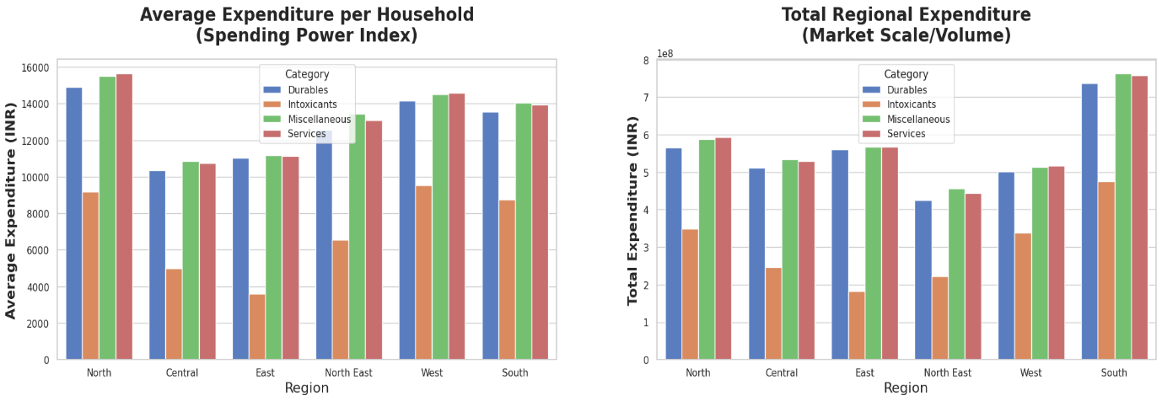
Region wise Household Consumables Expenditures

- Households in the Central and East have the lowest average expenditure on consumables comparatively to other regions, with North, South and West being the highest average expenditures indicating most of the wealthiest households identified.
- In the total expenditure plot south being the largest market distribution for consumables followed by North region with North east being the lowest addressable market.
- For intoxicants the highest average consumption for households is observed in the region North, South and West and lowest in the east and central.
- In the Total Expenditure we observe south being the largest market potential for intoxicants which is good reason to attract investments in manufacturing startups while lowest market potential in the east region due to the lack of population.
- In the plots we also observe that most households have higher expenditures on services and miscellaneous comparatively to durables, also the market size for services and miscellaneous is higher to that of durables.

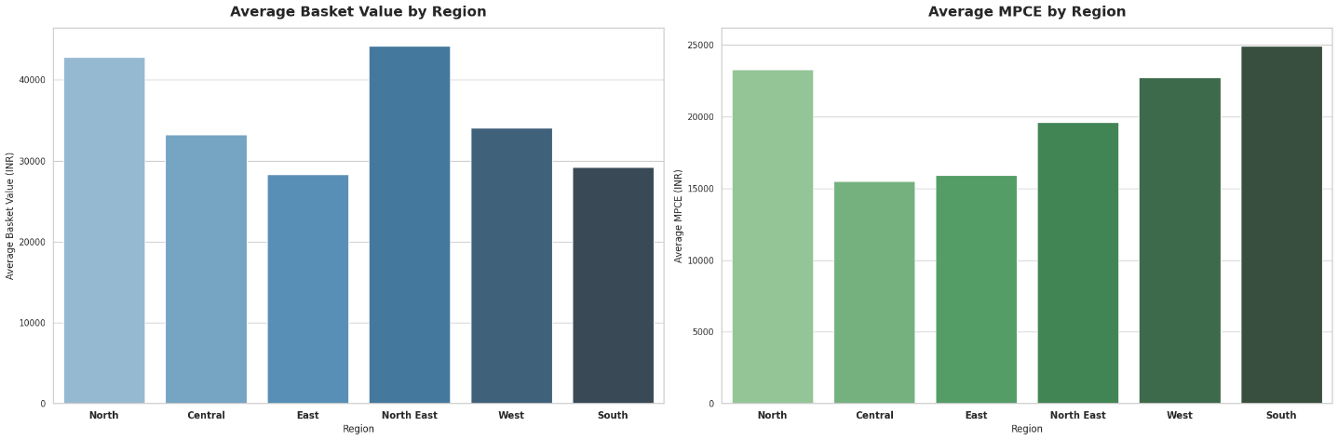
Region Wise Basket Value and MPCE

- The North region has a higher basket value and higher MPCE which indicates that the region has high buying power within households and are bulk buyers with large family size.
- Central and East region comparatively have lower basket value and MPCE which indicates that the market size is lower and expenses are based on price sensitivity.
- The North East region has higher basket value but lower MPCE may be due to bulk buying and high storage purchases or limited budget.
- In the West and South MPCE is higher but the basket value is lower which reveals that these consumers are inclined towards premium goods and services and generally have household size lower.

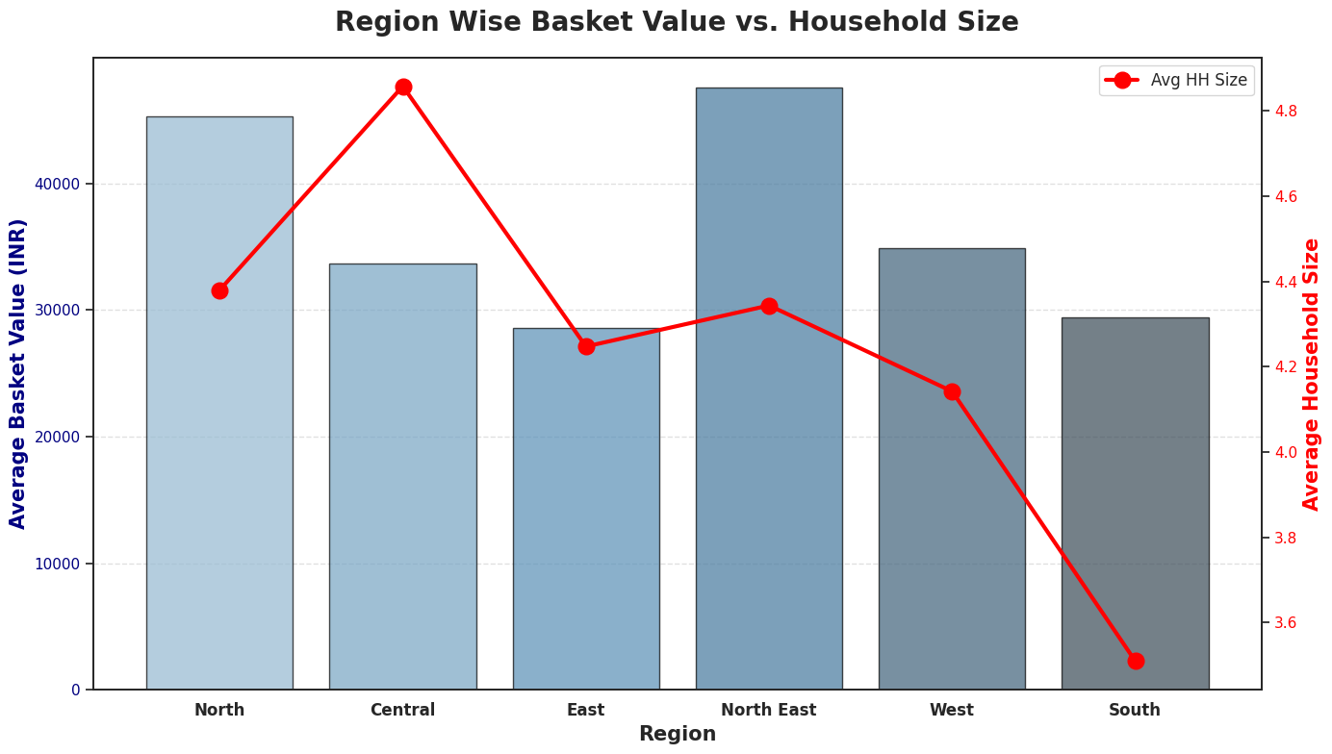
Region Wise Average HH Size and Basket Value

- North and North East Both have high basket value and higher family size which indicates that these are the frequent bulk buyers and have low storage capacity.
- The Central Region we observe that the basket value is lower but the family size is highest which explains a price sensitive market and purchases are based on daily needs.
- East and the West both have high basket value and high family size indicating a growing and mature stable market respectively.
- South Region is the premium market for businesses where the basket value is higher and the family size is lower this indicates south region households invest much in expensive brands, health-conscious items, or luxury goods.

Sector wise Households Consumables Expenditure
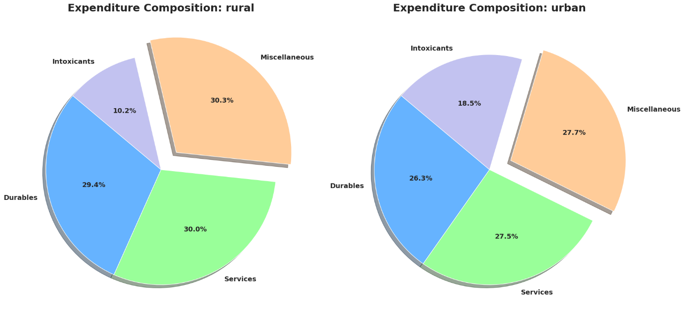

- Household in the rural side value more for quality of life and establish a potential of growing households with the lowest market size for the intoxicants.
- In the Urban side the consumer market expenditure is a stable and mature market where purchases have a pattern for less volume and high price, also purchases on intoxicants is marginally higher by 8%.
- In conclusion we observe that the rural have a balanced expenditures and lifestyle compared to urban consumers which indicate that there is a volatility in purchases at the urban side due to pricing variations.

Sector Wise Basket and MPCE Distribution
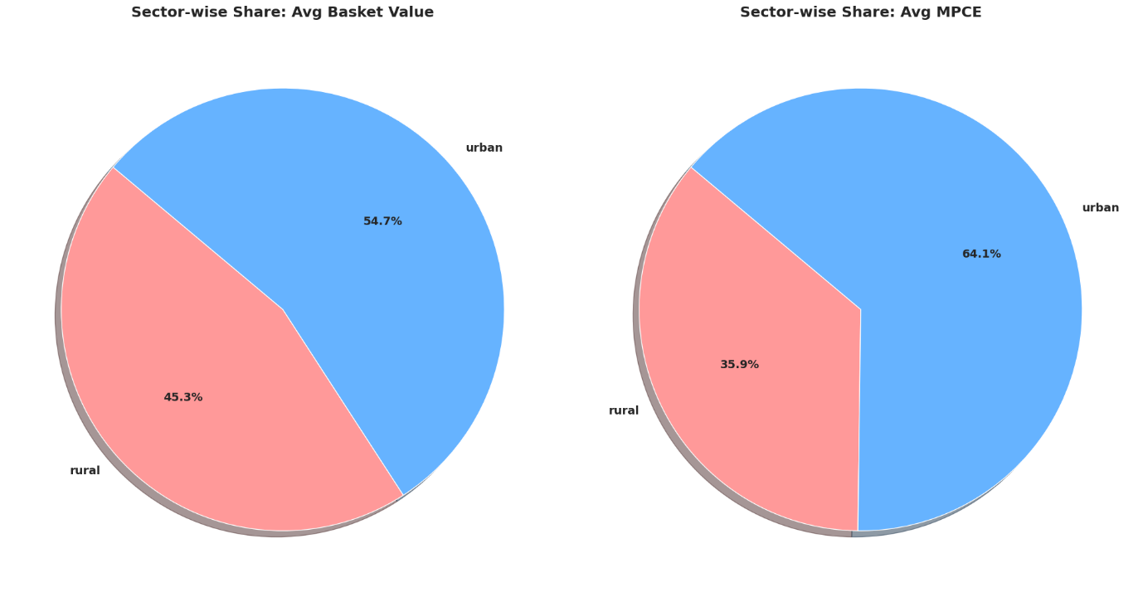

- The rural regions have higher basket value but lower MPCE which indicates that the consumers in rural regions have larger households that prefer stock pile buying and prefer lower margin products.
- The Urban Sector has a higher basket and high MPCE which indicate that the household sizes are generally smaller and prefer premium buying with potential for high margin products.

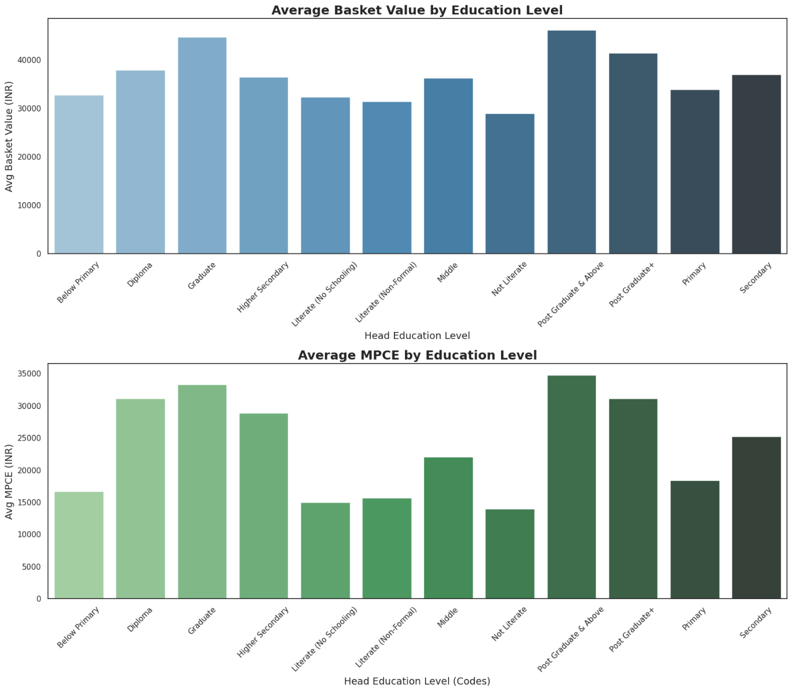
Education wise Average Basket and MPCE Value

- It is very evidently visible higher the education higher the basket value and MPCE this indicates that education is the primary driver for high clv.
- Another observation is that the lower educated households have higher basket value which suggests that these are frequent buyers of low marginal products.

Gender wise Basket and MPCE Value
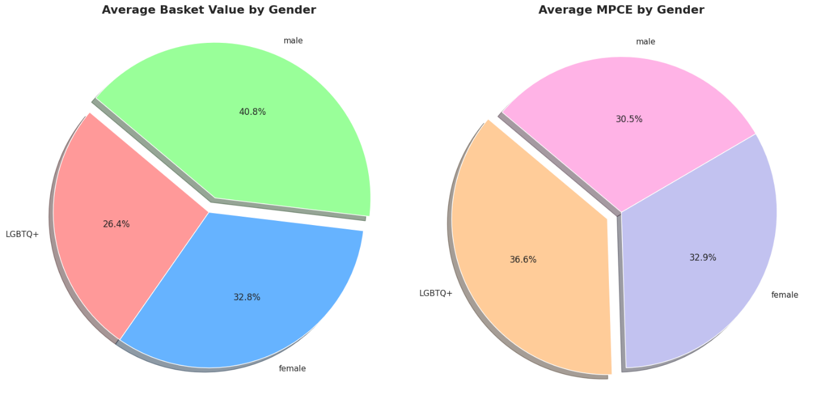

- In the consumer market male have dominated the market with high spending ratio regardless of expenditure less on per person.
- While the female market is a balanced market with high spending ratio and high expenditures per person, deriving a potential growth market than males in future.
- The other gender does have a low spending market ratio but high expenditure ratio per person indicating these genders is high value customer segment.

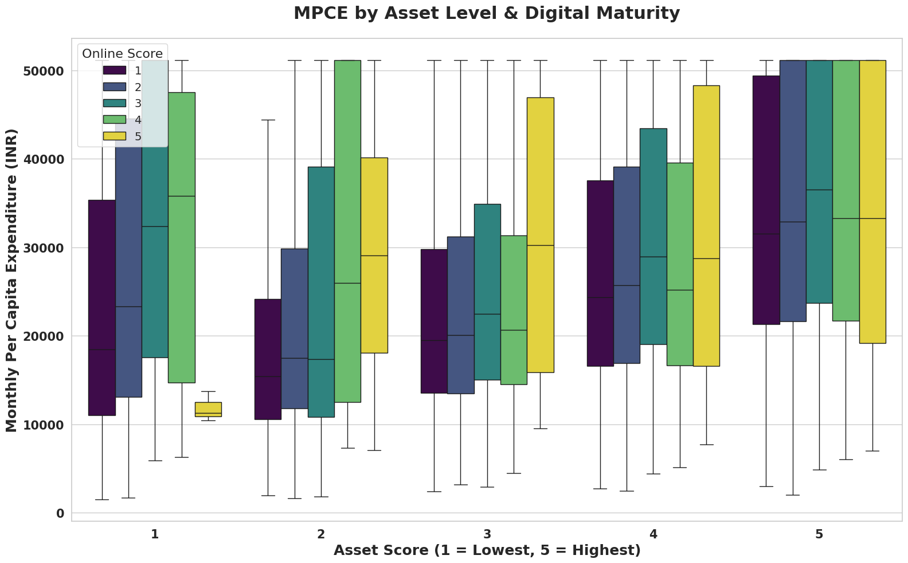
MPCE Based on Online and Asset Score

- the graph describes even with low asset score if the households are digitally equipped the expenditure on the asset score has more impact leading to increase in purchases.
- we also observe households with an online score between 2-4 have higher expenditure and are most valuable customers.
- The Biggest Middle-Class has the most significance in spend according to digital maturity occur between Asset Scores 2,3 and 4. This indicates that lifestyle and spending changes are more likely to have a direct impact on digital adoption among the new middle class.

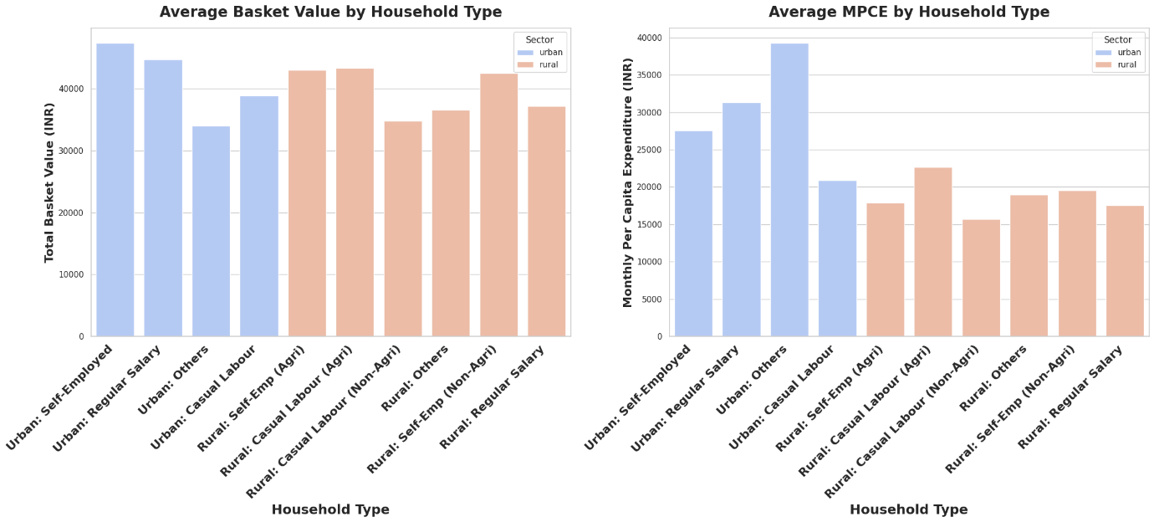
House hold Type Average basket and MPCE Value

- In the urban areas households with occupation as business, salaried employees and labors have higher spend ratio while in rural households with agriculture as business and labors have the highest spend ratio.
- In the urban areas urban households with other occupation have the highest family expenditures comparatively other occupation generally these people are rentiers or interest/ dividend earners with a single or nuclear family size.
- Comparison to rural and Urban, Urban households have high buying ratio and nuclear family households which indicate that most of the products purchased are luxury needs while in rural households have high expenditure ratio and huge family size which indicates most of their purchases are basic needs and only important for survival.

Key Findings

Top 5 Household Types Expenditure by Goods
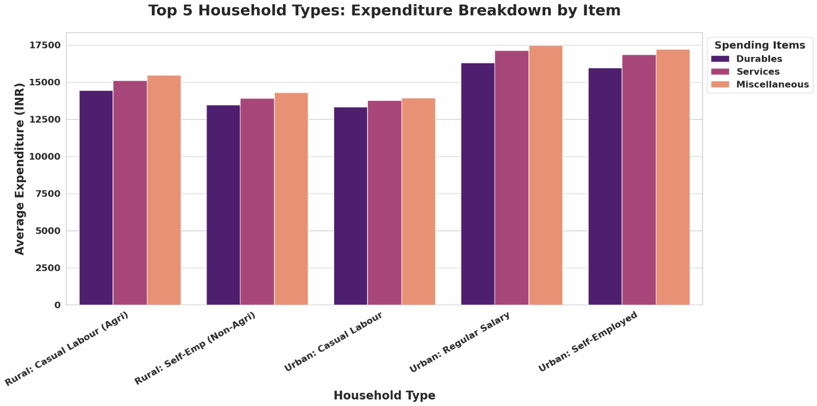

- We observe that in the urban areas salaried employees and businessmen households are direct target consumers for the luxury goods.
- In the rural areas households that own lands for farming business and businessmen non agriculture is the direct target for luxury goods.
- regardless of rural or urban households generally have higher expenditure on miscellaneous items which indicates households choose comforts.

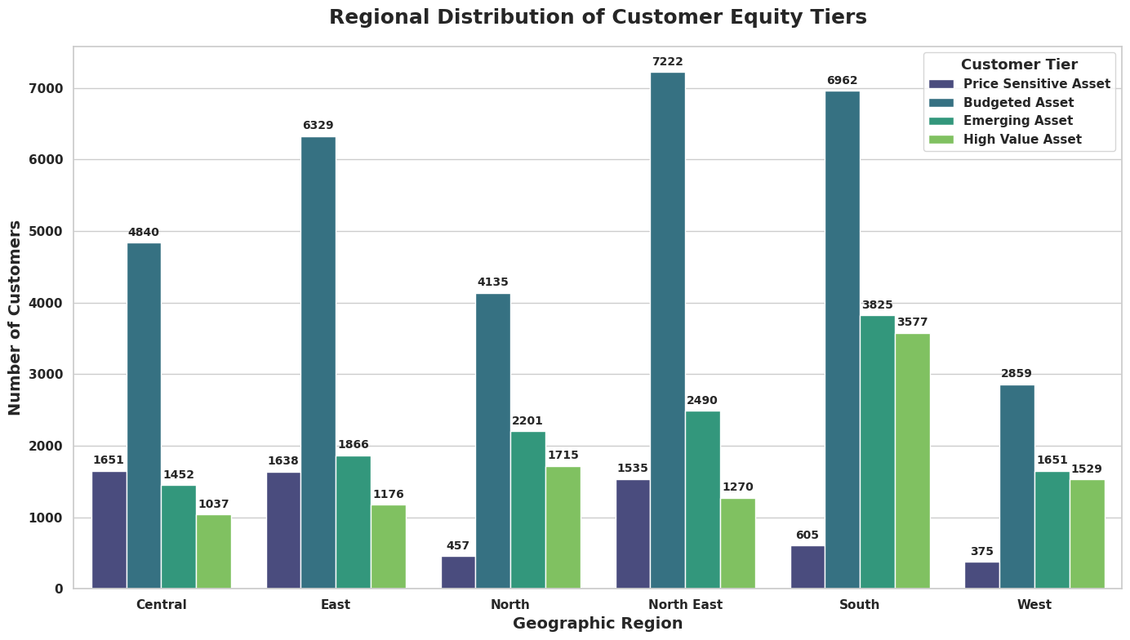
CLTV Distribution Chart by Region

- In the given clustered chart, we can observe that from all over India consumers fall into the segments Budgeted and Emerging tiers which indicate that Middle and Upper middle class comprise the most of population.
- South Region has the highest High asset value consumers with West region having the lowest price sensitive customers and Central region with highest price sensitive customers.

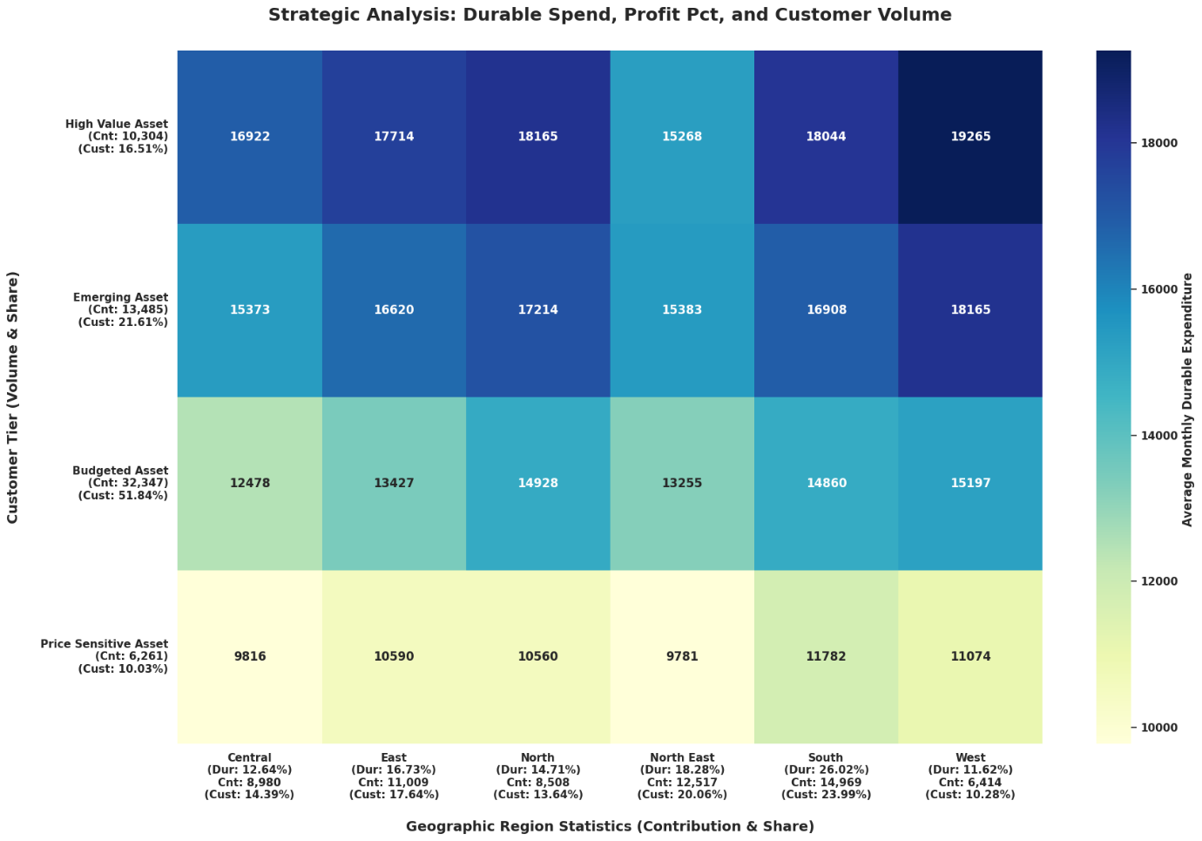
Region Wise Heatmap Expenditure on Durables Based on CLTV Labels

- For durables most of the consumers are in between the emerging and high value assets with West and North dominating with most profitable markets.
- The Central and North East region represents the lowest expenditure on chart suggesting that the market is saturated.
- There is marginal difference between price sensitive and Budgeted asset consumers, indicating a slight discounted reward system can lead to substantial revenue growth.
- The West Region having the highest expenditure margin on durable still has lower contribution margin compared to south at 26% due to lower number of price sensitive customers, this indicates the South region is the best market for the business.
- Since the price sensitive customers make an impact on the contribution percentage in the durables market any durable item less than or equal to a lakh must be discounted to generate volume.

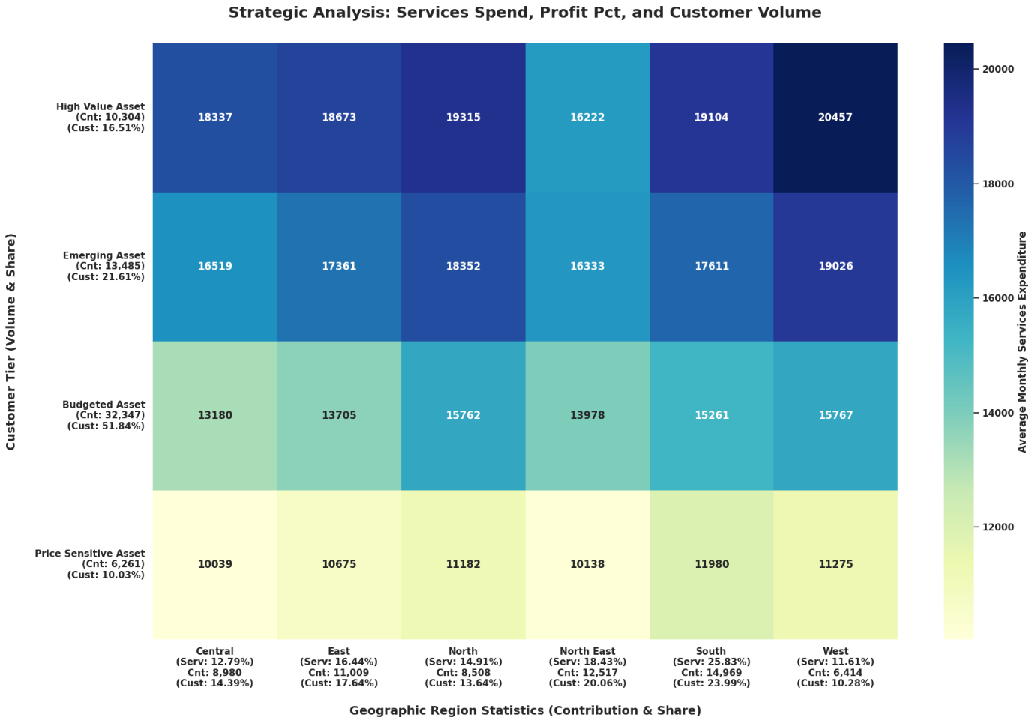
Region Wise Heatmap Expenditure on Services Based on CLTV Labels

- The south and the North East regions are the main consumers of Services indicating a balanced market with most of the consumers are from emerging and Budgeted Asset.
- The west contributes with highest spending ratio but still it stands lowest return on profits this might be due to west has the least volume of purchases.
- the primary profit regions for services are South, North East and East regions with high volume of customers.

Region Wise Heatmap Expenditure on Miscellaneous Based on CLTV Labels
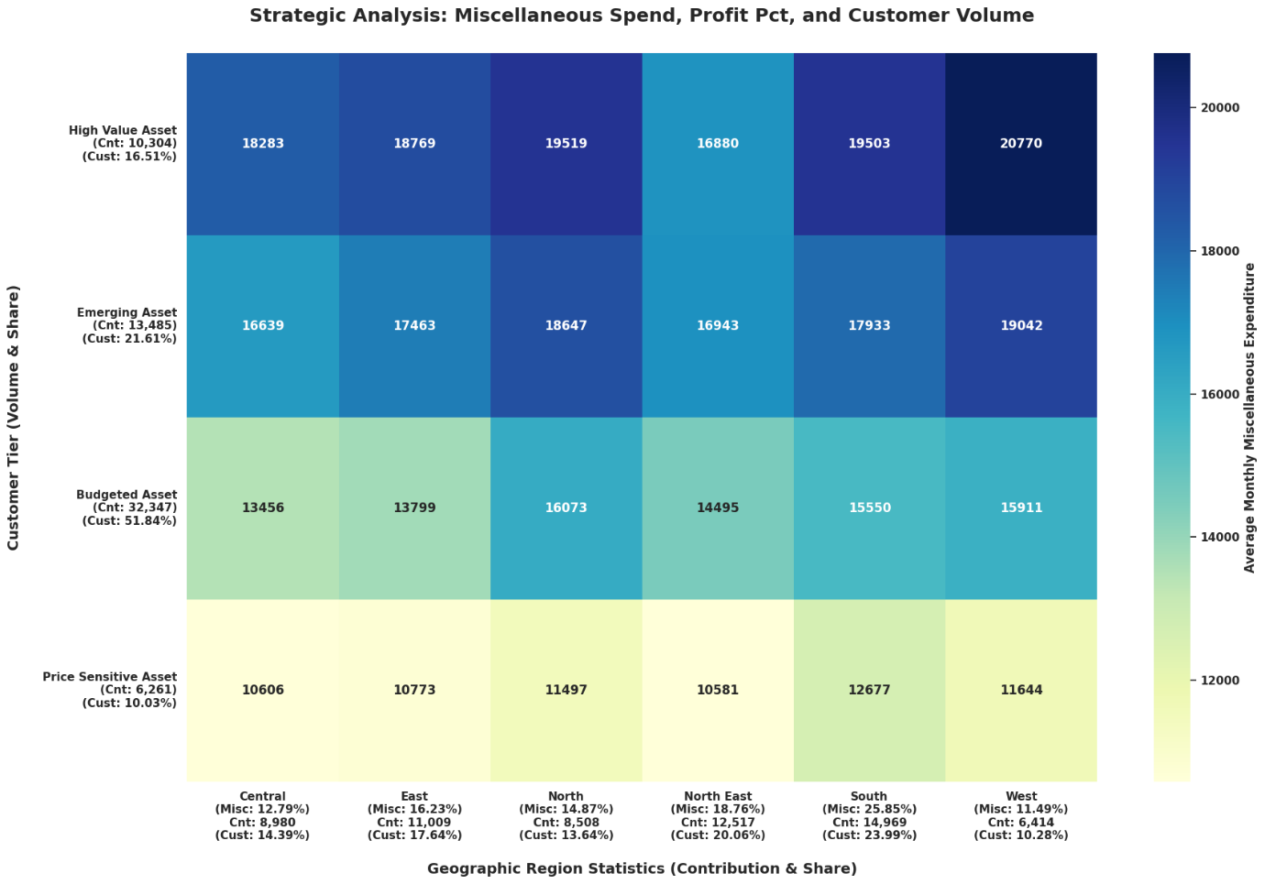

- The South, East and the North East are the most profitable regions towards expenses in miscellaneous activities, these regions prefer maintaining a certain life style.
- The North and the West have on purchases of miscellaneous lifestyle but in low volumes which indicates that targeted marketing would be effective here.

Heatmap analysis By MPCE Group
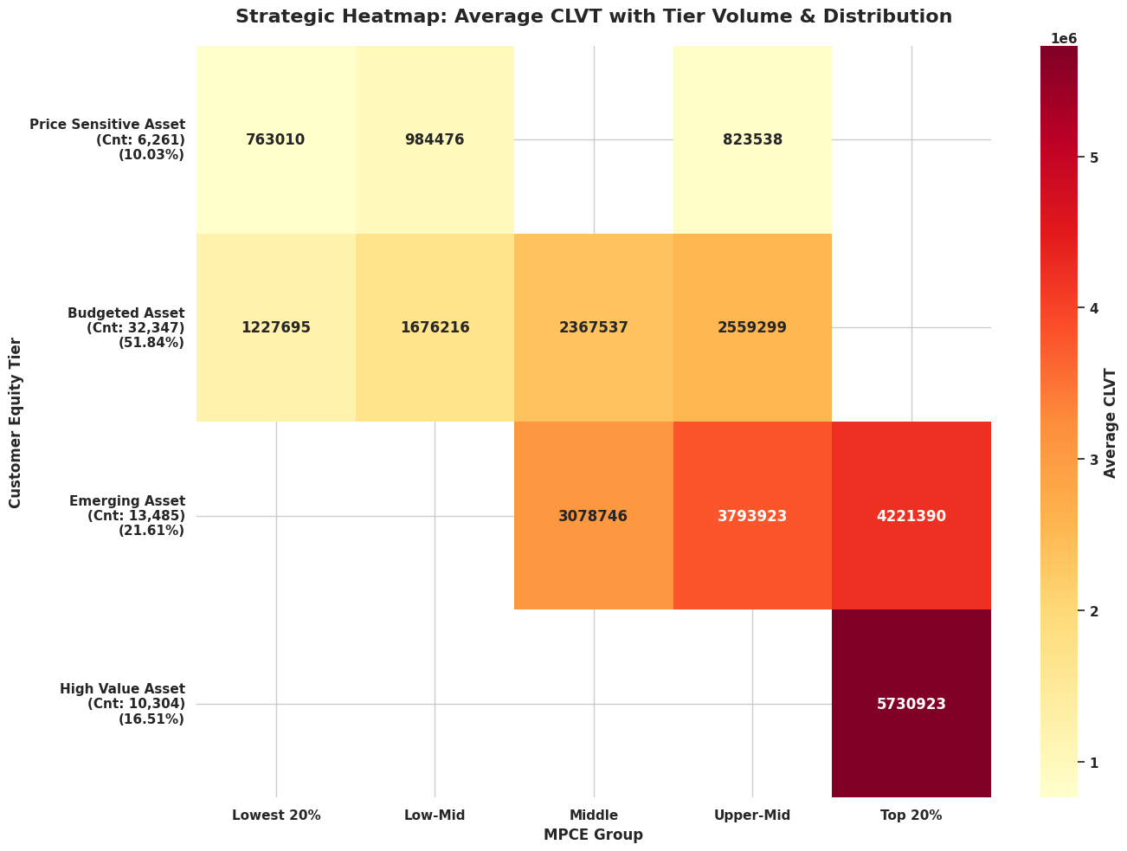

- The upper middle class and top 20% are under the high asset value that comprises of 23% indicates that these customers are more invested in luxury products that describes low volume and high revenue.
- The Budgeted and the Emerging asset customer form the largest revenue driver that include lowest 20% to Top 20% with a distribution of 72% which indicates high volume but medium or low margin purchases.
- The price sensitive customers comprise of 5% of total distribution but have the potential of converting them to Budgeted customers by targeted marketing on low margin products.

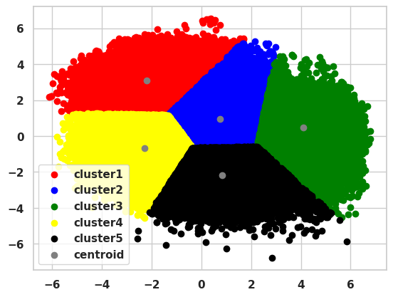
Cluster Analysis
Clusters | hh_size | head_age | total_basket_value | mpce | expected_remaining_years | CLTV | CLTV  Type
1 | 1.730248 | 28.174379 | 24039.728909 | 33551.380573 | 46.400327 | 3.964224e+06 | High Value Asset
2 | 3.725133 | 42.672449 | 41932.872535 | 32490.545949 | 33.506614 | 3.663947e+06 | Emerging Asset
3 | 4.445821 | 49.194870 | 56586.368965 | 44633.599416 | 28.174056 | 4.797810e+06 | High Value Asset
4 | 4.374490 | 50.599037 | 36058.805363 | 13722.838871 | 26.684829 | 1.458884e+06 | Budgeted Asset
5 | 5.891834 | 61.843302 | 56415.053546 | 19624.808790 | 17.913109 | 1.806224e+06 | Budgeted Asset

- In the cluster one the household size is smaller with generally most from young households, consumers in this cluster indicate a high mpce ratio despite being smaller in size that explains a high standard of living with high expected remaining years, these consumers are future gold mine falling under high value asset. the youth has controlled and targeted specific purchases.
- In the cluster two the household size is generally nuclear families with most of the consumers mid aged with lower mpce due to the family size, these consumers are the emerging asset with a potential to reach at high value asset with showing signs of consistent shopping
- In the cluster three the household size is higher with mature adults having highest affordability rate. The consumers in These have highest customer lifetime value even with lower expectancy year compared to cluster 1 which explains that these consumers are most wealthy and most invested into luxury products. Most wealthy consumers proving to be the largest profitable markets.
- In the cluster four the household size and age are marginally higher than cluster 3 inclusive as mature adults with lowest mpce because of large size of family, these are price sensitive customers and basically would like to invest only on the essential commodities. In this cluster most of the consumers are price conscious and limited savings, being labelled as budgeted assets.
- In the cluster five the household size is largest of all cluster, households with joint families and old adults with least expected remaining years. These households have the highest buying power but lowest mpce which explains are bulk buyers. The reason having the load of managing financing of large families generally are bundle buyers on a certain limit hence they are placed in Budgeted Assets.

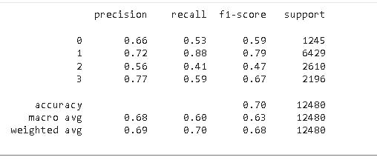
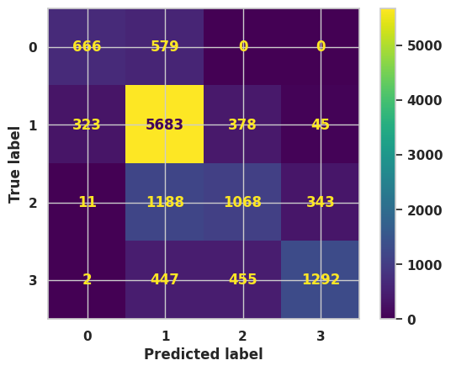
XG Boost Confusion Matrix and Classification Report

- 0 – Price Sensitive Consumer
- 1- Budgeted Asset Consumers
- 2- Emerging Asset Consumers
- 3 – High Value Asset Consumers
- Class 1 has the highest correct predictions for the budgeted asset consumer since they are higher in number in our given dataset and form the major contribution for the classification of our model.
- Class 0 has reasonably done well with classifying 666 correct predictions but 579 are predicted class 1 so the model treats the price sensitive customer as budgeted customers.
- For the class 2 the model has correctly identified 1068 households as emerging asset consumers while keeping 343 households in the other class.
- The high value asset consumer in class 3 with 1292 households correctly identifying the consumers with misclassified at adjacent tiers.
- Overall, the XG Boost model has performed very well on a population dataset with high precision on budgeted and high value asset consumers, with high recall for the budgeted asset consumers and good accuracy model at 70 percent.
- The final variables that classified the households were based on the household size, age of the family head, expenditures on lifestyle and luxury and whether the gender is female since in most of the households the females take charge on the expenditures.

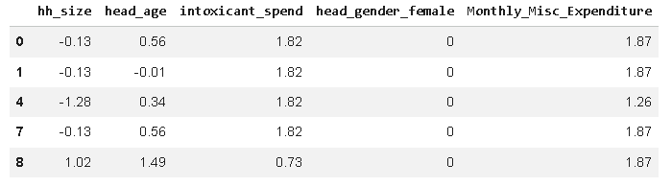
Training Dataset Variables

CHAPTER V

RECOMMENDATION AND FUTURE SCOPE

Conclusion
From a business perspective, this research highlights the need for precise consumer segmentation to ensure sustained profitability in India. Instead of barely-miss-the-mark one-size-fits-all marketing, businesses can deploy hyper-localized strategies by categorizing households into distinct tiers Price Sensitive; Budgeted Assets; Emerging Assets and High Value Assets. Particular demographics such as household size and the age of the head of family are among drivers to long-term value which recognizes the pivotal role that female heads of households play in expenditure decisions presents a tactical inference to point for brands to shape their messaging and product branding strategies around the principal decision-makers within Indian domestic culture. The study leverages machine learning to efficiently convert raw data into actionable insights as the implementation was carried out using a strong pipeline of data cleaning, feature engineering, followed by more classification models. The XG Boost model, in particular, had a high level of accuracy with household tiers 70% to be precise. The model's success in continuing to get high precision for the Budgeted and High Value asset consumers and even across hundreds of thousands of individual data points from a real-world population dataset, demonstrates that not only is vertically combining separated property level datasets allowing us ever greater accuracy but also our approach using non-traditional variables based on digital scores /asset score (as outlined earlier) translate because they allow us to estimate future lifetime value. this report acts as a guide for Indian enterprises to operate on their Customer Acquisition Cost (CAC) and Retention Value optimally. With these insights, firms are able to deploy their resources more efficiently by targeting high-touch loyalty programs at Emerging and High Value assets while deploying low cost; value-driven campaigns at key touch-points in the lifecycle for Price Sensitive.

Future Scope
Follow-up assessments of this study could be expanded beyond static survey data to include real-time behavioral metrics from digital touchpoints. By including UPI payment transaction histories, e-commerce browsing habits and whether consumers are engaging on social media into a real-time CLTV model. Transitioning from static historical socio-economic snapshots to live behavioral streams would facilitate businesses in identifying micro-moments of higher intent, enabling more precise interventions along the consumer decision journey and hyper-personalized offerings as customer needs change. This effort mapped consumers to high-level geographic buckets, but further work could enable more granular level geo modeling from the district or pin code perspective. India being such a diverse market, consumption drivers in tier-2 city of South India might be far apart from another similar sized city neighboring corner in North. Enlarging the scope of research to encompass localized cultural variables, regional holidays and vernacular preferences will be helpful in tightening how we define "High Value" vs "Emerging" asset tiers as they relate to place-based context for lifetime loyalty/spending capability. While there are promising technical possibilities in switching from commonly used machine learning models, e.g., XGBoost to deep learning architectures (RNNs or Transformers) to learn based on the temporal nature of household spending. There is potential future research to integrate psychographic data like consumer perception of sustainability to understand whether the brand matters more than price points and risk by coupling these soft variables with the hard socio-economic data leveraged within this study, a distinct dimensional profile could be created leading to better insights for predicting customer lifetime value. The cross-sectional research would be too longitudinal follow up studies among the same study population and could shed light on how CLTV segments evolve across decades before and after macro-economic shifts. Ahead in future research could explore the effect of any external shocks such as inflation, urbanization or shifts in digital infrastructure o defined as the Price Sensitive and Emerging Asset tiers for households.

Recommendations
- Targeted Marketing
The research discovered that the female heads of households are the dominant decision makers at home, businesses can more efficiently spend targeting them. Companies can move from their generalized advertisements campaigns to promote advertisement messages aimed at women that would result in increased conversion rates with a reduced customer acquisition cost. The need for sustained growth makes the female head as the most important group, since descriptive findings reveal that expenditure patterns are more consistent and high lifetime value.
- Segmentation and Focus Emerging Middle Class
The Budgeted Asset is the largest consumer group in India offering biggest potential for volume revenue. Businesses should work on getting higher recency and frequency from these households by implementing prescriptive actions such as loyalty based subscriptions or bulk purchase discounts to ensure they continue giving profits to businesses. These do not take the risk for an immediate spend, but with their immense numbers and consistent growth of stable assets they are revenue cluster for future market places.
- Premium Tiers Profiling
The power of psychographics analysis should trend towards a psychographic understanding of lifestyle and luxury preferences for the high value consumer segment. These consumer buy primarily based on comfort and a status driven purchase no matter which way the economy is moving and needs a prescriptive action of exclusivity, and having their own special services with platinum access to new luxury product lines that will ensure that the brand continues to be their primary lifestyle partner with most profitable market share.

- Targeted Region Marketing
An optimal business strategy for the Indian consumer market is therefore a regional customization approach, wherein focus should be on Western and Southern zone states of Maharashtra, Karnataka and Tamil Nadu respectively to capture premium services & lifestyle offerings; your research identifies these regions as top national clusters focusing high value asset types also targeting higher levels discretionary spending. Across Northern and Western parts of the country, especially in Punjab, Haryana and Gujarat where durable goods are hot ticket items amongst households crossing into an asset phase stage (looking to acquire physical assets to signal socio economic growth), businesses should consider prescriptive financing and upgrade programs. Acquisition efforts in these high growth zones need to target female decision makers demographically, as your findings identify the main household budget manager but apply psychographic messaging that leans into convenience and status for premium tiers while moving toward value driven reliability on larger budgeted segments of consumers. Companies should therefore, leverage the high digital adoption scores in South and West to roll out their low cost, automated service models while adopting higher touch engagement for Northern and North Eastern pockets where building personalized trust is imperative to tap into miscellaneous as well health related spends. Tracking the assets and scaling into particular districts where there is an upward trajectory of spending on lifestyles, brands can continually shrink their umbrella customer acquisition costs in response to driving margins while gaining first mover advantage against its most lucrative clusters nationally.

Bibliography/References
- Fader, P. S., Hardie, B. G., & Lee, K. L. (2005). "Counting your customers" the easy way: An alternative to the Pareto/NBD model. Marketing Science, 24(2), 275–284. https://www.brucehardie.com/papers/bgnbd_2004-01-20.pdf
- Khare, A. (2011). Influence of consumer lifestyle on online shopping behavior: An Indian perspective. International Journal of Retail & Distribution Management, 39(2), 126–143. https://www.researchgate.net/publication/227419790_Influence_of_consumer_lifestyle_on_online_shopping_behavior_An_Indian_perspective
- Ministry of Statistics and Programme Implementation. (2024). Household Consumption Expenditure Survey (HCES) 2022-23. National Sample Survey Office (NSSO), Government of India. https://www.mospi.gov.in/sites/default/files/publication_reports/Factsheet_HCES_2022-23.pdf
- Modigliani, F., & Brumberg, R. (1954). Utility analysis and the consumption function: An interpretation of cross-section data. Post-Keynesian Economics, 388–436. https://archive.org/details/postkeynesianeco0000unse
- Rust, R. T., Lemon, K. N., & Zeithaml, V. A. (2004). Return on marketing: Using customer equity to focus marketing strategy. Journal of Marketing, 68(1), 109–127. https://www.researchgate.net/publication/228384260_Return_on_Marketing_Using_Customer_Equity_to_Focus_Marketing_Strategy
- Venkatesan, R., & Kumar, V. (2004). A customer lifetime value framework for customer selection and resource allocation strategy. Journal of Marketing, 68(4), 106–125. https://www.researchgate.net/publication/228384355_A_Customer_Lifetime_Value_Framework_for_Customer_Selection_and_Resource_Allocation_Strategy

APPENDICES

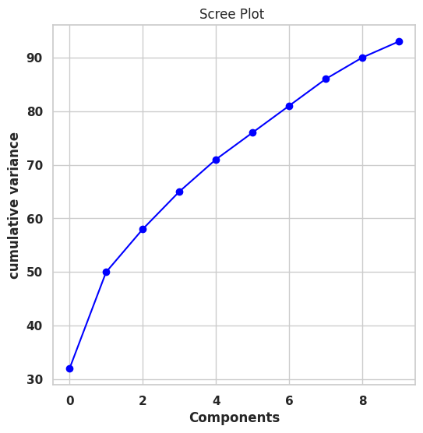
PCA Plot Used for feature selection for clustering

Since the variables were vast and varied the principal component analysis method worked better than the elimination method, hence with just two components we were able to capture 60% of the data and produced clusters using PCA techniques.

Silhouette Score and Cluster Number Plot
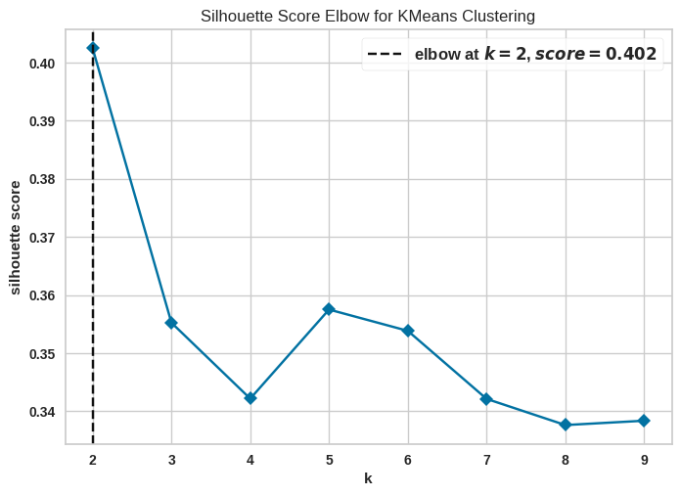
During fitting our clustering algorithms, the plot showed us a good score of 0.40 at two clusters with higher inertia but with the application of domain knowledge we used 5 cluster with a lower inertia at a silhouette score of 0.35 that formed denser clusters and segmented the large dataset into five segments.

RFCEV Plot for Feature Selection on Classification Models
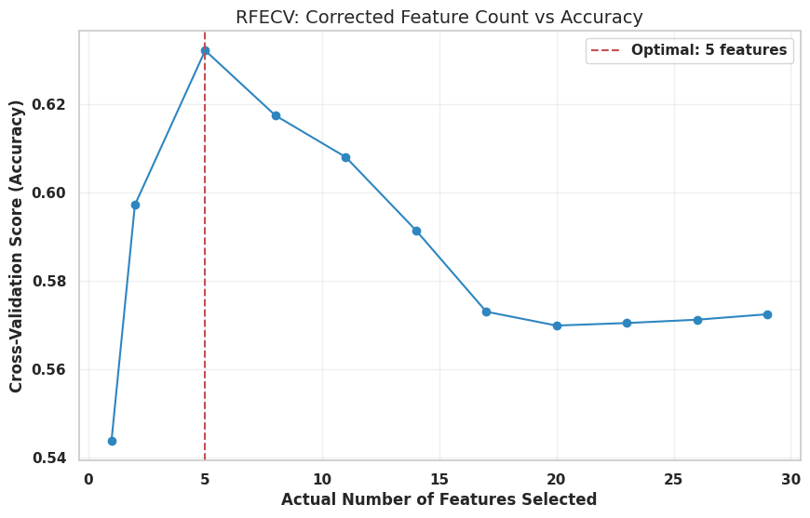

During our fitting for the model the feature selection technique we identified was recursive feature selection by elimination method, the method gives a particular ranking and based on those ranking suggests the best features that could give us better accuracy, in this case the model selected the best five variables that classified the consumers to the clan of customer lifetime value segment they belonged.

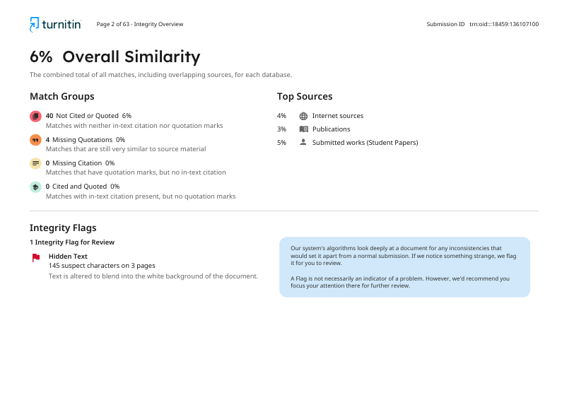
Plagiarism Report


AI Detection Report

