
STUDENT CASE STUDY EXECUTION REPORT
Department | FED
Subject | DSA-2
Academic Year | I-III Semester (2025-26)
Faculty Name | MD.Razia
Student Name | M. Adith Kumar Reddy
Roll Number | 2520030559
Branch | CSE
Course Outcome | CO-6
Case Study topic: HealthNet – Hospital Resource Scheduling and Optimization using Greedy Strategies and Dynamic Programming
Work Done Summary:
In this case study, we evaluated and constructed optimal solutions for real-world optimization problems using Greedy strategies and Dynamic Programming (memoization and tabulation).
We implemented Greedy Activity Selection to schedule operation-theatre time slots, the 0/1 Knapsack problem to allocate a fixed equipment budget for maximum value, the Longest Common Subsequence (LCS) problem to compare patient genetic/medical records, and Matrix Chain Multiplication to minimize computation cost in a medical-imaging pipeline.
For each problem we justified the choice of algorithm based on whether it exhibits the greedy-choice property, overlapping subproblems, and optimal substructure — the properties that determine whether a greedy strategy is sufficient or dynamic programming is required.
Implementation Details:
- Implemented Greedy Activity Selection by sorting surgery/appointment requests by finish time and selecting the maximum number of non-overlapping slots.
- Implemented the 0/1 Knapsack problem using bottom-up dynamic programming (tabulation) with backtracking to recover the selected items.
- Implemented the Longest Common Subsequence (LCS) problem using a 2D DP table with backtracking to reconstruct the actual subsequence.
- Implemented Matrix Chain Multiplication using interval (range) DP to compute the minimum number of scalar multiplications.
- Verified optimal substructure by confirming each DP solution is built from optimal solutions to its smaller subproblems.
- Verified overlapping subproblems by comparing the cost of naive exponential recursion against the memoized/tabulated DP solution.
- Compared the Greedy approach (locally optimal, irrevocable choices) against Dynamic Programming (globally optimal, exhaustive but efficient via memoization) for each problem.
Results and Screenshots:
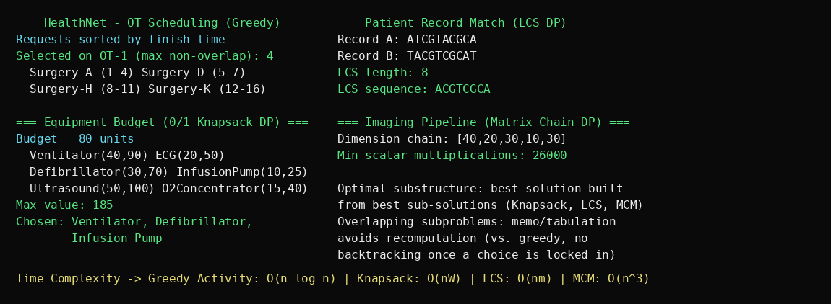
The Greedy Activity Selection algorithm scheduled 4 non-overlapping surgeries (Surgery-A, Surgery-D, Surgery-H, and Surgery-K) out of 11 requested operation-theatre slots — the maximum possible on a single OT — confirming that the greedy-choice property holds for interval scheduling. The 0/1 Knapsack DP selected the Ventilator, Defibrillator, and Infusion Pump for a maximum value of 185 within an 80-unit budget, a combination that a simple greedy by-value or by-ratio heuristic is not guaranteed to find.
The LCS DP matched two 10-character patient records with a longest common subsequence of length 8 (ACGTCGCA), and the Matrix Chain Multiplication DP found the optimal parenthesization for an imaging-pipeline matrix chain, reducing the multiplication cost to 26,000 scalar operations. Across all four problems, the dynamic-programming solutions relied on overlapping subproblems and optimal substructure, while the greedy solution worked only because activity scheduling satisfies the greedy-choice property — justifying why Knapsack, LCS, and Matrix Chain Multiplication require dynamic programming rather than a greedy method.
GitHub Link: https://github.com/Adith471/DSA-2

Student Signature | Faculty Signature

