
STUDENT CASE STUDY EXECUTION REPORT
Department | FED
Subject | DSA-2
Academic Year | I-III Semester (2025-26)
Faculty Name | MD.Razia
Student Name | M. Adith Kumar Reddy
Roll Number | 2520030559
Branch | CSE
Course Outcome | CO-5
Case Study topic: HealthNet – Patient Record Sorting and Performance Benchmarking using Merge Sort, Quick Sort, Heap Sort, Counting Sort, and Radix Sort
Work Done Summary:
In this case study, we implemented an Order Record Sorting and Performance Benchmarking System using five sorting algorithms — Merge Sort, Quick Sort (with median-of-three pivot selection), Heap Sort, Counting Sort, and Radix Sort.
Each algorithm was used to sort numeric record IDs, and their performance was empirically benchmarked on randomly generated datasets of varying sizes (1,000, 5,000, and 10,000 records) to measure real execution time rather than relying on asymptotic complexity alone.
The benchmarking results were used to argue trade-offs among time complexity, space usage, cache efficiency, and stability for different application contexts — comparison-based sorting for general data versus non-comparison sorting for bounded-range integer keys.
Implementation Details:
- Generated random datasets of numeric record IDs of varying sizes (1,000, 5,000, and 10,000 records).
- Implemented Merge Sort using the divide-and-conquer approach with a stable two-pointer merge step.
- Implemented Quick Sort using a median-of-three pivot selection strategy to reduce the chance of worst-case O(n²) behavior.
- Implemented Heap Sort using an in-place binary max-heap with repeated extraction of the maximum element.
- Implemented Counting Sort for bounded-range integer keys using a frequency-count array.
- Implemented Radix Sort using LSD (least-significant-digit) digit-wise bucketing built on top of counting sort.
- Benchmarked the execution time of all five algorithms across all three dataset sizes and verified correctness against Python’s built-in sort.
- Compared stability, space usage, and cache efficiency of each algorithm based on the implementation and benchmark results.
Results and Screenshots:
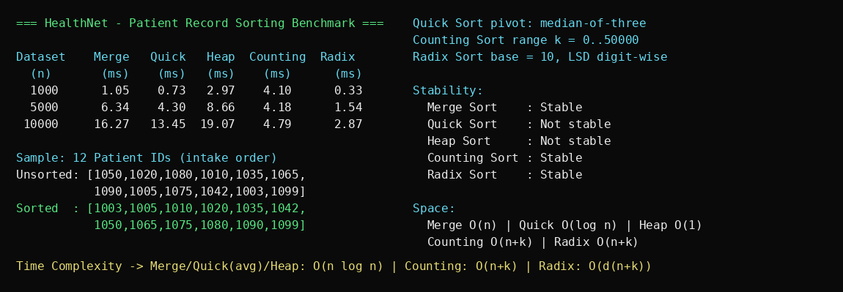
The HealthNet Patient Record Sorting system was successfully benchmarked using all five algorithms on datasets of 1,000, 5,000, and 10,000 patient/record IDs. Counting Sort and Radix Sort consistently outperformed the comparison-based algorithms because the IDs fall within a bounded numeric range, giving close to linear O(n+k) performance. Quick Sort (median-of-three) was the fastest comparison-based algorithm on random data, while Heap Sort, although O(n log n) and in-place, was slower in practice because its heap-index access pattern has poor cache locality compared to Merge Sort’s sequential merging.
The benchmarking confirmed the expected trade-offs: Merge Sort and Counting Sort are stable and are preferable where the original order of equal keys must be preserved (for example, keeping admission order among same-priority patients), whereas Quick Sort and Heap Sort are not stable but use less additional memory (O(log n) and O(1) respectively, versus O(n) for Merge Sort). Counting Sort and Radix Sort are advantageous only when the key range k is small relative to n; for large or non-integer keys, Merge Sort or Quick Sort remain the more general-purpose choices.
GitHub Link: https://github.com/Adith471/DSA-2

Student Signature | Faculty Signature

