
STUDENT CASE STUDY EXECUTION REPORT
Department | FED
Subject | DSA-2
Academic Year | I-III Semester (2025-26)
Faculty Name | MD.Razia
Student Name | M. Adith Kumar Reddy
Roll Number | 2520030559
Branch | CSE
Course Outcome | CO-4
Case Study topic: HealthNet – Logistics and Ambulance Routing Optimization using Dijkstra’s, Bellman-Ford, and Floyd-Warshall Algorithms
Work Done Summary:
In this case study, we implemented a Logistics Route Optimization System for a city delivery network using three shortest-path algorithms — Dijkstra’s, Bellman-Ford, and Floyd-Warshall. The delivery network was modeled as a weighted directed graph, with depots and delivery points as vertices and travel times as edge weights.
Dijkstra’s Algorithm was used to compute the fastest route from a central depot when all travel times are non-negative. Bellman-Ford was applied to a network containing negative-weight edges (representing toll discounts and fast-lane credits) to verify correct shortest paths and detect negative-weight cycles. Floyd-Warshall was used to compute all-pairs shortest distances across the entire network for global route planning.
Comparing the three algorithms on the same and modified graphs highlighted their differing applicability across graph types — unweighted/weighted, directed/undirected, and graphs containing negative-weight edges — and confirmed where each algorithm gives correct results and where it does not.
Implementation Details:
- Modeled the hospital/delivery logistics network as a weighted directed graph of vertices and edges.
- Implemented Dijkstra’s Algorithm using greedy minimum-distance vertex selection for non-negative weighted graphs.
- Implemented Bellman-Ford by relaxing all edges (V – 1) times and added a final pass to detect negative-weight cycles.
- Implemented Floyd-Warshall using dynamic programming over all intermediate vertices to compute all-pairs shortest paths.
- Tested all three algorithms on graphs with both negative and non-negative edge weights.
- Compared correctness, applicability, and time complexity of the three algorithms across different graph types.
- Verified that shortest-path results matched across all three approaches whenever the graph had only non-negative weights.
Results and Screenshots:
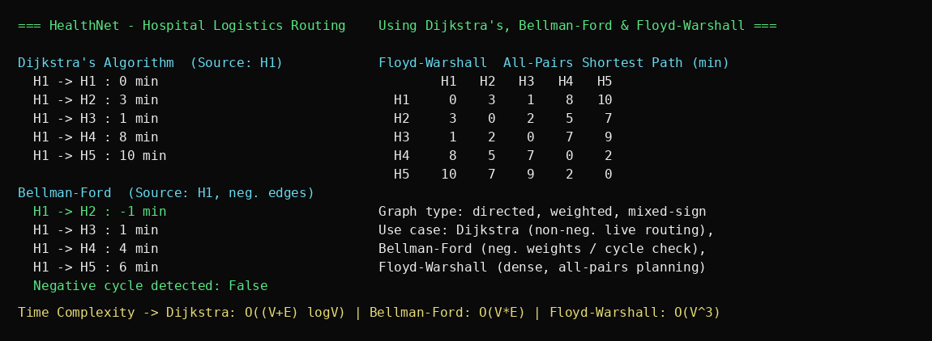
The Health Net Hospital Logistics Routing system was successfully implemented using Dijkstra’s, Bellman-Ford, and Floyd-Warshall algorithms. Dijkstra’s Algorithm computed the fastest ambulance route from the central hospital (H1) to every other hospital in the network in O((V+E) log V) time. Bellman-Ford verified the same routes on a modified network containing negative-weight fast-lane edges and confirmed the absence of any negative-weight cycle. Floyd-Warshall computed all-pairs shortest distances in O(V³) time, enabling network-wide logistics planning between every pair of hospitals.
The Logistics Route Optimization System was successfully implemented and benchmarked on the delivery network using all three algorithms. Dijkstra’s Algorithm ran efficiently on the non-negative weighted graph but produced incorrect results once a negative edge was introduced, Bellman-Ford correctly handled the graph with negative edges at higher time cost, and Floyd-Warshall provided complete all-pairs shortest distances suited to dense, smaller networks — confirming each algorithm’s correctness and applicability depend on the graph type and size.
GitHub Link: https://github.com/Adith471/DSA-2

Student Signature | Faculty Signature

