QUESTION:
3-a: Prepare an experimental report along with your observations and inferences for finding all the subdomains listed on the main megacorpone.com web page and find their corresponding IP addresses.
3-b: Prepare an experimental report along with your observations and inferences for the following scenario: Assume that you are in the middle of a penetration test and have unprivileged access to a Windows machine. As you continue to collect information, you realize it may be vulnerable to an exploit that you read about that began with the letters a, f, and d but you can’t remember the full name of the exploit. In an attempt to escalate your privileges, you want to search for that specific exploit.
3-c: Prepare an experimental report along with your observations and inferences for the following scenario: Let’s assume you are tasked with scanning a class C subnet to identify web servers and determine whether or not they present an interesting attack surface. Port scanning is the process of inspecting TCP or UDP ports on a remote machine with the intention of detecting what services are running on the target and potentially what attack vectors exist.

Exercise 3-a
AIM
To find all the subdomains listed on the main megacorpone.com web page and find their corresponding IP addresses.

PROCEDURE
- Download the index page with wget.
- Use grep "href=" to extract all the lines in index.html that contain HTML links.
- Use grep -v to strip away lines that contain the "www.megacorpone.com" domain.
- Set a multi-character delimiter using the -F option of awk to get rid of the extra HTML around the links.
- Use cut to set the delimiter to "/" and print the first field, leaving only the full subdomain name.
- To improve the search, use a regular expression to search for subdomains ending in “. megacorpone.com" regardless of whether or not the reference is contained in a link.
- Use the host command to discover the corresponding IP address of each domain name in the text file.
- Extract the IP addresses by piping the output into a grep for "has address", then cut the results and sort them.
OBSERVATION
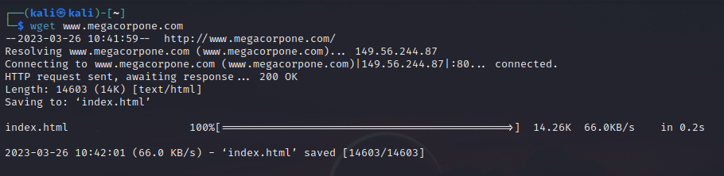
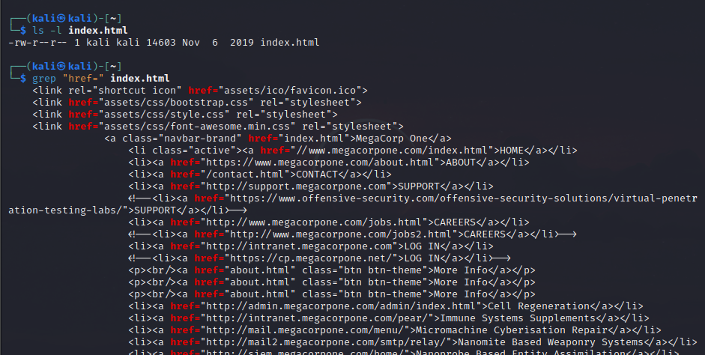
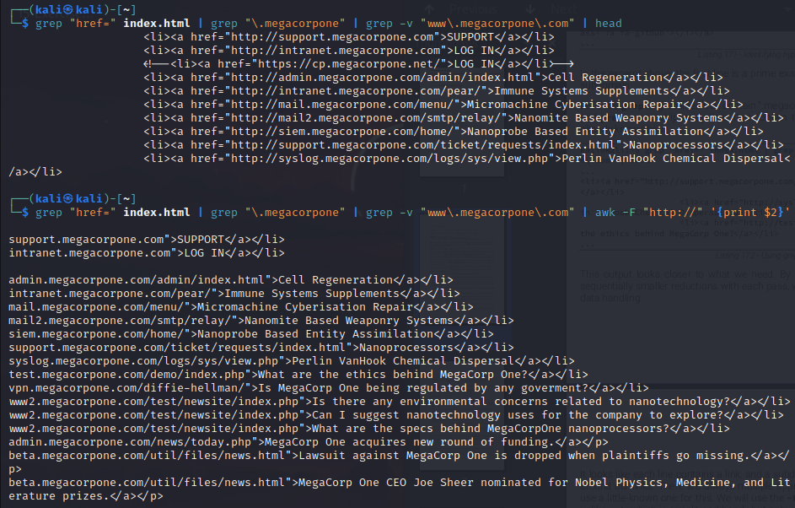
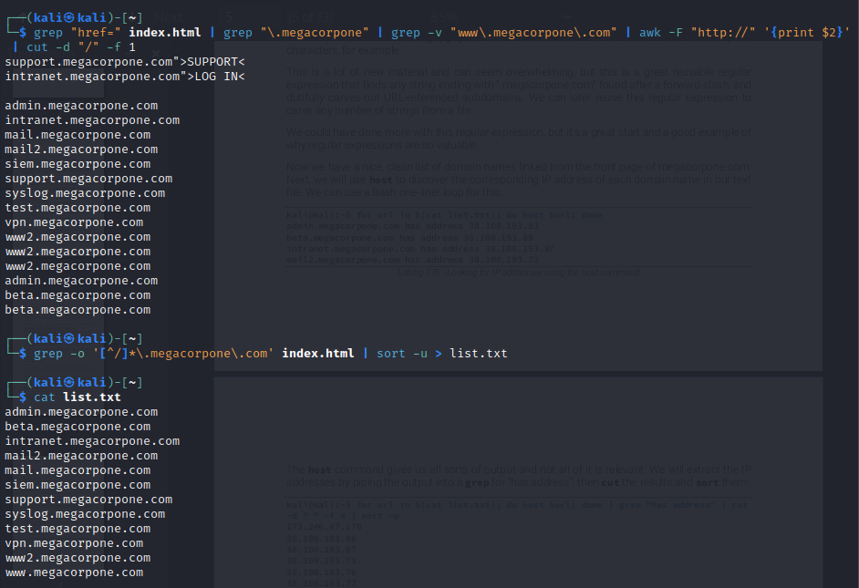
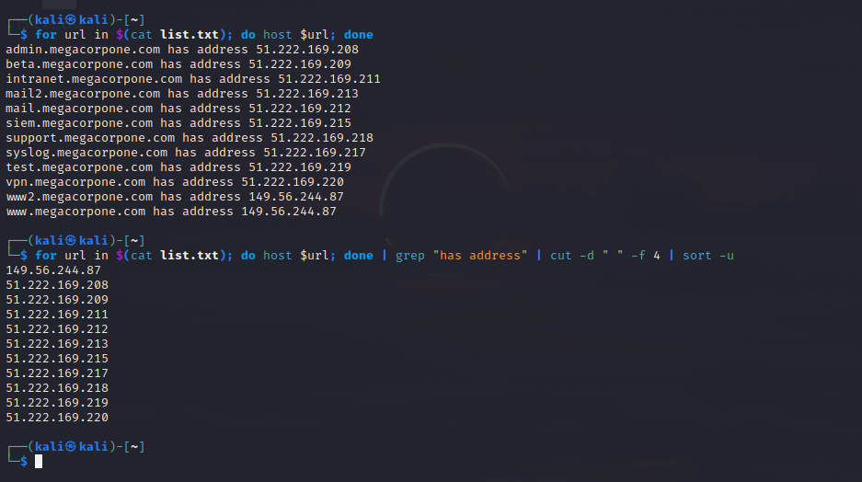

INFERENCE
The experiment aimed to find all the subdomains listed on the main megacorpone.com web page and their corresponding IP addresses. The procedure involved downloading the index page with wget, extracting all the lines in index.html that contain HTML links using grep "href=", stripping away lines that contain the "www.megacorpone.com" domain using grep -v, setting a multi-character delimiter using the -F option of awk to get rid of the extra HTML around the links, using cut to set the delimiter to "/" and print the first field, leaving only the full subdomain name. To improve the search, a regular expression was used to search for subdomains ending in “. megacorpone.com" regardless of whether or not the reference is contained in a link. The host command was used to discover the corresponding IP address of each domain name in the text file. The IP addresses were extracted by piping the output into a grep for "has address", then cut the results and sorted them. Overall, the procedure was successful in achieving the aim of finding all the subdomains listed on the main megacorpone.com web page and their corresponding IP addresses.

Exercise 3-b
AIM
To prepare a report along with observations and inferences for the given scenario.

PROCEDURE
- Search https://www.exploit-db.com for “afd windows” to find exploits that match the search criteria.
- Download the exploits that match the search criteria and inspect them until the proper one is found.
- To automate the task, start with the SearchSploit132 utility on Kali Linux, which is a command line search tool for Exploit-DB.
- Pass “afd windows” as a search string, use -w to return the URL for https://www.exploitdb.com rather than the local path, and -t to search the exploit title.
- Trim the results by using grep for “http” and then cut what is needed using a “|” field delimiter and extracting the second field.
- Use a Bash loop to download the files and save them locally.
- Notice that each page has a link to download the “raw” exploit code.
- Run sed (sed ‘s/exploits/raw/’) to modify the download URL and insert it into a Bash one-liner to download the raw code for the exploits.
- Use a for loop to iterate through the SearchSploit URLs.
- Set exp_name to the “name” of the exploit (using grep, cut, and command substitution), url to the raw download location (again with sed and command substitution), and grab the exploit with wget (in quiet mode with no certificate check) saving it locally with the exploit name as the local file name.
- Wait for the command prompt and verify that the exploits were indeed downloaded, using file to verify that the files are text.
- Put everything together in a Bash script to solve the problem.

OBSERVATION

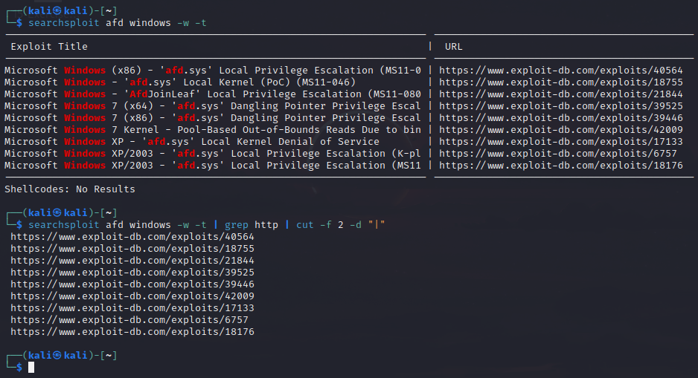
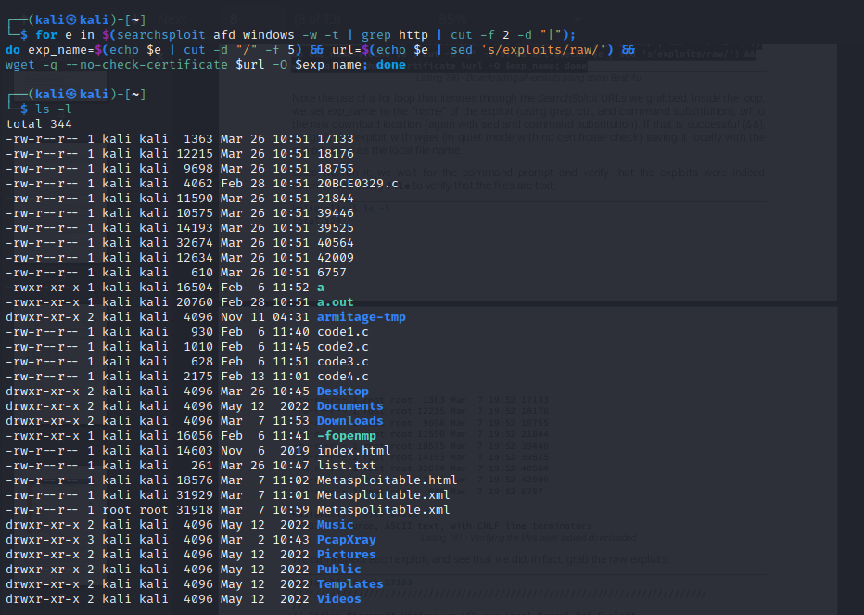
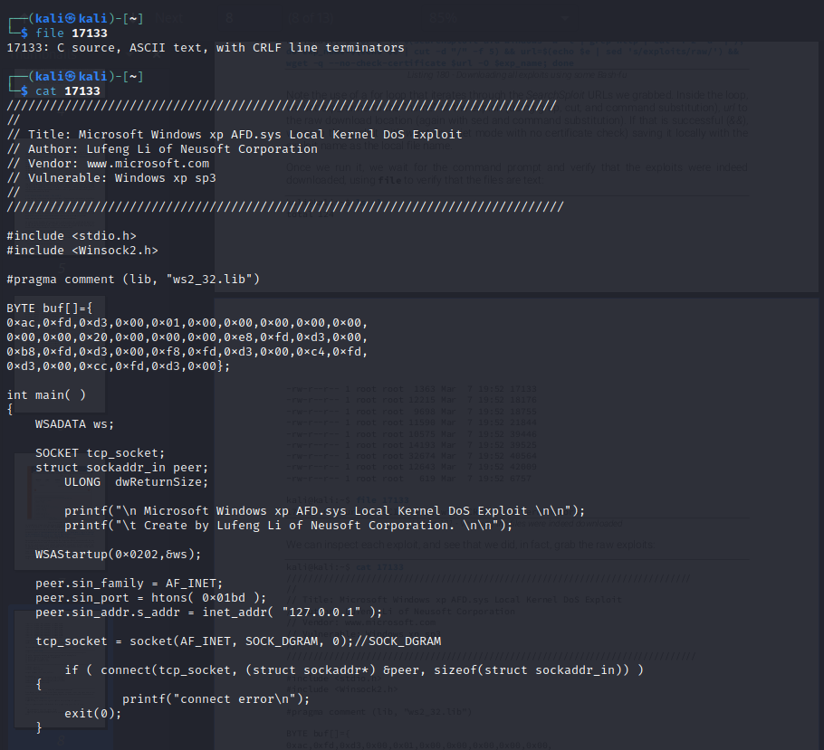
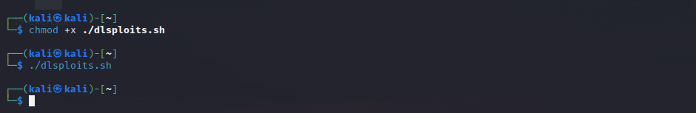

INFERENCE
The experiment aimed to search for a specific exploit on a Windows machine during a penetration test. The procedure involved searching https://www.exploit-db.com for “afd windows” to find exploits that match the search criteria. The exploits that match the search criteria were downloaded and inspected until the proper one was found. To automate the task, the SearchSploit132 utility on Kali Linux was used, which is a command-line search tool for Exploit-DB. A Bash loop was used to download the files and save them locally. Each page has a link to download the “raw” exploit code, which was downloaded using a Bash one-liner. A for loop was used to iterate through the SearchSploit URLs, set the exploit name and download location, and grab the exploit with wget saving it locally with the exploit name as the local file name. Finally, the experiment verified that the exploits were indeed downloaded using file to verify that the files are text. Overall, the procedure was successful in achieving the aim of searching for a specific exploit on a Windows machine during a penetration test.
Exercise 3-c
AIM
To prepare a report along with observations and inferences for the given scenario.

PROCEDURE
- Create a temporary folder for the exercise.
- Use "cd" to enter the temporary folder directory.
- Scan the class C subnet using nmap with the "-A" option for aggressive scanning, "-p" to specify port 80, "--open" to only return machines with open ports, and "-oG" to save the scan results in greppable format.
- Use "cat" command to view the output file format.
- Notice that each IP address is repeated twice, with the first line displaying the machine status and the second displaying the port number being scanned.
- Use "grep" to filter for lines containing port 80.
- Use "grep -v" to exclude the first line containing the case-sensitive keyword "Nmap".
- Use "awk" to print the second field, which is the IP addresses, using space as a delimiter.
- Use a Bash one-liner to loop through the IP address list and run cutycapt with "--url" to specify the target web site and "--out" to specify the name of the output file.
- Use "ls -1" to list the output files created by the Bash one-liner.
- Use scripting knowledge and basic HTML knowledge to create a Bash script that builds an HTML file (web.html), inserts each .PNG file name into an HTML IMG tag, appends this to our web.html file, and appends HTML end tags into the file.
- Make the script executable and view it in the browser to see a view of each web server's main page.

OBSERVATION
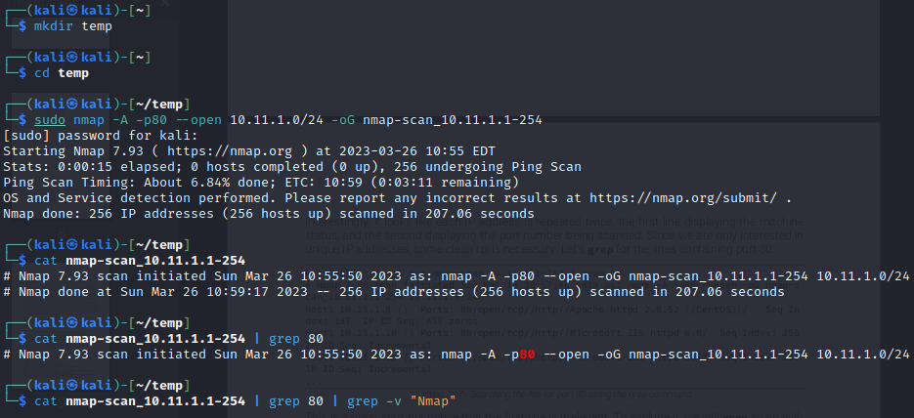

INFERENCE

The aim is to scan a class C subnet to identify web servers and determine whether or not they present an interesting attack surface. The procedure involves using nmap to scan the subnet and filter for machines with open port 80. The IP addresses are then extracted and used to generate screenshots of the web pages using cutycapt. The output files are then used to create an HTML file that displays the screenshots of each web server's main page.The use of aggressive scanning with nmap helps to identify potential attack vectors by detecting what services are running on the target machines. By filtering for machines with open port 80, the focus is on identifying web servers that may present an interesting attack surface. The use of cutycapt helps to generate screenshots of the web pages, which can be useful in identifying potential vulnerabilities or areas of interest.The final step of creating an HTML file to display the screenshots in a user-friendly format makes it easier to review the results and identify potential areas of interest. Overall, the procedure outlined in the scenario provides a systematic and effective way to scan a class C subnet and identify potential attack surfaces.

