QUESTION:
4-a: Prepare an experimental report along with your observations and inferences for SQL Injection using SQLMap in Kali Linux

4-b: Configure an Intrusion Detection System using Suricata on an Ubuntu VM (Host) and also perform a DDoS attack on this host using a Kali VM.

Exercise 4-a

AIM
To perform SQL Injection using SQL Map in Kali Linux

PROCEDURE
- Open the web browser and navigate to testphp.vulnweb.com.
- In Google, search for site:ht tp://testphp.vulnweb.com/ php?id= to get a list of URLs for the page.
- Open the terminal and type the following command to check if SQLMap is installed:
sqlmap -u ht tp://testphp.vulnweb.com/art ists.php?art ist=1 –dbs
- This command will provide a list of databases available on the website.
- Select a database to perform the SQL injection.
- Use the following command to find the columns of the selected database:
sqlmap -u ht tp://testphp.vulnweb.com/art ists.php?art ist=1 -D acuart –column.s
- This command will display the columns and the table name for the selected database.
- Once you have identified the tables and columns, you can use SQLMap to extract the data.
- Use the following command to extract all the data from the table:
- sqlmap -u ht tp://testphp.vulnweb.com/art ists.php?art ist=1 -D acuart -T <table_name> --dump
- Replace <table_name> with the name of the table you want to extract data from.
- SQLMap will start dumping the data from the selected table, which can take some time.
- Once the data is extracted, you can view it in the terminal or save it to a file for later analysis.
OBSERVATION
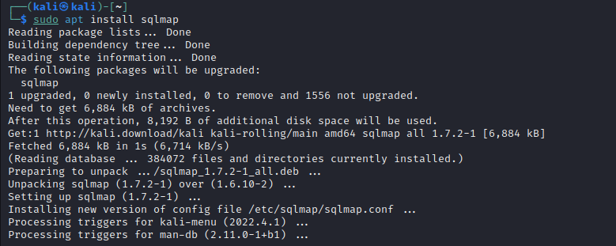
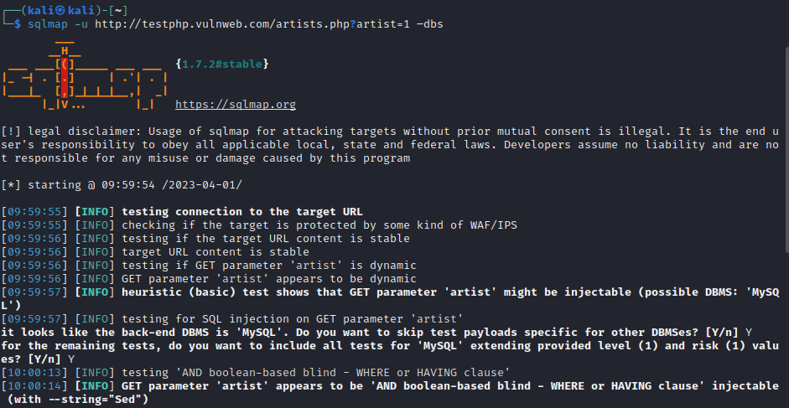
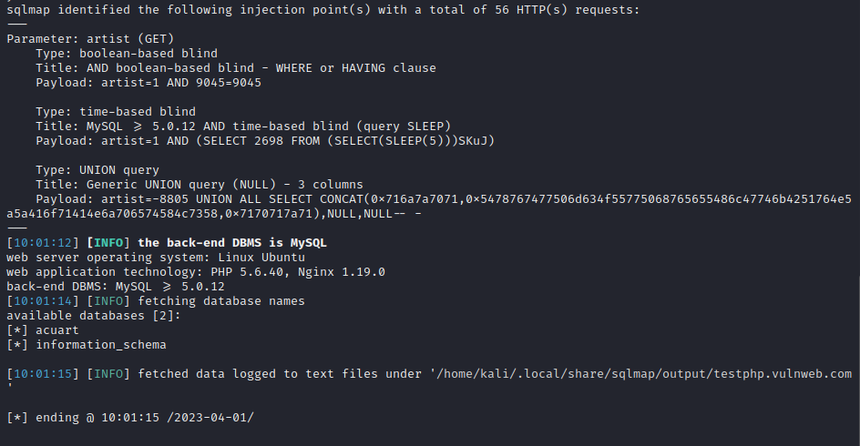
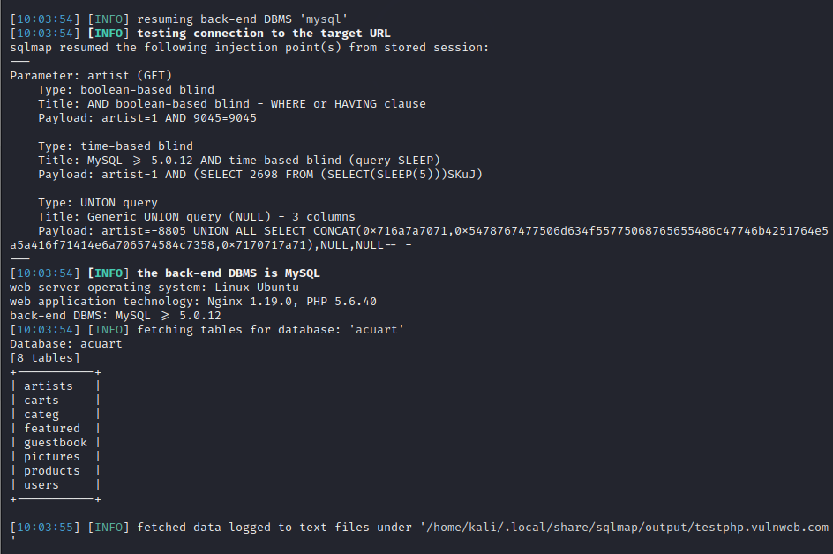
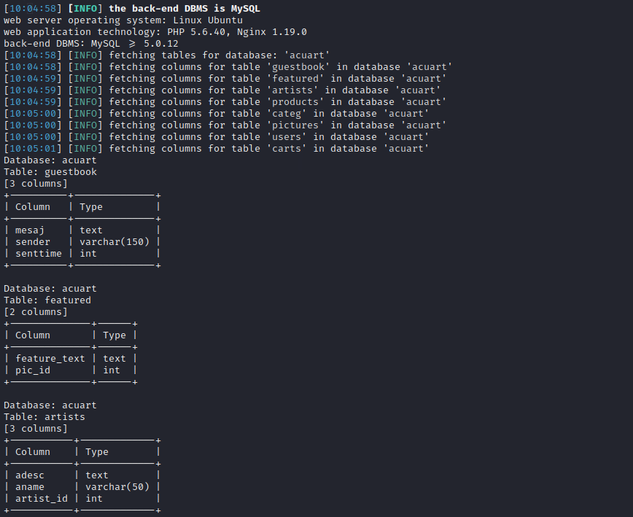
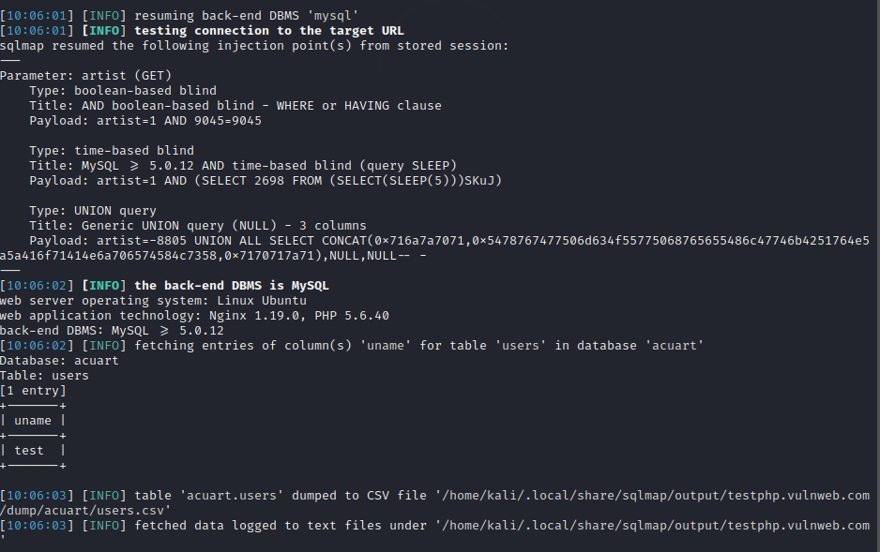
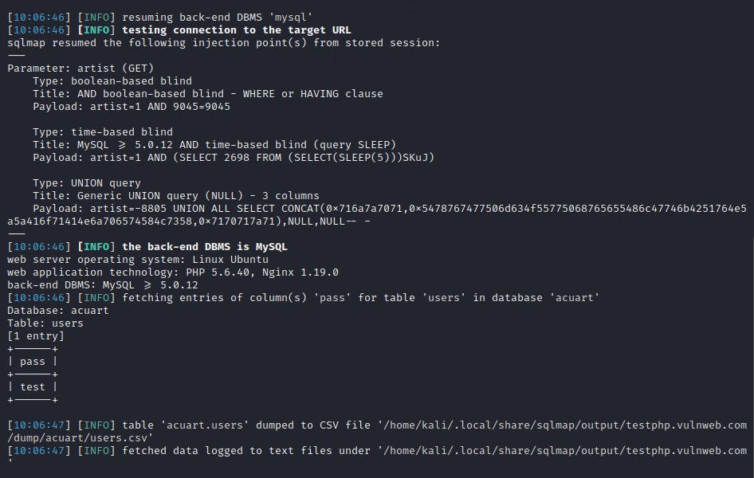

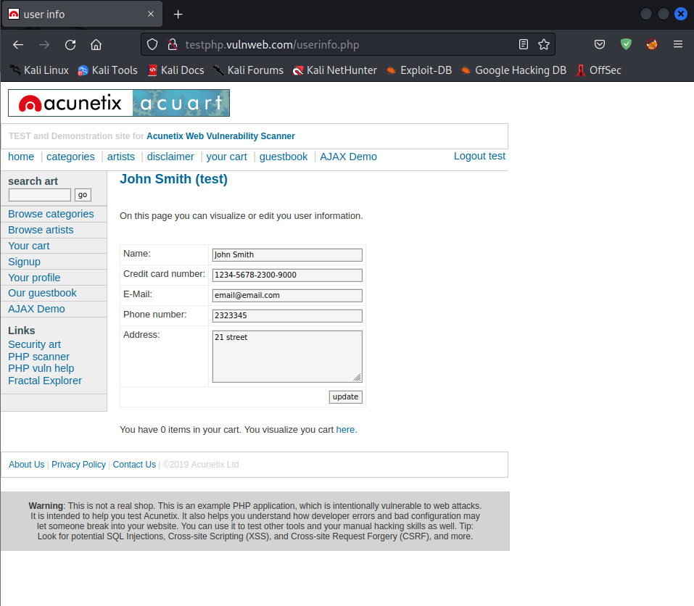

INFERENCE

The given procedure explains how to use SQL injection to extract data from a website. It involves using SQLMap to identify the databases and tables available on the website, and then extracting data from a selected table by using the SQLMap command. The extracted data can be viewed in the terminal or saved to a file for further analysis.

Exercise 4-b

AIM
To Configure an Intrusion Detection System using Suricata on an Ubuntu VM (Host) and also a DDoS attack on this host using a Kali VM.

PROCEDURE
- In Virtual Box, create a NAT Network under the Tools option, and link both Ubuntu and Kali Linux virtual machines with the same NAT Network address.
- Obtain the IP addresses of both virtual machines using the ifconfig command.
- Install Suricata on the Ubuntu VM by executing the following commands:
sudo add-apt-repository ppa:oisf/suricata-stable
sudo apt update && sudo apt upgrade -y
sudo apt install suricata suricata-dbg
- Update the contents of the suricata.yaml file with the IP address (10.0.2.15) of the Ubuntu VM and add a rule file to detect DDoS attacks.
- Open the detect-dos.rules file and add two rules to detect SYN flood attacks.
- Update Suricata with the new set of rules by running the command sudo suricata-update.
- Execute the IDS using the command sudo suricata -c /etc/suricata/suricata.yaml -i enp0s3.
- Download the DoS Attack file from the GitHub repository and modify the IP address to the Ubuntu VM's IP address.
- Run the DoS Attack file using the command sudo python3 dos_attack.py on Kali Linux VM.
- Check the log file where the packets captured from the DDoS attack are stored using the command sudo tail -f /var/log/suricata/fast.log on the Suricata server.

OBSERVATION

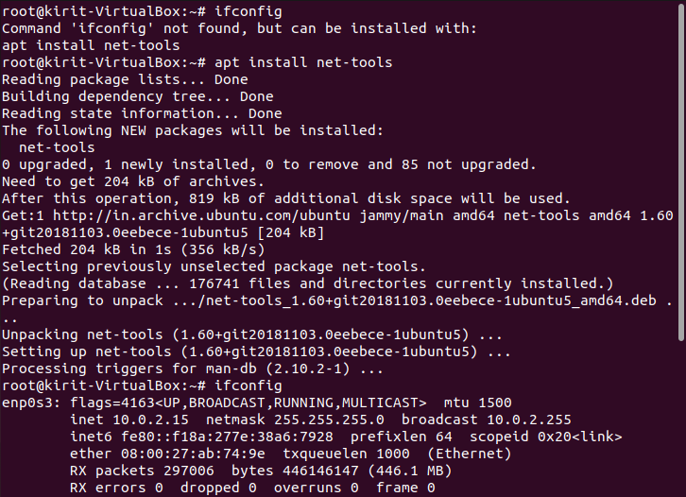
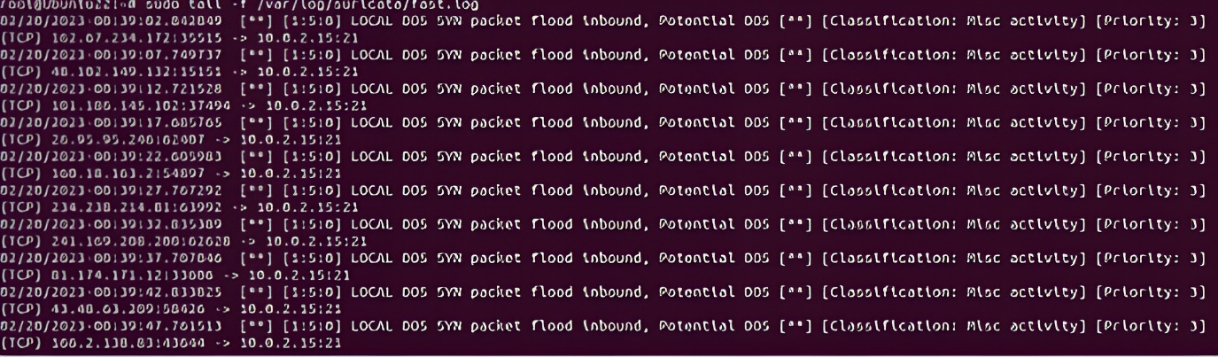
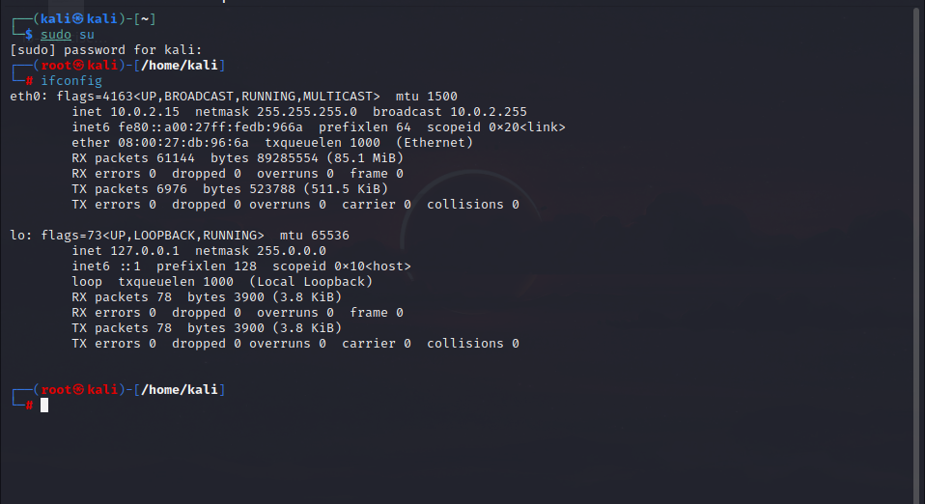
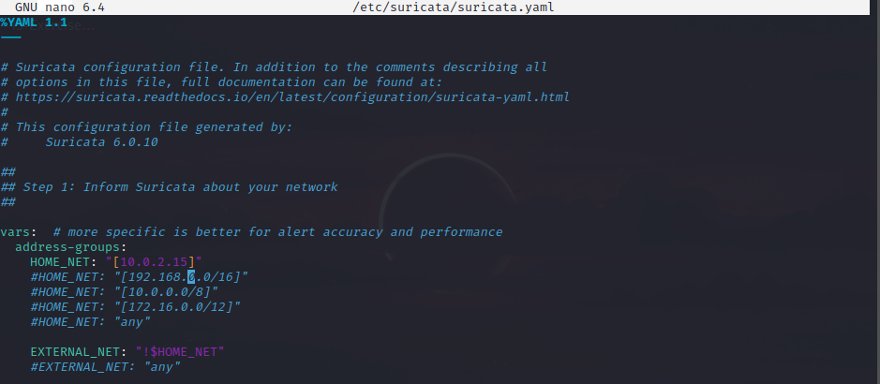
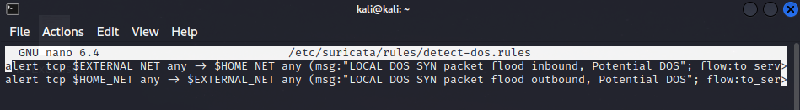
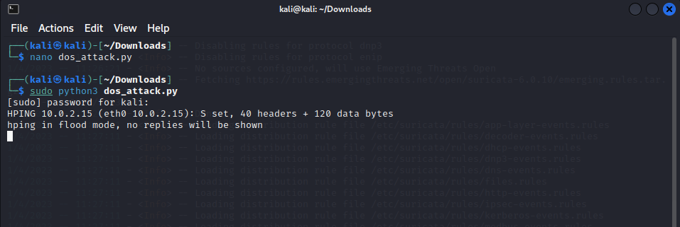

INFERENCE

This experiment describes the steps to set up and configure an intrusion detection system (IDS) using Suricata to detect a denial-of-service (DoS) attack. The process involves downloading and setting up VirtualBox, installing Ubuntu and Kali Linux as virtual machines, creating a common NAT network address, installing Suricata on the Ubuntu VM, updating the suricata.yaml file, adding a rule file, updating Suricata with new rules, and finally executing the IDS to capture packets from the DoS attack using the tail command to view the fast.log file.

