QUESTION:
5-a: Prepare an experimental report along with your observations and inferences for Port Forwarding on Cisco Router using Cisco Packet Tracer

5-b: Prepare an experimental report along with your observations and inferences for Port Address Translation (PAT) / NAT Overload using Cisco Packet Tracer

5-c: Prepare an experimental report along with your observations and inferences for Standard access control lists and Extended access control lists using Cisco Packet Tracer

Exercise 5-a

AIM
To perform Port Forwarding on Cisco Router using Cisco Packet Tracer

PROCEDURE

- From the Network Devices palette, pick and drop a router 4331 and rename it as Router R0.
- From the End Devices palette, pick and drop a server0 and rename it as Web Server.
- From the End Devices palette, pick and drop a PC and rename it as PC0.
- From the Connections palette, pick a copper cross-over cable, click on the Web Server, and choose FastEthernet0. Then connect the Web Server to the Router R0, and choose GigabitEthernet0/0/0.
- From the Connections palette, pick a copper cross-over cable, click on the PC0 and choose FastEthernet0. Then connect the PC0 to the Router R0, and choose GigabitEthernet0/0/1.
- Select Place Note and type the following below the Web Server: 172.16.1.2
- Select Place Note and type the following above the PC0: 192.168.1.0
- Select Place Note and type the following below the Router R0: 172.16.1.2:80 – 10.0.0.2:80. Then, select the IP configuration for the host (PC0) and the server (Web Server). The Web Server’s Ethernet Interface should be 172.16.1.2 and the Default Gateway 172.16.1.1, which will be the closest IP address of R0.
- Double-click on the Web Server, choose the Desktop, then select IP Configuration. In the IP configuration, set the following values: IPv4 Address: 172.16.1.2, Subnet Mask: 255.255.0.0, Default Gateway: 172.16.1.1. Close IP Configuration and minimize this Web Server window.
- Double-click on the PC0, choose the Desktop, then select IP Configuration. In the IP Configuration, set the following values: IPv4 Address: 192.168.1.2, Subnet Mask: 255.255.255.0, Default Gateway: 192.168.1.1. Close IP Configuration and minimize this PC0 window.
- Double-click on the Router R0, choose the CLI, and then press enter/return.

OBSERVATION
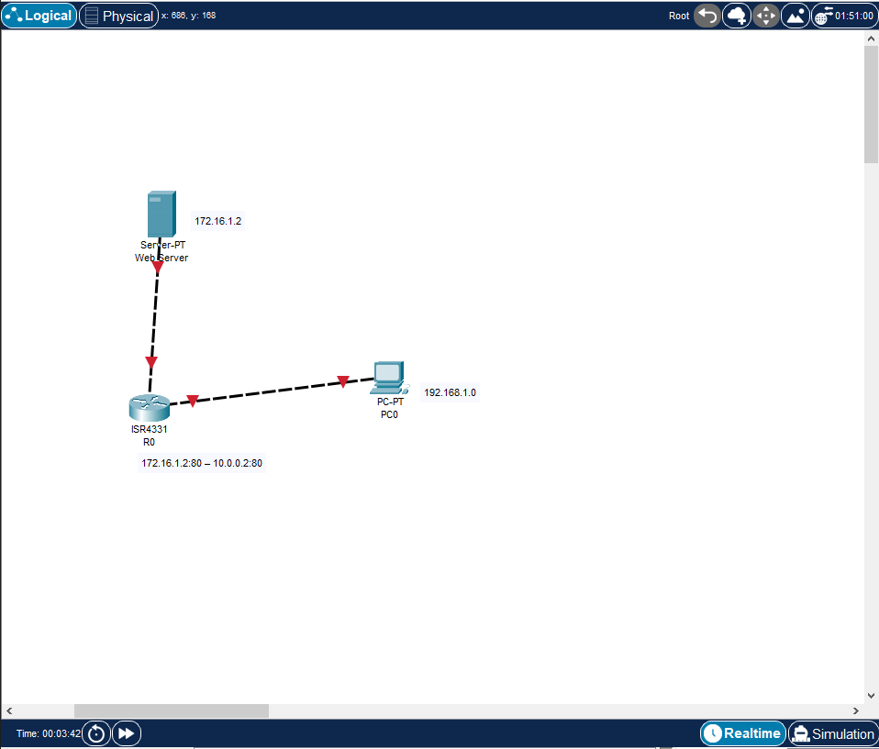
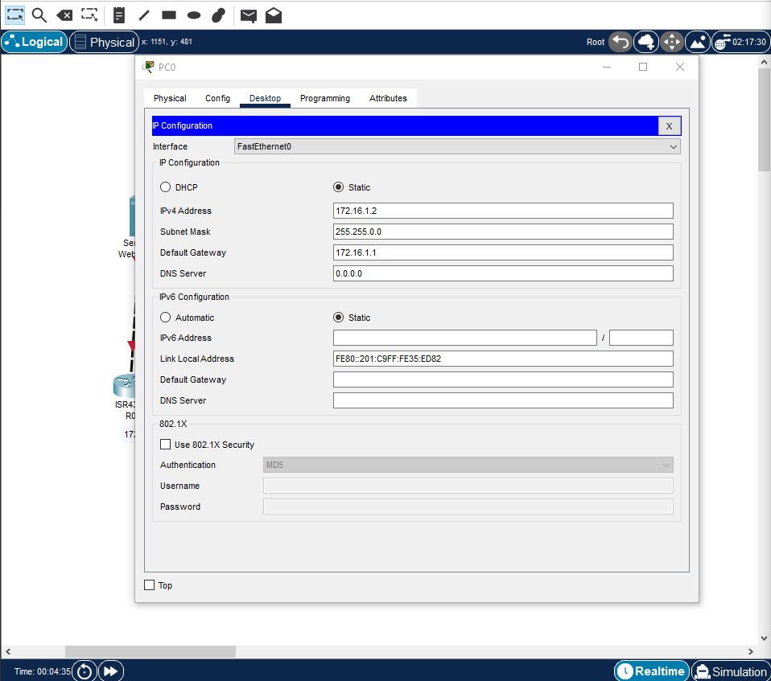

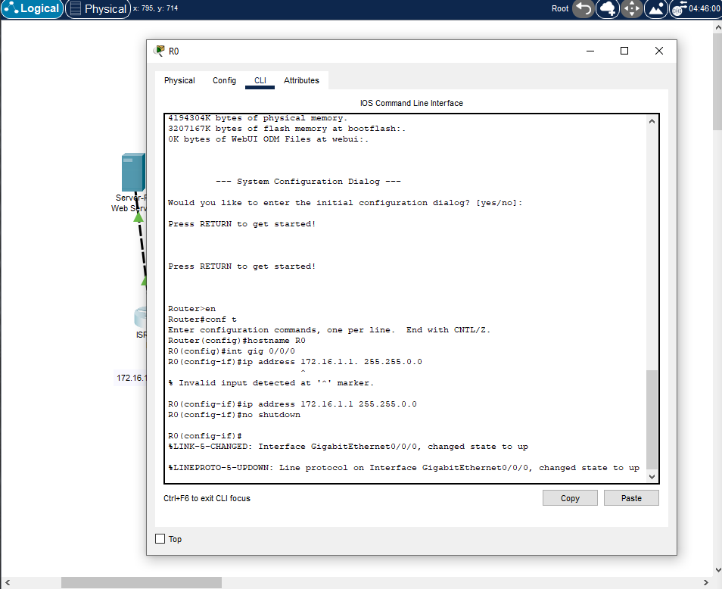

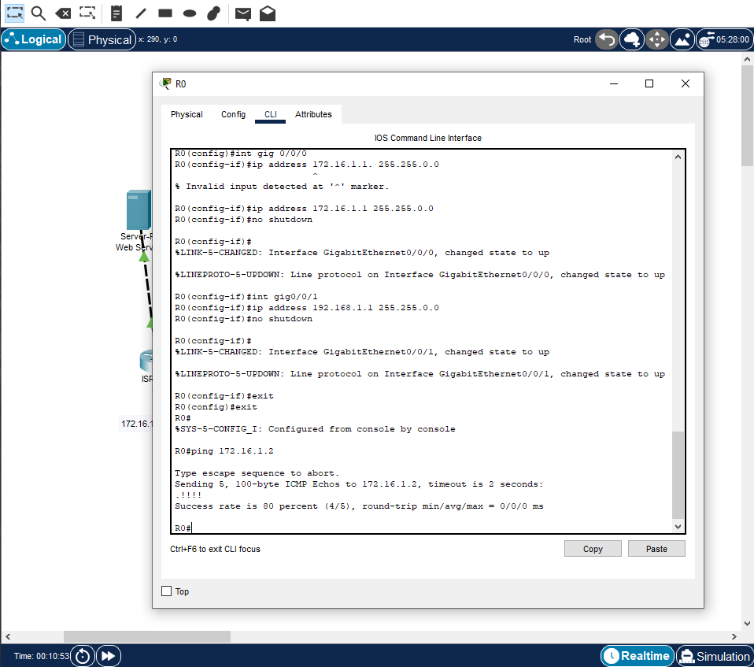

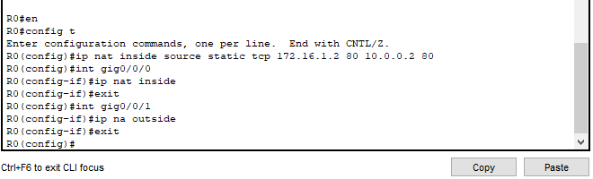

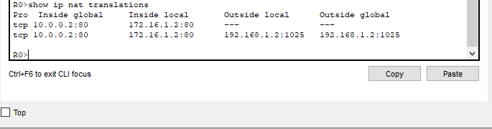

INFERENCE
An experiment was conducted to configure port forwarding using Cisco routers and Packet Tracer software to enable outside hosts to connect to web and email servers on the appropriate ports. The process involved selecting and renaming devices, connecting them using crossover cables, configuring IP addresses and default gateways, testing connectivity, and configuring port forwarding and NAT settings on the router. The configuration was verified by connecting to the web server from a PC's web browser and checking the NAT table on the router.

Exercise 5-b

AIM
To perform Port Address Translation (PAT) / NAT Overload using Cisco Packet Tracer

PROCEDURE
- Open Cisco Packet Tracer and create a new project.
- From the network devices palette, select the router 4331 and drag and drop it to the workspace; rename this router as R0.
- From the network devices palette, select the router 4331 and drag and drop it to the workspace; rename this router as R1.
- From the network devices palette, select the switch 2960 and drag and drop it to the workspace; rename this switch as SW0.
- From the end devices palette, select the PC and drag and drop it to the workspace; rename this PC as PC1.
- From the end devices palette, select the PC and drag and drop it to the workspace; rename this PC as PC2.
- Connect the individual PCs (PC1 and PC2) to the switch SW0, then connect the switch SW0 to the router R0; finally, connect the routers R0 and R1.
- Select the draw rectangle tool and draw a yellow rectangle on the workspace; place it over the PCs and switch. This will represent the inside network (172.16.0.0/16).
- Select the draw rectangle tool and draw a blue rectangle on the workspace; place it over the routers. This will represent the outside network (192.168.1.0/24).
- Select the place note tool and type "NAT INSIDE" below the yellow rectangle.
- Select the place note tool and type "NAT OUTSIDE" below the blue rectangle.
- Select the place note tool and type the details as shown in the following diagram.
- Double click on PC1 and choose the Desktop, then select IP configuration and proceed with the following settings: IPv4 Address: 172.16.0.1, Default Gateway: 172.16.0.254.
- Double click on PC2 and choose the Desktop, then select IP configuration and proceed with the following settings: IPv4 Address: 172.16.0.2, Default Gateway: 172.16.0.254.
- Double click on the router R0, choose the CLI, and then press enter/return.

OBSERVATION
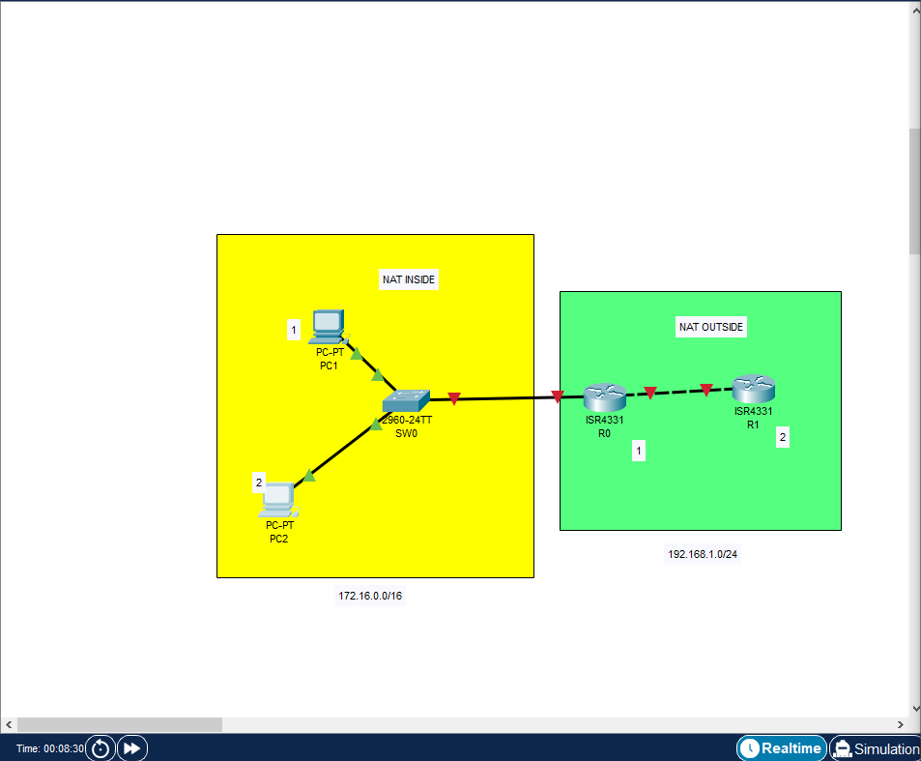
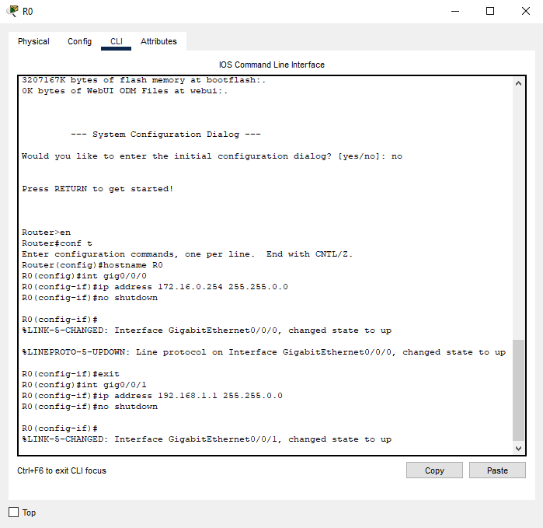
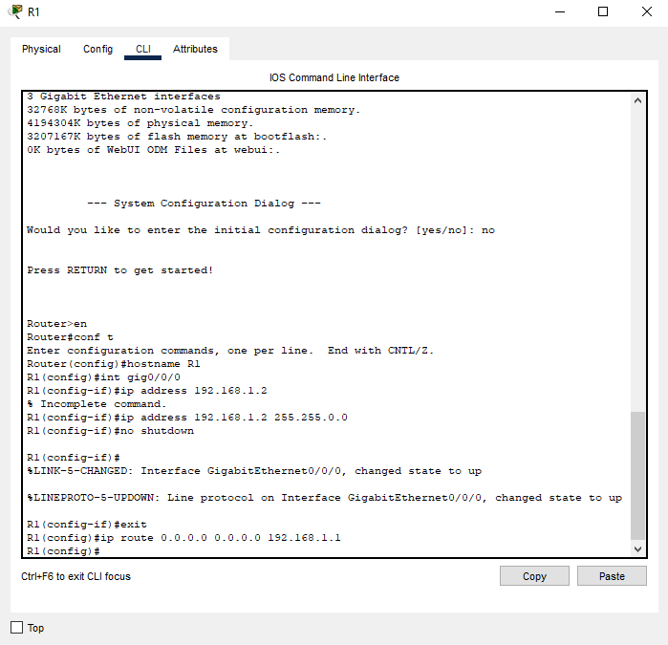
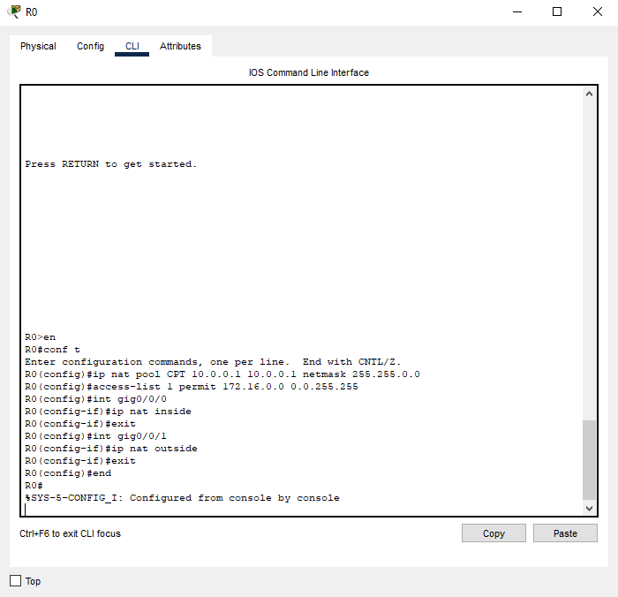
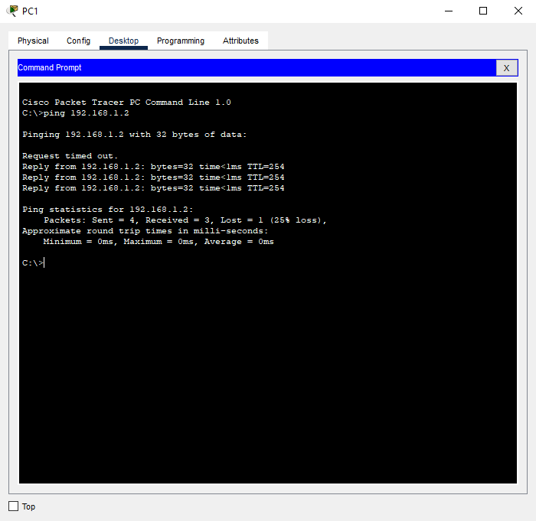
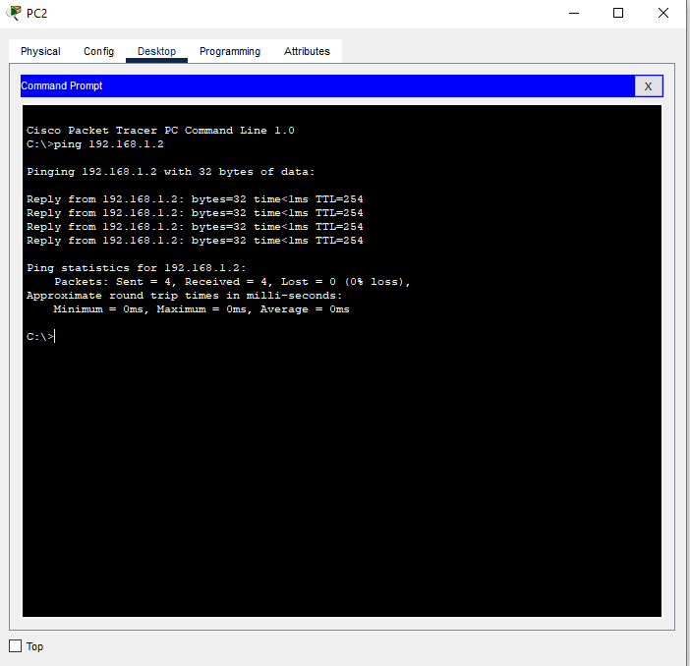

INFERENCE
Port Address Translation (PAT) is a technique used to allow multiple hosts to access the internet using a single IP address. In the experiment, the NAT overload was applied to the network using routers, switches, and end devices to illustrate the process of PAT. The experiment involves configuring the IP addressing for the hosts, adding static routes, and configuring NAT pools, source lists, and access lists on routers to enable PAT. The experiment shows that PAT allows multiple hosts to access the internet using a single IP address by adding a port number to the translation and keeping a log of which host uses which port.

Exercise 5-c

AIM
To perform Standard access control lists and Extended access control lists using Cisco Packet Tracer

PROCEDURE
- Create the topology in Cisco Packet Tracer as per the requirement.
- Configure the IP addresses on the routers and devices in the network topology.
- Use a routing method such as RIP to enable routing between the networks.
- Open Command Prompt on PC1 and verify the connectivity by pinging 20.0.0.2.
- Understand the command syntax for configuring an ACL using either the numbered ACL or named ACL method.
- Configure Standard ACL by denying a host and permitting all the hosts to filter incoming packets to Router2.
- Apply the ACL to the interface by specifying the direction of traffic to filter.
- Verify the applied ACL by executing the "show ip access-lists" command on Router2.
- Test the ACL configuration by pinging 192.168.0.2 from PC1, which should be blocked.
- Remove the ACL configuration to perform the next exercise

OBSERVATION
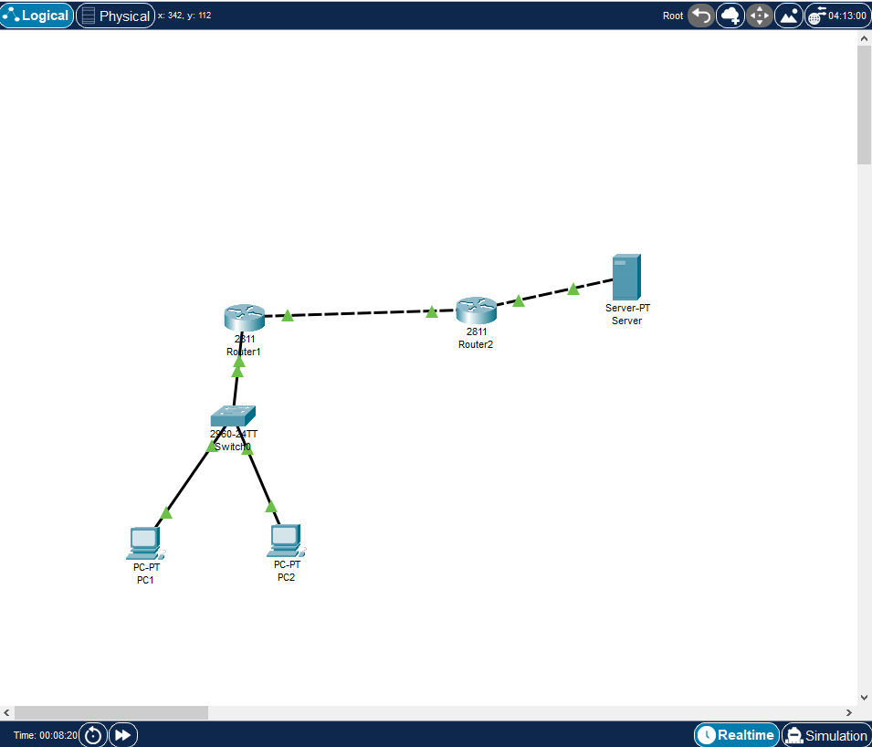
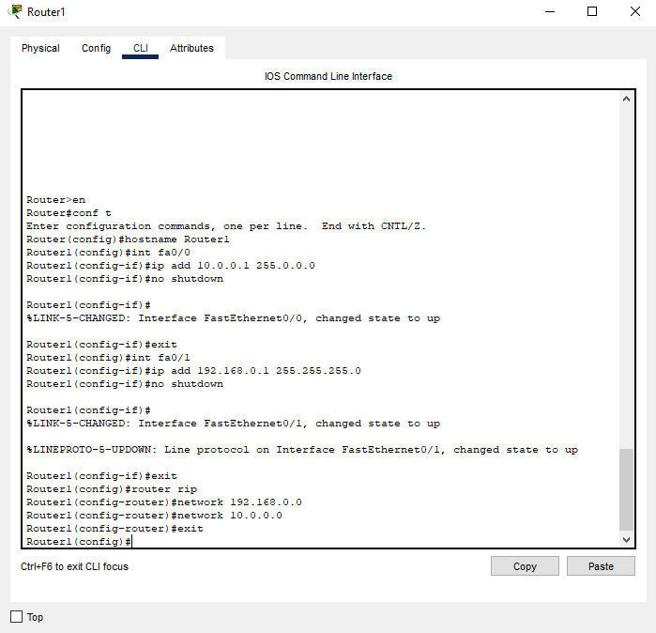
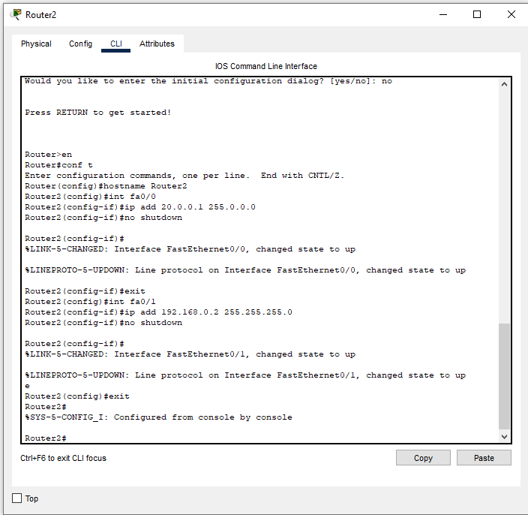
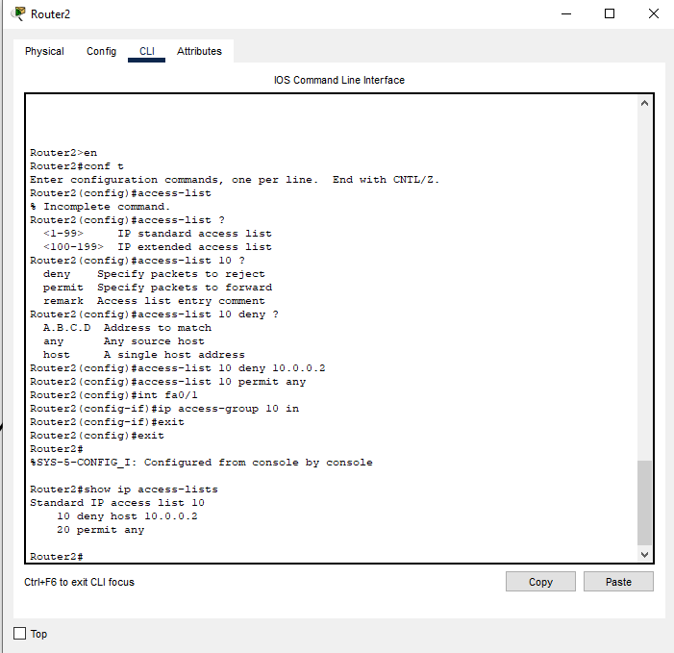
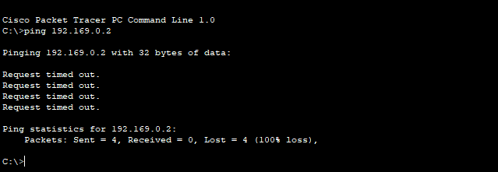

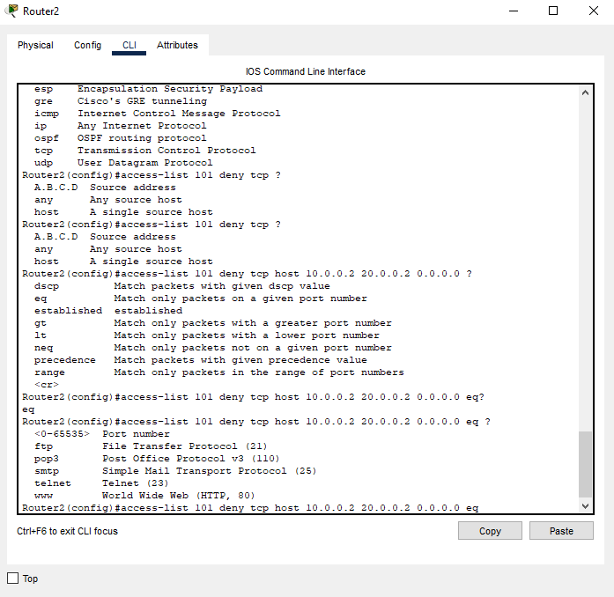

INFERENCE
Configuring an Access Control List (ACL) on a router is an effective way of filtering network traffic based on specific conditions. ACLs can be configured as either Standard or Extended access lists, and can be applied using either a number or a name. Applying an ACL to a router interface enables it to examine every packet moving from one interface to another interface in the specified direction and take the appropriate action. Configuring an ACL involves the following steps: defining the access list statements, permitting or denying access, specifying the direction of the traffic to filter, and applying the ACL to the interface. ACLs are useful for controlling network access and enhancing network security

