**Enterprise Data Warehousing**

***Professor: Saeed Kashif***

**Assignment - 1**

**Turo Online Car Rental**

Done By:

**Naga Adithya Kaushik Chandrabhatla**

**EUID: 11548817**

**About:**

**Turo is an Online car rental agency which acts as a mediator between the Owner of the car and the customer who is the renter of the car. It handles operations in multiple cities like London, Denver, New York, Los Angeles etc, however, in this assignment we will be building a database for the Turo Car Rental Company.**

**Entities:**

1. **Bookings**
2. **Car Owner**
3. **Customer(renter)**
4. **Cars**
5. **Reviews**
6. **Login Details**

**The entities are the tables which store specific data related to them. We create relations between the entities using an ER diagram which helps us in creating relations between them using Foreign keys which are unique keys used to identify specific rows of data in our tables.**

**ER Diagram:**

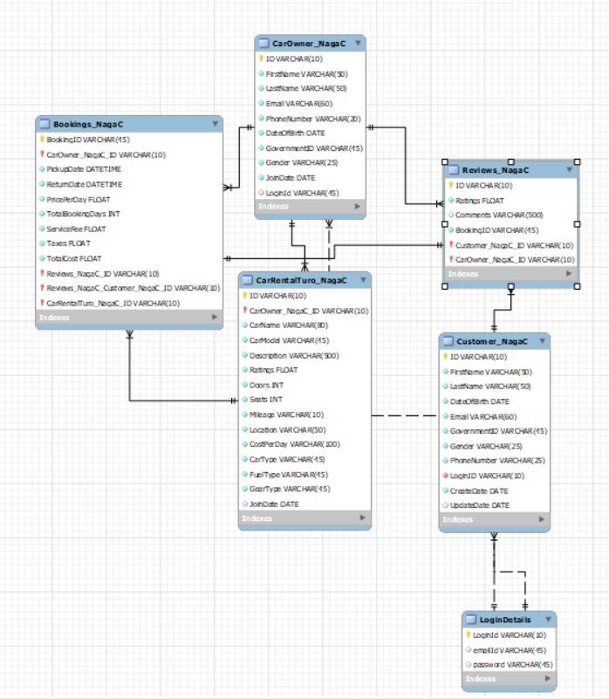

**All the entities are linked with each other with varying cardinalities like one to many or many to one.**

**Tables generated after running queries:**

1. **Bookings table:**

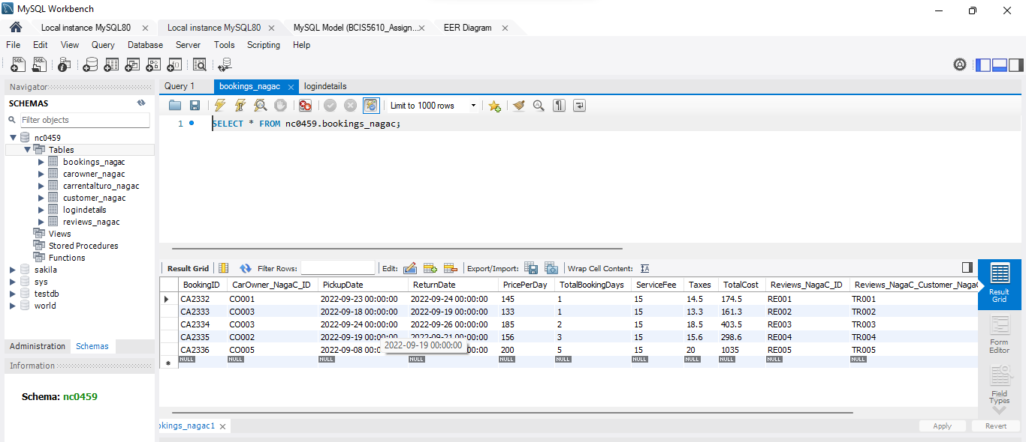

1. **CarOwner table:**

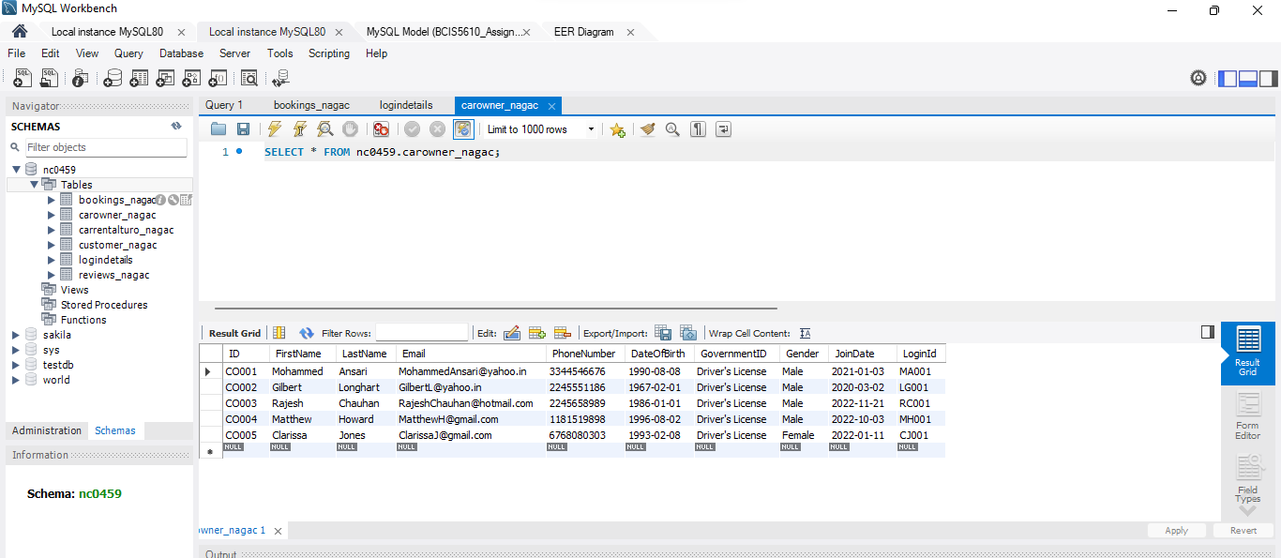

1. **CarOwner table:**

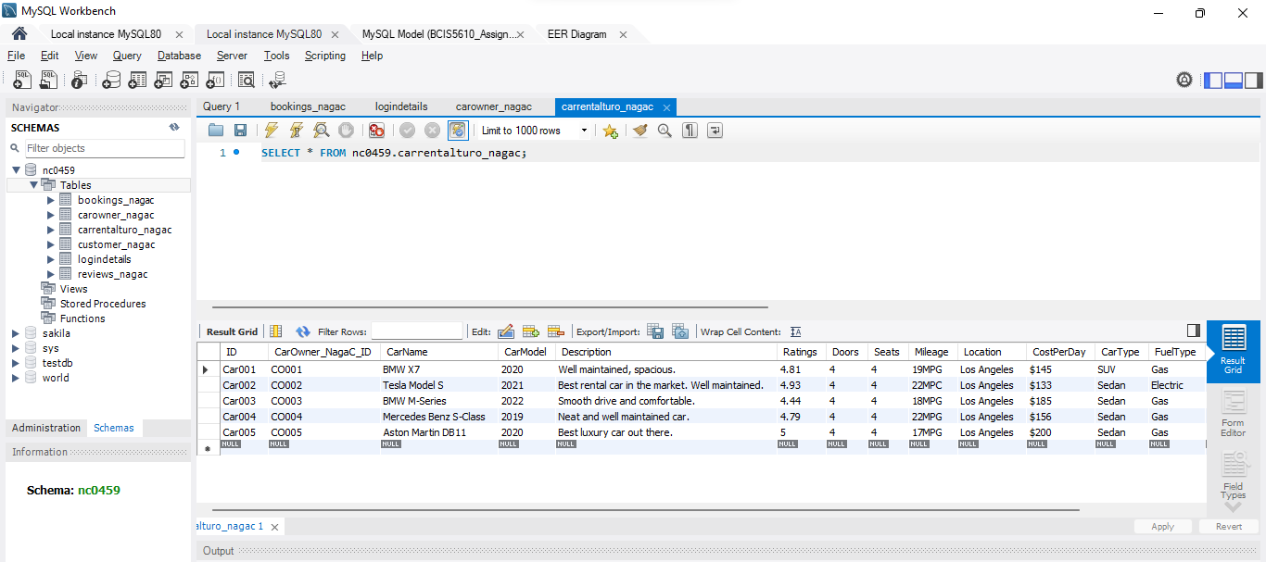

1. **Customer table:**

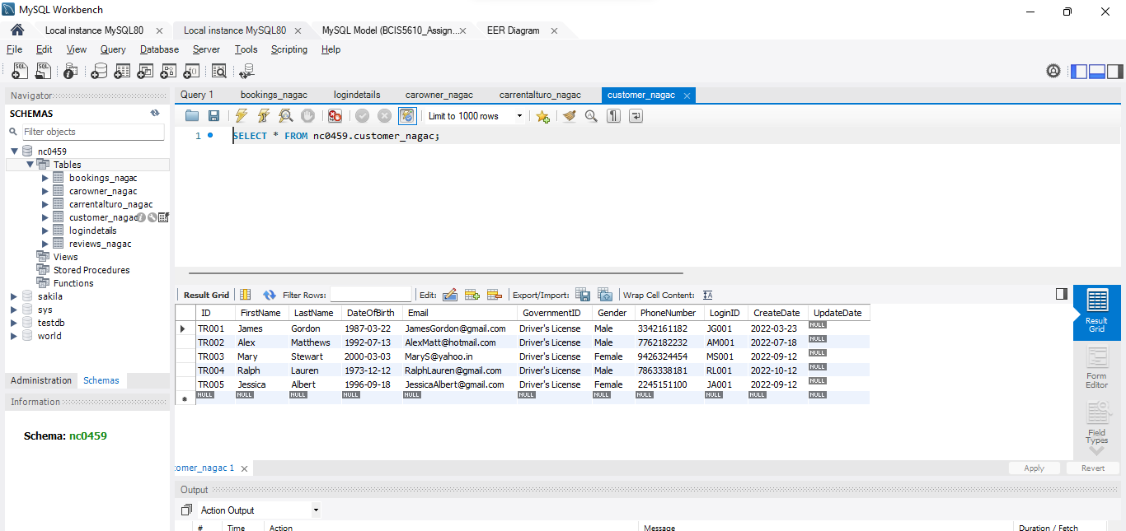

1. **LoginDetails table:**

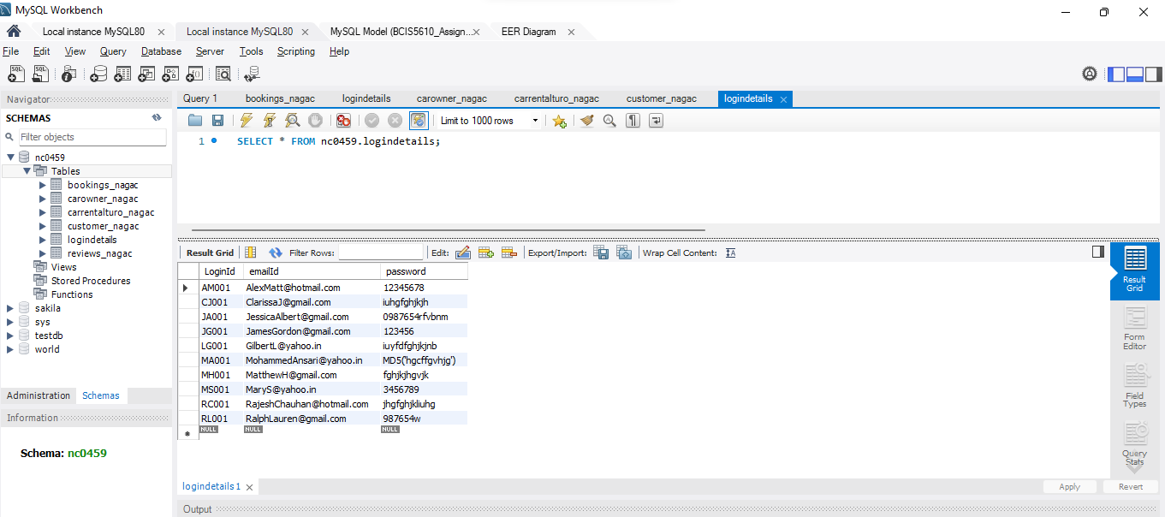

1. **Reviews table:**

