# Enterprise Data Warehousing BCIS5610

Fall 2022

Professor: Kashif Saeed

Assignment – 4

# Tableau Worksheets and Dashboard

Done by: Naga Adithya Kaushik Chandrabhatla, nc0459, 11548817

# Tableau Worksheets

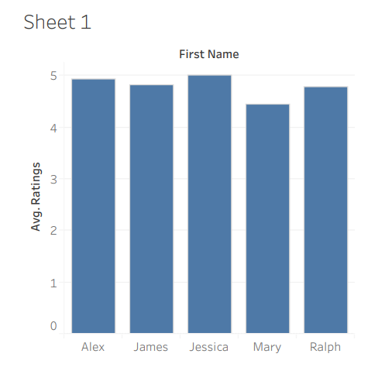

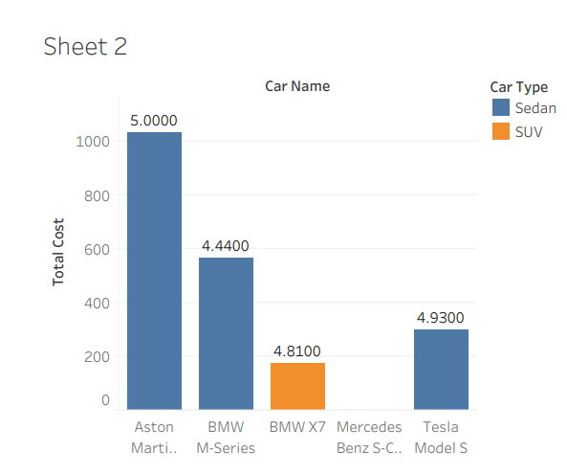

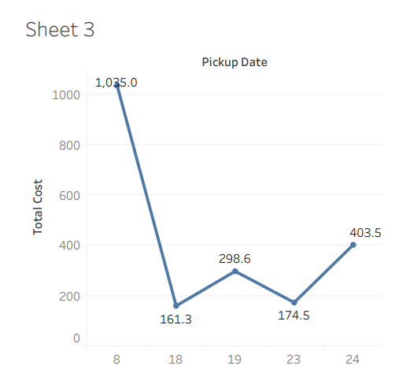

1. Document your challenges as compared to assignment 3. Do not use any workarounds. For example, how did you connect to the MySQL database? How did you resolve the loop(s)?

Answer: We can connect the tables as a dataset in tableau by dragging the tables and connecting them like we did in MySQL. There is a feature in tableau that handles the tables by connecting the primary and foreign keys. When we upload the tables to tableau using the same column name, then we can use the dataset to make graphs.

We have to manually resolve the loops issue in Tableau, whereas in Qlikview, it has an inbuilt feature to handle any kind of loops.