Department | Computer Science and Engineering
Programme: | B.E. |  |  | Semester: | I |  | AY: |  | 2026 – 2027 [ODD]
Faculty Handling: | Mr. A. Sendhooran, AP/CSE
Course Code & Title: | 2611CSSJ102 & Web Essentials
Assessment Task: | Mini Project (Project Based Learning) |  |  | Assessment Type: |  | Term Work / Individual |  |  |  | Required Hrs: | 2 Weeks
Assessment Question based on: | Open Ended |  | ✓ | Problem Based Learning |  |  |  |  | Creative Thinking |  | ✓
 | Close Ended |  |  | Project Based Learning |  |  |  | ✓ | Critical Thinking |  | ✓
 | Any Other Type |  | MCQ or any other | Challenge Based Learning |  |  |  |  | Level of Thinking (RBT) |  | K3/K6
SDG to be Addressed: | SDG is Required |  | Yes | SDG Number (Specify or Mention Students Choice) |  |  |  | SDG 4 / 9 | Target Number (If Applicable) |  | 4.4 / 9.c
SDG Integration Level:  (If Addressed) | Level 1: Awareness |  |  | Level 2: Design Alignment |  |  |  | ✓ | Level 3: Impact and Measurement
RIASEC Context | Realistic ✓ | Investigative ✓ |  | Artistic ✓ |  | Social |  |  | Enterprising | Conventional
Presentation Format: | Live Demonstration (localhost) / PDF Report / GitHub Repository
Max Marks: | 40 Marks
Relevant Course Outcome(s): | CO1, CO2
Submission Deadline: | 09/10/2026
Student Name & Register No. | Adithya K U – TRP26CS010 (I CSE A)
Allocated Website Topic | Department of Computer Science and Engineering

1. Topic and Aim
Item | Details
Course | 2611CSSJ102 – Web Essentials (Units 1 and 2)
Topic | Department of Computer Science and Engineering – informational website
Student | Adithya K U, TRP26CS010, I CSE A
Aim | To plan, build and test a responsive HTML5 website for the Department of Computer Science and Engineering that gives prospective students information about the UG and PG programmes, laboratories, placements, faculty and contact details, and to run it through a local Web server.

Objectives
• Create a single-page website with a header, navigation menu, hero section and six linked sections (About, Programmes, Labs, Placements, Faculty and Contact) using semantic HTML5.
• Present the UG and PG programmes with switchable tabs, the laboratories as cards, and the highest placement of the department (48 LPA).
• Use an accessible contact form with HTML5 input types and validation, CSS Grid and Flexbox for layout, and a responsive design that works on phones.
• Serve the site on localhost and verify it with Chrome Developer Tools and the tests T01 to T12.
2. Components Used
2.1 Hardware and Software
Component | Specification / Purpose
Computer | Any PC or laptop, 4 GB RAM, Windows / Linux / macOS
Code editor | Visual Studio Code – writing HTML and CSS
Web browser | Google Chrome – viewing pages and Developer Tools (Elements, Network, Console)
Local Web server | Python http.server on port 8000 (Apache in XAMPP can also be used)
Testing tools | Chrome Developer Tools (Console, Elements, device toolbar) and an automated browser script for tests T01–T12
Version control | GitHub repository – submission of source code

2.2 HTML5 Components
Area | Elements / attributes used | Where used
Document structure | <!DOCTYPE html>, html lang, head, meta charset, meta viewport, meta description, title, link, style, script | index.html
Semantic layout | header, nav (with aria-label), main, section, footer | index.html
Text | h1–h4, p, span, b, small, br | All sections
Lists | ul / li for the menu, ol / li for the placement path | Header, Placements
Links | Fragment links (#programmes, #labs, #contact), mailto: built by the contact form | Menu, buttons, footer
Layout and styling | CSS Grid, Flexbox, custom properties, gradients, media queries, :hover and :focus-visible | style.css
Forms | form, input, select, option, textarea, button | Contact section
Input types | text, email, select list, multi-line textarea | Contact section
Validation | required, type="email", autocomplete | Contact section
Icons | HTML character entities used as icons (for example &#127942;); no external images | Hero, Programmes, Labs
Accessibility | aria-label, aria-controls, lang="en", prefers-reduced-motion | All sections

2.3 Project Folder
File / Folder | Contents
index.html | Page structure: header, hero, About, Programmes, Labs, Placements, Faculty, Contact and footer
style.css | Colour theme, layout, cards, tabs and responsive rules
script.js | Mobile menu, programme tabs, statistics counter and contact form

2.4 Procedure
1. Collected the department details (programmes, labs, placements, faculty and contact) and planned one page with six sections.
2. Created the project folder cse-department with index.html, style.css and script.js.
3. Wrote the HTML in VS Code using semantic header, nav, main, section and footer elements.
4. Styled the page in style.css with a violet, cyan, coral and amber colour theme, CSS Grid, Flexbox and media queries for phones.
5. Wrote script.js for the mobile menu, programme tabs, animated statistics and the contact form.
6. Started the local server with "python -m http.server 8000", opened http://localhost:8000, recorded tests T01–T12 in Chrome and uploaded the folder to GitHub.
3. Program
The complete source code of the page (index.html), the stylesheet (style.css) and the script (script.js) is given below.
index.html
<!DOCTYPE html>
<html lang="en">
<head>
<meta charset="utf-8">
<meta name="viewport" content="width=device-width, initial-scale=1, viewport-fit=cover">
<title>Department of Computer Science and Engineering | SRM TRP Engineering College, Trichy</title>
<meta name="description" content="Department of Computer Science and Engineering, SRM TRP Engineering College, Trichy: UG and PG programmes, laboratories, placements, faculty, research and events.">
<link href="https://fonts.googleapis.com/css2?family=Poppins:wght@400;500;600;700;800&family=Fira+Code:wght@400;500&display=swap" rel="stylesheet">
<link rel="stylesheet" href="style.css">
</head>
<body>

<header><nav class="wrap nav" aria-label="Primary">
<a class="logo" href="#home"><i>&lt;/&gt;</i><span>Computer Science and Engineering<small>SRM TRP Engineering College, Trichy</small></span></a>
<button class="burger" id="burger" aria-label="Open menu" aria-controls="menu">&#9776;</button>
<ul class="menu" id="menu">
<li><a href="#about">About</a></li><li><a href="#programmes">Programmes</a></li><li><a href="#labs">Labs</a></li>
<li><a href="#placements">Placements</a></li><li><a href="#faculty">Faculty</a></li><li><a class="apply" href="#contact">Apply now</a></li>
</ul>
</nav></header>

<main>
<div class="hero" id="home"><div class="wrap">
<div>
<span class="pill">&#127891; SRM TRP Engineering College, Trichy</span>
<h1>Code the future. <span>Engineer</span> what comes next.</h1>
<p>A department where strong fundamentals meet modern labs, real projects and focused placement training, for students who want to build great software and great careers.</p>
<a class="btn b1" href="#programmes">Explore programmes</a><a class="btn b2" href="#placements">Placement record</a>
</div>
<div class="spot"><span class="crown">&#127942; Highest package</span><b class="big">48 LPA</b><h3>Adithya K U</h3><p>Computer Science and Engineering</p><small>SRM TRP Engineering College, Trichy</small></div>
</div></div>

<div class="wrap"><div class="stats">
<div class="stat"><b>48 LPA</b><span>Highest package</span></div>
<div class="stat"><b>UG + PG</b><span>B.Tech, M.Tech and Ph.D.</span></div>
<div class="stat"><b data-n="6">0</b><span>Specialised laboratories</span></div>
</div></div>

<section id="about"><div class="wrap about">
<div>
<h2>Where curiosity becomes <span class="grad">capability</span></h2>
<p>The Department of Computer Science and Engineering prepares students for careers in software development, data science, artificial intelligence, cyber security and research. Our curriculum is reviewed regularly with industry experts so that what you learn in class matches what employers need.</p>
<p>Every student works on projects from the first year, joins technical clubs, takes part in hackathons and completes internships before graduating.</p>
<span class="tag">Industry-aligned curriculum</span><span class="tag o">Hands-on labs</span><span class="tag g">Mentoring</span><span class="tag y">Higher studies guidance</span>
</div>
<div class="vm">
<div><h3>Our vision</h3><p>To be a centre of excellence in computing education and research that produces skilled, ethical and innovative engineers.</p></div>
<div><h3>Our mission</h3><p>To deliver quality teaching, encourage research and projects, and build strong links with industry and society.</p></div>
</div>
</div></section>

<section class="tint" id="programmes"><div class="wrap">
<div class="head"><h2>UG and PG <span class="grad">programmes</span></h2><p>Pick a level to see the courses on offer. All programmes include lab work and a final project.</p></div>
<div class="tabs"><button class="on" data-t="ug">Undergraduate (B.Tech)</button><button data-t="pg">Postgraduate (M.Tech)</button><button data-t="ph">Research (Ph.D.)</button></div>

<div class="grid panel" id="ug">
<div class="card"><div class="ico">&#128187;</div><h3>B.Tech in Computer Science and Engineering</h3><p>Programming, data structures, algorithms, operating systems, databases, networks and software engineering.</p><div class="meta"><span><b>4 years</b></span><span><b>8 semesters</b></span></div></div>
<div class="card"><div class="ico">&#129302;</div><h3>B.Tech in CSE (AI and Data Science)</h3><p>Machine learning, deep learning, data engineering, statistics and applied AI projects.</p><div class="meta"><span><b>4 years</b></span><span><b>Specialisation</b></span></div></div>
<div class="card"><div class="ico">&#128274;</div><h3>B.Tech in CSE (Cyber Security)</h3><p>Cryptography, secure systems, network defence, digital forensics and ethical hacking.</p><div class="meta"><span><b>4 years</b></span><span><b>Specialisation</b></span></div></div>
</div>

<div class="grid panel" id="pg" hidden>
<div class="card"><div class="ico">&#127979;</div><h3>M.Tech in Computer Science and Engineering</h3><p>Advanced algorithms, distributed systems, cloud computing and research methodology, ending in a thesis.</p><div class="meta"><span><b>2 years</b></span><span><b>4 semesters</b></span></div></div>
<div class="card"><div class="ico">&#129504;</div><h3>M.Tech in Artificial Intelligence</h3><p>Deep learning, natural language processing, computer vision and reinforcement learning.</p><div class="meta"><span><b>2 years</b></span><span><b>Thesis</b></span></div></div>
<div class="card"><div class="ico">&#128737;</div><h3>M.Tech in Cyber Security</h3><p>Advanced cryptography, malware analysis, secure software design and security operations.</p><div class="meta"><span><b>2 years</b></span><span><b>Thesis</b></span></div></div>
</div>

<div class="grid panel" id="ph" hidden>
<div class="card"><div class="ico">&#128300;</div><h3>Ph.D. in Computer Science and Engineering</h3><p>Full-time and part-time research under department faculty in AI, security, networks, data and software engineering.</p><div class="meta"><span><b>3 to 5 years</b></span><span><b>Coursework + thesis</b></span></div></div>
<div class="card"><div class="ico">&#128221;</div><h3>Eligibility and admission</h3><p>UG: Class 12 with Mathematics and an entrance score. PG: relevant B.Tech degree with a valid GATE or entrance score. Check the admissions office for the latest rules.</p></div>
</div>
</div></section>

<section class="dark" id="labs"><div class="wrap">
<div class="head"><h2>Our <span style="color:var(--amber)">laboratories</span></h2><p>Students spend a large part of their time building and testing in well-equipped labs.</p></div>
<div class="grid">
<div class="card"><div class="ico">&#129302;</div><h3>AI and Machine Learning Lab</h3><p>GPU workstations for training models, with Python, TensorFlow and PyTorch.</p></div>
<div class="card"><div class="ico">&#128272;</div><h3>Cyber Security Lab</h3><p>Isolated network for practising attacks and defences safely.</p></div>
<div class="card"><div class="ico">&#128225;</div><h3>Networks and IoT Lab</h3><p>Routers, switches, sensors and development boards for connected systems.</p></div>
<div class="card"><div class="ico">&#9881;</div><h3>Software Engineering Lab</h3><p>Team projects with Git, testing tools and continuous integration.</p></div>
<div class="card"><div class="ico">&#9729;</div><h3>Database and Cloud Lab</h3><p>Cloud accounts and database servers for large-scale data work.</p></div>
<div class="card"><div class="ico">&#127919;</div><h3>Programming and Algorithms Lab</h3><p>First-year coding practice with mentors and weekly contests.</p></div>
</div></div></section>

<section id="placements"><div class="wrap">
<div class="head"><h2>Placements that <span class="grad">open doors</span></h2><p>Students are trained from the second year, so they are ready when campus recruitment begins.</p></div>
<div class="two">
<div class="chart hl"><span class="crown">&#127942; Highest package</span><b class="big">48 LPA</b><h3>Adithya K U</h3><p>Adithya K U of our Computer Science and Engineering department secured the highest package of 48 LPA. His success shows what steady practice in coding, problem solving and interviews can achieve.</p><div class="logos"><span>Coding practice</span><span>Problem solving</span><span>Mock interviews</span></div></div>
<div class="chart"><h3>Your path to a job</h3>
<ol class="steps">
<li><b>Year 1 to 2:</b> programming, aptitude and communication skills.</li>
<li><b>Year 2 to 3:</b> data structures, projects, coding contests and certifications.</li>
<li><b>Summer of year 3:</b> internships with partner companies.</li>
<li><b>Year 4:</b> mock interviews, resume clinics and campus drives.</li>
<li><b>Offer:</b> join a company or move to higher studies.</li>
</ol></div>
</div></div></section>

<section class="tint" id="faculty"><div class="wrap">
<div class="head"><h2>Meet our <span class="grad">faculty</span></h2><p>Experienced teachers and researchers who mentor students every day.</p></div>
<div class="grid">
<div class="card fac"><div class="av">KI</div><h3>Dr. Kavish I</h3><p>Faculty, Department of Computer Science and Engineering</p></div>
<div class="card fac"><div class="av">DB</div><h3>Dr. Dhakshin B</h3><p>Faculty, Department of Computer Science and Engineering</p></div>
<div class="card fac"><div class="av">CS</div><h3>Dr. Chandru S</h3><p>Faculty, Department of Computer Science and Engineering</p></div>
<div class="card fac"><div class="av">BS</div><h3>Dr. Bala Sundar</h3><p>Faculty, Department of Computer Science and Engineering</p></div>
</div></div></section>

<section id="contact"><div class="wrap">
<div class="head"><h2>Get in <span class="grad">touch</span></h2><p>Questions about admissions, programmes or placements? Write to us.</p></div>
<div class="contact">
<div class="info">
<p><b>Address</b>Department of Computer Science and Engineering, SRM TRP Engineering College, Trichy, Tamil Nadu</p>
<p><b>Email</b>srmtrptrichy@edu.in</p>
<p><b>Phone</b>0421-657890</p>
<p><b>Office hours</b>Monday to Friday, 9:00 am to 4:30 pm</p>
</div>
<form id="f">
<input id="n" placeholder="Your name" aria-label="Your name" autocomplete="name" required>
<input id="e" type="email" placeholder="Your email" aria-label="Your email" autocomplete="email" required>
<select id="s" aria-label="Enquiry type"><option>UG admission</option><option>PG admission</option><option>Placements</option><option>Other</option></select>
<textarea id="m" rows="4" placeholder="Your message" aria-label="Your message" required></textarea>
<button class="btn b1" type="submit" style="margin:0">Send message</button>
</form>
</div></div></section>
</main>

<footer><div class="wrap">
<div class="cols">
<div><h4>Department of Computer Science and Engineering</h4>Building skilled and ethical engineers through teaching, labs, research and industry links.</div>
<div><h4>Explore</h4><a href="#programmes">Programmes</a><a href="#labs">Labs</a><a href="#placements">Placements</a><a href="#faculty">Faculty</a></div>
<div><h4>Connect</h4><a href="#contact">Contact us</a></div>
</div>
<div class="copy">&copy; 2026 Department of Computer Science and Engineering, SRM TRP Engineering College, Trichy. All rights reserved.</div>
</div></footer>

<script src="script.js"></script>
</body>
</html>
style.css
:root {
--ink: #161236;
--deep: #1a1446;
--violet: #6c3df4;
--cyan: #12c2e9;
--coral: #ff6b6b;
--amber: #ffc83d;
--mint: #2ed8a3;
--bg: #f7f6ff;
--card: #fff;
--muted: #5d5a7a;
--line: #e4e1fb;
box-sizing: border-box;
padding-top: env(safe-area-inset-top,0px);
padding-bottom: env(safe-area-inset-bottom,0px);
}

* {
box-sizing: border-box;
}

html {
scroll-behavior: smooth;
scroll-padding-top: 76px;
}

body {
margin: 0;
font: 16px/1.7 "Poppins",system-ui,Arial,sans-serif;
background: var(--bg);
color: var(--ink);
}

h1,h2,h3 {
line-height: 1.15;
margin: 0;
}

a {
color: inherit;
}

.wrap {
max-width: 1140px;
margin: 0 auto;
padding: 0 20px;
}

.grad {
background: linear-gradient(120deg,var(--violet),var(--cyan));
-webkit-background-clip: text;
background-clip: text;
color: transparent;
}

/* header */

header {
position: sticky;
top: 0;
z-index: 50;
background: rgba(255,255,255,.92);
backdrop-filter: blur(12px);
border-bottom: 1px solid var(--line);
}

.nav {
display: flex;
align-items: center;
justify-content: space-between;
height: 70px;
gap: 16px;
}

.logo {
display: flex;
align-items: center;
gap: 12px;
text-decoration: none;
font-weight: 700;
line-height: 1.2;
}

.logo i {
width: 42px;
height: 42px;
border-radius: 12px;
background: linear-gradient(135deg,var(--violet),var(--cyan));
display: grid;
place-items: center;
color: #fff;
font: 500 15px "Fira Code",monospace;
font-style: normal;
}

.logo small {
display: block;
font-weight: 500;
font-size: 12px;
color: var(--muted);
}

.menu {
display: flex;
gap: 2px;
list-style: none;
margin: 0;
padding: 0;
}

.menu a {
display: block;
padding: 9px 13px;
border-radius: 99px;
text-decoration: none;
font-weight: 500;
font-size: 14.5px;
color: var(--muted);
}

.menu a:hover {
background: #efeaff;
color: var(--violet);
}

.menu .apply {
background: var(--violet);
color: #fff;
font-weight: 600;
}

.menu .apply:hover {
background: var(--deep);
color: #fff;
}

.burger {
display: none;
background: none;
border: 0;
font-size: 28px;
color: var(--deep);
cursor: pointer;
}

/* hero */

.hero {
background: radial-gradient(circle at 85% 20%,rgba(18,194,233,.35),transparent 45%),radial-gradient(circle at 10% 90%,rgba(255,107,107,.28),transparent 40%),linear-gradient(135deg,#150f3d,#2a1a7a);
color: #fff;
padding: 90px 0 110px;
overflow: hidden;
}

.hero .wrap {
display: grid;
grid-template-columns: 1.1fr .9fr;
gap: 40px;
align-items: center;
}

.pill {
display: inline-block;
background: rgba(255,255,255,.14);
border: 1px solid rgba(255,255,255,.25);
padding: 6px 16px;
border-radius: 99px;
font-size: 13.5px;
margin-bottom: 20px;
}

.hero h1 {
font-size: clamp(34px,5.6vw,60px);
font-weight: 800;
letter-spacing: -.02em;
}

.hero h1 span {
color: var(--amber);
}

.hero p {
font-size: 18px;
color: #d9d4ff;
max-width: 52ch;
margin: 20px 0 30px;
}

.btn {
display: inline-block;
padding: 13px 26px;
border-radius: 99px;
font-weight: 600;
text-decoration: none;
margin: 0 10px 12px 0;
border: 2px solid transparent;
cursor: pointer;
font-family: inherit;
font-size: 15px;
}

.b1 {
background: var(--amber);
color: #2b2000;
}

.b2 {
border-color: rgba(255,255,255,.6);
color: #fff;
}

.btn:hover {
transform: translateY(-2px);
}

.spot {
background: rgba(255,255,255,.1);
border: 1px solid rgba(255,255,255,.25);
border-radius: 22px;
padding: 34px;
text-align: center;
}

.crown {
display: inline-block;
background: var(--amber);
color: #2b2000;
padding: 5px 16px;
border-radius: 99px;
font-weight: 600;
font-size: 13.5px;
}

.big {
display: block;
font-size: clamp(56px,9vw,88px);
font-weight: 800;
line-height: 1;
margin: 18px 0 8px;
color: var(--amber);
}

.spot h3 {
font-size: 24px;
}

.spot p {
margin: 4px 0 0;
color: #d9d4ff;
font-size: 15px;
}

.spot small {
display: block;
margin-top: 12px;
color: #bdb6f0;
}

.hl {
background: linear-gradient(135deg,var(--violet),#8d68ff);
color: #fff;
border: 0;
}

.hl p {
color: #efeaff;
font-size: 15.5px;
margin: 0 0 16px;
}

.hl .logos span {
background: rgba(255,255,255,.18);
color: #fff;
}

/* stats */

.stats {
display: grid;
grid-template-columns: repeat(3,1fr);
gap: 18px;
margin-top: -64px;
position: relative;
z-index: 2;
}

.stat {
background: var(--card);
border-radius: 18px;
padding: 24px 18px;
text-align: center;
box-shadow: 0 14px 34px rgba(60,40,160,.16);
border-bottom: 5px solid var(--violet);
}

.stat:nth-child(2) {
border-color: var(--cyan);
}

.stat:nth-child(3) {
border-color: var(--coral);
}

.stat:nth-child(4) {
border-color: var(--amber);
}

.stat b {
display: block;
font-size: 34px;
font-weight: 800;
}

.stat span {
font-size: 14px;
color: var(--muted);
}

/* sections */

section {
padding: 84px 0;
}

.head {
text-align: center;
max-width: 680px;
margin: 0 auto 48px;
}

.head h2 {
font-size: clamp(28px,4.4vw,42px);
font-weight: 800;
}

.head p {
color: var(--muted);
margin: 12px 0 0;
}

.tint {
background: #efeaff;
}

.dark {
background: linear-gradient(135deg,#150f3d,#2a1a7a);
color: #fff;
}

.dark .head p {
color: #cfc8ff;
}

.grid {
display: grid;
gap: 22px;
grid-template-columns: repeat(auto-fit,minmax(255px,1fr));
}

.card {
background: var(--card);
border-radius: 18px;
padding: 26px;
border: 1px solid var(--line);
transition: transform .25s,box-shadow .25s;
}

.card:hover {
transform: translateY(-6px);
box-shadow: 0 18px 36px rgba(80,50,200,.16);
}

.ico {
width: 54px;
height: 54px;
border-radius: 15px;
display: grid;
place-items: center;
font-size: 26px;
margin-bottom: 16px;
background: linear-gradient(135deg,#ece6ff,#d9f6ff);
}

.card h3 {
font-size: 19px;
margin-bottom: 8px;
}

.card p {
margin: 0;
color: var(--muted);
font-size: 15px;
}

.tag {
display: inline-block;
margin: 14px 6px 0 0;
padding: 3px 12px;
border-radius: 99px;
font-size: 12.5px;
font-weight: 600;
background: #efeaff;
color: var(--violet);
}

.tag.o {
background: #ffe9e9;
color: #d63c3c;
}

.tag.g {
background: #dcfbf0;
color: #0b8f69;
}

.tag.y {
background: #fff3cf;
color: #8a6200;
}

/* about */

.about {
display: grid;
grid-template-columns: 1fr 1fr;
gap: 44px;
align-items: center;
}

.about h2 {
font-size: clamp(28px,4vw,40px);
font-weight: 800;
margin-bottom: 14px;
}

.about p {
color: var(--muted);
}

.vm {
display: grid;
gap: 16px;
}

.vm div {
border-radius: 18px;
padding: 24px;
color: #fff;
}

.vm div:first-child {
background: linear-gradient(135deg,var(--violet),#8d68ff);
}

.vm div:last-child {
background: linear-gradient(135deg,var(--coral),#ff9a6b);
}

.vm h3 {
margin-bottom: 6px;
}

.vm p {
margin: 0;
color: #fff;
font-size: 15px;
}

/* tabs */

.tabs {
display: flex;
justify-content: center;
gap: 8px;
margin-bottom: 30px;
flex-wrap: wrap;
}

.tabs button {
border: 2px solid var(--violet);
background: #fff;
color: var(--violet);
padding: 10px 26px;
border-radius: 99px;
font: 600 15px "Poppins",sans-serif;
cursor: pointer;
}

.tabs button.on {
background: var(--violet);
color: #fff;
}

.panel[hidden] {
display: none;
}

.meta {
display: flex;
gap: 16px;
flex-wrap: wrap;
margin-top: 12px;
font-size: 13.5px;
color: var(--muted);
}

.meta b {
color: var(--ink);
}

/* labs */

.dark .card {
background: rgba(255,255,255,.07);
border-color: rgba(255,255,255,.16);
color: #fff;
}

.dark .card p {
color: #d3ccff;
}

.dark .ico {
background: rgba(255,255,255,.14);
}

/* placements */

.two {
display: grid;
grid-template-columns: 1fr 1fr;
gap: 24px;
}

.chart {
background: #fff;
border-radius: 18px;
padding: 26px;
border: 1px solid var(--line);
}

.chart h3 {
margin-bottom: 16px;
}

.row {
display: grid;
grid-template-columns: 48px 1fr 52px;
gap: 12px;
align-items: center;
margin: 12px 0;
font-size: 14.5px;
}

.bar {
height: 16px;
border-radius: 99px;
background: #efeaff;
overflow: hidden;
}

.bar i {
display: block;
height: 100%;
border-radius: 99px;
background: linear-gradient(90deg,var(--violet),var(--cyan));
}

.logos {
display: flex;
flex-wrap: wrap;
gap: 10px;
}

.logos span {
background: #efeaff;
color: var(--deep);
padding: 8px 16px;
border-radius: 12px;
font-weight: 600;
font-size: 14px;
}

.steps {
list-style: none;
margin: 0;
padding: 0;
counter-reset: s;
}

.steps li {
position: relative;
padding: 0 0 18px 52px;
color: var(--muted);
font-size: 15px;
}

.steps li::before {
counter-increment: s;
content: counter(s);
position: absolute;
left: 0;
top: 0;
width: 36px;
height: 36px;
border-radius: 50%;
background: var(--coral);
color: #fff;
display: grid;
place-items: center;
font-weight: 700;
}

.steps li::after {
content: "";
position: absolute;
left: 17px;
top: 38px;
bottom: 2px;
width: 2px;
background: var(--line);
}

.steps li:last-child::after {
display: none;
}

.steps b {
color: var(--ink);
}

/* faculty */

.fac {
text-align: center;
}

.av {
width: 92px;
height: 92px;
border-radius: 50%;
margin: 0 auto 14px;
display: grid;
place-items: center;
font-size: 30px;
font-weight: 700;
color: #fff;
background: linear-gradient(135deg,var(--violet),var(--cyan));
}

.fac:nth-child(2) .av {
background: linear-gradient(135deg,var(--coral),var(--amber));
}

.fac:nth-child(3) .av {
background: linear-gradient(135deg,var(--mint),var(--cyan));
}

.fac:nth-child(4) .av {
background: linear-gradient(135deg,var(--amber),var(--coral));
}

/* events */

/* contact */

.contact {
display: grid;
grid-template-columns: 1fr 1.2fr;
gap: 28px;
}

.info p {
margin: 0 0 14px;
color: var(--muted);
}

.info b {
color: var(--ink);
display: block;
}

form {
background: #fff;
border-radius: 18px;
padding: 26px;
border: 1px solid var(--line);
display: grid;
gap: 14px;
}

input,textarea,select {
width: 100%;
padding: 12px 14px;
border: 1.5px solid var(--line);
border-radius: 12px;
font: inherit;
background: #fbfaff;
color: var(--ink);
}

input:focus,textarea:focus,select:focus {
outline: 3px solid #cdbfff;
border-color: var(--violet);
}

footer {
background: var(--deep);
color: #bdb6f0;
padding: 44px 0 26px;
font-size: 14.5px;
}

footer .cols {
display: grid;
grid-template-columns: 2fr 1fr 1fr;
gap: 30px;
}

footer h4 {
color: #fff;
margin: 0 0 10px;
}

footer a {
display: block;
text-decoration: none;
margin: 5px 0;
}

footer a:hover {
color: var(--amber);
}

.copy {
border-top: 1px solid rgba(255,255,255,.14);
margin-top: 28px;
padding-top: 18px;
text-align: center;
}

@media (max-width:900px) {
.hero .wrap,.about,.two,.contact,footer .cols {
grid-template-columns: 1fr;
}
.stats {
grid-template-columns: 1fr;
}
.burger {
display: block;
}
.menu {
display: none;
position: absolute;
left: 0;
right: 0;
top: 70px;
background: #fff;
flex-direction: column;
padding: 12px 20px 18px;
border-bottom: 1px solid var(--line);
}
.menu.open {
display: flex;
}
header .wrap {
position: relative;
}
}

@media (prefers-reduced-motion:reduce) {
* {
animation: none!important;
transition: none!important;
}
html {
scroll-behavior: auto;
}
}
script.js
(function(){
var menu=document.getElementById('menu');
document.getElementById('burger').onclick=function(){menu.classList.toggle('open')};
menu.onclick=function(e){if(e.target.tagName==='A')menu.classList.remove('open')};
document.querySelectorAll('.tabs button').forEach(function(b){
b.onclick=function(){
document.querySelectorAll('.tabs button').forEach(function(x){x.classList.toggle('on',x===b)});
document.querySelectorAll('.panel').forEach(function(p){p.hidden=p.id!==b.dataset.t});
};
});
var done=false;
function count(){
if(done)return;done=true;
document.querySelectorAll('[data-n]').forEach(function(el){
var t=+el.dataset.n,s=el.dataset.s||'',i=0,step=Math.max(1,Math.ceil(t/40));
var id=setInterval(function(){i=Math.min(t,i+step);el.textContent=i+s;if(i>=t)clearInterval(id)},35);
});
}
if('IntersectionObserver' in window){
new IntersectionObserver(function(en,ob){if(en[0].isIntersecting){count();ob.disconnect()}}).observe(document.querySelector('.stats'));
}else{count()}
document.getElementById('f').onsubmit=function(ev){
ev.preventDefault();
var q='mailto:srmtrptrichy@edu.in?subject='+encodeURIComponent(document.getElementById('s').value+' enquiry from '+document.getElementById('n').value)+'&body='+encodeURIComponent(document.getElementById('m').value+'\n\nReply to: '+document.getElementById('e').value);
window.location.href=q;
};
})();

4. Output
The website was run through http://localhost:8000 in Google Chrome. Screenshots of each section are shown below.
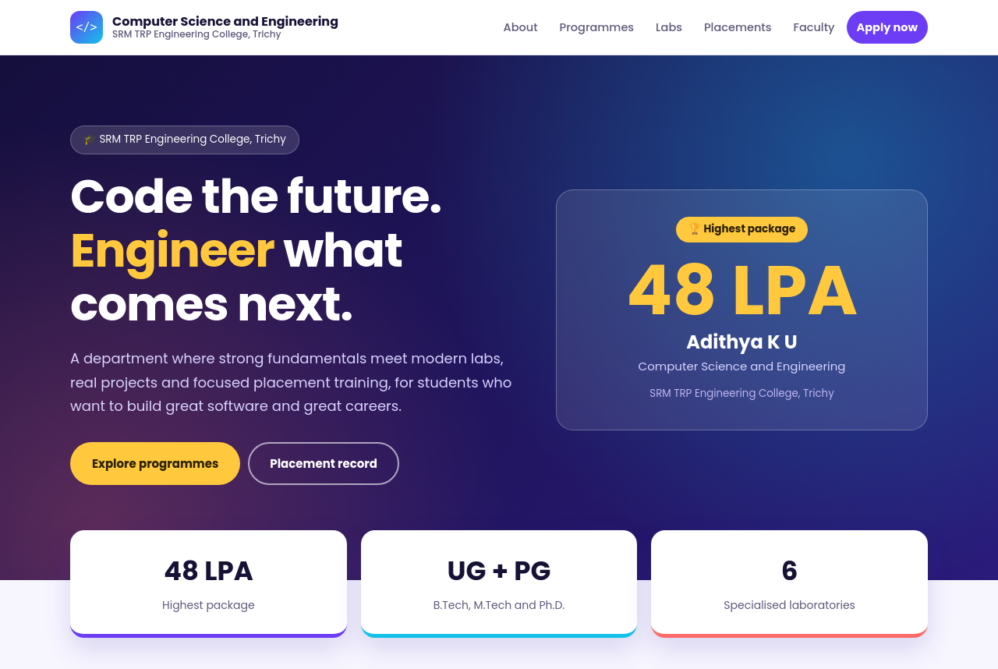
Figure 1: Home page – header, hero and highest placement (index.html)
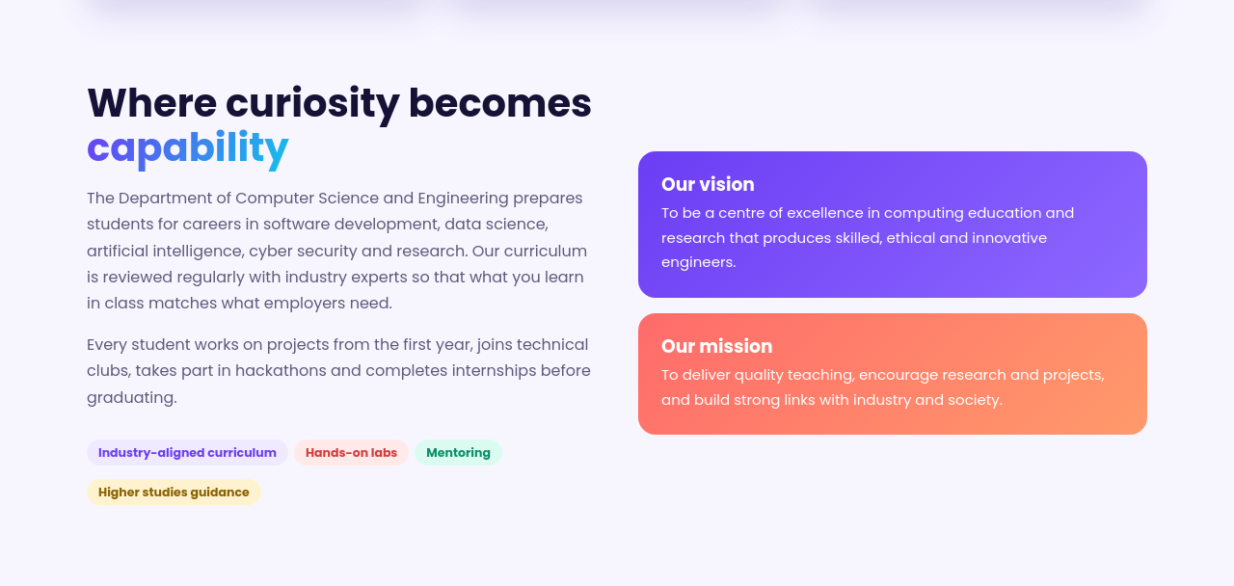
Figure 2: About section with vision and mission
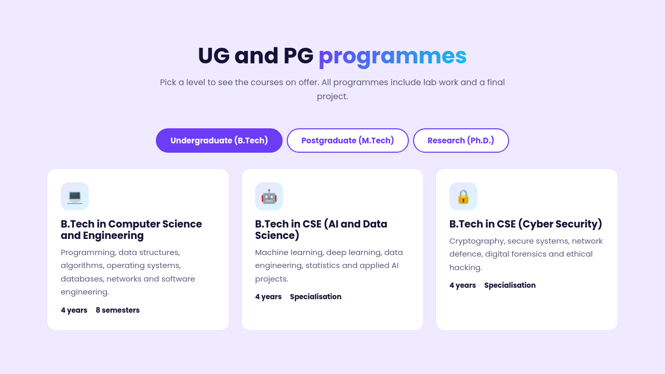
Figure 3: Programmes section – Undergraduate tab
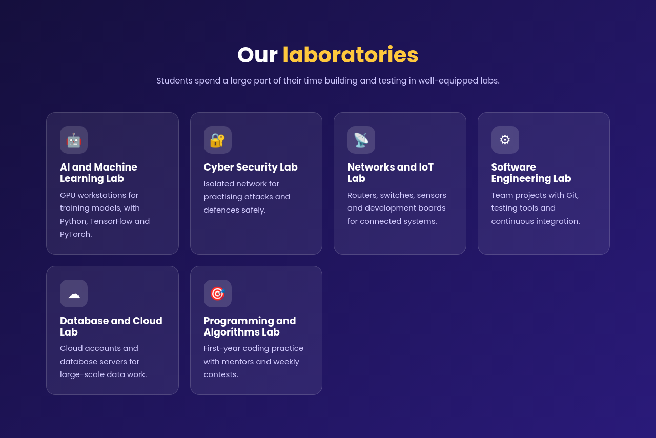
Figure 4: Laboratories section
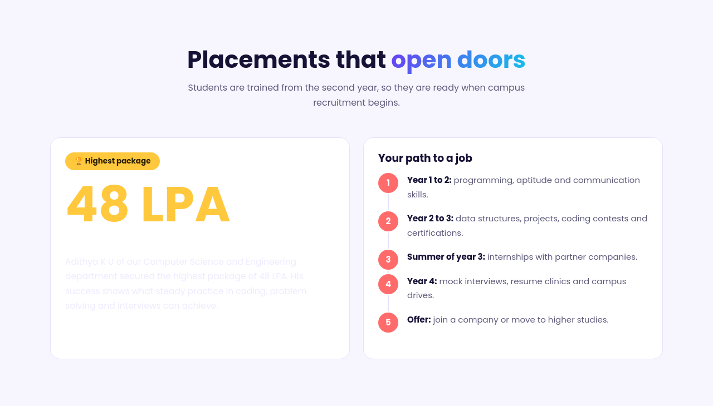
Figure 5: Placements section with the 48 LPA highest package
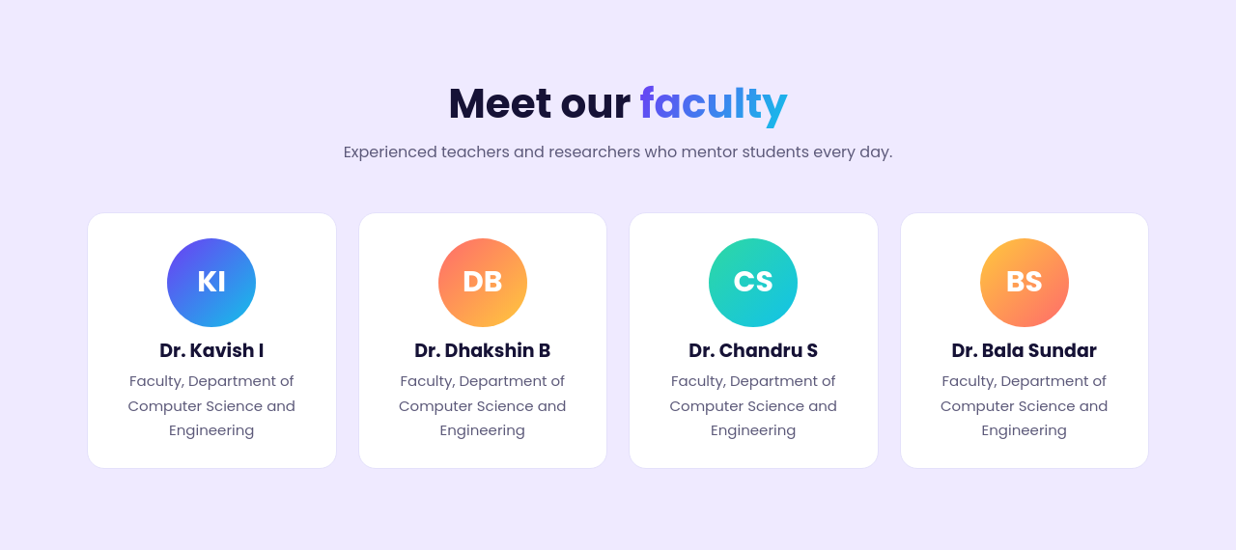
Figure 6: Faculty section
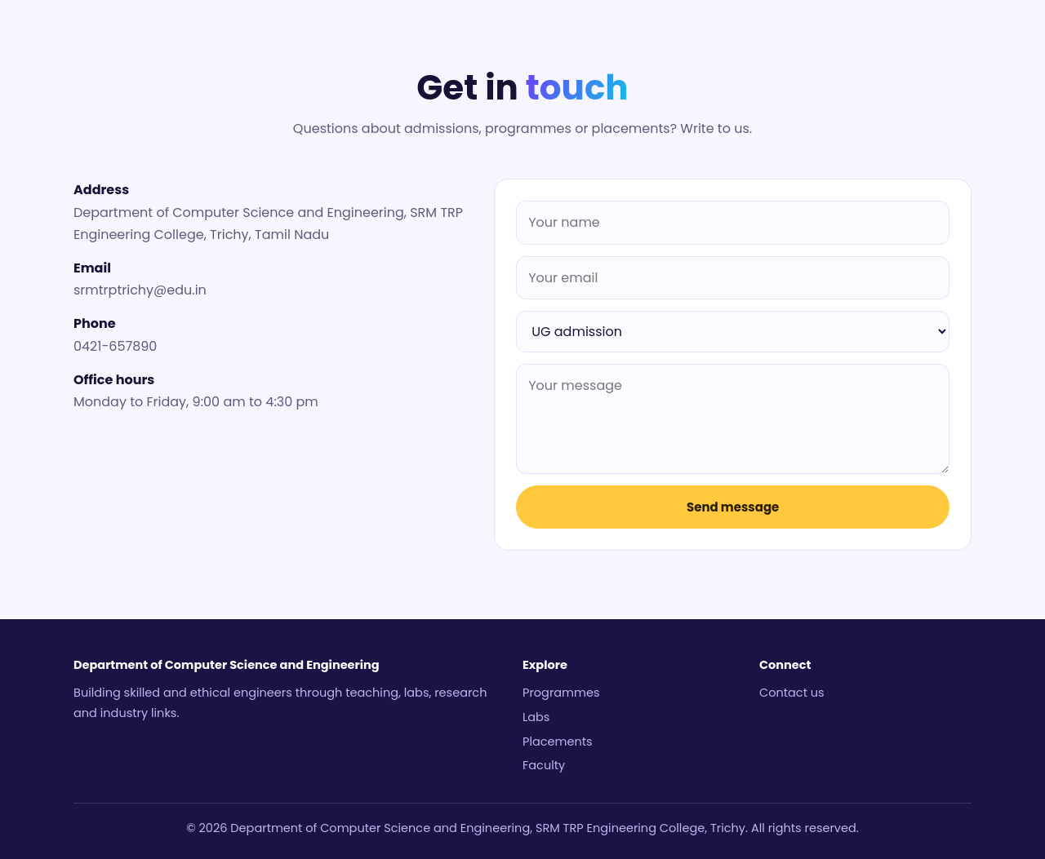
Figure 7: Contact section with the enquiry form and footer
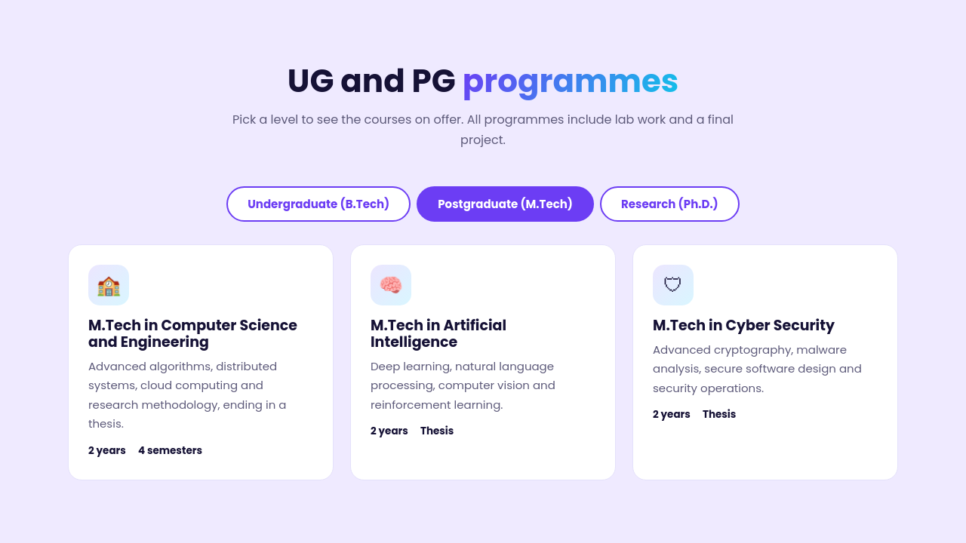
Figure 8: Programmes section – Postgraduate tab
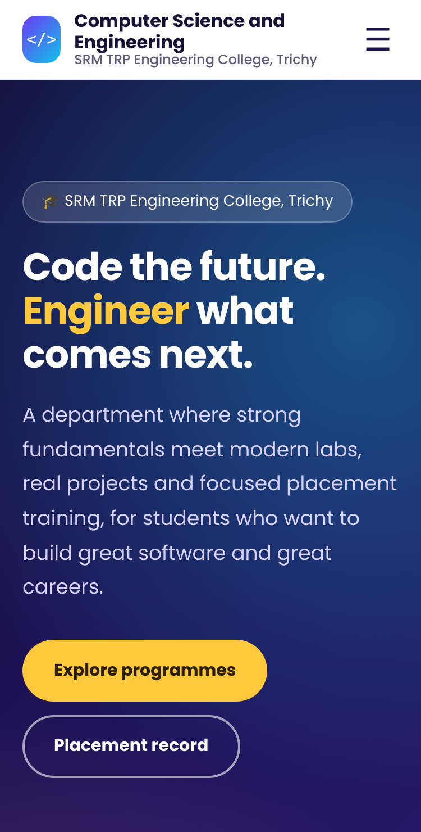  Figure 9: Home page at mobile width (375 px) | 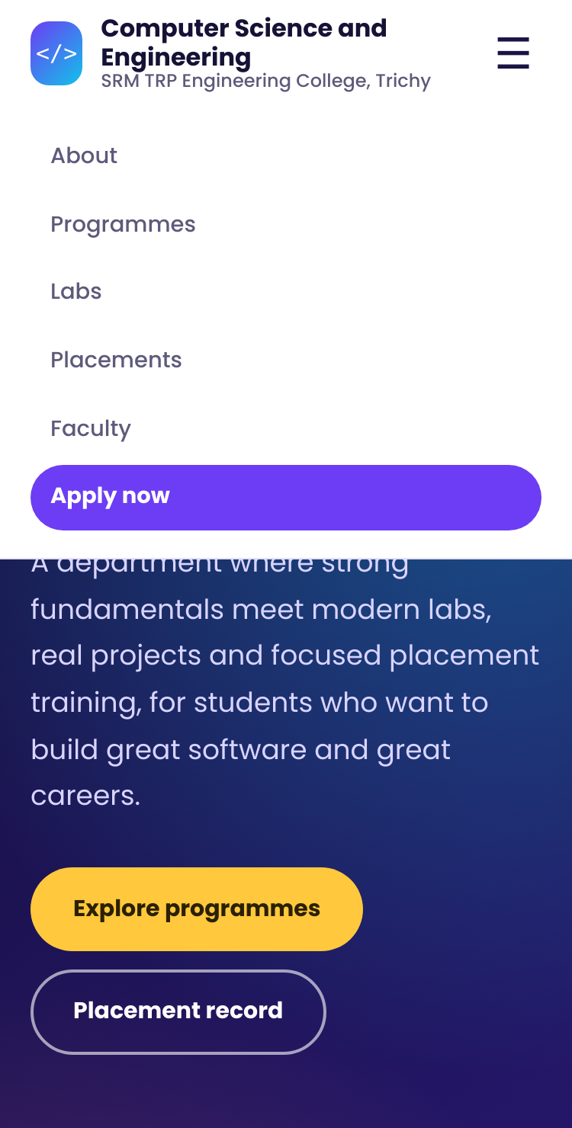  Figure 10: Mobile menu opened with the menu button

5. Testing Record
Test ID | Test | Expected result | Actual result | Status
T01 | Open index.html through localhost | Home page loads with status 200 | Returned 200; page title shown and lang="en" present | Pass
T02 | Check the Console for errors | No JavaScript errors | 0 JavaScript errors on load and during all tests | Pass
T03 | Check every fragment link | Every link points to an existing id | 14 fragment links checked, none broken | Pass
T04 | Use the menu links | Page scrolls to the chosen section | About, Programmes, Labs, Placements, Faculty and Apply now each moved to the matching section; URL hash updated | Pass
T05 | Switch programme tabs | Only the chosen level is shown | UG, PG and Ph.D. tabs each showed one panel and hid the other two | Pass
T06 | Check the statistics strip | Counter finishes with the correct value | Laboratories counter reached 6; 48 LPA and UG + PG shown | Pass
T07 | Submit empty form | Required-field feedback appears | Form blocked; 3 required fields flagged; "Please fill out this field." shown on Your name | Pass
T08 | Enter invalid email | Browser reports invalid value | "abc" rejected (missing @); form became valid with a@b.com | Pass
T09 | Inspect form controls | Every control has an accessible name | Controls had placeholders only. aria-label added to all 4 controls (name, email, enquiry type, message). | Fixed – Pass
T10 | Navigate by keyboard | Logical focus order | Logo → About → Programmes → Labs → Placements → Faculty → Apply now → hero buttons → programme tabs → name → email → enquiry type → message → Send message | Pass
T11 | Resize browser window to 375 px | Content remains readable with no sideways scroll | Page width stayed 375 px; menu button opened and closed the menu | Pass
T12 | Check page structure | Unique ids and one main heading | 17 ids with no duplicates, 1 h1 and 6 sections | Pass

6. Result
The single-page HTML5 website for the Department of Computer Science and Engineering was planned, created and tested successfully. The page, with its programmes, laboratories, placements, faculty and contact sections, was served through the local Web server at http://localhost:8000, and the navigation, programme tabs, contact form and mobile layout worked as expected. All twelve tests passed after the one defect found during testing was corrected. Hence the aim of the assignment was achieved, and the output was verified.

