Software Design Document
(SDD)

MoodMatch app for mood journal and AI powered recommendations

Prepared by Adithya Ranjit
IBIL Solutions
Date: 23 Apr. 26
TABLE OF CONTENTS

1. INTRODUCTION

1.1 Purpose
1.2 Scope
1.3 Overview
1.4 Definitions and Acronyms

2. SYSTEM OVERVIEW

3. SYSTEM ARCHITECTURE

3.1 Architectural Design
3.2 Decomposition Description
3.3 Design Rationale

4. DATA DESIGN

  - Data Description
4.2 Data Dictionary

5. HUMAN INTERFACE DESIGN

6. APPENDICES

1. INTRODUCTION

1.1 Purpose
MoodMatch is a mood journal coupled with AI mood detection and suggestions to improve the mood. This document explains the design of MoodMatch. This document is intended for the stakeholders reviewing the technical design.

1.2 Scope
MoodMatch allows users to log their current mood either through AI-powered facial detection via webcam or through manual selection. The app provides AI-generated suggestions — music, activities, and reflections — that grow more personalised over time as the system builds context from the user's mood history. Mood history is stored privately per user, powering both the 7-day mood timeline chart and the AI recommendation engine.
MoodMatch is designed to support general wellbeing and personal reflection. It is not intended to diagnose, treat, or cure any mental illness or mental health condition. Users experiencing serious emotional distress or crisis situations should seek support from a qualified mental health professional.

1.3 Overview
This document covers the system architecture, database design, and user interface design for MoodMatch.

1.4 Definitions and Acronyms

Term / Acronym | Definition
API | Application Programming Interface — allows different software components to communicate with each other
App Router | Next.js 14+ file-based routing system used to define pages and layouts
Auth.js | Open-source authentication library for Next.js handling login, sessions, and OAuth
Bcrypt | Password hashing algorithm used to securely store user passwords
Cascade Delete | Automatically deletes child records when a parent record is deleted
Client-Side | Code that runs on the user's browser rather than the server
Enum | A field restricted to a predefined set of values (e.g., mood: happy, sad, stressed, calm, energetic, tired)
face-api.js | Browser-based library for facial expression detection, runs entirely client-side
FK | Foreign Key — a column that links two database tables together
HTTPS | Secure protocol used for encrypted communication between browser and server
Index | A database structure that speeds up queries on frequently searched columns
LLM | Large Language Model — the AI model used to generate personalised recommendations
Middleware | Code that runs before a page loads, used to enforce authentication on protected routes
Next.js | Full-stack React framework supporting server-side rendering, API routes, and server actions
OAuth | Allows users to log in via a third-party provider like Google
ORM | Object Relational Mapper — lets developers interact with a database using code instead of raw SQL
PostgreSQL | Relational database used to store all MoodMatch application data
Prisma | The ORM used in MoodMatch to query PostgreSQL with type-safe generated code
Protected Route | A page or endpoint accessible only to authenticated users
SDD | Software Design Document — this document
Server Action | Next.js feature allowing server-side logic to be called directly from UI components
Session | Temporary authenticated state maintained after a successful login
SRS | Software Requirements Specification — defines the functional and non-functional requirements of MoodMatch
Streaming | Sending data progressively as it is generated — used to display AI recommendations token by token
Tailwind CSS | Utility-first CSS framework used to style the MoodMatch frontend
TypeScript | Strongly typed superset of JavaScript used throughout the codebase
UUID | Universally Unique Identifier — randomly generated string used as a database primary key
Vercel | Cloud platform used to deploy MoodMatch
Vercel AI SDK | Library that simplifies streaming AI responses from Anthropic into Next.js
Zod | Schema validation library used to validate all server-side inputs before hitting the database

2. SYSTEM OVERVIEW

MoodMatch is a full-stack mood journaling and AI recommendation web app built on Next.js 14+ (App Router) with TypeScript, organized into 3 main layers.
The frontend is built with of Next.js, Tailwind CSS, shadcn/ui. The mood capture UI supports two modes of user input- a webcam powered face emotion detection (entirely client side, no images ever sent to the server) powered by face-api.js or through a 6-button manual mood-picker. Recharts handle the 7-day mood timeline on the dashboard.

The backend is handled by the Next.js server actions and API routes. All inputs are validated with Zod. Auth.js manages sessions with email/password and optional Google OAuth. Protected routes gate all journal and dashboard access. The AI recommendation route pulls the user’s mood + last 3 journal entries, calls an LLM via the Vercel AI SDK (Anthropic), and streams the response back to the UI.
Database is PostgreSQL, accessed through Prisma ORM. The core schema has three tables: User (managed by Auth.js), JournalEntry (mood, source, confidence, note, timestamp), and Recommendation (category, content, liked flag) — linked by foreign keys with cascade deletes. Indexes on user_id and created_at cover the hot query paths.

3. SYSTEM ARCHITECTURE

3.1 Architectural Design

MoodMatch follows a 3-layered architecture deployed as a Next.js full-stack monolith on Vercel. The system is decomposed into subsystems based on responsibility boundaries — each subsystem owns a distinct concern and communicates only with adjacent layers.
High-Level Subsystems
- Presentation Subsystem: The entire user-facing layer built with Next.js App Router, React components, Tailwind, and shadcn/ui. Responsible for rendering pages, handling user input, and displaying streaming AI responses. Also hosts face-api.js which runs entirely within this layer — webcam frames never leave the browser. Communicates downward to the Application subsystem via server actions and API calls.
- Application Subsystem: The backend logic layer — Next.js Server Actions and API Routes. Responsible for all business rules: validating inputs with Zod, enforcing authentication via Auth.js, querying the database, building LLM prompts with context, and streaming responses back to the frontend. This is the central hub of the system — every other subsystem passes through here.
- Auth Subsystem: Auth.js (NextAuth v5) handles session management, email/password authentication, and optional Google OAuth. Sits within the Application layer but is treated as a distinct subsystem because it gates access to every other feature. Middleware enforces protected routes — no journal, dashboard, or scan is accessible without a valid session.
- Data Subsystem: PostgreSQL database accessed exclusively through Prisma ORM. Responsible for persisting Users, JournalEntries, and Recommendations. Prisma acts as the strict interface — no raw SQL, no direct DB access from the frontend. All queries filter by the logged-in user's ID enforced at this layer.
- AI Subsystem: The Anthropic API (external). Receives mood + last 3 journal entries as context from the Application subsystem, generates 3 recommendations (music, activity, reflection), and streams tokens back. Treated as a subsystem because it is stateless, external, and swappable — replacing Anthropic with OpenAI requires no architectural change.
- Browser ML Subsystem: Face-api.js running entirely client-side. Receives raw webcam frames, performs emotion detection in browser memory, and outputs only a mood label string to the Presentation subsystem. Completely isolated — no images, no biometric data ever leave this subsystem.

How Subsystems Collaborate
The collaboration follows a strict top-down flow:
- User opens the app → Auth Subsystem validates session via middleware before any page loads
- User triggers mood capture → Browser ML Subsystem processes webcam feed and returns a mood label to the Presentation Subsystem (or user picks manually)
- User confirms mood → Presentation Subsystem calls the Application Subsystem via server action
- Application Subsystem writes a JournalEntry to the Data Subsystem via Prisma
- Application Subsystem fetches the last 3 entries from Data Subsystem as context
- Application Subsystem sends mood + context to the AI Subsystem
- AI Subsystem streams tokens back → Application Subsystem pipes them to the Presentation Subsystem
- Once streaming completes, Application Subsystem writes 3 Recommendation records to the Data Subsystem

3.2 Decomposition Description
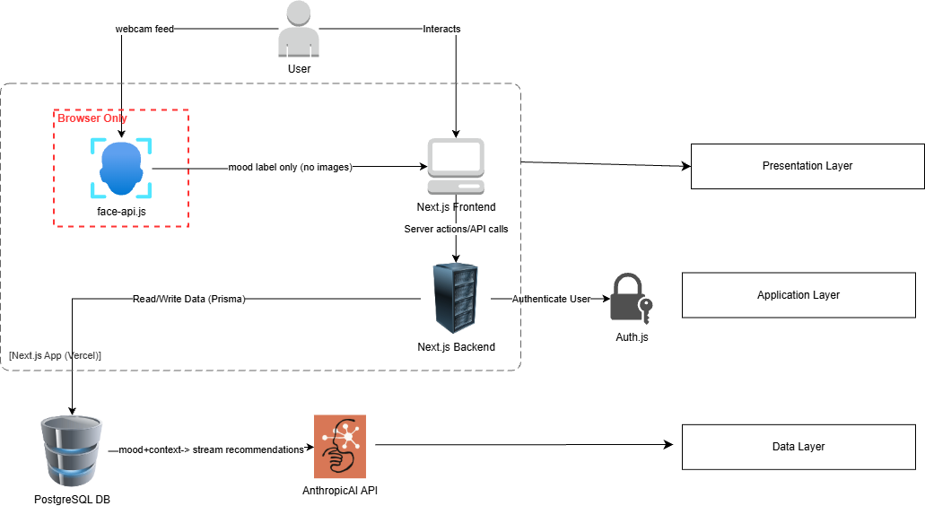

Presentation Subsystem
- Auth pages — /login, /signup
- Mood Capture UI — webcam trigger, face-api.js integration, manual 6-button picker, confirmation screen
- Recommendation View — streaming token renderer, liked toggle per recommendation
- Journal pages — /journal (paginated list, mood filter), /journal/[id] (detail, edit note, delete)
- Dashboard — 7-day mood chart (Recharts), most common mood, total entry count
- Account page — password change, JSON export, account deletion with confirmation modal
Application Subsystem
- Auth routes — signup, signin, signout (configured via Auth.js)
- Journal API — POST /api/journal, GET /api/journal, GET /api/journal/[id], PATCH /api/journal/[id], DELETE /api/journal/[id]
- Recommendation API — POST /api/recommendations (the most complex route — fetches context, calls LLM, streams, saves), PATCH /api/recommendations/[id] (liked toggle)
- Dashboard API — GET /api/dashboard (aggregates mood stats for the week)
- Account API — PATCH /api/account/password, GET /api/account/export, DELETE /api/account
- Zod validation — applied on every incoming request before any DB or LLM call.
Data Subsystem
- User table — id, email, name, hashed password, created_at (managed by Auth.js)
- JournalEntry table — id, user_id (FK), mood (enum), source (enum), confidence (nullable), user_note (nullable), created_at, updatedAt. Indexed on user_id and created_at
- Recommendation table — id, journal_entry_id (FK), category (enum), content, createdAt, liked (nullable). Cascade deletes when parent JournalEntry is deleted

3.3 Design Rationale

The technology stack and architecture for MoodMatch were defined as part of the project requirements. The following explains why each technology is well suited for the system.
- Next.js was specified as the full-stack framework because it allows the frontend and backend to live in a single codebase. Server Actions handle server-side logic without needing a separate backend, keeping the project simple and manageable for a 4-week timeline. Deployment to Vercel as a single unit means there is only one pipeline to manage.
- Layered Architecture naturally emerges from how Next.js is structured — the App Router is the Presentation layer, Server Actions and API Routes are the Application layer, and Prisma is the Data layer. This keeps responsibilities clean and ensures the UI never touches the database directly.
- Auth.js was specified because building authentication from scratch is risky. It handles password hashing, session management, and OAuth out of the box and integrates directly into Next.js middleware, so protected routes are enforced at the framework level.
- Prisma was specified as the ORM because it generates TypeScript types directly from the database schema, catching any schema changes as compile-time errors throughout the codebase rather than silent runtime bugs.
- PostgreSQL was specified because the data model is relational by nature — Users own JournalEntries, JournalEntries own Recommendations. Foreign key constraints and cascade deletes enforce data integrity at the database level. Indexes on user_id and created_at keep the most frequent queries fast.
- face-api.js was specified to run entirely in the browser as a privacy requirement. Only the mood label is sent to the server — no images or biometric data ever leave the device.
- Vercel AI SDK was specified to handle streaming responses from the Anthropic API, abstracting the complexity of progressively rendering tokens in the UI.
- Zod was specified to validate all incoming server-side input before it reaches the database, ensuring malformed or malicious data is rejected early.

4. DATA DESIGN

4.1 Data Description
MoodMatch organizes its information domain into three core entities — User, JournalEntry, and Recommendation — stored in a PostgreSQL relational database and accessed through Prisma ORM.
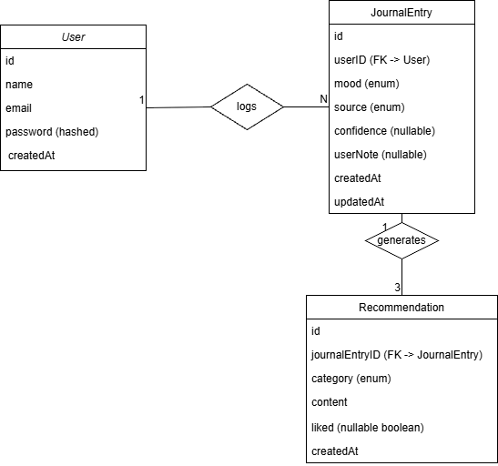
- User is the root entity. Every other piece of data in the system belongs to a user. Auth.js manages user creation and credential storage. All journal and recommendation data is tied to a user via foreign keys, ensuring complete data isolation between users.
- JournalEntry is created every time a user logs a mood. It stores the mood label, how it was captured (webcam or manual), an optional confidence score from face-api.js, an optional user note, and a timestamp. This is the central entity that links the user to their recommendations.
- Recommendation is created after the AI generates suggestions. Exactly three recommendation records are created per journal entry — one each for music, activity, and reflection. Each record stores the generated content and a three-state rating — liked, disliked, or unrated.
  - The relationships are one-to-many:
  - One User → many JournalEntries
  - One JournalEntry → exactly 3 Recommendations
  - Cascade deletes are configured at the database level. Deleting a User deletes all their JournalEntries, and deleting a JournalEntry deletes its Recommendations. This satisfies the account deletion requirement without relying on application code to clean up data.
  - Indexes are placed on user_id and created_at in the JournalEntry table because every query in the app filters by user and sorts by date. These are the hot query paths.

4.2 Data Dictionary

JournalEntry
Field | Type | Description
id | String (UUID) | Primary key, auto-generated
userId | String (FK) | References User.id
mood | Enum | One of: happy, sad, stressed, calm, energetic, tired
source | Enum | One of: webcam, manual
confidence | Float (nullable) | Confidence score from face-api.js, null if manual input
userNote | String (nullable) | Optional note added by the user
createdAt | DateTime | Timestamp of mood capture

Recommendation
Field | Type | Description
id | String (UUID) | Primary key, auto-generated
journalEntryId | String (FK) | References JournalEntry.id
category | Enum | One of: music, activity, reflection
content | String | AI-generated recommendation text
liked | Boolean (nullable) | null = unrated, true = liked, false = disliked

User
Field | Type | Description
Id | String (UUID) | Primary key, auto-generated
name | String | Stores name of the user
email | String | Unique user email address
hashedPassword | String | bcrypt hashed password managed by Auth.js
createdAt | DateTime | Account creation timestamp

5. HUMAN INTERFACE DESIGN

Overview of User Interface

MoodMatch provides a clean, minimal web interface accessible on both desktop and mobile browsers. The application guides the user through a simple flow — log in, capture mood, get recommendations, and review journal history.

- Login / Signup: The first screen a user sees is the login page. New users can switch to the signup form and register with an email and password. If any field is invalid — such as a missing email or a weak password — an error message is shown inline below the field. On successful login or signup, the user is redirected to the dashboard.

- Dashboard: After logging in the user lands on the dashboard. It shows a 7-day mood timeline chart, the most common mood of the current week, and the total number of journal entries. If the user is new and has no entries yet, a friendly empty state message is displayed encouraging them to log their first mood.

- Mood Capture: The user can log a mood in two ways. The first is manual selection — six mood buttons are displayed (happy, sad, stressed, calm, energetic, tired) and the user simply clicks one. The second is webcam detection — the user clicks an enable webcam button, grants camera permission, and face-api.js detects their emotion directly in the browser. The detected mood is displayed on screen and the user must confirm it before anything is saved. If the camera permission is denied or no face is detected, a clear error message is shown and the app automatically falls back to the manual picker.

- Recommendation Screen: Once the mood is confirmed, three AI-generated recommendations stream onto the screen in real time — a music suggestion, an activity, and a reflection. The user sees the text appear progressively as the AI generates it. Each recommendation has a like and dislike button. The user can also type an optional personal note in a text field and save it. If the AI call fails, an error message is shown and the user is informed that their mood entry has still been saved.

- Journal List: The journal page shows all past mood entries in reverse chronological order. Each entry card displays the mood, date, and a short preview. The user can filter entries by mood using a dropdown. Older entries are loaded through pagination controls at the bottom of the page.

- Journal Detail: Clicking any entry opens the detail view. It shows the full entry — mood, timestamp, capture source (webcam or manual), the three AI recommendations, and the user's note. The user can edit their note directly on this page and save it. A delete button is also available. Clicking delete opens a confirmation modal asking the user to confirm before the entry is permanently removed.

- Account Page: The account page lets the user manage their profile. They can change their password by entering their current password and a new one. They can export all their journal data as a downloadable JSON file. They can also delete their account — clicking the delete button opens a confirmation modal that warns the user all their data will be permanently removed. Once confirmed, the account and all associated data are deleted and the user is redirected to the signup page.

6. APPENDICES
Appendix A — Glossary
(Refer to Section 1.4 Definitions and Acronyms)

Appendix B — References
- Next.js Documentation — https://nextjs.org/docs
- Prisma Documentation — https://www.prisma.io/docs
- face-api.js Documentation — https://justadudewhohacks.github.io/face-api.js/docs
- Auth.js Documentation — https://authjs.dev
- Vercel AI SDK Documentation — https://sdk.vercel.ai/docs
- Anthropic API Documentation — https://docs.anthropic.com
- Tailwind CSS Documentation — https://tailwindcss.com/docs
- shadcn/ui Documentation — https://ui.shadcn.com
- Recharts Documentation — https://recharts.org
- Zod Documentation — https://zod.dev

