# B.TECH. (CSE) IV, VIII SEMESTER

**UE20CS301 – Database Management Systems (Minors)**

**Mini-Project Report**

**on**

**Title-Police Management System**

## SUBMITTED BY

| **Name** | **SRN** |
| --- | --- |
| Sanraj Lachhiramka | PES1UG21EC252 |
| S.Vighnesh | PES1UG21EC233 |
| Adithya B Shetty | PES1UG19EC009 |
| Krishna V Prabhu | PES1UG21EC913 |

**January – May 2023**

**DEPARTMENT OF COMPUTER SCIENCE & ENGINEERING BENGALURU – 560100, KARNATAKA, INDIA**

**CONTENTS**

| **Slno** | **Topic** | **Pgno** |
| --- | --- | --- |
| 1 | Problem Statement(Synopsis) | 3 |
| 2 | Entity Relationship(ER) diagram | 4 |
| 3 | Relational Schema | 5 |
| 4 | Individual contribution of each team  member | 6 |
| 5 | Operations on the database with screenshots | 7-21 |
| 6 | Conclusion | 22 |

**PROBLEM STATEMENT(SYNOPSIS)**

This project deals with creation of a database of the police management system.It has information about-Officers,cases,complaints,complainants,arrests and criminals.Tables have been formed on each and the ER diagram establishes the relationship between the entities and attributes.The project also demonstrates the performance of certain operations like create, select, delete, update, read, trigger, functions and many more.We have used github, streamlit, python and xampp to execute the same.There are screenshots of the table after performing each operation along with the sql query command for the same.

**ER DIAGRAM**

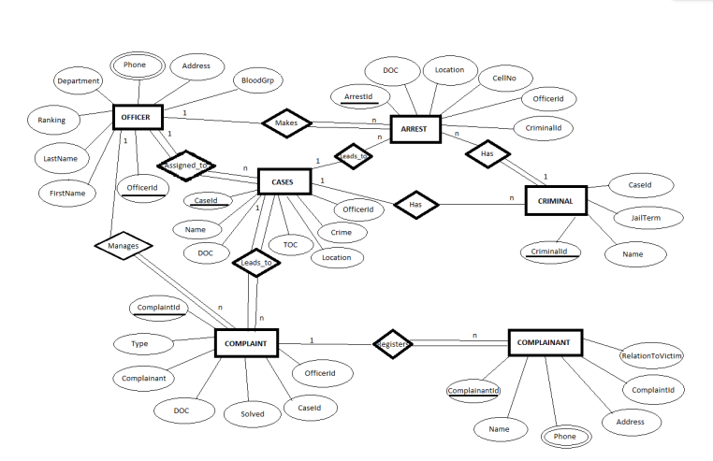

**RELATIONAL SCHEMA**

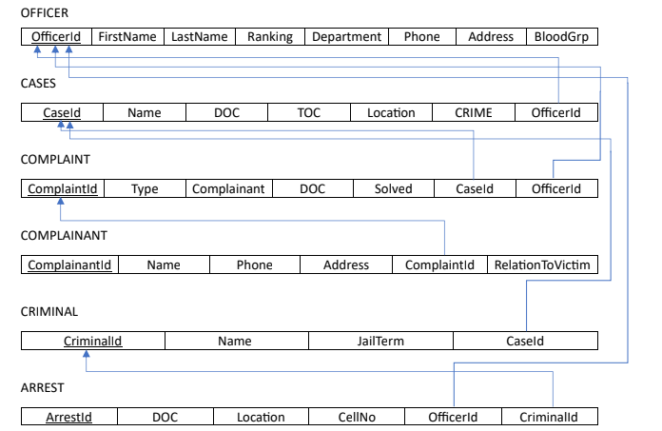

**INDIVIDUAL CONTRIBUTION OF EACH TEAM MEMBER**

1. **Vighnesh**- ER diagram and Relational Schema along with join operation

2. **Krishna**- Create,Insert,Select, Making of report.

3. **Sanraj**- Update, delete operations in CRUD. Creating trigger and function.

4. **Adithya**- Setting up streamlit. Create and Read operations in CRUD. Debugging Update function. Creating triggers and function and using union and aggregate.

**OPERATIONS ON THE DATABASE WITH SCREENSHOTS**

**CREATE**

Create the tables titled officer,cases,complainant,complaint,arrest and criminal

Add suitable datatypes

1.officer-Add the fields-Officer Id(Primary Key),First name, Last name, Ranking,Department,phone ,Address and Blood group

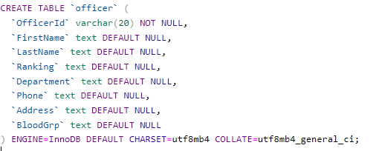

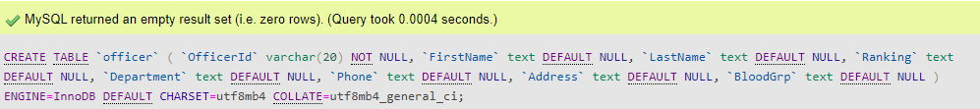

Output



2.Cases-Add the fields;Case Id(primary key), Name, Date, Location, crime, Officer Id.

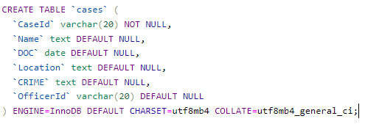

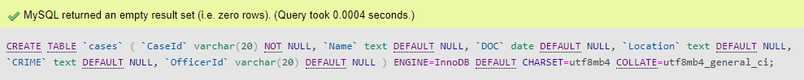

Output



3.complaint-Add the fields;Complaint id(primary key), Type, Complainant,Date,Solved(Yes/no),Case Id, Officer Id

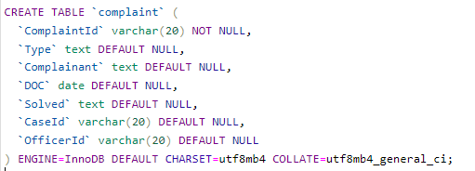

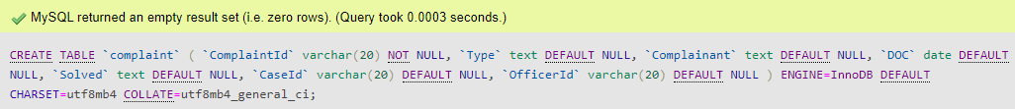

output



4.Complainant-Add the fields- Complainant Id(primary key),Name,Phone,Address,Complaint Id and relation to victim.

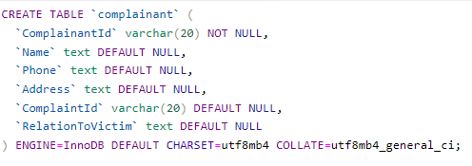

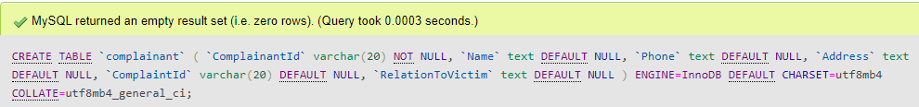

Output



5.Arrest- Add the fields; Arrest Id(primary key), Date,Location,Cell number, Officer Id, Criminal Id.

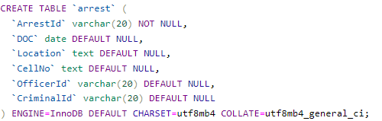

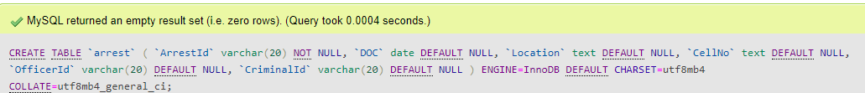

Output



6.Criminal-Add the fields-Criminal Id(primary key),Name,Jail term and Case Id

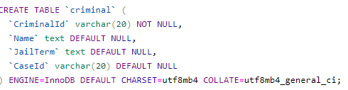



Output



**Insert**

Q.Insert tuples for each field in the above created tables

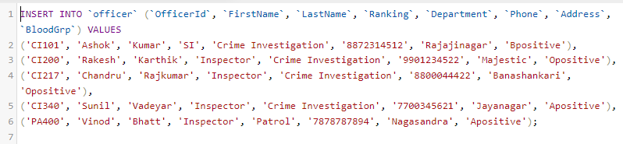

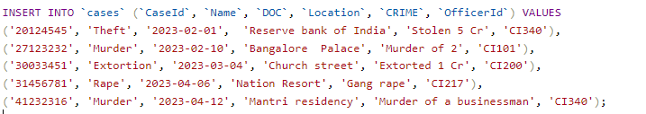

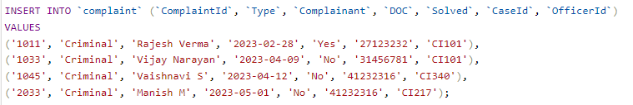

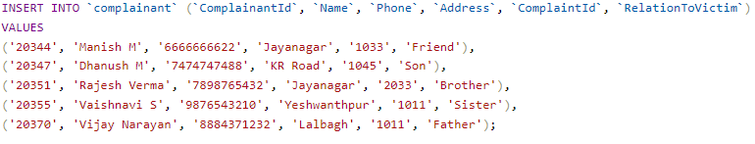

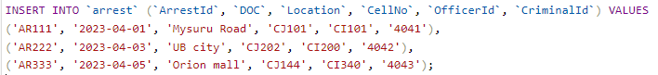

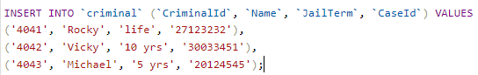

**Outputs-**

1.officer

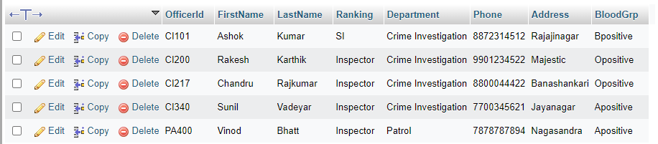

2.cases

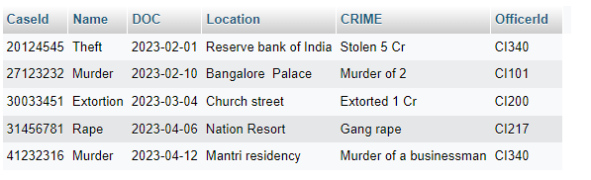

3.complaint

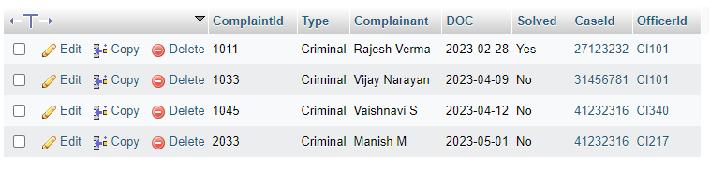

4.complainant

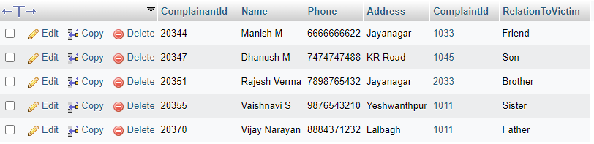

5.arrest

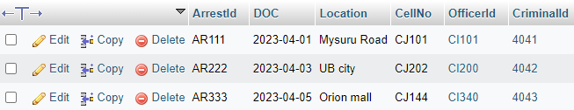

6.criminal

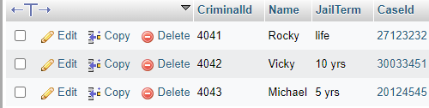

**Select**

1.Display the contents of the table officer



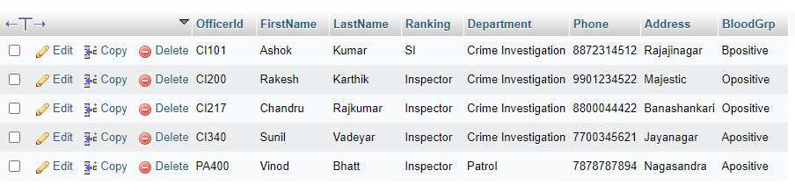

2.Display all the entries from the table cases if the case is not solved



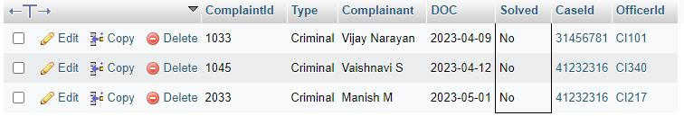

3.Select an entry which does not exist





**The below CRUD operations was performed using streamlit as frontend and MySQL as backend**

**Create**

Add to Officer table

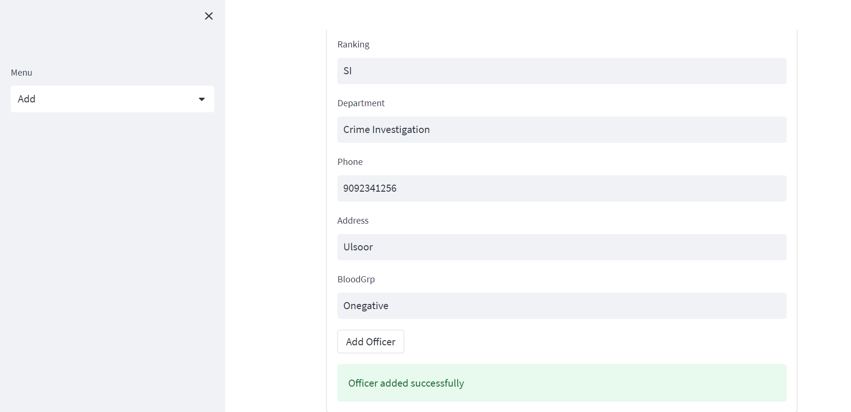

Add to Cases table

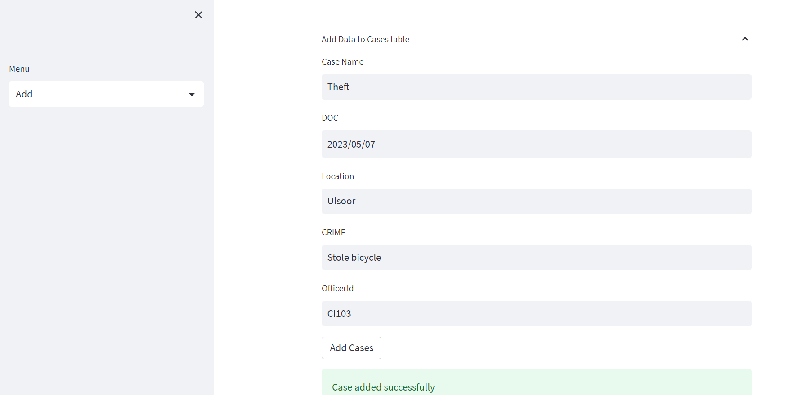

Add to complaint table

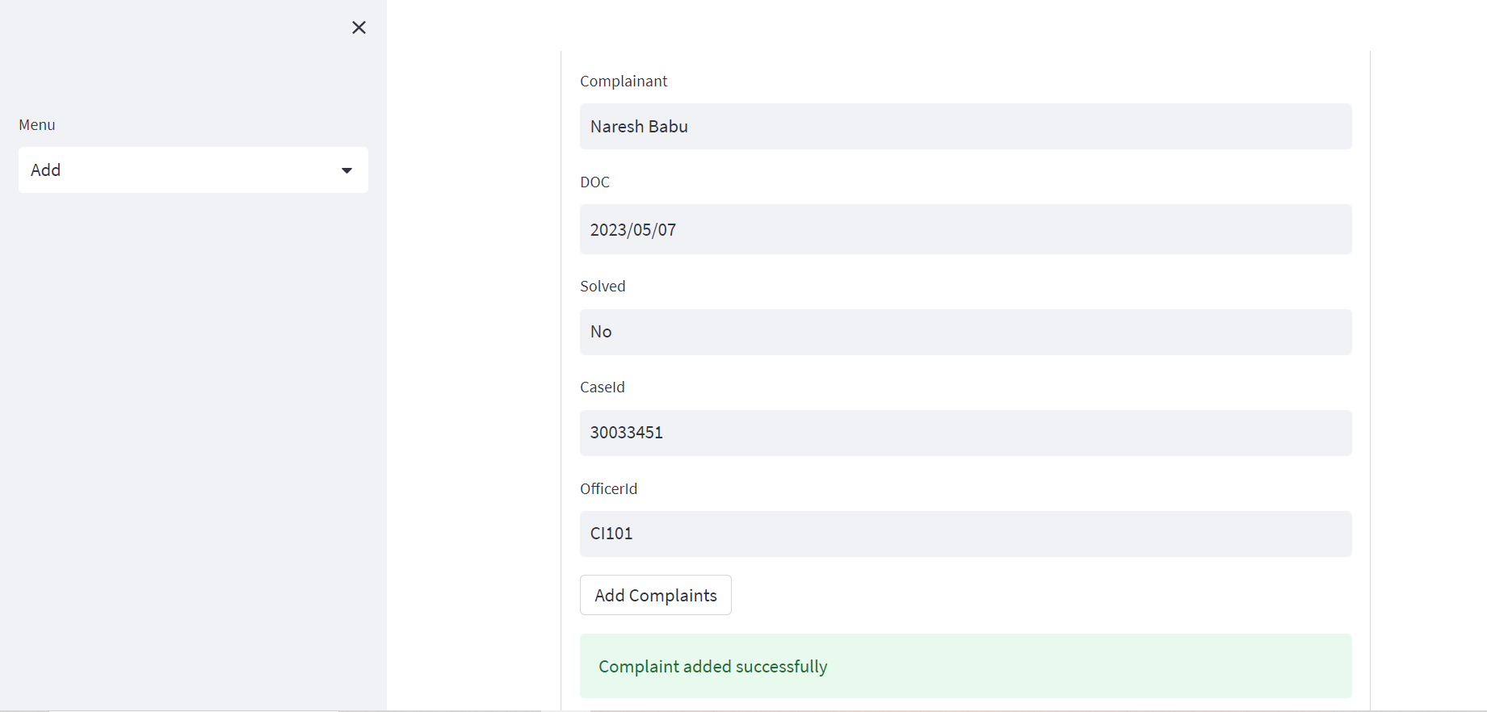

Add to complainant table

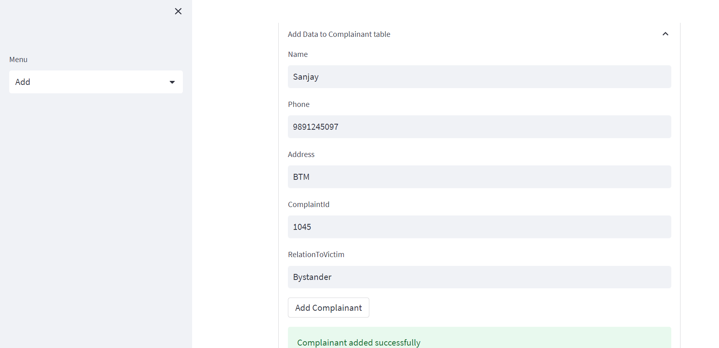

Add to criminal table

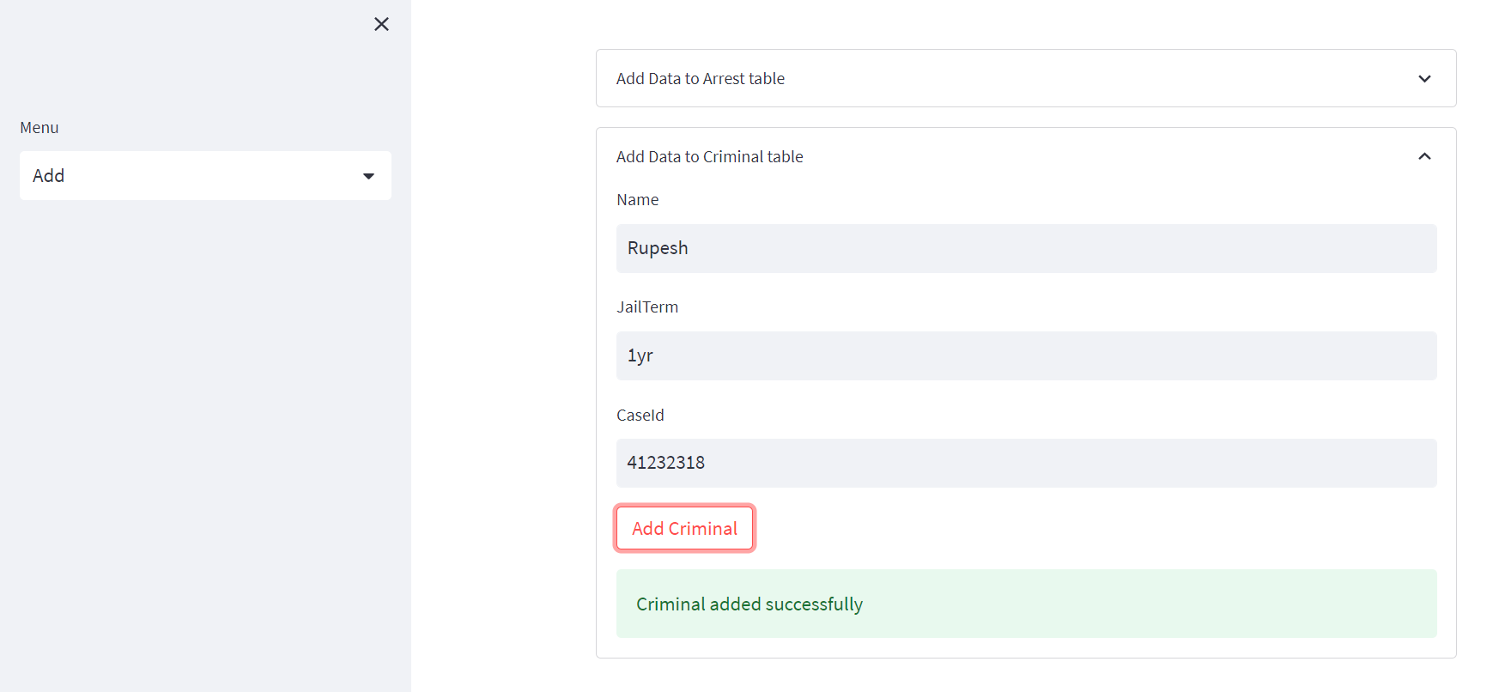

Add to arrest table

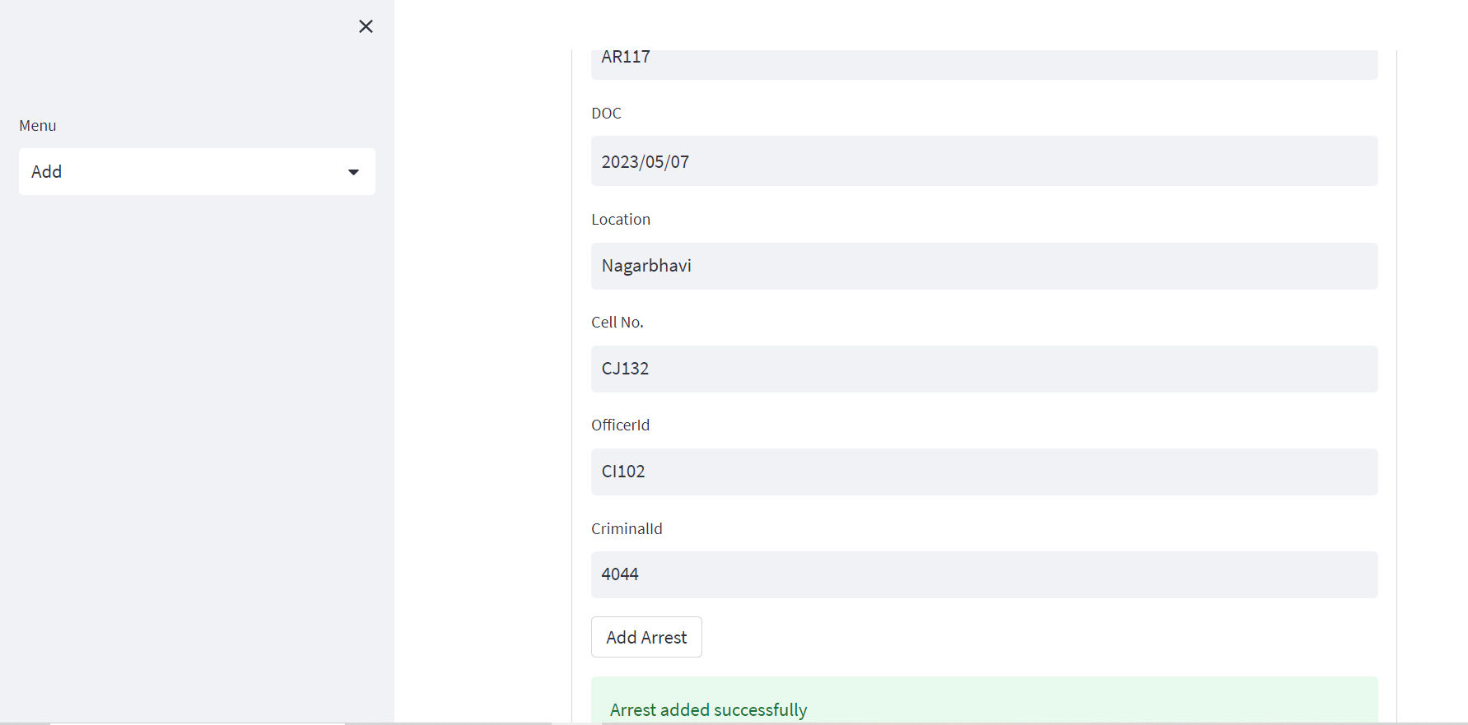

**Read**

View Officer table

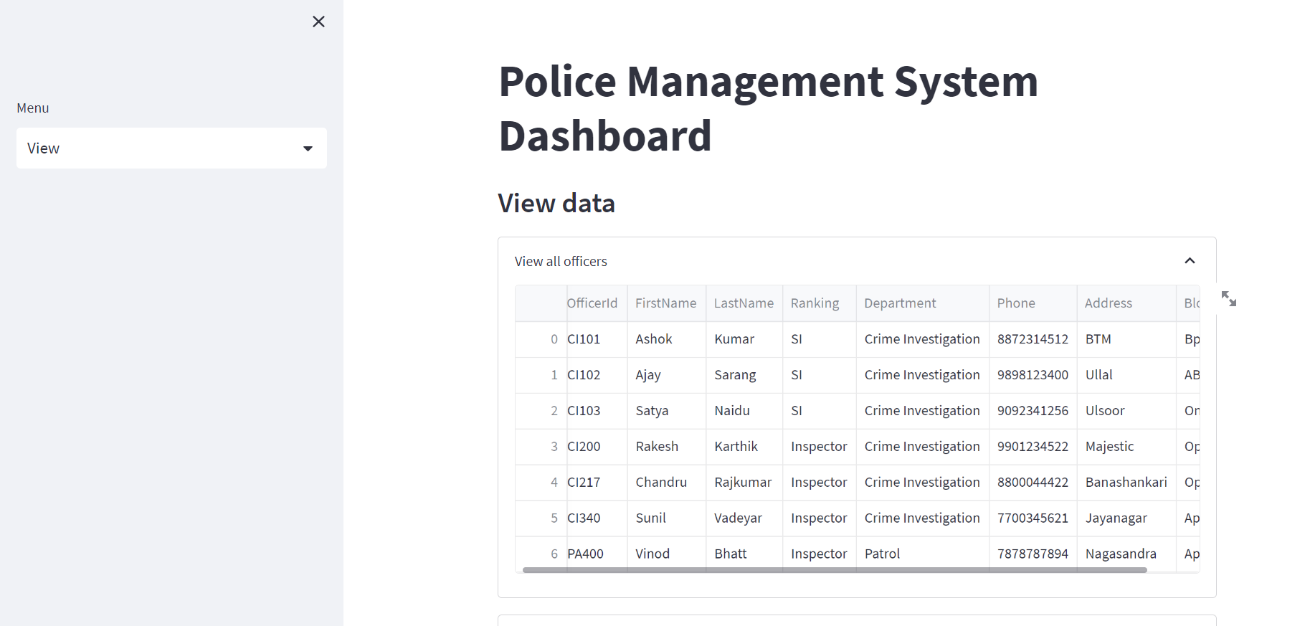

View Cases table

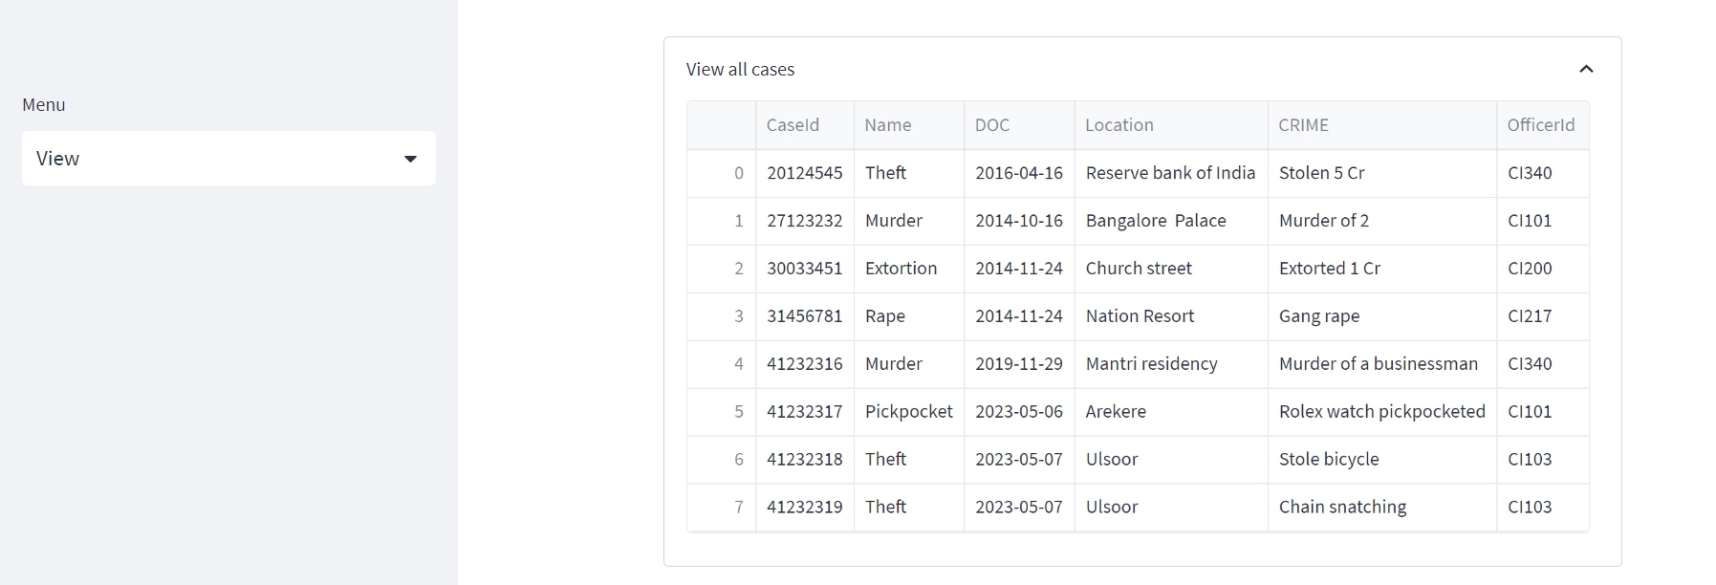

View complaints and complainant table

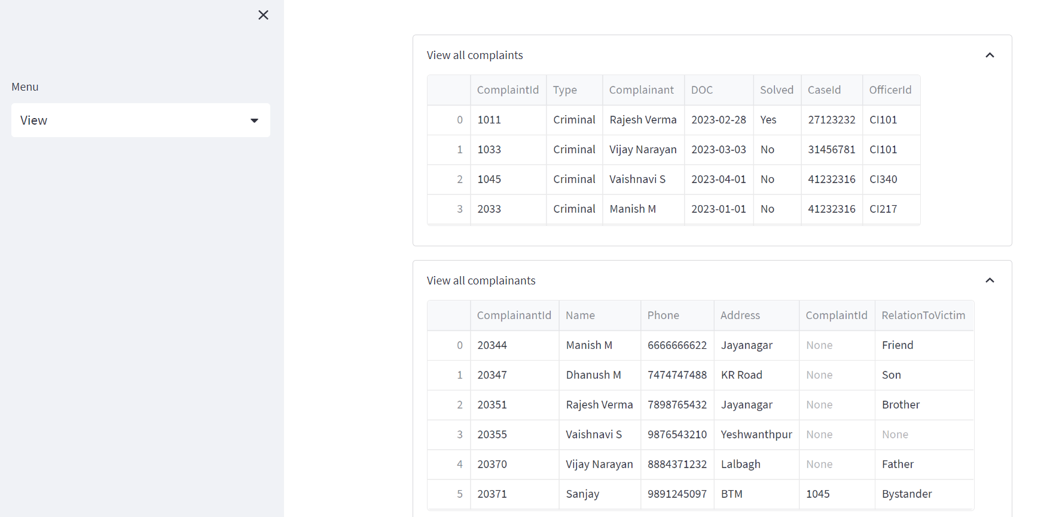

View arrests and criminals table

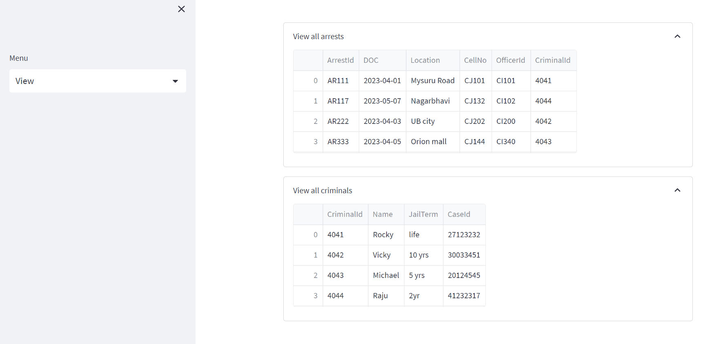

**Update**

Q.Add a row with the following details in Officer table

**Id=CI101, Ranking=SI,Department=Crime Investigation, Ph=8872314512, Address=HSR, for the officer Ashok Kumar.**

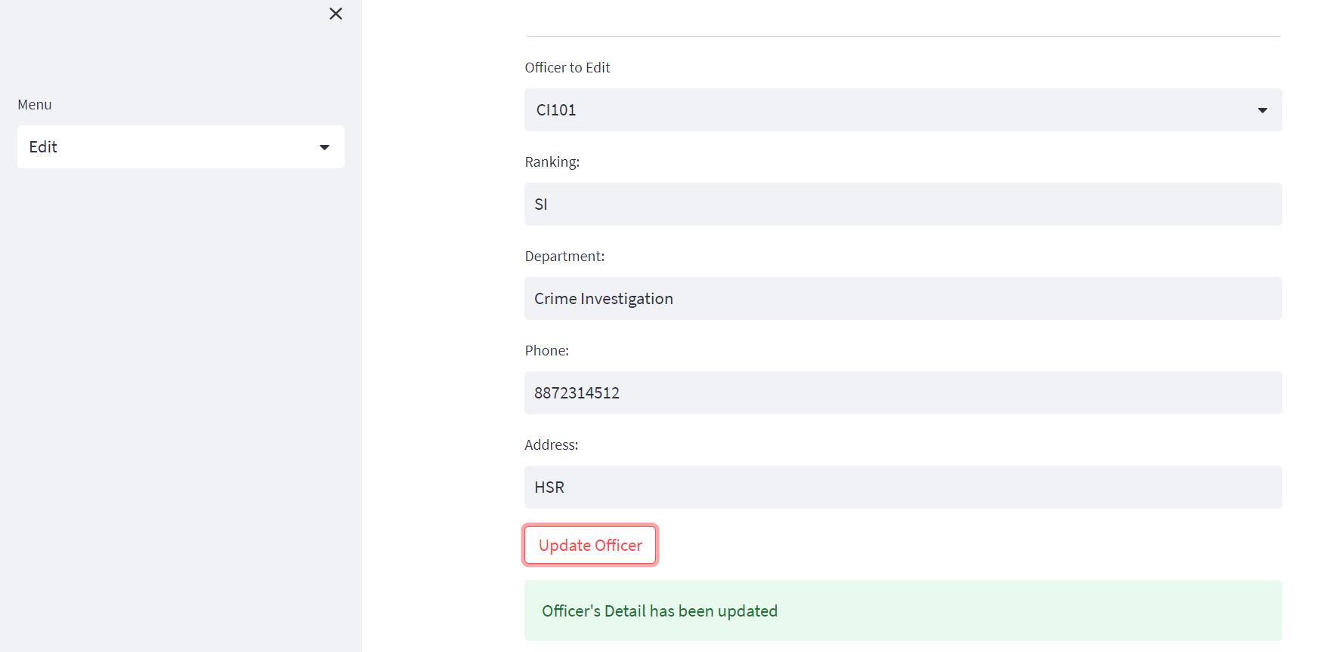

Updated row value



**Delete**

**Delete the entry of the case that has already been solved.**

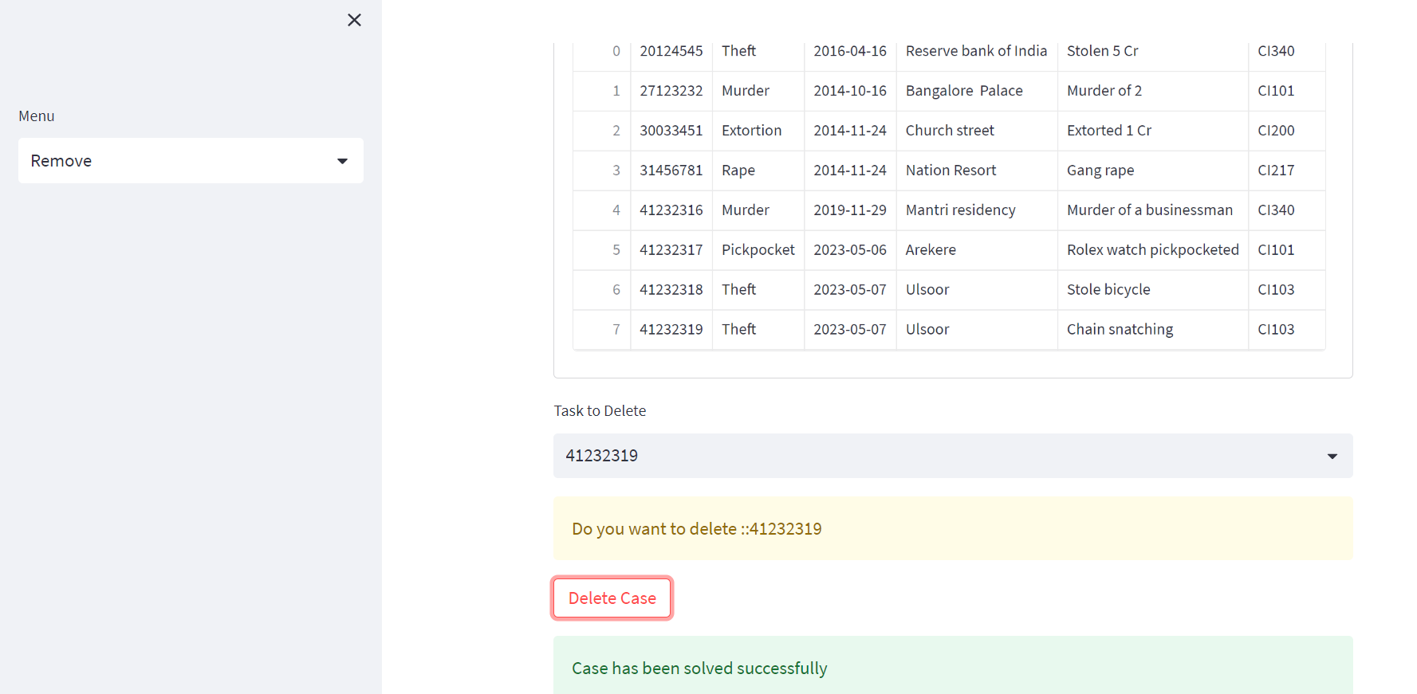

**Stored function**

Q.Create a stored function to count the number of days between current date and date the criminal was arrested.

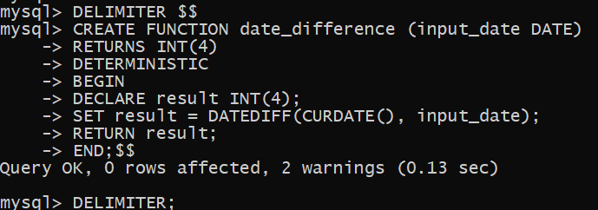

OUTPUT

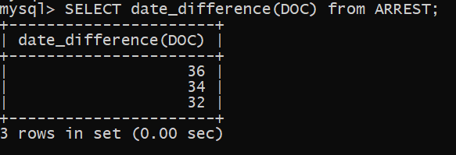

**Trigger**

Q.Using Trigger, set the id of Cases, Criminal, Complaint and Complainant tables, and increment the max id value by one for each new row added.

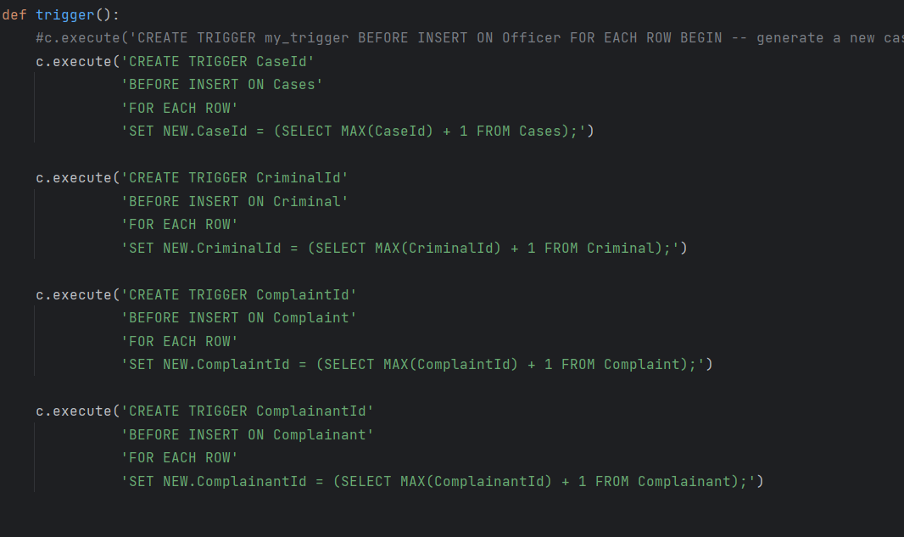

You can see here that as soon as trigger was created, after **41232316** all the case ids are automatically incremented by one.

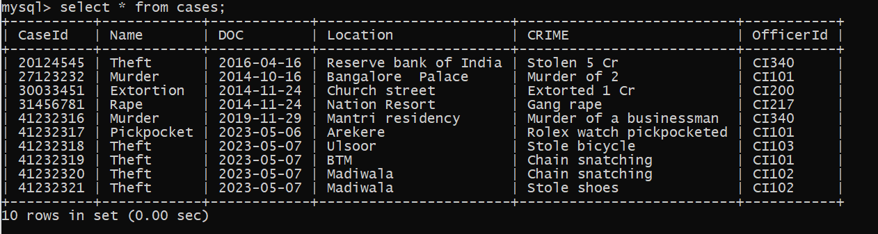

**Aggregate**

1.count of number of cases which occurred in each area?

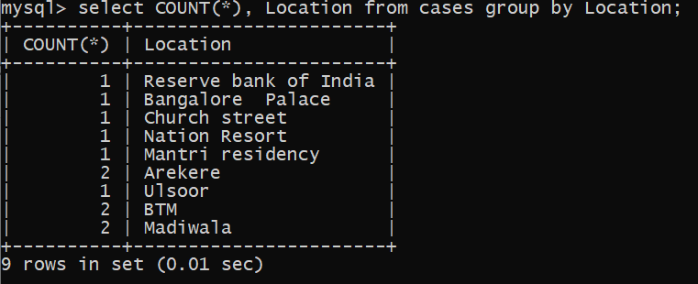

1. Count of number of cases solved by each officer?

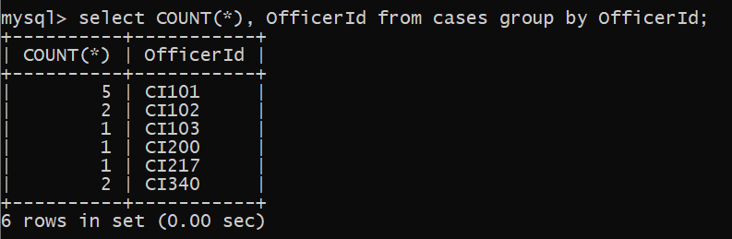

**Unions**

1. Give the list of cases which occurred before 2015 and after 2022.

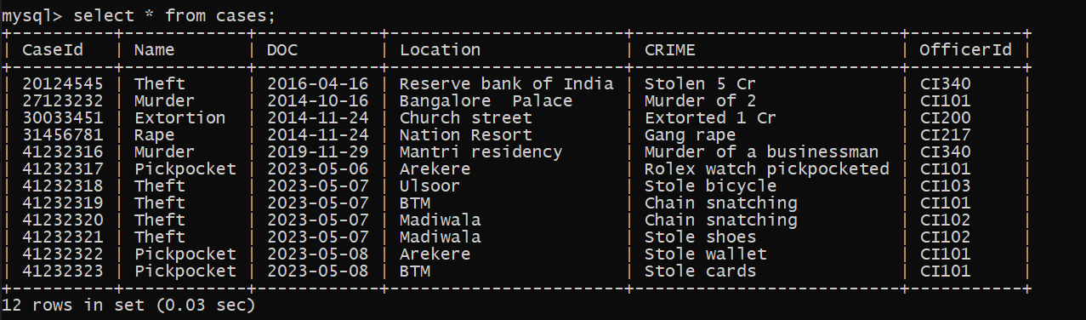

With union:

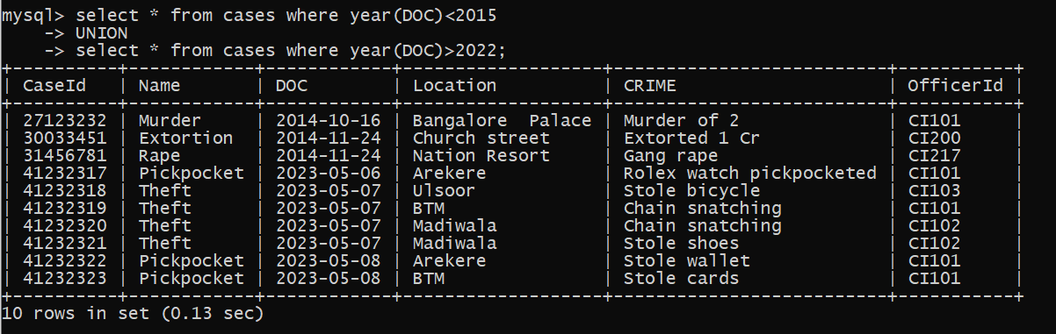

**Join**

**Q1.Retrieve the details of all arrests made, including the arrest date and location, the officer's full name, and the associated criminal's name.**



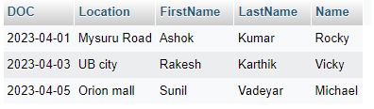

**Q2.Retrieve the details of all officers along with the number of cases they are assigned to. Using left join**



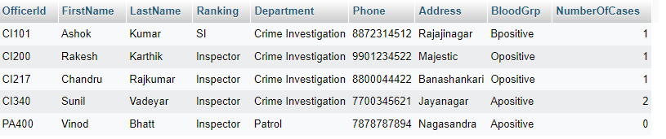

**CONCLUSION**

**(i)Successfully created a database on the police management system with various tables and its ER diagram and Relational schema**

**(ii)Successfully performed several operations on the database.**

**THE END!!!!**