VISVESVARAYA TECHNOLOGICAL UNIVERSITY, BELAGAVI

REPORT ON
“Intelligent Breast Cancer Classification System
using Dimensionality Reduction”

Submitted by:
Sl. No | Student name | USN | Student signature | Marks Awarded | Signature of faculty
1 | ABHISHEK R | 1JS23CS004

Guided by
Dr. Mallikarjuna P B
Associate Professor
Department of Computer Science and Engineering


JSS Academy of Technical Education, Bengaluru – 560060 Department of Computer Science Engineering
Abstract
Breast cancer is one of the leading causes of mortality among women worldwide, making early and accurate diagnosis critical for improving survival rates. This project presents an intelligent breast cancer classification system that integrates dimensionality reduction techniques, wrapper-based feature selection methods, and machine learning models to achieve high predictive accuracy. The system leverages Principal Component Analysis (PCA), Linear Discriminant Analysis (LDA), Singular Value Decomposition (SVD), and Correlation-based filtering to reduce feature space complexity. Additionally, advanced wrapper methods such as Sequential Forward Selection (SFS), Sequential Backward Selection (SBS), Sequential Floating Forward Selection (SFFS), and Sequential Floating Backward Selection (SFBS) are used for optimal feature selection.
Multiple classification models were evaluated, with Support Vector Machine (SVM) demonstrating superior performance. The system is implemented as a full-stack application with a Flask-based backend providing REST APIs and a Streamlit frontend offering interactive dashboards. Explainable AI is integrated using SHAP (SHapley Additive Explanations), enabling interpretability through visualizations such as waterfall plots.
The proposed system achieves high accuracy while maintaining interpretability, making it suitable for real-world healthcare applications.
Introduction
Background
Breast cancer is a major global health concern, requiring early detection to reduce mortality rates. Traditional diagnostic methods rely heavily on manual analysis and clinical expertise, which can be subjective and time-consuming.
Machine Learning in Healthcare
Machine learning (ML) has revolutionized healthcare by enabling automated and data-driven decision-making. ML models can identify complex patterns in medical datasets, assisting clinicians in diagnosis and prognosis.
Need for Dimensionality Reduction
Medical datasets often contain a large number of features, leading to:
- Increased computational complexity
- Risk of overfitting
- Reduced model interpretability
Dimensionality reduction helps:
- Eliminate redundant features
- Improve model performance
- Reduce training time

Motivation for Explainable AI
In healthcare, model transparency is essential. Black-box models lack trust and acceptance among clinicians. Explainable AI (XAI) ensures:
- Transparency in predictions
- Better decision support
- Increased trust in ML systems
Objectives
- Implement dimensionality reduction techniques (PCA, LDA, SVD, Correlation)
- Apply wrapper-based feature selection methods (SFS, SBS, SFFS, SFBS)
- Train and evaluate multiple classification models
- Identify the best-performing model (SVM)
- Develop a Flask-based backend with REST APIs
- Build an interactive Streamlit dashboard
- Integrate SHAP for model explainability
- Enable real-time predictions and feature analysis

Exploratory Data Analysis (EDA)
Objective
To understand the structure, distribution, correlation, and characteristics of the Breast Cancer dataset before applying dimensionality reduction and classification models.
EDA will help justify:
- Need for scaling
- Need for dimensionality reduction
- Feature redundancy

import pandas as pd
import numpy as np
import matplotlib.pyplot as plt
import seaborn as sns
sns.set(style="whitegrid")
df = pd.read_csv(r"C:\ML PROJECT\Dimensionality-Reduction-Classification-Study\data\raw_data\breast_cancer.csv")
df.head()
mean radius mean texture mean perimeter mean area mean smoothness
0 17.99 10.38 122.80 1001.0 0.11840
1 20.57 17.77 132.90 1326.0 0.08474
2 19.69 21.25 130.00 1203.0 0.10960
3 11.42 20.38 77.58 386.1 0.14250
4 20.29 14.34 135.10 1297.0 0.10030
mean compactness mean concavity mean concave points mean symmetry
0 0.27760 0.3001 0.14710 0.2419
1 0.07864 0.0869 0.07017 0.1812
2 0.15990 0.1974 0.12790 0.2069
3 0.28390 0.2414 0.10520 0.2597
4 0.13280 0.1980 0.10430 0.1809
mean fractal dimension ... worst texture worst perimeter worst area
0 0.07871 ... 17.33 184.60 2019.0
1 0.05667 ... 23.41 158.80 1956.0
2 0.05999 ... 25.53 152.50 1709.0
3 0.09744 ... 26.50 98.87 567.7
4 0.05883 ... 16.67 152.20 1575.0
worst smoothness worst compactness worst concavity worst concave points
0 0.1622 0.6656 0.7119 0.2654
1 0.1238 0.1866 0.2416 0.1860
2 0.1444 0.4245 0.4504 0.2430
3 0.2098 0.8663 0.6869 0.2575
4 0.1374 0.2050 0.4000 0.1625
worst symmetry worst fractal dimension target
0 0.4601 0.11890 0
1 0.2750 0.08902 0
2 0.3613 0.08758 0
3 0.6638 0.17300 0
4 0.2364 0.07678 0
[5 rows x 31 columns]
print("Shape:", df.shape)
df.info()
Shape: (569, 31)
<class 'pandas.core.frame.DataFrame'>
RangeIndex: 569 entries, 0 to 568
Data columns (total 31 columns):

# Column Non-Null Count Dtype
--- ------ -------------- -----
0 mean radius 569 non-null float64
1 mean texture 569 non-null float64
2 mean perimeter 569 non-null float64
3 mean area 569 non-null float64
4 mean smoothness 569 non-null float64
5 mean compactness 569 non-null float64
6 mean concavity 569 non-null float64
7 mean concave points 569 non-null float64
8 mean symmetry 569 non-null float64
9 mean fractal dimension 569 non-null float64
10 radius error 569 non-null float64
11 texture error 569 non-null float64
12 perimeter error 569 non-null float64
13 area error 569 non-null float64
14 smoothness error 569 non-null float64
15 compactness error 569 non-null float64
16 concavity error 569 non-null float64
17 concave points error 569 non-null float64
18 symmetry error 569 non-null float64
19 fractal dimension error 569 non-null float64
20 worst radius 569 non-null float64
21 worst texture 569 non-null float64
22 worst perimeter 569 non-null float64
23 worst area 569 non-null float64
24 worst smoothness 569 non-null float64
25 worst compactness 569 non-null float64
26 worst concavity 569 non-null float64
27 worst concave points 569 non-null float64
28 worst symmetry 569 non-null float64
29 worst fractal dimension 569 non-null float64
30 target 569 non-null int64
dtypes: float64(30), int64(1)
memory usage: 137.9 KB
- The dataset contains 569 samples.
- 30 numerical features.
- 1 target column.

df.isnull().sum()
mean radius 0
mean texture 0
mean perimeter 0
mean area 0
mean smoothness 0
mean compactness 0
mean concavity 0
mean concave points 0
mean symmetry 0
mean fractal dimension 0
radius error 0
texture error 0
perimeter error 0
area error 0
smoothness error 0
compactness error 0
concavity error 0
concave points error 0
symmetry error 0
fractal dimension error 0
worst radius 0
worst texture 0
worst perimeter 0
worst area 0
worst smoothness 0
worst compactness 0
worst concavity 0
worst concave points 0
worst symmetry 0
worst fractal dimension 0
target 0
dtype: int64
No missing values are present in the dataset.
df["target"].value_counts()
target
1 357
0 212
Name: count, dtype: int64

sns.countplot(x="target", data=df)
plt.title("Target Class Distribution")
plt.show()
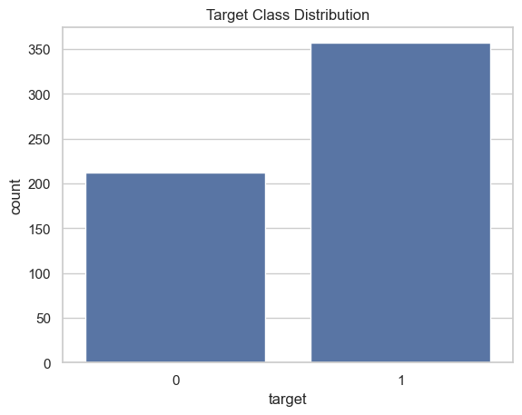
The dataset is relatively balanced between benign and malignant classes.
df.describe()
mean radius mean texture mean perimeter mean area
count 569.000000 569.000000 569.000000 569.000000
mean 14.127292 19.289649 91.969033 654.889104
std 3.524049 4.301036 24.298981 351.914129
min 6.981000 9.710000 43.790000 143.500000
25% 11.700000 16.170000 75.170000 420.300000
50% 13.370000 18.840000 86.240000 551.100000
75% 15.780000 21.800000 104.100000 782.700000
max 28.110000 39.280000 188.500000 2501.000000
mean smoothness mean compactness mean concavity mean concave points
count 569.000000 569.000000 569.000000 569.000000
mean 0.096360 0.104341 0.088799 0.048919
std 0.014064 0.052813 0.079720 0.038803
min 0.052630 0.019380 0.000000 0.000000
25% 0.086370 0.064920 0.029560 0.020310
50% 0.095870 0.092630 0.061540 0.033500
75% 0.105300 0.130400 0.130700 0.074000
max 0.163400 0.345400 0.426800 0.201200

mean symmetry mean fractal dimension ... worst texture
count 569.000000 569.000000 ... 569.000000
mean 0.181162 0.062798 ... 25.677223
std 0.027414 0.007060 ... 6.146258
min 0.106000 0.049960 ... 12.020000
25% 0.161900 0.057700 ... 21.080000
50% 0.179200 0.061540 ... 25.410000
75% 0.195700 0.066120 ... 29.720000
max 0.304000 0.097440 ... 49.540000
worst perimeter worst area worst smoothness worst compactness
count 569.000000 569.000000 569.000000 569.000000
mean 107.261213 880.583128 0.132369 0.254265
std 33.602542 569.356993 0.022832 0.157336
min 50.410000 185.200000 0.071170 0.027290
25% 84.110000 515.300000 0.116600 0.147200
50% 97.660000 686.500000 0.131300 0.211900
75% 125.400000 1084.000000 0.146000 0.339100
max 251.200000 4254.000000 0.222600 1.058000
worst concavity worst concave points worst symmetry
count 569.000000 569.000000 569.000000
mean 0.272188 0.114606 0.290076
std 0.208624 0.065732 0.061867
min 0.000000 0.000000 0.156500
25% 0.114500 0.064930 0.250400
50% 0.226700 0.099930 0.282200
75% 0.382900 0.161400 0.317900
max 1.252000 0.291000 0.663800
worst fractal dimension target
count 569.000000 569.000000
mean 0.083946 0.627417
std 0.018061 0.483918
min 0.055040 0.000000
25% 0.071460 0.000000
50% 0.080040 1.000000
75% 0.092080 1.000000
max 0.207500 1.000000
[8 rows x 31 columns]
Feature ranges vary significantly. Some features range from 0–1 while others exceed 1000. This justifies feature scaling before applying PCA, SVM, or KNN.

plt.figure(figsize=(12,10))
sns.heatmap(df.corr(), cmap="coolwarm", linewidths=0.5)
plt.title("Correlation Matrix")
plt.show()
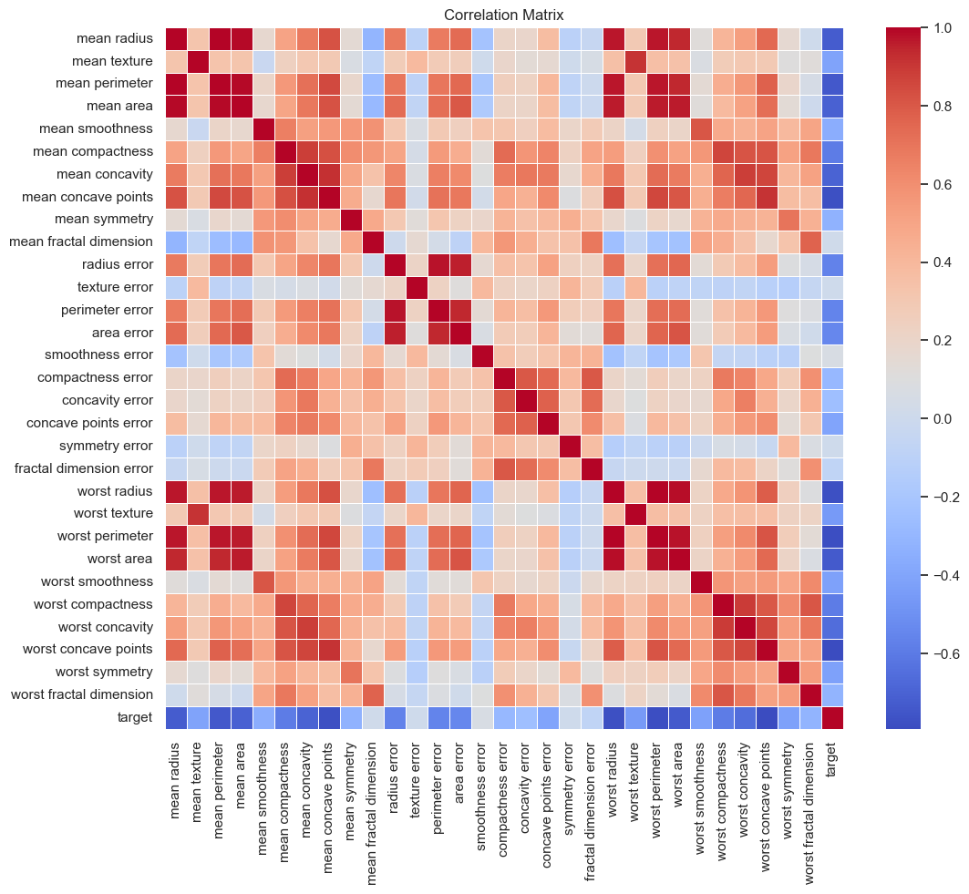
Strong correlations observed among:
- mean radius, mean perimeter, mean area
- worst radius, worst perimeter, worst area
This indicates multicollinearity and justifies dimensionality reduction.
corr_matrix = df.corr().abs()
upper = corr_matrix.where(
np.triu(np.ones(corr_matrix.shape), k=1).astype(bool)
)
high_corr = [
column for column in upper.columns
if any(upper[column] > 0.9)
]
print("Highly correlated features:", high_corr)

Highly correlated features: ['mean perimeter', 'mean area', 'mean concave points', 'perimeter error', 'area error', 'worst radius', 'worst texture', 'worst perimeter', 'worst area', 'worst concave points']
features = ["mean radius", "mean area", "mean concavity"]
for feature in features:
sns.histplot(data=df, x=feature, hue="target", kde=True)
plt.title(f"Distribution of {feature}")
plt.show()
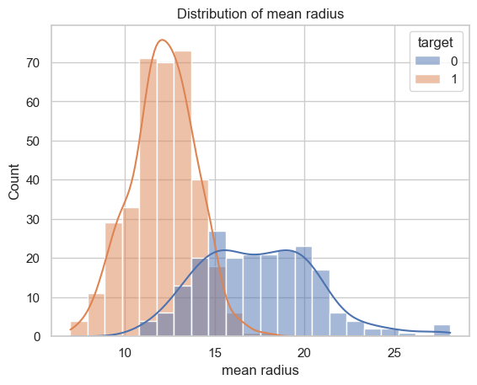
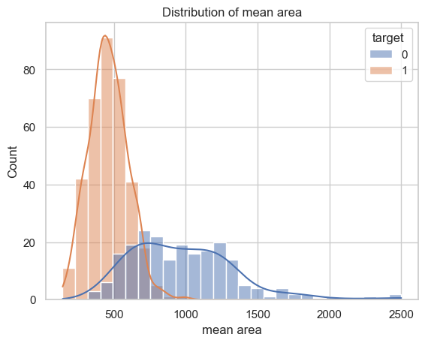
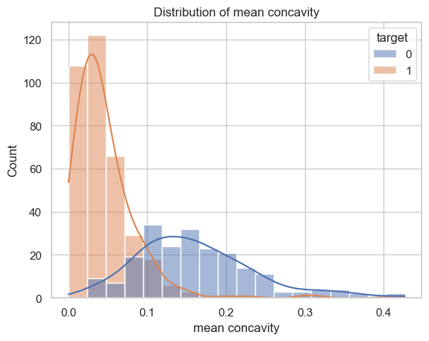
from sklearn.preprocessing import StandardScaler
from sklearn.decomposition import PCA
X = df.drop("target", axis=1)
y = df["target"]
scaler = StandardScaler()
X_scaled = scaler.fit_transform(X)
pca = PCA(n_components=2)
X_pca = pca.fit_transform(X_scaled)
plt.figure(figsize=(8,6))
plt.scatter(X_pca[:,0], X_pca[:,1], c=y, cmap="coolwarm", alpha=0.7)
plt.xlabel("PC1")
plt.ylabel("PC2")
plt.title("2D PCA Projection")
plt.colorbar()
plt.show()
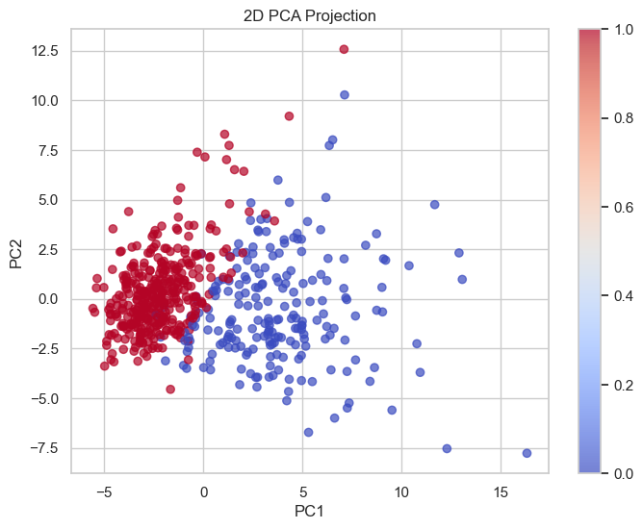
PCA shows clear separation between benign and malignant samples. This suggests dimensionality reduction may preserve classification power.
Key Observations
- No missing values present.
- Dataset is reasonably balanced.
- Significant multicollinearity exists.
- Feature scales vary widely.
- PCA visualization shows strong separability.
Conclusion: Dimensionality reduction techniques are justified for reducing redundancy and improving computational efficiency.

Baseline Model Performance
Objective
To evaluate classification performance using all 30 original features without applying dimensionality reduction.
This will serve as a reference for comparison with feature reduction methods.
import pandas as pd
import numpy as np
from sklearn.model_selection import train_test_split
from sklearn.preprocessing import StandardScaler
from sklearn.metrics import accuracy_score, precision_score, f1_score, roc_auc_score
from sklearn.ensemble import RandomForestClassifier
from sklearn.tree import DecisionTreeClassifier
from sklearn.svm import SVC
from sklearn.naive_bayes import GaussianNB
from sklearn.neighbors import KNeighborsClassifier
df = pd.read_csv(r"C:\ML PROJECT\Dimensionality-Reduction-Classification-Study\data\raw_data\breast_cancer.csv")
X = df.drop("target", axis=1)
y = df["target"]
X_train, X_test, y_train, y_test = train_test_split(
X, y, test_size=0.2, random_state=42, stratify=y
)
scaler = StandardScaler()
X_train_scaled = scaler.fit_transform(X_train)
X_test_scaled = scaler.transform(X_test)
models = {
"Random Forest": RandomForestClassifier(random_state=42),
"Decision Tree": DecisionTreeClassifier(random_state=42),
"SVM": SVC(probability=True, random_state=42),
"Naive Bayes": GaussianNB(),
"KNN": KNeighborsClassifier()
}
results = []
for name, model in models.items():
model.fit(X_train_scaled, y_train)
y_pred = model.predict(X_test_scaled)
y_prob = model.predict_proba(X_test_scaled)[:, 1]
results.append({
"Model": name,
"Accuracy": accuracy_score(y_test, y_pred),
"Precision": precision_score(y_test, y_pred),
"F1 Score": f1_score(y_test, y_pred),
"ROC-AUC": roc_auc_score(y_test, y_prob)
})
results_df = pd.DataFrame(results)
results_df

Model Accuracy Precision F1 Score ROC-AUC
0 Random Forest 0.956140 0.958904 0.965517 0.993882
1 Decision Tree 0.912281 0.955882 0.928571 0.915675
2 SVM 0.982456 0.986111 0.986111 0.995040
3 Naive Bayes 0.929825 0.944444 0.944444 0.986772
4 KNN 0.956140 0.958904 0.965517 0.978836

import numpy as np
import matplotlib.pyplot as plt
metrics = ["Accuracy", "Precision", "F1 Score", "ROC-AUC"]
x = np.arange(len(results_df["Model"]))
width = 0.2
plt.figure(figsize=(10,6))
for i, metric in enumerate(metrics):
plt.bar(x + i*width, results_df[metric], width, label=metric)
plt.xticks(x + width*1.5, results_df["Model"], rotation=45)
plt.ylabel("Score")
plt.title("Baseline Model Performance Comparison")
plt.legend()
plt.tight_layout()
plt.show()
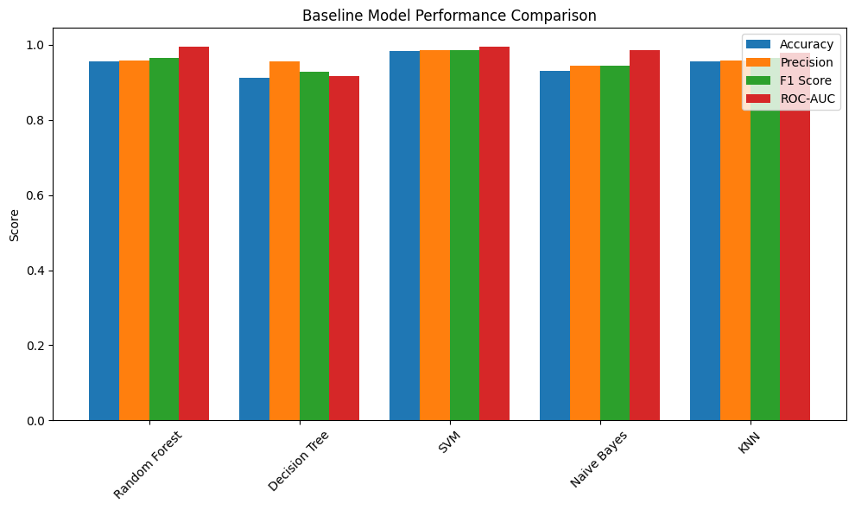

results_df.to_csv(r"C:\ML PROJECT\Dimensionality-Reduction-Classification-Study\results\baseline_results.csv", index=False)

Filter-Based Dimensionality Reduction
Objective
To apply filter-based dimensionality reduction techniques independent of classifier performance and evaluate their impact on classification accuracy.
Methods:
- Correlation-based feature selection
- PCA
- LDA
- SVD
import pandas as pd
import numpy as np
import matplotlib.pyplot as plt
import seaborn as sns
from sklearn.model_selection import train_test_split
from sklearn.preprocessing import StandardScaler
from sklearn.metrics import accuracy_score, precision_score, f1_score, roc_auc_score
from sklearn.decomposition import PCA, TruncatedSVD
from sklearn.discriminant_analysis import LinearDiscriminantAnalysis
from sklearn.ensemble import RandomForestClassifier
from sklearn.tree import DecisionTreeClassifier
from sklearn.svm import SVC
from sklearn.naive_bayes import GaussianNB
from sklearn.neighbors import KNeighborsClassifier
df = pd.read_csv(r"C:\ML PROJECT\Dimensionality-Reduction-Classification-Study\data\raw_data\breast_cancer.csv")
X = df.drop("target", axis=1)
y = df["target"]
X_train, X_test, y_train, y_test = train_test_split(
X, y, test_size=0.2, random_state=42, stratify=y
)
scaler = StandardScaler()
X_train_scaled = scaler.fit_transform(X_train)
X_test_scaled = scaler.transform(X_test)

Correlation-Based Feature Selection
corr_matrix = X_train.corr().abs()
upper = corr_matrix.where(
np.triu(np.ones(corr_matrix.shape), k=1).astype(bool)
)
to_drop = [column for column in upper.columns if any(upper[column] > 0.9)]
X_train_corr = X_train.drop(columns=to_drop)
X_test_corr = X_test.drop(columns=to_drop)
X_train_corr = scaler.fit_transform(X_train_corr)
X_test_corr = scaler.transform(X_test_corr)
Principal Component Analysis
pca = PCA(n_components=10)
X_train_pca = pca.fit_transform(X_train_scaled)
X_test_pca = pca.transform(X_test_scaled)
plt.plot(np.cumsum(pca.explained_variance_ratio_))
plt.xlabel("Number of Components")
plt.ylabel("Cumulative Explained Variance")
plt.show()
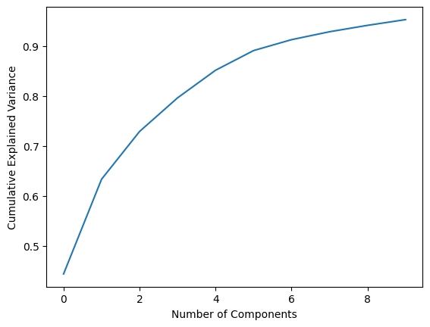

LDA
lda = LinearDiscriminantAnalysis(n_components=1)
X_train_lda = lda.fit_transform(X_train_scaled, y_train)
X_test_lda = lda.transform(X_test_scaled)
SVD
svd = TruncatedSVD(n_components=10)
X_train_svd = svd.fit_transform(X_train_scaled)
X_test_svd = svd.transform(X_test_scaled)
models = {
"Random Forest": RandomForestClassifier(random_state=42),
"Decision Tree": DecisionTreeClassifier(random_state=42),
"SVM": SVC(probability=True, random_state=42),
"Naive Bayes": GaussianNB(),
"KNN": KNeighborsClassifier()
}
def evaluate_models(X_train, X_test, y_train, y_test, method_name):
results = []
for name, model in models.items():
model.fit(X_train, y_train)
y_pred = model.predict(X_test)
y_prob = model.predict_proba(X_test)[:, 1]
results.append({
"Method": method_name,
"Model": name,
"Accuracy": accuracy_score(y_test, y_pred),
"Precision": precision_score(y_test, y_pred),
"F1 Score": f1_score(y_test, y_pred),
"ROC-AUC": roc_auc_score(y_test, y_prob)
})
return pd.DataFrame(results)

results_corr = evaluate_models(X_train_corr, X_test_corr, y_train, y_test, "Correlation")
results_pca = evaluate_models(X_train_pca, X_test_pca, y_train, y_test, "PCA")
results_lda = evaluate_models(X_train_lda, X_test_lda, y_train, y_test, "LDA")
results_svd = evaluate_models(X_train_svd, X_test_svd, y_train, y_test, "SVD")
filter_results = pd.concat([
results_corr,
results_pca,
results_lda,
results_svd
])
filter_results

Method Model Accuracy Precision F1 Score ROC-AUC
0 Correlation Random Forest 0.947368 0.945946 0.958904 0.992394
1 Correlation Decision Tree 0.912281 0.918919 0.931507 0.900794
2 Correlation SVM 0.964912 0.985714 0.971831 0.995701
3 Correlation Naive Bayes 0.885965 0.927536 0.907801 0.953373
4 Correlation KNN 0.964912 0.972222 0.972222 0.995040
0 PCA Random Forest 0.921053 0.943662 0.937063 0.984954
1 PCA Decision Tree 0.912281 0.930556 0.930556 0.905754
2 PCA SVM 0.973684 0.985915 0.979021 0.995040
3 PCA Naive Bayes 0.921053 0.931507 0.937931 0.970899
4 PCA KNN 0.956140 0.958904 0.965517 0.978836
0 LDA Random Forest 0.921053 0.984615 0.934307 0.986938
1 LDA Decision Tree 0.921053 0.984615 0.934307 0.932540
2 LDA SVM 0.973684 0.972603 0.979310 0.992394
3 LDA Naive Bayes 0.964912 0.959459 0.972603 0.992394
4 LDA KNN 0.956140 0.971831 0.965035 0.987599
0 SVD Random Forest 0.921053 0.943662 0.937063 0.984954
1 SVD Decision Tree 0.912281 0.930556 0.930556 0.905754
2 SVD SVM 0.973684 0.985915 0.979021 0.995040
3 SVD Naive Bayes 0.921053 0.931507 0.937931 0.970899
4 SVD KNN 0.956140 0.958904 0.965517 0.978836

import seaborn as sns
plt.figure(figsize=(12,6))
sns.barplot(data=filter_results, x="Method", y="Accuracy", hue="Model")
plt.title("Filter Methods - Accuracy Comparison")
plt.xticks(rotation=45)
plt.show()
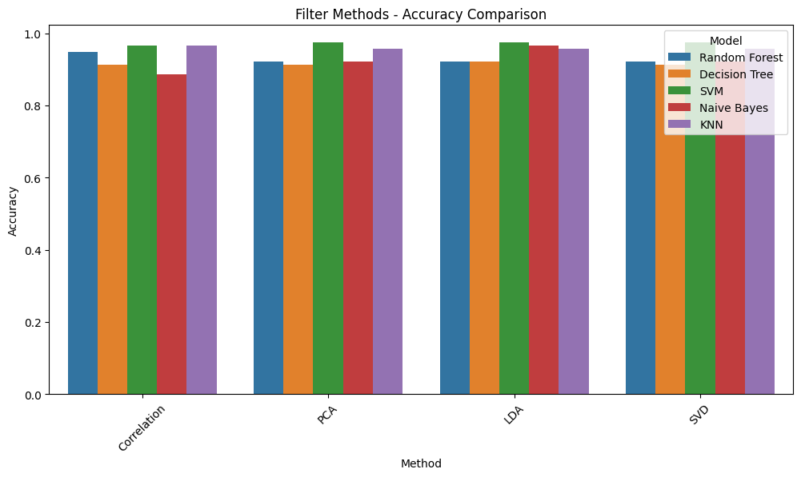
filter_results.to_csv(r"C:\ML PROJECT\Dimensionality-Reduction-Classification-Study\results\filter_results.csv", index=False)

Wrapper-Based Feature Selection
Objective
To apply model-dependent feature selection techniques and evaluate their impact on classification performance.
Methods:
- Sequential Forward Selection (SFS)
- Sequential Backward Selection (SBS)
- Sequential Floating Forward Selection (SFFS)
- Sequential Floating Backward Selection (SFBS)

import pandas as pd
import numpy as np
from sklearn.model_selection import train_test_split
from sklearn.preprocessing import StandardScaler
from sklearn.metrics import accuracy_score, precision_score, f1_score, roc_auc_score
from sklearn.ensemble import RandomForestClassifier
from sklearn.svm import SVC
from sklearn.tree import DecisionTreeClassifier
from sklearn.naive_bayes import GaussianNB
from sklearn.neighbors import KNeighborsClassifier
from mlxtend.feature_selection import SequentialFeatureSelector as SFS
df = pd.read_csv(r"C:\ML PROJECT\Dimensionality-Reduction-Classification-Study\data\raw_data\breast_cancer.csv")
X = df.drop("target", axis=1)
y = df["target"]
X_train, X_test, y_train, y_test = train_test_split(
X, y, test_size=0.2, random_state=42, stratify=y
)
scaler = StandardScaler()
X_train_scaled = scaler.fit_transform(X_train)
X_test_scaled = scaler.transform(X_test)

Choose Base Model for Feature Selection
base_model = RandomForestClassifier(random_state=42)
Sequential Forward Selection (SFS)
sfs_forward = SFS(
base_model,
k_features=8,
forward=True,
floating=False,
scoring='accuracy',
cv=5,
n_jobs=-1
)
sfs_forward.fit(X_train_scaled, y_train)
selected_features_forward = list(sfs_forward.k_feature_idx_)
X_train_sfs = X_train_scaled[:, selected_features_forward]
X_test_sfs = X_test_scaled[:, selected_features_forward]
Sequential Backward Selection (SBS)
sfs_backward = SFS(
base_model,
k_features=8,
forward=False,
floating=False,
scoring='accuracy',
cv=5,
n_jobs=-1
)
sfs_backward.fit(X_train_scaled, y_train)
selected_features_backward = list(sfs_backward.k_feature_idx_)
X_train_sbs = X_train_scaled[:, selected_features_backward]
X_test_sbs = X_test_scaled[:, selected_features_backward]
Sequential Floating Forward Selection (SFFS)
sfs_floating_forward = SFS(
base_model,
k_features=8,
forward=True,
floating=True,
scoring='accuracy',
cv=5,
n_jobs=-1
)
sfs_floating_forward.fit(X_train_scaled, y_train)
selected_features_sffs = list(sfs_floating_forward.k_feature_idx_)
X_train_sffs = X_train_scaled[:, selected_features_sffs]
X_test_sffs = X_test_scaled[:, selected_features_sffs]
Sequential Floating Backward Selection (SFBS)
sfs_floating_backward = SFS(
base_model,
k_features=8,
forward=False,
floating=True,
scoring='accuracy',
cv=5,
n_jobs=-1
)
sfs_floating_backward.fit(X_train_scaled, y_train)
selected_features_sfbs = list(sfs_floating_backward.k_feature_idx_)
X_train_sfbs = X_train_scaled[:, selected_features_sfbs]
X_test_sfbs = X_test_scaled[:, selected_features_sfbs]
def evaluate_models(X_train, X_test, y_train, y_test, method_name):
models = {
"Random Forest": RandomForestClassifier(random_state=42),
"Decision Tree": DecisionTreeClassifier(random_state=42),
"SVM": SVC(probability=True, random_state=42),
"Naive Bayes": GaussianNB(),
"KNN": KNeighborsClassifier()
}
results = []
for name, model in models.items():
model.fit(X_train, y_train)
y_pred = model.predict(X_test)
y_prob = model.predict_proba(X_test)[:, 1]
results.append({
"Method": method_name,
"Model": name,
"Accuracy": accuracy_score(y_test, y_pred),
"Precision": precision_score(y_test, y_pred),
"F1 Score": f1_score(y_test, y_pred),
"ROC-AUC": roc_auc_score(y_test, y_prob)
})
return pd.DataFrame(results)
results_sfs = evaluate_models(X_train_sfs, X_test_sfs, y_train, y_test, "SFS")
results_sbs = evaluate_models(X_train_sbs, X_test_sbs, y_train, y_test, "SBS")
results_sffs = evaluate_models(X_train_sffs, X_test_sffs, y_train, y_test, "SFFS")
results_sfbs = evaluate_models(X_train_sfbs, X_test_sfbs, y_train, y_test, "SFBS")
wrapper_results = pd.concat([
results_sfs,
results_sbs,
results_sffs,
results_sfbs
])
wrapper_results

Method Model Accuracy Precision F1 Score ROC-AUC
0 SFS Random Forest 0.947368 0.958333 0.958333 0.988922
1 SFS Decision Tree 0.903509 0.955224 0.920863 0.908730
2 SFS SVM 0.947368 0.971429 0.957746 0.993056
3 SFS Naive Bayes 0.921053 0.956522 0.936170 0.978505
4 SFS KNN 0.929825 0.944444 0.944444 0.977017
0 SBS Random Forest 0.964912 0.972222 0.972222 0.994874
1 SBS Decision Tree 0.912281 0.969697 0.927536 0.920635
2 SBS SVM 0.938596 0.971014 0.950355 0.995040
3 SBS Naive Bayes 0.929825 0.957143 0.943662 0.988757
4 SBS KNN 0.921053 0.956522 0.936170 0.988095
0 SFFS Random Forest 0.947368 0.958333 0.958333 0.988922
1 SFFS Decision Tree 0.903509 0.955224 0.920863 0.908730
2 SFFS SVM 0.947368 0.971429 0.957746 0.993056
3 SFFS Naive Bayes 0.921053 0.956522 0.936170 0.978505
4 SFFS KNN 0.929825 0.944444 0.944444 0.977017
0 SFBS Random Forest 0.964912 0.972222 0.972222 0.995370
1 SFBS Decision Tree 0.894737 1.000000 0.909091 0.916667
2 SFBS SVM 0.956140 0.971831 0.965035 0.993386
3 SFBS Naive Bayes 0.956140 0.946667 0.965986 0.991733
4 SFBS KNN 0.956140 0.958904 0.965517 0.983135

import matplotlib.pyplot as plt
import seaborn as sns
plt.figure(figsize=(10,6))
sns.barplot(data=wrapper_results, x="Model", y="Accuracy", hue="Method")
plt.title("Accuracy Comparison Across Models (Wrapper Methods)")
plt.xticks(rotation=45)
plt.tight_layout()
plt.show()
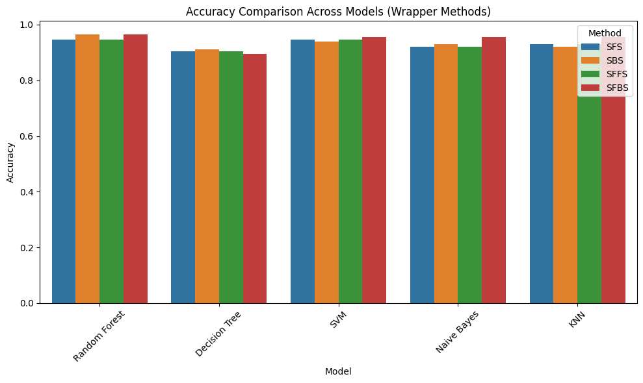
wrapper_results.to_csv(r"C:\ML PROJECT\Dimensionality-Reduction-Classification-Study\results\wrapper_results.csv", index=False)

Final Model Comparison
Objective
To compare baseline performance with filter-based and wrapper-based dimensionality reduction techniques across multiple classifiers.
This notebook identifies:
- The best dimensionality reduction method
- The best performing classifier
- The impact of feature reduction on model performance
import pandas as pd
baseline = pd.read_csv(r"C:\ML PROJECT\Dimensionality-Reduction-Classification-Study\results\baseline_results.csv")
filter_results = pd.read_csv(r"C:\ML PROJECT\Dimensionality-Reduction-Classification-Study\results\filter_results.csv")
wrapper_results = pd.read_csv(r"C:\ML PROJECT\Dimensionality-Reduction-Classification-Study\results\wrapper_results.csv")
baseline["Method"] = "Baseline"
all_results = pd.concat([
baseline,
filter_results,
wrapper_results
])
all_results.head()

Model Accuracy Precision F1 Score ROC-AUC Method
0 Random Forest 0.956140 0.958904 0.965517 0.993882 Baseline
1 Decision Tree 0.912281 0.955882 0.928571 0.915675 Baseline
2 SVM 0.982456 0.986111 0.986111 0.995040 Baseline
3 Naive Bayes 0.929825 0.944444 0.944444 0.986772 Baseline
4 KNN 0.956140 0.958904 0.965517 0.978836 Baseline

all_results[["Accuracy","Precision","F1 Score","ROC-AUC"]] = \
all_results[["Accuracy","Precision","F1 Score","ROC-AUC"]].round(3)
all_results

Model Accuracy Precision F1 Score ROC-AUC Method
0 Random Forest 0.956 0.959 0.966 0.994 Baseline
1 Decision Tree 0.912 0.956 0.929 0.916 Baseline
2 SVM 0.982 0.986 0.986 0.995 Baseline
3 Naive Bayes 0.930 0.944 0.944 0.987 Baseline
4 KNN 0.956 0.959 0.966 0.979 Baseline
0 Random Forest 0.947 0.946 0.959 0.992 Correlation
1 Decision Tree 0.912 0.919 0.932 0.901 Correlation
2 SVM 0.965 0.986 0.972 0.996 Correlation
3 Naive Bayes 0.886 0.928 0.908 0.953 Correlation
4 KNN 0.965 0.972 0.972 0.995 Correlation
5 Random Forest 0.921 0.944 0.937 0.985 PCA
6 Decision Tree 0.912 0.931 0.931 0.906 PCA
7 SVM 0.974 0.986 0.979 0.995 PCA
8 Naive Bayes 0.921 0.932 0.938 0.971 PCA
9 KNN 0.956 0.959 0.966 0.979 PCA
10 Random Forest 0.921 0.985 0.934 0.987 LDA
11 Decision Tree 0.921 0.985 0.934 0.933 LDA
12 SVM 0.974 0.973 0.979 0.992 LDA
13 Naive Bayes 0.965 0.959 0.973 0.992 LDA
14 KNN 0.956 0.972 0.965 0.988 LDA
15 Random Forest 0.921 0.944 0.937 0.985 SVD
16 Decision Tree 0.912 0.931 0.931 0.906 SVD
17 SVM 0.974 0.986 0.979 0.995 SVD
18 Naive Bayes 0.921 0.932 0.938 0.971 SVD
19 KNN 0.956 0.959 0.966 0.979 SVD
0 Random Forest 0.947 0.958 0.958 0.989 SFS
1 Decision Tree 0.904 0.955 0.921 0.909 SFS
2 SVM 0.947 0.971 0.958 0.993 SFS
3 Naive Bayes 0.921 0.957 0.936 0.979 SFS
4 KNN 0.930 0.944 0.944 0.977 SFS
5 Random Forest 0.965 0.972 0.972 0.995 SBS
6 Decision Tree 0.912 0.970 0.928 0.921 SBS
7 SVM 0.939 0.971 0.950 0.995 SBS
8 Naive Bayes 0.930 0.957 0.944 0.989 SBS
9 KNN 0.921 0.957 0.936 0.988 SBS
10 Random Forest 0.947 0.958 0.958 0.989 SFFS
11 Decision Tree 0.904 0.955 0.921 0.909 SFFS
12 SVM 0.947 0.971 0.958 0.993 SFFS
13 Naive Bayes 0.921 0.957 0.936 0.979 SFFS
14 KNN 0.930 0.944 0.944 0.977 SFFS
15 Random Forest 0.965 0.972 0.972 0.995 SFBS
16 Decision Tree 0.895 1.000 0.909 0.917 SFBS
17 SVM 0.956 0.972 0.965 0.993 SFBS
18 Naive Bayes 0.956 0.947 0.966 0.992 SFBS
19 KNN 0.956 0.959 0.966 0.983 SFBS
import seaborn as sns
import matplotlib.pyplot as plt
plt.figure(figsize=(14,6))
sns.barplot(data=all_results, x="Method", y="Accuracy", hue="Model")
plt.title("Accuracy Comparison: Baseline vs Filter vs Wrapper")
plt.xticks(rotation=45)
plt.tight_layout()
plt.show()
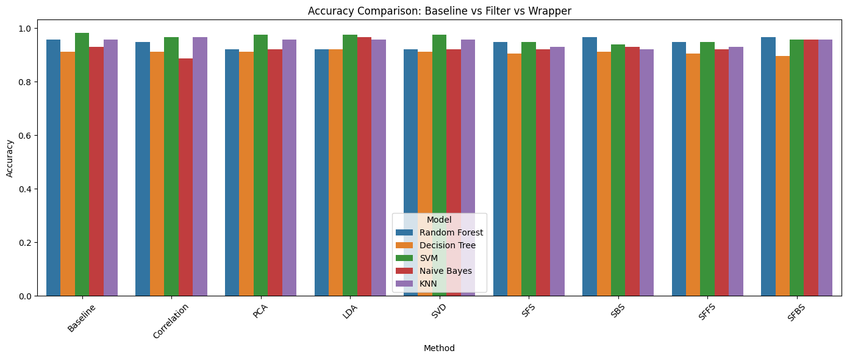
plt.figure(figsize=(14,6))
sns.barplot(data=all_results, x="Method", y="F1 Score", hue="Model")
plt.title("F1 Score Comparison: Baseline vs Filter vs Wrapper")
plt.xticks(rotation=45)
plt.tight_layout()
plt.show()
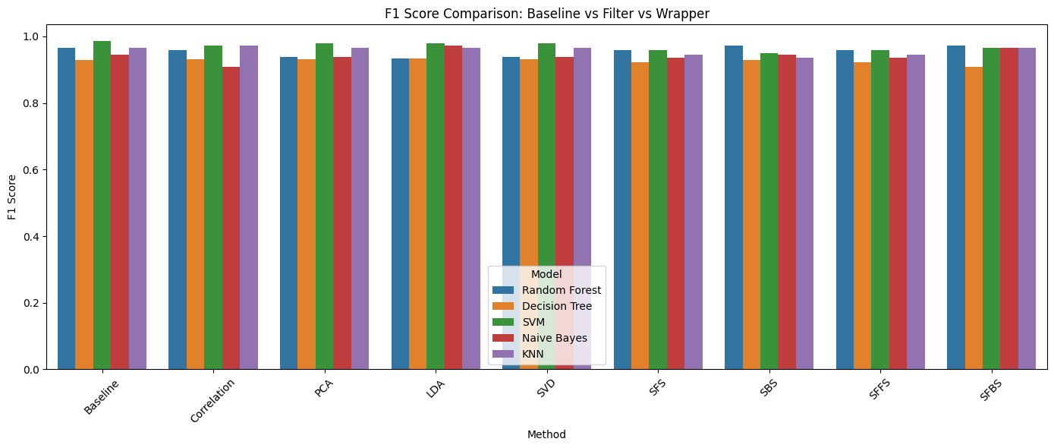

plt.figure(figsize=(14,6))
sns.barplot(data=all_results, x="Method", y="ROC-AUC", hue="Model")
plt.title("ROC-AUC Comparison: Baseline vs Filter vs Wrapper")
plt.xticks(rotation=45)
plt.tight_layout()
plt.show()
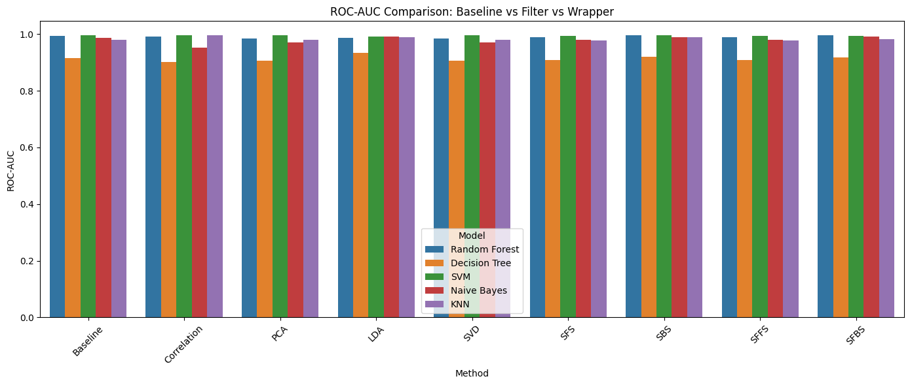
best_per_model = all_results.loc[
all_results.groupby("Model")["Accuracy"].idxmax()
]
best_per_model
Model Accuracy Precision F1 Score ROC-AUC Method
11 Decision Tree 0.921 0.985 0.934 0.933 LDA
11 Decision Tree 0.904 0.955 0.921 0.909 SFFS
4 KNN 0.956 0.959 0.966 0.979 Baseline
4 KNN 0.965 0.972 0.972 0.995 Correlation
4 KNN 0.930 0.944 0.944 0.977 SFS
13 Naive Bayes 0.965 0.959 0.973 0.992 LDA
13 Naive Bayes 0.921 0.957 0.936 0.979 SFFS
5 Random Forest 0.921 0.944 0.937 0.985 PCA
5 Random Forest 0.965 0.972 0.972 0.995 SBS
2 SVM 0.982 0.986 0.986 0.995 Baseline
2 SVM 0.965 0.986 0.972 0.996 Correlation
2 SVM 0.947 0.971 0.958 0.993 SFS

overall_best = all_results.loc[
all_results["Accuracy"].idxmax()
]
overall_best
Model Accuracy Precision F1 Score ROC-AUC Method
2 SVM 0.982 0.986 0.986 0.995 Baseline
2 SVM 0.965 0.986 0.972 0.996 Correlation
2 SVM 0.947 0.971 0.958 0.993 SFS
baseline_accuracy = baseline.set_index("Model")["Accuracy"]
comparison = best_per_model.set_index("Model")["Accuracy"] - baseline_accuracy
comparison

Model
Decision Tree 0.008719
Decision Tree -0.008281
KNN -0.000140
KNN 0.008860
KNN -0.026140
Naive Bayes 0.035175
Naive Bayes -0.008825
Random Forest -0.035140
Random Forest 0.008860
SVM -0.000456
SVM -0.017456
SVM -0.035456
Name: Accuracy, dtype: float64

Key Findings
- The baseline SVM model using all 30 features achieved the highest overall Accuracy (0.982) and F1 Score (0.986).
- Feature extraction methods such as PCA, LDA, and SVD preserved most of the predictive performance with only minor accuracy reduction.
- Correlation-based feature selection achieved the highest ROC-AUC (0.996), indicating strong ranking performance despite a slight drop in accuracy.
- Wrapper methods (SFS, SBS, SFFS, SFBS) reduced dimensionality but resulted in lower classification performance compared to the baseline.
- Overall, dimensionality reduction did not significantly improve SVM performance for this dataset, suggesting that the original feature space is already highly discriminative.
svm_results = all_results[all_results["Model"] == "SVM"]
svm_results
Model Accuracy Precision F1 Score ROC-AUC Method
2 SVM 0.982 0.986 0.986 0.995 Baseline
2 SVM 0.965 0.986 0.972 0.996 Correlation
7 SVM 0.974 0.986 0.979 0.995 PCA
12 SVM 0.974 0.973 0.979 0.992 LDA
17 SVM 0.974 0.986 0.979 0.995 SVD
2 SVM 0.947 0.971 0.958 0.993 SFS
7 SVM 0.939 0.971 0.950 0.995 SBS
12 SVM 0.947 0.971 0.958 0.993 SFFS
17 SVM 0.956 0.972 0.965 0.993 SFBS
import seaborn as sns
import matplotlib.pyplot as plt
plt.figure(figsize=(10,6))
sns.barplot(data=svm_results, x="Method", y="Accuracy")
plt.title("SVM Performance Across Methods")
plt.xticks(rotation=45)
plt.show()
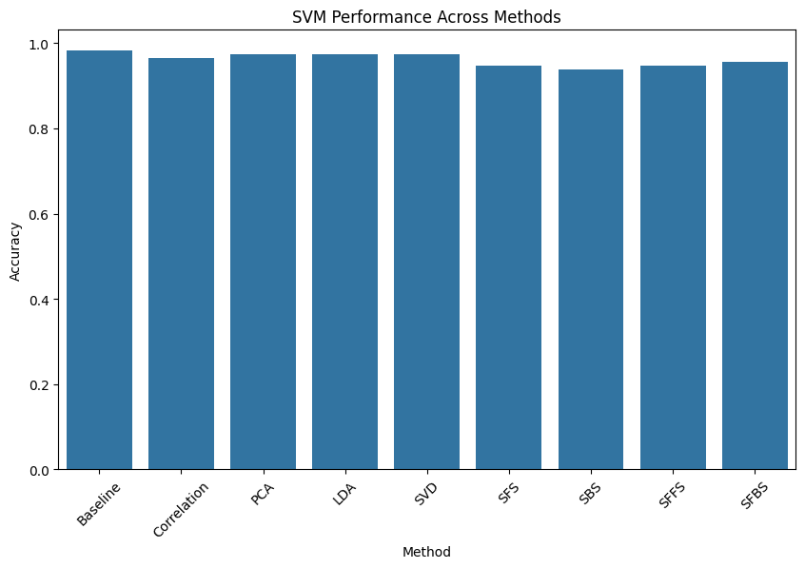

Final Observations
- SVM achieved the highest overall baseline performance using all 30 original features.
- Feature extraction methods such as PCA, LDA, and SVD preserved most of the classification performance with only a minor reduction in accuracy.
- Correlation-based feature selection achieved the highest ROC-AUC, indicating strong ranking capability despite a slight drop in accuracy.
- Wrapper methods (SFS, SBS, SFFS, SFBS) reduced feature dimensionality but did not outperform the baseline configuration.
- Overall, dimensionality reduction did not significantly improve SVM performance for this dataset, suggesting that the original feature set is already highly discriminative.

Web Application
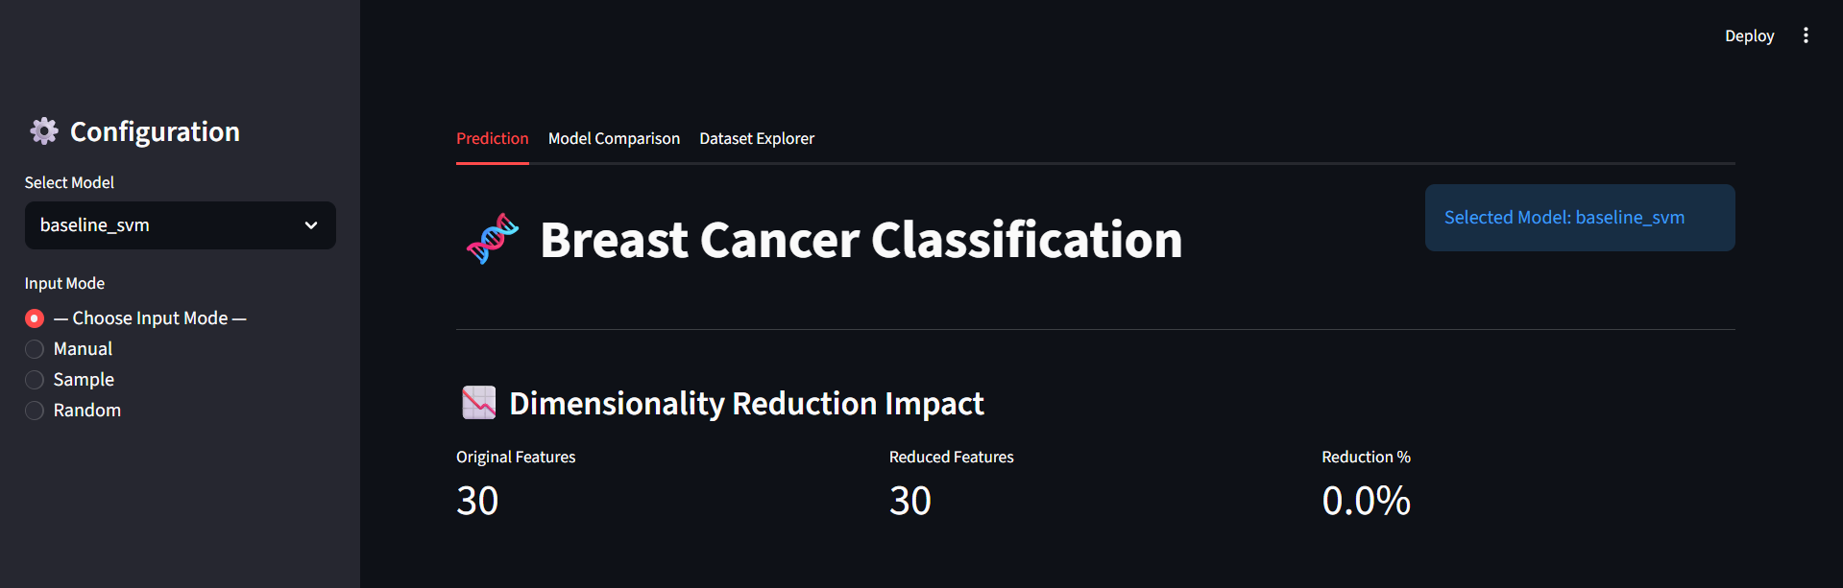

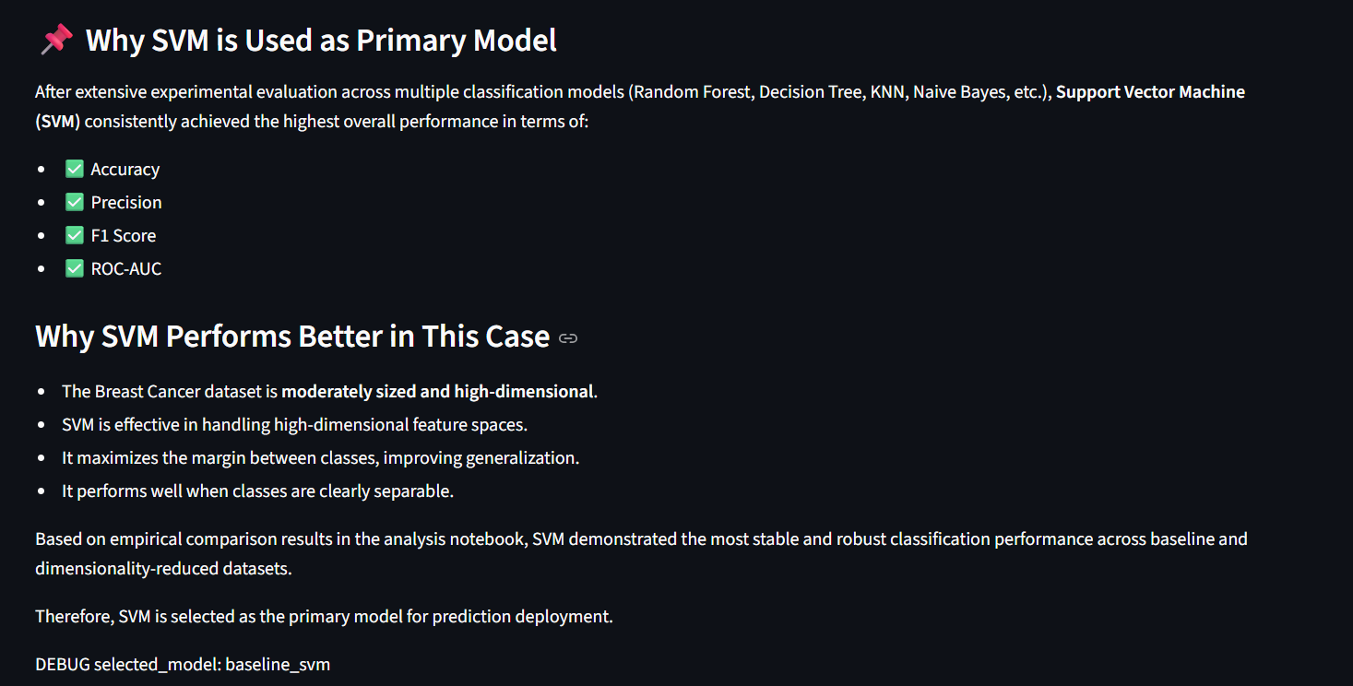

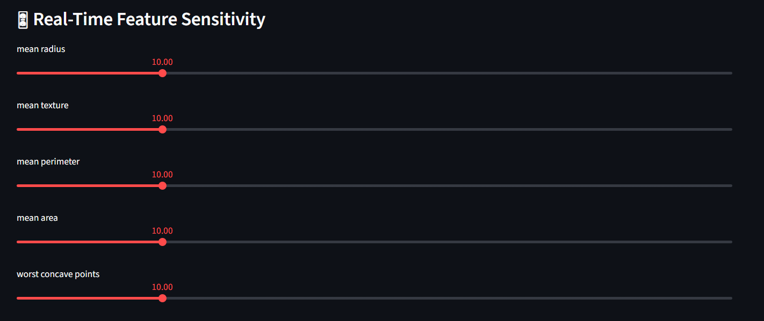

Random Sample loaded
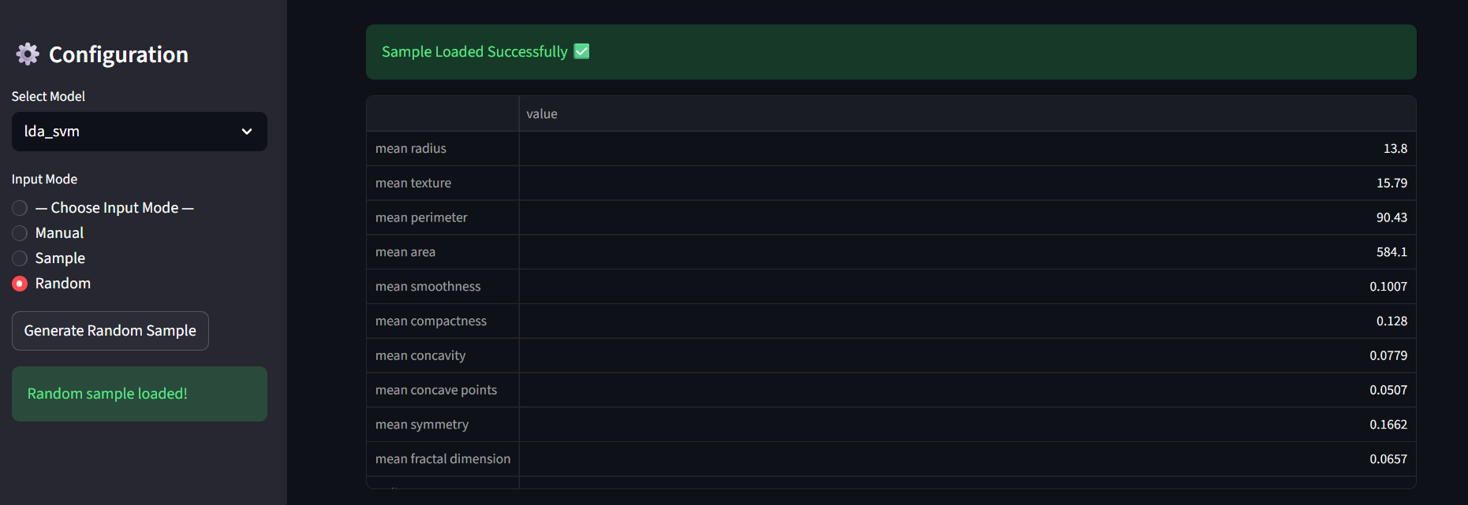

Sample Index loaded
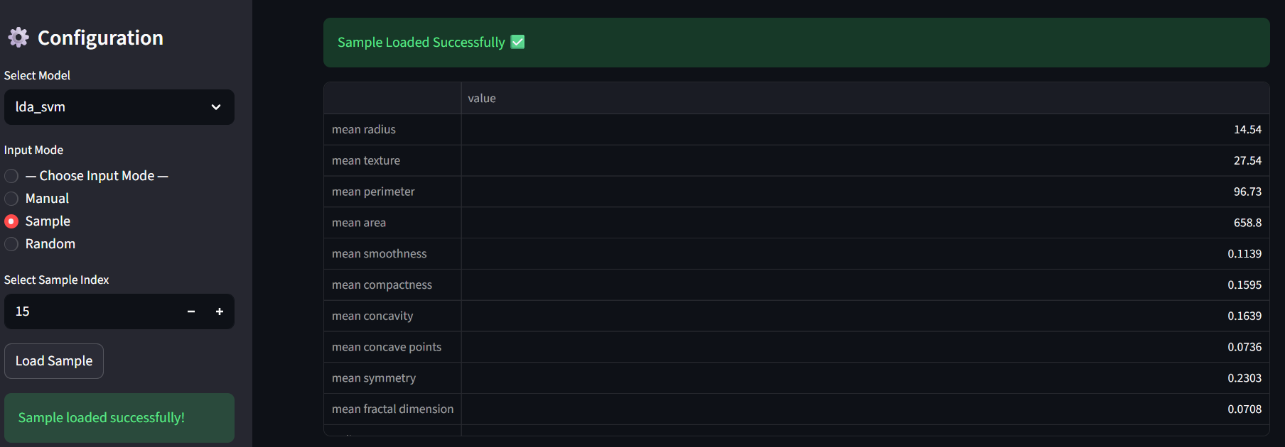



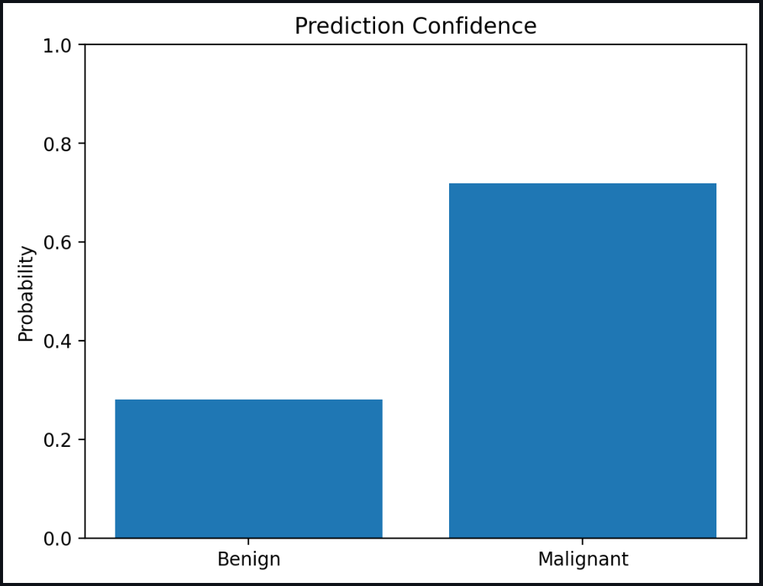



🔍 SHAP Waterfall Explanation
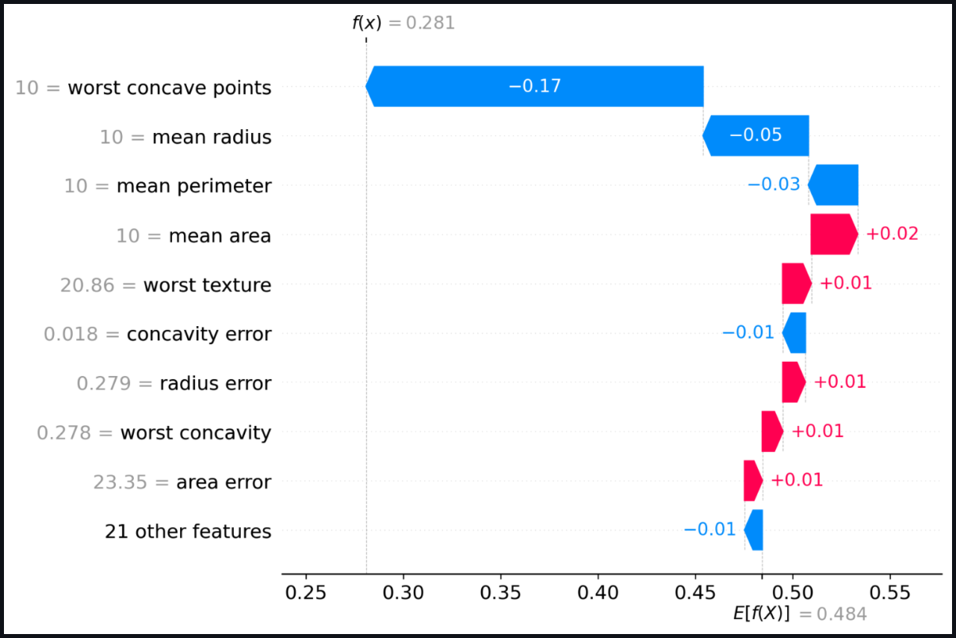

📊 Feature Importance
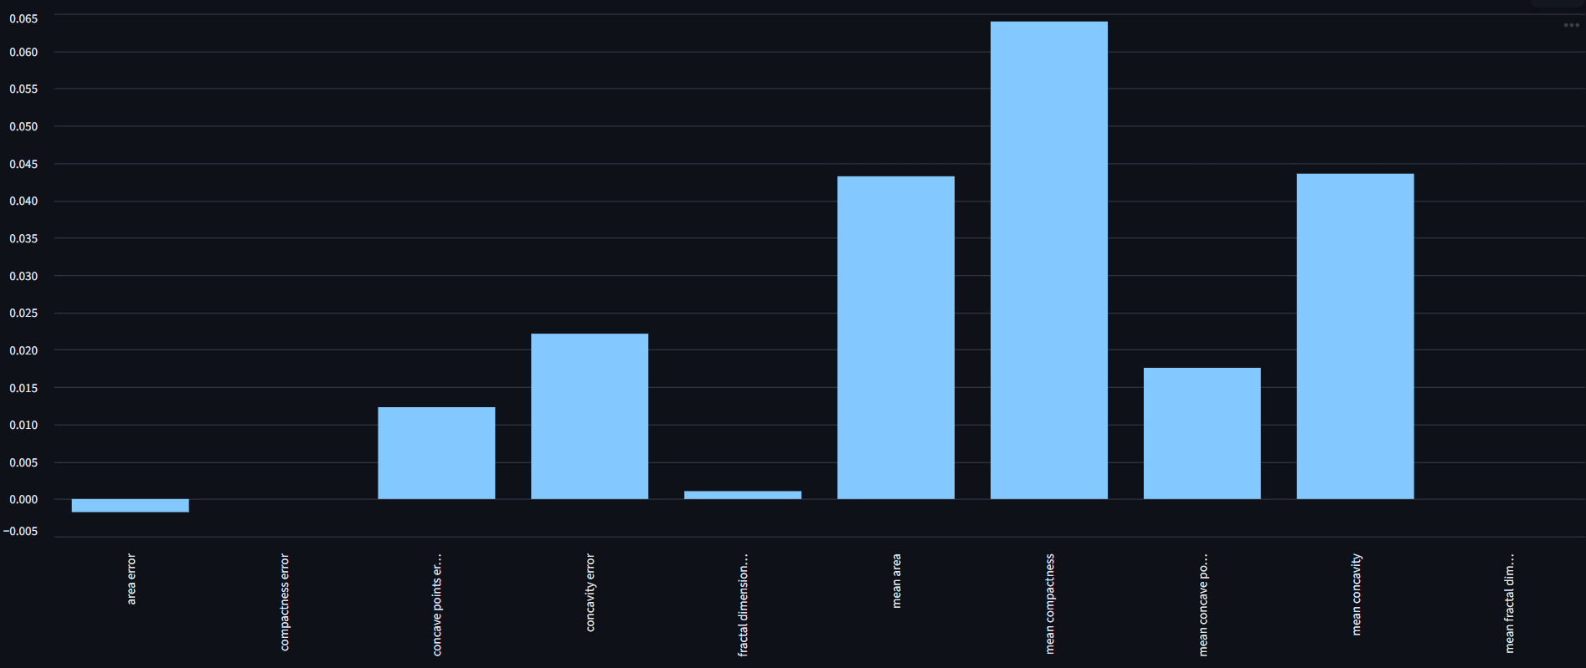

📊 Model Comparison Dashboard
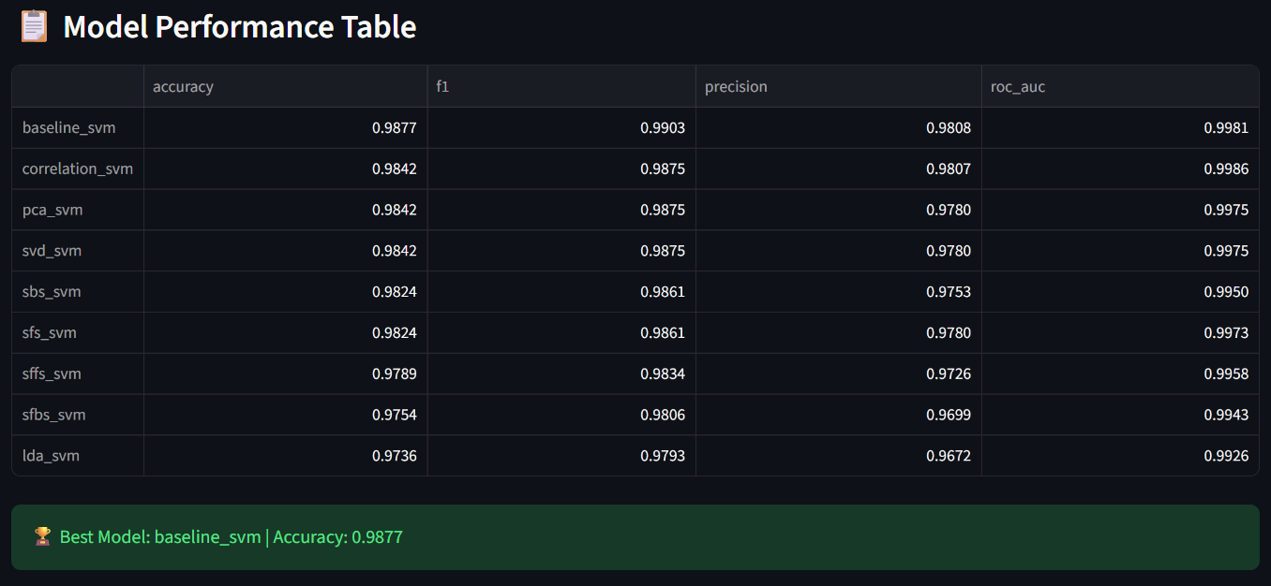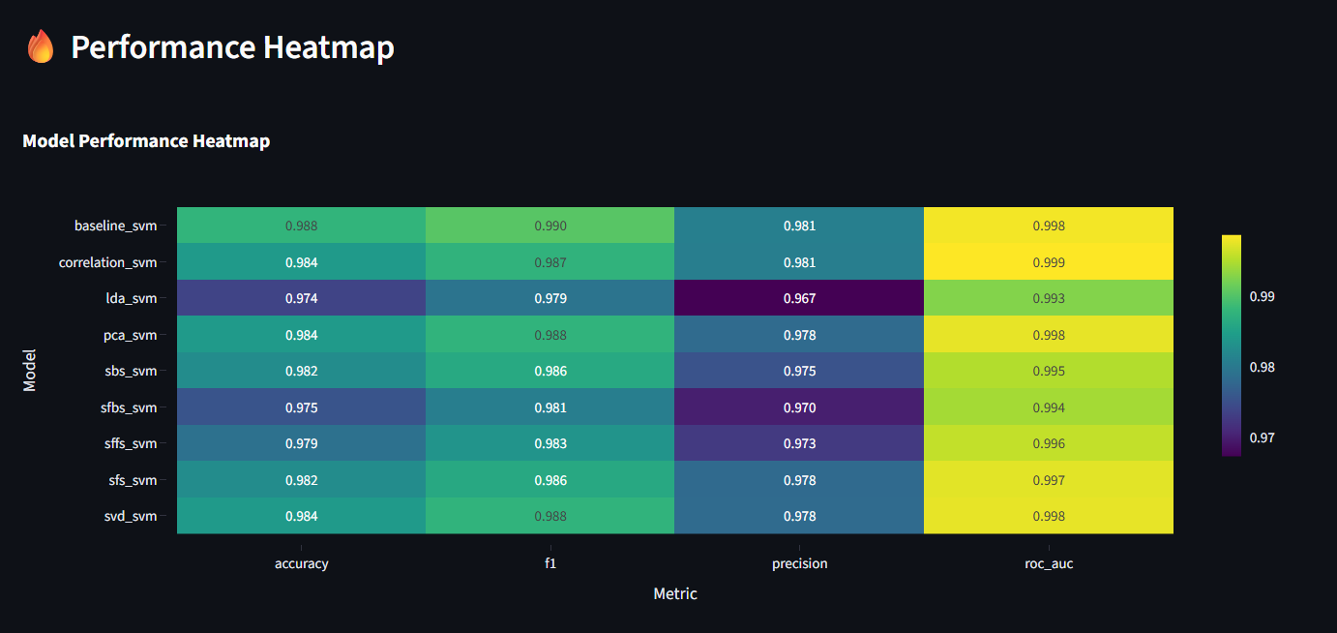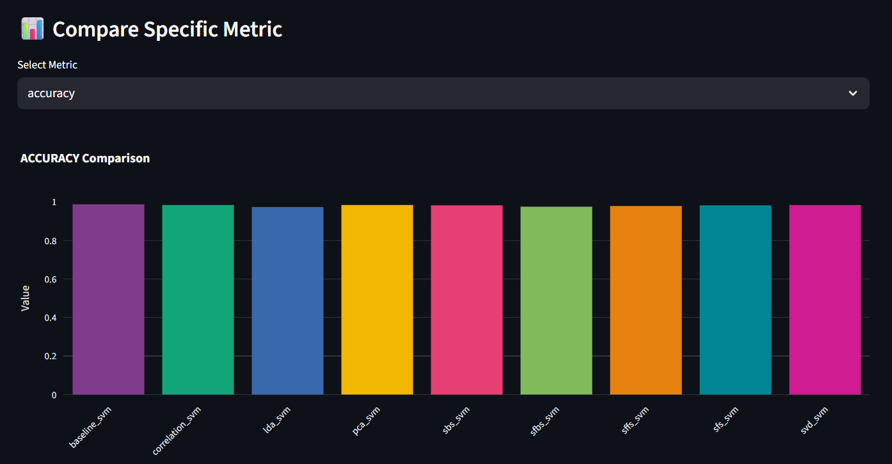
📊 Dataset Explorer
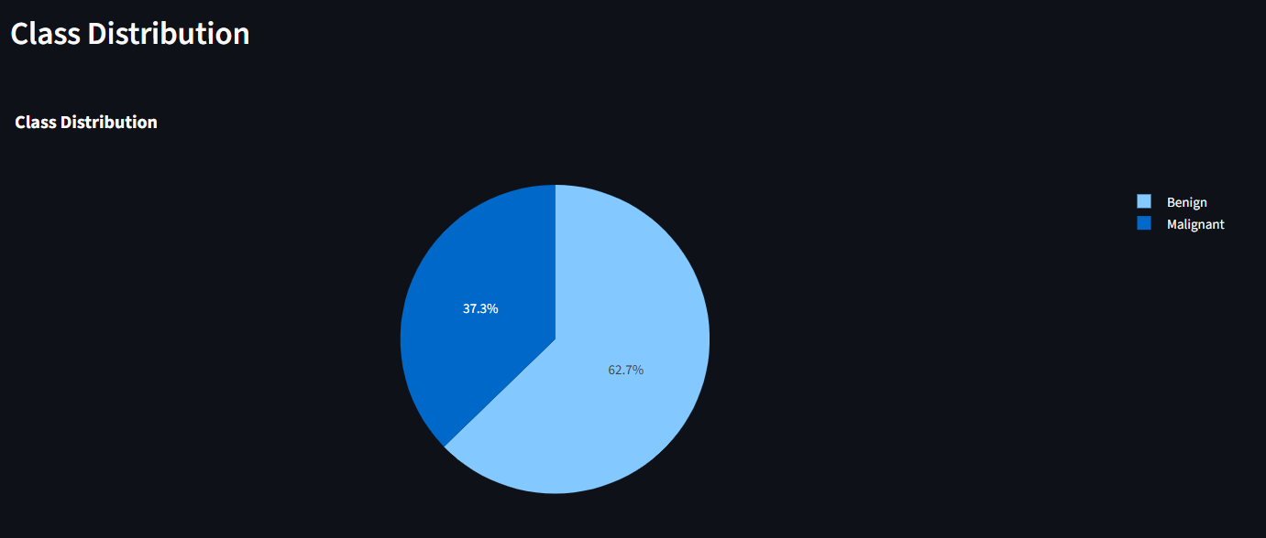
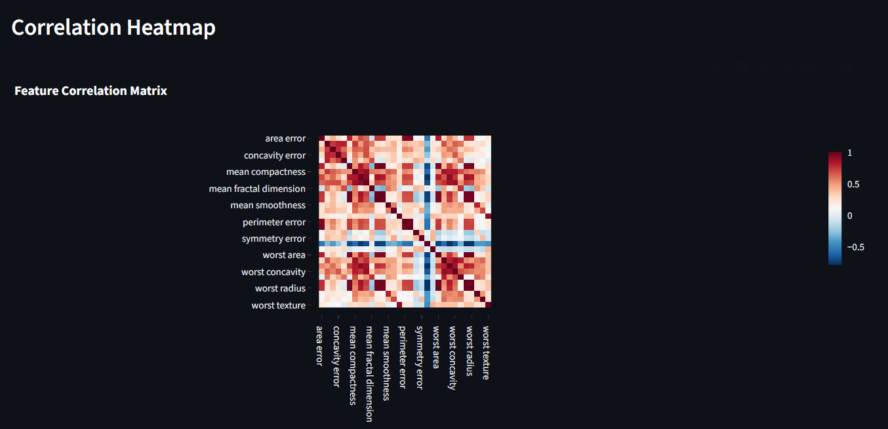
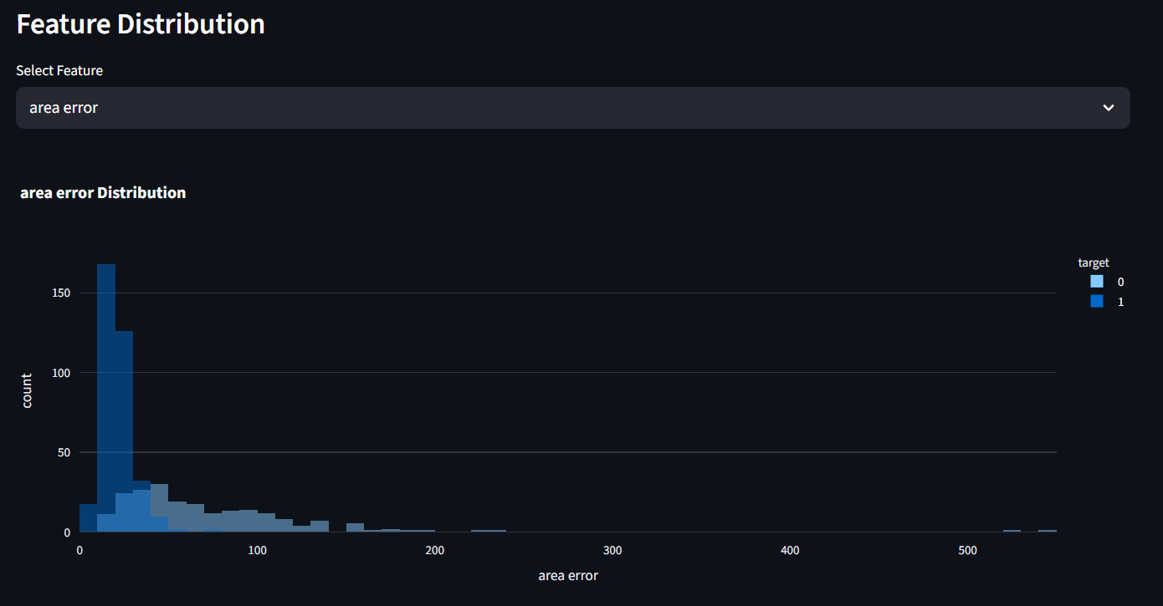
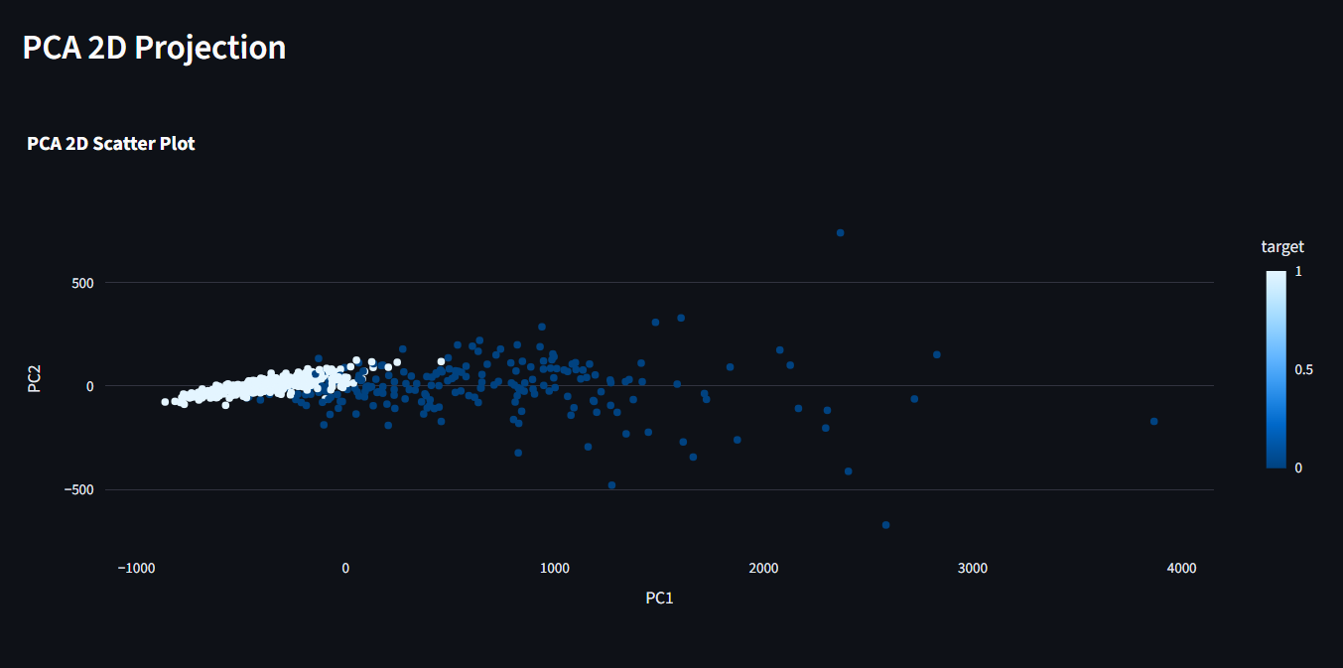

Conclusion
This project successfully demonstrates an intelligent breast cancer classification system that integrates dimensionality reduction, advanced feature selection techniques, machine learning algorithms, and explainable AI into a unified framework. By systematically reducing feature space complexity and selecting the most relevant attributes, the system enhances both computational efficiency and predictive performance. Among the evaluated models, Support Vector Machine (SVM) emerged as the most effective, achieving superior accuracy and robustness in handling high-dimensional medical data.
Furthermore, the incorporation of SHAP-based explainability ensures that model predictions are transparent and interpretable, allowing users to understand the contribution of each feature toward the final decision. This is particularly critical in healthcare applications, where trust, accountability, and interpretability are essential for clinical adoption.
The full-stack implementation, comprising a Flask-based backend and an interactive Streamlit frontend, enables seamless real-time predictions, model comparison, and dynamic feature analysis. The system not only facilitates accurate diagnosis but also provides an intuitive interface for users to explore data insights and model behaviour.
Overall, the proposed solution bridges the gap between high-performance machine learning models and practical usability in clinical environments. It highlights the potential of combining optimization techniques with explainable AI to develop reliable, efficient, and user-centric decision support systems. With further enhancements and real-world integration, this system can significantly contribute to early detection and improved prognosis of breast cancer, ultimately supporting better healthcare outcomes.

