VISVESVARAYA TECHNOLOGICAL UNIVERSITY, BELAGAVI

REPORT ON
"Network Intrusion Detection using Multi-Technique Dimensionality Reduction"

Submitted by:
Name: ____________________
USN: _____________________
Guided by:
Dr. ______________________
Department of Computer Science and Engineering

Abstract
This project develops a Network Intrusion Detection (NID) pipeline and evaluates multiple dimensionality reduction and feature-selection techniques in one framework. Using KDDCup99 (subset=SA), the task is binary classification (normal vs intrusion). The study benchmarks No-DR baseline, Correlation FS, PCA, LDA, SVD, SelectKBest, RFE, SFFS, and SFBS across Logistic Regression, SVM-RBF, KNN, Decision Tree, GaussianNB, and Random Forest. The project also provides explainability (feature importance + SHAP) and a Streamlit web app for experiment visualization and inference.

Introduction

Background
High-dimensional network traffic data can contain redundant and correlated attributes. Dimensionality reduction helps improve efficiency and interpretability while preserving predictive power.

Objectives
? Implement and compare multiple dimensionality reduction techniques in one project.
? Benchmark multiple classifiers for each technique.
? Identify best-performing model-technique combinations.
? Provide explainability using feature importance and SHAP waterfall.
? Deliver a Streamlit web application for analysis and predictions.

Dataset
Dataset: KDDCup99 (subset=SA, percent10=True)
Samples used: 5000 | Train: 4000 | Test: 1000
Original features: 41

Exploratory Data Analysis (EDA)
EDA was used to inspect feature correlation, class-separability, and distribution characteristics.
Correlation Heatmap
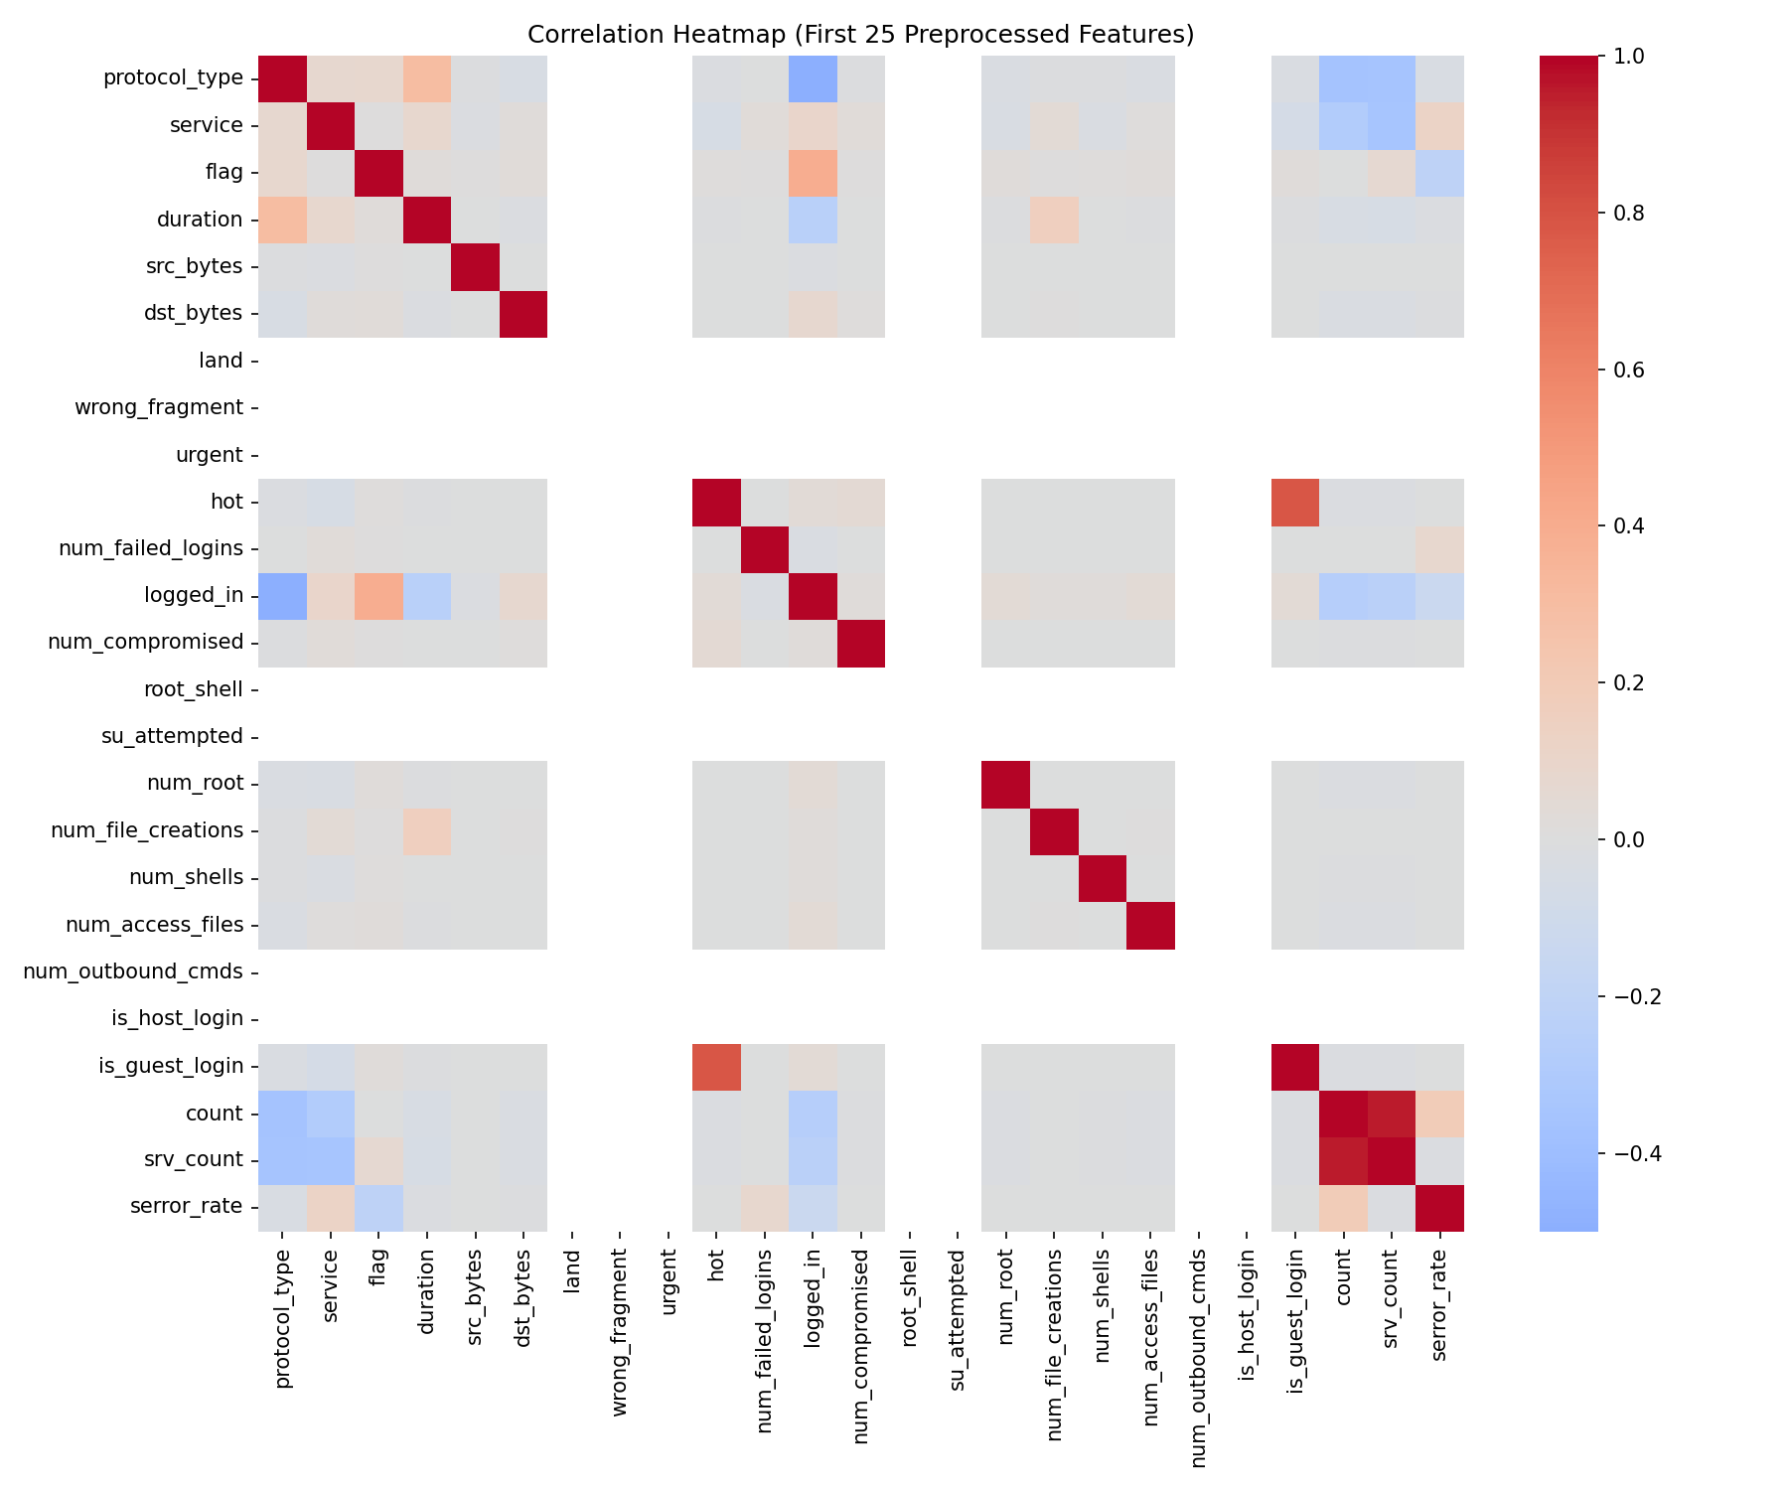
Feature Distribution
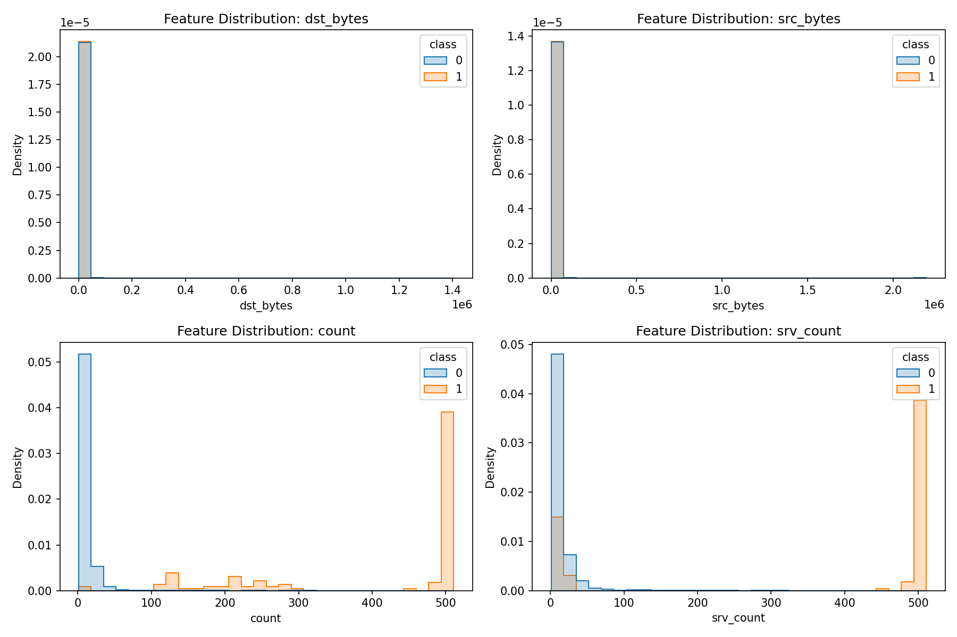
PCA 2D Projection
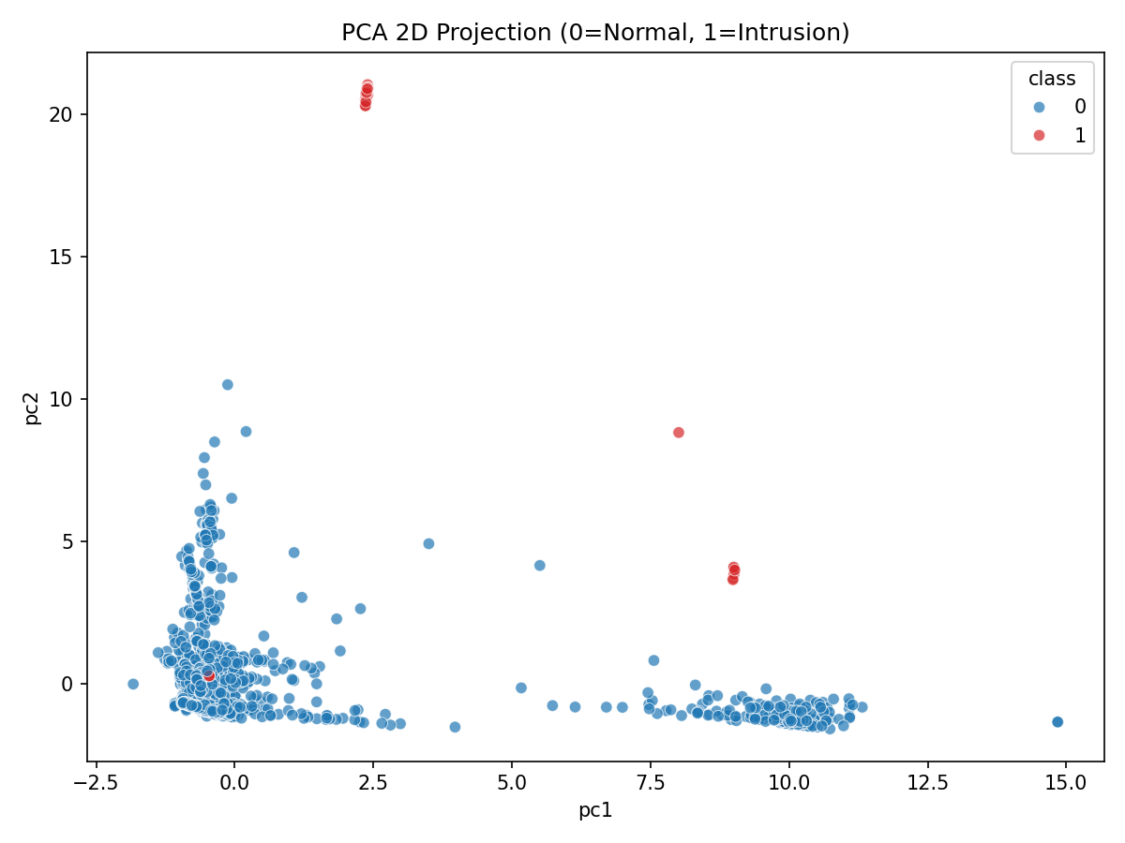

Methodology
Dimensionality reduction / feature-selection methods implemented:
? No DR baseline
? Correlation-based FS
? PCA
? LDA
? SVD
? Filter (SelectKBest)
? Wrapper (RFE)
? SFFS
? SFBS
Classifiers: Logistic Regression, SVM-RBF, KNN, Decision Tree, GaussianNB, Random Forest

Model Performance Summary
Best model per technique:
technique | model_short | accuracy | precision | recall | f1 | roc_auc
Correlation FS | SVM-RBF | 1.0000 | 1.0000 | 1.0000 | 1.0000 | 1.0000
Filter (SelectKBest) | LogisticRegression | 1.0000 | 1.0000 | 1.0000 | 1.0000 | 1.0000
LDA | SVM-RBF | 1.0000 | 1.0000 | 1.0000 | 1.0000 | 1.0000
No DR | SVM-RBF | 1.0000 | 1.0000 | 1.0000 | 1.0000 | 1.0000
PCA | SVM-RBF | 1.0000 | 1.0000 | 1.0000 | 1.0000 | 1.0000
SFBS | SVM-RBF | 1.0000 | 1.0000 | 1.0000 | 1.0000 | 1.0000
SFFS | LogisticRegression | 1.0000 | 1.0000 | 1.0000 | 1.0000 | 1.0000
SVD | SVM-RBF | 1.0000 | 1.0000 | 1.0000 | 1.0000 | 1.0000
Wrapper (RFE) | SVM-RBF | 1.0000 | 1.0000 | 1.0000 | 1.0000 | 1.0000
PCA retained 20 components; explained variance = 0.9600; reduction = 51.22%.
Model Performance Heatmap
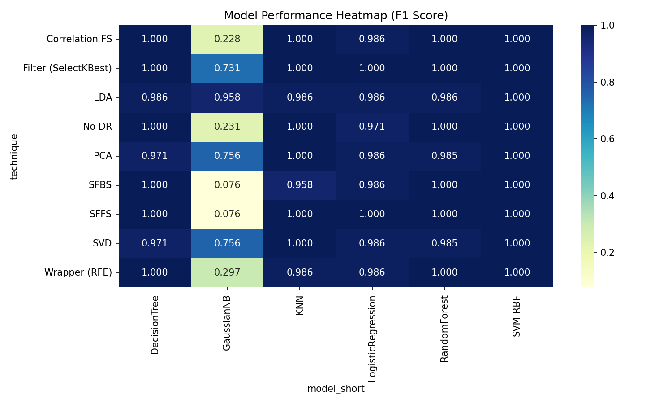
Filter Methods - Accuracy Comparison
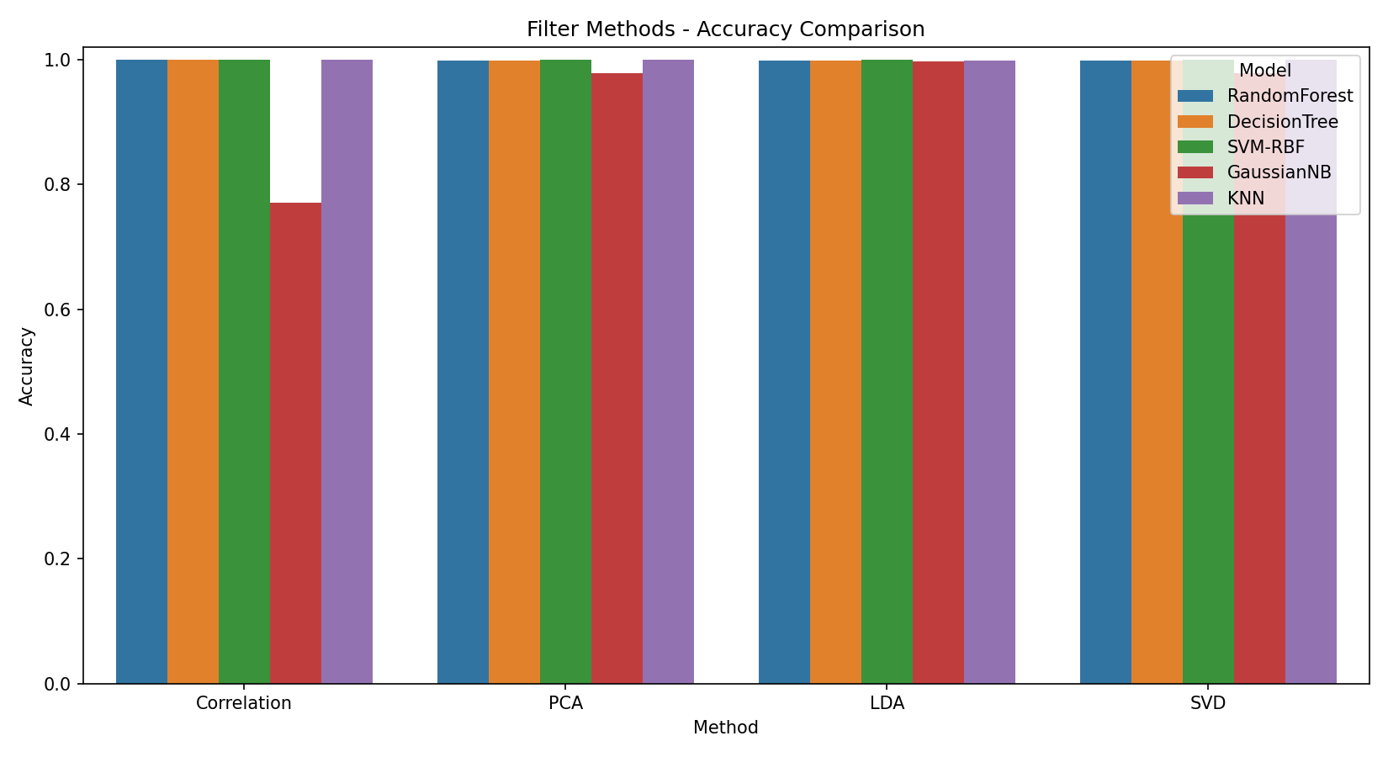
Confusion Matrix (Best Overall)
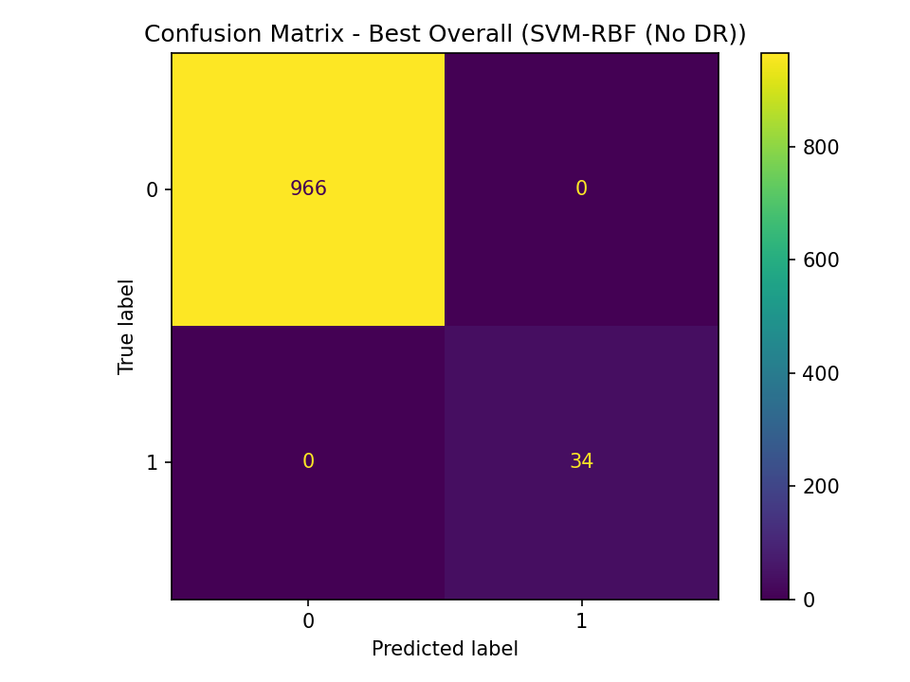
Feature Importance
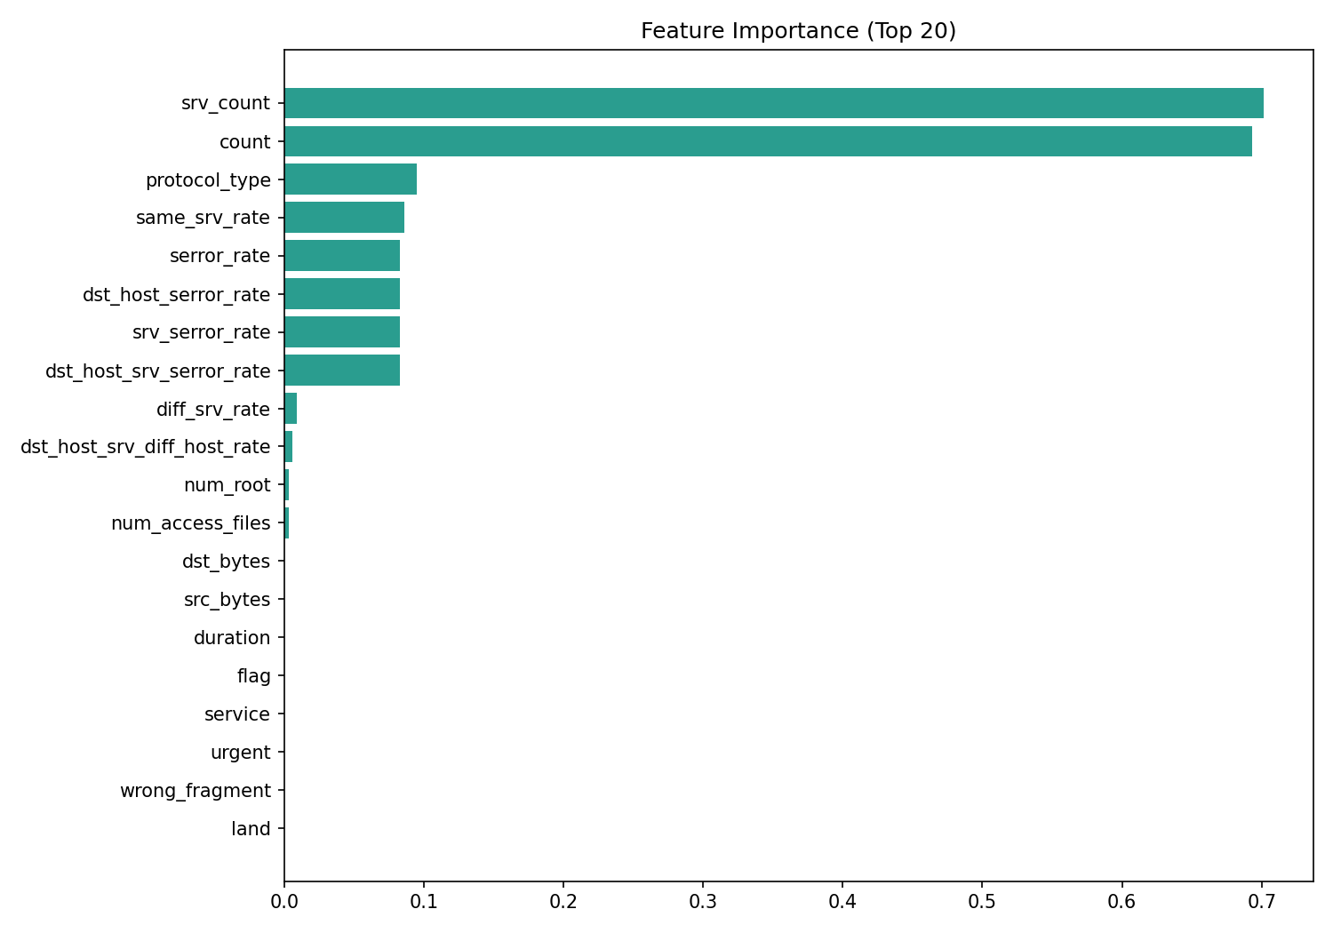
SHAP Waterfall Explanation
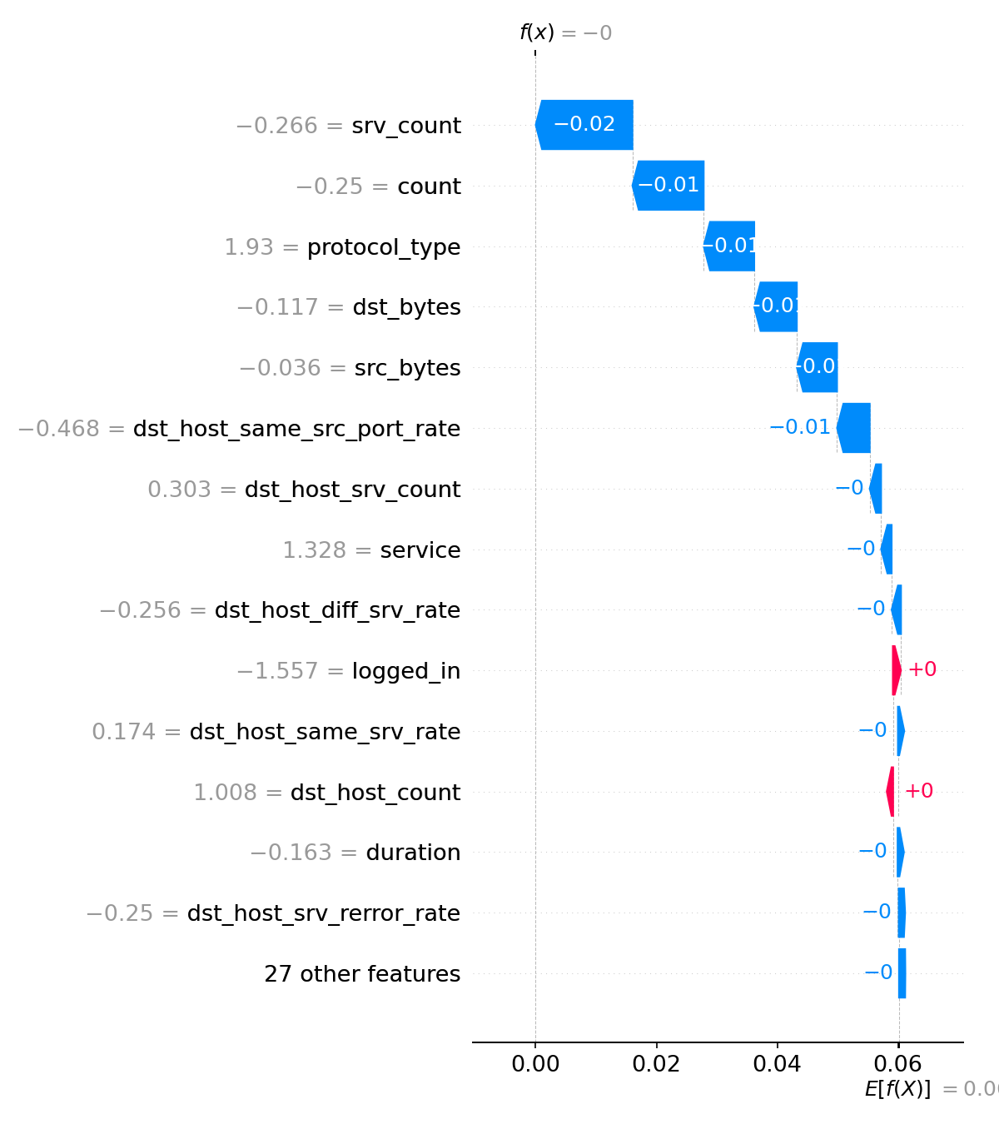
Prediction Confidence Distribution
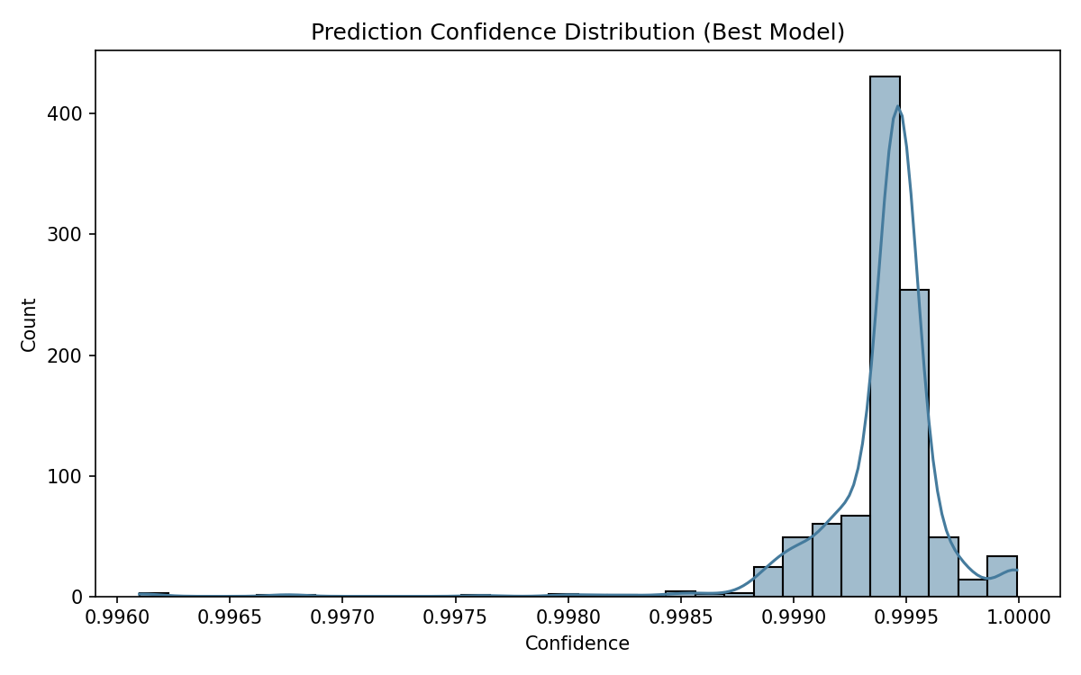

Final Model Comparison and Observations
Best overall model: SVM-RBF (No DR)
Best overall technique: No DR
? SVM-RBF remained consistently strong across techniques.
? Dimensionality reduction preserved high performance while reducing feature dimensions.
? Correlation FS, PCA, LDA, and SVD were all benchmarked and visualized.
? Wrapper and floating selection methods were included in final comparison.

Web Application
A Streamlit dashboard was implemented with Overview, Metrics, Plots, Dataset, and Inference tabs.
? Overview: final observations + random sample loaded + sample index loaded
? Metrics: full performance table + heatmap
? Plots: PCA 2D projection, correlation heatmap, feature distribution, feature importance, SHAP waterfall
? Inference: CSV upload and intrusion prediction with confidence

References
1. Scikit-learn documentation (KDDCup99, PCA, LDA, SVD, feature selection, classifiers).
2. SHAP documentation for explainability.
3. Streamlit documentation for web deployment.

