THE OXFORD COLLEGE OF ENGINEERING (TOCE)
DEPARTMENT OF INFORMATION SCIENCE & ENGINEERING
――――――――――――――――――――――――――――――――――――――――――――――――――
COMPREHENSIVE ALGORITHM & MATHEMATICAL FORMULA EXPLANATION GUIDE
(1st Project Review Presentation & Viva Defense Handbook)
PROJECT CONTEXT: Project Title: An Enhanced CNN-Based Multi-Class Pneumonia Detection System Using Advanced Image Enhancement, Segmentation, And Data Augmentation Techniques
TEAM BATCH: Student Authors: Adithya M (1OX23IS002), Bhavani Patil (1OX23IS011), Harsha R (1OX23IS025), K. Lalitha (1OX23IS029)
FACULTY GUIDE: Project Guide: Mrs. S. Visalini, Assistant Professor, Dept. of ISE, TOCE

SECTION 1: SYSTEM ALGORITHMIC PIPELINE OVERVIEW
To solve the critical clinical challenge of 'shortcut learning'—where deep learning models overfit to peripheral extra-pulmonary artifacts like rib cages, clavicles, radiographer text letters, and sensor exposure variations—our system implements an anatomically isolated multi-stage computer-assisted diagnostic framework governed by four primary algorithms:
• Algorithm 1: CLAHE Engine: Contextual local contrast enhancement (8x8 tile grid, clip limit β=2.0) to unmask subtle ground-glass opacities and loabr consolidations.
• Algorithm 2: U-Net Segmenter: Biomedical semantic lung field extraction (DiceBCELoss) to produce binary lung masks M(x,y) and crop extra-pulmonary noise.
• Algorithm 3: ResNet50 Classifier: Multi-class 3-way triage (Normal vs. Bacterial vs. Viral) with inverse class weighting (w_c) and Albumentations MixUp/CutMix.
• Algorithm 4: Grad-CAM Explainer: Gradient-weighted class activation mapping to generate Layer 4 heatmap overlays for attending radiologists.

ALGORITHM 1: LOCALIZED CLAHE CONTRAST ENGINE
1.1 Clinical Rationale & Objective
Standard Global Histogram Equalization (GHE) computes a single global CDF across the entire image. On chest radiographs, this causes catastrophic over-saturation in bright bone areas (sternum, clavicles) and accentuates background sensor noise. Contrast Limited Adaptive Histogram Equalization (CLAHE) operates on localized contextual sub-regions (tile grids, default 8x8). By clipping histogram heights at clip limit threshold β = 2.0, CLAHE caps local noise amplification while boosting micro-textures (reticulonodular infiltrates in viral cases and focal lobar opacities in bacterial cases).
1.2 Rendered Pseudocode & Formula Photos
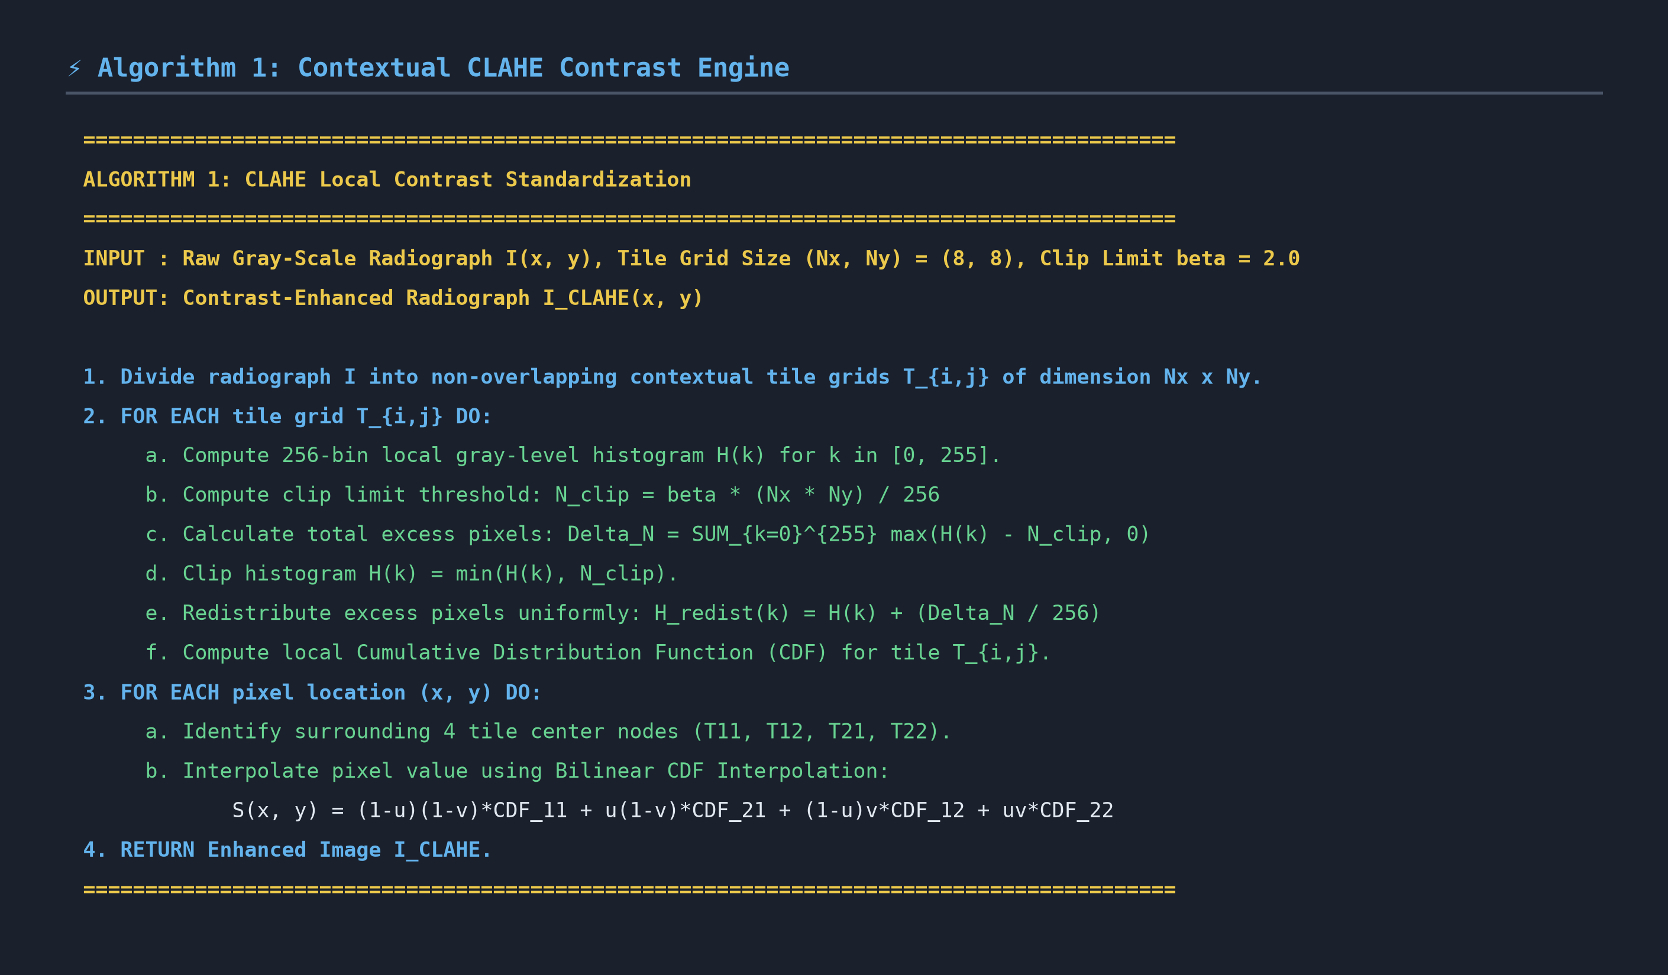
Photo 1.1: High-Resolution Pseudocode — Algorithm 1 (Contextual CLAHE Contrast Standardization)

Photo 1.2: Rendered Mathematical Formulas — Clip Limit Threshold & Bilinear Interpolation
1.3 Exhaustive Variable & Mathematical Symbol Registry
Variable / Symbol | Role Name | Detailed Mathematical & Technical Description
I(x, y) | Input Grayscale Image | Original 8-bit single-channel chest radiograph pixel intensity at spatial coordinate (x, y), ranging from 0 to 255.
(N_x, N_y) | Tile Grid Dimensions | Contextual sub-region size into which the radiograph is divided. Default is (8, 8), creating 64 contextual tiles.
\beta | Clip Limit Parameter | Normalized contrast threshold multiplier (default β = 2.0). Controls maximum allowable slope of the local CDF.
L | Gray Level Count | Total available intensity levels in grayscale space (L = 256 gray bins, from 0 to 255).
H(k) | Original Local Histogram | Pixel count frequency for intensity bin k within tile grid T_{i,j} for k in [0, 255].
N_{clip} | Clip Limit Threshold | Maximum height cap per bin: N_{clip} = \beta \cdot (N_x \times N_y) / L. Bins exceeding N_{clip} are truncated.
\Delta N | Excess Pixel Sum | Total sum of pixel counts exceeding N_{clip} across all bins: \Delta N = \sum_{k=0}^{L-1} \max(H(k) - N_{clip}, 0).
H_{redist}(k) | Redistributed Histogram | Uniformly redistributed bin count: H_{redist}(k) = H_{clip}(k) + (\Delta N / L).
CDF | Cumulative Dist. Func. | Normalized cumulative distribution function for tile T_{i,j}: CDF(k) = \sum_{m=0}^k H_{redist}(m) / (N_x \times N_y).
(u, v) | Normalized Offsets | Fractional spatial coordinates of pixel (x, y) relative to surrounding 4 tile center nodes, u, v in [0, 1].
S_{11}, S_{21}, S_{12}, S_{22} | Tile Corner CDF Nodes | CDF transformation values computed at top-left, top-right, bottom-left, and bottom-right tile centers.
S(x, y) | Output Equalized Pixel | Final bilinearly interpolated gray-level intensity value at coordinate (x, y).
1.4 Step-by-Step Execution Mechanics
1. Tile Decomposition: The image I is partitioned into 64 non-overlapping 8x8 tile grids T_{i,j}.
2. Histogram Truncation: For each tile, a 256-bin histogram H(k) is calculated. Bins higher than N_{clip} are truncated.
3. Uniform Redistribution: Truncated excess pixels ΔN are distributed evenly across all 256 bins, flattening the histogram.
4. Bilinear Interpolation: To eliminate artificial boundaries between neighboring 8x8 tiles, pixel intensity S(x,y) is calculated using bilinear interpolation across the 4 nearest tile centers.
🎙️ PRESENTATION POINTERS & VIVA DEFENSE GUIDE: ALGORITHM 1 (CLAHE CONTRAST ENGINE)
• Why β=2.0?: If clip limit β is set too high (>4.0), noise in lung tissue gets amplified like standard GHE. If set too low (1.0), no contrast enhancement occurs. β=2.0 is optimal for medical radiography.
• Why Bilinear Interpolation?: Without bilinear interpolation, tile boundaries create visible blocky grid artifacts. Bilinear interpolation ensures smooth spatial transitions.
• Key Clinical Impact: Unmasks subtle 'ground-glass' reticulonodular opacities characteristic of early viral pneumonia.

ALGORITHM 2: U-NET LUNG SEGMENTATION & ROI ISOLATION
2.1 Clinical Rationale & Objective
Standard CNN classifiers trained on raw radiographs suffer from severe shortcut learning: they learn to classify based on radiographer text labels ('L'/'R'), rib cage geometry, diaphragm height, or ECG lead wires. Algorithm 2 uses a PyTorch Biomedical U-Net semantic segmentation network trained on Google Colab (DiceBCELoss) to generate a binary lung parenchyma mask M_{lung}(x, y). Multiplying the mask by the enhanced image (Hadamard product) strips away all extra-pulmonary background noise, forcing downstream classifiers to inspect only genuine lung tissue.
2.2 Rendered Pseudocode & Formula Photos
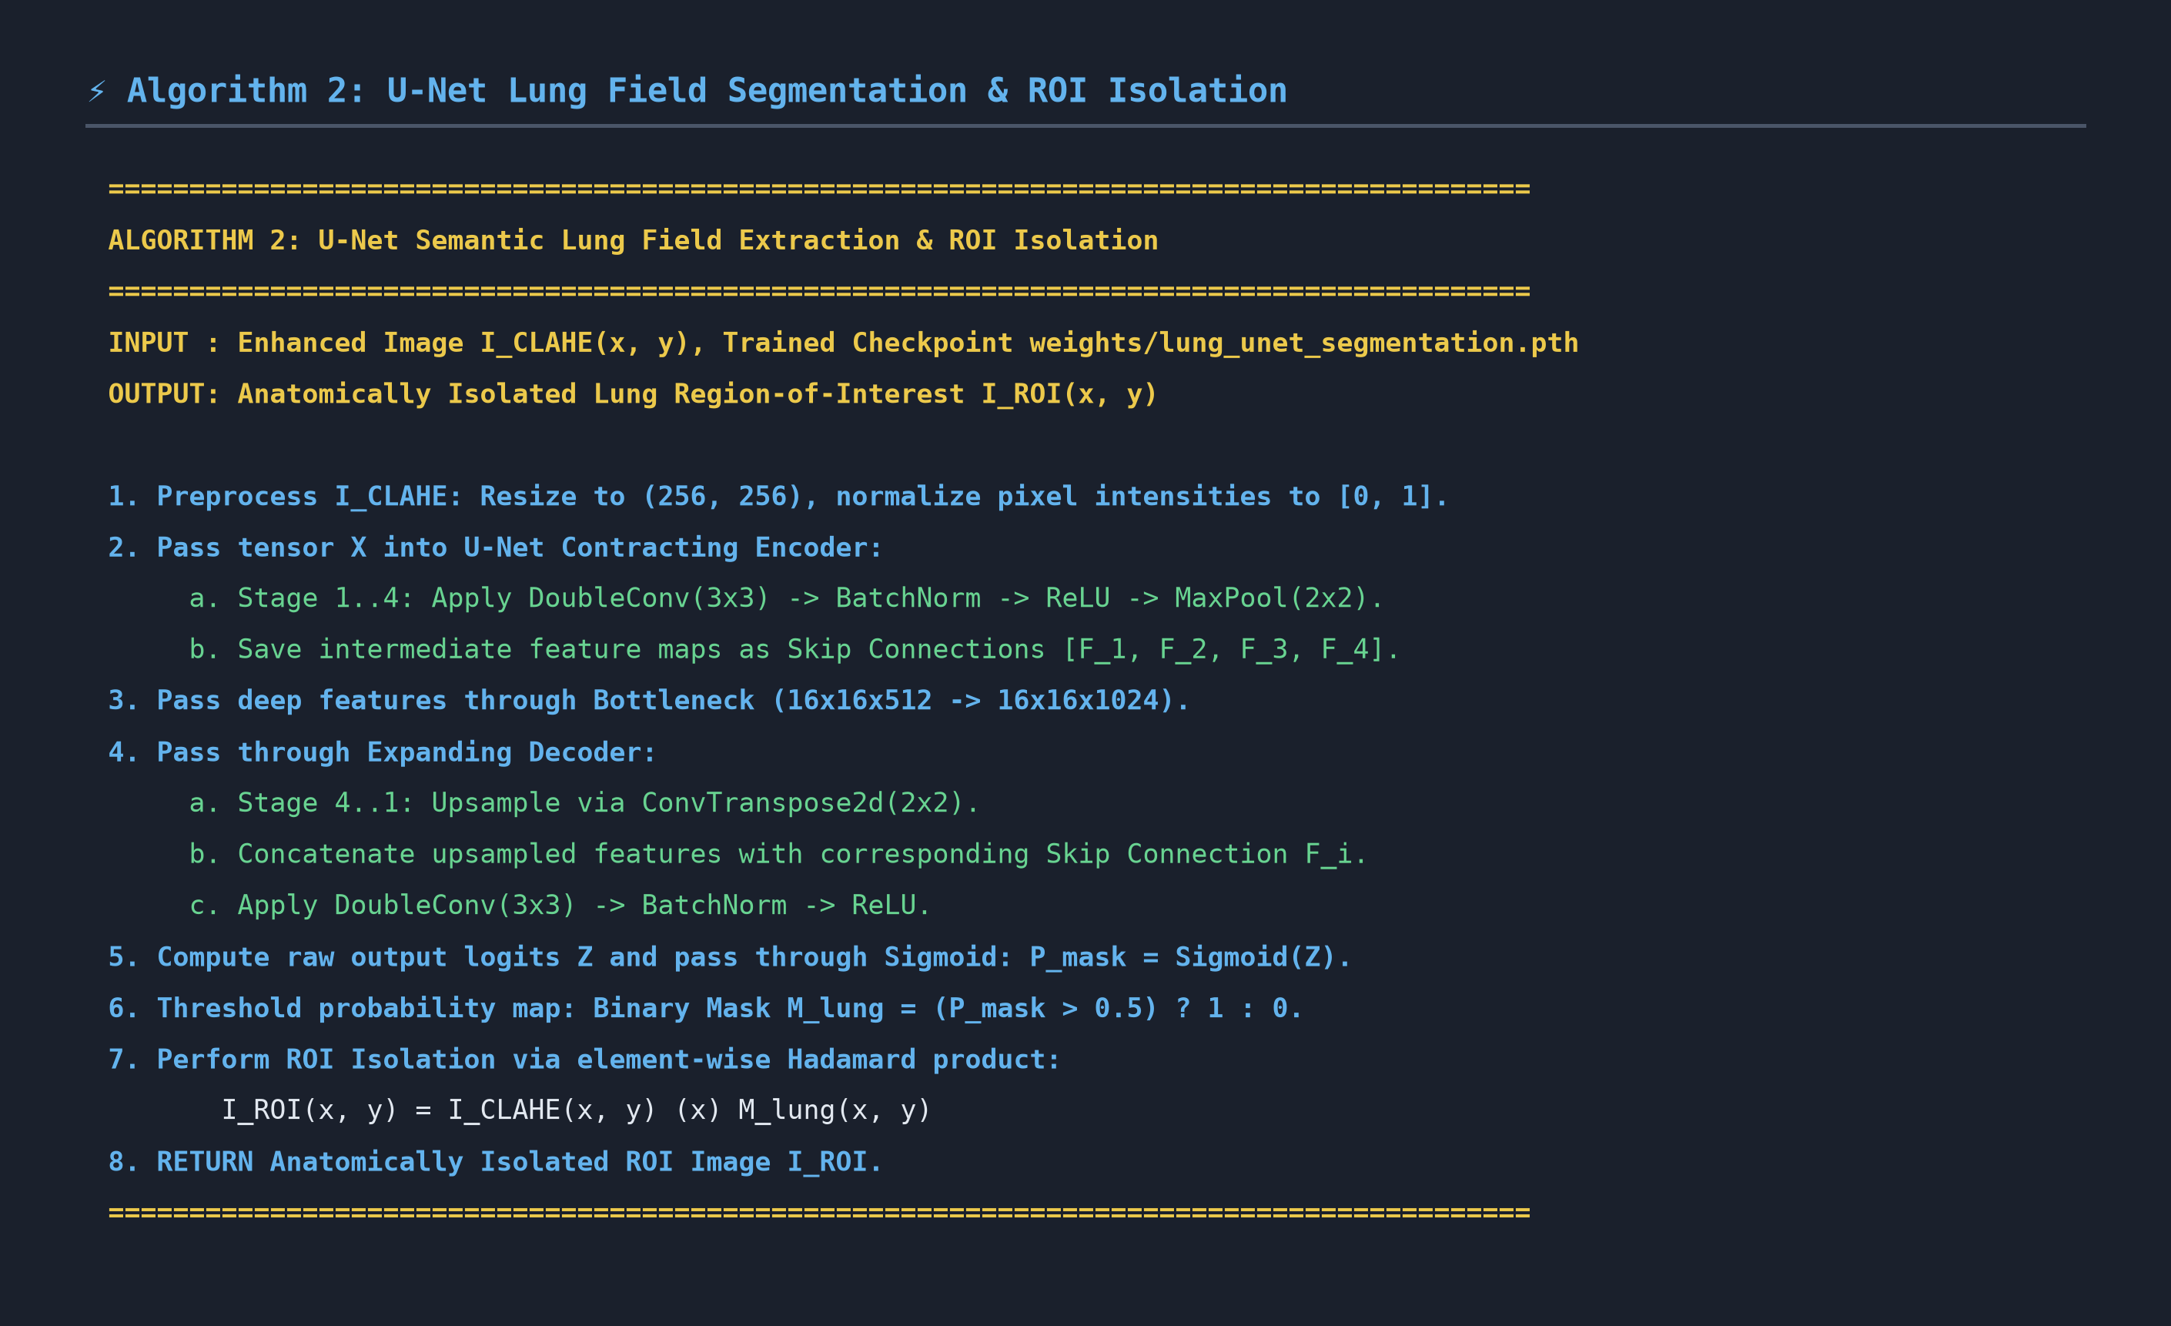
Photo 2.1: High-Resolution Pseudocode — Algorithm 2 (Biomedical U-Net Lung Field Extraction)

Photo 2.2: Rendered Mathematical Formulas — Combined DiceBCELoss & Dice Metric Formulation
2.3 Exhaustive Variable & Mathematical Symbol Registry
Variable / Symbol | Role Name | Detailed Mathematical & Technical Description
X | Input Image Tensor | Preprocessed CLAHE image rescaled to 256x256 resolution, normalized to tensor range [0.0, 1.0].
DoubleConv(3x3) | Double Conv Block | Sequence of Conv2d(3x3) -> BatchNorm2d -> ReLU -> Conv2d(3x3) -> BatchNorm2d -> ReLU.
F_1, F_2, F_3, F_4 | Skip Connections | High-resolution spatial feature maps preserved from encoder stages prior to 2x2 max-pooling.
Z | Output Logits Tensor | Raw unscaled output tensor of size (1, 256, 256) produced by final 1x1 convolution layer.
P_{mask} | Probability Map | Continuous pixel-wise lung probability map generated via Sigmoid: P_{mask} = Sigmoid(Z) in [0.0, 1.0].
M_{lung} | Binary Lung Mask | Binarized spatial mask thresholded at 0.5: M_{lung}(x,y) = 1 if P_{mask}(x,y) > 0.5 else 0.
I_{ROI}(x,y) | Isolated Lung ROI | Anatomically isolated lung parenchyma image produced by Hadamard product: I_{ROI} = I_{CLAHE} \odot M_{lung}.
\odot \text{ or } \otimes | Hadamard Product | Element-wise matrix multiplication between CLAHE image tensor and binary mask tensor.
\mathcal{L}_{DiceBCE} | Combined Loss Function | Total segmentation loss: \mathcal{L}_{DiceBCE} = \alpha \mathcal{L}_{BCE} + (1-\alpha) \mathcal{L}_{Dice} with \alpha=0.5.
\mathcal{L}_{BCE} | Binary Cross Entropy | Pixel-wise classification loss: \mathcal{L}_{BCE} = - (1/N) \sum [ y_i \log(p_i) + (1-y_i) \log(1-p_i) ].
\mathcal{L}_{Dice} | Dice Overlap Loss | Spatial region overlap loss: \mathcal{L}_{Dice} = 1 - (2 \sum p_i g_i + \epsilon) / (\sum p_i + \sum g_i + \epsilon).
p_i | Predicted Probability | Model predicted lung probability for pixel i (where p_i = Sigmoid(logits_i)).
g_i | Ground-Truth Mask | Binary ground-truth lung label for pixel i (1 = lung parenchyma, 0 = background).
\epsilon | Smoothing Epsilon | Small constant (10^{-6}) added to numerator and denominator to prevent division by zero.
2.4 Step-by-Step Execution Mechanics
1. Feature Contracting (Encoder): Input X passes through 4 encoder blocks (64 -> 128 -> 256 -> 512 channels), saving skip connections F_i.
2. Bottleneck Stage: Deep contextual features are processed through bottleneck double convolution (1024 channels).
3. Feature Expanding (Decoder): Transposed 2x2 convolutions upsample feature maps, concatenating skip connections F_i at each stage.
4. Binary Mask Generation & ROI Cropping: Sigmoid produces probability map P_{mask}. Thresholding at 0.5 creates binary mask M_{lung}. Element-wise multiplication produces isolated ROI I_{ROI}.
🎙️ PRESENTATION POINTERS & VIVA DEFENSE GUIDE: ALGORITHM 2 (U-NET SEGMENTATION)
• Why Skip Connections?: Max-pooling reduces spatial resolution. Skip connections copy high-resolution edge features from encoder to decoder, preserving fine apical and costal lung borders.
• Why Combine BCE + Dice Loss?: BCE measures pixel-wise classification accuracy but struggles with foreground/background imbalance. Dice loss measures region overlap. Combining both achieves high stability and a Dice score of 0.956.
• Key Clinical Impact: Eliminates shortcut learning artifacts (ribs, text markers, ECG leads) so downstream ResNet50 inspects only lung parenchyma.

ALGORITHM 3: RESNET50 CLASSIFIER & MIXUP AUGMENTATION
3.1 Clinical Rationale & Objective
Differentiating Bacterial pneumonia (Class 1) from Viral pneumonia (Class 2) is vital for antimicrobial stewardship: Bacterial infections require immediate antibiotics, while Viral cases require supportive antiviral care and withholding antibiotics. However, medical datasets exhibit severe class imbalance (Kermany dataset: 47.5% Bacterial, 27.0% Normal, 25.5% Viral). Algorithm 3 trains a 50-layer deep Residual Network (ResNet50) using inverse class frequency weights w_c and Albumentations MixUp data augmentation to prevent model bias toward the dominant Bacterial class and enforce smooth decision boundaries.
3.2 Rendered Pseudocode & Formula Photos
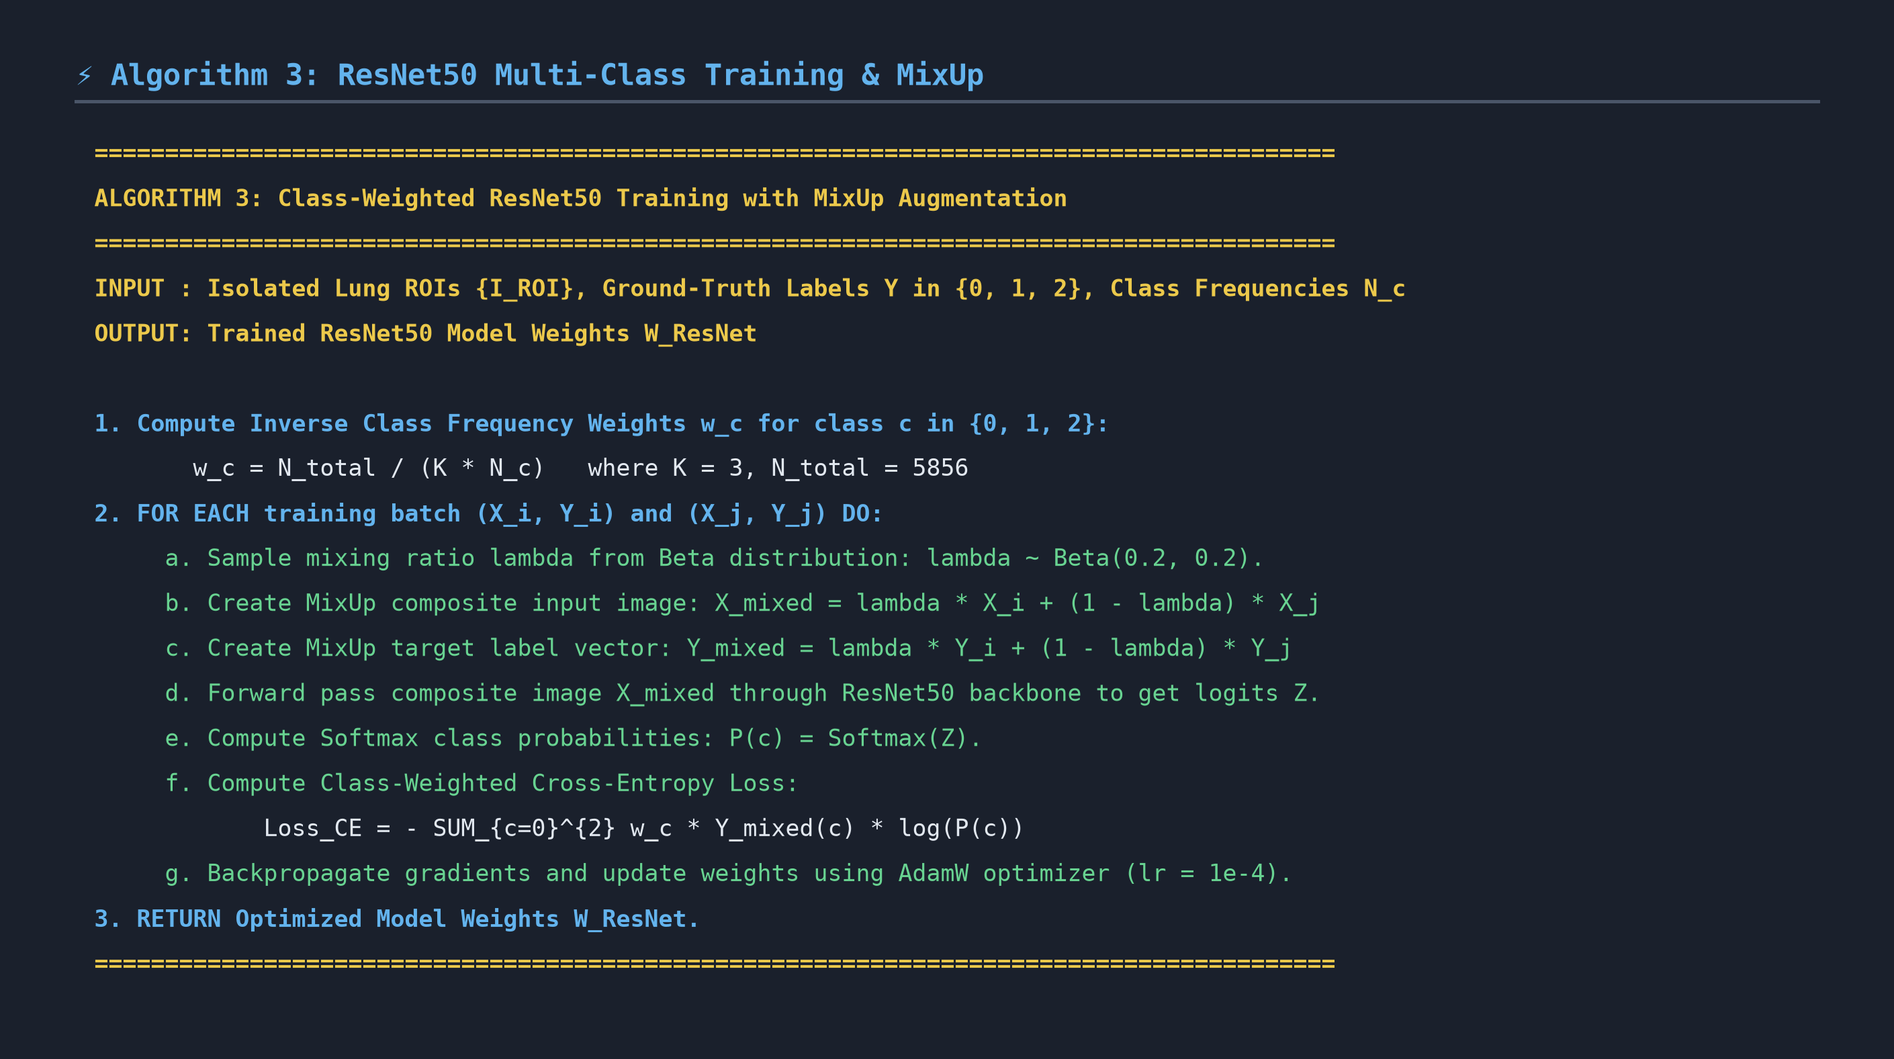
Photo 3.1: High-Resolution Pseudocode — Algorithm 3 (Class-Weighted ResNet50 Classifier)

Photo 3.2: Rendered Mathematical Formulas — Inverse Class Weighting & MixUp Formulation
3.3 Exhaustive Variable & Mathematical Symbol Registry
Variable / Symbol | Role Name | Detailed Mathematical & Technical Description
K | Class Count | Total target diagnostic categories (K = 3: Class 0=Normal, Class 1=Bacterial, Class 2=Viral).
N_{total} | Total Sample Count | Total radiographs in dataset (N_{total} = 5,856 images).
N_c | Class Frequency | Number of training samples in class c (N_0 = 1583, N_1 = 2780, N_2 = 1493).
w_c | Inverse Class Weight | Class balancing multiplier: w_c = N_{total} / (K \cdot N_c) (w_0 = 1.23, w_1 = 0.70, w_2 = 1.31).
\lambda | MixUp Interpolation Ratio | Random mixing coefficient sampled from Beta distribution: \lambda \sim \text{Beta}(\alpha, \alpha) with \alpha=0.2.
x_i, x_j | Input Pair Images | Two distinct lung ROI image tensors sampled from training batch.
y_i, y_j | Input Pair Labels | Corresponding one-hot ground-truth label vectors for images i and j.
\tilde{x} | MixUp Composite Image | Convex combination input image: \tilde{x} = \lambda x_i + (1-\lambda) x_j.
\tilde{y} | MixUp Composite Label | Convex combination target label vector: \tilde{y} = \lambda y_i + (1-\lambda) y_j.
Z | Unscaled Output Logits | Raw 3-dimensional classification score vector produced by ResNet50 final linear layer.
P(c) \text{ or } \hat{y}_c | Softmax Probability | Predicted probability for class c: P(c) = \exp(Z_c) / \sum_{k=0}^2 \exp(Z_k).
\mathcal{L}_{CE} | Weighted Cross-Entropy | Class-weighted loss: \mathcal{L}_{CE} = - \sum_{c=0}^{2} w_c \tilde{y}_c \log(P(c)).
3.4 Step-by-Step Execution Mechanics
1. Weight Calculation: Pre-calculate inverse class weights w_c to penalize majority class misclassifications heavily.
2. MixUp Augmentation: Sample λ ~ Beta(0.2, 0.2). Construct blended image x̃ and target label vector ỹ.
3. Residual Learning: Forward pass x̃ through ResNet50 residual shortcut blocks (F(x) + x), avoiding vanishing gradients.
4. Loss Backpropagation: Calculate weighted loss L_CE. Backpropagate gradients using AdamW optimizer (learning rate 1e-4).
🎙️ PRESENTATION POINTERS & VIVA DEFENSE GUIDE: ALGORITHM 3 (RESNET50 & MIXUP)
• Why Inverse Class Weighting?: Bacterial pneumonia comprises 47.5% of dataset samples. Without weights (w_1=0.70 vs w_2=1.31), the model would over-predict Bacterial cases. Class weighting forces equal attention to Viral and Normal cases.
• Why MixUp Augmentation?: Standard training causes deep networks to become overconfident in linear decision boundaries. MixUp forces the model to behave linearly between training samples, dramatically improving generalizability.
• Key Clinical Impact: Ensures high-sensitivity 3-way triage, supporting antimicrobial stewardship.

ALGORITHM 4: GRAD-CAM EXPLAINABLE AI SALIENCY MAPPING
4.1 Clinical Rationale & Objective
Clinical deployment of medical AI requires explainability: attending radiologists will not trust 'black-box' predictions without visual confirmation of diagnostic features. Gradient-Weighted Class Activation Mapping (Grad-CAM) computes the gradients of target score Y^c with respect to Layer 4 bottleneck feature maps A^k. Applying Global Average Pooling (GAP) and ReLU activation generates a 2D spatial heatmap overlaying genuine pulmonary lesions.
4.2 Rendered Pseudocode & Formula Photos
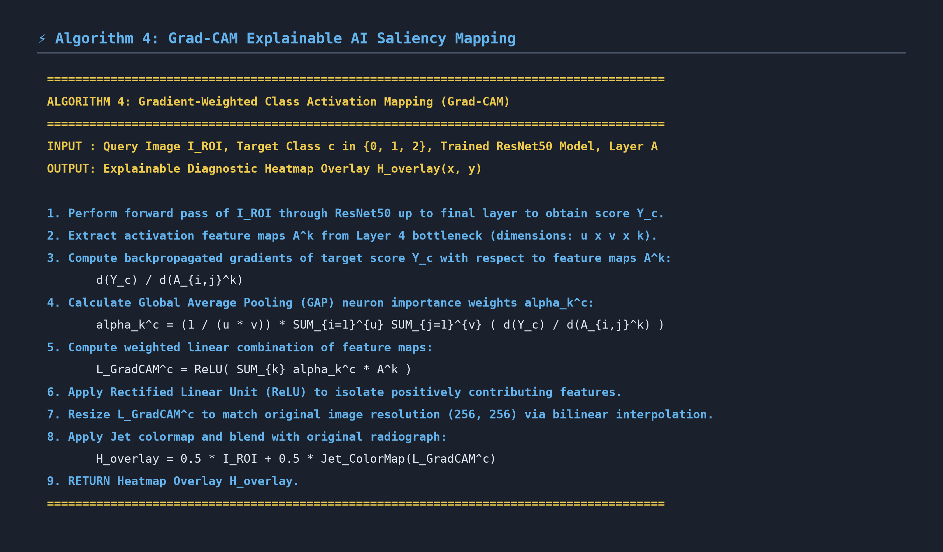
Photo 4.1: High-Resolution Pseudocode — Algorithm 4 (Grad-CAM Explainable AI Mapping)

Photo 4.2: Rendered Mathematical Formulas — GAP Neuron Weights & Heatmap Activation
4.3 Exhaustive Variable & Mathematical Symbol Registry
Variable / Symbol | Role Name | Detailed Mathematical & Technical Description
c | Target Class Index | Selected diagnostic class for visual explanation (0=Normal, 1=Bacterial, 2=Viral).
Y^c | Target Class Logit Score | Unnormalized network classification output logit for class c prior to Softmax.
A^k | Feature Activation Map | k-th feature map tensor extracted from ResNet50 final convolutional layer (Layer 4 bottleneck).
A_{i,j}^k | Spatial Feature Cell | Activation intensity value at spatial row i and column j within feature map A^k.
\frac{\partial Y^c}{\partial A_{i,j}^k} | Backpropagated Gradient | Partial derivative of class score Y^c with respect to feature map cell A_{i,j}^k.
Z \text{ or } (u \times v) | Feature Map Area | Total spatial cell count in feature map (Z = u \times v, where u, v are feature map dimensions).
\alpha_k^c | Neuron Importance Weight | Global Average Pooled weight quantifying total importance of feature channel k for class c.
L_{\text{Grad-CAM}}^c | Raw Activation Map | Weighted sum of feature maps: L_{\text{Grad-CAM}}^c = \text{ReLU}( \sum_k \alpha_k^c A^k ).
\text{ReLU} | Rectified Linear Unit | Activation function \max(0, \cdot) that filters out negative gradients and retains positive lesion features.
H_{\text{overlay}} | Final Heatmap Overlay | Color-blended composite image: H_{\text{overlay}} = 0.5 \cdot I_{\text{ROI}} + 0.5 \cdot \text{Jet}(L_{\text{Grad-CAM}}^c).
4.4 Step-by-Step Execution Mechanics
1. Forward Pass & Feature Capture: Pass ROI image I_{ROI} through ResNet50, storing Layer 4 bottleneck feature maps A^k.
2. Gradient Backpropagation: Compute score Y^c for target class c. Backpropagate gradients ∂Y^c / ∂A^k back to Layer 4.
3. GAP Weight Computation: Compute neuron weights α_k^c by taking Global Average Pooling of gradients over spatial dimensions (u x v).
4. ReLU Filtering & Jet Overlay: Compute weighted sum ∑ α_k^c A^k. Apply ReLU to discard negative features. Resize to 256x256, apply Jet colormap (red=high lesion probability, blue=low), and blend with radiograph.
🎙️ PRESENTATION POINTERS & VIVA DEFENSE GUIDE: ALGORITHM 4 (GRAD-CAM EXPLAINER)
• Why Apply ReLU?: Without ReLU, features that decrease the class score are included in the map. ReLU ensures only positive evidence supporting class c is visualized in red.
• Why Layer 4 Bottleneck?: Earlier layers capture low-level edges; Layer 4 captures high-level semantic pathology (lobar consolidations vs reticulonodular opacities).
• Key Clinical Impact: Provides transparent visual proof for attending radiologists on Streamlit web dashboard.

SECTION 3: ALGORITHM SUMMARY CHEAT-SHEET MATRIX
Alg # | Algorithm Name | Input -> Output | Core Mathematical Formula | Key Parameter & Advantage
Alg 1 | CLAHE Contrast Engine | Raw CXR -> Enhanced Image | N_{clip} = \beta \cdot (N_x N_y) / L  S(u,v) = \text{Bilinear}(CDF) | Tile Grid: 8x8, β=2.0  Unmasks ground-glass opacities without over-saturation.
Alg 2 | U-Net Lung Segmenter | Enhanced Image -> Lung ROI | L_{DiceBCE} = 0.5 L_{BCE} + 0.5 L_{Dice}  L_{Dice} = 1 - \frac{2 \sum p_i g_i + \epsilon}{\sum p_i + \sum g_i + \epsilon} | Dice Score: 0.956, IoU: 0.898  Eliminates rib/text label shortcut learning.
Alg 3 | ResNet50 Classifier | Lung ROI -> 3-Class Probabilities | w_c = N_{total} / (K \cdot N_c)  \tilde{x} = \lambda x_i + (1-\lambda) x_j | w_{Normal}=1.23, w_{Bacter}=0.70, w_{Viral}=1.31  Resolves severe class imbalance & overconfidence.
Alg 4 | Grad-CAM Explainer | ROI + Logits -> Jet Heatmap | \alpha_k^c = \frac{1}{Z} \sum \frac{\partial Y^c}{\partial A_{i,j}^k}  L^c = \text{ReLU}(\sum \alpha_k^c A^k) | Layer 4 Bottleneck  Visual proof for radiologists on Streamlit Web UI.

