
Vivekananda College of Engineering & Technology
[A unit of Vivekananda Vidyavardhaka Sangha, Puttur ®]
Affiliated to Visvesvararaya Technological University, Belagavi
Approved by AICTE, New Delhi & Govt of Karnataka

ASSINGNMENT-2
WEB TECHNOLOGIES(MMC105)
HOSPITAL APPOINTMENT BOOKING SYSTEM
“A Frontend-Based System for Easy and Efficient Hospital Appointment Scheduling”

Submitted To,
Dr. Jothimani K,
Head of the Department,
Dept of MCA,
VCET, Puttur-574203

Submitted by,
Regno: 25MC001 Regno: 25MC029
Name: Adithya Sharma M Name: Pradeeshraj V S
Class: 1 year Class: 1 year
Dept: MCA Dept: MCA

Submitted on,
Date: 19-02-2026

Nehru Nagar, Puttur - 574 203, DK, Karnataka State – INDIA.
Phone :+91-8251-235955, 234555 Fax : 236444, Web: www.vcetputtur.ac.in ,E mail: principal@vcetputtur.ac.in

INTRODUCTION
TITLE OF THE PROJECT – MediBook
HOSPITAL APPOINTMENT BOOKING SYSTEM
“A Frontend-Based System for Easy and Efficient Hospital Appointment Scheduling”
- INTRODUCTION
The modern healthcare landscape requires efficient digital solutions to bridge the gap between patients and medical specialists. MediBook is a web-based appointment request system designed to streamline the process of scheduling medical visits. It provides a professional interface where patients can select departments and book slots instantly, replacing manual phone-based or walk-in systems.

PROBLEM STATEMENT

Traditional medical booking systems often suffer from:

Inconsistent appointment tracking.

Long waiting times for patient registration.

Lack of personalized confirmation for patients.

Difficulty in managing department-specific specialist queues.

3. OBJECTIVES

To provide a user-friendly digital platform for healthcare booking.

To implement personalized patient responses using dynamic web technology.

To organize medical services by specialty (Cardiology, Neurology, etc.).

To ensure a mobile-responsive experience for users on all devices.

TECHNOLOGY USED & ARCHITECTURE

4. TECHNOLOGY STACK

Frontend:

HTML5: Structured the booking form and success pages.

CSS3 & Bootstrap 5.3: Used for the "Frosted Glass" UI effect, responsive grids, and professional typography.

Google Fonts (Inter): For a clean, modern medical interface.

Interactivity:

JavaScript (ES6): Used for date validation (disabling past dates), form submission handling, and URL parameter parsing to personalize the success message.

Design Elements:

Animate.css Logic: Custom CSS animations for card "Slide-Up" effects and background movements.

5. SYSTEM ARCHITECTURE

MediBook follows a Client-Side Data Flow model:

User Input: Patient enters details (Name, Email, Specialty) on the appointment.html page.

Validation: JavaScript ensures the appointment date is not in the past.

Data Transfer: Upon submission, data is encoded into URL parameters.

Dynamic Rendering: The success.html page extracts the patient's name and displays a personalized "Safe Hands" confirmation.

SYSTEM FEATURES & USER ROLES

6. KEY FEATURES

Personalized Success Page: Dynamically greets the patient by name upon successful booking.

Safe Hands Badge: A specialized UI component that provides psychological comfort to the patient.

Smart Date Picker: Automatically restricts users from picking dates that have already passed.

Frosted Glass UI: High-end aesthetic using backdrop-filter for a modern, professional look.

Specialty Selection: Categorized departments for efficient routing.

7. SYSTEM USERS

Patient: Can view specialist profiles, select departments, and submit appointment requests.

Medical Staff (Backend Logic): Receives structured data to finalize and confirm the visit via email or phone.

INTERFACE PREVIEW
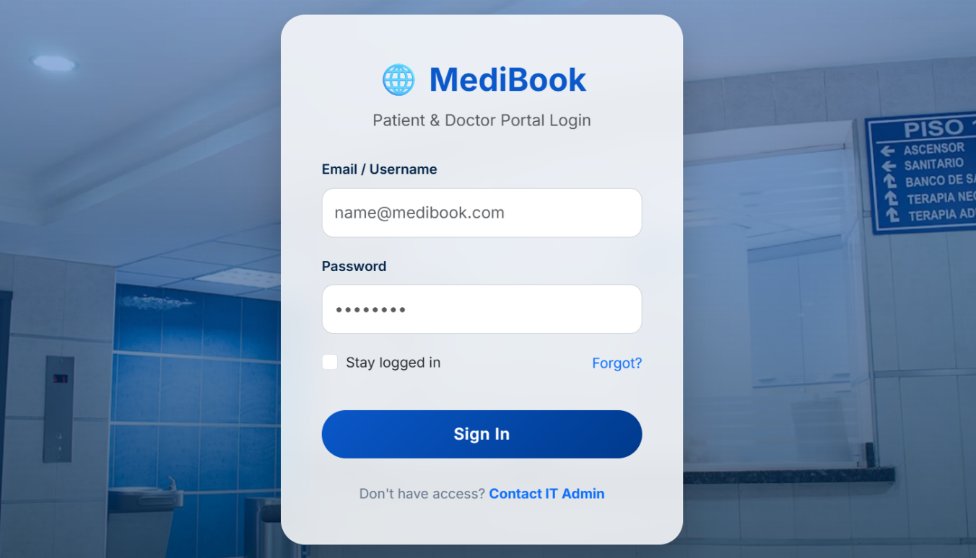

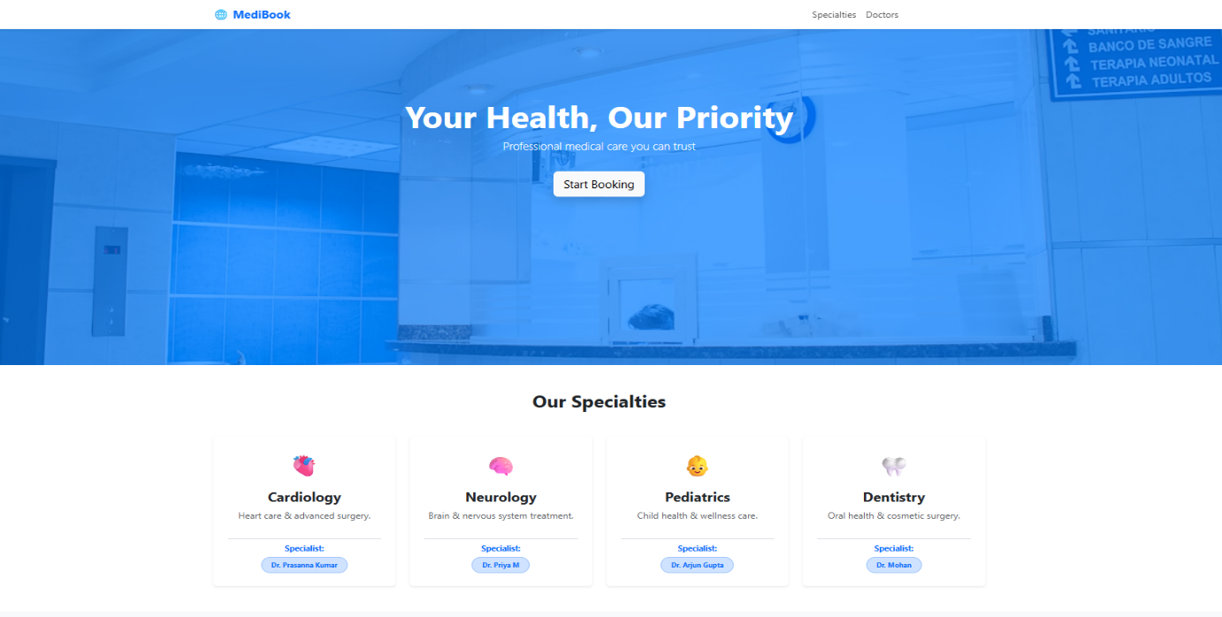
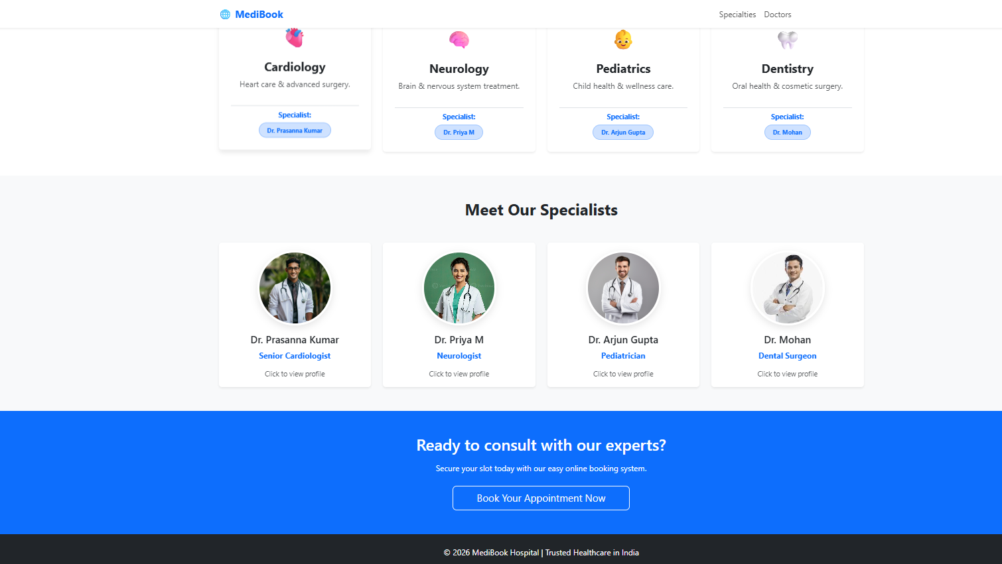
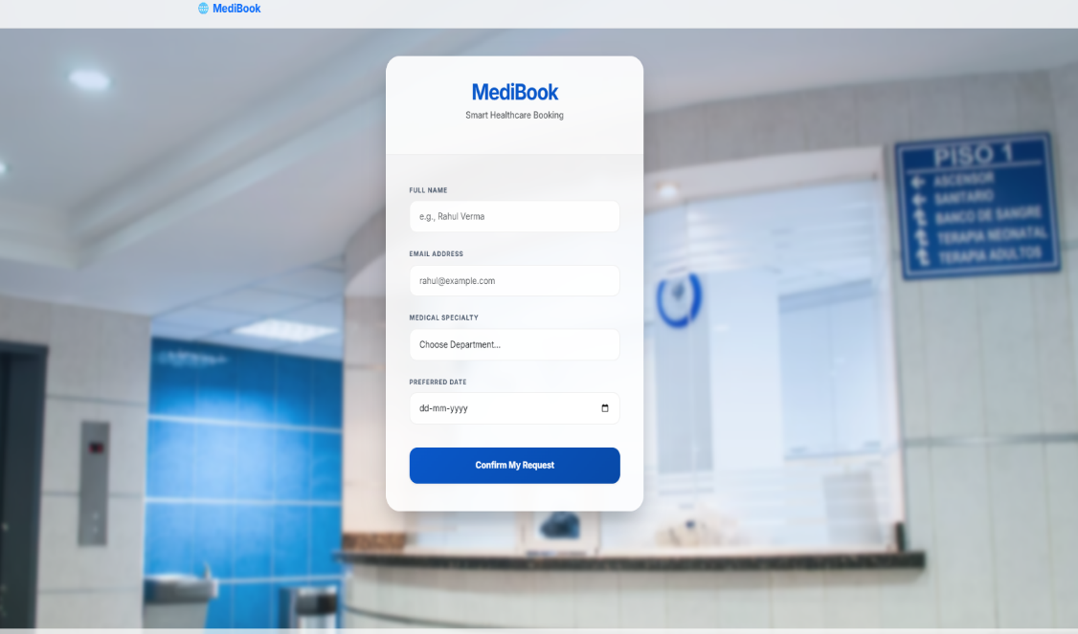
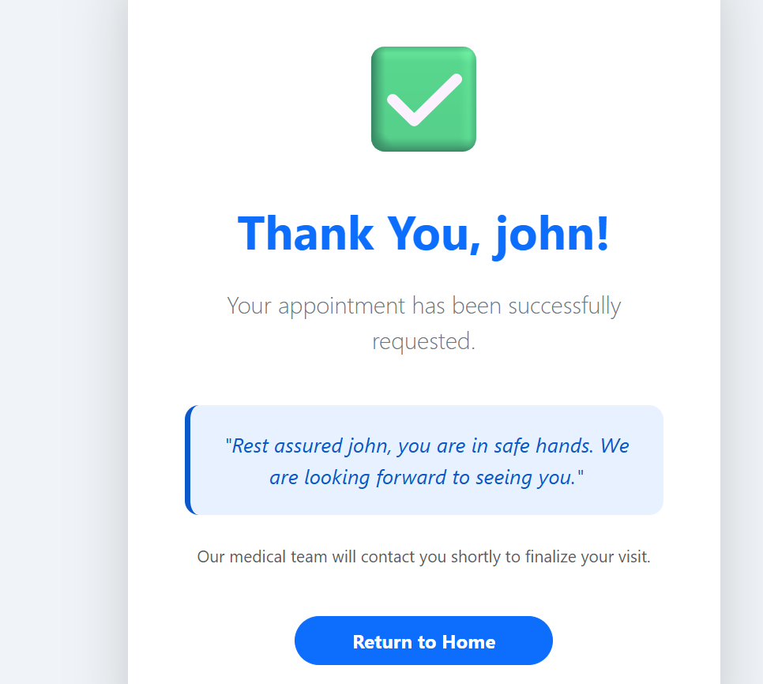

8. DESIGN PHILOSOPHY

The interface uses a High-Quality Clinic Background with a blur filter (4px) and a linear gradient to maintain text readability while providing a professional medical atmosphere. The "Confirm My Request" button utilizes a 135-degree blue gradient for high visibility.

CONCLUSION & ADVANTAGES

9. ADVANTAGES

Personalization: Individualized "Thank You" messages improve patient trust.

Efficiency: Reduces the administrative load on hospital front-desk staff.

Accessibility: Accessible via Desktop, Tablet, or Mobile devices anytime.

Safety: Ensures patients feel secure through "Safe Hands" messaging and professional design.

10. CONCLUSION

The MediBook system effectively demonstrates the practical application of front-end web technologies in the healthcare sector. By combining Bootstrap's layout power with JavaScript's dynamic capabilities, the project provides a seamless user journey from browsing doctor profiles to receiving a personalized confirmation. This project serves as a robust foundation for a full-scale hospital management system.

