Computer-Use Automation System
Detailed Architecture & Implementation Proposal
Python • Accessibility-first discovery • Verified capabilities • Deterministic replay

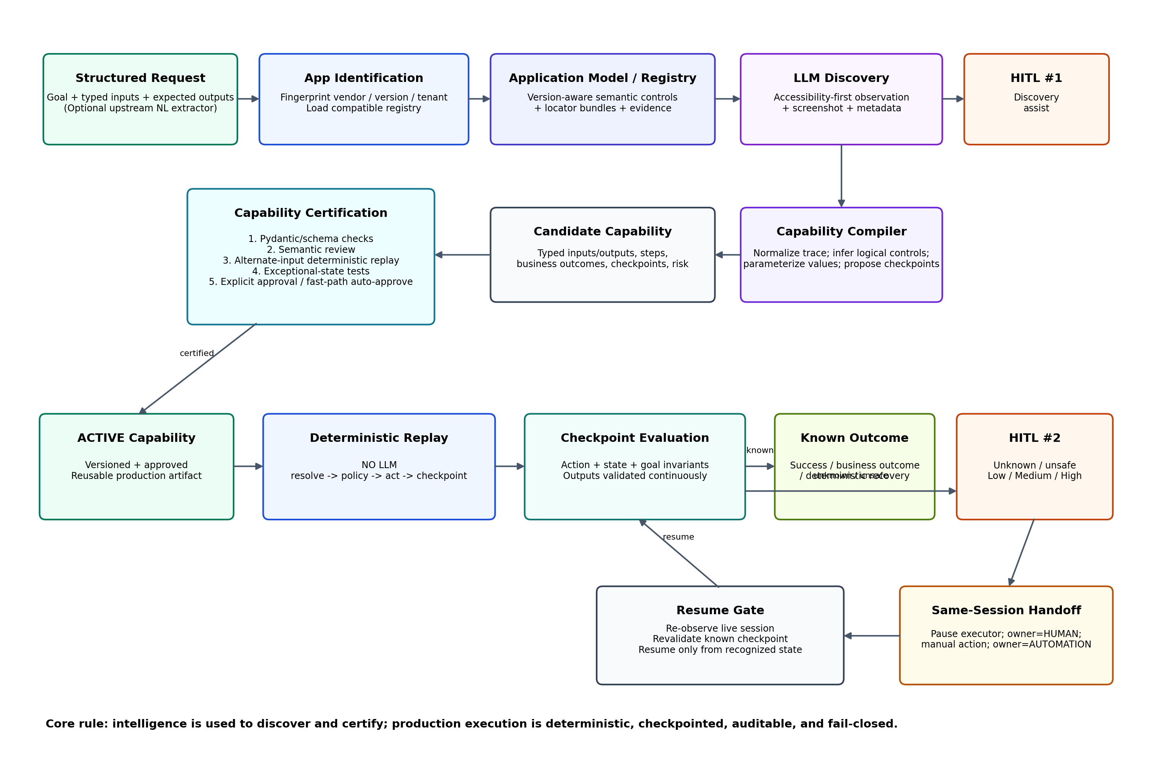
North-star principle: The model discovers. The artifact becomes a reusable capability. Deterministic replay is how the AI agent invokes it in production.

Executive Summary
This proposal treats computer-use automation as a capability compilation problem rather than a browser-agent problem. An LLM is valuable when the system must understand an unfamiliar interface semantically, but it is deliberately removed from production execution. A successful discovery run is compiled into a typed, versioned capability, certified against different inputs and failure modes, explicitly approved, and only then allowed to replay deterministically.
The system is intentionally conservative because the target environment is regulated financial software. Ambiguity is not resolved by “best guess” clicking. Unknown application versions, conflicting locator evidence, unrecognized dialogs, or high-risk actions cause the automation to pause and escalate. The design favors auditability, version control, checkpoint proof, and human control over aggressive self-healing.

Design Principles
Principle | Design consequence
Semantic discovery, not keyword matching | The LLM interprets control meaning from task context, accessibility/UI data, nearby content, and screenshots. Exact label text is evidence, not identity.
Logical identity is separate from locator | Capabilities refer to semantic controls; version-specific registries map those controls to runtime locator bundles.
Discovery is not approval | An LLM may propose a capability. Schema checks, behavioral verification, exceptional-state tests, and approval certify it.
No LLM in production replay | Unknown states trigger deterministic recovery or human intervention—never open-ended model recovery.
Checkpoints prove success | Action, state, and goal checkpoints demonstrate that the correct record/state/output was reached.
Fail closed | Ambiguity, drift, unsafe states, or unresolved control ownership stop execution rather than encouraging improvisation.
Human intervention does not silently rewrite production | Human actions are evidence for a new draft/version; approved capabilities are immutable during a live production incident.

Explicit Assumptions and Scope Decisions
- The core execution layer receives a structured goal contract with typed inputs and expected outputs. A separate upstream language/planning agent may convert free-form user language into that contract.
- The prototype targets a deliberately legacy-style local banking application and uses Playwright as the concrete web surface. This is a stand-in for real bank software, not a claim that all target systems are browser-based.
- Accessibility/UI-tree semantics are preferred over raw DOM selectors. Screenshots provide corroborating visual evidence and a fallback when accessibility metadata is incomplete.
- Application-specific runtime IDs, labels, and locator evidence are extracted from the live surface during discovery. They are not hardcoded into the capability to simulate successful discovery.
- Certification requires a replay with data different from the discovery example so the system proves parameterization rather than memorization.
- For the take-home prototype, explicit human approval is required before a capability becomes ACTIVE. A reviewer-friendly auto-approve CLI fast path is provided only to reduce evaluation friction.

1. Architecture
The architecture separates semantic learning from production actuation. This is the central trade-off: the system accepts additional complexity in discovery and certification so that runtime behavior is cheap, deterministic, reviewable, and safer.

1.1 End-to-End Lifecycle
A. Structured request: A goal contract declares the requested capability intent, typed example inputs, expected outputs, and constraints. Example values such as member_id=12345 are explicitly marked as inputs so the compiler knows they must be parameterized rather than copied into the artifact.
B. Application identification: The system observes page/window title, application metadata, route patterns, accessibility landmarks, known control signatures, and optional displayed version information to compute an application fingerprint. That fingerprint selects the compatible version/tenant registry.
C. Discovery: The model receives a normalized UI observation—accessibility/UI tree, relevant application metadata, and screenshot evidence—and proposes one primitive action at a time. A policy engine validates each action before execution.
D. Capability compilation: A successful trace is normalized. Exploratory detours are removed, example values are replaced by symbolic input references, control semantics are promoted into logical control identities, outputs are typed, business outcomes are represented, and checkpoints are proposed.
E. Certification: The candidate artifact passes structural validation, semantic validation, alternate-input replay, exceptional-state tests, and approval. Only then can its status become ACTIVE.
F. Production replay: The executor loads an ACTIVE capability and a compatible application registry. It follows a fixed step graph, resolves controls deterministically, checks policy, executes actions, and validates checkpoints. No LLM is in the replay path.
G. Escalation: If the replay hits a state that cannot be handled safely, it creates an intervention request with Low/Medium/High severity, pauses the executor, and cedes control of the same live session to a human operator.
H. Resume: After human action, automation does not blindly continue. It re-observes the live session and must re-enter through a recognized checkpoint before execution resumes.

1.2 Core Components
Component | Responsibility
Goal Contract | Typed intent, inputs, output contract, constraints, and success requirements.
SurfaceAdapter | Normalizes perception and actions across browser/desktop implementations.
Discovery Agent | Uses LLM semantic reasoning during first-time workflow discovery.
Policy Engine | Enforces allowed domains/routes/actions and risk rules independently of the model.
Evidence Recorder | Persists structured observations, sanitized action/result logs, screenshots on failure, and human actions.
Application Model / Control Registry | Caches version-aware semantic controls and locator bundles.
Capability Compiler | Converts a successful exploratory trace into a reusable declarative procedure.
Certification Service | Validates schema, semantics, alternate-input replay, exceptional states, and approval status.
Replay Engine | Runs the approved artifact with deterministic control resolution and checkpoint validation.
Session Controller | Maintains explicit AUTOMATION/HUMAN ownership and same-session pause/resume.
Intervention Manager | Creates severity-ranked handoff requests and records resolution evidence.

1.3 Control Identity vs. Locator
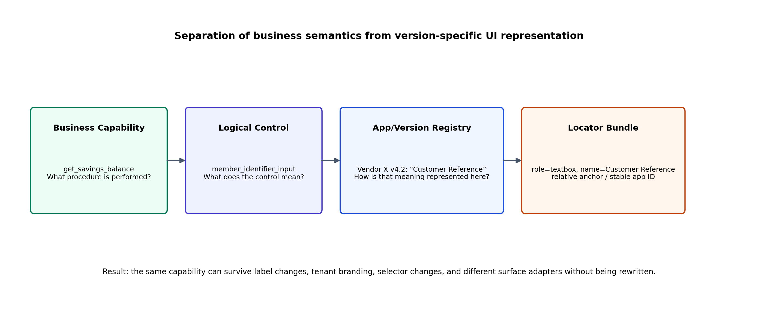
This separation is what makes the approach credible across application versions. “Customer Reference,” “Member Number,” and “Party ID” may all represent the same business-semantic control. The LLM learns that mapping during discovery; deterministic replay later uses the stored version-specific mapping without re-reasoning.

1.4 Why Accessibility-First Multimodal Discovery
A DOM-first design would be easy to demonstrate but would overfit modern web applications. A screenshot-only design would generalize visually but make deterministic replay and control identity fragile. The proposed compromise is accessibility-first observation augmented by screenshots and available DOM/application metadata. Accessibility concepts—roles, names, states, bounds, parent/child relationships—also have direct analogues in Windows UI Automation and macOS Accessibility, providing a credible extension seam to desktop applications.

2. Artifact Schema
The design intentionally splits reusable knowledge into an Application Model / Control Registry and a Capability Artifact. The registry describes how a particular application version expresses business-semantic controls; the capability describes what procedure should be performed.

2.1 Application Model / Control Registry
Each application family/version maintains its own registry or cached model. A tenant may inherit the vendor-version registry and provide a narrowly scoped override for branding, labels, layout, or local configuration. Entries are created from observed controls and evidence during discovery, not predefined merely to make the demo work.
application:
family: vendor-x-member-servicing
version: "4.2"
fingerprint: "sha256:..."
controls:
member_identifier_input:
observed:
runtime_id: "ctl00_Main_txtCustomerRef"
role: "textbox"
label: "Customer Reference"
locators:
- strategy: accessibility
role: textbox
name: "Customer Reference"
- strategy: relative
section: "Customer Inquiry"
role: textbox
discovery_evidence:
- "entered example member id and resulting record matched input"

2.2 Capability Artifact
capability:
id: get_savings_balance
version: "1.0.0"
status: ACTIVE
inputs:
member_id:
type: string
sensitive: true
outputs:
balance:
type: decimal
currency:
type: string
steps:
- id: enter_member_id
action: input
control: member_identifier_input
value: { input: member_id }
checkpoint: member_identifier_field_contains_input
- id: lookup_member
action: activate
control: member_lookup_action
outcomes:
member_not_found: BUSINESS_OUTCOME
session_expired: RECOVERABLE
- id: extract_savings_balance
action: extract
control: savings_balance
output: balance
goal_checkpoints:
- displayed_member_id == input.member_id
- selected_account_semantic_type == "savings"
- balance is parseable_decimal

2.3 Capability Lifecycle
DISCOVERING → DRAFT → VALIDATING → VERIFIED → APPROVED → ACTIVE → (SUSPENDED | DEPRECATED). A discovery success therefore creates only a candidate. The certification path must prove that the candidate can generalize and fail safely before it is eligible for unattended execution.

2.4 Capability Certification
Structural validation: Pydantic verifies required fields, type contracts, step references, checkpoints, outputs, risk metadata, and lifecycle state.
Semantic validation: A logically separate review pass checks whether the proposed logical controls, parameterization, outputs, and checkpoints correspond to the goal and discovery evidence. The LLM can assist here, but its result is advisory.
Behavioral verification: Replay the generated artifact with a different valid member/input. This is the strongest proof that the artifact represents a procedure rather than the example run.
Exceptional-state verification: Test at least one legitimate business outcome and one simulated recoverable/failure condition.
Approval: Prototype default: explicit approval. Reviewer convenience: a clearly marked `--auto-approve` fast path executes certification tests and activates the artifact when all gates pass.

3. Determinism & Error Handling

3.1 Deterministic Replay Contract
Deterministic does not mean the application must be static or that every interaction uses the same coordinates. It means the executor follows a fixed algorithm and fixed artifact with no model making runtime decisions. Locator fallbacks, waits, business-outcome branches, and recovery handlers are declared or implemented deterministically.

3.2 Control Resolution
The replay engine never chooses the “best-looking” candidate unconditionally. It generates candidates using the stored locator bundle and accepts a target only when required evidence is satisfied and the match is sufficiently unique. If two controls are near-equivalent, that is treated as ambiguity rather than an opportunity to guess.

3.3 Checkpoint Model
Checkpoint | Question | Example
Action | Did the immediate UI operation take effect? | The member input contains the supplied member_id.
State | Did the application reach the expected state? | The member-details screen is present and stable.
Goal | Did the requested business objective actually complete? | Displayed member matches input; savings account identified; balance extracted and typed.
The model may propose that discovery is complete, but system success is only granted when the declared goal checkpoints can be satisfied. This prevents “the model said it was done” from becoming the correctness criterion.

3.4 Error Taxonomy
Business outcome: The automation worked and the application returned a legitimate result the caller needs, e.g., MEMBER_NOT_FOUND.
Recoverable condition: A known condition has a deterministic handler, e.g., a known informational modal or a retryable slow load.
Hard failure / intervention: The system cannot safely establish a valid next state, e.g., target ambiguity, unknown dialog, incompatible app fingerprint, exhausted retry, or policy denial.
Retries are only allowed when the action is safe or idempotent. A timeout after a non-idempotent financial action is not blindly retried; the executor first establishes whether the operation committed, and escalates when that cannot be determined safely.

3.5 Drift and Version Mismatch
Before replay, the system computes a runtime application fingerprint and compares it with the registry entry. High-confidence compatibility allows normal use. Medium confidence can require stricter checkpoint validation or manual approval. Low confidence suspends the cached mapping and routes to rediscovery/review. Production replay never “self-heals” a changed UI by asking an LLM what to click.

4. Heterogeneity & Multi-Tenant
The prototype implements one concrete browser surface, but the artifact does not encode Playwright commands or CSS selectors as business logic. The `SurfaceAdapter` is the seam between a capability and a concrete UI technology.
class SurfaceAdapter:
def observe(self) -> SurfaceObservation: ...
def resolve(self, control: LogicalControl) -> ResolvedControl: ...
def execute(self, action: Action) -> ActionResult: ...
def capture_evidence(self) -> Evidence: ...
A browser adapter can use Playwright plus accessibility/DOM metadata. A desktop adapter can use Windows UI Automation or macOS Accessibility while returning the same normalized `SurfaceObservation` and accepting the same logical actions. This keeps capabilities portable even when the perception/actuation mechanism changes.

4.1 Registry Inheritance Across Tenants
The registry hierarchy is: vendor product → version → tenant variant. A capability belongs primarily to the application family, while locator differences live in the registry. Tenant-specific overrides are narrow and reviewable rather than duplicating an entire workflow per institution.
Vendor X / Member Servicing
└── v4.2 base registry
├── Bank A: inherits base
├── Bank B: override member_identifier_input label
└── Bank C: override account tab locator + branding landmark

4.2 Generalization Test
A discovery run on member 10001 does not prove a reusable capability if verification also uses member 10001. Certification deliberately replays with member 10002 and expects its real balance, then exercises a nonexistent or restricted member. This demonstrates that runtime inputs and outputs are parameterized and that expected business outcomes are represented rather than memorized.

5. Escalation & Handoff
Two separate intervention paths are implemented because discovery uncertainty and production uncertainty have different consequences.

5.1 Discovery HITL
Discovery may pause when semantic mapping is ambiguous, the model is stuck after bounded attempts, a required action is policy-sensitive, or the surface cannot be interpreted confidently. A human operates the same live session, and the recorder captures those actions as evidence. The resumed discovery may use that evidence, but the resulting capability still undergoes normal certification.

5.2 Replay HITL
Replay pauses when deterministic execution cannot safely continue. The session controller owns a single live browser/context and maintains an explicit ownership state. When `owner=AUTOMATION`, the executor may issue actions. On intervention it atomically moves to `PAUSED_FOR_HUMAN` / `owner=HUMAN`, stops the replay event loop from issuing further actions, and exposes the already-running session for manual control. Human completion signals transition to a resume gate rather than directly back to execution.

5.3 Same-Session Pause / Resume Mechanics
- The Playwright BrowserContext/Page remain alive throughout handoff; a fresh browser is never created for the operator.
- The executor checks an asyncio/Event-based control token before every action and wait boundary. Pausing clears that token and prevents race conditions where the agent acts after ownership changed.
- The human operator manipulates the same headed page while automation is paused. Human actions are recorded separately with actor=HUMAN.
- Resume sets owner back only after the operator explicitly signals completion. The executor then re-observes the page and must match a known checkpoint/state before continuing.
- If the human leaves the application in a state not represented by the capability, replay does not improvise. It remains paused or terminates with a structured intervention result.

5.4 Severity
Severity | Meaning | Example
Low | Limited impact; typically discovery ambiguity or non-critical interruption. | A label meaning is unclear during discovery but no risky action is pending.
Medium | Execution is blocked and manual action is required before the capability can continue. | Unexpected runtime dialog or ambiguous control resolution.
High | Potential security, sensitive-data, or irreversible financial impact. | Unexpected state immediately before account creation/transaction submission.
Severity is primarily rule-derived from risk level, production impact, data sensitivity, and whether an irreversible operation is pending—not an arbitrary LLM-generated score.

6. Safety
Safety controls sit outside the LLM and are applied during both discovery and replay. This ensures an unsafe model proposal or a stale capability cannot bypass policy merely because it was previously approved.
Control | Behavior
Allowlist | Permitted domains/applications, routes, action types, navigation boundaries, and capability classes.
Risk classification | Read-only, reversible, and irreversible/high-risk actions. Risk metadata determines whether automated execution, confirmation, or human approval is permitted.
Sensitive-data handling | Artifacts use symbolic input references rather than embedding example PII. Logs redact marked fields. API keys and credentials are external configuration and never persist into evidence.
Fail-closed targeting | Ambiguous matches, unknown version fingerprints, and unexpected confirmation states stop execution.
Immutable active artifacts | A human production intervention does not mutate the active artifact. Remediation creates a new draft/version that must be certified.
Evidence | Structured logs contain run/capability/step IDs, action/outcome codes, sanitized observations, and screenshots or snapshots on failure.

6.1 Limits of the Safety Model
No automation framework can prove a business operation is safe from UI evidence alone. Safety depends on correct policy configuration, accurate application modeling, checkpoint coverage, and trustworthy deployment controls. The design therefore treats observability, approval, versioning, and human escalation as part of the safety boundary rather than optional operational conveniences.

7. Cuts
The implementation should maximize depth in the core vertical slice rather than spend effort on scaling infrastructure that does not demonstrate the key design decisions.

7.1 Intentionally Not Built in the Prototype
- Distributed queues, worker fleets, Kubernetes, or high-scale orchestration.
- A production-grade remote-desktop/cobrowsing operator console; the handoff mechanism is real, while the operator UI may remain minimal.
- Full desktop implementation; only the adapter contract and design are included.
- Open-ended LLM recovery during production replay.
- Automatic mutation of active capabilities from human intervention.
- A full general-purpose natural-language planning agent; the seam is documented instead.
- Automatic approval of risky capabilities in production.

7.2 What I Would Build Next
- Windows UI Automation adapter and a second legacy-style desktop target to validate the surface abstraction.
- Reliability scoring from repeated replay runs and automatic suspension when a capability crosses a failure/drift threshold.
- Central application-registry service with inheritance, version diffs, tenant overlays, and approval workflow.
- Operator queue with RBAC, audit history, intervention SLA/priority, and secure remote session streaming.
- Capability catalog/API so the upstream agent can discover approved capabilities and invoke them with typed arguments.
- Stronger independent semantic certification, potentially using a separate model/provider for high-risk capabilities.

Demonstration Plan
Demo 1 — Discovery → Certification → Replay: Discover `get_savings_balance` using one member, compile it, certify using a different member, approve it, and replay with no LLM.
Demo 2 — Business Outcome: Replay with a nonexistent member. The executor returns a structured `MEMBER_NOT_FOUND` business outcome rather than a crash.
Demo 3 — Human Intervention: Inject an unknown/high-risk state. Replay creates an intervention request with severity, pauses the same Playwright session, allows human control, records the human action, and resumes only after checkpoint revalidation.
Demo 4 — Drift / Registry Mismatch: Present a modified application fingerprint or locator ambiguity. The executor refuses to guess and routes to review/rediscovery.

Suggested Python Module Boundaries
src/
discovery/
agent.py
observer.py
semantic_mapper.py
compiler/
capability_compiler.py
normalizer.py
schemas/
goal.py
application_model.py
capability.py
execution.py
intervention.py
surface/
base.py
playwright_surface.py
registry/
repository.py
fingerprint.py
certification/
validator.py
verifier.py
approval.py
replay/
engine.py
resolver.py
checkpoints.py
recovery.py
policy/
engine.py
handoff/
session_controller.py
intervention_manager.py
evidence/
recorder.py
redaction.py
logging/
setup.py
error_codes.py

Reviewer Experience / Fast Path
Certification is intentionally part of the architecture, but it should not create unnecessary friction for assignment reviewers. The CLI should therefore support both a review-first flow and a fast-path mode such as:
# Normal path
python -m app discover --goal-file examples/get_savings_balance.json
python -m app certify --artifact artifacts/get_savings_balance.json
python -m app approve --artifact artifacts/get_savings_balance.json
python -m app replay --artifact artifacts/get_savings_balance.json --input member_id=10002
# Reviewer fast path: runs certification gates then auto-approves if they all pass
python -m app discover --goal-file examples/get_savings_balance.json --auto-approve
python -m app replay --artifact artifacts/get_savings_balance.json --input member_id=10002
The `--auto-approve` option is an evaluation convenience, not a recommendation to bypass approval for real bank capabilities. It must still execute structural and behavioral certification checks; it only removes the manual approval click/command when those gates pass.

Evidence Package
evidence/
discovery/
run.jsonl
screenshots/
candidate_capability.json
application_registry.json
certification/
alternate_input_result.json
exceptional_state_result.json
approval.json
replay_success/
run.jsonl
result.json
replay_not_found/
run.jsonl
result.json
replay_handoff/
run.jsonl
intervention.json
human_actions.jsonl
result.json

Final Position
The proposal intentionally does not try to make the production executor intelligent. Intelligence is concentrated where it produces durable value: understanding an unfamiliar surface, discovering semantic controls, and proposing a reusable capability. Production execution is deliberately less clever—typed, versioned, checkpointed, policy-constrained, deterministic, and willing to stop. For financial software, that asymmetry is a feature rather than a limitation.

