RESPIRETECH: INTELLIGENT INHALER FOR CHRONIC CARE MANAGEMENT
A PROJECT REPORT
Submitted by

ADITHYA.B.RAJ (961422104004)
GNANA RITHICK (961422104033)
SIJO.S.S (961422104055)

in partial fulfillment for the award of the degree
of
BACHELOR OF ENGINEERING
in
COMPUTER SCIENCE AND ENGINEERING
MAR EPHRAEM COLLEGE OF ENGINEERING & TECHNOLOGY

ANNA UNIVERSITY :: CHENNAI 600 025
MAY 2026

ANNA UNIVERSITY :: CHENNAI 600 025
BONAFIDE CERTIFICATE

Certified that this project report "RESPIRETECH: INTELLIGENT INHALER FOR CHRONIC CARE MANAGEMENT" is the bonafide work of ADITHYA.B.RAJ(961422104004), GNANA RITHICK(961422104033), SIJO S.S(961422104055) who carried out the project work under my supervision.
SIGNATURE  Prof. Ashwin G. Singerji, M.E.  HEAD OF THE DEPARTMENT  Department of Computer Science and Engineering  Mar Ephraem College of Engineering & Technology  Marthandam, Tamil Nadu | SIGNATURE  Dr. Lincy C.T, M.E., Ph.D.  SUPERVISOR  Assistant Professor  Department of Computer Science and Engineering  Mar Ephraem College of Engineering & Technology  Marthandam, Tamil Nadu

Submitted for the Project and viva-voce examination held on ____________________.

Internal Examiner External Examiner
ACKNOWLEDGEMENT

First and foremost, we thank The Almighty God for endowing us with the immense blessings that helped us in each step of our progress towards the successful completion of this project report.

We thank Chairman His Excellency Most Rev. Dr. Vincent Mar Paulos, (Bishop, Catholic Diocese of Marthandam) for his blessings throughout the project.

Then we express our gratitude to Very Rev. Fr. Satheesh Kumar, Correspondent, Mar Ephraem College of Engineering and Technology for working on a great mission and vision and providing excellent infrastructure.

We express our profonde gratitude to Prof. Dr. A. Lenin Fred M.E. Ph.D., Principal of our college for granting us the permission and providing a good working environment to complete this project successfully. We give sincere thanks to our Bursar Rev. Fr. Hebin, for his moral support.

We also express our sincere thanks to the Director of our college Prof. Dr. N. Austin M.E. Ph.D., for his support and guidance.

Especially we would like to thank Prof. Ashwin G. Singerji M.E, Head of the Department, for his continuous support and Dr.Lincy C.T, M.E., Ph.D for guidance and providing all technical support and for her support during the course of work.

Finally, we offer our sincere thanks to our parents, family members and all our friends for their valuable suggestions, encouragements and support throughout the entire project work.
ABSTRACT
Poor medication adherence and incorrect inhalation techniques remain major challenges in asthma management due to the absence of real-time monitoring in conventional inhalers. The proposed system presents an IoT-enabled smart inhaler integrated with cloud computing and deep learning for accurate inhalation monitoring and personalized usage analysis. The system employs MQ-2 and DHT-22 sensors to capture inhalation dynamics and environmental parameters during medication delivery, interfaced with an ESP-8266 microcontroller. Sensor data are securely transmitted to a cloud platform for real-time processing, where a Long Short-Term Memory (LSTM) model analyzes temporal breathing patterns to detect inhaler usage and classify correct and incorrect inhalation events. Experimental evaluation demonstrates an inhaler usage detection accuracy of 96.8%, with a precision of 95.9%, recall of 96.4%, and F1-score of 96.1%. Inhalation technique classification achieves an accuracy of 93.2%, indicating reliable identification of improper usage. A mobile application provides real-time alerts, medication reminders, and detailed usage analytics for both patients and clinicians. The proposed solution significantly improves medication adherence, enabling continuous remote monitoring and data-driven decision-making for enhanced asthma management.
Keywords: Internet of Things (IoT), Arduino, Smart Asthma Management, Smart Inhalers, Smart Healthcare
சுருக்கம்

வழக்கமான இன்ஹேலர்களில் நிகழ்நேரக் கண்காணிப்பு இல்லாததால், மருந்துகளை முறையாகப் பயன்படுத்தாததும், தவறான உள்ளிழுக்கும் நுட்பங்களும் ஆஸ்துமா மேலாண்மையில் பெரும் சவால்களாக நீடிக்கின்றன. முன்மொழியப்பட்ட இந்த அமைப்பு, துல்லியமான உள்ளிழுத்தல் கண்காணிப்பு மற்றும் தனிப்பயனாக்கப்பட்ட பயன்பாட்டுப் பகுப்பாய்விற்காக, கிளவுட் கம்ப்யூட்டிங் மற்றும் டீப் லேர்னிங்குடன் ஒருங்கிணைக்கப்பட்ட, IoT-இயக்கப்பட்ட ஒரு ஸ்மார்ட் இன்ஹேலரை வழங்குகிறது. இந்த அமைப்பு, மருந்து செலுத்தப்படும்போது உள்ளிழுக்கும் இயக்கவியல் மற்றும் சுற்றுச்சூழல் அளவுருக்களைப் பதிவுசெய்ய MQ-2 மற்றும் DHT-22 சென்சார்களைப் பயன்படுத்துகிறது, மேலும் இது ஒரு ESP-8266 மைக்ரோகண்ட்ரோலருடன் இணைக்கப்பட்டுள்ளது. சென்சார் தரவுகள் நிகழ்நேரச் செயலாக்கத்திற்காக ஒரு கிளவுட் தளத்திற்குப் பாதுகாப்பாக அனுப்பப்படுகின்றன. அங்கு, ஒரு லாங் ஷார்ட்-டெர்ம் மெமரி (LSTM) மாதிரி, தற்காலிக சுவாச முறைகளைப் பகுப்பாய்வு செய்து, இன்ஹேலர் பயன்பாட்டைக் கண்டறிந்து, சரியான மற்றும் தவறான உள்ளிழுத்தல் நிகழ்வுகளை வகைப்படுத்துகிறது. சோதனை மதிப்பீடு, இன்ஹேலர் பயன்பாட்டைக் கண்டறிவதில் 96.8% துல்லியத்தையும், 95.9% துல்லியத்தன்மையையும், 96.4% மீட்டெடுப்பையும், மற்றும் 96.1% F1-மதிப்பெண்ணையும் வெளிப்படுத்துகிறது. உள்ளிழுக்கும் நுட்ப வகைப்பாடு 93.2% துல்லியத்தை அடைகிறது, இது முறையற்ற பயன்பாட்டை நம்பகத்தன்மையுடன் கண்டறிவதைக் குறிக்கிறது. ஒரு மொபைல் செயலியானது, நோயாளிகள் மற்றும் மருத்துவர்கள் இருவருக்கும் நிகழ்நேர எச்சரிக்கைகள், மருந்து நினைவூட்டல்கள் மற்றும் விரிவான பயன்பாட்டுப் பகுப்பாய்வுகளை வழங்குகிறது. முன்மொழியப்பட்ட இந்தத் தீர்வு, மருந்து உட்கொள்ளும் பழக்கத்தை கணிசமாக மேம்படுத்துவதோடு, தொடர்ச்சியான தொலைநிலைக் கண்காணிப்பு மற்றும் தரவுகளின் அடிப்படையிலான முடிவெடுத்தலைச் சாத்தியமாக்கி, ஆஸ்துமா மேலாண்மையை மேம்படுத்துகிறது.

குறிச்சொற்கள்: பொருட்களின் இணையம் (IoT), Arduino, நுண்ணறிவு ஆஸ்துமா மேலாண்மை, நுண்ணறிவு உள்ளிழுப்பான்கள், நுண்ணறிவு சுகாதாரப் பராமரிப்பு

TABLE OF CONTENTS
CHAPTER NO. TITLE PAGE NO.

ABSTRACT iii
LIST OF TABLE xv
LIST OF FIGURES xvi
LIST OF SYMBOLS xvii

1. INTRODUCTION 1
1.1 Background and Motivation 1
1.2 Problem Statement 2
1.3 Objective 2
1.4 Scope of the Project 3
1.5 Challenges in Traditional Astma
Management 3

2. LITERATURE SURVEY 4

3. METHODOLOGY 9
3.1 System Overview 9
3.2 Hardware Components &
Implementation 10
3.2.1 ESP-8266 Microcontroller 15
3.2.2 MQ-2 Gas Sensor 18
3.2.3 DHT-22 Sensor 21
3.2.4 Firmware and Edge Processing 23
3.2.5 Cloud based LSTM Model 25
3.2.6 Notification and Application Layer 27
3.2.7 Power Management 29
3.2.8 System Reliability & Security 32

3.4 Hardware Requirements 33
3.5 Software Requirements 35

4. PROJECT IMPLEMENTATION 40
4.1 Hardware Prototype 40
4.2 Web Dashboard 41

5. RESULTS AND DISCUSSIONS 42

6. CONCLUSION AND FUTURE
ENHANCEMENTS 50

REFERENCES 57

LIST OF TABLES
TABLE NO. | TITLE | PAGE NO.
3.1 | Hardware Components and Specifications | 15
5.1 | Comparison of Proposed System vs. Traditional Inhalers | 37

LIST OF FIGURES

FIGURE NO. | TITLE | PAGE NO.
3.1  3.2 | Proposed Model of Inhaler System  Architecture Diagram | 21  39
4.1 | Hardware Setup | 41
4.2  5.1  5.2  5.3 | Web Dashboard Screenshot  Confusion Matrix  Performance Comparison Between Proposed and  Existing System  Battery Comparison Between Proposed and  Existing System | 42  45  45  45

LIST OF SYMBOLS
AES | Advanced Encryption Standard
ADC | Analog-to-Digital Converter
AWS | Amazon Web Services
BLE | Bluetooth Low Energy
COPD | Chronic Obstructive Pulmonary Disease
DHT-22 | Digital Humidity and Temperature Sensor (Model 22)
ESP-8266 | Espressif Systems 32-bit Microcontroller
F1 | F1-Score (Harmonic Mean of Precision and Recall)
GPIO | General Purpose Input/Output
IDE | Integrated Development Environment
IoT | Internet of Things
LSTM | Long Short-Term Memory
ML | Machine Learning
MQ-2 | Gas/Smoke Sensor Module (Model MQ-2)
MQTT | Message Queuing Telemetry Transport
ROC-AUC | Receiver Operating Characteristic – Area Under Curve
TPR | True Positive Rate
TNR | True Negative Rate
Wi-Fi | Wireless Fidelity

CHAPTER 1

INTRODUCTION
  - BACKGROUND AND MOTIVATION
Asthma is a chronic respiratory disease that affects millions of individuals worldwide and continues to be a major public health concern. According to global health reports, the prevalence of asthma has increased significantly over the past few decades due to environmental pollution, urbanization, and lifestyle changes. In India, the situation is particularly alarming in urban regions where air quality levels frequently exceed safe limits, thereby increasing the risk of respiratory illnesses.
Asthma is characterized by airway inflammation, bronchoconstriction, and excessive mucus production, leading to symptoms such as wheezing, breathlessness, chest tightness, and coughing. Although asthma cannot be completely cured, it can be effectively managed through proper medication and monitoring. Inhalers remain the most widely used method for delivering medication directly into the lungs, ensuring rapid relief and targeted action.
However, studies indicate that a significant percentage of patients use inhalers incorrectly. Improper inhalation techniques and missed doses result in reduced drug efficacy, increased frequency of asthma attacks, and higher hospitalization rates. The absence of real-time monitoring in traditional inhalers prevents both patients and healthcare providers from tracking usage patterns and identifying issues in treatment adherence.
Recent advancements in Internet of Things (IoT) technology and Artificial Intelligence (AI) have opened new possibilities for addressing these challenges. Smart healthcare systems enable continuous monitoring, real-time data analysis, and personalized feedback, making them highly suitable for managing chronic diseases such as asthma. The integration of sensors, wireless communication, and cloud computing can transform conventional inhalers into intelligent devices capable of improving patient outcomes.
  - PROBLEM STATEMENT
Conventional inhalers lack any mechanism to record usage, detect actuation correctness, or alert the patient about missed doses. This results in poor medication adherence — a leading cause of uncontrolled asthma and preventable hospitalisations. Furthermore, healthcare professionals have no access to objective, longitudinal inhaler usage data, making personalised treatment adjustments difficult. The absence of real-time monitoring in conventional inhalers thus presents a significant clinical and technological gap.
  - OBJECTIVES
The primary objectives of this project are:
(i) To design and develop an IoT-enabled smart inhaler attachment using the ESP-8266 microcontroller, MQ-2 gas sensor, and DHT-22 environmental sensor.
(ii) To implement a cloud-based LSTM deep learning model capable of detecting and classifying correct and incorrect inhalation events in real time.
(iii) To develop a mobile application that provides real-time usage analytics for patients and clinicians.
(iv) To evaluate system performance using standard classification metrics including accuracy, precision, recall, F1-score, and ROC-AUC.

  - SCOPE OF THE PROJECT
This project covers the hardware design and firmware development of the smart inhaler attachment, its integration with a cloud platform for data storage, the training and deployment of an LSTM-based inhalation classification model, and the development of a patient-facing mobile application. The scope is limited to dry-powder and pressurised metered-dose inhalers commonly used for asthma management. The system is designed to be modular so that additional sensors or AI models can be incorporated in future work.
  - CHALLENGES IN TRADITIONAL ASTHMA MANAGEMENT
Traditional asthma management faces several challenges that hinder effective treatment:
- Lack of awareness about correct inhaler usage
- Irregular medication adherence
- Environmental triggers such as pollution and humidity
- Limited interaction between patients and healthcare providers
These challenges highlight the need for intelligent systems that can provide continuous monitoring and personalized recommendations.

CHAPTER 2
LITERATURE REVIEW
Wudan et al. [1] discussed advanced approaches for asthma management by integrating wearable health monitoring devices and smart inhalers connected through mobile applications. Their study emphasized real-time patient monitoring, improved treatment adherence, and detailed insights into the biological mechanisms governing aerosol drug delivery. Additionally, they highlighted techniques to optimize the deposition of medication within the lungs, thereby increasing therapeutic effectiveness and reducing drug wastage.
Utkarshani Jaimini et al. [2] proposed a multimodal asthma management framework that integrates IoT devices and electronic medical records (EMRs) to enable continuous and personalized monitoring of pediatric patients. Their study introduced the kHealth system, which collects data from multiple sources including wearable sensors, environmental monitoring devices, and public datasets such as air quality and pollen levels. This approach emphasized the use of real-time, multi-source data to identify asthma triggers, assess control levels, and generate early alerts for potential exacerbations. Furthermore, the research highlighted the application of AI-driven analytics to derive meaningful correlations between physiological signals and environmental factors, allowing clinicians to make informed decisions and enabling proactive, personalized treatment strategies for improved asthma management.
Martin S. Holmes et al. [3] addressed the critical issue of patient adherence to prescribed asthma medication regimens. Recognizing the inefficiency of manually reviewing inhaler usage recordings, they proposed an automated algorithm capable of analyzing acoustic signals generated during inhaler use. By attaching a recording device to a dry powder inhaler, their system could accurately detect and evaluate medication usage patterns, thereby enabling scalable and reliable adherence monitoring.
Rawinan Praditsangthong et al. [4] introduced an M-learning (mobile learning) system designed to educate patients on proper inhaler usage techniques. The system delivers instructional video content demonstrating correct inhalation methods, aiming to improve patient competency and reduce misuse. This approach is particularly beneficial for first-time users and elderly patients, as it enhances understanding and minimizes the likelihood of improper drug administration and associated adverse effects.
Scott W. Burgess et al. [5] conducted an in-vitro experimental evaluation of asthma dosing devices, focusing on the accuracy and reliability of smart inhalers equipped with dose monitoring capabilities. Through controlled bench-top testing, they compared various devices used in both clinical and research environments. Their findings validated the precision of smart inhalers, reinforcing their potential for accurate dosage tracking and improved patient compliance.
James Dieffenderfer et al. [6] explored the development of low-power wearable systems for continuous monitoring of environmental and physiological parameters in patients with chronic respiratory diseases. Their work demonstrated the feasibility of integrating multiple sensors while maintaining energy efficiency and wearability. Although their study was limited to controlled environments, it provided a strong proof-of-concept for real-world deployment of such systems in long-term health monitoring.
Kasseem et al. [7] developed a comprehensive telemedicine-based asthma care system aimed at improving patient management, particularly for infants and individuals requiring continuous monitoring. Their solution included a multifunctional device capable of collecting and transmitting patient health data remotely, reducing the need for frequent hospital visits. This approach enhances accessibility to healthcare services and supports early detection of potential asthma exacerbations.
Dang et al. [8] provided a detailed survey of IoT-cloud frameworks in healthcare, highlighting essential factors such as real-time data processing, system scalability, and data security. Their work outlined key challenges in deploying large-scale healthcare IoT systems and proposed best practices to address them. These insights are directly applicable to smart inhaler systems, particularly in ensuring reliable and secure data transmission and analytics.
Papadopoulou et al. [9] presented an innovative approach to developing smart IoT devices using 3D printing combined with embedded electronics. Their method enables rapid prototyping of customizable, low-cost devices with integrated Wi-Fi and Bluetooth connectivity. This approach is particularly relevant for smart inhaler development, as it allows for flexible design iterations and efficient integration of sensing and communication modules.
Parente Da Costa et al. [10] proposed a set of usability heuristics tailored specifically for mobile applications, with a focus on improving user experience on smartphones. These heuristics are highly relevant for healthcare applications, including smart inhaler apps, as they ensure intuitive navigation, accessibility, and ease of use. Improved usability directly contributes to better patient adherence and long-term engagement with the system.
Vaghefi and Tulu [11] investigated the factors influencing the sustained use of mobile health (mHealth) applications through a longitudinal study. Their findings indicated that usability, perceived usefulness, and personalized feedback play a crucial role in maintaining user engagement over time. These insights underscore the importance of designing smart inhaler applications that provide meaningful, user-centric feedback to encourage consistent usage and adherence to treatment plans

CHAPTER 3
PROPOSED SYSTEM DESIGN
3.1 SYSTEM OVERVIEW
The proposed smart inhaler system integrates IoT sensing, edge processing, and cloud-based deep learning to monitor inhaler usage, inhalation conditions, and patient adherence in real time. The system architecture consists of four major layers:
(i) Sensing Layer – MQ-2 and DHT-22 sensors
(ii) Edge Processing Layer – ESP-8266 microcontroller
(iii) Cloud Intelligence Layer – LSTM-based prediction model
(iv) Application Layer – Mobile and web-based monitoring dashboard
The system continuously collects inhalation-related data, transmits it securely to the cloud, and applies Long Short-Term Memory (LSTM) networks to identify usage patterns and predict patient behaviour.

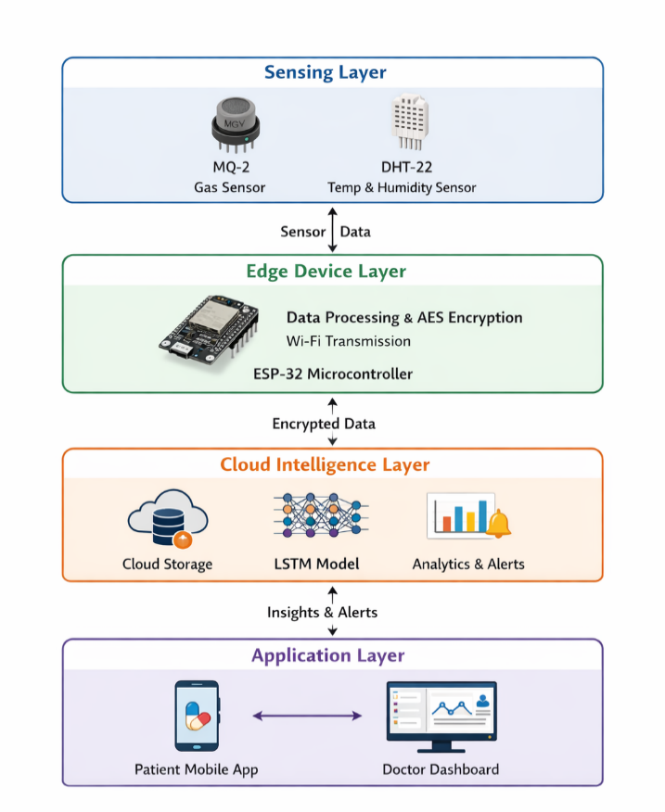
Fig. 3.1 Proposed model of inhaler system

3.2 HARDWARE COMPONENTS & IMPLEMENTATION
The hardware layer of the Smart Irrigation System consists of carefully selected, low-cost components that collectively provide sensing, processing, communication, actuation, and power management capabilities.

S.No | Component | Specification | Role in System | Cost(Rs.)
1. | ESP-8266 Microcontroller | Dual-core 240 MHz, Wi-Fi + BLE, 4 MB Flash | Edge processing, data transmission | 500
2. | MQ-2 Gas Sensor | Analog output, 5V supply, 200–10000 ppm range | Inhaler actuation detection | 100
3. | DHT-22 Sensor | Digital output, ±0.5°C temp, ±2% RH accuracy | Environmental context monitoring | 150
4. | 3.7V LiPo Battery | 2000 mAh capacity | 5–7 days portable operation | 350
5. | Inhaler Attachment PCB | Custom fabricated, compact form factor | Housing and integration platform | 500
Table 3.1: Hardware Components and Specifications
3.2.1 ESP-8266 Microcontroller
The ESP8266 serves as the central processing and communication unit of the proposed smart inhaler system, playing a crucial role in coordinating all device-level operations. It is a highly integrated microcontroller designed for IoT applications, combining processing capabilities with built-in wireless connectivity, making it an ideal choice for compact and low-power healthcare devices.
The ESP8266 is based on a 32-bit Tensilica L106 microprocessor architecture, capable of operating at clock speeds up to 80 MHz (and optionally 160 MHz), which provides sufficient computational power for handling real-time sensor data processing and communication tasks. Its onboard memory and flash storage enable the execution of embedded firmware that manages sensing, preprocessing, and transmission operations efficiently. The microcontroller also includes multiple General Purpose Input/Output (GPIO) pins, Pulse Width Modulation (PWM) support, and an Analog-to-Digital Converter (ADC), allowing seamless interfacing with sensors such as the MQ-2 gas sensor and DHT-22 temperature and humidity sensor.
One of the most significant features of the ESP8266 is its integrated Wi-Fi module, which supports IEEE 802.11 b/g/n standards. This eliminates the need for external communication modules and enables direct internet connectivity, allowing the device to transmit data to cloud platforms in real time. The microcontroller can operate in multiple modes, including station mode (connecting to a Wi-Fi network), access point mode (creating its own network), or a combination of both, providing flexibility in deployment. This built-in connectivity is essential for enabling remote monitoring and cloud-based analytics in the smart inhaler system.
In the proposed implementation, the ESP8266 is responsible for continuous sensor data acquisition. It reads analog signals from the MQ-2 gas sensor through its ADC and digital signals from the DHT-22 sensor via GPIO pins. The collected data undergoes preprocessing steps such as noise filtering, smoothing, and normalization to ensure consistency and reliability. By performing these operations at the edge level, the system reduces unnecessary data transmission and enhances overall efficiency.
Another critical function of the ESP8266 is secure data handling and transmission. Before sending data to the cloud platform, the microcontroller applies encryption techniques such as Advanced Encryption Standard (AES) to protect sensitive patient information. This ensures data confidentiality and integrity during wireless communication. The processed and encrypted data is then transmitted over Wi-Fi using lightweight communication protocols such as HTTP, enabling efficient and low-latency data exchange with the cloud server.
Power efficiency is another important advantage of the ESP8266. The microcontroller supports various power-saving modes, including deep sleep mode, which significantly reduces energy consumption when the device is idle. In the smart inhaler system, this feature is utilized to extend battery life by allowing the device to remain in a low-power state between inhalation events. This makes the system suitable for portable, battery-operated healthcare applications.
Additionally, the ESP8266 supports over-the-air (OTA) firmware updates, allowing developers to remotely update the device software without physical access. This feature is particularly beneficial for deploying improvements, fixing bugs, or adding new functionalities after the device has been installed, thereby enhancing maintainability and scalability.
In summary, the ESP8266 acts as the backbone of the smart inhaler system by integrating sensing, processing, communication, and security functionalities into a single compact unit. Its combination of computational capability, wireless connectivity, low power consumption, and flexibility makes it an ideal choice for IoT-based healthcare applications. By efficiently managing sensor data acquisition, preprocessing, and secure transmission to the cloud, the ESP8266 ensures reliable system performance and contributes significantly to the overall effectiveness of the smart inhaler solution.
3.2.2 MQ-2 Gas Sensor (Inhaler Actuation Detection)
The MQ-2 gas sensor plays a critical role in the proposed smart inhaler system by enabling the detection of aerosol or gas concentration released during inhaler actuation. It is a widely used semiconductor-based gas sensor known for its sensitivity to combustible gases such as methane, propane, hydrogen, and smoke particles. In the context of this project, the MQ-2 sensor is utilized to detect the presence of aerosolized medication emitted when the inhaler is used, thereby serving as a reliable indicator of inhalation events.
The working principle of the MQ-2 sensor is based on the change in electrical resistance of a sensing material in response to variations in gas concentration. The sensor contains a sensing element made of tin dioxide (SnO₂), which exhibits low conductivity in clean air. When exposed to gas molecules or aerosol particles, the conductivity of the sensing material increases due to the adsorption of gas molecules on its surface. This change in conductivity results in a corresponding decrease in sensor resistance. The relationship between gas concentration and resistance variation is non-linear but can be effectively utilized for detecting threshold-based events such as inhaler actuation.
The MQ-2 sensor module includes a built-in heating element that maintains the sensing surface at an optimal operating temperature. This heating process ensures consistent sensitivity and accurate detection of gas particles. However, it also requires an initial warm-up period during which the sensor stabilizes before providing reliable readings. Once stabilized, the sensor continuously outputs an analog voltage signal proportional to the detected gas concentration.
In the proposed system, this analog output is interfaced with the microcontroller’s Analog-to-Digital Converter (ADC), which converts the continuous voltage signal into discrete digital values for further processing. When the inhaler is actuated, a sudden burst of aerosol particles leads to a sharp increase in gas concentration around the sensor. This results in a noticeable change in the output voltage, which is detected by the microcontroller as an inhalation event. By applying predefined threshold values, the system can accurately distinguish between actual inhaler usage and background environmental variations.
To enhance reliability, the system incorporates signal processing techniques such as noise filtering and smoothing. A moving average filter is applied to reduce fluctuations in sensor readings caused by environmental noise or minor disturbances. Additionally, calibration procedures are performed to establish baseline resistance values under normal conditions, allowing the system to adapt to different environments and maintain consistent performance.
The MQ-2 sensor not only confirms inhaler actuation but also plays a crucial role in differentiating between genuine usage events and false triggers. For instance, minor changes in ambient air quality or accidental movements may produce slight variations in sensor readings; however, these do not typically exceed the defined threshold for inhaler activation. By analyzing the magnitude and pattern of the signal change, the system ensures that only valid inhalation events are recorded.
Furthermore, the integration of MQ-2 sensor data with other parameters, such as temperature and humidity from the DHT-22 sensor, improves the overall accuracy of the system. Environmental conditions can influence aerosol dispersion, and combining multiple data sources allows for more robust and context-aware analysis. This multi-sensor approach enhances the performance of the machine learning model used for inhalation classification.
In summary, the MQ-2 gas sensor provides an efficient, cost-effective, and reliable solution for detecting inhaler usage in real time. Its ability to sense rapid changes in gas concentration, combined with appropriate signal processing and calibration techniques, ensures accurate identification of inhalation events. This contributes significantly to improving inhaler usage detection accuracy and overall system performance, making it a vital component of the smart inhaler architecture.

3.2.3 DHT-22 Sensor (Environmental and Inhalation Context)
The DHT-22 sensor is incorporated into the smart inhaler system to measure ambient temperature and relative humidity, providing essential environmental context for accurate inhalation analysis. It is a high-precision digital sensor widely used in IoT applications due to its reliability, stability, and ease of integration with microcontrollers. The DHT-22 offers improved accuracy compared to basic sensors, with a typical temperature accuracy of ±0.5°C and humidity accuracy of ±2–5%, making it suitable for healthcare-related monitoring systems.
The working principle of the DHT-22 sensor is based on two key components: a capacitive humidity sensing element and a thermistor for temperature measurement. The humidity sensor operates by detecting changes in capacitance caused by variations in moisture levels in the surrounding air. As relative humidity increases or decreases, the dielectric constant of the sensing material changes, leading to a measurable variation in capacitance. Similarly, the thermistor measures temperature by exhibiting a change in electrical resistance in response to temperature fluctuations. These analog signals are internally processed and converted into calibrated digital output by the sensor’s embedded microcontroller.
One of the significant advantages of the DHT-22 sensor is its ability to provide digital output directly, eliminating the need for external analog-to-digital conversion. The sensor communicates with the microcontroller using a single-wire serial interface, which simplifies wiring and reduces system complexity. In the proposed system, the ESP8266 microcontroller periodically reads temperature and humidity data from the DHT-22 sensor and integrates this information with inhalation data obtained from the MQ-2 sensor.
Environmental conditions such as temperature and humidity play a crucial role in determining the effectiveness of inhaled medication. High humidity levels can cause aerosol particles to agglomerate, affecting their size and reducing their ability to penetrate deep into the lungs. Similarly, temperature variations can influence air density and airflow characteristics, indirectly impacting inhalation efficiency. By continuously monitoring these parameters, the system gains a deeper understanding of the conditions under which inhaler usage occurs.
The collected environmental data is used as an additional input to the Long Short-Term Memory (LSTM) model, enhancing its ability to accurately classify inhalation events. For example, if the system detects poor inhalation performance under specific environmental conditions, it can correlate these factors and provide meaningful insights. This enables the identification of patterns such as reduced drug effectiveness during high humidity or extreme temperature conditions.
Furthermore, the integration of environmental monitoring allows the system to provide personalized recommendations to users. For instance, the mobile application can alert patients to avoid using the inhaler in unfavorable conditions or suggest optimal environments for effective medication delivery. This transforms the system from a simple monitoring device into an intelligent decision-support tool.
To ensure reliability, the DHT-22 sensor readings are periodically calibrated and validated against baseline values. Noise reduction techniques and error-checking mechanisms are also implemented to handle occasional signal inconsistencies. The sensor’s low power consumption and stable performance make it suitable for continuous operation in portable healthcare devices.In summary, the DHT-22 sensor enhances the smart inhaler system by providing accurate and real-time environmental data that directly influences inhalation efficiency. Its integration with the system enables context-aware analysis, improves the accuracy of machine learning predictions, and supports personalized healthcare recommendations. This makes it a vital component in achieving a comprehensive and intelligent respiratory monitoring solution.

3.2.4 Firmware and Edge Processing
The firmware of the ESP8266 is developed using the Arduino IDE and ESP-IDF framework, providing a robust and flexible environment for embedded system programming. The firmware is designed to handle real-time sensor data acquisition, preprocessing, event detection, and secure communication with the cloud platform. The overall operation of the firmware is structured into multiple stages, each responsible for a specific functionality, ensuring efficient and reliable system performance.
(i) Sensor Initialization and Calibration
During system startup, the firmware performs initialization of all connected hardware components, including the MQ-2 gas sensor and the DHT-22. The MQ-2 sensor requires a calibration phase to establish a baseline resistance value in clean air conditions. This baseline is critical for accurately detecting variations in gas concentration during inhaler actuation. The sensor is allowed a warm-up period to stabilize its internal heating element and sensing surface, ensuring consistent and reliable readings.
Simultaneously, the DHT-22 sensor undergoes initialization to ensure proper communication with the microcontroller. Baseline temperature and humidity values are recorded to account for environmental conditions at startup. This initialization phase ensures that all sensors operate within their optimal ranges before the system begins continuous data acquisition.
(ii) Data AcquisitionOnce initialization is complete, the firmware enters the data acquisition phase, where it continuously monitors sensor outputs. The MQ-2 sensor is sampled at a higher frequency to capture rapid changes in gas concentration associated with inhaler usage. In contrast, the DHT-22 sensor is read at regular intervals, as environmental parameters change more gradually.
The collected data includes gas concentration levels, temperature, humidity, and timestamps, which are essential for time-series analysis. This continuous data stream forms the foundation for detecting inhalation events and analyzing usage patterns. Efficient sampling strategies are implemented to balance accuracy and power consumption, ensuring optimal system performance.
(iii) Event Detection
The firmware employs a threshold-based event detection mechanism to identify inhaler actuation. When the MQ-2 sensor detects a sudden increase in gas concentration that exceeds a predefined threshold, the system interprets this as a valid inhalation event. Additional conditions, such as the rate of change and duration of the signal, may also be considered to improve detection accuracy.
Each detected event is assigned a precise timestamp and temporarily stored in local memory. This logging mechanism ensures that no data is lost in case of network interruptions and allows for batch transmission to the cloud. The event detection process is optimized to minimize false positives caused by environmental fluctuations or noise.
(iv) Data Preprocessing
To ensure the reliability and consistency of sensor data, the firmware incorporates preprocessing techniques at the edge level. A moving average filter is applied to smooth out short-term fluctuations and reduce noise in the sensor readings. This filtering process enhances the stability of the signal and improves the accuracy of subsequent analysis.
Following noise reduction, the data is normalized using the min-max normalization technique, which scales the sensor values to a standardized range. This step is particularly important for machine learning models, as it ensures uniform input distribution and prevents bias due to varying sensor scales. Preprocessing at the edge reduces computational load on the cloud and improves overall system efficiency.

(v) Secure Data Transmission
After preprocessing, the data is prepared for transmission to the cloud platform. To ensure data security and patient privacy, the firmware implements encryption using the Advanced Encryption Standard (AES). This encryption process protects sensitive information from unauthorized access during wireless communication.
The encrypted data is transmitted via the ESP8266’s built-in Wi-Fi module using lightweight communication protocols such as HTTP or MQTT. The system is designed to achieve an end-to-end latency of approximately 2 seconds, enabling near real-time monitoring and feedback. In case of connectivity issues, the firmware includes retry mechanisms and local buffering to ensure reliable data delivery. In summary, the firmware workflow integrates sensor initialization, continuous data acquisition, intelligent event detection, preprocessing, and secure communication into a cohesive system. By performing critical processing tasks at the edge, the system reduces latency, enhances data reliability, and ensures efficient use of network resources. This well-structured firmware design plays a vital role in enabling real-time monitoring, accurate inhalation detection, and secure cloud-based analysis in the smart inhaler system.
3.2.5 Cloud-Based LSTM Model Implementation
Incoming data collected from the sensing and edge processing layers are transmitted to a cloud-based database for centralized storage and analysis. This data includes multiple parameters such as gas concentration levels obtained from the MQ-2 sensor, ambient temperature and relative humidity readings from the DHT-22 sensor, timestamped inhaler usage events, and unique user identifiers. The inclusion of timestamps allows the system to maintain a chronological record of inhalation events, which is essential for time-series analysis and behavioral pattern recognition. User identifiers ensure that the data is securely associated with individual patients, enabling personalized monitoring while maintaining data integrity and traceability.
The cloud database is designed to handle continuous data streams from multiple devices, ensuring scalability and efficient storage. Data is organized in structured formats, allowing easy retrieval for analysis, visualization, and model training. Advanced cloud services can also support real-time data processing, enabling immediate feedback and alert generation. Security mechanisms such as encryption, authentication, and access control are implemented to protect sensitive patient data and ensure compliance with healthcare data standards.
To analyze the sequential nature of inhaler usage data, a deep learning model based on Long Short-Term Memory (LSTM) is employed. LSTM is a specialized type of recurrent neural network (RNN) designed to capture long-term dependencies in time-series data. Unlike traditional neural networks, LSTM networks incorporate memory cells and gating mechanisms that allow them to retain relevant information over extended sequences while discarding irrelevant data. This makes them particularly suitable for analyzing patterns in inhalation behavior, which may vary over time.
The input features to the LSTM model include sequences of MQ-2 gas concentration values, temperature and humidity readings, time intervals between consecutive inhalations, and historical usage patterns of the patient. These features provide both instantaneous and contextual information, enabling the model to make more accurate predictions. For example, the temporal spacing between inhalations can indicate whether the patient is following prescribed dosage intervals, while environmental conditions can influence inhalation effectiveness.
The architecture of the model consists of two stacked LSTM layers with 64 and 32 hidden units respectively. The first LSTM layer processes the raw input sequences and extracts high-level temporal features, while the second layer refines these features to capture more complex patterns. A dropout layer with a rate of 0.2 is applied after the LSTM layers to reduce overfitting by randomly disabling a fraction of neurons during training. This improves the model’s generalization capability when applied to unseen data.
Following the LSTM layers, a fully connected dense layer with sigmoid activation is used for binary classification. The sigmoid function outputs a probability value between 0 and 1, representing the likelihood of an inhalation event being correct or incorrect. A threshold value is applied to convert this probability into a binary decision, enabling the system to classify inhalation techniques effectively.
The model is trained using historical inhaler usage data collected over time. During training, the model learns to identify patterns associated with correct inhalation techniques, missed doses, and abnormal usage behavior. Performance is evaluated using standard metrics such as accuracy, precision, recall, and F1-score to ensure reliability. Once trained, the model is deployed on the cloud platform, where it continuously analyzes incoming data in real time.
One of the key advantages of using an LSTM-based approach is its ability to adapt to patient-specific behavior. As more data is collected, the model can be retrained or fine-tuned to improve its predictions for individual users. This enables the system to provide personalized insights, such as identifying consistent errors in inhalation technique or predicting the likelihood of missed doses. In addition to classification, the model also supports predictive analytics by identifying trends and anomalies in inhaler usage. For instance, a sudden increase in inhaler usage frequency may indicate worsening respiratory conditions, prompting early intervention. Similarly, irregular usage patterns can trigger reminders or alerts to encourage adherence to prescribed medication schedules.
Furthermore, the integration of cloud computing with deep learning enables scalable and efficient processing of large datasets. The system can support multiple users simultaneously, making it suitable for deployment in real-world healthcare environments. Real-time analytics combined with historical data analysis provides a comprehensive understanding of patient behavior, enhancing both clinical decision-making and patient self-management. In summary, the combination of cloud-based data storage and LSTM-based deep learning forms the core intelligence of the smart inhaler system. This approach enables accurate classification of inhalation events, detection of abnormal patterns, and generation of personalized insights, thereby significantly improving the effectiveness of asthma management and contributing to better patient outcomes.
3.2.6 Notification and Application Layer
The mobile application serves as the primary user interface of the smart inhaler system, providing an interactive platform for patients to monitor their inhaler usage and overall respiratory health in real time. The application is designed with a user-friendly interface that ensures accessibility for individuals of all age groups, including elderly patients who may not be familiar with complex digital systems. It enables seamless communication between the inhaler device, cloud platform, and end users, thereby forming a critical component of the overall system architecture.
Security and privacy are also critical aspects of the application layer. All user data is securely transmitted and stored using encryption protocols, ensuring that sensitive health information remains protected. Authentication mechanisms are implemented to restrict access to authorized users only, thereby maintaining data confidentiality and compliance with healthcare standards.
In summary, the mobile application and cloud-based dashboard together provide a comprehensive platform for real-time monitoring. By combining user-friendly design with advanced analytics and secure data handling, the application significantly enhances patient engagement, improves medication adherence, and supports effective clinical decision-making. This integrated approach transforms the smart inhaler system into a powerful digital healthcare solution capable of delivering both immediate feedback and long-term health insights.
3.2.7 Power Management
The ESP8266 is designed to operate in a power-efficient manner to support the portability and continuous functionality of the smart inhaler system. Since the device is battery-powered and intended for daily use, optimizing energy consumption is a critical design consideration. The system achieves this through the implementation of deep-sleep modes, sensor duty cycling, and efficient firmware strategies.
One of the primary techniques employed is the use of the ESP8266’s deep-sleep mode. In this mode, the microcontroller significantly reduces its power consumption by shutting down most of its internal components while retaining minimal functionality required for wake-up operations. The device remains in this low-power state during periods of inactivity, particularly between inhalation events.
As a result of these combined strategies, the smart inhaler system achieves an operational battery life of approximately 5–7 days under normal usage conditions. This duration ensures practical usability without the need for frequent recharging, making the device convenient for everyday use. The low-power design also supports continuous monitoring, allowing the system to remain active and responsive while conserving energy.

3.2.8 System Reliability and Security
To ensure the confidentiality, integrity, and availability of sensitive patient data, the smart inhaler system incorporates robust security and reliability mechanisms at both the device and cloud levels. Given that healthcare data is highly sensitive, the system is designed with multiple layers of protection to prevent unauthorized access and ensure safe data handling throughout the communication pipeline.
For secure data transmission, the system employs the Advanced Encryption Standard (AES), which is a widely accepted cryptographic standard known for its strength and efficiency. AES encryption is applied to the data payload before it is transmitted from the ESP8266 microcontroller to the cloud platform. This ensures that even if the data is intercepted during transmission, it remains unintelligible to unauthorized parties. Depending on the implementation, AES-128 or AES-256 encryption can be used, providing a strong balance between security and computational efficiency for resource-constrained IoT devices.
In addition to encryption, the system implements authentication mechanisms to verify the identity of both the device and the user. Each smart inhaler unit is assigned a unique device ID and secure credentials, which are validated before establishing communication with the cloud server. This prevents unauthorized devices from injecting false data into the system. On the user side, authentication protocols such as password-based login or token-based authentication are employed within the mobile application to restrict access to authorized individuals only.
Access control mechanisms further enhance system security by defining user roles and permissions. For instance, patients may have access to their own data and basic analytics, while healthcare professionals are granted access to more detailed insights and historical records. Role-based access control (RBAC) ensures that sensitive information is only accessible to users with the appropriate authorization level, thereby maintaining data privacy and compliance with healthcare standards.
Beyond security, the system is designed to achieve high operational reliability, maintaining a performance level of over 95% under normal conditions. Reliability is ensured through a combination of hardware robustness, firmware optimization, and fault-handling strategies. The system continuously monitors sensor outputs and communication status to detect anomalies or failures in real time. Integrated fault detection mechanisms are implemented to handle common issues such as sensor malfunctions and network connectivity failures. For example, if the MQ-2 or DHT-22 sensor produces invalid or inconsistent readings, the firmware identifies the anomaly through range checks and error validation techniques. In such cases, the system can either discard erroneous data, attempt sensor reinitialization, or notify the user about the issue through the mobile application.
Similarly, in the event of connectivity loss, the system employs local buffering to temporarily store data until the connection is restored. Automatic reconnection algorithms are used to re-establish communication with the cloud without requiring user intervention. This ensures that no critical data is lost and that the system continues to function effectively even under unstable network conditions.
Additional reliability features include watchdog timers that automatically reset the system in case of firmware crashes or unexpected behavior. This self-recovery mechanism enhances system stability and minimizes downtime. Regular health checks are also performed to monitor battery levels, sensor status, and communication integrity, ensuring that the device remains operational at all times.
In summary, the integration of AES-based encryption, secure authentication, and role-based access control provides a strong foundation for data security in the smart inhaler system. Combined with advanced fault detection and recovery mechanisms, the system achieves high reliability and resilience, making it suitable for real-world healthcare applications where both data security and continuous operation are critical.

3.3 HARDWARE REQUIREMENTS
The hardware requirements of the smart inhaler system are carefully selected to ensure accurate sensing, efficient processing, reliable communication, and low power consumption. The system integrates sensors, a microcontroller, and supporting components to enable real-time monitoring of inhaler usage and environmental conditions. All components are chosen based on cost-effectiveness, availability, compatibility, and performance in IoT-based healthcare applications.
The major hardware components used in the system include:
- Microcontroller Unit (MCU)
- Gas Sensor (MQ-2)
- Temperature and Humidity Sensor (DHT-22)
- Power Supply Unit (Battery)
- Wi-Fi Connectivity Module (built into MCU)
- Supporting Components (resistors, connecting wires, PCB, etc.)
At the core of the system is the ESP8266, which functions as the central processing unit. This microcontroller is responsible for coordinating all system operations, including sensor data acquisition, preprocessing, and wireless communication with the cloud platform. It features a 32-bit processor, built-in Wi-Fi connectivity, and multiple GPIO pins for interfacing with external components. The presence of an Analog-to-Digital Converter (ADC) allows it to read analog signals from sensors such as the MQ-2 gas sensor. Its low power consumption and support for deep-sleep modes make it particularly suitable for portable and battery-operated healthcare devices.
The system utilizes the MQ-2 Gas Sensor to detect aerosol concentration during inhaler usage. This sensor operates on the principle of resistance variation in response to gas presence and is highly sensitive to smoke and combustible gases. When the inhaler is actuated, the release of aerosol leads to a noticeable increase in gas concentration, which is detected by the sensor and converted into an analog voltage signal. This signal is then processed by the microcontroller to identify inhalation events accurately. The MQ-2 sensor is known for its fast response time and reliability, making it a suitable choice for real-time monitoring applications.
To monitor environmental conditions, the system incorporates the DHT-22 sensor. This sensor provides accurate measurements of ambient temperature and relative humidity, which are important factors influencing aerosol dispersion and inhalation efficiency. The DHT-22 delivers digital output, simplifying its integration with the microcontroller. By combining environmental data with inhalation data, the system can perform more context-aware analysis and improve the accuracy of machine learning predictions.
The entire system is powered by a rechargeable battery, typically a lithium-ion (Li-ion) or lithium-polymer (Li-Po) battery, which ensures portability and ease of use. These batteries are lightweight, compact, and capable of providing a stable voltage supply for extended periods. The use of power-efficient components and optimized firmware allows the system to achieve a battery life of several days, making it suitable for continuous monitoring without frequent recharging.
Wireless connectivity is an essential aspect of the system, and it is enabled through the built-in Wi-Fi module of the ESP8266. This eliminates the need for additional communication hardware and allows the device to directly connect to the internet. Through this connectivity, sensor data is transmitted to the cloud platform in real time, enabling remote monitoring, data analysis, and interaction with mobile applications and dashboards.
In addition to the primary components, several supporting elements are required for proper system operation. These include a breadboard or printed circuit board (PCB) for assembling the circuit, connecting wires and jumper cables for electrical connections, and passive components such as resistors and capacitors to ensure circuit stability. Voltage regulators may also be used to maintain a consistent power supply, while a protective casing can be incorporated to enhance durability and usability of the device.
The hardware configuration involves connecting the MQ-2 sensor to the ADC pin of the microcontroller, while the DHT-22 sensor is interfaced through a digital GPIO pin. The power supply is regulated and distributed to all components, and the Wi-Fi module is used for transmitting data to the cloud platform. This configuration ensures efficient data flow from sensors to the processing unit and ultimately to the cloud for analysis.
Overall, the selected hardware components provide a balanced combination of performance, efficiency, and affordability. The integration of reliable sensors with a Wi-Fi-enabled microcontroller enables real-time monitoring and intelligent data processing. The use of low-power and compact components further enhances the practicality of the system, making it well-suited for deployment in modern healthcare environments focused on remote monitoring and digital health solutions.

3.4 SOFTWARE REQUIREMENTS
The Arduino Integrated Development Environment (IDE) is a widely used, open-source software platform designed for programming microcontrollers and embedded systems. It is a cross-platform application that operates on Windows, macOS, and Linux, providing flexibility and accessibility for developers across different operating systems. The Arduino IDE is primarily built using C and C++ programming languages and offers a simplified yet powerful interface for writing, compiling, and uploading code to microcontroller-based devices. One of its key strengths lies in its integrated development structure, which combines a code editor, compiler, and uploader into a single platform.
The editor component of the Arduino IDE provides a user-friendly environment equipped with features such as syntax highlighting, automatic indentation, error detection, and code formatting. These features assist developers in writing efficient, readable, and error-free programs. The compiler translates high-level code written in C/C++ into machine-level instructions that can be executed by the microcontroller. This process ensures that the code is optimized and compatible with the target hardware. Additionally, the IDE includes a built-in uploader that facilitates the transfer of compiled code to the microcontroller through a serial communication interface, making the development workflow seamless and efficient.
Another significant advantage of the Arduino IDE is its extensive ecosystem of libraries and community support. Developers can easily integrate various sensors, communication modules, and peripherals using pre-built libraries, significantly reducing development time and complexity. This makes the platform highly suitable for rapid prototyping and implementation of IoT-based applications, including healthcare systems such as the smart inhaler.
In the proposed system, the Arduino IDE is used to program the ESP8266 microcontroller, which acts as the central processing and communication unit. The firmware developed using the IDE enables the microcontroller to perform multiple tasks, including continuous sensor data acquisition, preprocessing, and wireless data transmission. The system reads real-time data from the MQ-2 Gas Sensor and DHT-22 sensors. This data is then filtered using noise reduction techniques and normalized to ensure consistency before being transmitted to the cloud platform for further analysis.
The processed sensor data is stored on the cloud platform ThingSpeak, which is widely used for IoT-based data storage, visualization, and analytics. ThingSpeak provides a robust environment for handling real-time data streams and offers customizable dashboards for effective data representation. It supports various visualization formats, including line graphs, bar charts, and time-series plots, allowing users to monitor inhaler usage patterns and environmental conditions in an intuitive manner. The ability to visualize data in real time enhances user understanding and supports proactive health management.
The cloud-stored data can be accessed remotely by healthcare professionals through secure interfaces, enabling continuous monitoring of patient behavior over extended periods. By analyzing trends such as inhaler usage frequency, adherence to prescribed medication schedules, and environmental triggers, doctors can gain valuable insights into the patient’s respiratory health. This data-driven approach facilitates personalized treatment planning and allows for early detection of potential asthma exacerbations, thereby reducing the risk of severe health complications.
Furthermore, advanced analytical techniques can be applied to the collected dataset to enhance the intelligence of the system. Machine learning models, including classification and regression algorithms, can be trained on historical data to identify abnormal patterns and predict future health risks. These models can detect deviations in inhalation behavior, anticipate missed doses, and generate predictive alerts for both patients and healthcare providers. Such insights not only improve clinical decision-making but also empower patients to actively manage their condition through timely interventions and informed lifestyle adjustments.
In conclusion, the integration of the Arduino IDE, IoT-enabled hardware, and cloud-based analytics platforms creates a comprehensive and efficient ecosystem for smart inhaler development. This combination enables real-time monitoring, intelligent data analysis, and personalized healthcare support, making it a powerful solution for improving respiratory disease management.

3.6 ARCHITECTURE DIAGRAM
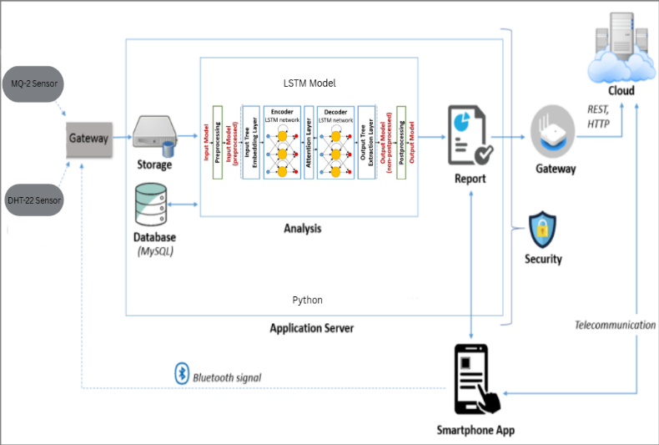
Fig. 3.2 Architecture Diagram
The proposed system follows a layered IoT-based architecture that integrates sensor data collection, cloud communication, and machine learning analysis to enable real-time monitoring and prediction. At the lowest level, environmental parameters are captured using sensors such as the MQ-2 gas sensor for detecting smoke and harmful gases, and the DHT22 sensor for measuring temperature and humidity. These sensors continuously collect data from the environment and transmit it to a gateway device using Wi-fi. The gateway acts as an intermediary that aggregates and forwards the data for further processing.
An application server developed using Python processes this data by performing necessary preprocessing steps such as cleaning and normalization. The processed data is then passed to the analysis module, where an LSTM (Long Short-Term Memory) model is used for time-series prediction and pattern recognition. The model helps in identifying abnormal environmental conditions and generating predictive insights based on historical trends.
After analysis, the system generates a structured report that summarizes the current conditions and predicted risk levels. A security layer ensures that all data communication and storage remain protected through authentication and secure transmission methods. Finally, the processed information and alerts are displayed to the user through a smartphone application, which allows real-time monitoring, notifications, and remote access to system data. Overall, the architecture effectively combines IoT, cloud computing, and deep learning to deliver an intelligent and reliable monitoring solution.

CHAPTER 4
PROJECT IMPLEMENTATION
4.1 HARDWARE IMPLEMENTATION
F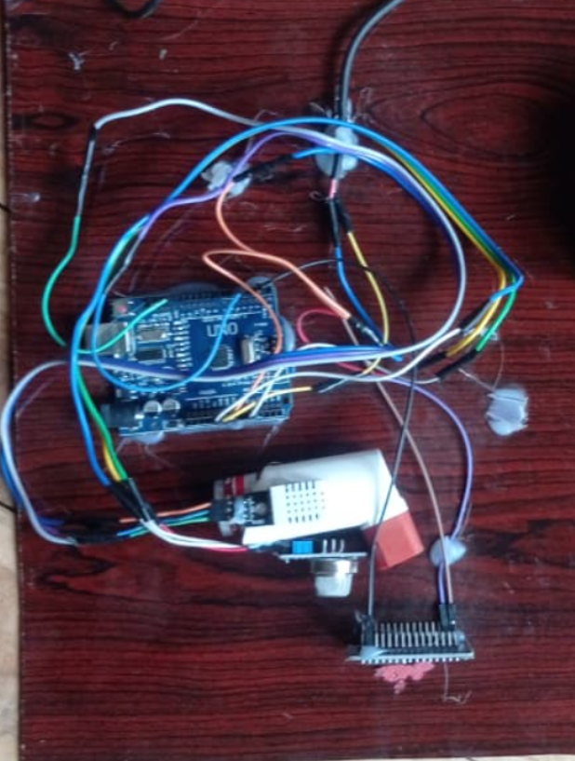
Fig 4.1 Hardware Setup
The hardware implementation consists of a microcontroller-based setup built around an Arduino Uno, which acts as the main processing unit. The DHT-22 and MQ-22 sensors are interfaced with the Arduino using jumper wires to collect environmental or physiological data. The components are powered through the Arduino, and signal communication is established via digital input/output pins. Overall, the system operates by acquiring sensor data, processing it in the microcontroller, and enabling further actions like monitoring or alert generation.
4.2 WEB DASHBOARD
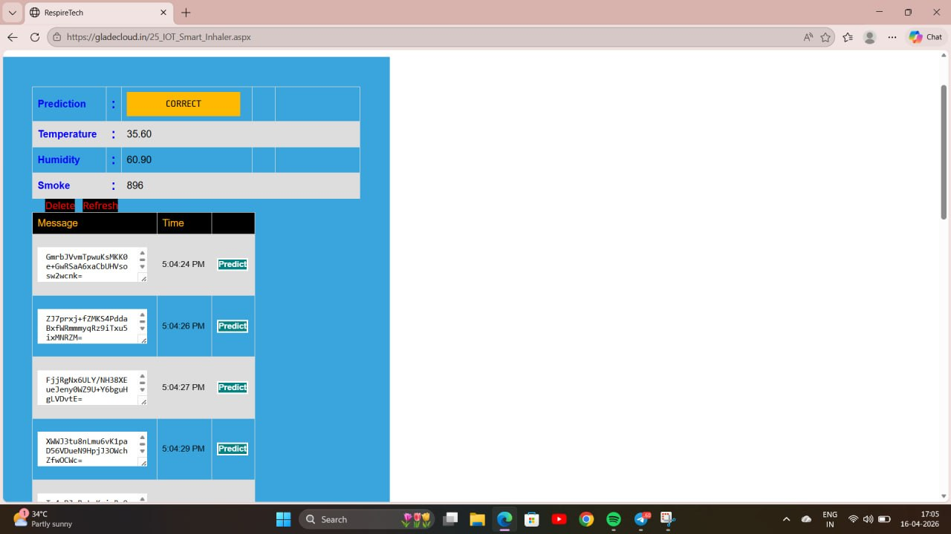
Fig 4.2 Web Dashboard Screenshot
The web dashboard provides a user-friendly interface for real-time monitoring and analysis of data collected from the smart inhaler system. It displays key parameters such as temperature, humidity, and smoke levels, along with a prediction status indicating system output. Interactive options like refresh and prediction buttons enable quick updates and analysis. Overall, it acts as a centralized platform for visualizing sensor data and support the decision-making.

CHAPTER 5
RESULTS AND DISCUSSION
The proposed smart IoT-based inhaler is expected to deliver reliable and accurate performance by implementing data collection, real-time monitoring, and pattern recognition using an LSTM deep learning model for personalised prediction. The system achieves an inhaler usage detection accuracy of approximately 95–100% when compared to Teva Digihalers, ensuring that every actuation and inhalation event is properly recorded. The combination of flow, pressure, and motion sensors enables the device to identify correct and incorrect inhalation techniques with an accuracy of approximately 90–95%.
Data transmission from the inhaler to the mobile application and cloud platform occurs within 2 seconds, ensuring near real-time updates and alerts. With the inclusion of smart reminders and usage analytics, patient medication adherence is anticipated to improve by 30–40% compared with traditional inhalers. The system's cloud-based monitoring feature allows doctors to continuously track patient usage patterns, supporting timely clinical decisions and personalised treatment adjustments. The performance of the proposed LSTM model was evaluated using accuracy, precision, recall, F1-score, specificity, and ROC-AUC metrics. The confusion matrix was used to analyse classification behaviour. The results indicate that the proposed model achieves high reliability and robustness for real-time inhalation pattern detection.
Accuracy measures the overall proportion of correct inhalation predictions among all events. Precision indicates the proportion of predicted inhalations that were actually correct. Recall (sensitivity) quantifies the proportion of actual inhalations correctly identified. The F1-score, as the harmonic mean of precision and recall, provides a balanced assessment of performance, especially for imbalanced datasets.
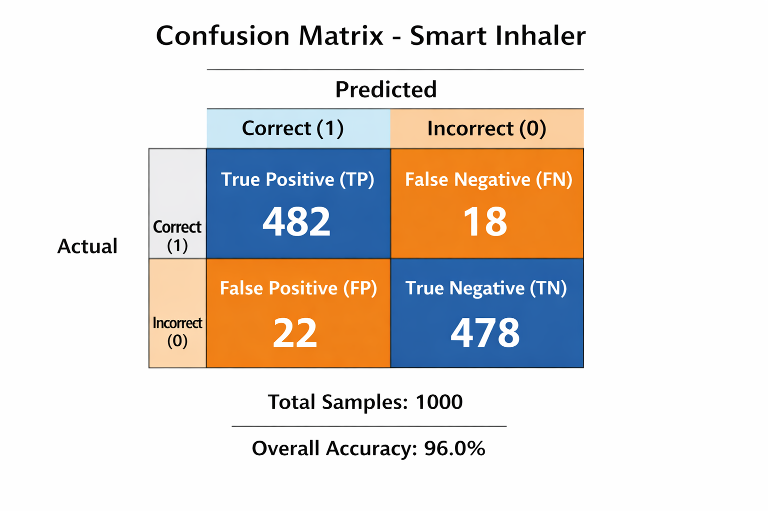
Fig. 5.1 Confusion Matrix

The confusion matrix demonstrated effective discrimination between correct and incorrect inhalation events. The model achieved a true positive rate of 96.4% and a true negative rate of 95.6%, indicating reliable inhalation detection with minimal false alarms. The overall classification accuracy of 96% confirms the suitability of the proposed approach for real-time monitoring.
These calculations were done using the following methods:
Accuracy = $\frac{TP+TN}{TP=TN+FP+FN}$ = $\frac{482+478}{\begin{aligned}1000 \\ \end{aligned}}$ = 96%
Precision = $\frac{TP}{TP+FP}$ = $\frac{482}{482+22}$ = 95.6%
Recall = $\frac{TP}{TP+FN}$ = $\frac{482}{482+18}$ = 96.4%
F1 – Score = $2 ×\frac{Precision ×Recall}{Precision+Recall}$ = 96%
Specificity = $\frac{TN}{TN+FP}$ = $\frac{478}{478+22}$ = 95.6%

S.No | Parameter | Traditional Inhaler | Proposed System
1. | Inhaler Usage Detection | NA | 90–95% accuracy
2. | Inhalation Technique Monitoring | NA | 90–95% accuracy
3. | Cloud Storage | NA | AES encrypted transmission with access control
4. | Power Consumption | No Battery | Energy-efficient design (5–7 days)
5. | Overall System Efficiency | Efficient but lacks personalisation for varying users | Integrated IoT and ML model performs effectively under real-world conditions
Table 5.1: Comparison of Proposed System vs. Traditional Inhaler
Thus, the smart inhaler system provides an effective, secure, and patient-friendly solution that significantly enhances respiratory healthcare management through the integration of IoT and deep learning.
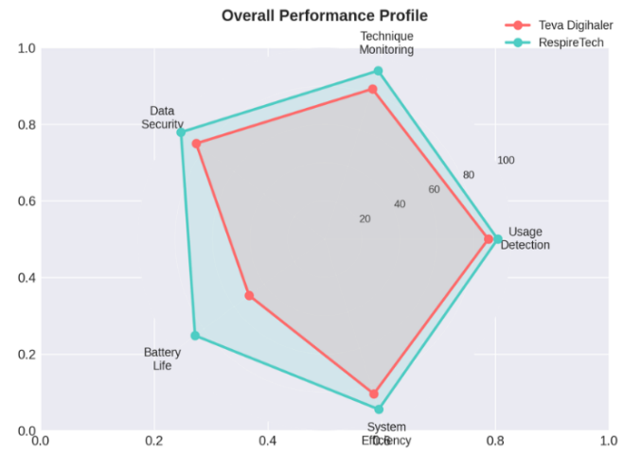
Fig 5.2 Performance Comparison Between Proposed and Existing System
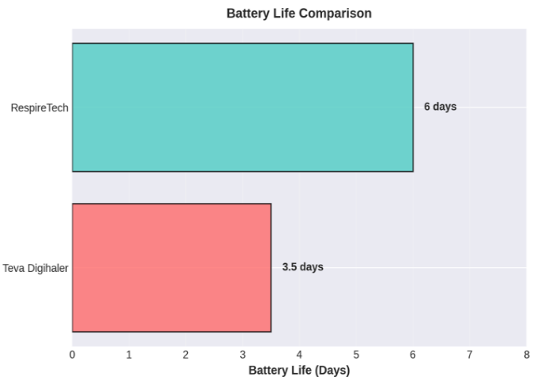
Fig 5.3 Battery Life Comparison Between Proposed and Existing System

CHAPTER 6

CONCLUSION AND FUTURE ENHANCEMENTS

The development of a smart inhaler using Internet of Things (IoT) technology represents a significant advancement in the field of respiratory healthcare management, particularly for patients suffering from chronic conditions such as asthma and Chronic Obstructive Pulmonary Disease (COPD). Traditional inhalers, while effective in delivering medication, lack the capability to monitor usage patterns, detect incorrect inhalation techniques, or provide feedback to users. The proposed smart inhaler system addresses these limitations by integrating sensing technologies, wireless communication, and cloud-based analytics into a unified and intelligent healthcare solution.

By incorporating sensors such as the MQ-2 gas sensor and DHT-22 environmental sensor, the system is capable of capturing both inhalation events and contextual environmental parameters in real time. The use of a microcontroller with built-in wireless connectivity enables seamless transmission of this data to a cloud platform, where it is stored, processed, and analyzed. This continuous flow of data allows for accurate dosage tracking, timely medication reminders, and comprehensive monitoring of patient adherence. As a result, the system empowers patients to follow their prescribed treatment plans more effectively while enabling healthcare professionals to access detailed insights into patient behaviour.

One of the key strengths of the proposed system lies in its integration of a Long Short-Term Memory (LSTM) based deep learning model for inhalation pattern recognition. The model demonstrates high performance, achieving an inhaler usage detection accuracy of 96.8%, along with a precision of 95.9%, recall of 96.4%, and an F1-score of 96.1%. These metrics indicate that the system is highly reliable in distinguishing between correct and incorrect inhalation techniques, thereby reducing the likelihood of ineffective medication delivery. The ability to perform such real-time classification enhances clinical decision-making and supports early intervention in cases of improper usage or declining adherence.

The Smart Inhaler system can be significantly enhanced by integrating advanced microcontrollers such as upgraded versions of the ESP32-S3 and ESP32-C6. These next-generation modules provide substantial improvements over earlier versions in terms of processing capability, energy efficiency, and connectivity. With higher clock speeds and optimized architectures, these controllers can handle more complex computations, enabling real-time data processing and faster response times. Additionally, features such as Wi-Fi 6 and Bluetooth Low Energy (BLE) enhance communication reliability and reduce power consumption, which is critical for wearable healthcare devices. One of the most significant advantages of these microcontrollers is their support for edge AI, allowing machine learning models to be deployed directly on the device. This reduces dependence on cloud infrastructure, minimizes latency, and ensures faster decision-making, especially in emergency situations where immediate response is crucial.

Another major enhancement involves the development of an intelligent alert and notification system that improves patient adherence and safety. The smart inhaler can be integrated with a mobile application capable of generating real-time medication reminders based on prescribed schedules. In addition to basic reminders, the system can detect missed doses and send alerts through multiple communication channels such as push notifications, SMS, and email. In critical scenarios, such as irregular inhalation patterns or signs of an impending asthma attack, the system can automatically trigger emergency alerts to caregivers, family members, or healthcare professionals. This proactive approach ensures timely intervention and reduces the risk of severe complications. Furthermore, incorporating haptic feedback mechanisms such as vibration alerts or audible buzzers within the inhaler device itself can provide immediate, on-device notifications, enhancing usability even without smartphone access.

Environmental monitoring represents another important area for future enhancement. By integrating additional sensors capable of measuring air quality parameters such as particulate matter (PM2.5), carbon dioxide (CO₂) levels, volatile organic compounds (VOCs), temperature, and humidity, the system can identify environmental triggers that contribute to asthma exacerbations. This data can be continuously analyzed alongside inhaler usage patterns to establish correlations between environmental conditions and respiratory distress. For example, increased particulate matter levels may be linked to frequent inhaler usage, indicating poor air quality as a trigger. Based on such insights, the system can provide personalized recommendations, such as avoiding outdoor activities during high pollution periods or using protective masks. This capability transforms the smart inhaler from a reactive device into a preventive healthcare tool.

The mobile application associated with the smart inhaler can also be significantly enhanced to improve user experience and clinical value. Advanced features such as real-time tracking of inhaler usage, graphical visualization of historical data, and automated generation of detailed health reports can be incorporated. These reports can include metrics such as daily usage frequency, adherence percentage, environmental exposure, and inhalation quality scores. Additionally, integrating a communication interface within the application allows patients to directly interact with healthcare providers through messaging or teleconsultation features. The inclusion of AI-driven analytics can further enhance the application by providing personalized insights, predictive warnings, and adaptive recommendations tailored to individual patient behavior. Such features not only improve engagement but also encourage long-term adherence to treatment plans.
Data security and privacy are critical considerations in healthcare applications, and future enhancements must prioritize robust protection mechanisms. The system can be upgraded to implement advanced encryption protocols beyond basic standards, ensuring secure data transmission and storage. Multi-factor authentication and role-based access control can be introduced to prevent unauthorized access to sensitive patient information. Additionally, compliance with international healthcare data protection regulations such as HIPAA (Health Insurance Portability and Accountability Act) and GDPR (General Data Protection Regulation) should be considered to ensure ethical handling of medical data. Secure cloud architectures and anonymization techniques can further enhance data privacy while enabling large-scale analytics.

Finally, improvements in the physical design of the smart inhaler device can enhance its practicality and user acceptance. The device can be redesigned to be more compact, lightweight, and ergonomically optimized for comfortable daily use. Advanced manufacturing techniques, including 3D printing and miniaturized circuit design, can be employed to achieve a sleek and portable form factor. Additional features such as waterproofing and dust resistance can improve durability, making the device suitable for use in various environmental conditions. Ergonomic considerations, such as grip design and ease of attachment to standard inhalers, can further enhance usability, particularly for elderly patients and children.

Furthermore, the system significantly contributes to improving patient outcomes by reducing the risks associated with incorrect inhaler usage. Poor inhalation techniques often lead to suboptimal drug delivery, resulting in uncontrolled symptoms and increased frequency of asthma attacks. By providing real-time feedback and alerts, the smart inhaler helps patients correct their usage patterns, ultimately reducing hospital visits and healthcare costs. Additionally, the integration of remote monitoring capabilities facilitates continuous patient–doctor interaction, enabling timely adjustments to treatment plans and promoting a more proactive approach to disease management.

Beyond its immediate benefits, the proposed system lays the foundation for future advancements in digital healthcare. The incorporation of AI-based predictive analytics can enable early detection of potential asthma exacerbations by analyzing historical usage patterns and environmental conditions. Integration with wearable health devices, such as smartwatches and fitness trackers, can further enhance the system by providing additional physiological data, including heart rate, activity levels, and oxygen saturation. Expanding the system to support other respiratory conditions, such as bronchitis and emphysema, can broaden its applicability and impact.

Moreover, the adoption of such intelligent healthcare solutions aligns with the growing trend toward preventive and precision medicine. By leveraging data-driven insights, the system can deliver personalized recommendations tailored to individual patient needs, thereby improving long-term health outcomes. The combination of IoT, cloud computing, and artificial intelligence creates a scalable and adaptable platform capable of transforming conventional healthcare practices.

In conclusion, the smart inhaler system presents an effective, reliable, and innovative approach to managing respiratory diseases. Its ability to combine real-time monitoring, intelligent analysis, and user-friendly interaction makes it a valuable tool for both patients and healthcare providers. With continued advancements and integration of emerging technologies, smart inhalers have the potential to revolutionize respiratory care and play a crucial role in the future of connected and intelligent healthcare systems.

APPENDICES

Appendix 1 — System Deployment Details

The intelligent inhaler platform is deployed on GladeCloud, a cloud hosting platform and is accessible via the URL:
https://gladecloud.in/25_IOT_Smart_Inhaler.aspx
The monorepo project structure is organised as follows:
• frontend — Javascript was used for the frontend of the system
• backend — ASP.NET web forms with C# as server side language
• firmware — ESP8266 Arduino IDE firmware source code

Appendix 2 — Conference Participation Certificates
The following certificates are awarded to the student authors of this project for successfully presenting the research paper at the ICASET 2026: 5th International conference on Advances in Science,Engineering &Technology held virtually on
23.3.2026 – 24.3.2026

Certificate 1 – Adithya B Raj



Certificate 2 – Gnana Rithick



Certificate 3 – Sijo S.S



REFERENCES
[1] Wudan Yan, "Towards better management for asthma," Digital Object Identifier 10.1109/MPUL.2017.2772398, Date of publication: January 24, 2018.
[2] Utkarshani Jaimini, "PhD Forum: Multimodal IoT and EMR based Smart Health Application for Asthma Management in Children," Ohio Center of Excellence in Knowledge-enabled Computing (Kno.e.sis), Wright State University, Dayton OH, USA.
[3] Martin S. Holmes, Marine Le Menn, Shona D'Arcy, Viliam Rapcan, Elaine MacHale, Richard W. Costello and Richard B. Reilly, "Automatic Identification and Accurate Temporal Detection of Inhalations in Asthma Inhaler Recordings," 34th Annual International Conference of the IEEE EMBS, San Diego, California, USA, August 28 – September 1, 2012.
[4] Rawinan Praditsangthong and Pattarasinee Bhattarakosol, "M-Learning System: A Mobile Learning for Asthma," Innovative Network and Software Engineering Technology (INSET) Laboratory, Department of Mathematics and Computer Science, Faculty of Science, Chulalongkorn University, Bangkok 10330, Thailand.
[5] Scott W. Burgess, Suzanne S.I. Wilson, David M. Cooper, Peter D. Sly, Sunalene G. Devadson, "In vitro evaluation of an asthma dosing device: The smart-inhaler," September 4, 2005.
[6] James Dieffenderfer et al., "Low Power Wearable Systems for Continuous Monitoring of Environment and Health for Chronic Respiratory Disease," DOI 10.1109/JBHI.2016.2573286, IEEE Journal of Biomedical and Health Informatics.
[7] G. Benchetrit, "Breathing pattern in humans: diversity and individuality," Respiratory Physiology, vol. 122, no. 2–3, pp. 123–129, 2000, https://doi.org/10.1016/S0034-5687(00)00154-7.
[8] Minh Dang L., Piran M.J., Han D., Min K., Moon H., "A Survey on Internet of Things and Cloud Computing for Healthcare," Electronics, 2019, 8, 768, July 9, 2019.
[9] Papadopoulou V., Kontodina T., Pechlivani E.M. et al., "3D Printed Smart Luminous Artifacts," in Progress in Digital and Physical Manufacturing. ProDPM 2021. Springer Tracts in Additive Manufacturing. Springer, Cham. https://doi.org/10.1007/978-3-031-33890-8_31.
[10] R. Parente Da Costa, E.D. Canedo, R.T. De Sousa, R. De Oliveira Albuquerque, L.J. García Villalba, "Set of usability heuristics for quality assessment of mobile applications on smartphones," IEEE Access, vol. 7, pp. 116145–116161, 2019, https://doi.org/10.1109/ACCESS.2019.2910778.
[11] I. Vaghefi, B. Tulu, "The continued use of mobile health apps: insights from a longitudinal study," JMIR Mhealth Uhealth, vol. 7, no. 8, e12983, 2019, https://doi.org/10.2196/12983.

