Instructions to Run the code:

* Open Eclipse and import the project given
* Run the user configuration program, you will see a GUI pop up, enter the desired symbol and the desired target rate
* This info will be stored in a text file in the project directory, you can double check it
* Now, run the XML Parser program, you can see another GUI window pop up if the desired rate has been reached. If the rate has not yet been reached you will not get a notification.

Alternatively, for Linux machines,

* Compile and Run the User Configuration.java
  + Javac UserConfiguration.java
  + Java UserConfiguration
* Now, the GUI will pop up and enter the required data as stated above
* Similarly, Compile and Run the XMLParser.java
  + Javac XMLParser.java
  + Java XMLParser
* Now, you will get a notification pop up window if the target rate has been reached.

**SCREEN IMAGES**

**List of Currency Pair:**

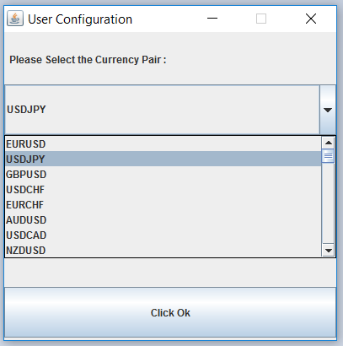

**Correct Input Value:**

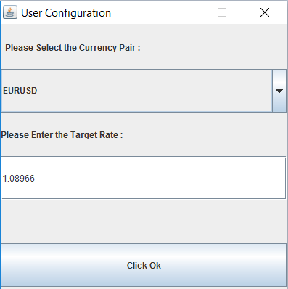

**Result Prompted to User:**

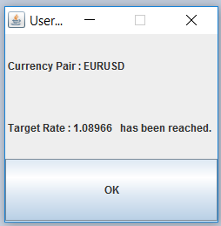

**Empty Value:**

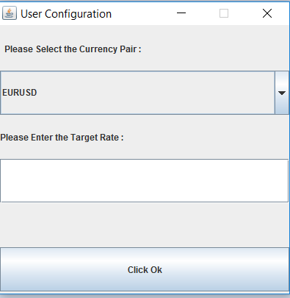

**Incorrect Value:**

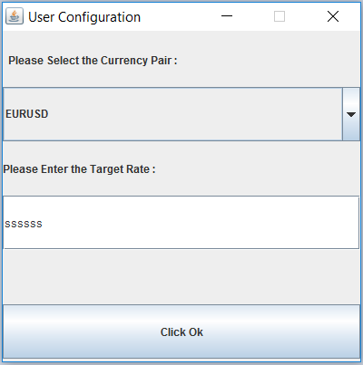

**Prompt Message to User for Incorrect Value:**

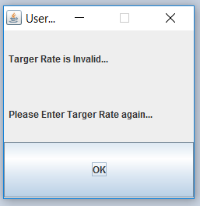

**Prompt the User to Enter another Currency Pair & Target Value:**

