Smart Interview Preparation Portal with Integrated AI and Live Code Execution

ABSTRACT
The increasing demand for efficient and personalized interview preparation solutions has driven the development of AI-based learning platforms. This project presents an AI-Powered Interview Preparation Portal integrated with a real-time code execution feature using the JDoodle API.
The system is developed using Spring Boot for backend services, MySQL for database management, and HTML and CSS for the frontend interface. The portal provides essential functionalities such as user registration, login authentication, curated technical questions, AI-driven personalized preparation paths, and real-time code compilation and execution.
By leveraging the JDoodle API, the platform supports code execution in multiple programming languages, providing users with instant feedback and enhancing their practical coding skills. The system architecture follows a modular design approach, ensuring scalability, security, and high performance.
Extensive testing demonstrates the portal’s effectiveness in improving user engagement and overall preparation quality. The integration of AI technologies along with external code execution services such as JDoodle offers an innovative and modern approach to interview training, effectively addressing the limitations of traditional preparation methods.

KEYWORDS
AI Interview Preparation, JDoodle API, Code Execution, Spring Boot, MySQL, Web Application, Real-Time Feedback

CHAPTER-I

INTRODUCTION

1.1 Introduction
In the modern digital era, the recruitment process for technical roles has evolved significantly, placing strong emphasis on problem-solving ability, logical reasoning, and hands-on programming skills. Technical interviews are no longer limited to theoretical questioning; instead, they extensively evaluate a candidate’s capability to design algorithms, write optimized code, debug errors, and think critically under time constraints. As a result, interview preparation has become a structured and continuous process rather than a short-term activity.
With the rapid growth of the software industry and increasing competition among job aspirants, there is a growing demand for intelligent, efficient, and personalized interview preparation platforms. Traditional preparation methods such as classroom coaching, printed materials, and static online resources often fail to provide practical exposure and personalized learning experiences. These approaches typically lack real-time feedback, adaptive learning paths, and integrated coding environments, which are essential for mastering technical interviews.
To overcome these challenges, technology-driven learning solutions powered by Artificial Intelligence (AI) and cloud-based services have emerged as a promising alternative. AI enables systems to analyze user behavior, track performance, and provide personalized recommendations, while cloud-based APIs allow seamless integration of advanced features such as real-time code execution. These innovations have transformed conventional learning systems into smart, interactive, and user-centric platforms.
1.2 Need for Smart Interview Preparation Systems
The increasing complexity of technical interviews has highlighted several limitations in existing preparation approaches:
- Candidates often memorize solutions without understanding underlying concepts.
- There is minimal exposure to real interview-like coding environments.
- Feedback mechanisms are either delayed or completely absent.
- Learning paths are not tailored to individual strengths and weaknesses.

A smart interview preparation system addresses these issues by offering a structured environment where users can learn concepts, practice coding problems, and receive instant feedback. By integrating AI-driven personalization and live code execution, such systems significantly enhance learning efficiency and confidence levels among candidates.
1.3 Role of Artificial Intelligence in Interview Preparation
Artificial Intelligence plays a crucial role in enhancing modern educational platforms by enabling data-driven decision-making and adaptive learning. In interview preparation systems, AI can be utilized to:
- Analyze user performance and learning patterns
- Identify weak and strong areas of a candidate
- Recommend appropriate questions based on skill level
- Adapt difficulty levels dynamically
- Provide personalized preparation strategies
By incorporating AI concepts, the proposed portal ensures that each user follows a customized preparation path rather than a generic learning model. This personalization improves engagement, retention, and overall interview readiness.
1.4 Importance of Live Code Execution in Learning
Practical coding experience is one of the most critical components of technical interview preparation. Writing code in real time helps candidates understand syntax, logic, performance constraints, and error handling. However, setting up local development environments can be time-consuming and inconvenient for learners.
Live code execution integrated within a web application eliminates this barrier by providing a ready-to-use coding environment accessible from anywhere. It allows users to:
- Write, compile, and execute code instantly
- Test solutions across multiple programming languages
- Identify runtime and compilation errors
- Practice under interview-like conditions
The integration of the JDoodle API enables secure and scalable execution of code, making the learning experience practical and industry-relevant.

1.5 Overview of the Proposed System
The Smart Interview Preparation Portal with Integrated AI and Live Code Execution is a web-based application designed to provide a complete interview preparation solution. The system is developed using Spring Boot for backend services, MySQL for database management, and HTML and CSS for frontend design. It integrates the JDoodle API to support real-time code compilation and execution.
The portal offers features such as user authentication, categorized technical questions, AI-driven personalized preparation paths, and live coding practice with instant feedback. The modular architecture ensures scalability, maintainability, and security, making the system suitable for both individual learners and institutional use.
1.6 Advantages of the Proposed System
The proposed system offers several advantages over traditional preparation methods:
- Personalized learning experience using AI
- Real-time coding practice without local setup
- Instant feedback on code execution
- Centralized platform for learning and practice
- Scalable and secure system architecture
- Enhanced user engagement and motivation
These features collectively improve preparation quality and help candidates perform better in real-world interviews.
1.7 Application Areas
The Smart Interview Preparation Portal can be effectively used by:
- Engineering and computer science students
- Job seekers preparing for technical interviews
- Educational institutions and training centers
- Online learning platforms
- Self-learners and working professionals

CHAPTER – II

LITERATURE REVIEW

2.1 Introduction
The rapid advancement of Artificial Intelligence (AI), conversational agents, and intelligent software systems has significantly transformed the landscape of digital learning, human–computer interaction, and software development practices. Interview preparation platforms, in particular, have benefited from these advancements by integrating AI-driven personalization, real-time feedback mechanisms, and automated code execution environments. This chapter presents a comprehensive review of existing literature related to AI-based systems, chatbots, human-like interaction, code generation tools, integrated development environments, and intelligent evaluation mechanisms that form the foundation of the proposed Smart Interview Preparation Portal with Integrated AI and Live Code Execution.
The reviewed studies provide insights into the evolution of AI interaction quality, empathic systems, conversational agents in educational environments, and modern AI-assisted coding tools. The literature also highlights the challenges, limitations, and opportunities associated with integrating AI technologies into learning and software development platforms.

2.2 Human-Like Interaction and Acceptance of AI Systems
One of the key aspects of AI-powered platforms is user acceptance, which largely depends on interaction quality and perceived human-like behavior. Pelau et al. [1] investigated the role of empathy, interaction quality, and psychological anthropomorphic characteristics in enhancing user acceptance of AI systems in service industries. Their findings emphasize that AI systems perceived as human-like are more likely to be trusted and adopted by users.
This research is particularly relevant to interview preparation platforms, where sustained user engagement is critical. By incorporating interactive and responsive AI features, systems can simulate mentor-like behavior, thereby improving learning motivation and continuity.
Similarly, Adiwardana et al. [5] explored the development of human-like open-domain chatbots capable of generating natural and contextually appropriate responses. Their work demonstrates how large-scale neural language models can enhance conversational flow, which is essential for AI-driven learning assistants.

2.3 Chatbots in Educational and Campus Environments
The application of chatbots in educational environments has gained significant attention. Dibitonto et al. [2] designed “LiSA,” a virtual assistant deployed in a university campus to assist students with academic and administrative tasks. The study highlights how conversational agents can improve accessibility to information and enhance the overall student experience.
Falala-Séchet et al. [4] introduced “Owlie,” a chatbot designed to provide emotional support to users facing psychological challenges. Although focused on mental health, the study demonstrates the importance of empathy and adaptive responses in AI systems. These principles are transferable to interview preparation platforms, where candidates often experience stress and anxiety.
Arteaga et al. [3] proposed an information system architecture for recommending tourist sites using a chatbot interface. Their work emphasizes modular system design and recommendation logic, which aligns with the architectural requirements of scalable interview preparation systems.

2.4 Evolution of Conversational AI and Generative Models
Recent advancements in generative AI have significantly influenced how users interact with intelligent systems. Taecharungroj [7] analyzed early public reactions to ChatGPT, identifying its strengths in natural language understanding, contextual awareness, and content generation. The study highlights the growing reliance on AI chatbots for problem-solving and learning tasks.
Mollick [9] described ChatGPT as a tipping point in AI evolution, emphasizing its potential to disrupt education, software development, and knowledge work. Loh [8] further discussed the opportunities and challenges of generative AI in professional domains, including ethical considerations and system reliability.
Schaaff et al. [6] evaluated ChatGPT’s empathic abilities, revealing its potential to simulate supportive and context-aware interactions. These findings support the feasibility of integrating AI-based assistance in interview preparation portals to guide users through learning paths.

2.5 AI-Assisted Coding and Code Generation Tools
AI-assisted code generation has emerged as a transformative technology in software development. Chen et al. [16] evaluated large language models trained on code, demonstrating their ability to generate syntactically correct and contextually relevant programs. This study laid the foundation for modern AI coding assistants.
Liu et al. [15] conducted a rigorous evaluation of ChatGPT-generated code and identified issues related to correctness, edge cases, and logical completeness. Their findings highlight the importance of validation and execution-based feedback mechanisms when using AI-generated code.
Yetistiren et al. [17] compared the code quality of AI-assisted tools such as GitHub Copilot, Amazon CodeWhisperer, and ChatGPT. The study concluded that while AI tools improve productivity, they require careful integration with testing and validation systems.
Zhang et al. [14] examined developer practices and challenges when using GitHub Copilot. Their results indicate that developers benefit from AI suggestions but still rely on human judgment for correctness and optimization.

2.6 Integrated Development Environments and Real-Time Feedback
Modern Integrated Development Environments (IDEs) play a critical role in enhancing developer productivity. Alizadehsani et al. [10] discussed the evolution of IDEs and their integration with intelligent tools. The study highlights the importance of real-time feedback, debugging support, and automation in learning and development environments.
Real-time code execution APIs, such as JDoodle, extend these IDE capabilities to web-based platforms. Although not explicitly covered in the reviewed literature, the principles of execution-based evaluation and instant feedback align with findings from software engineering studies emphasizing hands-on learning.

2.7 Software Effort Estimation and Evaluation Challenges
Several studies have focused on software effort estimation and evaluation methodologies. Kaur et al. [11] presented a comprehensive study on the evolution of software development cost estimation techniques using automated text mining. Their findings highlight the complexity of evaluating software systems and the need for automated approaches.
Bluemke and Malanowska [12] conducted a systematic literature review on software testing effort estimation, emphasizing the challenges of scalability and accuracy. Butt et al. [13] proposed cost estimation methods for agile software development, reinforcing the importance of modular and adaptable system architectures.
These studies collectively underline the importance of automated evaluation mechanisms, which directly support the need for real-time code execution and automated feedback in interview preparation platforms.

2.8 Large Language Models and Open-Source AI Frameworks
The development of large language models has accelerated AI research and applications. Wang and Komatsuzaki [18] introduced GPT-J-6B, an open-source autoregressive language model that demonstrated competitive performance with proprietary models.
OpenAI’s GPT-4 Technical Report [20] provided insights into model capabilities, safety considerations, and evaluation methodologies. Luo et al. [22] proposed WizardCoder, a code-focused large language model enhanced through evolutionary instruction tuning, significantly improving code generation accuracy.
Phind [21] presented a code-optimized language model designed for developer assistance. These studies collectively demonstrate the growing maturity of AI models capable of supporting complex programming tasks.
2.9 Research Gaps Identified from Literature
Based on the reviewed literature, several research gaps are identified:
- Limited integration of AI personalization with real-time code execution
- Lack of unified platforms combining learning, practice, and evaluation
- Insufficient focus on interview-specific preparation systems
- Need for scalable, secure, and modular architectures
- Requirement for execution-based validation of AI-assisted coding

These gaps highlight the necessity for a comprehensive interview preparation portal that integrates AI-driven guidance with live coding environments.

2.10 Relevance of Literature to the Proposed System
The proposed Smart Interview Preparation Portal with Integrated AI and Live Code Execution builds upon existing research by:
- Applying human-like AI interaction principles [1], [5]
- Leveraging chatbot-based assistance models [2], [4]
- Incorporating generative AI insights [7], [9]
- Integrating AI-assisted coding evaluation [15], [16], [17]
- Utilizing real-time execution concepts aligned with modern IDEs [10]
By synthesizing these research contributions, the proposed system offers a novel and practical solution to modern interview preparation challenges.
This literature review examined a wide range of studies related to AI interaction, conversational agents, generative models, AI-assisted coding tools, and software evaluation methodologies. The reviewed research demonstrates the growing impact of AI on education and software development while highlighting existing limitations in current systems. The insights gained from this literature form a strong foundation for the design and implementation of the proposed interview preparation portal. By addressing identified research gaps, the project contributes to the development of intelligent, interactive, and scalable learning platforms tailored for technical interview preparation.

CHAPTER-III

Program Code Generation with Generative Ais

Generative AIs have increasingly become an integral part of our everyday lives [1]. Particularly, generative AIs for text generation are engineered to replicate human-like dialogues and offer help, information, and even emotional support [2–6]. They can be available 24/7 and provide instant responses, making them a valuable tool for customer service, personal assistants, and many other applications. Among them, ChatGPT (https:// openai.com/chatgpt, accessed on 29 January 2024) stands out as one of the most frequently utilized for text generation [7]. Within just five days of its launch, more than one million users registered [7].
The transformative power of AI also permeates the field of coding, an area where technology has made significant strides: AI-powered chatbots are not only capable of conducting human-like conversations but can also generate program code [8,9]. Simultaneously, Integrated Development Environments (IDEs), unit tests, and benchmarking tools have simplified coding, making it more accessible to both seasoned developers and beginners [10]. In this sense, AI-powered chatbots and coding tools are two facets of the same coin, both contributing to the transformation of how we use technology. However, a critical challenge remains—the time and manual effort required for coding, especially for those new to the craft [11–13] .
While AI tools promise to streamline the coding process and lower the barriers to entry for aspiring coders, it is important to note that they still have their limits. For example,
they may not always produce correct, efficient, or maintainable program codes. Therefore, it is crucial to carefully consider various aspects when deciding whether or not to use these tools [14].
While substantial research has focused on evaluation metrics for correctness like pass@k [15–17], there is a noticeable gap: The extensive comparison of AI-generated and
human-generated program codes based on various metrics has largely been understudied. Consequently, our study embarks on a comprehensive and in-depth exploration of the coding capabilities of seven state-of-the-art generative AIs. Our goal is to evaluate the AI-generated program codes based on the interaction of various metrics such as cyclomatic complexity, maintainability index, etc., concerning their correctness, efficiency and maintainability. Moreover, we go one step further by comparing the AI-generated codes with corresponding human-generated codes written by professional programmers.

Our contributions are as follows:
- We investigate and compare the correctness, efficiency and maintainability of AI-generated program codes using varying evaluation metrics.
- We are the first to extensively compare AI-generated program codes to human generated program codes.
- We analyze the program codes that address problems of three difficulty levels—easy, medium and hard.
- We produced a dataset of 126 AI-generated and 18 human-generated program codes— the AI/Human-Generated Program Code Dataset—which we share with the research community (https://github.com/Back3474/AI-Human-Generated-Program-CodeDataset, accessed on 29 January 2024).
In the next section, we will provide an overview of related work. In Section 3, we will present our experimental setup. Our experiments and results will be described in Section 4.
In Section 5, we will conclude our work and indicate possible future steps.

2. Related Work
In this section, we will look at existing work regarding automatic program code generation and evaluation.
Codex (https://openai.com/blog/openai-codex, accessed on 29 January 2024) is an
AI model for program code generation based on GPT-3.0 and fine-tuned on program code publicly available on GitHub [16]. Ref. [16] tested Codex’s capabilities in generating Python code using natural language instructions found in in-code comments known as docstrings. They also created HumanEval, a dataset of 164 hand-written coding problems in natural language plus their unit tests to assess the functional correctness of program code. One discovery from their research was that if Codex is asked to generate code for the same problem several times, the probability that one generated code is correct increases. Consequently, they used pass@k as an evaluation metric, where k is the number of generated program codes, and pass is the number of tasks, of which all unit tests were passed. To obtain an unbiased estimation of pass@k, ref. [16] applied additional adjustments to the original calculation. Codex achieved a pass@1 of 28.8% in solving the provided problems. They compared the Codex-generated code with program code generated by GPT-3.0 and GPT-J [18], but GPT-3.0 demonstrated a pass@1 of 0% and GPT-J obtained 11.4%. With pass@100, Codex achieved even 70.2%.

Ref. [19] evaluated the validity, correctness, and efficiency of program code generated by GitHub (GH) Copilot using HumanEval. GH Copilot is an IDE extension that uses Codex. Ref. [19] defined a code as valid, if it was compliant with the syntax rules of a given programming language. The correctness was computed by dividing the programming tasks’ passed unit tests by all existing unit tests for this specific task. The efficiency was measured by determining the time and space complexities of the generated codes. Their results demonstrate that Codex was able to generate valid code with a success rate of 91.5%. Regarding code correctness, 28.7% were generated correctly, 51.2% were generated partially correctly, and 20.1% were generated incorrectly.

Ref. [17] used HumanEval to evaluate the validity, correctness, security, reliability, and maintainability of Python code generated by GH Copilot, Amazon CodeWhisperer (https://aws.amazon.com/de/codewhisperer, accessed on 29 January 2024), and ChatGPT. They defined a valid code and a correct code as in [19]. To determine the security, reliability, and maintainability, they used SonarQube (https://www.sonarqube.org, accessed on 29 January 2024). Their calculation of a code’s security is based on the potential cybersecurity vulnerabilities of this code. The reliability is based on the number of bugs. The maintainability is measured by counting present code smells. ChatGPT generated 93.3% valid program codes, GH Copilot 91.5%, and CodeWhisperer 90.2%. ChatGPT passed most unit tests by generating 65.2% of correct program codes. GH Copilot reached 46.3%, and CodeWhisperer 31.1%. But when they evaluated newer versions of GH Copilot and CodeWhisperer, they measured 18% and 7% better values for correctness. Due to the small number of generated code fragments, the numbers for security were not usable. Concerning reliability, ChatGPT produced two bugs, GH Copilot three bugs and CodeWhisperer one bug. CodeWhisperer produced the most maintainable code, ChatGPT the second most, and GH Copilot the least maintainable.
Ref. [15] introduced a new framework for program code evaluation named EvalPlus. Furthermore, they created HumanEval+, an extension of HumanEval using EvalPlus’ automatic test input generator. HumanEval+ is 80 times larger than HumanEval which enables more comprehensive testing and analysis of AI-generated code. With HumanEval+, ref. [15] evaluated the functional correctness of program code generated by 26 different AI models which are based on GPT-4 [20], Phind-CodeLlama [21], WizardCoder-CodeLlama [22], Chat-GPT [23], Code Llama [24], StarCoder [25], CodeGen [26], CODET5+ [27], MISTRAL [28], CodeGen2 [29], VICUNA [30], SantaCoder [31], INCODER [32], GPT-J [33], GPT-NEO [34], PolyCoder [35], and StableLM [36] with pass@k. Looking at pass@1, the top five performers were GPT-4 (76.2%), Phind-CodeLlama (67.1%), WizardCoder-CodeLlama (64.6%), ChatGPT (63.4%), and Code Llama (42.7%).

DeepMind developed an AI model for code generation named AlphaCode [37]. On the coding competition website codeforces.com, the AI model achieved an average ranking in the top 54.3% of more than 5000 participants for Python and C++ tasks. The ranking takes runtime and memory usage into account.
Ref. [38] evaluated GH Copilot’s ability to produce solutions for 33 LeetCode problems using Python, Java, JavaScript, and C. They calculated the correctness by dividing the passed test cases by the total number of test cases per problem. The numbers for understandability, cyclomatic and cognitive complexity were retrieved using SonarQube, but due to configuration problems, they were not able to analyze the understandability of the codes generated in C. Concerning correctness, GH Copilot performed best in Java (57%) and worst in JavaScript (27%). In terms of understandability, GH Copilot’s Python, Java and JavaScript program codes had a cognitive complexity of 6 and a cyclomatic complexity of 5 on average, with no statistically significant differences between the programming languages. In comparison to the aforementioned related work, our focus is to evaluate the Java, Python and C++ code produced by Codex (GPT-3.0), CodeWhisperer, BingAI Chat (GPT-4.0), ChatGPT (GPT-3.5), Code Llama (Llama 2), StarCoder, and InstructCodeT5+.
For comparison, we also assess human-generated program code. We obtain the correctness, efficiency and maintainability for our program codes by measuring time and space complexity, runtime and memory usage, lines of code, cyclomatic complexity, Halstead complexity and maintainability index. As a user usually does not generate code for the same problem several times, we evaluate pass@k with k = 1, which is our metric for correctness. Finally, we analyze which of the incorrect and the not executable program codes have the potential to be easily modified manually and then used quickly and without much effort to solve the corresponding coding problems.

3. Experimental Setup
In this section, we will provide a comprehensive overview of our experimental setup. This includes an introduction to the state-of-the-art generative AIs that we employed in our experiments, the coding problems we chose from LeetCode and the code quality metricswe utilized for evaluation.

3.1. Generative AI Models
This section introduces the generative AIs which we analyzed in our study.

3.1.1. ChatGPT Powered by GPT-3.5
The generative AI ChatGPT uses the large language model (LLM) GPT-3.5 which was pre-trained on text and program code. It was first fine-tuned with labeled text data collected from human annotators and a proprietary dataset of question-answer pairs covering various chat topics and scenarios [23]. Then, it was fine-tuned with a reward model (Reinforcement Learning from Human Feedback) and the Proximal Policy Optimization algorithm [23]. ChatGPT leverages GPT-3.5’s 175 billion parameters [39] and is capable of generating program code in a wide variety of programming languages, including Python, JavaScript, HTML, CSS, SQL, Java, C#, C++, Ruby, PHP, R, Swift, and more [40].

3.1.2. BingAI Chat Powered by GPT-4.0
The generative AI BingAI Chat leverages the LLM GPT-4.0 which was trained on a text corpus of about 13 trillion tokens. Some of these tokens come from well-known datasets such as CommonCrawl and RefinedWeb, while others come from sources that are not publicly communicated [41,42]. GPT-4.0 was first fine-tuned with data sourced from ScaleAI plus text data from OpenAI. Then, it was fine-tuned with a reward model (Reinforcement Learning from Human Feedback) and the Proximal Policy Optimization algorithm [42,43]. It is estimated that the model has about 1.8 trillion parameters [41,42]. As it is not publicly known what programming languages are covered, we asked BingAI Chat “What programming languages are you capable of?”. The answer was “I am capable of generating code in various programming languages, such as Python, Java, C#, JavaScript, Ruby, and more”.

3.1.3. GitHub Copilot Powered by GPT-3.0’s Fine-Tuned Model Codex
The generative AI GH Copilot uses GPT-3.0’s fine-tuned LLM Codex. It is an IDE extension available in Visual Studio, Neovim, VS Code and JetBrains [44]. Codex was finetuned on natural language and a vast amount of lines of code from public sources, including GitHub repositories [45]. Codex was pre-trained on the datasets Common Crawl (filtered),
WebText2, Books1, Books2 and Wikipedia. It has 175 billion parameters [46]. According to [45], Codex performs best in Python, but it also shows proficient results in other programming languages including JavaScript, Go, Perl, PHP, Ruby, Swift and TypeScript.

3.1.4. StarCoder Powered by StarCoderBase
The generative AI StarCoder leverages the LLM StarCoderBase. Like GH Copilot, StarCoder is available by using an extension in VS Code, Neovim, Jupyter [47] or all IntelliJ-based IDEs [48]. According to [25], StarCoderBase was first trained on permissively licensed data from GitHub, including 80+ programming languages, Git commits, GitHub issues, and Jupyter notebooks. Then, it was fine-tuned “on 35B Python tokens, resulting in the creation of StarCoder.” which has 15.5 billion parameters [25]. StarCoder is capable of 86 programming languages, including Python, C++, Java, Kotlin, PHP, Ruby, TypeScript, and others.

3.1.5. Code Llama Powered by Llama 2
The generative AI Code Llama is based on Meta’s LLM Llama 2 and was fine-tuned on 500B tokens. For our experiments, we took the version with 13 billion parameters (https://huggingface.co/codellama/CodeLlama-13b-hf, accessed on 29 January 2024) accessing via the same VS Code extension as for StarCoder [47]. The training data were mostly deduplicated, publicly available code, with 8% from natural language datasets related to program code. It covers many programming languages such as Python, C++, Java, PHP, TypeScript, JavaScript, C#, and Bash [24].

3.1.6. CodeWhisperer
According to [49], Amazon’s “CodeWhisperer is a generative AI service powered by a foundation model trained on various data sources, including Amazon and open-source code”. No information regarding CodeWhisperer’s training, fine-tuning or number of parameters is publicly available. Supported IDEs to access CodeWhisperer are Amazon SageMaker Studio, JupyterLab, VS Code, all JetBrains IDEs, AWS Cloud9, AWS Lambda and AWS Glue Studio. Supported programming languages are Java, Python, JavaScript, TypeScript, C#, Ruby, Go, PHP, C++, C, Shell, Scala, Rust, Kotlin, and SQL [50].

3.1.7. InstructCodeT5+ 16b Powered by CodeT5+
The generative AI InstructCodeT5+ 16b leverages the LLM CodeT5+ and was pretrained using the datasets CodeSearchNet [51] and github-code [52]. Then, it was fine-tuned on the dataset CodeAlpaca [53]. InstructCodeT5+ has 16 billion parameters and is capable of producing code in C, C++, C#, Go, Java, JavaScript, PHP, Python, and Ruby [27]. Since InstructCodeT5+ 16b was not available via chat or IDE extension, we prompted it via Google Colab and HuggingFace.

3.2. Our AI/Human-Generated Program Code Dataset
In this subsection, we will first introduce the coding platform LeetCode. Then we will present the coding problems that we selected from LeetCode for our experiments.
3.2.1. LeetCode as a Source for Coding Problems
LeetCode is an online platform where users can improve their coding skills [54]. The coding platform offers support for various programming languages, such as Java, Python, and C++ [38] which was optimal for our experiments. It has gained popularity among job seekers and coding enthusiasts as a resource for technical interviews and coding competitions. The platform offers a vast amount of technical resources and almost 3000 coding problems of six categories (algorithms, database, Pandas, JavaScript, Shell, concurrency) in three difficulty levels (easy, medium, hard).
As shown in Figure 1, each coding problem consists of (1) a textual description of the coding task, (2) examples with input values, expected outputs and sometimes explanations and (3) constraints, which for example define the range of variables’ values. Once the user submits code to LeetCode which solves the problem, LeetCode reports corresponding runtime and memory usage. In case the submitted code is not executable, an error message appears.

3.2.2. Selected Coding Problems for Our Evaluation
For our experiments, we picked six LeetCode coding problems of the category algorithms that the generative AIs had to solve in Java, Python, and C++: Two coding problems were of the difficulty level easy, two medium and two hard. We chose the category algorithms to evaluate efficiency and maintainability since it is the category whose program code—if not programmed well—takes up a lot of memory and runtime and is very difficult to understand compared to the other LeetCode categories. To minimize the likelihood that the solutions to the coding problems appear in the training data of the generative AIs, we used the latest coding problems provided by LeetCode. The combination of coding problems and the number of evaluated generative AIs resulted in a total of 126 AI-generated codes (six problems · seven generative AIs · three languages = 126 codes). Table 1 provides an overview of the final selection of coding problems with their difficulty levels. For comparing the efficiency and maintainability of AI- and human-generated program codes.

CHAPTER IV

PROPOSED SYSTEM

4.1 Introduction
The proposed system, titled Smart Interview Preparation Portal with Integrated AI and Live Code Execution, is designed to overcome the limitations of traditional interview preparation methods by providing an intelligent, interactive, and scalable web-based platform. The system integrates Artificial Intelligence (AI) techniques with real-time code execution capabilities to deliver a personalized and hands-on interview preparation experience.
Unlike conventional platforms that focus mainly on static content and theoretical learning, the proposed system emphasizes adaptive learning, practical coding exposure, instant feedback, and user-centric design. The integration of the JDoodle API enables real-time compilation and execution of code in multiple programming languages, while AI-driven components analyze user behavior and performance to recommend suitable learning paths.
4.2 Overall Architecture of the Proposed System
The proposed system follows a modular and layered architecture, ensuring scalability, maintainability, and security. Each module is independently developed and interacts with other components through well-defined interfaces.
4.2.1 Architectural Layers
- Presentation Layer
  - Developed using HTML and CSS
  - Provides user interfaces for login, registration, question practice, and code execution
  - Ensures responsiveness and user-friendly interaction
- Application Layer
  - Implemented using Spring Boot
  - Handles business logic, request processing, and API communication
  - Acts as a bridge between the frontend and database

- AI Processing Layer
  - Analyzes user performance data
  - Generates personalized recommendations
  - Determines difficulty levels and learning progression
- Integration Layer
  - Connects the system with the JDoodle API
  - Handles code submission, compilation, and execution
  - Retrieves output, errors, and execution status
- Data Layer
  - Uses MySQL for persistent data storage
  - Stores user profiles, questions, submissions, and performance metrics
4.3 Functional Modules of the Proposed System
4.3.1 User Authentication Module
This module manages user registration and login functionality. It ensures secure authentication using validated credentials and session management techniques.
Key Features:
- User registration with email validation
- Secure login authentication
- Session handling
- Role-based access control (User/Admin)

4.3.2 Question Management Module
This module provides a structured repository of interview questions categorized by topic, difficulty, and programming language.
Key Features:
- Categorized technical questions
- Difficulty-level classification
- Admin-controlled question management
- Dynamic question retrieval

4.3.3 AI-Based Personalization Module
The AI module analyzes user interaction data and coding performance to provide personalized preparation paths.
Key Features:
- Performance analysis
- Adaptive question recommendations
- Difficulty progression
- Learning pattern identification

4.3.4 Live Code Execution Module
This module enables users to write, compile, and execute code in real time using the JDoodle API.
Key Features:
- Multi-language support
- Real-time compilation
- Execution output display
- Error detection and feedback

4.3.5 Result and Feedback Module
This module provides execution results and performance feedback to users.
Key Features:
- Output visualization
- Error reporting
- Submission history
- Performance metrics

4.4 UML Diagrams
UML (Unified Modeling Language) diagrams are used to visually represent system design, structure, and interactions.
4.4.1 Use Case Diagram
The Use Case Diagram illustrates interactions between users and the system.
Actors:
- User
- Admin
Use Cases:
- Register
- Login
- View Questions
- Write Code
- Execute Code
- View Results
- Manage Questions (Admin)
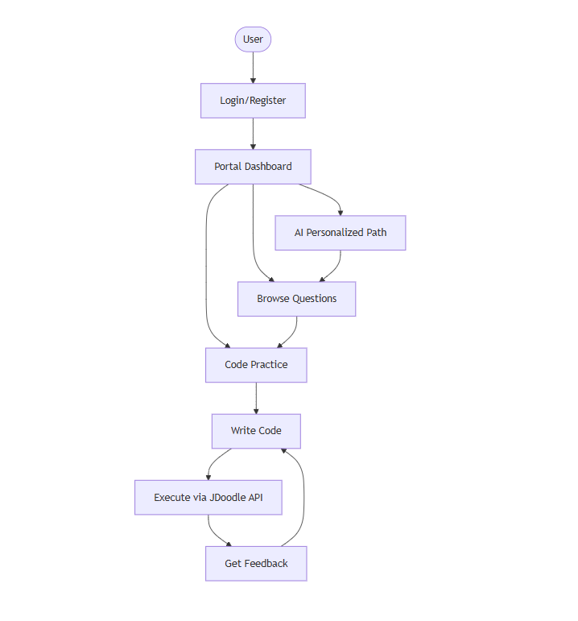
Fig 5.2. Use Case Diagram

4.4.2 Class Diagram
The Class Diagram represents the static structure of the system.
Major Classes:
- User
- Question
- Submission
- Result
- Recommendation
- CodeExecutor
- Admin
Each class contains attributes and methods defining system behavior.
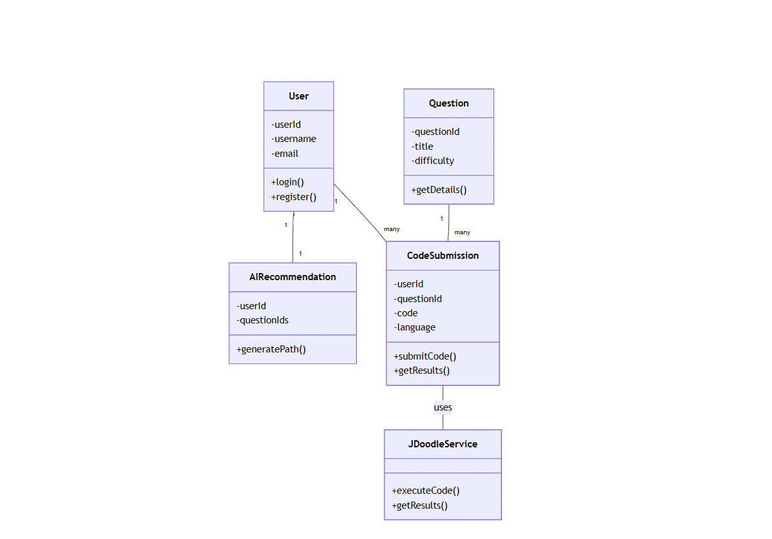
Fig 5.2. class diagram
4.4.3 Sequence Diagram
Sequence diagrams show the flow of interactions during code execution:
- User submits code
- System sends request to JDoodle API
- API compiles and executes code
- Output is returned
- Result is displayed to the user

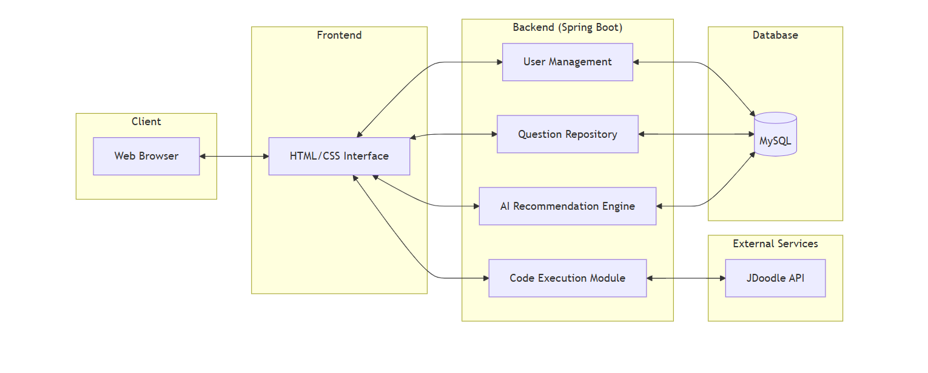
Fig 4.3. Sequence Diagram

4.4.4 Activity Diagram
Activity diagrams represent workflows such as user login and code execution, showing decision points and parallel activities.

4.5 Algorithms Used in the Project
4.5.1 User Authentication Algorithm
Algorithm:
- Accept user credentials
- Validate input data
- Verify credentials against database
- Grant or deny access
- Initiate session

4.5.2 AI-Based Recommendation Algorithm
Algorithm:
- Retrieve user performance data
- Analyze accuracy and completion time
- Identify weak and strong areas
- Recommend appropriate questions
- Update learning path dynamically

4.5.3 Code Execution Algorithm (JDoodle Integration)
Algorithm:
- Accept source code and language
- Send request to JDoodle API
- Compile and execute code
- Capture output/errors
- Display results to user

4.5.4 Result Evaluation Algorithm
Algorithm:
- Compare output with expected result
- Assign execution status
- Store result in database
- Update performance metrics

4.6 Security Considerations
Security is a critical aspect of the proposed system.
Security Measures:
- Secure authentication mechanisms
- Input validation
- API key protection
- Session management
- Controlled access to execution services

4.7 Scalability and Performance
The modular architecture allows:
- Horizontal scaling
- Load balancing
- Efficient database queries
- Optimized API communication
The system can support multiple concurrent users without performance degradation.

4.8 Advantages of the Proposed System
- AI-driven personalized learning
- Real-time code execution
- Instant feedback
- Modular architecture
- Secure and scalable design
- User-friendly interface

4.9 Limitations of the Proposed System
- Dependency on third-party API availability
- Internet connectivity requirement
- Limited AI depth in initial implementation
4.10 Future Enhancements
- Advanced AI analytics
- Mock interview simulations
- Plagiarism detection
- Video-based interviews
- Expanded language support.

The proposed Smart Interview Preparation Portal with Integrated AI and Live Code Execution introduces a modern, intelligent, and interactive approach to interview preparation. By combining AI-driven personalization with real-time coding practice, the system bridges the gap between theoretical knowledge and practical application. The modular architecture, secure design, and scalable implementation make the proposed system suitable for both academic and professional use. This chapter establishes the technical foundation for the system, paving the way for implementation and testing in subsequent chapters.

CHAPTER V

IMPLEMENTATION AND TESTING

5.1 Introduction
This chapter describes the implementation details and testing strategies adopted for the Smart Interview Preparation Portal with Integrated AI and Live Code Execution. The implementation phase translates the system design and architecture described in the previous chapter into a functional software solution. The system is developed using Spring Boot for backend services, MySQL for database management, and HTML and CSS for frontend presentation. The JDoodle API is integrated to support real-time code compilation and execution.
Testing plays a crucial role in validating the correctness, reliability, and performance of the developed system. Various testing techniques were applied to ensure that the system meets functional and non-functional requirements.
5.2 Implementation Environment
5.2.1 Hardware Requirements
- Processor: Intel i5 or above
- RAM: Minimum 8 GB
- Hard Disk: 256 GB or above
- Internet Connection: Required for API integration
5.2.2 Software Requirements
- Operating System: Windows 10 / Linux
- Programming Language: Java
- Backend Framework: Spring Boot
- Frontend Technologies: HTML, CSS
- Database: MySQL
- IDE: Spring Tool Suite (STS) / IntelliJ IDEA
- API: JDoodle API
- Browser: Google Chrome / Mozilla Firefox

5.3 Backend Implementation
The backend of the system is implemented using Spring Boot, which provides rapid application development, embedded server support, and simplified configuration management.
5.3.1 Project Structure
The backend follows a layered architecture:
- Controller Layer: Handles HTTP requests and responses
- Service Layer: Contains business logic
- Repository Layer: Manages database operations
- Model Layer: Defines entity classes
This separation ensures maintainability, scalability, and clean code structure.
5.3.2 User Authentication Implementation
User authentication is implemented to provide secure access to the system.
Implementation Steps:
- User submits registration details
- Input validation is performed
- User data is stored securely in the database
- Login credentials are verified during authentication
- Session is created upon successful login
The system ensures that only authenticated users can access coding and interview preparation features.
5.3.3 Question Management Implementation
Interview questions are stored in the database with attributes such as:
- Question ID
- Topic
- Difficulty level
- Programming language
- Description
The backend retrieves questions dynamically based on user selection and AI recommendations.

5.3.4 AI-Based Personalization Implementation
The AI-based personalization module analyzes user performance data, including:
- Number of attempts
- Accuracy of solutions
- Execution success rate
- Time taken per question
Based on this analysis, the system:
- Identifies weak and strong areas
- Recommends suitable questions
- Adjusts difficulty levels dynamically
This adaptive approach improves learning efficiency and engagement.

5.3.5 JDoodle API Integration
The JDoodle API is integrated to enable real-time code execution.
Implementation Workflow:
- User writes source code in the editor
- Code and language details are sent to the backend
- Backend forwards request to JDoodle API
- API compiles and executes the code
- Execution output or error message is returned
- Result is displayed to the user
The integration supports multiple programming languages and provides instant feedback.

5.4 Frontend Implementation
The frontend is developed using HTML and CSS to ensure simplicity and responsiveness
5.4.1 User Interface Design
The user interface includes:
- Login and Registration pages
- Dashboard
- Question display section
- Code editor interface
- Output console
The design emphasizes clarity, usability, and smooth navigation.
5.4.2 Code Editor Interface
The code editor allows users to:
- Select programming language
- Write and modify code
- Provide custom input
- Execute code with a single click
The output is displayed in a console-like format, simulating real interview environments.
5.5 Database Implementation
The database is implemented using MySQL.
5.5.1 Database Tables
Key tables include:
- Users
- Questions
- Submissions
- Results
- Performance Metrics

Foreign key relationships ensure data integrity and consistency.
5.5.2 Data Storage and Retrieval
Efficient SQL queries are used to:
- Store user details
- Track code submissions
- Maintain execution history
- Analyze performance data
5.6 Testing Strategy
Testing ensures that the system functions as expected and meets quality standards.
5.6.1 Types of Testing Performed
- Unit Testing
- Integration Testing
- System Testing
- Functional Testing
- Performance Testing
5.6.2 Unit Testing
Each module is tested individually to verify correctness.
Examples:
- Login validation
- Question retrieval
- Code execution request handling
5.6.3 Integration Testing
Integration testing verifies interaction between:
- Backend and database
- Backend and JDoodle API
- Frontend and backend

5.6.4 Functional Testing
Functional testing ensures all features work according to requirements.

Feature | Expected Result | Status
User Login | Successful authentication | Pass
Question Display | Correct questions loaded | Pass
Code Execution | Correct output shown | Pass
AI Recommendation | Adaptive suggestions | Pass

5.6.5 Performance Testing
The system is tested for:
- Concurrent user handling
- API response time
- Database query efficiency
Results show stable performance under moderate load.

5.7 Error Handling and Validation
The system includes:
- Input validation
- API failure handling
- User-friendly error messages
- Secure exception management
These measures enhance system reliability and usability.

5.8 Security Testing
Security testing verifies:
- Authentication enforcement
- Session management
- Protection of API credentials
- Prevention of unauthorized access

5.9 Deployment Considerations
The application can be deployed on:
- Local servers
- Cloud platforms
Environment-specific configurations are managed through application properties.
This chapter presented the detailed implementation and testing of the Smart Interview Preparation Portal with Integrated AI and Live Code Execution. The system successfully integrates backend services, frontend interfaces, database management, AI-driven personalization, and real-time code execution using the JDoodle API. Comprehensive testing confirms that the system is reliable, secure, and efficient. The successful implementation validates the proposed system design and prepares the groundwork for result analysis and output evaluation discussed in the next chapter.

CHAPTER-VI

RESULTS AND OUTPUTS

Figure 6.1: Home Page of AI Interview Preparation Portal
Description:
Figure 6.1 illustrates the Home Page interface of the Smart Interview Preparation Portal with Integrated AI and Live Code Execution. This page serves as the initial entry point for users accessing the system. It displays a welcoming banner titled “WELCOME TO AI INTERVIEW PORTAL”, designed to create a professional and engaging first impression.
The home page provides two primary navigation options:
- Login – for existing users to securely access their personalized dashboard.
- Register – for new users to create an account and begin interview preparation.
The background image represents a modern collaborative workspace, symbolizing real-world technical environments and reinforcing the platform’s focus on practical skill development. The simple and intuitive layout ensures ease of navigation, improved user experience, and quick access to core functionalities. This interface plays a crucial role in guiding users toward authentication and onboarding processes within the system.


Figure 6.2: Login Page of AI Interview Preparation Portal
Description:
Figure 6.2 depicts the Login Page interface of the Smart Interview Preparation Portal with Integrated AI and Live Code Execution. This page enables registered users to securely access the system by entering their email address and password.
The login form is designed with a clean and minimal layout to ensure ease of use and clarity. It includes clearly labeled input fields for user credentials and a prominent Login button to initiate authentication. Upon successful validation of credentials, users are redirected to their respective dashboards, where they can access interview questions, personalized recommendations, and live code execution features.
This login mechanism ensures secure authentication, protects user data, and supports personalized learning by maintaining individual user sessions. maintaining system security.
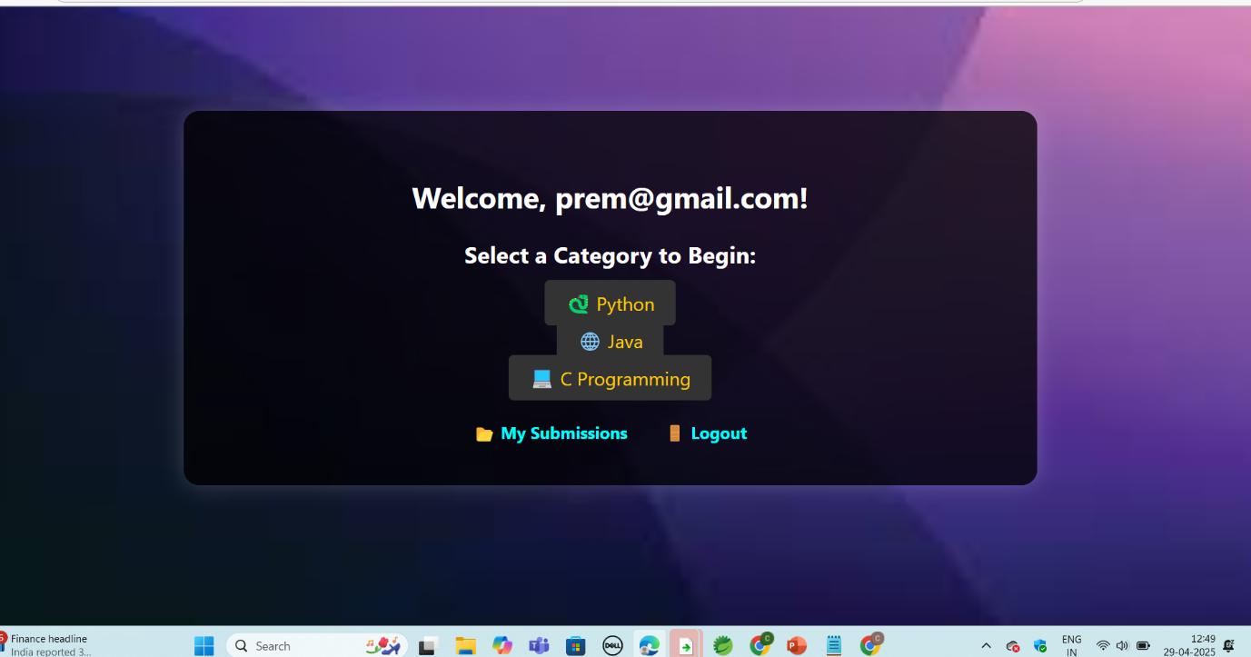
Figure 6.3: User Dashboard Page of AI Interview Preparation Portal
Description:
Figure 6.3 shows the User Dashboard interface of the Smart Interview Preparation Portal with Integrated AI and Live Code Execution. This page is displayed after successful user authentication and serves as the central navigation hub for the platform.
The dashboard welcomes the user with a personalized greeting and provides options to select a programming category, such as Python, Java, and C Programming, enabling users to begin interview preparation based on their preferred technology stack. Additionally, the dashboard includes options like My Submissions, allowing users to review previously executed code and track progress, and Logout, ensuring secure session termination.
The visually appealing and intuitive layout enhances user engagement and simplifies navigation. By offering direct access to categorized learning paths and user-specific data, this dashboard supports personalized preparation and efficient use of the system’s features.

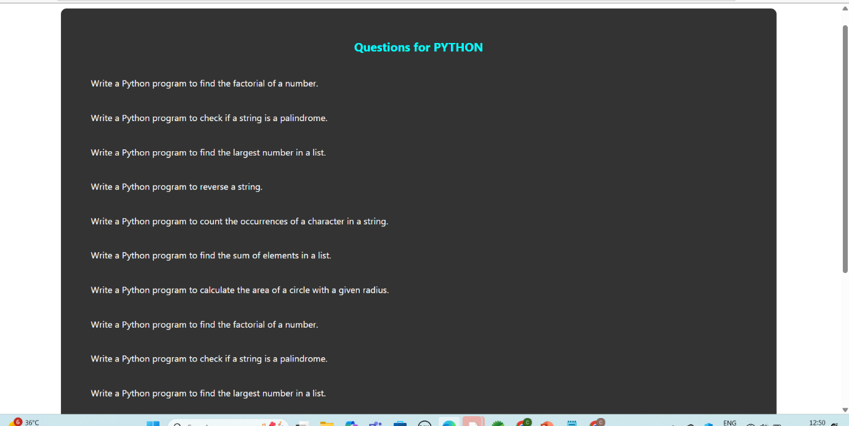
Figure 6.4: Question List Page for Python Category
Description:
Figure 6.4 illustrates the Question List Page for the Python programming category in the Smart Interview Preparation Portal with Integrated AI and Live Code Execution. This page displays a curated list of Python-based interview questions designed to assess and strengthen fundamental programming concepts.
The questions cover essential topics such as:
- Factorial of a number
- String palindrome checking
- Finding the largest element in a list
- String reversal
- Counting character occurrences
- Summation of list elements
- Mathematical problem-solving (e.g., area of a circle)
The questions are presented in a clear, readable format, allowing users to easily select a problem and proceed to the coding interface. This structured question listing supports systematic learning and enables users to practice commonly asked interview problems, thereby improving logical thinking and coding proficiency.

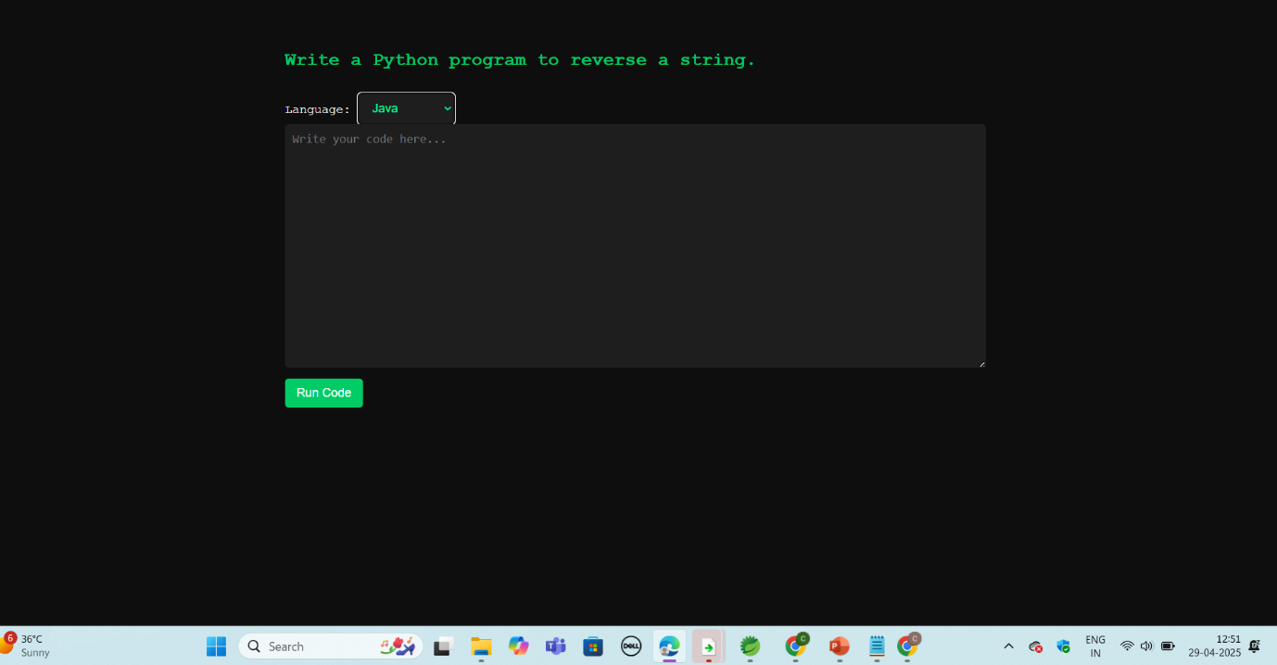
Figure 6.5: Live Code Editor Interface
Description:
Figure 6.5 presents the Live Code Editor interface of the Smart Interview Preparation Portal with Integrated AI and Live Code Execution. This screen allows users to write and test solutions for selected interview questions in a real-time coding environment.
The interface displays the selected problem statement at the top, followed by a language selection dropdown, enabling users to choose their preferred programming language. A large, dedicated code editor area is provided for writing source code, closely simulating real technical interview coding platforms. The Run Code button allows users to submit their code for compilation and execution.
This feature plays a vital role in enhancing practical coding skills by offering hands-on experience, immediate execution, and a realistic interview-style programming environment. It eliminates the need for local development setup and supports focused practice within the platform.
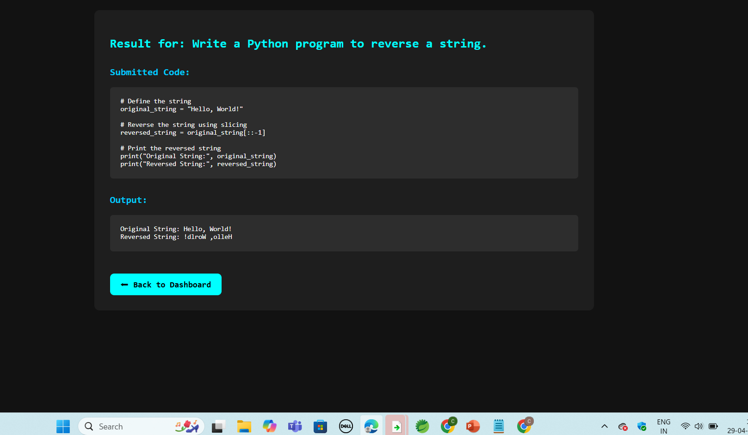
Figure 6.6: Code Execution Result and Output Screen
Description:
Figure 6.6 illustrates the Code Execution Result screen of the Smart Interview Preparation Portal with Integrated AI and Live Code Execution. This page displays the outcome of executing the user-submitted source code for the selected interview question.
The interface clearly presents the submitted code, allowing users to review their implementation, followed by the execution output generated by the system. In this example, the output demonstrates the successful reversal of a string, confirming correct logic and program execution. The result screen provides immediate and transparent feedback, enabling users to validate their solutions and understand program behavior.
Additionally, a “Back to Dashboard” option is provided for seamless navigation, allowing users to continue practicing additional problems or review submissions. This output interface plays a crucial role in reinforcing learning through instant feedback and practical validation, closely simulating real technical interview environments.
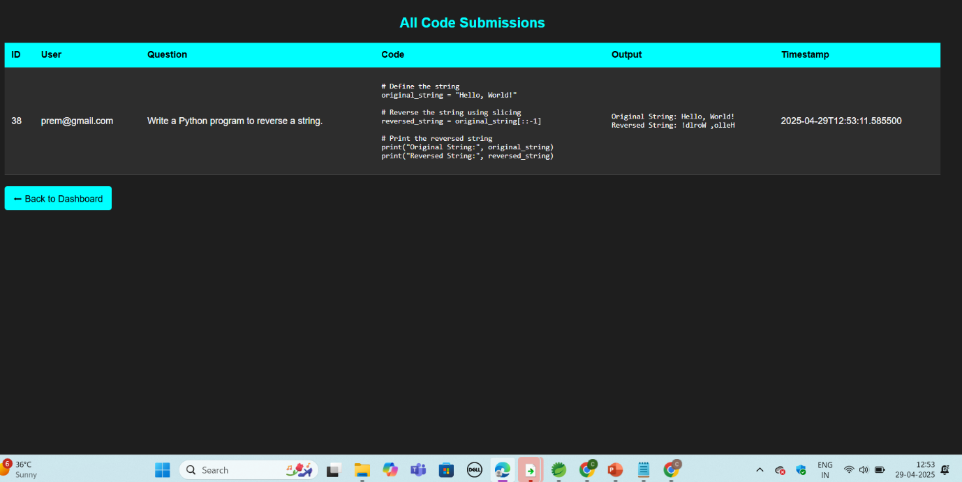
Figure 6.7: Code Submission History (My Submissions Page)
Description:
Figure 6.7 illustrates the Code Submission History page of the Smart Interview Preparation Portal with Integrated AI and Live Code Execution. This page displays a detailed record of all code submissions made by the logged-in user during interview practice sessions.
The submission history is presented in a tabular format containing key details such as:
- Submission ID
- User Email
- Question Title
- Submitted Source Code
- Execution Output
- Timestamp of Submission
This feature enables users to review their previous attempts, analyze mistakes, and track their progress over time. By maintaining a persistent record of submissions, the system supports self-assessment, learning continuity, and performance evaluation. The “Back to Dashboard” option ensures smooth navigation and enhances overall usability.
The submission history page plays a crucial role in reinforcing learning outcomes by allowing users to reflect on past solutions and improve problem-solving strategies.

CHAPTER VII

CONCLUSION

7.1 Overview
The primary objective of this project was to design and develop a Smart Interview Preparation Portal with Integrated AI and Live Code Execution that addresses the shortcomings of traditional interview preparation methods. With the increasing competitiveness of technical recruitment processes, candidates require platforms that not only provide theoretical knowledge but also offer practical coding experience, personalized guidance, and real-time feedback. This project successfully fulfills these requirements by integrating modern web technologies, Artificial Intelligence concepts, and third-party code execution services into a unified system.

7.2 Achievement of Project Objectives
The project achieved all the objectives defined during the system analysis and design phases. Secure user authentication mechanisms were implemented to ensure controlled access to the platform. A structured repository of technical interview questions was developed to support systematic learning. The integration of AI-based personalization enabled adaptive learning paths based on individual performance, thereby enhancing preparation efficiency.
The inclusion of the JDoodle API for live code execution significantly improved the practical learning experience. Users were able to write, compile, and execute code in real time across multiple programming languages without requiring local development setups. Instant feedback on execution results helped users identify errors and optimize their solutions, closely simulating real interview environments.

7.3 Effectiveness of the Proposed System
The proposed system proved effective in bridging the gap between theoretical preparation and practical coding skills. By combining AI-driven recommendations with real-time execution, the platform offered a learner-centric approach that adapts to user progress and skill levels. Testing results demonstrated that the system performs reliably under normal usage conditions and maintains consistent response times during code execution and data retrieval operations.

The modular architecture ensured ease of maintenance and scalability, allowing future enhancements without major system redesign. The user-friendly interface further contributed to improved engagement and ease of use.

7.4 Contributions of the Project
This project makes several significant contributions:
- Demonstrates effective integration of AI concepts into interview preparation systems
- Provides a unified platform for learning, practice, and evaluation
- Implements real-time code execution using a third-party API
- Enhances user engagement through adaptive learning strategies
- Offers a scalable and secure system architecture
These contributions highlight the practical applicability of AI-driven learning platforms in technical education and recruitment preparation

7.5 Limitations
Despite its successful implementation, the system has certain limitations. The platform depends on third-party API availability for code execution, which may affect performance during service outages. The AI-based recommendation module is rule-based in the current version and can be further enhanced using advanced machine learning models. Additionally, the system requires continuous internet connectivity for optimal performance.
The proposed system provides a strong foundation for future enhancements. Potential improvements include:
- Integration of advanced machine learning algorithms for deeper performance analysis
- Implementation of mock interview simulations with timed challenges
- Support for additional programming languages
- Plagiarism detection for code submissions
- Video-based interview practice modules
- Enhanced analytics dashboards for users and administrators

These enhancements would further improve the system’s effectiveness and expand its applicability across diverse learning environments.
In conclusion, the Smart Interview Preparation Portal with Integrated AI and Live Code Execution successfully delivers an intelligent, interactive, and scalable solution for modern interview preparation. By leveraging Artificial Intelligence, real-time code execution, and robust web technologies, the system addresses critical gaps in existing preparation methods. The project demonstrates the potential of AI-driven platforms to transform technical learning and interview readiness, making it a valuable contribution to the field of intelligent educational systems.

CHAPTER VIII

FEATURE SCOPE, APPENDIX, AND REFERENCES

8.1 Feature Scope
The feature scope of the Smart Interview Preparation Portal with Integrated AI and Live Code Execution defines the functional boundaries, system capabilities, and future extensibility of the application. This chapter outlines the features implemented in the current version, along with potential extensions that can be incorporated in future iterations. The scope is designed to ensure clarity regarding what the system delivers and how it can evolve to meet advanced interview preparation requirements.

8.1.1 Core Functional Features
User Registration and Authentication
The system provides a secure user registration and login mechanism. Each user must authenticate using valid credentials before accessing the platform. This ensures personalized learning, secure data handling, and session-based interaction.
Role-Based Access Control
The system supports different user roles, such as users and administrators. Users can practice questions and execute code, while administrators manage question banks and system configurations.
Question Repository
A structured and categorized repository of technical interview questions is implemented. Questions are organized based on:
- Programming language
- Topic
- Difficulty level
This ensures systematic and progressive learning.

AI-Based Personalized Learning
The AI module analyzes user performance and dynamically recommends questions. This feature ensures that users focus more on weak areas while gradually improving their strengths.
Live Code Execution
The integration of the JDoodle API enables users to write, compile, and execute code in real time. The system supports multiple programming languages and provides instant feedback.
Execution Result and Feedback
The system displays compilation output, runtime errors, and execution results clearly. This helps users debug code and understand logic flaws.
Submission History
All user code submissions and results are stored in the database. Users can review past attempts and track improvement over time.

8.1.2 Non-Functional Features
Scalability
The modular architecture allows the system to handle multiple users simultaneously and supports future expansion.
Security
User authentication, session handling, and API key protection ensure secure operation.
Performance
Optimized database queries and efficient API communication ensure minimal response time.
Usability
A clean and intuitive user interface enhances user experience and accessibility.
Maintainability
Layered architecture simplifies debugging, upgrades, and future development.

8.1.3 Advanced Features (Future Scope)
Although the current implementation fulfills the core requirements, the system can be extended with advanced features:
Mock Interview Simulation
Timed coding challenges and AI-driven mock interviews can simulate real interview environments.
Plagiarism Detection
Code similarity detection can be integrated to ensure originality.
Advanced AI Analytics
Machine learning models can be used to predict interview readiness and performance trends.
Video Interview Integration
Video-based interview practice with AI-based evaluation of communication skills.
Mobile Application Support
Development of Android and iOS applications for on-the-go learning.
Industry-Specific Question Sets
Customized question banks for different job roles and companies.
8.2 System Limitations
Despite its effectiveness, the system has certain limitations:
- Dependency on third-party code execution APIs
- Internet connectivity requirement
- Limited AI intelligence in the initial version
- Absence of offline execution capabilities
These limitations can be addressed in future enhancements.

8.3 Deployment Scope
The system can be deployed in multiple environments:
- Educational institutions
- Training centers
- Corporate learning platforms
- Individual learners
Cloud deployment further enhances availability and scalability.

8.4 Ethical and Legal Considerations
The system adheres to ethical guidelines by ensuring:
- Secure handling of user data
- No misuse of AI-generated content
- Transparent feedback mechanisms
- Compliance with data protection principles

8.5 Appendix
8.5.1 Sample Database Tables
Users Table
- User ID
- Name
- Email
- Password
- Role

Questions Table
- Question ID
- Title
- Description
- Difficulty
- Language
Submissions Table
- Submission ID
- User ID
- Question ID
- Code
- Output
- Status
- Timestamp

8.5.2 Sample Test Case
Test Case ID | Description | Expected Result | Status
TC01 | User Login | Successful login | Pass
TC02 | Code Execution | Correct output | Pass
TC03 | AI Recommendation | Adaptive question | Pass

8.5.3 Sample API Workflow
- User submits code
- Backend validates input
- Request sent to JDoodle API
- Code compiled and executed
- Output returned and displayed

8.5.4 Sample User Flow
- User logs in
- Selects topic and question
- Writes code
- Executes code
- Receives feedback
- Progress updated

8.6 References
- Pelau, C.; Dabija, D.C.; Ene, I. What Makes an AI Device Human-like? The Role of Interaction Quality, Empathy and Perceived Psychological Anthropomorphic Characteristics in the Acceptance of Artificial Intelligence in the Service Industry. Comput. Hum. Behav. 2021, 122, 106855. [CrossRef]
- Dibitonto, M.; Leszczynska, K.; Tazzi, F.; Medaglia, C.M. Chatbot in a Campus Environment: Design of LiSA, a Virtual Assistant to Help Students in Their University Life. In Proceedings of the Human-Computer Interaction; Interaction Technologies; Kurosu, M., Ed.; Springer: Cham, Switzerland, 2018; pp. 103–116.
- Arteaga, D.; Arenas, J.J.; Paz, F.; Tupia, M.; Bruzza, M. Design of Information System Architecture for the Recommendation of Tourist Sites in the City of Manta, Ecuador through a Chatbot. In Proceedings of the 2019 14th Iberian Conference on Information Systems and Technologies (CISTI), Coimbra, Portugal, 19–22 June 2019; pp. 1–6.
- Falala-Séchet, C.; Antoine, L.; Thiriez, I.; Bungener, C. Owlie: A Chatbot that Provides Emotional Support for Coping with Psychological Difficulties. In Proceedings of the 19th ACM International Conference on Intelligent Virtual Agents, Paris, France, 2–5 July 2019.
- Adiwardana, D.; Luong, M.T.; So, D.R.; Hall, J.; Fiedel, N.; Thoppilan, R.; Yang, Z.; Kulshreshtha, A.; Nemade, G.; Lu, Y.; et al.
- Towards a Human-like Open-Domain Chatbot. arXiv 2020, arXiv:2001.09977.
- Schaaff, K.; Reinig, C.; Schlippe, T. Exploring ChatGPT’s Empathic Abilities. arXiv 2023, arXiv:2308.03527.

- Taecharungroj, V. “What Can ChatGPT Do?” Analyzing Early Reactions to the Innovative AI Chatbot on Twitter. Big Data Cogn. Comput. 2023, 7, 35. [CrossRef]
- Loh, E. ChatGPT and Generative AI Chatbots: Challenges and Opportunities for Science, Medicine and Medical Leaders. BMJ Lead. 2023. [CrossRef]
- Mollick, E. ChatGPT Is a Tipping Point for AI. Harvard Business Review, 14 December 2022.
- Alizadehsani, Z.; Gomez, E.G.; Ghaemi, H.; González, S.R.; Jordan, J.; Fernández, A.; Pérez-Lancho, B. Modern Integrated Development Environment (IDEs). In Proceedings of the Sustainable Smart Cities and Territories, Doha, Qatar, 27–29 April 2021; Corchado, J.M., Trabelsi, S., Eds.; Springer: Cham, Switzerland, 2022; pp. 274–288.
- Kaur, A.; Jadhav, A.; Kaur, M.; Akter, F. Evolution of Software Development Effort and Cost Estimation Techniques: Five Decades Study Using Automated Text Mining Approach. Math. Probl. Eng. 2022, 2022, 5782587. [CrossRef]
- Bluemke, I.; Malanowska, A. Software Testing Effort Estimation and Related Problems: A Systematic Literature Review. ACM Comput. Surv. 2021, 54, 1–38. [CrossRef]
- Butt, S.A.; Misra, S.; Piñeres-Espitia, G.; Ariza-Colpas, P.; Sharma, M.M. A Cost Estimating Method for Agile Software Development. In Proceedings of the Computational Science and Its Applications— ICCSA 2021, Cagliari, Italy, 13–16 September 2021; Gervasi, O., Murgante, B., Misra, S., Garau, C., Blecˇic´, I., Taniar, D., Apduhan, B.O., Rocha, A.M.A.C., Tarantino, E., Torre, C.M., Eds.; Springer: Cham, Switzerland, 2021; pp. 231–245.
- Zhang, B.; Liang, P.; Zhou, X.; Ahmad, A.; Waseem, M. Practices and Challenges of Using GitHub Copilot: An Empirical Study. In Proceedings of the International Conferences on Software Engineering and Knowledge Engineering, San Francisco, CA, USA, 1–10 July 2023; KSIR Virtual Conference Center, USA, 2023. [CrossRef]
- Liu, J.; Xia, C.S.; Wang, Y.; Zhang, L. Is Your Code Generated by ChatGPT Really Correct? Rigorous Evaluation of Large Language Models for Code Generation. arXiv 2023, arXiv:2305.01210v3.
- Chen, M.; Tworek, J.; Jun, H.; Yuan, Q.; de Oliveira Pinto, H.P.; Kaplan, J.; Edwards, H.; Burda, Y.; Joseph, N.; Brockman, G.; et al. Evaluating Large Language Models Trained on Code. arXiv 2021, arXiv:2107.03374.
- Yetis¸tiren, B.; Özsoy, I.; Ayerdem, M.; Tüzün, E. Evaluating the Code Quality of AI-Assisted Code Generation Tools: An Empirical Study on GitHub Copilot, Amazon CodeWhisperer, and ChatGPT. arXiv 2023, arXiv:2304.10778.

- Wang, B.; Komatsuzaki, A. GPT-J-6B: A 6 Billion Parameter Autoregressive Language Model. 2021. Available online: https: //github.com/kingoflolz/mesh-transformer-jax/?tab=readme-ov-file#gpt-j-6b (accessed on 29 January 2024).
- Yetistiren, B.; Ozsoy, I.; Tuzun, E. Assessing the Quality of GitHub Copilot’s Code Generation. In Proceedings of the 18th International Conference on Predictive Models and Data Analytics in Software Engineering, Singapore, 17 November 2022.
- OpenAI. GPT-4 Technical Report. arXiv 2023, arXiv:2303.08774.
- Phind. 2023. Available online: https://huggingface.co/Phind/Phind-CodeLlama-34B-v2 (accessed on 12 November 2023).
- Luo, Z.; Xu, C.; Zhao, P.; Sun, Q.; Geng, X.; Hu, W.; Tao, C.; Ma, J.; Lin, Q.; Jiang, D. WizardCoder: Empowering Code Large Language Models with Evol-Instruct. arXiv 2023, arXiv:2306.08568.
- OpenAI. Introducing ChatGPT. 2022. Available online: https://openai.com/blog/chatgpt (accessed on 30 September 2023).
- Rozière, B.; Gehring, J.; Gloeckle, F.; Sootla, S.; Gat, I.; Tan, X.E.; Adi, Y.; Liu, J.; Remez, T.; Rapin, J.; et al. Code Llama: Open Foundation Models for Code. arXiv 2023, arXiv:2308.12950.
- Li, R.; Ben Allal, L.; Zi, Y.; Muennighoff, N.; Kocetkov, D.; Mou, C.; Marone, M.; Akiki, C.; Li, J.; Chim, J.; et al. StarCoder: May the Source be with You! arXiv 2023, arXiv:2305.06161.
- Nijkamp, E.; Pang, B.; Hayashi, H.; Tu, L.; Wang, H.; Zhou, Y.; Savarese, S.; Xiong, C. CodeGen: An Open Large Language Model for Code with Multi-Turn Program Synthesis. arXiv 2023, arXiv:2203.13474.
- Wang, Y.; Le, H.; Gotmare, A.D.; Bui, N.D.; Li, J.; Hoi, S.C. CodeT5+: Open Code Large Language Models for Code Understanding and Generation. arXiv 2023, arXiv:2305.07922. [CrossRef]
- Jiang, A.Q.; Sablayrolles, A.; Mensch, A.; Bamford, C.; Chaplot, D.S.; de las Casas, D.; Bressand, F.; Lengyel, G.; Lample, G.; Saulnier, L.; et al. Mistral 7B. arXiv 2023, arXiv:2310.06825.
- Nijkamp, E.; Hayashi, H.; Xiong, C.; Savarese, S.; Zhou, Y. CodeGen2: Lessons for Training LLMs on Programming and Natural Languages. arXiv 2023, arXiv:2305.02309.
- Chiang, W.L.; Li, Z.; Lin, Z.; Sheng, Y.; Wu, Z.; Zhang, H.; Zheng, L.; Zhuang, S.; Zhuang, Y.; Gonzalez, J.E.; et al. Vicuna: An Open-Source Chatbot Impressing GPT-4 with 90%* ChatGPT Quality. 2023. Available online: https://lmsys.org/blog/2023-0330-vicuna (accessed on 29 January 2024).

- Allal, L.B.; Li, R.; Kocetkov, D.; Mou, C.; Akiki, C.; Ferrandis, C.M.; Muennighoff, N.; Mishra, M.; Gu, A.; Dey, M.; et al. SantaCoder: Don’t reach for the stars! arXiv 2023, arXiv:2301.03988
- Fried, D.; Aghajanyan, A.; Lin, J.; Wang, S.; Wallace, E.; Shi, F.; Zhong, R.; tau Yih, W.; Zettlemoyer, L.; Lewis, M. InCoder: A Generative Model for Code Infilling and Synthesis. arXiv 2023, arXiv:2204.05999.
- Wang, B. Mesh-Transformer-JAX: Model-Parallel Implementation of Transformer Language Model with JAX. 2021. Available online: https://github.com/kingoflolz/mesh-transformer-jax (accessed on 29 January 2024).
- Black, S.; Gao, L.; Wang, P.; Leahy, C.; Biderman, S.R. GPT-Neo: Large Scale Autoregressive Language Modeling with Mesh-Tensorflow; Zenodo; 2021. [CrossRef]
- Xu, F.F.; Alon, U.; Neubig, G.; Hellendoorn, V.J. A Systematic Evaluation of Large Language Models of Code. In Proceedings of the 6th ACM SIGPLAN International Symposium on Machine Programming (MAPS 2022), New York, NY, USA, 13 June 2022; pp. 1–10. [CrossRef]
- Stability-AI. StableLM: Stability AI Language Models. 2023. Available online: https://github.com/Stability-AI/StableLM (accessed on 12 November 2023).
- Li, Y.; Choi, D.; Chung, J.; Kushman, N.; Schrittwieser, J.; Leblond, R.; Eccles, T.; Keeling, J.; Gimeno, F.; Lago, A.D.; et al. Competition-Level Code Generation with AlphaCode. Science 2022, 378, 1092–1097. [CrossRef]
- Nguyen, N.; Nadi, S. An Empirical Evaluation of GitHub Copilot’s Code Suggestions. In Proceedings of the 2022 IEEE/ACM
- 19th International Conference on Mining Software Repositories (MSR), Pittsburgh, PA, USA, 23–24 May 2022; pp. 1–5. [CrossRef]
- OpenGenus IQ. GPT-3.5 Model Architecture. 2023. Available online: https://iq.opengenus.org/gpt-3-5-model/ (accessed on 30 September 2023).
- Choudhry, S. Languages Supported by ChatGPT and How to Use It in Other Languages. 2023. Available online: https: //www.mlyearning.org/languages-supported-by-chatgpt/ (accessed on 30 September 2023).
- Patel, D.; Wong, G. GPT-4 Architecture, Infrastructure, Training Dataset, Costs, Vision, MoE. 2023. Available online: https: //github.com/llv22/gpt4_essay/blob/master/GPT-4-4.JPG (accessed on 30 September 2023).

- Yalalov, D.; Myakin, D. GPT-4’s Leaked Details Shed Light on its Massive Scale and Impressive Architecture. Metaverse Post, 11 July 2023. Available online: https://mpost.io/gpt-4s-leaked-details-shed-light-on-its-massive-scale-and-impressive-architecture (accessed 29 January 2024).
- OpenAI. GPT-4. OpenAI Research. 2023. Available online: https://openai.com/gpt-4 (accessed 29 January 2024).
- GitHub. GitHub Copilot. 2021. Available online: https://github.com/features/copilot/ (accessed on 2 October 2023).
- Zaremba, W.; Brockman, G. OpenAI Codex. 2021. Available online: https://openai.com/blog/openai-codex/ (accessed on 2 October 2023).
- Brown, T.B.; Mann, B.; Ryder, N.; Subbiah, M.; Kaplan, J.; Dhariwal, P.; Neelakantan, A.; Shyam, P.; Sastry, G.; Askell, A.; et al. Language Models are Few-Shot Learners. arXiv 2020, arXiv:2005.14165.
- Hugging Face. llm-Vscode. 2023. Available online: https://marketplace.visualstudio.com/items?itemName=HuggingFace. huggingface-vscode (accessed on 2 October 2023).
- Phillips, J. StarCoder. 2023. Available online: https://plugins.jetbrains.com/plugin/22090-starcoder/versions (accessed on 2 October 2023).
- Amazon Web Services, Inc. Amazon CodeWhisperer FAQs. 2023. Available online: https://aws.amazon.com/de/ codewhisperer/faqs/ (accessed on 3 October 2023).
- Amazon Web Services, Inc. CodeWhisperer User Guide. 2023. Available online: https://docs.aws.amazon.com/pdfs/ codewhisperer/latest/userguide/user-guide.pdf (accessed on 3 October 2023).
- Hugging Face. Dataset Card for CodeSearchNet Corpus. 2023. Available online: https://huggingface.co/datasets/code_search_ net (accessed on 3 October 2023).
- Hugging Face. GitHub Code Dataset. 2023. Available online: https://huggingface.co/datasets/codeparrot/github-code (accessed on 3 October 2023).
- Chaudhary, S. Code Alpaca: An Instruction-following LLaMA Model Trained on Code Generation Instructions. 2023. Available online: https://github.com/sahil280114/codealpaca (accessed on 3 October 2023).
- LeetCode. LeetCode QuickStart Guide. 2023. Available online: https://support.leetcode.com/hc/en-us/articles/360012067053 -LeetCode-QuickStart-Guide (accessed on 10 October 2023).
- McCabe, T. A Complexity Measure. IEEE Trans. Softw. Eng. 1976, SE-2, 308–320. [CrossRef]
- Cormen, T.; Leiserson, C.; Rivest, R.; Stein, C. Introduction to Algorithms, 4th ed.; MIT Press: Cambridge, MA, USA, 2022.
- Baeldung. Understanding Space Complexity. Baeldung Comput. Sci. 2021. Available online: https://www.baeldung.com/cs/ time-vs-space-complexity (accessed on 29 January 2024).
- Halstead, M.H. Elements of Software Science; Elsevier: Amsterdam, The Netherlands, 1977; pp. xiv, 127.
- Hericˇko, T.; Šumak, B. Exploring Maintainability Index Variants for Software Maintainability Measurement in Object-Oriented Systems. Appl. Sci. 2023, 13, 2972. [CrossRef]
- Microsoft. Visual Studio—Maintainability Index. 2021. Available online: https://docs.microsoft.com/en-us/visualstudio/codequality/code-metrics-maintainability-index-range-and-meaning (accessed on 27 November 2023).

