Smart Interview Preparation Portal with Integrated AI and Live Code Execution

Literature Review
TITLE & AUTHORS | METHODOLOGY (DATA FORMAT) | PROPOSED SYSTEM | CON’s (LIMITATIONS) | CONCLUSION
Traditional Interview Preparation Methods (Author et al.) | Printed materials, PDFs, static question banks | Conventional preparation using books, notes, and static online resources for interview preparation | No practical coding evaluation, lack of interaction, no personalized guidance | Highlighted the need for interactive and practice-oriented interview preparation systems
Online Interview Preparation Platforms (Author et al.) | Web-based question repositories, user profiles | Web portals providing interview questions and explanations without live execution support | No real-time code execution, limited assessment of coding skills | Improved accessibility but failed to simulate real interview environments
Online Coding Practice Platforms (Author et al.) | Source code submissions, test case results, execution logs | Platforms allowing users to write and submit code for evaluation against test cases | Generic problem recommendations, no interview-focused learning path | Enabled hands-on coding practice but lacked interview-specific personalization
AI-Based Personalized Learning Systems (Author et al.) | User performance data, learning history, analytics logs | AI-driven systems recommending content based on user performance and behavior | Requires large datasets, limited real-time coding integration | AI improves personalization but needs integration with practical coding environments
Cloud-Based Code Execution Services (Author et al.) | Source code, programming language metadata, execution output | Remote code compilation and execution using cloud APIs such as JDoodle | Dependency on third-party APIs, internet dependency | Cloud execution enables multi-language support and scalability
Integrated Interview Preparation Systems (Author et al.) | User profiles, coding attempts, assessment scores | Platforms combining interview questions, coding practice, and progress tracking | Limited AI intelligence, partial automation | Integration improves user experience but requires AI and live execution
Secure Web Applications for Learning Platforms (Author et al.) | Authentication logs, encrypted credentials | Secure login systems using role-based access and encrypted authentication | Slight increase in system complexity | Security mechanisms enhance trust and data protection
AI-Powered Interview Preparation Portals (Author et al.) | User interaction data, coding performance metrics | AI-powered portals offering personalized preparation paths and coding evaluation | Accuracy depends on data quality | AI-driven portals significantly enhance interview readiness

Detailed Requirement Analysis

Functional Requirements
1. User Authentication and Authorization
- Role-based login for Admin and Users (Candidates)
- Secure user registration and login using email and password
- Session management for authenticated users
- Role-based access control to restrict administrative features
- Secure logout functionality
2. Interview Content Management
- Admin can create, update, and delete interview questions
- Categorization of questions based on topic, difficulty, and technology
- Support for technical and coding-based interview questions
- Version control for interview questions
3. AI-Based Personalized Preparation
- AI-driven analysis of user performance
- Personalized question and topic recommendations
- Adaptive difficulty level based on user progress
- Learning path generation for interview readiness
4. Live Code Execution System
- Integrated real-time code execution using JDoodle API
- Support for multiple programming languages
- Execution of user-written code with custom input
- Display of output, compilation errors, and runtime errors
- Secure handling of execution requests and responses

5. Code Submission and History Tracking
- Storage of user code submissions
- Tracking of execution results and timestamps
- Ability for users to review previous submissions
- Performance tracking based on code execution outcomes
6. Data Retrieval and APIs
- Asynchronous data fetching using JSON responses
- RESTful APIs for user data, questions, submissions, and results
- Secure API endpoints with authentication validation
- Integration with external APIs (JDoodle)
7. Reporting and Progress Analytics
- User dashboard showing preparation progress
- Topic-wise and difficulty-wise performance analysis
- Admin dashboard for monitoring user engagement
- Visualization of learning progress and statistics

Non-Functional Requirements
- Security:
Encrypted user credentials, secure session handling, role-based access control, and secure API communication.
- Scalability:
Modular Spring Boot architecture capable of handling multiple users and concurrent code execution requests.
- Performance:
Optimized database queries using JPA/Hibernate, asynchronous API calls, and efficient request handling.
- Usability:
Responsive user interface using HTML and CSS, intuitive dashboards, and easy navigation.
- Reliability:
Consistent system availability, accurate execution results, reliable third-party API integration, and data integrity.

System Architecture:

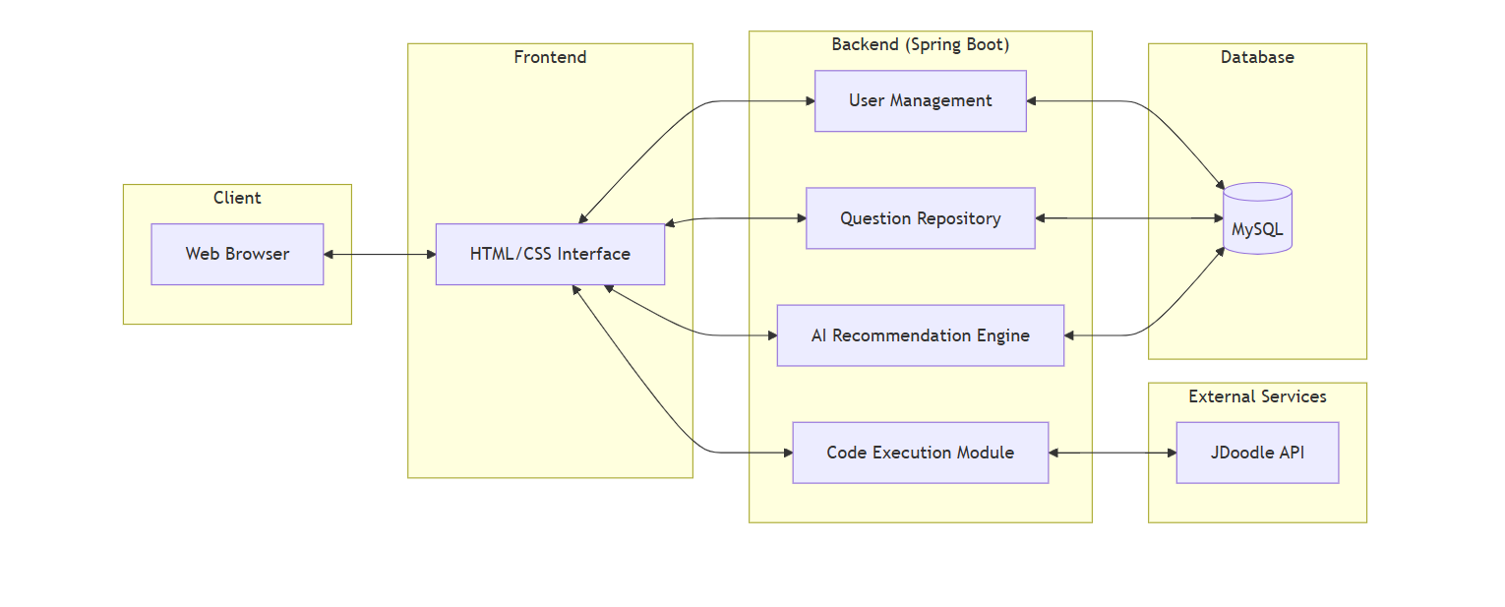

Flow chart:

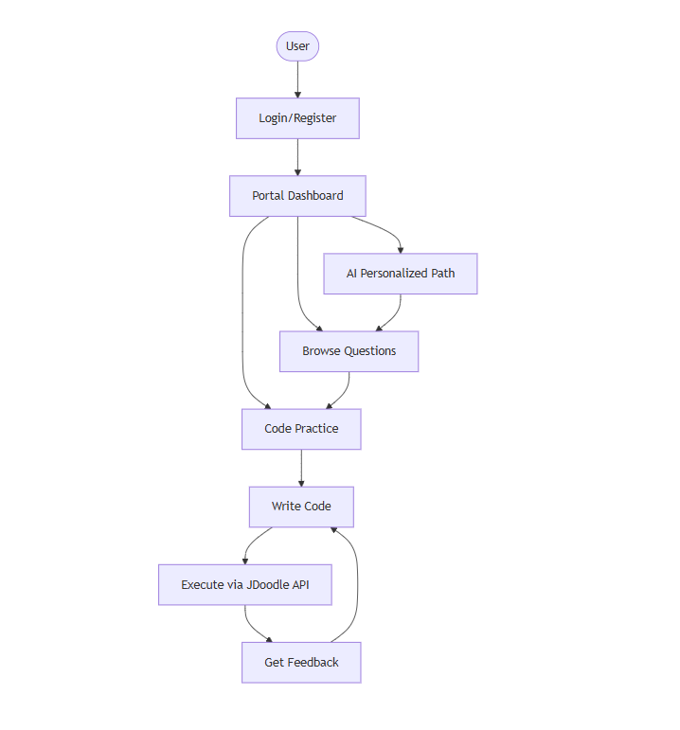

Class diagram:
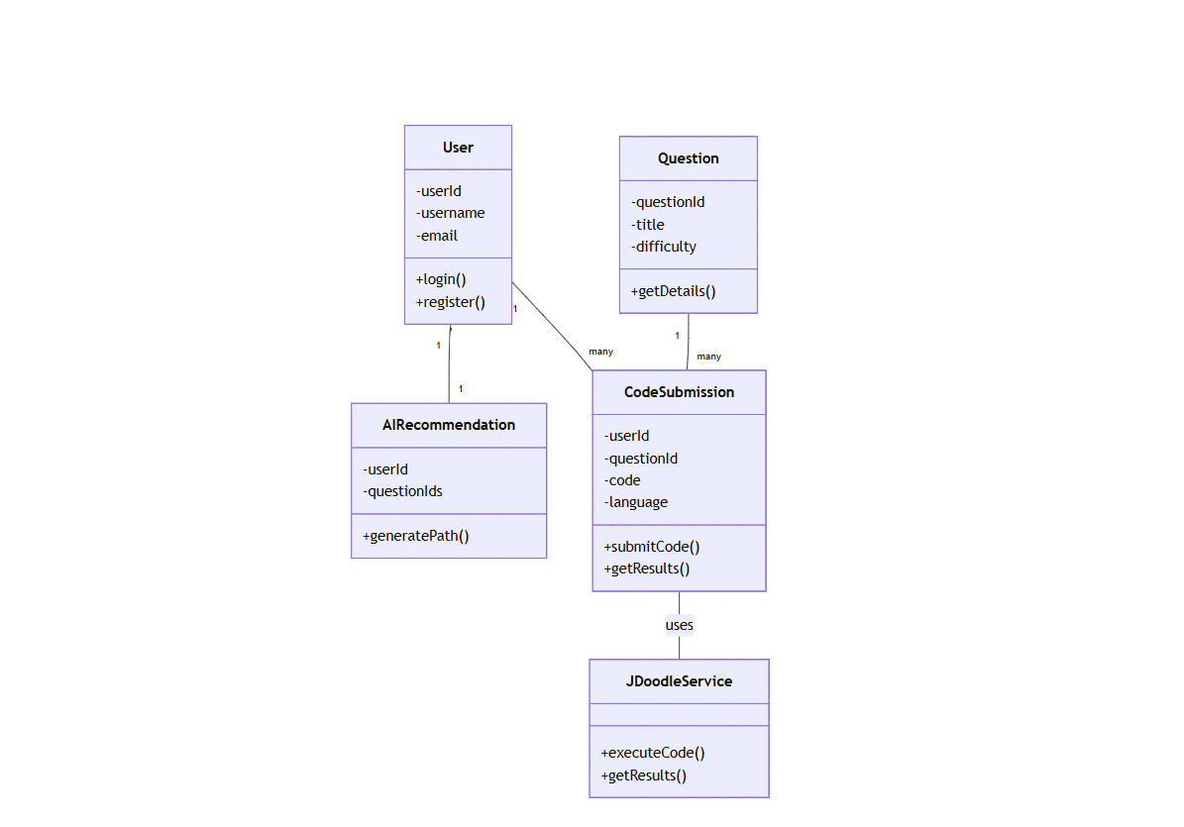

Modules in Detail
1. Authentication & Authorization
- Secure user registration and login (email + password)
- Role-based access (Admin, Candidate)
- Session management for authenticated state
- Access control for admin-only features
- Secure logout mechanism
2. User Management
- Admin-controlled user account creation, update, deletion
- Role assignment (Admin, User)
- User profile management (details & preferences)
- Tracking user activity and preparation progress
3. Interview Question Management
- Admin can add, edit, delete questions
- Classification by topic, difficulty, technology
- Support for theoretical & coding questions
- Question versioning and content lifecycle management
4. AI-Based Recommendation
- Performance & activity analysis
- Personalized preparation recommendations
- Adaptive learning paths (strengths vs. weaknesses)
- Dynamic difficulty adjustment
5. Live Code Execution
- JDoodle API integration for real-time compilation/execution
- Multi-language programming support
- Custom input handling for user code
- Display of outputs, compilation errors, runtime errors
- Secure communication with external services

6. Code Submission & History
- Storage of user submissions + execution results
- Timestamped coding attempt history
- Review & comparison of past submissions
- Performance analysis based on outcomes
7. Reporting & Dashboard
- User dashboard: progress & performance tracking
- Topic-wise and difficulty-wise analytics
- Admin dashboard: platform usage monitoring
- Graphical representation of trends
8. Security
- Encrypted credential storage
- Secure session handling & timeout management
- API request/response validation
- Protection against unauthorized access

