**Exercise 1: Control Structures**

**Scenario 1:** The bank wants to apply a discount to loan interest rates for customers above 60 years old.

* + **Question:** Write a PL/SQL block that loops through all customers, checks their age, and if they are above 60, apply a 1% discount to their current loan interest rates.

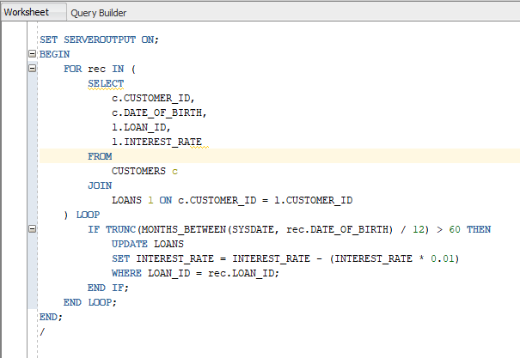

Output

Before

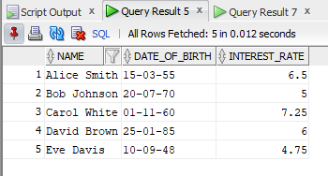

After

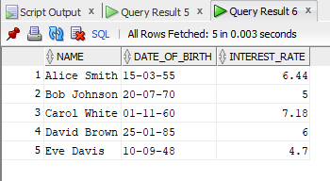

**Scenario 2:** A customer can be promoted to VIP status based on their balance.

* + **Question:** Write a PL/SQL block that iterates through all customers and sets a flag IsVIP to TRUE for those with a balance over $10,000.

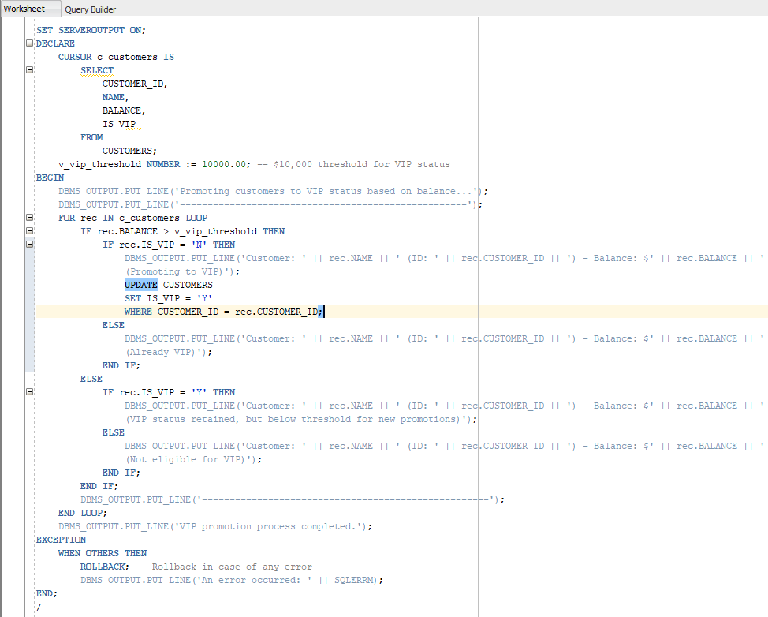

Output

Before

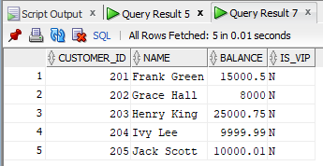

After

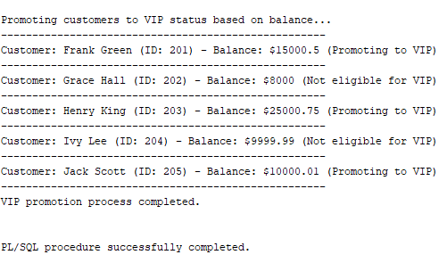

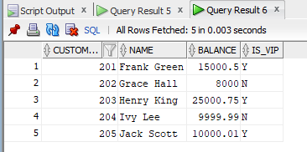

**Scenario 3:** The bank wants to send reminders to customers whose loans are due within the next 30 days.

* + **Question:** Write a PL/SQL block that fetches all loans due in the next 30 days and prints a reminder message for each customer.

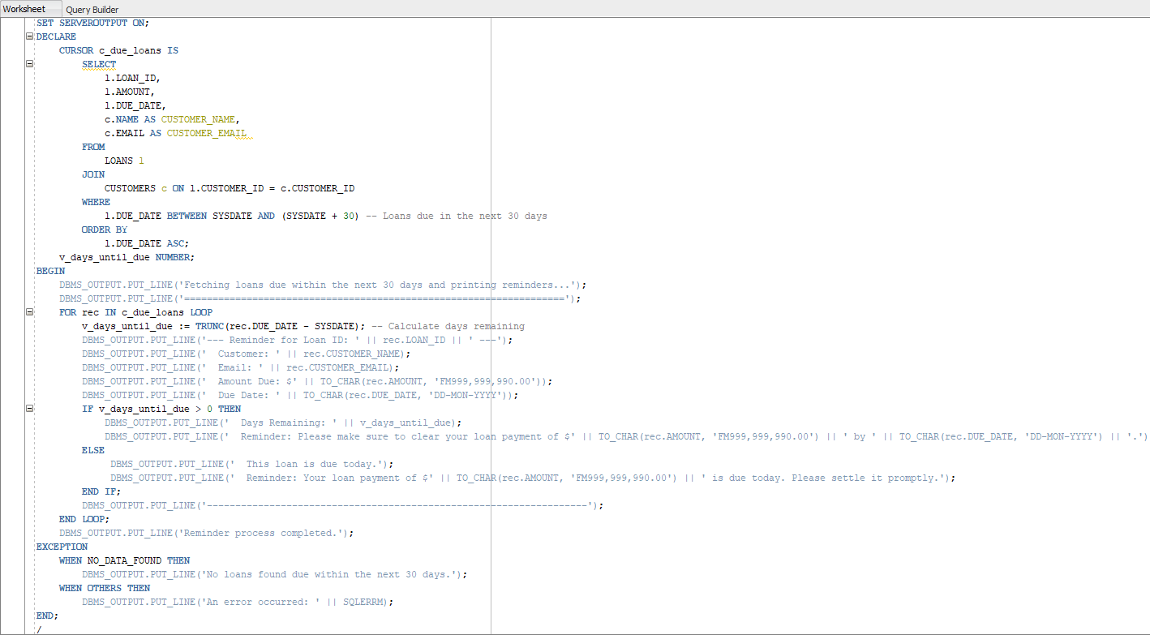

Output

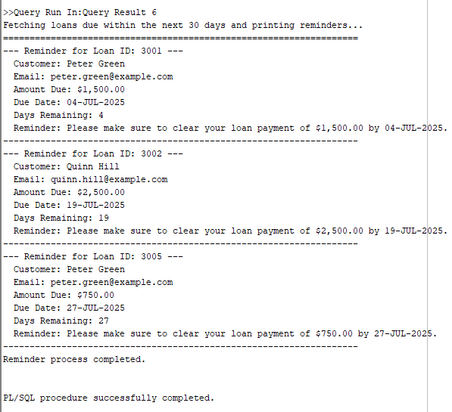

**Exercise 3: Stored Procedures**

**Scenario 1:** The bank needs to process monthly interest for all savings accounts.

* + **Question:** Write a stored procedure **ProcessMonthlyInterest** that calculates and updates the balance of all savings accounts by applying an interest rate of 1% to the current balance.

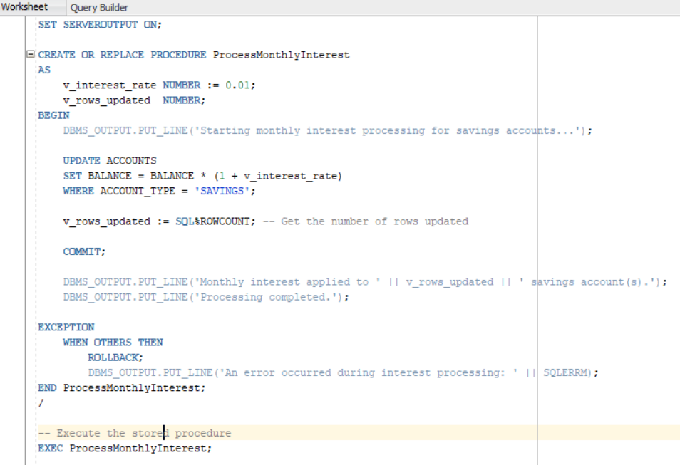

Output

Before

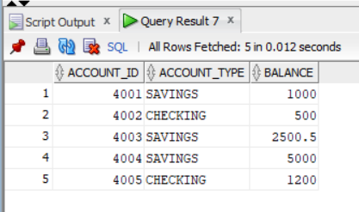

After

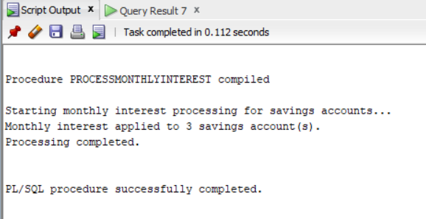

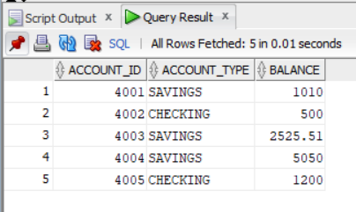

**Scenario 2:** The bank wants to implement a bonus scheme for employees based on their performance.

* + **Question:** Write a stored procedure **UpdateEmployeeBonus** that updates the salary of employees in a given department by adding a bonus percentage passed as a parameter.

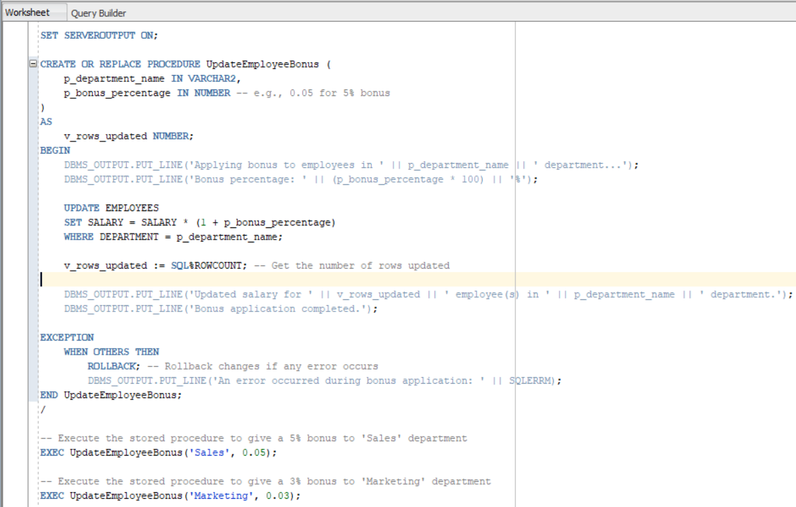

Output

Before

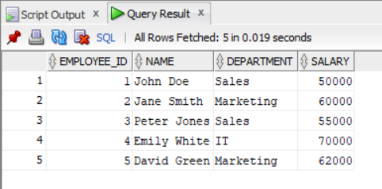

After

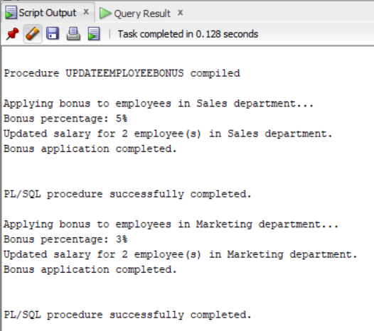

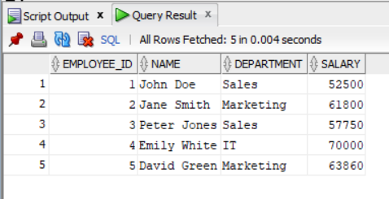

**Scenario 3:** Customers should be able to transfer funds between their accounts.

* + **Question:** Write a stored procedure **TransferFunds** that transfers a specified amount from one account to another, checking that the source account has sufficient balance before making the transfer.

Code

SET SERVEROUTPUT ON;

CREATE OR REPLACE PROCEDURE TransferFunds (

p_source_account_number IN VARCHAR2,

p_destination_account_number IN VARCHAR2,

p_amount IN NUMBER

)

AS

v_source_balance NUMBER;

e_insufficient_funds EXCEPTION;

PRAGMA EXCEPTION_INIT(e_insufficient_funds, -20001); -- Custom error number

BEGIN

DBMS_OUTPUT.PUT_LINE('Attempting to transfer $' || p_amount || ' from ' || p_source_account_number || ' to ' || p_destination_account_number || '...');

-- 1. Check if source and destination accounts exist

-- (Adding this check for robustness, though not explicitly asked)

DECLARE

v_source_exists NUMBER;

v_dest_exists NUMBER;

BEGIN

SELECT COUNT(*) INTO v_source_exists FROM BANK_ACCOUNTS WHERE ACCOUNT_NUMBER = p_source_account_number;

SELECT COUNT(*) INTO v_dest_exists FROM BANK_ACCOUNTS WHERE ACCOUNT_NUMBER = p_destination_account_number;

IF v_source_exists = 0 THEN

RAISE_APPLICATION_ERROR(-20002, 'Source account ' || p_source_account_number || ' does not exist.');

END IF;

IF v_dest_exists = 0 THEN

RAISE_APPLICATION_ERROR(-20003, 'Destination account ' || p_destination_account_number || ' does not exist.');

END IF;

END;

-- 2. Get current balance of source account

SELECT BALANCE

INTO v_source_balance

FROM BANK_ACCOUNTS

WHERE ACCOUNT_NUMBER = p_source_account_number

FOR UPDATE OF BALANCE; -- Lock the row to prevent concurrent updates

-- 3. Check for sufficient balance

IF v_source_balance < p_amount THEN

RAISE e_insufficient_funds; -- Raise custom exception

END IF;

-- 4. Deduct from source account

UPDATE BANK_ACCOUNTS

SET BALANCE = BALANCE - p_amount

WHERE ACCOUNT_NUMBER = p_source_account_number;

-- 5. Add to destination account

UPDATE BANK_ACCOUNTS

SET BALANCE = BALANCE + p_amount

WHERE ACCOUNT_NUMBER = p_destination_account_number;

COMMIT; -- Commit the transaction

DBMS_OUTPUT.PUT_LINE('Transfer of $' || p_amount || ' completed successfully.');

EXCEPTION

WHEN e_insufficient_funds THEN

ROLLBACK;

DBMS_OUTPUT.PUT_LINE('Transfer failed: Insufficient funds in account ' || p_source_account_number || '. Current balance: $' || v_source_balance || '. Amount requested: $' || p_amount || '.');

WHEN NO_DATA_FOUND THEN

ROLLBACK;

DBMS_OUTPUT.PUT_LINE('Transfer failed: One of the accounts was not found. (This should be caught by explicit checks above now).');

WHEN OTHERS THEN

ROLLBACK; -- Rollback all changes in case of any other error

DBMS_OUTPUT.PUT_LINE('An unexpected error occurred during transfer: ' || SQLERRM);

END TransferFunds;

/

Output

Before

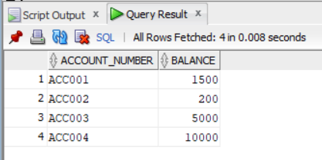

After

