**Exercise 1: Configuring a Basic Spring Application**

package com.library.repository;  
  
public class BookRepository {  
 public void saveBook(String bookName) {  
 System.*out*.println("Book '" + bookName + "' saved to the repository.");  
 }  
}

package com.library.service;  
  
import com.library.repository.BookRepository;  
  
public class BookService {  
  
 private BookRepository bookRepository;  
  
 // Setter for dependency injection  
 public void setBookRepository(BookRepository bookRepository) {  
 this.bookRepository = bookRepository;  
 }  
  
 public void addBook(String bookName) {  
 System.*out*.println("Adding book: " + bookName);  
 bookRepository.saveBook(bookName);  
 }  
}

package com.library;  
  
import com.library.service.BookService;  
import org.springframework.context.ApplicationContext;  
import org.springframework.context.support.ClassPathXmlApplicationContext;  
  
public class Main {  
 public static void main(String[] args) {  
 // Load Spring context from XML  
 ApplicationContext context = new ClassPathXmlApplicationContext("applicationContext.xml");  
  
 // Get bean and test  
 BookService bookService = (BookService) context.getBean("bookService");  
 bookService.addBook("Clean Code by Robert C. Martin");  
 }  
}

Output

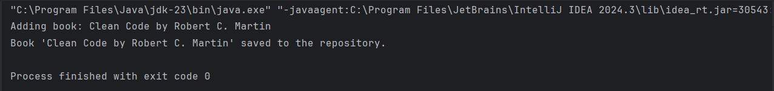

**Exercise 2: Implementing Dependency Injection**

package com.library.repository;  
  
import java.util.Arrays;  
import java.util.List;  
  
public class BookRepository {  
  
 public List<String> findAllBooks() {  
 return Arrays.*asList*("Clean Code", "Effective Java", "Spring in Action");  
 }  
}

package com.library.service;  
  
import com.library.repository.BookRepository;  
  
public class BookService {  
  
 private BookRepository bookRepository;  
  
 // Setter for Dependency Injection  
 public void setBookRepository(BookRepository bookRepository) {  
 this.bookRepository = bookRepository;  
 }  
  
 public void listAllBooks() {  
 bookRepository.findAllBooks().forEach(System.*out*::println);  
 }  
}

package com.library;  
  
import com.library.service.BookService;  
import org.springframework.context.ApplicationContext;  
import org.springframework.context.support.ClassPathXmlApplicationContext;  
  
public class Main {  
  
 public static void main(String[] args) {  
 ApplicationContext context = new ClassPathXmlApplicationContext("applicationContext.xml");  
  
 BookService bookService = (BookService) context.getBean("bookService");  
 bookService.listAllBooks();  
 }  
}

Output

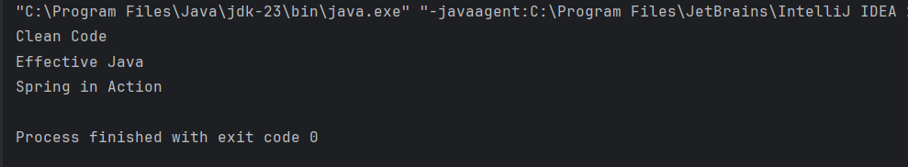

**Exercise 4: Creating and Configuring a Maven Project**

<project xmlns="http://maven.apache.org/POM/4.0.0"  
 xmlns:xsi="http://www.w3.org/2001/XMLSchema-instance"  
 xsi:schemaLocation="http://maven.apache.org/POM/4.0.0  
 http://maven.apache.org/xsd/maven-4.0.0.xsd">  
  
 <modelVersion>4.0.0</modelVersion>  
 <groupId>com.example</groupId>  
 <artifactId>LibraryManagement</artifactId>  
 <version>1.0-SNAPSHOT</version>  
 <packaging>jar</packaging>  
  
 <name>LibraryManagement</name>  
  
 <properties>  
 <java.version>1.8</java.version>  
 <spring.version>6.1.14</spring.version>  
 </properties>  
  
 <dependencies>  
 <!-- Spring Context -->  
 <dependency>  
 <groupId>org.springframework</groupId>  
 <artifactId>spring-context</artifactId>  
 <version>${spring.version}</version>  
 </dependency>  
  
 <!-- Spring AOP -->  
 <dependency>  
 <groupId>org.springframework</groupId>  
 <artifactId>spring-aop</artifactId>  
 <version>${spring.version}</version>  
 </dependency>  
  
 <!-- Spring Web MVC -->  
 <dependency>  
 <groupId>org.springframework</groupId>  
 <artifactId>spring-webmvc</artifactId>  
 <version>${spring.version}</version>  
 </dependency>  
  
 <!-- Logging dependency -->  
 <dependency>  
 <groupId>commons-logging</groupId>  
 <artifactId>commons-logging</artifactId>  
 <version>1.2</version>  
 </dependency>  
  
 <!-- JUnit (optional for testing) -->  
 <dependency>  
 <groupId>junit</groupId>  
 <artifactId>junit</artifactId>  
 <version>4.13.2</version>  
 <scope>test</scope>  
 </dependency>  
 </dependencies>  
  
 <!-- Step 3: Maven Compiler Plugin -->  
 <build>  
 <plugins>  
 <!-- Compiler Plugin -->  
 <plugin>  
 <groupId>org.apache.maven.plugins</groupId>  
 <artifactId>maven-compiler-plugin</artifactId>  
 <version>3.10.1</version>  
 <configuration>  
 <source>${java.version}</source>  
 <target>${java.version}</target>  
 </configuration>  
 </plugin>  
 </plugins>  
 </build>  
</project>

Output

