# **AI IN FARMING**

# **GROUP 5**

|  |  |
| --- | --- |
| Name: | Roll No: |
| Sreenandana Nandakumar | AM.EN.U4AIE21161 |
| V Rithin Chand | AM.EN.U4AIE21174 |
| Syed Muhammed Tahir | AM.EN.U4AIE21163 |
| Adithya D Varma | AM.EN.U4AIE21104 |

**INDEX**

|  |  |  |
| --- | --- | --- |
| SerialNo: | Topic and Subtopics | Page No |
| 1 | Introduction |  |
| 1.1 | What is Artificial Intelligence | 3 |
| 1.2 | Life Cycle Of Agriculture | 3 |
| 1.3 | Challenges Faced by farmers by manual techniques | 4 |
| 2 | Advantages of AI in Agriculture | 5 |
| 3 | Robotics in Agriculture |  |
| 3.1 | General Idea of AI Robots in Farming | 6 |
| 3.2 | Types of Agriculture Robots | 7 |
| 3.3 | Innovative Ideas being Used | 7 |
| 3.4 | Intelligent Spraying | 8 |
| 4 | Monitoring Crops with AI | 10 |
| 5 | Crop Yield Prediction, Forecast and Pest Detection | 10 |
| 6 | Challenges Faced by Farmers in implementing AI | 12 |
| 7 | Innovative ideas & Conclusion | 13 |
| 8 | References | 14 |

**What is Artificial Intelligence (1.1)?**

**Artificial intelligence** (AI) is the ability of a computer or a robot controlled by a software to do tasks that are usually done by humans because they require human intelligence and discernment. This type of intelligence is not naturally occurring but indeed created artificially by humans.

The term is frequently applied to the project of developing systems endowed with the intellectual processes characteristic of humans, such as the ability to reason, discover meaning, generalize, or learn from past experience  
Before going into the application of AI in farming, we first need to know what is done in farming and also what are the challenges farmers are facing due to traditional farming techniques, so in coming next two subtopic we will be discussing about them.

SOURCE:Google

**Life Cycle in Agriculture (1.2):**

The steps involved in farming are listed below, AI can monitor and do all these steps very precisely.

Preparation of soil: This is the very first step of farming. Farmers plough their fields in order to sow the seeds.

Sowing of seeds: This stage requires taking care of the distance between two seeds, depth for planting seeds. At this stage climatic conditions such as temperature, humidity, and rainfall play an important role.

Adding Fertilizers: Fertilizers maintain soil fertility. Fertilizers are simply planted nutrients applied to agricultural fields to supplement the required elements found naturally in the soil.

Irrigation: This stage helps to keep the soil moist and maintain humidity. Under watering or overwatering can hamper the growth of crops and if not done properly it can lead to damaged crops.

Weed protection: Weeds are unwanted plants that grow near crops or at the boundary of farms. Weed protection is important to factor as weed decreases yields, increases production cost, interfere with harvest, and lower crop quality.

Harvesting: It is the process of gathering ripe crops from the fields. It requires a lot of labourers for this activity so this is a labour-intensive activity. This stage also includes post-harvest handling such as cleaning, sorting, packing, and cooling.

Storage: This phase of the post-harvest system during which the products are kept in such a way as to guarantee food security other than during periods of agriculture. It also includes packing and transportation of crops.

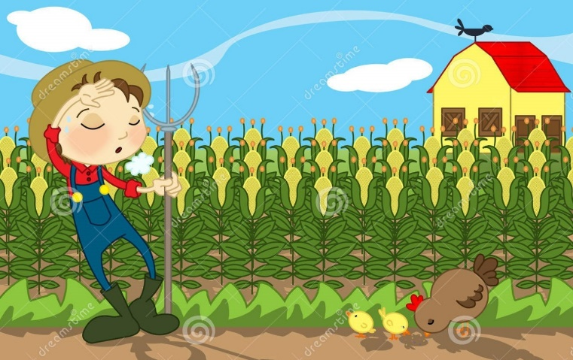**Challenges faced by farmers with traditional methods of farming (1.3):**

1. Farming is mostly based upon the climatic factors such as rainfall, temperature and humidity. These days climatic changes are also becoming abnormal and predicting weather is also becoming difficult as the time of sowing mostly depends on it.

SOURCE: dreamstime

1. Moisture and nutrients in soil are difficult to be monitored from time to time. The deficiency of nutrients can lead to poor quality of crops.
2. The predictive analysis of prices of commodities is also difficult to do manually.
3. Few places like hilly terrain are facing labour shortages.

**Advantages of AI in agriculture (2)**

Technology has redefined farming over the years and technological advances have affected the agriculture industry in more ways than one. Predictive analytics can be advantageous to farmers as they would be able to collect and process significantly more data and do it faster with AI than they would manually. Problems such as shortage of manual labor can also be solved by using AI. Moreover, AI-driven tools are faster and more accurate.

Applying the concepts of artificial intelligence in agriculture can be prove to be advantageous for the following processes:

* AI can be used to analyze market demands. It can make the crop selection process simpler by helping farmers identify which produce will be most profitable at what particular period of time.
* AI can play a significant role in risk management. AI can be used for forecasting and predictive analytics to help farmers reduce errors in business processes and ensure that minimum risk of crop failures ensues.
* Using AI ,farmers can produce crops that are less prone to diseases and that which can adapt to weather conditions better, using data collected on plant growth.
* AI systems can be used to conduct soil analysis to provide the required information regarding missing nutrients.
* AI can be used not only to detect and identify pests and diseases but also to suggest effective treatments for the same.
* Identification of ideal irrigation and nutrient application patterns and predicting the ideal mix of agronomic products can be achieved with the help of AI.
* AI can also be helpful to automate harvesting and predict the best time for the same.
* The farmers have a chance to be self-employed as labour expenses are decreased and the profits obtained can be huge.
* Farming will never be an occupation which is tough and can also bring in young generation and hence increase the food production of the world.

**General Idea of AI Robots in farming (3.1):**

Agricultural Robot ( also called agribot or agbot) is a robot that is autonomous, is helpful in farming, increases the crops’ efficiency,  reduces the manual labor required hence helping the farmers. They have proved to be efficient labourers and is a combination of mechanics and software application which removes the need of manpower  in the area of implementation.

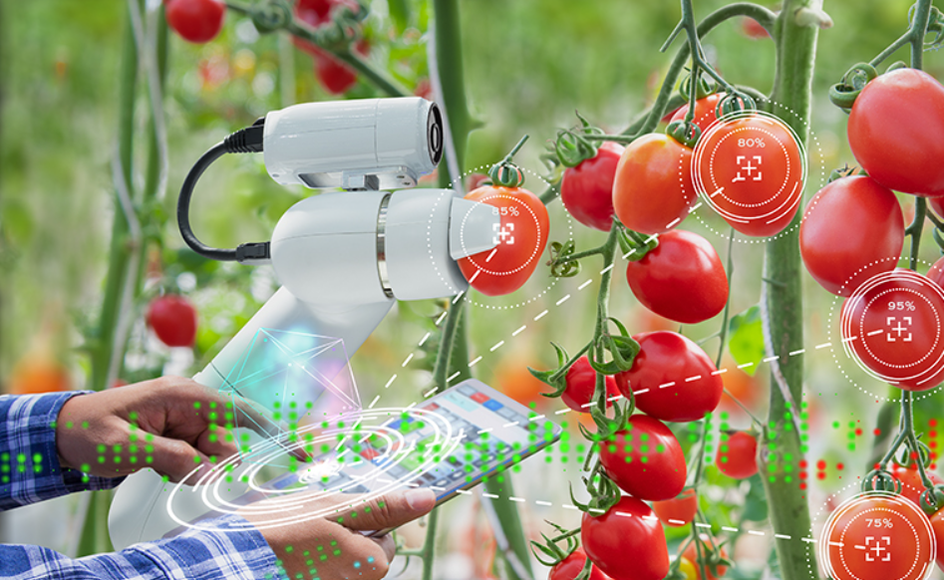

Most farms are facing a shortage of workforce due to less people entering this profession. Traditionally farms have needed many workers, mostly seasonal, to harvest crops and keep farms productive. However, as we have moved away from being an agrarian( related to cultivating) society with large quantities of people living on farms to now large quantities of people living in cities less people are able and willing to tend to the land.

SOURCE:Cropin

Due to these reasons came to the emergence of agricultural bots in the field of farming. These bots augment the human labour workforce and are used in various forms. These bots can harvest crops at a higher volume and faster pace than human laborers, more accurately identify and eliminate weeds, and reduce costs for farms by having a round the clock labour force.

Robotics in agriculture was developed first in the early times of 1920 and for decades research and development have been done on this and they have been used in both indoor and outdoor industries.

**Types of Agriculture Robots (3.2):**

* 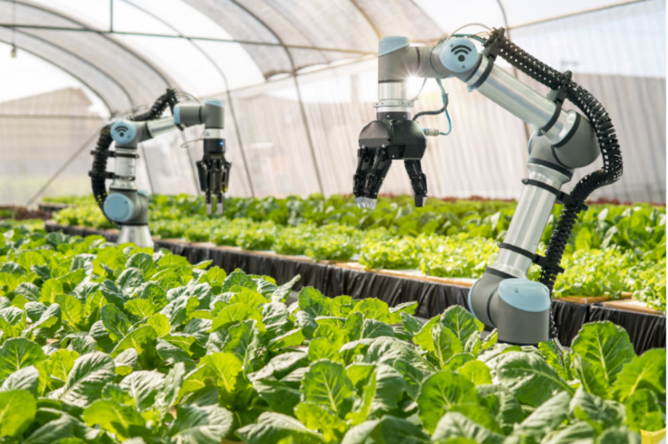Precision Agriculture
* Monitoring the pollution
* Livestock Ranching
* Weed control
* Automation of nursery
* Harvesting of crops
* Harvesting of fruits
* Seeding and planting

SOURCE:IndustryWired

**Innovative Ideas Being Used (3.3):**

The technology have been so advanced nowadays that we can witness “Driverless Tractors” which can cultivate and harvest a whole field by itself.

Drones have also been used to spray fertilizers, pesticides, weedicides etc regularly and in a proper way with equal spread to all crops.

AI companies are developing robots that can easily perform multiple tasks in farming fields. This type of robot is trained to control weeds and harvest crops at a faster pace with higher volumes compared to humans. These types of robots are trained to check the quality of crops and detect weed with picking and packing of crops at the same time. These robots are also capable to fight with challenges faced by agricultural force labour.

**Intelligent spraying (3.4)**

* Over-spraying herbicides puts pressing challenges on the agriculture industry. Farmers spend $25 billion per year buying 3 billion pounds of herbicides. But a huge volume of these chemicals never reaches weeds. Rather, it lands on soil or healthy plants or is carried away with rainwater. Applying conventional spraying technology, farmers lose money on herbicides that are sprayed in vain. Furthermore, these chemicals contaminate the soil, harming the environment; meanwhile, the weeds themselves develop herbicide resistance.
* The reason for this inefficiency lies in the poor precision of broadcast sprayers. AgriTech providers claim that smart spraying solutions can lower the costs of herbicides by 90% due to selective application on weeds only. Some of the most prominent technologies enabling farmers to advance from broadcast to smart spraying are GPS guidance, machine learning algorithms, and computer vision for weed recognition.

**How smart spraying solution works:**

**Step1**. Find the define:

* Sprayers equipped with cameras can capture real time images of the spraying area in the field. Trained on input examples of what weeds look like, machine learning algorithms can identify weeds in images and label them as targets for spraying.

**Step2**. Decide and act:

* As soon as a camera captures an image and AI analyses it for the presence of weeds, robotic nozzles target those weeds with high precision and spray a herbicide dose that’s adequate for the weed’s size and age. Just as an inkjet printer applies ink only to targeted points and in specific colors while avoiding white spaces, farm spraying technology applies herbicides only to targeted plants with precise dosages and avoids areas of open soil.

**Step3**. Analyze and improve:

* Selective spraying can reduce the use of chemicals and potentially cut the global annual consumption of herbicides by up to 2.5 billion pounds. Analytics that complement smart spraying solutions can show farmers the exact amount of product used to calculate cost savings.

**Available smart spraying solutions:**

Bosch — Smart spraying for precise herbicide application

* Bosch says that herbicides can save yields and contribute to solving the challenge of feeding almost twice the current global population. At the same time, Bosch aims to reinvent agricultural machinery for farm spraying. Their intelligent spraying software covers the entire spraying operation, from recording images to selecting a herbicide type for each weed.

Blue River Technology — Optimizing every plant

* Blue River has introduced next-generation equipment for spraying in agriculture that’s adjusted with see&spray technologies. The company promises to give farmers a new way to control herbicide use and prevent herbicide resistance among weeds. They highlight the cost efficiency of their smart spraying solution, which they claim can eliminate 90% of the herbicide volume farmers spray today.

Greeneye Technology – Spray less, grow more

* Greeneye applies AI and deep learning technologies to reinvent the herbicide application process by shifting from broadcast spraying with a lot of herbicide waste to precise and selective farm spraying technologies. Their product is designed to decrease the use of herbicides that cause soil and water contamination and to solve the issue of herbicide resistance while saving healthy plants from spraying-related risks.

**Monitoring Crops with AI (4):**

* 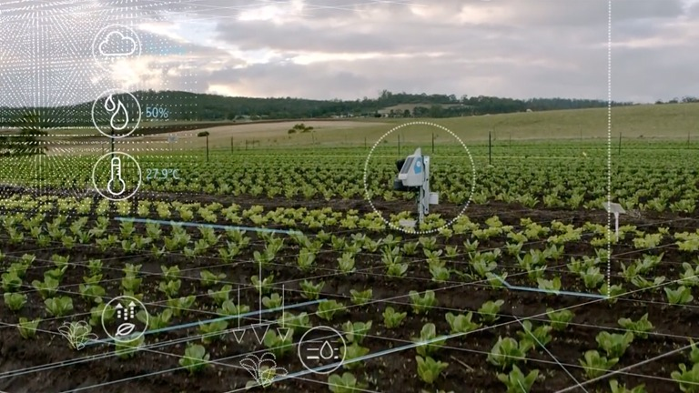Low cost and accurate assessment of crop and soil health has long been key to a successful farm and agricultural economy. Recent advancements in drone and satellite technology enable the acquisition of cost effective, timely and localized high resolution multispectral imagery of agricultural land. AI and machine learning offers the ability to recognize highly valuable patterns in this and similar imagery.

Governments often want to understand where soil is degrading and inventory which crops are present (crop identification) in which areas. NGOs and hedge funds often want to predict future yields [1], the former to predict food scarcity, the latter to modify purchases in wheat, corn and other futures. Farmers want to know exactly which crops to spray with fertilizer or pesticide, thus reducing cost and impact to the environment.

SOURCE:Google

**Crop yield predictions, forecasts and pest detection (5)**

Minimum support price is a form of market intervention by the government of India to insure agricultural producers against any sharp fall in farm prices. The minimum support prices are a guarantee for their produce from the government.

In a case study conducted by Dr. Anandi Subramanian in her paper “Towards A Pareto Efficient Indian Agricultural Market”, the effect of price fluctuation in crops has been analyzed. According to the study, due to farmers in certain areas not receiving even the MSP, much-needed crops like pulses, oilseeds, and commercial production of fruits and vegetables, especially those such as tomatoes with a very low shelf life have witnessed a declination in production as farmers are not able to plan a definite production pattern. However, now these problems do have a solution: AI.

Satellite images are often used in agriculture these days as they provide accurate pictures that produce precise estimations regarding the acreage which is important in terms of marketing, economy and sustainability.

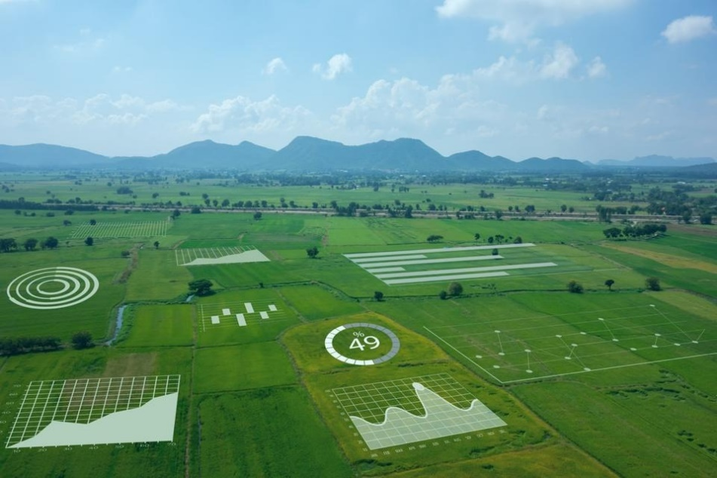AI can be used to incorporate data into mathematical models to calculate the probabilities and determine how much yield is expected at the time at which the crop was harvested, taking into consideration the price fluctuation. They can guide the farmers and government on the future price patterns, demand level, types of crop to sow for maximum benefit and also provide the best way to ensure efficient usage of resources.

SOURCE:Google

Yet another factor that plays a major role in affecting the crop yield outcome are diseases and pest infestations. The United Nations Food and Agriculture Organization estimates that between 20% and 40% of global crop yields are reduced each year because of plant diseases and pests. These pests cause direct injury to the plants as they feed on their tissues, it leads to reduction in the leaf surface available for photosynthesis, distortion of growing shoots and the wilting of shoots and branches caused by the insects' tunneling activities.

In 2015 Plantix a mobile crop advisory app for farmers was released. Plantix was developed by PEAT GmbH, a Berlin-based AI startup and the main aim of this app was to diagnose pest damages, plant diseases and nutrient deficiencies.

Plantix uses machine-learning and scientific image data supplied by ICRISAT (International Crops Research Institute for the Semi-Arid Tropics) and local research institutions to bring farmers information about pests and diseases. The app helps farmers diagnose pest damage, plant disease and nutrient deficiencies by taking a photo of their affected crop. Farmers can then discuss the possible causes and solutions with experts to obtain scientifically verified solutions. Over seven million farmers have downloaded this app and it has helped identify over 385 crop diseases among field crops, fruits, and vegetables.

Combining AI with big data, help farmers can get valid recommendations and solutions based on well-sorted real-time information on crop needs. This ensures a reduction in guesswork and enable more precise farming practices

Similarly farmers can use IoT sensors and other supporting technology such as drones and GIS to monitor, measure, and store data from fields. Combining AI farming tools with IoT devices and software guarantees that farmers can get more accurate information faster, and this in turn leads to better decision making within a significantly shorter span of time, hence saving money spent on trial and error.

**Challenges faced by farmers in adopting AI (6):**

Although AI can be useful, there’s still a lot of work to be done by technology providers to help farmers implement it the right way. Still farmers face a lot of problems in this. Farmers tend to think AL as something that applies for digital world. Most of the farmers are not well educated and lacks the knowledge of applying a high end technology like AI into their farms. Their resistance is caused by a lack of understanding of the practical application of AI tools. New technologies often seem confusing and unreasonably expensive because AgriTech providers fail to clearly explain why their solutions are useful and how exactly they should be implemented. This is what happens with artificial intelligence in agriculture. The cost of these robots are a major concern because all the farmers are not able to afford such expensive robots. The other issue here has been concerning the manual dexterity(manual skill) required to pick various fruits and vegetables. Each type of produce has its own unique requirement and this requires tremendous amounts of research and mechanical expertise.

**Innovative ideas & Conclusion (7):**

Advanced technology AI developed till now is limited to only human instructible programming where machine couldn’t take a decision making on its own. It should be programmed by human and undertake human’s instructions.

In future, we can expect AI technology in which the humanoid robots can take the decisions on their own and accordingly instruct other machines what work they have to do. So this works in a way where a AI based humanoid robot analyses the moisture and nutrients of soil and gives instructions to the intelligent spraying machines for maintaining the level of nutrients and moisture.

AI can be developed in such a way, where it can analyse the crops and harvest it according to the seasonal time. Immediately after harvesting, again the field will be analysed, ploughed and seeds are sown for the next yield.

AI can be appropriate and efficacious in so with all the details covered till know we can say that agriculture sector as it optimizes the resource use and efficiency, It solves the scarcity of resources and labour to a large extent. Adoption of AI is quite useful in agriculture. and we can imagine that the future of agriculture will be completely based on AI.

**REFERENCES (8):**

INTRODUCTION

* <https://www.analyticsvidhya.com/blog/2020/11/artificial-intelligence-in-agriculture-using-modern-day-ai-to-solve-traditional-farming-problems/>

ADVANTAGES OF AI

* <https://intellias.com/artificial-intelligence-in-agriculture/>

AI ROBOTS

* <https://www.cropin.com/blogs/futuristic-farming-a-look-into-artificial-intelligence-in-farm-machinery/>
* <https://www.wipro.com/holmes/towards-future-farming-how-artificial-intelligence-is-transforming-the-agriculture-industry/>
* <https://www.agrifarming.in/agricultural-robots-advantages-automation-history-future#:~:text=An%20agricultural%20robot%20is%20also,manual%20labour%20to%20the%20farmer>.

INTELLIGENT SPRAYING & MONITORING CROPS

* <https://intellias.com/smart-spraying-technology-in-agriculture-for-precise-herbicide-application/>
* <https://www.xyonix.com/crop-monitoring>

CROP YIELD PREDICTION AND FORECAST

* <https://dea.gov.in/sites/default/files/Crossing_Rubicon_IndianAgriMarket_0.pdf>
* <https://www.fao.org/news/story/en/item/1187738/icode/>
* Working Paper No. 04/2014-DEA

CROSSING THE RUBICON

Towards A Pareto Efficient Indian Agricultural Market -

with specific focus on rice and wheat markets-

Dr Anandi Subramanian

* <https://en.wikipedia.org/wiki/Pest_(organism)>
* <https://en.wikipedia.org/wiki/Plantix>