INTRODUCTION TO ELECTRICAL ENGINEERING [19AIE104]

S1 B.TECH CSE (AIE)

**ROOM TEMPERATURE DETECTOR**

A Project Report

*Submitted by*

**ROLL NUMBER**  **NAME**

AM.EN.U4AIE21163 SYED MUHAMMED TAHIR

AM.EN.U4AIE21174 VANGAPANDU RITHIN CHAND

AM.EN.U4AIE21104 ADITHYA D VARMA

AM.EN.U4AIE21161 SREENANDANA NANDAKUMAR



AMRITA SCHOOL OF ENGINEERING

AMRITA VISHWA VIDYAPEETHAM

AMRITAPURI 690 525

January 2022

**ABSTRACT**

Our project serves as an efficient system to detect room temperature. The system makes use of four LED’s of distinct colors to detect the temperature. If temperature is below or around 24 degrees Celsius then the **blue** LED glows, if temperature is between 24 degrees to 32 degrees Celsius then **yellow** LED glows, if the temperature is between 32 degrees to 42 degrees Celsius then **orange** LED glows, if at all the temperature exceeds 42 degrees Celsius then **red** LED glows. We can then decrease or increase the room temperature as required by sliding the temperature sensor.

**TABLE OF CONTENT**

|  |
| --- |
| 1.Introduction |
| 2.Components Required |
| 3.Result and Analysis |
| 4.Conclusion |
| 5. Reference |

**INTRODUCTION**

In this project, an Arduino is used to make a temperature sensor, which is used to detect the temperature in a room, and register the output with four LEDs of distinct colors (Blue, Yellow, Orange, and Red) according to the degree of hotness or coolness. Even though the Arduino is a digital tool, it can interpret signals from an analog input, like the TMP36 temperature sensor. A C++ script is created for the Arduino for temperature-detection purposes according to which the corresponding LEDs will glow.

In this project a temperature sensor is built virtually by using the virtual components listed below in Tinker Cad.

**COMPONENTS REQUIRED**

|  |  |
| --- | --- |
| **COMPONENTS** | **QUANTITY** |
| Resistors of 221 Ω | 4 |
| LED’s | 4 |
| Temperature sensor | 1 |
| Arduino Uno R3 | 1 |
| Breadboard Small | 1 |

**CIRCUIT DIAGRAM**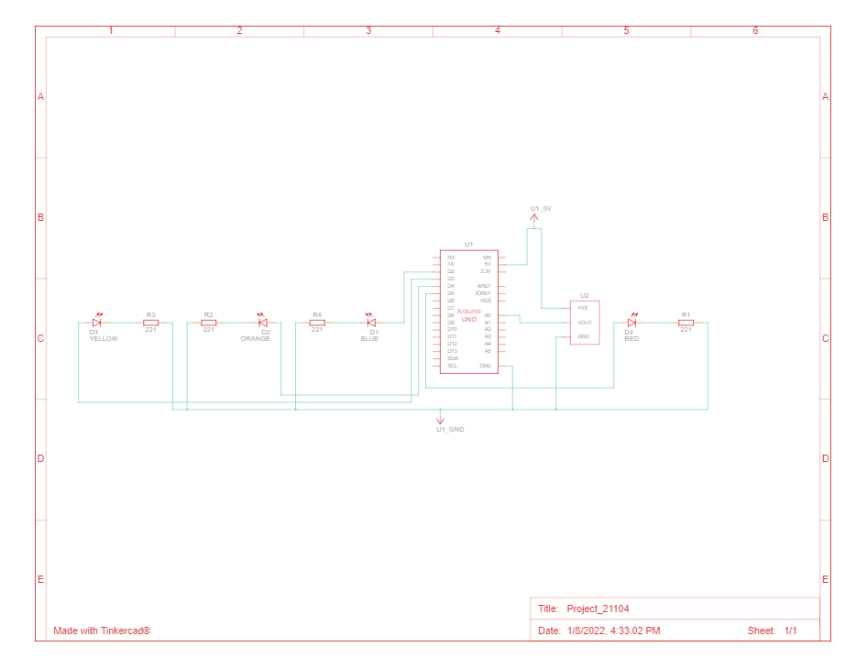

**GENERALDIAGRAM** **(BEFORESIMULATION)** 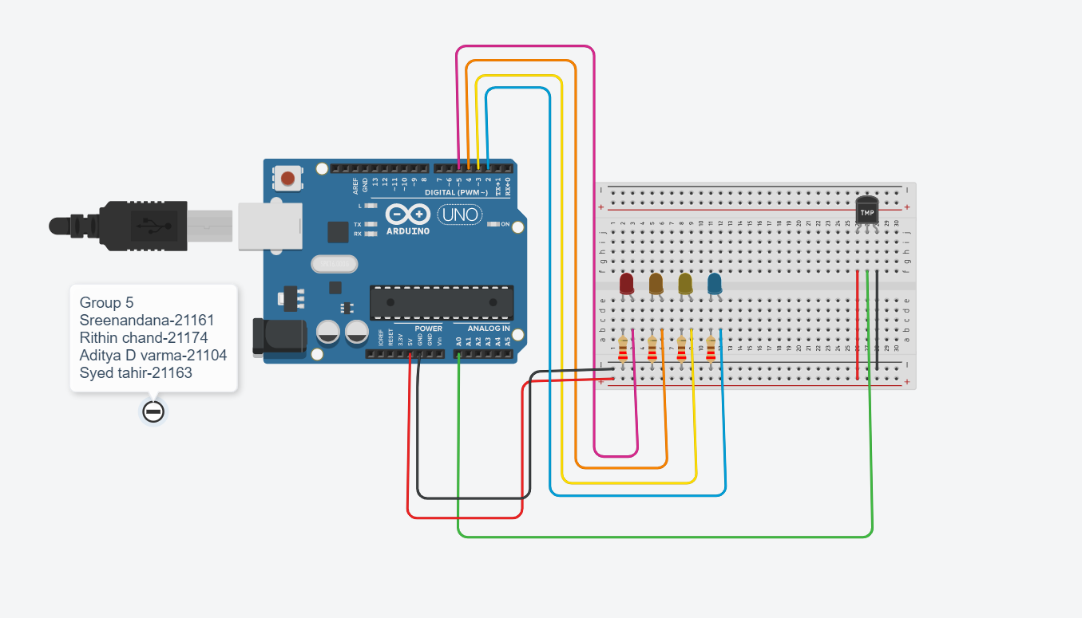

**WORKING OF THE SYSTEM**

In this project 4 LEDs are used to detect the temperature. The blue light indicates low temperature, yellow light indicates warm temperature, orange light indicates high temperature and red light indicates extremely high temperature. High value resistors are used to control the voltage flow to the LEDs so that it doesn't break.

**Case1:** If the temperature is at 12 degrees Celsius upon starting the simulation, the blue LED glows which indicates that the temperature is below the required temperature.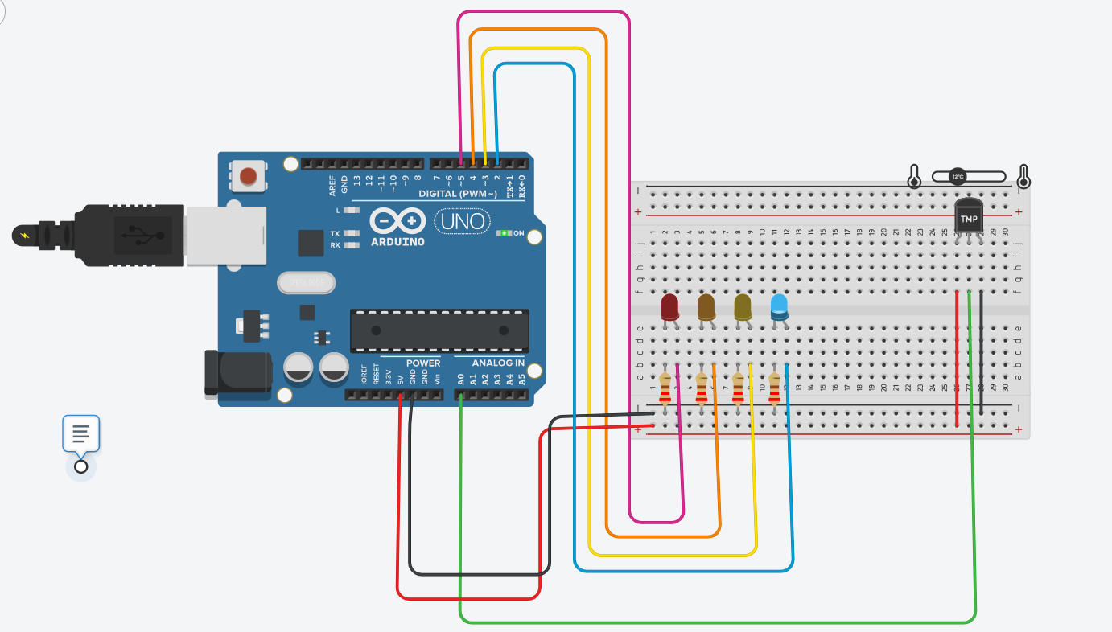

**Case2:**

If the temperature is set at 28 degrees celsius, upon starting the simulation the yellow LED glows which indicates that the temperature is warm.

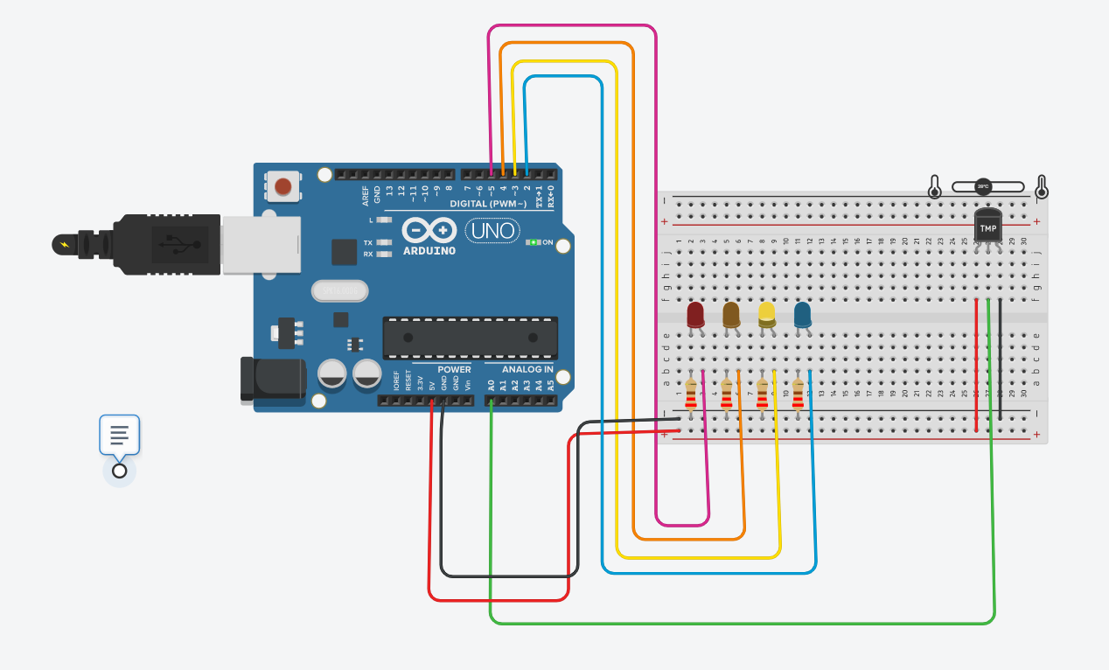

**Case3:**

If the temperature is set at 38 degrees Celsius, upon starting the simulation the orange LED glows which indicate that the temperature is high.

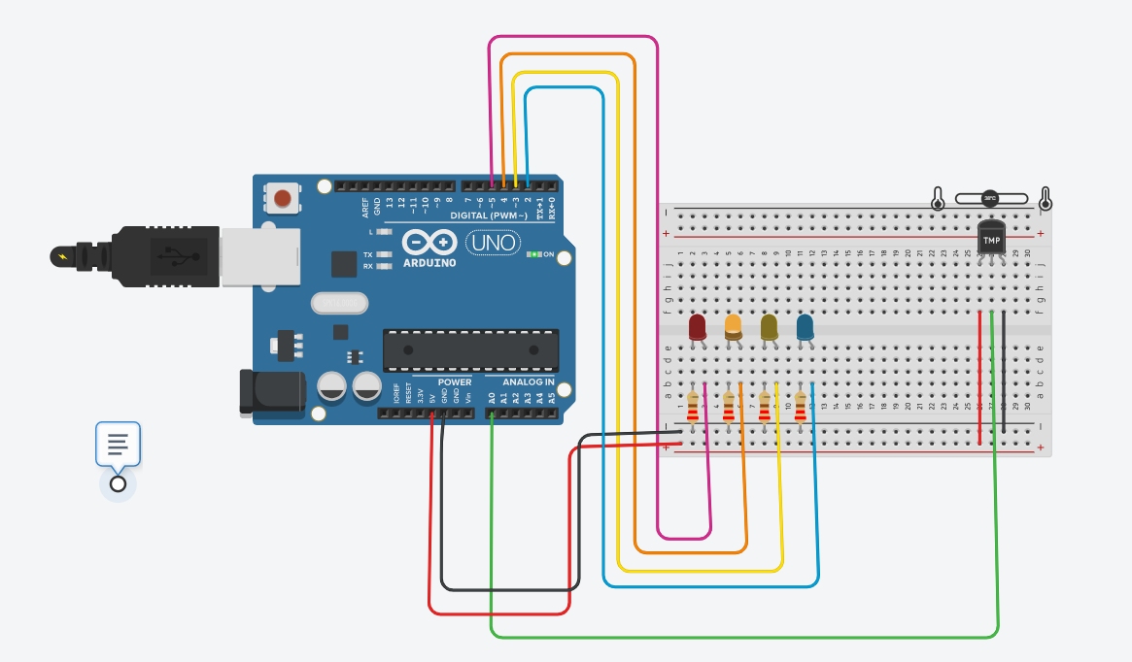

**Case4:**

If the temperature is set at 49 degrees Celsius, upon starting the simulation the red LED glows which indicate that the temperature is extremely high.

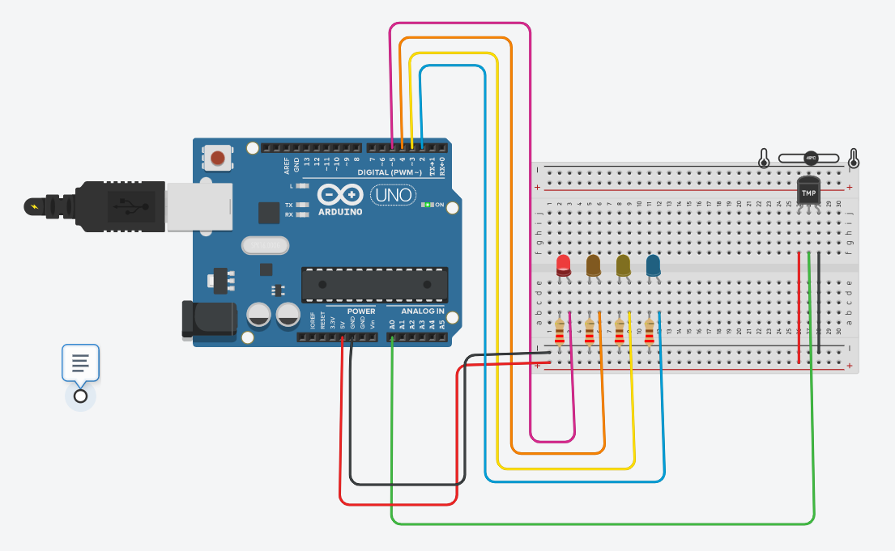

**RESULT**

* Simulation generated using tinkercad.
* C++ script created in tinkercad.

**CONCLUSION**

The project successfully makes use of the idea of using an Arduino sensor and 4 LEDs to detect room temperature with a distinctive visual representation of the current room temperature.

This proves to be an effective method to detect and change the room temperature according to the user's comfort.

**APPENDIX**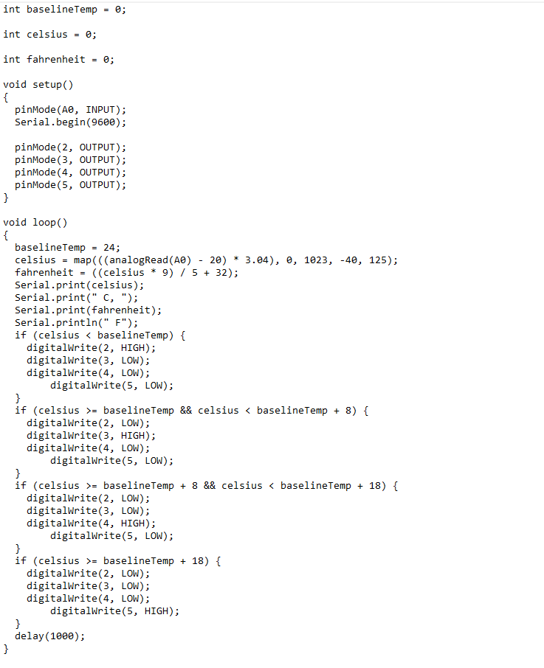

**REFERENCES**

* <https://en.wikipedia.org/wiki/Arduino_Uno>
* <https://www.instructables.com/TMP36-Temperature-Sensor-Arduino-Tinkercad/>
* <https://www.geeksforgeeks.org/c-plus-plus/>