ACKNOWLEDGEMENT

We believe that our project will be complete only after we thank the people who have contributed to make this project successful.

First and foremost, our sincere thanks to our beloved principal, Dr. Niranjan N. Chiplunkar for giving us an opportunity to carry out our project work at our college and providing us with all the needed facilities.

We express our deep sense of gratitude and indebtedness to our guide Dr. Jyothi Shetty Professor and Head, Department of Computer Science and Engineering, for his inspiring guidance, constant encouragement, support and suggestions for improvement during the course for our project.

We express our gratitude to the project coordinator Mr. Raju K and project guide Mrs. Joylin Priya Pinto for constant support.

We also thank all those who have supported us throughout the entire duration of our project.

Finally, we thank the staff members of the Department of Computer Science and Engineering and all our friends for their honest opinions and suggestions throughout the course of our project.

ADITHYA HOLLAK (4NM19CS007)
ADITYA MURUGAN (4NM19CS010)
AKIL RAIF (4NM19CS014)
ASHWAMEDH AROTE (4NM19CS031)

ABSTRACT

Facial analysis systems can ultimately change the way we live. Allied to Artificial Intelligence, it can provide personal assistance in every aspect of life. It can estimate our mood from the start of the day, connect itself to our habits and other factors. It can provide the perfect meal for the moment, the best music to accompany that meal, and the perfect outfit linked to the weather prediction. Machines will be capable of taking care of the uninteresting part of life. Due in large part to the expansion of social media and online social networking websites, automatic gender, age, and emotion identification has become more significant, leading to an expansion of its usage in various software and hardware. The commercials could be tailored to the caller's age and gender. In criminal instances, it can also aid in the identification of suspects, or at the very least, it can reduce the number of suspects. A deep neural network (DNN) known as a convolutional neural network is frequently used for NLP and image recognition and processing. The model is trained for gender, age, and emotion recognition from photos using a convolutional neural network architecture.

Keywords: Emotion detection, Age Detection, Gender Detection, Flask, Ngrok, Convolutional Neural Network

TABLE OF CONTENTS

Contents Page
Title Page i | I
Certificate ii | 2
Acknowledgement iii | 3
Abstract iv | 4
List of figures ix-x
CHAPTER 1 INTRODUCTION 1-5 | 4
1.1 Overview Of Gender Age And Emotion Recognition 1-2
1.2 Importance of Gender Age And Emotion Recognition 2
1.3 Role Of IT In Gender Age And Emotion Recognition 2
1.4 Problem Specification 3
1.5Problem Statement 3 | 3
1.6 Applications 3-4
1.7 Objectives 4
1.8 Organization Of The Report 4
1.9 Summary 5
CHAPTER2 LITERATURE SURVEY 6-8 | -6
2.1 Existing System 6-7 | 5
2.2 Proposed System 8 | 6
CHAPTER 3 SYSTEM ANALYSIS & REQUIREMENTS 9-10  3.1 Functional Requirements 9 | -9
3.2 Non Functional Requirements 9
3.3 Hardware Requirements 9
3.4 Software Requirements 10
3.5 Challenges 10
3.6 Summary 10
CHAPTER 4 SOFTWARE APPROACH 11-12
4.1 About Spyder 11
4.2 About Python 11-12
4.3 About Tensor Flow 12
4.4 Ngrok 12
CHAPTER 5 SOFTWARE DESIGN 13-18
5.1 High Level Design Architecture 13
5.2 Data Flow Diagram 14  5.2.2 Age And Gender Emotion Model 14 | 5
5.3 Use Case Diagram 14-15
5.4 Sequence Diagram 15-16
5.5 Configuration Issues 16
5.6 System Architecture 17-18
5.7 Synopsis 18
CHAPTER 6 SYSTEM IMPLEMENTATION 19-22
6.1 Working Of Age Gender Prediction 19
6.2 Working Of Emotion Prediction 20
6.3 Working Of JavaScript Component 21
6.4 Implementation Of Flask’s Web Application 21-22
CHAPTER 7 SYSTEM TESTING 23-24
7.1 Unit Testing 23
7.2 Advantages Of Unit Testing 23-24
7.3 Integration Testing 24
CHAPTER 8 RESULTS AND DISCUSSIONS 25-33
8.1 Results 25-32
8.3 Discussions 33
CHAPTER 9 CONCLUSION AND FUTURE WORK 34
REFERENCES 35-36

LIST OF FIGURES

Figure Name Page

Figure 5.1 System Architecture 13
Figure 5.2.1 Data Flow Diagram For Identification Processing Pipe Line 14
Figure 5.2.2 Age Gender Emotion Model 14
Figure 5.3 Use case Diagram 15
Figure 5.4 Sequence Diagram 16
Figure 6.1 Working Of Age And Gender Prediction 19
Figure 6.2 Working Of Emotion Prediction 20
Figure 6.3 Working Of The JavaScript Component Written 21
Figure 8.1.1 Ngrok Execution Window 25
Figure 8.1.2 Flask Output Home Page 25
Figure 8.1.3 Image Browsing Window 26
Figure 8.1.4 Browsed Image View 26
Figure 8.1.5 Displaying Predicted Result 27
Figure 8.1.6 Browsed Image View 28
Figure 8.1.7 Displaying Predicted Result 29
Figure 8.1.8 Browsed Image View 30
Figure 8.1.9 Displaying Predicted Result 31
Figure 8.2.0 Python Console After Prediction 32
Figure 8.2.1 Code Snippets 32

CHAPTER 1
INTRODUCTION
An overview of gender, age, and emotion recognition is given in this chapter. The significance of gender, age, and emotion recognition is also discussed, as well as the part that IT plays in these areas.

  - OVERVIEW OF GENDER, AGE AND EMOTION RECOGNITION
There is now a paradigm shift taking place. For the past few decades, computers have routinely outperformed humans in many daily jobs, and we now rely more and more on them. The whole economy may crash if a bank's database servers went down for any reason and deleted all of its data. We live in an information age where technologies are increasingly used to gather and store data. This data is used by machine learning to discover patterns. It can be used to forecast the weather, assist with credit approval, or suggest a doctor's appointment if an abnormal heartbeat is found.
However, this paradigm shift is currently being driven by the development of deep learning and convolutional neural networks in the area of computer vision, a particular branch of computer science. The rate of image uploads to the internet has been rising significantly over the past ten years. This is driving an increase in computer vision research, along with the fact that high computational power is becoming more widely available to the average user. Now, efforts are being made to research issues that were previously thought to be intractable because of a lack of data or computational capability. These days, cars are capable of driving themselves, detecting pedestrians, and foreseeing or preventing accidents. Even though self-driving cars are a popular issue right now, facial analysis may be even more so. Several functions that are covered by facial analysis that can be used to a variety of situations. For tasks like face detection, pose estimation, age estimation, face recognition, smile detection, gender recognition, and more, there are models available. Machine estimating has frequently surpassed human performance, producing excellent results.
Competitions in artificial intelligence and the IT industry have created a sense of urgency in the desire to research and create the best model. These systems can be used for marketing, security, biometrics, platforms for human-computer interaction, and more. We are gradually moving towards total connectivity with technology, which can now detect and gauge our requirements and traits. In this situation, facial analysis is crucial because nonverbal communication accounts for a large portion of human communication.

  - IMPORTANCE OF GENDER, AGE AND EMOTION RECOGNITION
After all, facial analysis technologies may transform how we live. When combined with artificial intelligence, it can offer individualized support in every area of life. It can predict our mood when we wake up and, by relating it to our habits, age, and other criteria, recommend the ideal meal for the occasion, the best music to go with that meal, and the ideal outfit, all of which are connected to the weather forecast. Similar to that, when you enter a clothes store, it can automatically recommend the ideal outfit for you based on your age and gender and send a photo of you virtually wearing that outfit to your smartphone. The boring aspects of life will eventually be completely handled by machines. The entire connection and understanding of humans will soon occur, supported by computer vision and facial analysis. In many facial analysis tasks, modern models have really already surpassed human recognition.

  - ROLE OF IT IN GENDER, AGE AND EMOTION RECOGNITION
Convolutional neural networks (CNNs) are the foundation of all cutting-edge approaches for image-related tasks, including object detection and image categorization. After the introduction of Alex Net by Krizhevsky et al., human face analysis and soft-biometric categorization have grown in popularity. Several computer vision researchers are interested in the topic of such face soft-biometrics, which include age, gender, and facial expression. Deep learning's application to this field has eliminated the necessity for manually created facial features and data pre-processing techniques. D-CNN models have been effectively used for other purposes besides computer vision.
  - PROBLEM SPECIFICATION
In the end, facial analysis technologies may transform how we live. United with facial analysis tools may ultimately change the way we live. It can provide specialized assistance in every aspect of life when paired with artificial intelligence. The best cuisine for the occasion, the greatest music to go with that meal, and the optimum outfit- all of which are linked to the weather forecast- may be suggested by it based on our habits, age, and other factors. It can also predict our mood when we wake up. Any mundane part of life will be capable of being handled by robots. Complete human connection and comprehension will soon be possible thanks to facial analysis and computer vision.

  - PROBLEM STATEMENT
The potential of deep learning can be combined with the already significant role that mobile phones play in our lives to produce user experiences that astonish and delight people. There isn't a decent Android application that uses the convolution neural network to combine the gender, age, and emotion of a human face for facial recognition. The main objective is to develop a method for determining a person's age and gender from their face, which will remain crucial for pattern recognition and computer vision. Facial expression detection is another crucial component of computer vision, in addition to age estimation. For the simultaneous tasks of age estimation, gender recognition, and emotion detection on face photos, this implementation suggests a new framework. Age, gender, and emotion identification are built into an Android application. The frames from the phone's photo capture are pre-processed and sent to the model to complete this task, and the forecast is then shown as a result.

  - APPLICATIONS
The following use cases allow for the purpose of gender, age, and emotion recognition:
- Advertisements: In accordance with the age and gender of the caller, the ads may be tailored.
- E-commerce also helps identify suspects in criminal cases, or at the very least, it can reduce the number of suspects because product lists can be changed.
- By monitoring client emotional responses, it can offer insightful feedback for in-store promotions, enabling businesses to better classify their products and deliver better customer care.

  - OBJECTIVES
- To develop a deep learning model that can accurately recognize emotions in individuals according to their age and gender.
- To increase the precision of emotion recognition systems by incorporating age and gender parameters into the analysis.
- To investigate the connection between age, gender, and emotions, and how these variables can affect the accuracy of emotion recognition

  - ORGANIZATION OF THE REPORT
The Project Report has been organized under nine chapters, which are as follows:
Chapter 1: Introduces to the main idea of the project. It gives a brief knowledge about the aim and methodology of the same.
Chapter II: It includes literature survey of related works
Chapter III: Discusses the system requirements that are needed for the project. These include functional requirements, non-functional requirements, user requirements and hardware requirements.
Chapter IV: Includes the implementation details of the project, application is explained in detail. It also deals with software approach
Chapter V: Includes the system design details which includes flowchart, sequence diagram.
Chapter VI: Deals with system testing concepts and the various test cases for the project.
Chapter VII: Includes the screenshots of the application and the database.
Chapter VIII: Includes the screenshots of the application and the database.
Chapter IX: outlines conclusions and future work that can be done

1.9 SUMMARY
As this chapter explains, the system was designed with content customization in mind. The system handles age, gender, and mood prediction.

CHAPTER 2
LITERATURE SURVEY
2.1 EXISTING SYSTEM
The suggested layout adheres to the CNN architecture. A deep neural network (DNN) known as a convolutional neural network is frequently used for NLP and image recognition and processing.
Human age, gender, and emotion detection have been extensively studied. This study's main objective is to examine how various deep learning techniques have been applied in recent years to identify age, gender, and emotion. The accuracy of the results has increased significantly with technological improvement and the use of new approaches.
A breakthrough in "facial emotion recognition using deep convolutional networks" was made in 2017 by Mr. M. Mohammadpour and his group. This study's main objective was to build a model based on facial action units (AUs), which CNN first identified and then used to recognize the seven basic emotional states. They used the Cohn-Kanade database and integrated AU to get the best accuracy rate of 97.01, whereas other studies in the literature used a direct CNN and could only manage an accuracy rate of 95.75%.

According to P. Smith and C. Chen's paper “Transfer Learning with Deep CNNs for Gender Recognition and Age Estimation” prediction accuracy was increased by transfer learning using both the VGG19 and by examining the results of modifications to various design strategies and training parameters, VGGFace pretrained models were created. This study also shows that using the appropriate model training strategies can result in high accuracy.

In his article " A Quick Overview of Visual Information-Based Facial Emotion Recognition," Mr. Byoung C categorizes approaches into two groups: traditional FER (Facial Emotion Recognition) approaches, which include three steps: detection of the face and facial components, and feature extraction, expression classification and novel FER (Facial Emotion Recognition) approaches, which include four steps: detection of the face and facial components, and feature extraction, expression classification, and this is a quick study of visual information-based face emotion recognition.

PCA is applied to PST of short EEG sequences. “Deep Learning Classification of Neuro-Emotional Phase Domain Complexity Levels Generated by Affective Video Film Clips” is the title of a study by Aydin. This study serves as an illustration of a cutting-edge technique for identifying nine different emotional states.

According to a different article by Milad Mohammad Taghi Zadeh and colleagues titled "Fast Face Emotion Detection Using Convolutional Neural Networks and Gabor Filters”, the Gabor filter really takes the image sub feature and delivers it to the neural network. As a result, the convolutional neural network gathers a large number of sub features and improves accuracy by percent when extracting emotions from faces.
Imane Lasri employed a very sophisticated method for face emotion detection in her paper, "Facial Emotion Recognition of Students Using Convolutional Neural Network” which contained four convolutional layers, four max pooling layers, and two fully connected layers. The system recognizes faces in input pictures and classifies them into seven facial emotions using a Haar-like detector.

Rabie Helaly and colleagues used a method similar to the one used in the previous paper in their "Deep Convolution Neural Network Implementation for Emotion Detection” Rabie Helaly and colleagues used a method similar to the one used in the previous paper in their "Deep Convolution Neural Network Implementation for Emotion Detection System", However, the models' testing and training procedures were entirely different. They created two processes to verify and validate the indicated system's accuracy: model testing on an embedded device, as well as model training and testing on the GPU (the Raspberry Pi 4). When the described system is trained and tested on the GPU, the results are accurate to 94 percent. It also showed that precision was quite high even with simple embedded systems
2.1 PROPOSED SYSTEM
The project is a web based application that takes people's images as input. The dataset which is used to train the model is then loaded in the backend. Emotion model is trained using the FER2013 dataset. After the model has been trained, the input image gets processed by the CNN. Initially the input image is resized and converted from the colourful RGB image to greyscale. The image after being processed is converted finally into a 1D array. It is then given to the HAAR Cascade Classifier. Haar cascade model is used to detect faces and eyes in an image. Once the faces are detected and extracted, this cropped facial image is passed to the age and gender models to make a prediction. Function for loading the caffe models is written. It returns the variable of both the models. This contains the information of the trained neural network. The model then compares the output with the predefined values for emotions, age and gender and predicts the corresponding age, emotion and gender values.

CHAPTER 3
SYSTEM ANALYSIS AND REQUIREMENTS
3.1 FUNCTIONAL SPECIFICATIONS
The following list summarizes the functional requirements for deep learning-based gender, age, and emotion recognition:
- Image Capture: A mobile device or laptop take a picture of a picture of person’s face to use as input for the prediction.
- Image Processing: For effective recognition, the acquired image needs to be aligned and trimmed.
- Computing gender, age, emotion: To compute the age, gender and emotion of the human in the taken image, the pre-processed image is input to the developed model.
- Show the result: The user must be shown the computed results.
3.2 NON FUCTIONAL REQUIREMENTS
The following are the non-functional requirements for the deep learning based gender, age and emotion recognition system:
- Performance and Scalability: The system should operate accurately and efficiently overall.
- Usability: Taking a selfie or screenshot is comparable to how it works.
- Maintainability: If a better dataset is created in the future, the existing dataset can be swapped out for one that is more accurate.
3.3 HARDWARE SPECIFICATIONS
- Intel Pentium 2 or latest Processor
- Dual cores at very least
- Memory of at least 8 GB
- A hard disc of at least 100 GB.’

3.4 SOFTWARE REQUIREMENTS
- Flask
- NGROK
- OpenCV-Python
- Tensor flow
- Spyder
3.5 CHALLENGES
- People from different ethnic groups have varied facial characteristics, which could slightly change the actual age from the anticipated age, which could lead to misclassifications.
- Wearing glasses could interfere with the traits that are used to classify emotions
- In order to have a better categorization, it is tough and delicate to extract features from one face to another from the database, which may contain grey-scale images of human faces.
- Overfitting is a minor issue that typically arises when using machine learning or deep learning techniques with a dataset that only contains a small number of face photos.
3.6 SUMMARY
The problems and the hardware and software components are summarized in this chapter. Each element is crucial, and its implementation requires careful consideration.

CHAPTER 4
SOFTWARE APPROACH
4.1 SPYDER
Spyder is a Python- grounded intertwined development terrain (IDE) that's open- source and cross-platform. The scientific Python mound's most well- known packages, similar as NumPy, SciPy, Matplotlib, Pandas, IPython, SymPy, and Cython, as well as fresh open- source programmes, are all integrated with Spyder. It's distributed under the MIT licence.
Since 2012, a group of scientific Python inventors and the community have been maintaining and constantly enhancing Spyder, which was first designed and erected by Pierre Raybaut in 2009.In addition to supporting interactive tools for data examination and embedding Python-specific law quality assurance and soul-searching tools like Pyflakes, Pylint, and Rope, Spyder is expandable using first- and third- party plugins. Through Anaconda, it's available in Windows, macOS, and major Linux distributions like Arch Linux, Debian, Fedora, Gentoo Linux, openSUSE, and Ubuntu.The Python tapes for PyQt or PySide can be used with Spyder, which uses Qt for its graphical stoner interface. Use of either backend is possible thanks to QtPy, a featherlight abstraction subcaste created by the Spyder design and latterly used by multitudinous other packages.
4.2 PYTHON
A high- position, all- purpose programming language is Python. Its design gospel places a strong emphasis on law readability with aid of considerable off- side rule- grounded indentation. Python uses scrap collection and has dynamic typing. It supports a number of programming paradigms, including procedural, object- acquainted, and functional programming, as well as structured programming (especially this). Due to its expansive standard library, it's constantly appertained to as a" batteries included" language.
Python was created by Guido van Rossum in the late 1980s to replace the ABC programming language, and it was firstly made available as Python0.9.0 in 1991. In 2000, Python2.0 was made available. The 2008 release of Python3.0 was a significant update that was only incompletely backwards compatible with former duplications. The final Python 2 release was Python2.7.18, which was made available in 2020.
4.3 TENSOR FLOW
A free and open- source software library for artificial intelligence and machine literacy is called TensorFlow. It is applicable in different tasks, mainly in the networked deep learning training and conclusion are given special attention.The Google Brain platoon created TensorFlow for use in internal Google exploration and product. 2015 saw the demoiselle release under the Apache Licence2.0. TensorFlow2.0, the upgraded interpretation of TensorFlow from Google, was launched in September 2019.Python, JavaScript, C, and Java are just a many of the programming languages that support TensorFlow. This rigidity allows for a enormous varieties of operations across multitudinous diligence.
4.4 NGROK
ngrok is a burrowing, back delegate that lays out secure coverts from a public endpoint to a locally running organization administration while handling all business for assessment and restoration. Ngrok uncovered unique servers behind NATs and firewalls to the public web over secure coverts.

CHAPTER 5
SYSTEM DESIGN
5.1 HIGH LEVEL DESIGN ARCHITECTURE
Figure 5.1 shows the general high-level architecture of this project. The major goal is to provide a system for estimating the age and gender of human faces, which will remain crucial for pattern recognition and computer vision. Facial expression detection is another crucial component of computer vision, in addition to age estimation.
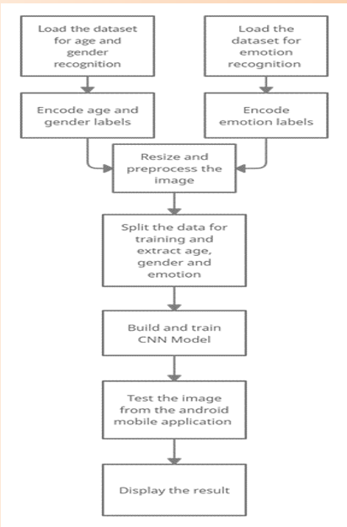
FIGURE: 5.1 System Architecture
5.2 DATA FLOW DIAGRAM
An image processing pipeline that analyses the user-provided image and feeds it into the classifier is used for the age, gender, and emotion identification. First, the classifier decides whether or not the image is of a person. The results of age, gender, and emotion are then computed. The user sees this outcome in the output.

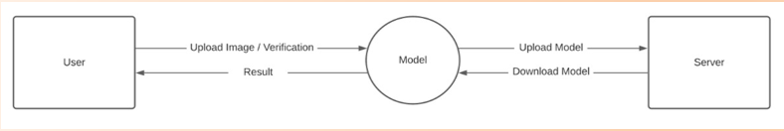
FIGURE 5.2.1 Data Flow Diagram Processing Pipe Line

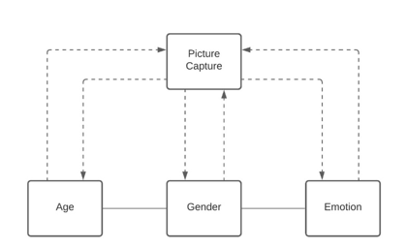
FIGURE 5.2.2 Age Gender Emotion Model

5.3 USE CASE DIAGRAM
By uploading their facial image, the user can communicate with the model. The model is used to forecast the user's gender, age, and emotion after the image has been submitted to the server. After the computation, the server informs the user of this anticipated outcome.

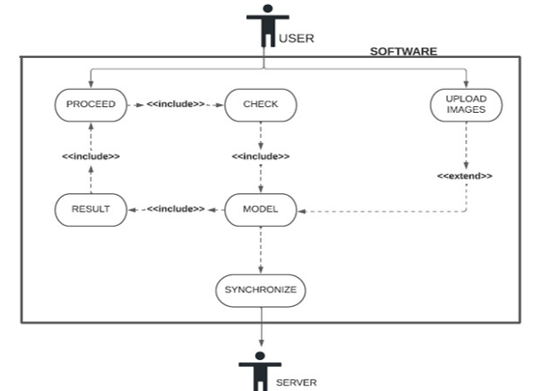
FIGURE 5.3 Use Case Diagram
5.4 SEQUENCE DIAGRAM
Firstly, the user opens the application. Then, the user can capture or select an image to upload and get the result from the model. This repeats in itself and when the user wants to close the application, before the closing the application checks if there is something to be updated to the remote server.
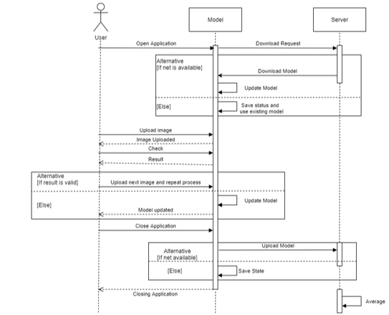
FIGURE 5.4 Sequence Diagram
Programming plan and execution is the stage in the programming system at which an executable programming framework is created.
5.5 CONFIGURATION ISSUES
• Unfortunate web network it very well may be an issue with modem or switch or poor signals.
• Uncouth picture outline the picture caught ought to contain a human face and ought to be adjusted properly. The individual should not be excessively close nor excessively far (an edge like an identification size print would be pertinent).
• vaticination delicacy-The delicacy of the vaticination is to a great extent reliant upon the casing caught.
• Dynamic URL-The ngrok gives circle liberated from cost however the URL changes with each figure. Accordingly, this URL should be changed in the android activity and the activity must be raised once more.
5.6 SYSTEM ARCHITECTURE
The general elevated place armature of this plan is portrayed in Figure4.1. The fundamental intention is to foster an age and orientation assessment framework towards mortal faces which will proceed to hold a significant part in PC vision and example acknowledgment. Piecemeal from age assessment, facial feeling acknowledgment additionally has a significant impact in PC vision. This execution proposes another casing of Convolutional Brain Organization for the contemporaneous assignments old enough assessment, orientation acknowledgment and feeling acknowledgment on face pictures
• Tensor Flow: It is a free and open-source programming library for machine proficiency. It very well may be utilized across a scope of errands however has a specific spotlight on preparing furthermore, finish of profound brain organizations. Tensor flow is a symbolic computation library grounded on dataflow and differentiable programming. It's utilized for both investigation and item at Google. Tensor Flow was created by the Google Cerebrum unit for inward Google use. It was delivered under the Apache License2.0 in 2015
• Flask: Is a miniature web outline written in Python. It's named a micro framework on the grounds that it doesn't bear specific instruments or libraries It has no data set reflection sub caste, structure affirmation, or whatever other elements where prior outsider libraries give normal capabilities. All things considered, Recepticle upholds expansions that can add activity highlights as though they were authorized in Flask itself. Augmentations live for object-social mappers, structure affirmation, transfer running, vivid open validation advances and a few normal edge partnered instruments
. • OpenCV (Open-Source PC Vision Library) is a library of programming capabilities significantly focused on constant PC vision. Right off the bat created by Intel. The library is cross-stage and free for use under the open source Apache 2 Permit. Beginning with 2011, OpenCV highlights GPU speed increase for continuous tasks.
• CAFFE (Convolutional Design for Quick point Inserting) is a profound education outline, right off the bat created at College of California, Berkeley. It is open source, under a BSD permit. It's written in C, with a Python interface. Caffe upholds various kinds of profound proficiency frameworks outfitted towards picture section and picture division. It upholds CNN, RCNN, LSTM and totally associated brain network plans. Caffe upholds GPU and computer processor grounded speed increase computational portion libraries comparative as NVIDIA cuDNN and Intel MKL.
• Ngrok is a burrowing, back delegate that lays out secure coverts from a public endpoint to a locally running organization administration while handling all business for assessment and restoration. Ngrok uncovered unique servers behind NATs and firewalls to the public web over secure coverts.
5.7 Synopsis
In this segment implantation of vivid modules associated with the plan of the Orientation, Age also, Feeling Acknowledgment utilizing profound proficiency is investigated.

CHAPTER 6
SYSTEM IMPLEMENTATION
6.1 WORKING OF AGE, GENDER PREDICTION
Bringing in cv2, which is an OpenCV library which has the CNN capacities. Tape is caught utilizing the raised in camera. Information can be changed like usb camera connected. Haar cascade model is utilized to descry faces and eyes in a picture. Recently, the level and scope of the edge is set. Capability for stacking the caffe models is composed. It returns the variable of both the models. These lines were downloaded from the Kaggle site. This framework was presented by two Israel experimenters, Gil Levi and Tal Hassner in 2015. This contains the data of the prepared brain organization (prepared model). Both. Caffe model lines are the model lines. The reasoning lines characterize the layers in the brain organization, each subcaste's bits of feedbacks, works and usefulness. The tape caught is reused progressively to descry the appearances utilizing the Haar cascade
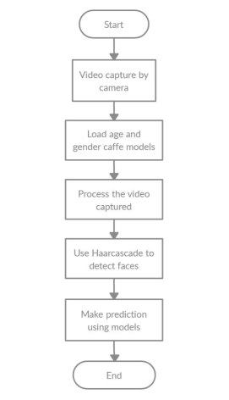
FIGURE 6.1 Working Of Age And Gender Prediction
6.2 WORKING OF EMOTION PREDICTION
The FER2013 is used to train the emotion model. The grayscale face images in the FER2013 dataset (facial expression recognition) measure 48 by 48 pixels. The photos are equally spaced apart and centered. This dataset comprises of the seven facial emotion categories of anger, contempt, happiness, sadness, and surprise. The dataset has been downloaded. Extract it into a data folder with distinct directories for training and testing. Create the training and validation generators from scratch. Create the architecture for the convolution network. Compile and train the model, then finish. Model weights should be saved as a ".h5" file. The bounding boxes of the face in the webcam are detected using OpenCV Haar cascade xml, and emotion is predicted using the trained model.
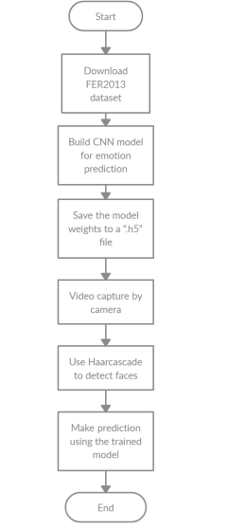
FIGURE 6.2 Working Of Emotion Prediction

6.3 WORKING OF THE JAVASCRIPT COMPONENT WRITTEN
A picture can be chosen or clicked using the upload button. Once the image has been chosen, the "Predict and Suggest" button will appear. Clicking it will cause the computation to be run at the remote workspace, and the predicted outcome will then be shown in the appropriate manner.
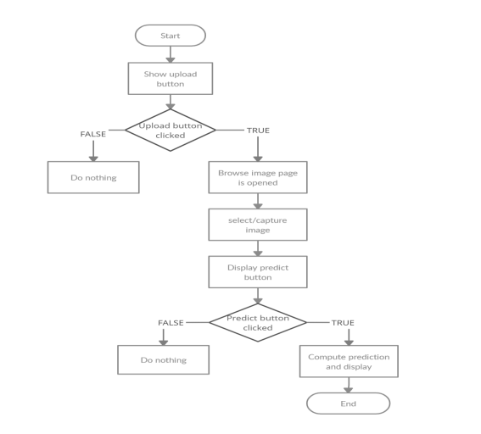
FIGURE 6.3 Working Of The JavaScript Component Written

6.4 IMPLEMENTATION OF FLASK'S WEB APPLICATION
To render HTML pages and make it possible for the Python code (used to make predictions) to interface with the HTML pages without any issues, the Flask application was developed. The web pages are deployed using NGROK for testing reasons. It is a tunnelling reverse proxy that builds safe tunnels between a public endpoint and an active local network service while capturing all traffic for replay and analysis. The upload button can be used to either pick or click an image after the HTML page has been produced. Once the image has been chosen, the "Predict and Suggest" button will appear. Clicking it will cause the computation to be run at the remote workspace, and the predicted outcome will then be shown in the appropriate manner.

CHAPTER 7
SYSTEM TESTING
7.1 INTRODUCTION
After rendering, the testing phase is carried out to find all crimes, give quality assurance, and guarantee the software's responsibility. The system's success is dependent on testing. The software that's going to be tested is run through a set of test cases, and the system's geste during those test cases is looked at to see if it's working as anticipated. It goes without saying that the test cases play a pivotal part in determining whether or not testing reveals crimes.
7.2 UNIT TESTING
Unit testing is a degree of programming testing where individual unit’s corridor of a product are tried. The ideal is to insure that each element of the software works as intended. A unit is the lowest software element that can be tested. It typically has one or a couple of sources of word and typically a solitary result. A single program, function, procedure, etc., can be a unit in procedural programming. A system is the lowest unit in object- acquainted programming. It can be a member of a base or super class, an abstract class, or a deduced or child class. Some treat a module of an operation as a unit.
7.3 THE ADVANTAGES OF UNIT TESTING INCLUDE:
• Unit testing supplements trust in changing keeping up with law. We'll be suitable to snappily identify any blights brought about by the change if good unit tests are written and run each time law is changed. Also changes to any law have a lower unintended impact if they're formerly made lower interdependent in order to enable unit testing.
• Canons can be used more times. Modular canons are necessary for unit testing to be possible. As a result, it's simpler to exercise canons.
• Development is quicker. However, you write your law and do the vague" inventor test"( you set breakpoints, open the GUI, If you do not have unit testing. still, compared to system testing or acceptance testing, the trouble needed to identify and address blights discovered during unit testing is significantly lower.
• Compared to blights set up at advanced situations, the cost of fixing a disfigurement set up during unit testing is lower. When a disfigurement is discovered during acceptance testing or when the software is live, the costs — time, trouble, destruction, demotion — are compared. Debugger is simple. Only the most recent changes need to be amended when a test fails. When testing at advanced situations, it's necessary to examine changes made over a number of days, weeks, or months.
• Coding is more reliable. I suppose there's compelling reason need to make sense of this for a rational individual.
7.4 INTEGRATION TESTING
When performing software testing at the integration testing level, numerous software components are combined and assessed as a whole. This level of testing aims to find problems with the interactions between integrated units. Integration testing is aided by the use of test drivers and test stubs.
The following are definitions of integration testing:
- Testing is carried out to reveal flaws in the interactions and interfaces between integrated systems or components.
- Component integration testing is testing done to find issues with how integrated components interact and interface with one another.
- System integration testing includes testing the interfaces to external organizations as well as the integration of systems and packages.

CHAPTER 8
RESULTS AND DISCUSSIONS
8.1 RESULTS
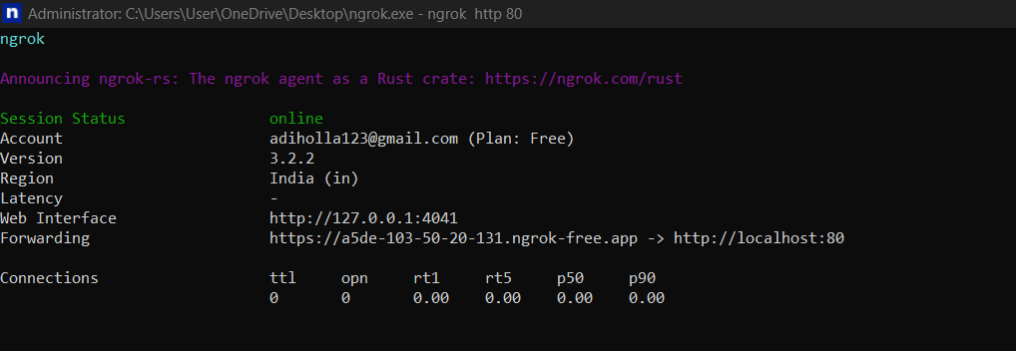
Figure 8.1.1 Ngrok Execution Window

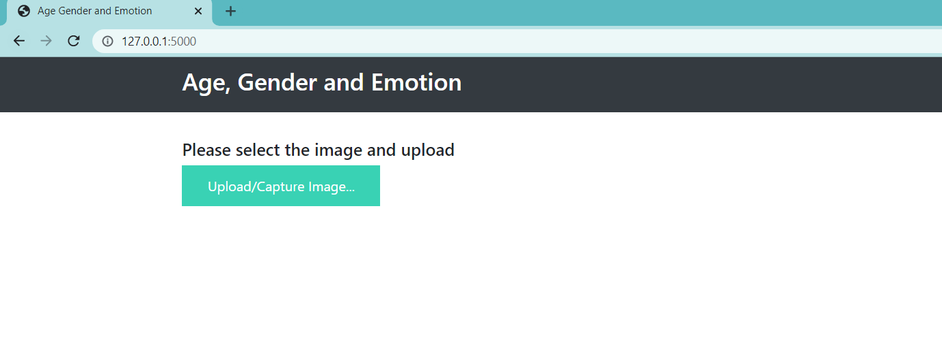
Figure 8.1.2 Flask Output Home Page

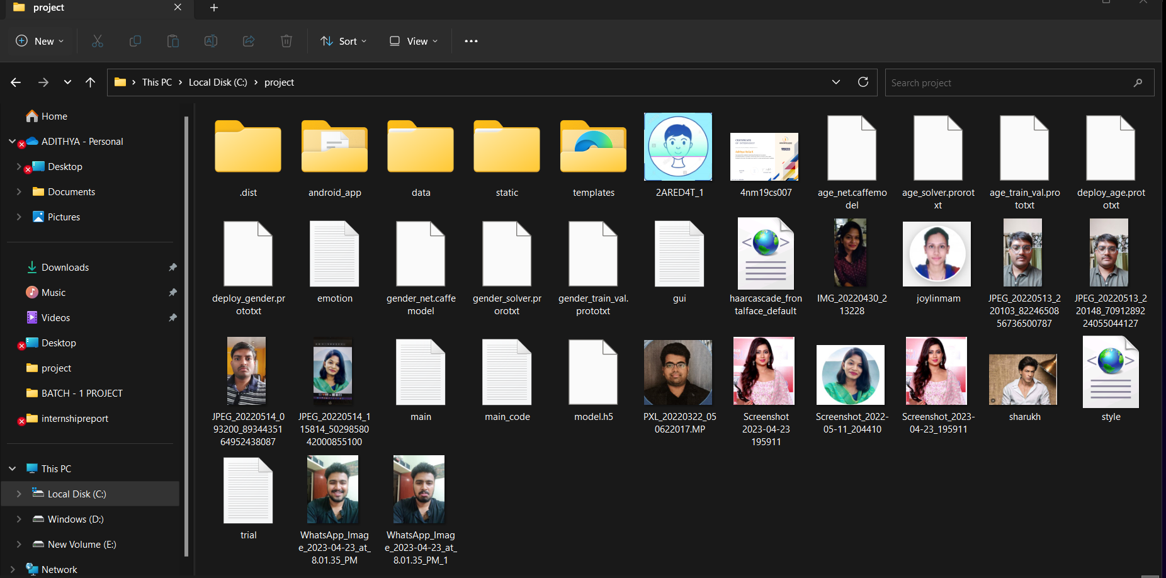
Figure 8.1.3 Image Browsing Window
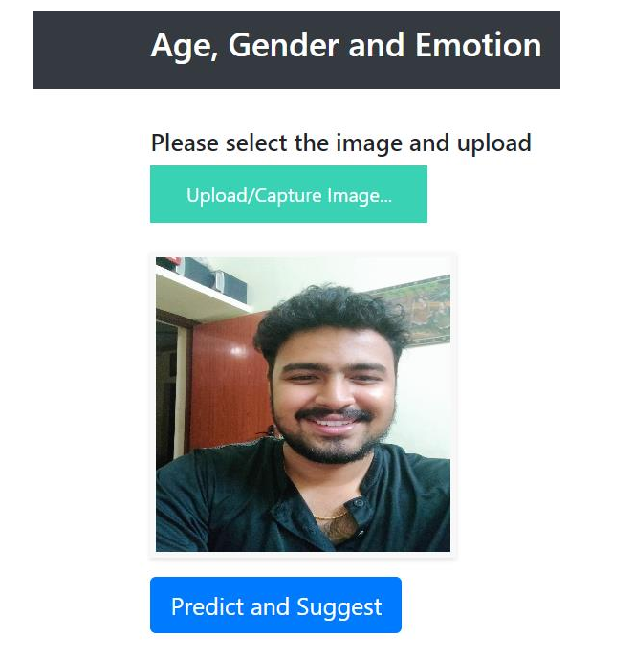
Figure 8.1.4 Browsed Image View
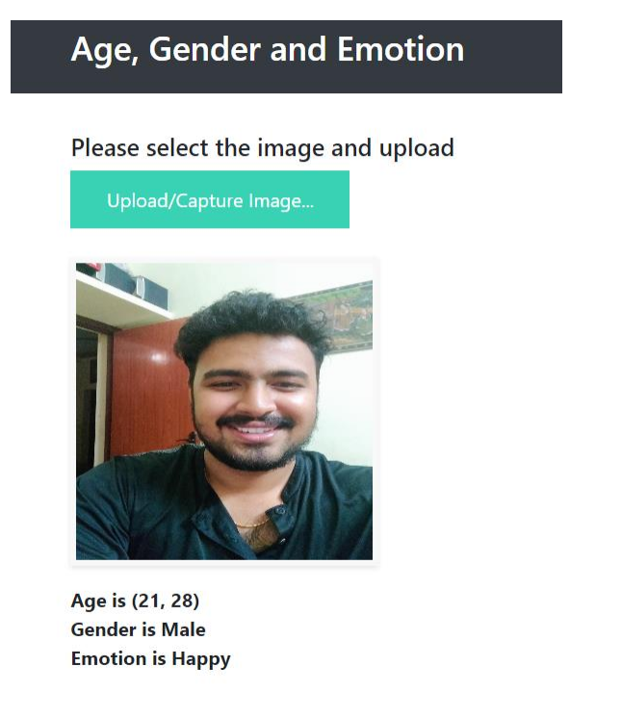
Figure 8.1.5 Displaying Predicted Result

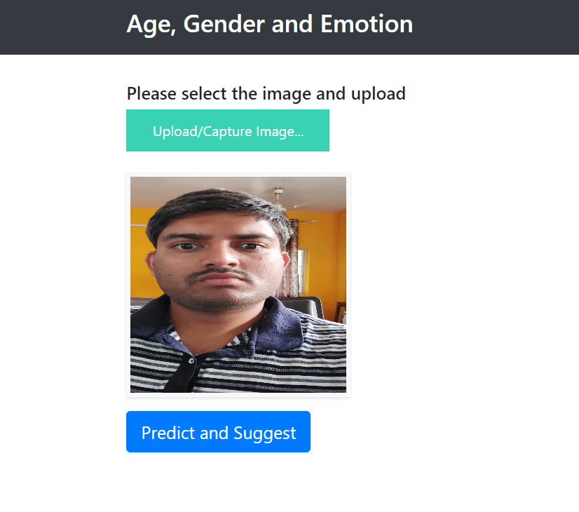
Figure 8.1.6 Browsed Image View
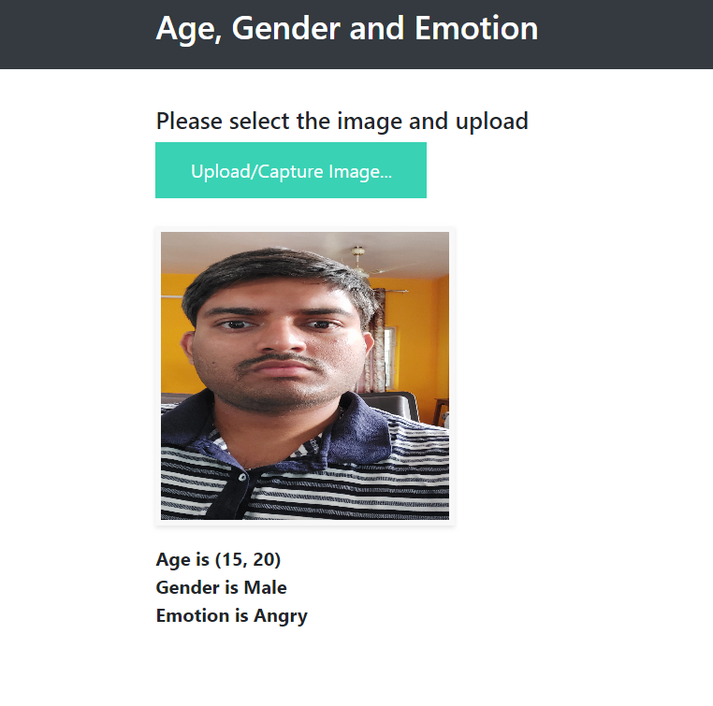
Figure 8.1.7 Displaying Predicted Result

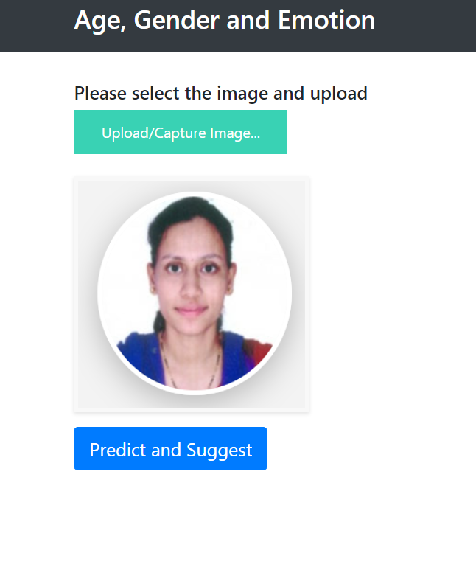
Figure 8.1.8 Browsed Image View
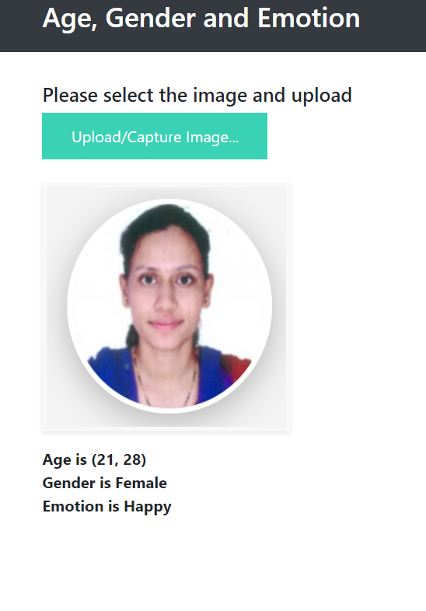
Figure 8.1.9 Displaying Predicted Result
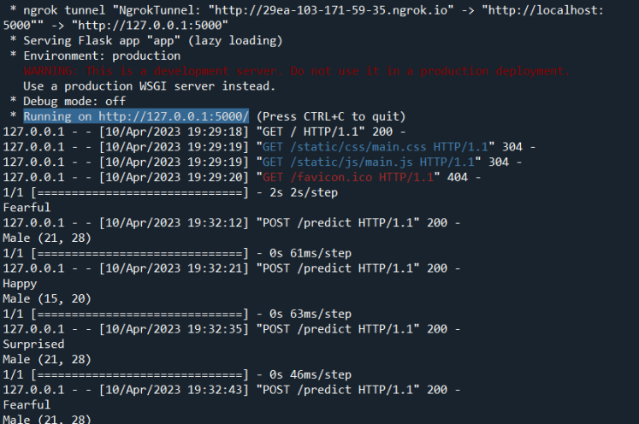
Figure 8.2.0 Python Console After Prediction
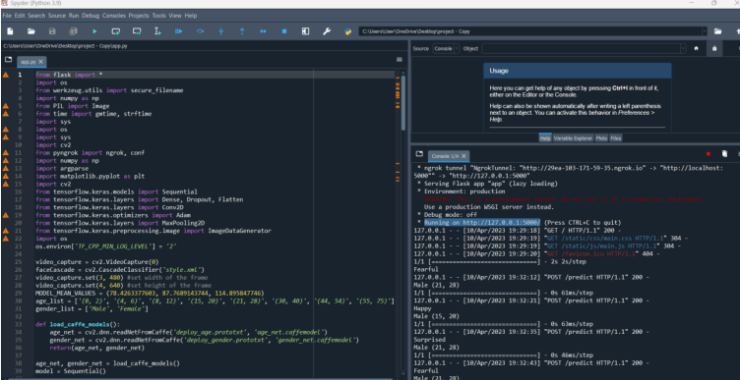
Figure 8.2.1 Code Snippets

8.3 DISCUSSIONS
Gender, age and emotion recognition has relevant use in various software and hardware. Its use can help provide specialized advertisements that targets the mood of the user. If the user is angry, the website can show advertisements of food or other pleasant activities that calm us down. Further it has more use in security systems that are used in airports or banks and even prisons. Criminals can be monitored from their cells. It can predict the emotion of the suspects in the vicinity of the premise which helps in arriving at further conclusions of their actions. A person who has intentions to rob a bank might be scared thinking if he might get caught. By taking the image of him and using the proposed system, it can detect the emotion, gender and age which will help in understanding future actions of the suspect.

CHAPTER 9
CONCLUSION AND FUTURE SCOPE
The suggested frame has contemporaneous, quick, and effective gender, age, and emotion recognition capabilities. As a result, both a Beaker operation to emplace web operations and an Android operation are created. People from different ethnical groups have varied facial characteristics, which could slightly change the factual age from the awaited age, which can lead to misclassifications. By snooping with the learned features, the use of specs may have an impact on emotion bracket.
The sigmoid function was employed by the models in our exploration, but we enforced it far more effectively by replacing it with a ReLU function, which boosts both speed and delicacy.
We can observe a sizable enhancement in age and gender discovery delicacy when we differ our design and perpetration with the other executions listed in our exploration. Our programme also mixes gender, age, and emotion to produce results that are specifically acclimatized to each stoner's gender, age, and emotion. Our model's effective delicacy for age, gender, and emotion is 93, 80, and 85, independently.
Incipiently, applying this approach to a performing business service would be interesting. This design can be used to outline culprits and help in catching them either as they're committing the crime or after they've escaped, as well as to customize announcements and content on social media, product rosters in e-commerce, and OTT(over-the-top) content in the entertainment assiduity

REFERENCES
[1] Atanassov and D. Pilev, "Pre-trained Deep Learning Models for Facial Emotions Recognition," 2020 International Conference Automatics and Informatics (ICAI), 2020, pp. 1-6, doi: 10.1109/ICAI50593.2020.9311334
.
[2] I. Lasri, A. R. Solh and M. E. Belkacemi, "Facial Emotion Recognition of Students using Convolutional Neural Network," 2019 Third International Conference on Emotion Recognition By Inclusion Of Age And Gender Parameter By Deep Learning Dept. of CSE, NMAMIT, NITTE Page 21 Intelligent Computing in Data Sciences (ICDS), 2019, pp. 1-6, doi: 10.1109/ICDS47004.2019.8942386.

[3] Ko, Byoung C. 2018. "A Brief Review of Facial Emotion Recognition Based on Visual Information" Sensors 18, no. 2: 401.

[4] M. M. Taghi Zadeh, M. Imani and B. Majidi, "Fast Facial emotion recognition Using Convolutional Neural Networks and Gabor Filters," 2019 5th Conference on Knowledge Based Engineering and Innovation (KBEI), 2019, pp. 577-581, doi: 10.1109/KBEI.2019.8734943.

[5] M. Mohammadpour, H. Khaliliardali, S. M. R. Hashemi and M. M. AlyanNezhadi, "Facial emotion recognition using deep convolutional networks," 2017 IEEE 4th International Conference on Knowledge-Based Engineering and Innovation (KBEI), 2017, pp. 0017-0021, doi: 10.1109/KBEI.2017.8324974.

[6] P. Aiswarya, Manish and P. Mangalraj, "Emotion recognition by inclusion of age and gender parameters with a novel hierarchical approach using deep learning," 2020 Advanced Communication Technologies and Signal Processing (ACTS), 2020, pp. 1- 6, doi: 10.1109/ACTS49415.2020.9350479.

[7] P. Smith and C. Chen, "Transfer Learning with Deep CNNs for Gender Recognition and Age Estimation," 2018 IEEE International Conference on Big Data (Big Data), 2018, pp. 2564-2571, doi: 10.1109/BigData.2018.8621891.
[8] R. Helaly, M. A. Hajjaji, F. M'Sahli and A. Mtibaa, "Deep Convolution Neural Network Implementation for Emotion Recognition System," 2020 20th International Conference on Sciences and Techniques of Automatic Control and Computer Engineering (STA), 2020, pp. 261-265, doi: 10.1109/STA50679.2020.9329302

[9] S. Arora and M. P. S. Bhatia, "A Robust Approach for Gender Recognition Using Deep Learning," 2018 9th International Conference on Computing, Communication and Networking Technologies doi: 10.1109/ICCCNT.2018.8494194.

[10] S. Aydın, "Deep Learning Classification of Neuro-Emotional Phase Domain Complexity Levels Induced by Affective Video Film Clips," in IEEE Journal of Biomedical and Health Informatics, vol. 24, no. 6, pp. 1695-1702, June 2020, doi: 10.1109/JBHI.2019.2959843.

