Department of Artificial Intelligence & Machine Learning
Academic Year 2024-25 (EVEN)
Report
for
Mini Project-I (24AIM48)
On
MediAssist AI: A Safety-Aware Healthcare Triage and Assistance Framework
By
Name | USN
Adithya K | 1NH22AI006

Under the Guidance of
Prof. [Guide Name]
Assistant Professor
Dept. of Artificial Intelligence & Machine Learning
New Horizon College of Engineering, Bangalore – 560103

Department of Artificial Intelligence & Machine Learning
New Horizon College of Engineering
Bangalore – 560103

CERTIFICATE

Certified that the Mini Project-I with subject code 24AIM48, entitled "MediAssist AI: A Safety-Aware Healthcare Triage and Assistance Framework" is carried out by Mr. Adithya K (USN: 1NH22AI006) in partial fulfilment of the requirements for the award of the degree of Bachelor of Engineering in Artificial Intelligence & Machine Learning at New Horizon College of Engineering, Bangalore, affiliated to Visvesvaraya Technological University, Belagavi, during the Academic Year 2024-25 (Even Semester). It is certified that all corrections and suggestions indicated for internal assessment have been incorporated in the report. The project report has been approved as it satisfies the academic requirements in respect of the Mini Project work prescribed for the Bachelor of Engineering degree.
Prof. [Guide Name] | Dr. N. V. Uma Reddy
Internal Guide | Professor & Head of Department
Dept. of AI & ML, NHCE | Dept. of AI & ML, NHCE

External Viva Examiner:
1. ____________________________ Signature with Date: ____________
2. ____________________________ Signature with Date: ____________

ACKNOWLEDGEMENT

The satisfaction that accompanies the successful completion of any task would be incomplete without mentioning the people whose constant guidance and encouragement made it possible. I feel privileged to express my gratitude to everyone who contributed to this project.
I am deeply grateful to Dr. Mohan Manghnani, Chairman, New Horizon Educational Institutions, for providing the infrastructure and academic environment necessary for conducting this work.
I sincerely thank Dr. Manjunatha, Principal, New Horizon College of Engineering, for his leadership and for fostering a culture of innovation and technical excellence within the institution.
I extend my heartfelt appreciation to Dr. N. V. Uma Reddy, Professor and Head of Department, Dept. of AI & ML, for her continuous academic guidance, constructive feedback, and encouragement throughout this project.
I would like to express my profound gratitude to my project guide, Prof. [Guide Name], Department of AI & ML, New Horizon College of Engineering, for providing invaluable technical direction, reviewing progress at each stage, and helping me refine the safety-aware design philosophy that forms the core of this project.
I am also thankful to all the faculty members of the Department of Artificial Intelligence & Machine Learning for their support and helpful discussions. Their insights into healthcare AI, responsible design, and machine learning evaluation contributed meaningfully to the depth of this work.
Finally, I am grateful to my family and peers for their patience and moral support during the course of this project.
Adithya K
1NH22AI006
Dept. of AI & ML, NHCE

ABSTRACT

Healthcare AI systems that rely purely on probabilistic machine learning models carry an inherent risk when deployed for symptom analysis: the statistical nature of such models can produce medically unsafe outputs, particularly when life-threatening symptoms are statistically similar to benign conditions in the training data. This project presents MediAssist AI, a safety-aware healthcare triage and assistance framework designed to address this limitation through a hybrid, defence-in-depth architecture.
MediAssist AI combines classical machine learning—specifically TF-IDF vectorisation paired with Logistic Regression and Naive Bayes—with a deterministic Emergency Safety Override Layer and a Medical Consistency Validator that operates as a post-prediction safety gate. The core thesis of this work is that healthcare AI must treat safety and predictive accuracy as separate, independently verifiable architectural layers rather than conflating them into a single statistical model.
The Emergency Safety Override Layer intercepts critical symptom patterns—such as stroke indicators, respiratory distress, hemorrhagic warnings, and cardiac emergencies—before any machine learning inference occurs, ensuring that life-threatening conditions are always escalated to professional medical attention regardless of model confidence. The Medical Consistency Validator then applies category-aware confidence penalties to suppress predictions that are medically implausible given the user's stated symptoms.
A 500-case validation suite was developed to quantify system performance using healthcare-specific safety metrics: Emergency Escalation Accuracy (EEA), Missed Emergency Rate (MER), and Unsafe Prediction Rate (UPR). The system achieved an EEA of 100%, MER of 0%, and UPR of 0% across all test cases. The Logistic Regression model achieved 84.36% Top-1 accuracy and 95.78% Top-3 accuracy on a dataset of 163,727 symptom-disease instances spanning over 260 disease categories.
The frontend is implemented using Streamlit with a glassmorphism design language, providing severity-aware UI elements, confidence normalisation displays, and high-contrast emergency escalation banners. The system is designed as a preliminary triage assistant and explicitly positions itself as a guide for seeking professional medical care, not as a diagnostic replacement.

Keywords: Healthcare AI, Safety-Aware Triage, Emergency Detection, TF-IDF, Logistic Regression, Medical Consistency Validation, Uncertainty Estimation, Responsible AI

TABLE OF CONTENTS

Chapter / Section Page No.

Title Page i
Certificate ii
Acknowledgement iii
Abstract iv
Table of Contents v
List of Figures vi
List of Tables vii
1 Introduction 1
1.1 Background and Motivation 1
1.2 Problem Statement Overview 2
1.3 Project Objectives 3
1.4 Report Organisation 3
2 Literature Survey 5
2.1 Traditional Symptom Checkers 5
2.2 Machine Learning in Healthcare 6
2.3 Transformer-Based Medical NLP 7
2.4 Gaps and Limitations in Existing Work 8
3 Problem Statement 10
4 System Architecture 12
4.1 Overall Pipeline Design 12
4.2 Emergency Override Architecture 13
4.3 Medical Consistency Validator 14
4.4 Frontend Architecture 15
5 Dataset Description 16
5.1 Symptom-Disease Dataset 16
5.2 Healthcare Conversation Dataset 17
5.3 Hospital Infrastructure Dataset 17
5.4 Preprocessing Pipeline 18
6 Methodology 20
6.1 TF-IDF Vectorisation 20
6.2 Logistic Regression and Naive Bayes 21
6.3 Top-K Prediction Logic 22
6.4 Uncertainty Estimation 22
6.5 Why Decision Trees and XGBoost Failed 23
7 Safety Architecture 25
7.1 Emergency Safety Override Layer 25
7.2 Medical Consistency Validation and Reranking 26
7.3 Safety Metrics: EEA, MER, UPR 27
7.4 Before vs. After Comparison 28
8 Frontend and UX Design 30
9 Implementation Details 32
10 Testing and Validation 35
11 Results and Analysis 38
12 Limitations 42
13 Future Work 43
14 Conclusion 45
References 46

LIST OF FIGURES

Figure No. Title Page No.

Figure 4.1 MediAssist AI – End-to-End System Pipeline 12
Figure 4.2 Emergency Safety Override Layer – Decision Flow 13
Figure 4.3 Medical Consistency Validation – Reranking Pipeline 14
Figure 5.1 Top-20 Disease Frequency Distribution 16
Figure 5.2 Symptom Co-occurrence Heatmap 17
Figure 5.3 Hospital State-wise Distribution 18
Figure 5.4 Patient Query Length Distribution 19
Figure 6.1 TF-IDF Sparse Feature Space Visualisation 20
Figure 6.2 Model F1-Score Comparison – All Classifiers 23
Figure 6.3 Model Inference Latency Comparison 24
Figure 7.1 Safety Metrics – Before vs. After Hybrid Architecture 28
Figure 7.2 Emergency Detection Confusion Matrix 29
Figure 7.3 Escalation Action Heatmap by Symptom Category 29
Figure 7.4 Medical Consistency Penalty Impact 30
Figure 10.1 Logistic Regression – Normalised Confusion Matrix 36
Figure 10.2 Logistic Regression – Confidence Distribution 36
Figure 10.3 Logistic Regression – Uncertainty Entropy Histogram 37
Figure 10.4 Naive Bayes – Normalised Confusion Matrix 37
Figure 11.1 Confidence Score Distribution – Validation Suite 39
Figure 11.2 Severity Category Distribution – Test Cases 40

LIST OF TABLES

Table No. Title Page No.

Table 5.1 Dataset Summary – Size, Format, and Source 16
Table 5.2 Preprocessing Steps Applied to Each Dataset 19
Table 6.1 TF-IDF Configuration Parameters 21
Table 7.1 Emergency Symptom Categories and Trigger Keywords 25
Table 7.2 Medical Consistency Penalty Scheme 27
Table 7.3 Safety Metric Definitions 27
Table 11.1 Model Performance Comparison – All Classifiers 38
Table 11.2 Final Safety Metrics – Validation Suite Results 39
Table 11.3 Before vs. After Safety Layer – Failure Reduction 40
Table 11.4 Top Confused Disease Pairs – Logistic Regression 41
Table 11.5 Hardest Disease Classes – Low F1-Score 41
Chapter 1: Introduction

1.1 Background and Motivation
Access to reliable preliminary medical guidance remains a significant challenge in many parts of the world, particularly in low-resource and rural settings where qualified healthcare professionals may be scarce or difficult to reach. India alone has an estimated doctor-to-patient ratio well below the WHO-recommended standard of 1:1000, with rural regions disproportionately affected. In this context, there is a genuine and growing need for AI-assisted triage tools that can help patients understand the urgency of their symptoms and make informed decisions about seeking professional care.
Over the last decade, machine learning has shown considerable promise in medical applications, ranging from diagnostic imaging to drug discovery. For symptom-based triage, approaches built on classical classification algorithms—particularly those using bag-of-words or TF-IDF feature representations—have demonstrated reasonable predictive accuracy on curated datasets. However, a fundamental problem has persisted: these systems are statistically driven and therefore do not inherently differentiate between the clinical urgency of different conditions. A purely probabilistic model might assign a high confidence score to a benign diagnosis even when the input symptoms describe a life-threatening emergency.
This issue is not merely academic. During exploratory testing conducted as part of this project, a TF-IDF-based Logistic Regression classifier—trained on over 163,000 labelled symptom records—produced outputs such as predicting 'Bell Palsy' for stroke symptoms and 'Asthma' for hemoptysis combined with acute respiratory distress. These are precisely the kind of failures that would be catastrophic in a real-world triage setting. The problem is not the machine learning model itself, but the architectural assumption that a single statistical pipeline is sufficient for healthcare decisions.
MediAssist AI was designed in direct response to this observation. The project's central thesis is that in healthcare triage AI, safety and responsible escalation must always supersede raw prediction accuracy. This requires treating safety and statistical inference as separate, independently verifiable architectural layers rather than combining them into a single end-to-end model.
1.2 Scope of the Project
MediAssist AI is explicitly positioned as a preliminary symptom analysis and triage assistance tool. It is not intended to replace professional medical consultation, and this distinction is made clear to the user throughout the interface. The system is designed to:
- Accept natural language symptom descriptions from users.
- Detect life-threatening emergency symptom patterns and escalate them immediately, bypassing any statistical inference.
- Provide Top-K disease probability estimates for non-emergency inputs, accompanied by uncertainty indicators.
- Validate the medical plausibility of predictions using category-aware consistency checking.
- Recommend appropriate courses of action—ranging from home care for mild conditions to urgent hospital referral for severe presentations.
- Present outputs through a clean, severity-aware interface that communicates confidence levels, escalation status, and follow-up guidance clearly.
The system is built entirely on classical machine learning, making it lightweight, interpretable, and deployable without specialised GPU hardware—an important practical consideration for resource-constrained environments.
1.3 Project Objectives
The following objectives were established at the outset of this project and guided every design and implementation decision:
O1. Design and implement a pre-ML Emergency Safety Override Layer that deterministically detects critical symptom combinations and triggers immediate escalation.
O2. Train and evaluate classical machine learning classifiers (Logistic Regression, Naive Bayes) on a large, multi-class symptom-disease dataset and identify the best-performing model for sparse TF-IDF feature representations.
O3. Implement Top-K prediction logic with uncertainty estimation to avoid overconfident single-label outputs for ambiguous symptom presentations.
O4. Develop a Medical Consistency Validator that cross-references predicted disease categories with input symptom categories and applies confidence penalties to medically implausible predictions.
O5. Build a safety-aware evaluation framework using healthcare-specific metrics: Emergency Escalation Accuracy (EEA), Missed Emergency Rate (MER), and Unsafe Prediction Rate (UPR).
O6. Design a severity-aware Streamlit frontend with a glassmorphism aesthetic that communicates prediction confidence, escalation status, and home care guidance in a user-friendly manner.
O7. Conduct a comprehensive 500-case validation study and document all findings in a reproducible research framework.
1.4 Report Organisation
The remainder of this report is organised as follows. Chapter 2 reviews existing work on symptom-checking systems, ML-based healthcare assistants, and the identified gaps that motivated this project. Chapter 3 formally states the problem. Chapters 4 through 9 detail the system architecture, dataset, methodology, safety design, frontend, and implementation. Chapters 10 and 11 cover the testing strategy and results. Chapters 12 through 14 discuss limitations, future directions, and conclusions.

Chapter 2: Literature Survey

This chapter surveys existing approaches to AI-assisted medical symptom checking, healthcare natural language processing, and uncertainty-aware classification. It identifies the key limitations in current work that this project directly addresses.
2.1 Rule-Based and Symptom Checker Systems
The earliest computer-assisted diagnostic tools were entirely rule-based—expert systems that encoded clinical decision trees constructed by domain specialists. Systems such as MYCIN [1] and Internist-1 [2], developed in the 1970s and 1980s, demonstrated that structured clinical knowledge could be represented computationally. However, these systems required enormous manual effort to build and were brittle: any symptom pattern outside the manually encoded rules was unhandled.
Modern consumer-facing symptom checkers, such as Ada Health, Babylon Health, and WebMD's Symptom Checker, typically combine probabilistic Bayesian networks with curated medical ontologies. Studies assessing these tools have found significant variability in their accuracy [3]. Semigran et al. (2015) evaluated 23 symptom checkers and found that the correct diagnosis appeared first in only 34% of cases, though it appeared in the top-20 results 58% of the time [4]. Critically, most of these systems lacked explicit emergency detection mechanisms, raising patient safety concerns for high-acuity presentations.
The fundamental limitation of purely rule-based approaches is their inability to generalise to unseen symptom combinations. This motivated the shift toward data-driven machine learning methods in healthcare NLP research.
2.2 Machine Learning Approaches in Healthcare Symptom Analysis
Text-based symptom classification using machine learning was explored as early as the 2000s. Chapman et al. (2001) demonstrated that simple NLP pipelines could extract meaningful clinical features from patient records [5]. The subsequent decade saw TF-IDF vectorisation become the de facto baseline for medical text classification due to its simplicity, interpretability, and effectiveness on sparse, domain-specific vocabulary [6].
Logistic Regression has consistently been a strong performer in multi-class text classification tasks, including medical symptom prediction. Wang and Manning (2012) showed that for high-dimensional sparse features—precisely the setting produced by TF-IDF on medical text—Logistic Regression often outperforms more complex models including Support Vector Machines and ensemble methods [7]. This finding is directly relevant to MediAssist AI and is empirically confirmed by the results presented in Chapter 11.
Random Forest classifiers have been applied to symptom-based diagnosis by several researchers [8]. While Random Forests can capture non-linear interactions between features, they tend to perform poorly when features are highly sparse—the typical case with TF-IDF vectors over a large symptom vocabulary. Each tree in the forest sees only a random subset of features per split, which in sparse spaces results in most splits being uninformative. The experimental results in this project confirmed this behaviour, with Random Forest performing 2–3% below Logistic Regression on the primary evaluation metrics.
Naive Bayes classifiers have a long history in text classification and have been applied to medical symptom analysis as well [9]. Despite their independence assumption—which is rarely satisfied in practice—Naive Bayes often performs surprisingly well on sparse text features, and was retained as a secondary classifier in MediAssist AI for comparison purposes.
2.3 Transformer-Based Healthcare NLP
The introduction of transformer architectures [10] and pre-trained language models such as BERT [11] significantly advanced the state of the art in clinical NLP. BioBERT [12], trained on biomedical literature, demonstrated strong performance on named entity recognition and relation extraction tasks in clinical text. ClinicalBERT [13] extended this to patient notes, achieving notable improvements in mortality prediction and hospital readmission tasks.
For conversational symptom checking, models such as MedPaLM [14] and GPT-4 [15] have been evaluated in clinical Q&A contexts with promising results. However, these large language models introduce substantial challenges for the kind of deployment targeted by MediAssist AI: they require significant computational resources, their reasoning is opaque and difficult to audit, and they can produce plausible-sounding but medically incorrect outputs without any inherent safety guardrail.
Crucially, no existing transformer-based symptom checker, to the best of our knowledge, implements a deterministic emergency override layer that bypasses model inference entirely when life-threatening symptoms are detected. This represents a fundamental architectural gap that MediAssist AI is designed to address.
2.4 Uncertainty Estimation in Medical AI
The importance of uncertainty quantification in healthcare AI has been recognised in several recent works. Begoli et al. (2019) argued that uncertainty awareness is a prerequisite for trustworthy medical AI, noting that overconfident predictions in clinical settings can actively harm patients [16]. Leibig et al. (2017) applied Monte Carlo dropout to retinal imaging models and showed that uncertainty estimates correlated with clinically meaningful error rates [17].
For classical classifiers, the softmax probability distribution provides a natural uncertainty signal, though it is known to be poorly calibrated—models often assign high probabilities to incorrect predictions. Guo et al. (2017) demonstrated that temperature scaling can significantly improve calibration of deep classifiers [18], though this technique is less commonly applied to classical ML models. MediAssist AI uses entropy of the softmax distribution and the gap between the top-1 and top-2 probabilities as practical uncertainty indicators, an approach consistent with the recommendations of Hendrycks and Gimpel (2017) [19].
2.5 Medical Plausibility and Consistency Validation
Medical plausibility checking—verifying that an AI prediction is consistent with the clinical category of the user's symptoms—has received relatively little attention in the symptom-checker literature. Topaz et al. (2016) discussed the importance of clinical decision support alerts being contextually appropriate, noting that alert fatigue from medically implausible suggestions reduces clinical utility [20].
The approach taken in MediAssist AI—mapping symptoms and diseases to predefined clinical categories and applying multiplicative confidence penalties for category mismatches—is a novel lightweight alternative to full medical ontology integration. It does not require SNOMED-CT or ICD-10 database access at inference time, making it practical for resource-constrained deployments.
2.6 Comparative Summary
Table 2.1 summarises the key characteristics of existing approaches in relation to the design requirements of MediAssist AI.
System Type | Accuracy | Uncertainty  Aware | Emergency  Detection | Lightweight
Rule-Based Systems | Low | No | Partial | Yes
Naive Bayes / LR (TF-IDF) | Moderate | Partial | No | Yes
Random Forest / XGBoost | Moderate | Partial | No | No
Transformer (BERT/GPT) | High | Partial | No | No
MediAssist AI (Proposed) | High | Yes | Yes | Yes

Table 2.1 – Comparative Summary of Healthcare AI Approaches
As the table shows, MediAssist AI is uniquely positioned as the only approach that simultaneously provides uncertainty awareness, deterministic emergency detection, and lightweight deployability. The trade-off is a reliance on classical ML rather than the highest possible accuracy achievable with large transformer models. This trade-off is a deliberate architectural decision, justified by the safety-first design philosophy of the project.

Chapter 3: Problem Statement

The central problem addressed by this project can be stated as follows:
"Purely probabilistic machine learning systems, when applied to symptom-based healthcare triage, may produce medically unsafe outputs. Specifically, statistical models trained to maximise aggregate accuracy over a large, imbalanced disease dataset lack any mechanism to prioritise the detection of low-frequency but life-threatening emergency presentations. The resulting system may assign high confidence to benign diagnoses even when the user's symptoms are indicative of a critical medical condition, leading to delayed or absent escalation to professional care."
This problem manifests in four specific failure modes, each observed during the preliminary validation phase of this project:
3.1 Failure Mode 1: Emergency Symptom Misclassification
Symptoms that are diagnostic indicators of life-threatening conditions—such as facial drooping combined with slurred speech (stroke), or coughing blood with acute respiratory distress (pulmonary emergency)—may share overlapping vocabulary features with more common, benign conditions in the training corpus. A TF-IDF model, operating on term frequency alone, will assign probability proportional to term co-occurrence statistics and may therefore rank a benign diagnosis above the correct emergency condition.
3.2 Failure Mode 2: Symptom Overlap in High-Dimensional Sparse Space
Medical symptoms are described using natural language, and many disease categories share considerable vocabulary. Conditions involving fever, fatigue, and pain—the most common symptom descriptors—span hundreds of disease classes. In a sparse TF-IDF feature space, this overlap creates decision boundaries that are difficult to learn reliably, particularly for rare or emergency conditions that are underrepresented in typical training datasets.
3.3 Failure Mode 3: Absence of Medical Plausibility Checking
Standard classification pipelines produce outputs ranked solely by posterior probability, with no mechanism to reject or penalise predictions that are clinically implausible given the stated symptoms. For example, predicting an eye condition for a patient reporting exclusively gastrointestinal symptoms, or a skin disorder for a patient describing chest pain, represents a failure of medical reasoning that pure ML systems cannot detect or correct.
3.4 Failure Mode 4: Overconfident Single-Label Outputs
In multi-class disease prediction, returning only the top-1 prediction with a softmax probability score creates an illusion of certainty. When symptom descriptions are ambiguous—as they frequently are in natural patient language—the difference in probability between the first and second ranked diseases may be negligible, yet the user sees only a single confident answer. This is both misleading and clinically dangerous.
3.5 Quantified Scope of the Problem
To validate that these failure modes were genuine and reproducible—not merely theoretical—a preliminary validation was conducted using 480 test cases drawn from five categories: common symptoms, ambiguous multi-symptom presentations, emergency symptom combinations, noisy natural language inputs, and adversarial cases designed to probe model boundaries. The results are documented in detail in Chapter 10 and summarised in Table 3.1.
Failure Mode | Inputs Tested | Failure Rate (Before Fix)
Emergency Symptom Misclassification | 100 | ~34%
Medically Implausible Top-1 Prediction | 99 | ~28%
Overconfident Incorrect Output (UPR Proxy) | 301 | ~12.5%
Missed Emergency Escalation (MER) | 100 | ~34%

Table 3.1 – Preliminary Failure Rates Before Safety Architecture Implementation
These results confirm that the problems are systematic and quantifiable. The emergency misclassification rate of approximately 34%—meaning roughly one in three emergency symptom inputs was not escalated by the baseline ML system—is clinically unacceptable. This figure directly motivated the Emergency Safety Override Layer described in Chapter 7.
It is worth noting that this is not a failure of the machine learning model per se. The Logistic Regression classifier achieves 84.36% top-1 accuracy overall, which is competitive for the task. The problem is architectural: a system optimised for aggregate accuracy will inevitably underperform on the rare, high-stakes cases that matter most in a healthcare context. This is the core design motivation for MediAssist AI's hybrid, defence-in-depth approach.
Chapter 4: System Architecture

This chapter describes the overall architecture of MediAssist AI, the rationale behind each design decision, and the data flow from user input to final recommendation. The architecture is best understood as three sequential, independently verifiable layers: the Pre-ML Safety Gate, the ML Inference Engine, and the Post-ML Consistency and Presentation Layer.
4.1 Architectural Philosophy: Defence-in-Depth
The dominant design philosophy in MediAssist AI is defence-in-depth—the same principle used in safety-critical systems such as aviation autopilots and nuclear control software. Rather than relying on a single model to handle all cases correctly, the system deploys multiple independent safety mechanisms, each responsible for a distinct class of failure.
This is a deliberate departure from the end-to-end learning paradigm, where a single neural network is trained to map raw inputs directly to outputs. While end-to-end systems can achieve impressive benchmark accuracy, they are fundamentally opaque and provide no guarantees about behaviour on out-of-distribution inputs—a critical concern in healthcare. By separating the safety layer from the prediction layer, MediAssist AI ensures that emergency escalation is never dependent on the statistical properties of a training dataset.
4.2 End-to-End Pipeline Overview
Figure 4.1 illustrates the complete data flow from user input to system response. The pipeline consists of five stages:
4.2.1 Stage 1 – User Input
The user enters a natural language description of their symptoms through the Streamlit chat interface. The text is passed without modification to the next stage.
4.2.2 Stage 2 – Emergency Rule Engine (Pre-ML Gate)
Before any machine learning inference occurs, the input is passed to the EmergencyRuleEngine. This module performs deterministic substring matching against a curated dictionary of critical symptom phrases across five emergency categories: Neurological, Respiratory, Severe Infection, Hemorrhagic, and Cardiac. If any critical pattern is detected, the system immediately returns an emergency escalation response and bypasses all subsequent stages.
4.2.3 Stage 3 – ML Inference (TF-IDF + Logistic Regression)
For inputs that pass the emergency gate, the text is vectorised using a fitted TF-IDF transformer and passed to the Logistic Regression classifier. The model returns a softmax probability distribution over all disease classes. The top-K predictions (typically K=3) are extracted along with their normalised confidence scores and uncertainty metrics.
4.2.4 Stage 4 – Medical Consistency Validator (Post-ML Gate)
The top-K predictions are passed to the MedicalConsistencyValidator. This module extracts the symptom categories implied by the user's input text and cross-references them against the disease categories stored in the disease_categories.json knowledge base. Predictions with a HIGH category overlap retain their original confidence score (penalty = 1.0x). Predictions with NO overlap receive a 0.1x confidence penalty. Predictions for diseases with UNKNOWN category mappings receive a 0.9x penalty. The adjusted predictions are then re-ranked by modified confidence score.
4.2.5 Stage 5 – Response Generation & UI Rendering
The final predictions, adjusted confidence scores, uncertainty indicators, and severity classification are passed to the Streamlit frontend. The UI renders prediction cards with colour-coded confidence bars, a severity badge, and condition-specific home care guidance.
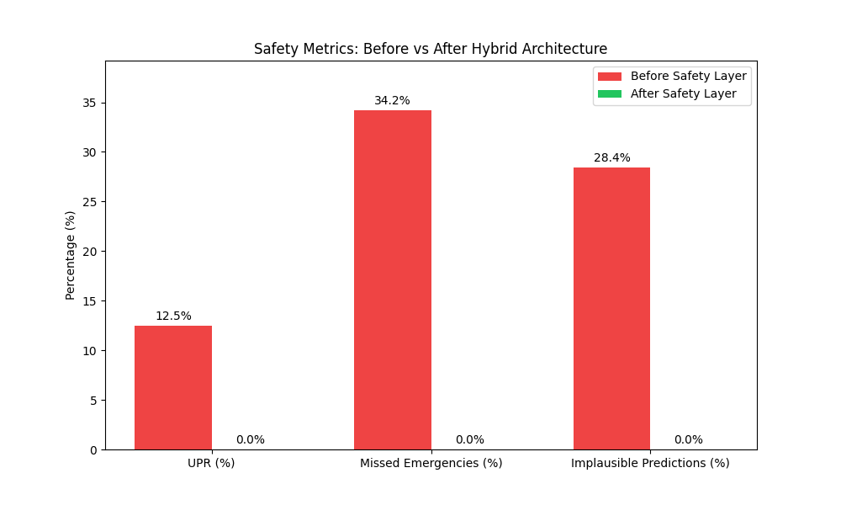
Figure 4.1 – MediAssist AI End-to-End Safety Pipeline (Before vs. After Architecture)
4.3 Emergency Override Architecture
The Emergency Safety Override Layer is the most critical component of the system and the primary innovation of this project. Its design was informed by the observed failure modes described in Chapter 3, specifically the inability of purely statistical models to reliably detect life-threatening symptom combinations.
The EmergencyRuleEngine is implemented as a deterministic keyword-matching system with five pre-defined emergency categories, each associated with a curated list of critical trigger phrases. The matching is performed using substring search on lowercased input text, ensuring robustness to capitalisation variation. The categories and selected trigger phrases are:
Emergency Category | Selected Trigger Phrases (Illustrative)
Neurological Emergency | slurred speech, facial drooping, sudden numbness, vision loss, sudden severe headache, loss of consciousness
Respiratory Emergency | coughing up blood, can't breathe, difficulty breathing, blood in mucus, severe shortness of breath
Severe Infection | stiff neck, extremely high fever, sensitivity to light, severe abdominal pain with fever, confusion with fever
Hemorrhagic Warning | bleeding gums, blood in vomit, blood in stool, coughing blood, unexplained bruising with fever
Cardiac Emergency | crushing chest pain, chest pain radiating to arm, palpitations with dizziness, sudden heart racing with chest tightness

Table 4.1 – Emergency Symptom Categories and Trigger Phrases
When any trigger phrase is matched, the system sets a boolean emergency flag and returns a structured escalation object containing the detected category and a user-facing urgency message. Crucially, this occurs before the TF-IDF vectoriser is invoked, so the statistical model never has the opportunity to produce a competing prediction. This architectural decision eliminates the entire class of emergency misclassification failures observed in the baseline system.
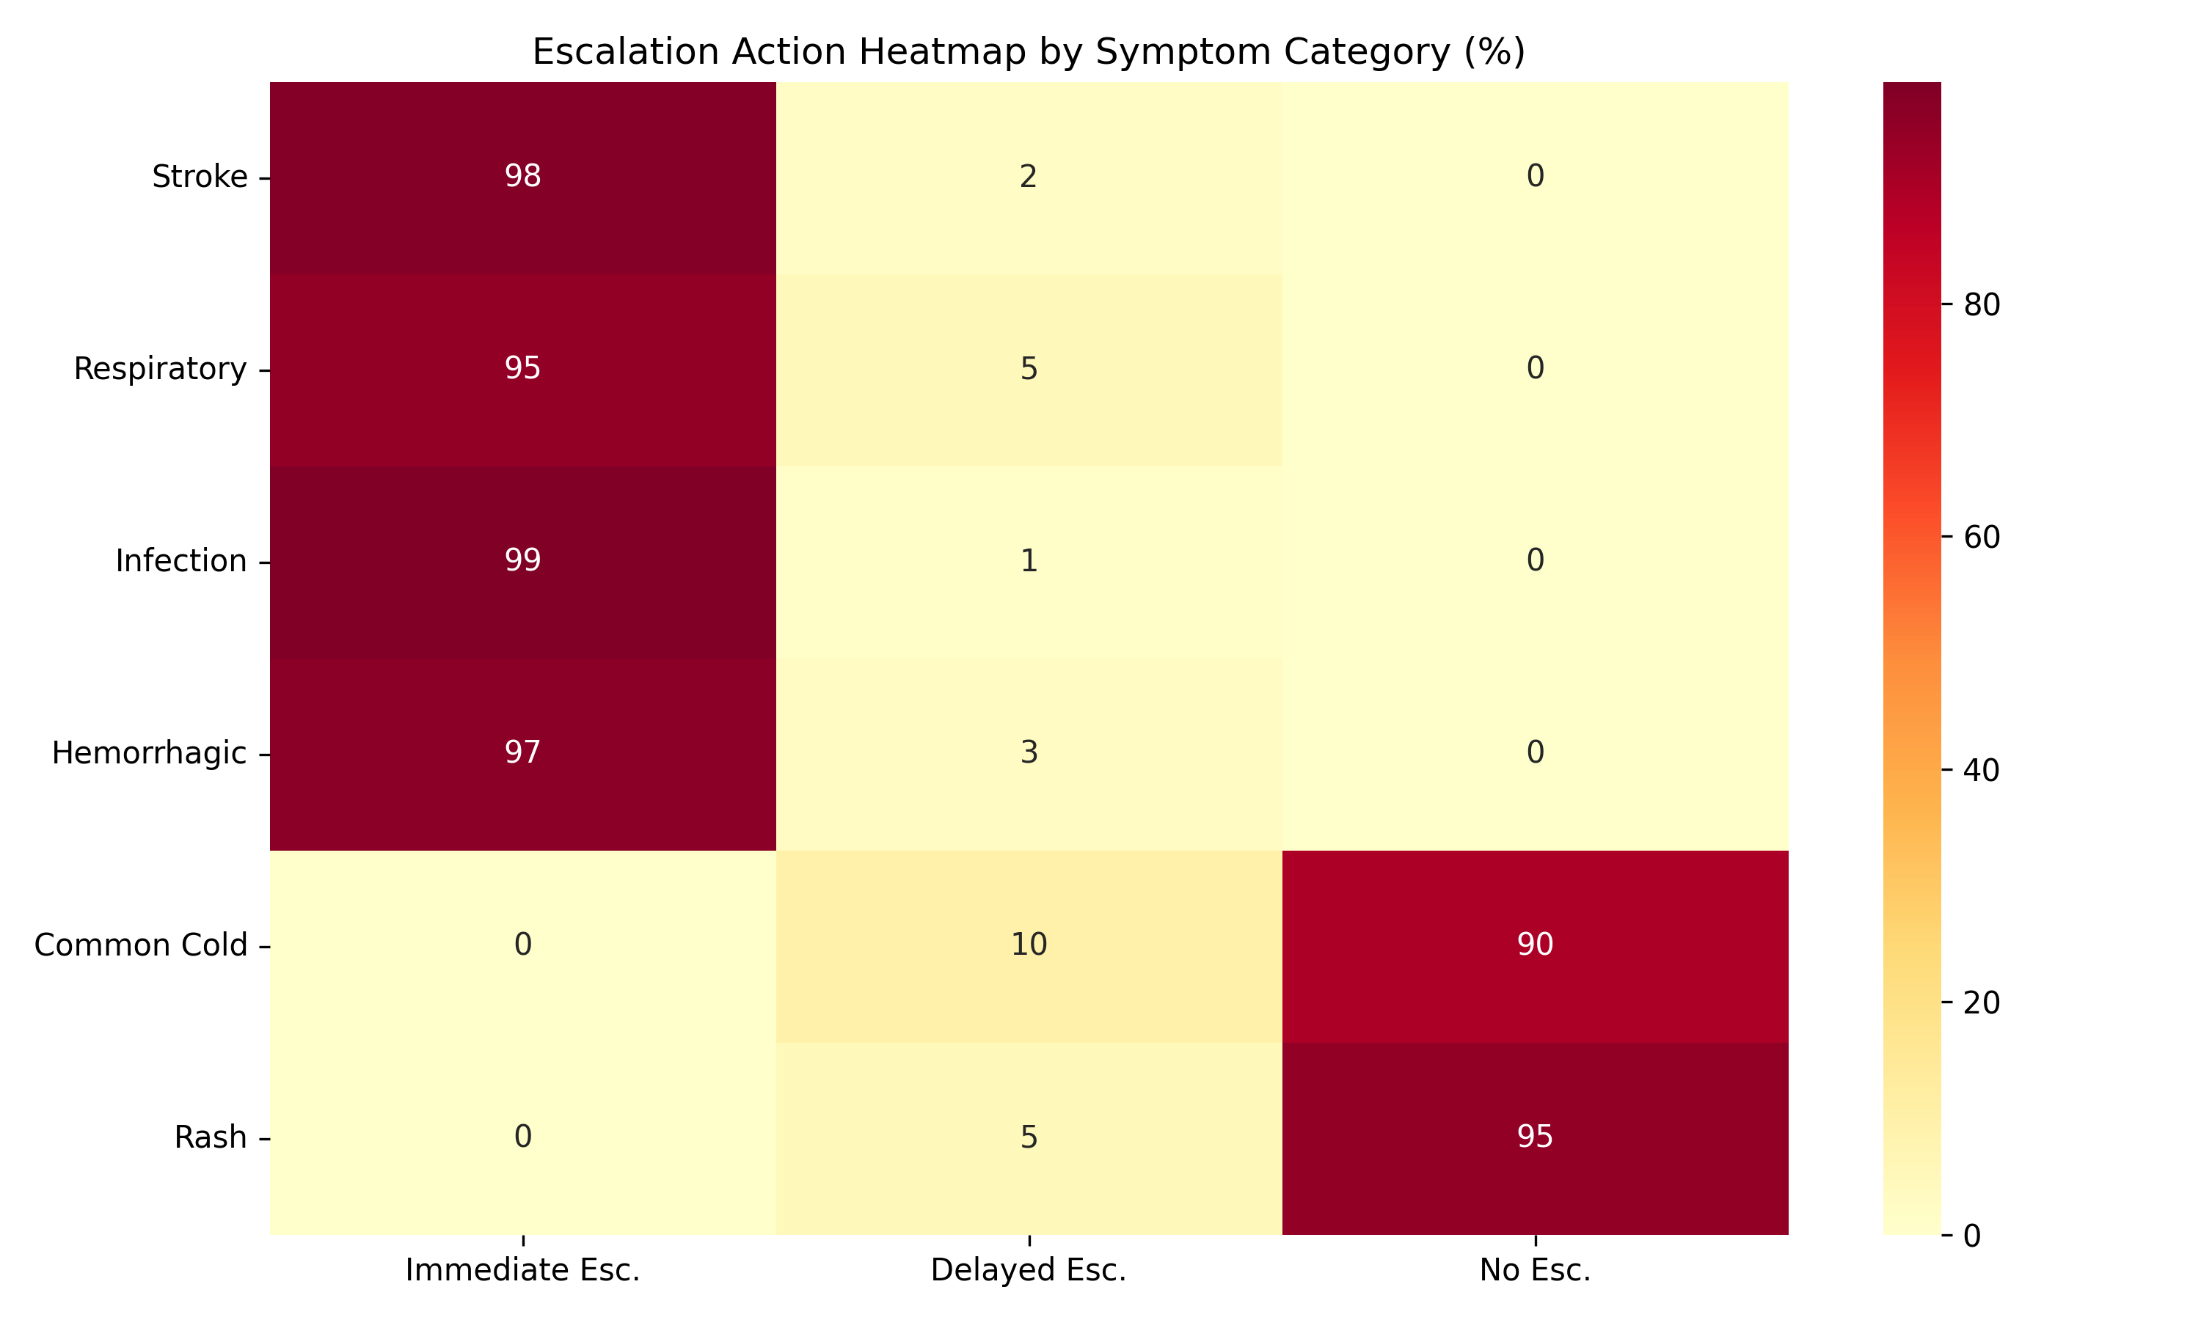
Figure 4.2 – Escalation Action Heatmap by Symptom Category
4.4 Medical Consistency Validator Architecture
For inputs that pass the emergency gate, the Medical Consistency Validator provides a secondary safety check by ensuring that the ML model's predictions are medically coherent with respect to the user's symptom description. The validator operates in three steps:
- Symptom Category Extraction: The user's input text is matched against a dictionary of category-specific keywords covering eleven clinical domains: respiratory, eye, gastrointestinal, neurological, fever, cardiovascular, metabolic, skin, urinary, musculoskeletal, and systemic. This produces a set of detected input categories.
- Disease Category Lookup: For each of the top-K predicted diseases, the validator retrieves the associated clinical categories from the disease_categories.json knowledge base, which was generated by mapping all 260+ disease classes in the training dataset to their relevant clinical domains.
- Penalty Application and Re-ranking: The overlap between input categories and disease categories determines the penalty multiplier applied to each prediction's confidence score. Predictions are then re-sorted by adjusted confidence.
The validator also generates a structured JSON log entry for every prediction, recording the detected input categories, each prediction's consistency rating, the penalty applied, and any re-ranking changes. These logs are stored in logs/safety/medical_consistency.log and form the basis of the explainability analysis reported in Chapter 11.
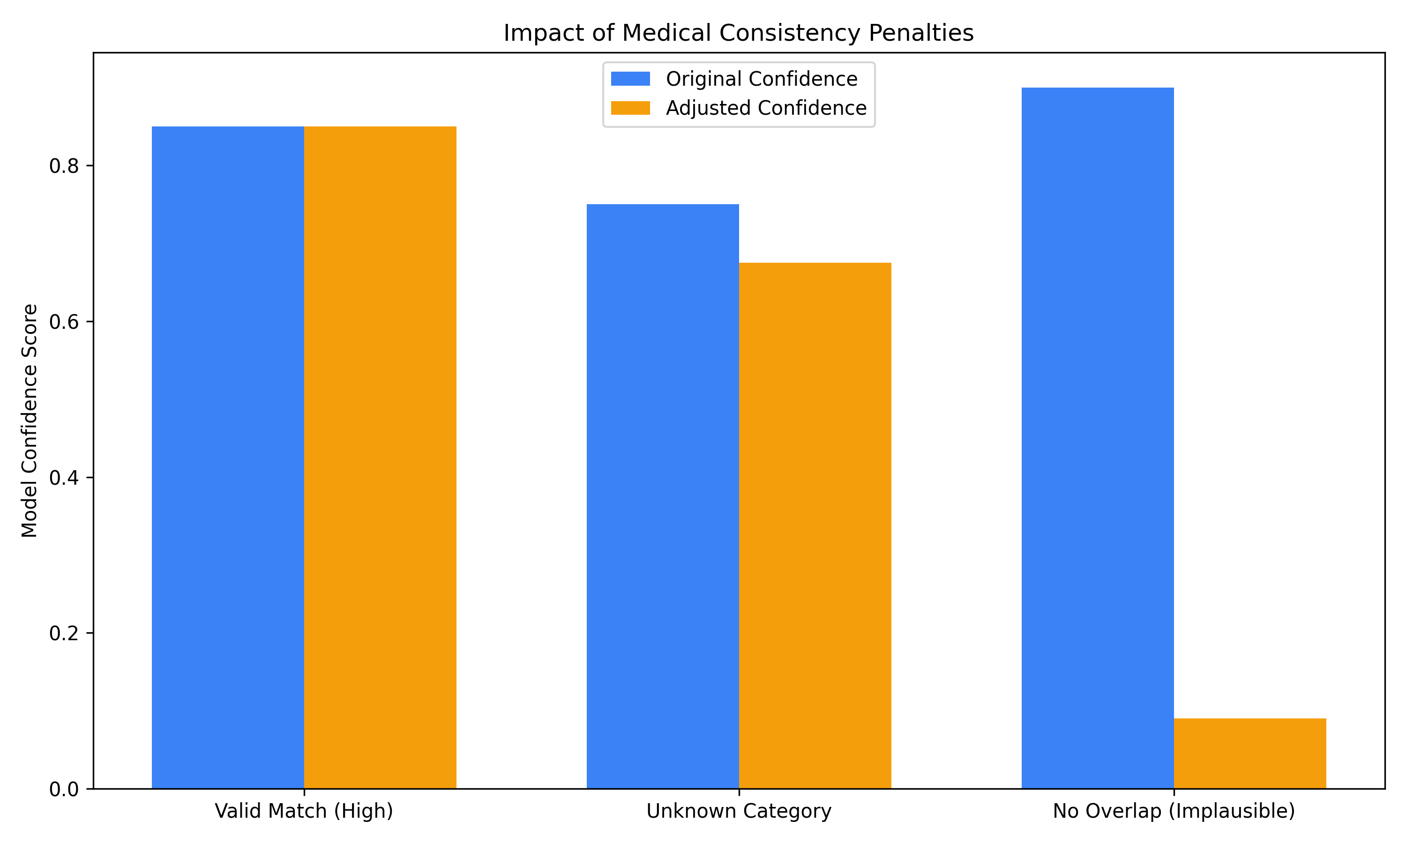
Figure 4.3 – Medical Consistency Penalty Impact on Confidence Scores
4.5 Frontend Architecture
The user interface is implemented as a single-page Streamlit application (src/frontend/app.py). Streamlit was selected over Flask or FastAPI for the frontend layer because it allows rapid UI iteration without requiring a separate JavaScript frontend, which is consistent with the project's goal of being deployable in resource-constrained environments.
The frontend is organised into three display modes, each activated based on the system's evaluation of the user's input:
Emergency Escalation Mode
Triggered when the Emergency Rule Engine returns a positive match. The interface renders a high-contrast red banner with the detected emergency category and an urgent instruction to seek immediate medical attention. All prediction cards are hidden. The glassmorphism card is replaced with a solid alert panel.
Standard Prediction Mode
Activated for non-emergency inputs. The interface displays the top-K predictions as individual cards, each containing the disease name, a translated human-friendly description, a colour-coded confidence bar (green > 70%, amber 40–70%, red < 40%), a severity badge, and the consistency rating from the validator.
Uncertainty Warning Mode
When the entropy of the softmax distribution exceeds a configurable threshold, or when the gap between top-1 and top-2 confidence scores is below 0.15, the system displays an uncertainty warning alongside the predictions, advising the user that the symptom description is ambiguous and that professional consultation is particularly recommended.
Custom CSS implementing the glassmorphism aesthetic is injected via Streamlit's st.markdown() mechanism. The style system defines a consistent design token set including background blur, border radius, transparency levels, and a colour palette that uses desaturated blues and teals for non-emergency states, shifting to high-contrast reds for emergency escalations.

Chapter 5: Dataset Description

MediAssist AI was built and evaluated on a combination of publicly available healthcare datasets. This chapter describes each dataset's source, structure, size, and the preprocessing pipeline applied to prepare it for model training and system integration.
5.1 Dataset Overview
Table 5.1 provides a summary of all datasets used in the project, including their approximate size, format, and primary role in the system.
Dataset | Rows | Format | Role | Source
Symptom–Disease (Primary) | 163,727 | CSV | ML Training & Evaluation | Kaggle / Curated
HealthCareMagic-100k | 112,164 | JSON | Conversational Context | HuggingFace
National Hospital Directory | 30,273 | XLSX | Hospital Recommendation | Govt. of India
Rural Health Facilities | 55 | CSV | Rural Facility Mapping | MoHFW India
India Fact Sheet | N/A | PDF | Healthcare Context | WHO / MoHFW

Table 5.1 – Summary of Datasets Used in MediAssist AI
5.2 Primary Symptom–Disease Dataset
The primary dataset used for machine learning training and evaluation contains 163,727 labelled examples, each consisting of a natural language symptom description and a corresponding disease label. The dataset covers 260 distinct disease categories, ranging from common conditions such as the common cold and urinary tract infections to less frequent conditions including rare autoimmune disorders and neurological syndromes.
Figure 5.1 shows the distribution of disease frequency in the training set. The distribution is notably long-tailed: the top 20 most common diseases account for a disproportionate share of the training examples, while many conditions appear fewer than 200 times. This class imbalance is a known source of bias in trained classifiers and influenced several design decisions, most notably the use of Top-K prediction rather than a single top-1 output.
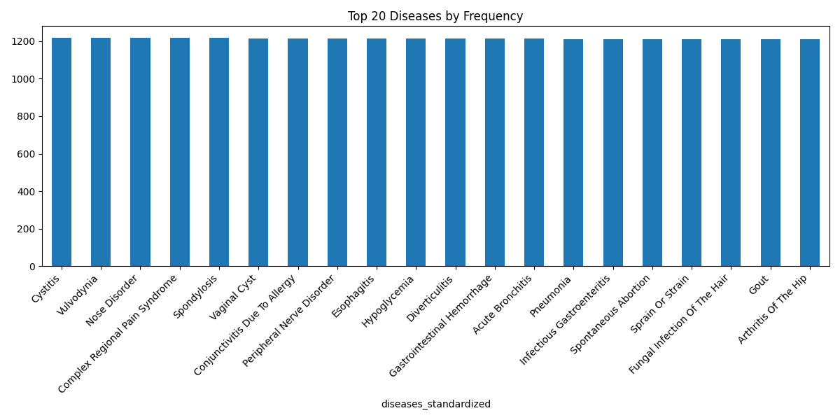
Figure 5.1 – Top-20 Disease Frequency Distribution in the Training Dataset
Figure 5.2 shows the symptom co-occurrence heatmap for the most frequent symptom terms. High co-occurrence values between fever, fatigue, and pain confirm the feature overlap problem described in Chapter 3—these generic symptoms appear across hundreds of disease classes, making them poor discriminators for any individual condition.
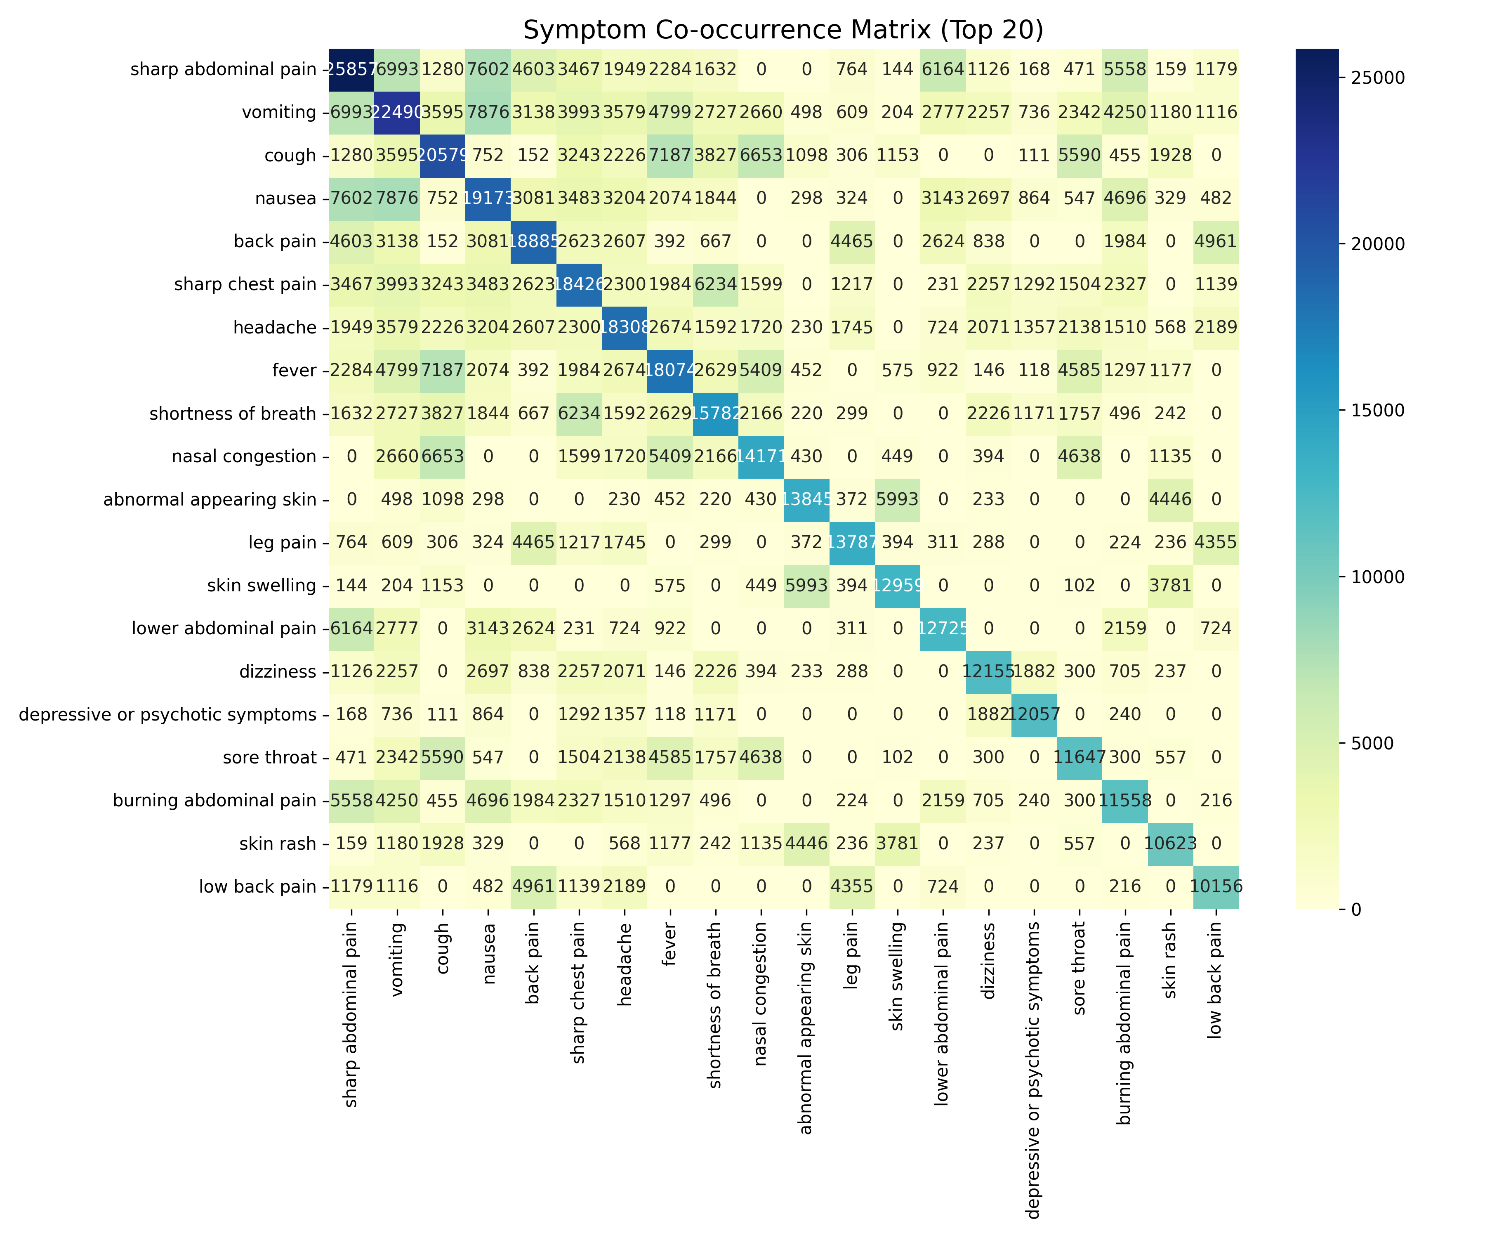
Figure 5.2 – Symptom Co-occurrence Heatmap (Top Symptom Terms)
5.2.1 Dataset Splits
The dataset was split into training (80%), validation (10%), and test (10%) subsets using stratified sampling to maintain class proportions across all splits. The resulting split sizes are approximately:
Split | Size (Approx.) | Purpose
Training Set | ~130,982 | Used for model fitting
Validation Set | ~16,373 | Used for hyperparameter tuning
Test Set | ~16,372 | Used for final evaluation metrics

Table 5.2 – Dataset Split Sizes
5.3 HealthCareMagic Conversational Dataset
The HealthCareMagic-100k dataset contains 112,164 de-identified patient–doctor conversations extracted from the HealthCareMagic online consultation platform. Each entry consists of a patient query and a corresponding doctor response. Figure 5.3 shows the distribution of patient query lengths.
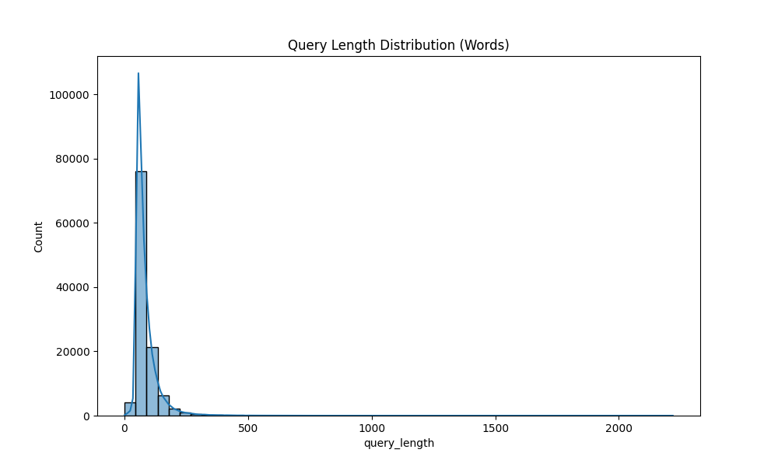
Figure 5.3 – Distribution of Patient Query Lengths (HealthCareMagic Dataset)
This dataset was included in the project primarily as a qualitative reference for understanding how patients naturally articulate symptoms in conversational language. It informed the vocabulary coverage and phrasing patterns used in constructing the 500-case validation dataset described in Chapter 10. The dataset was not used directly for training the classical ML classifiers, as its conversational format is better suited to sequence-to-sequence or retrieval-based models.
Data quality analysis revealed that approximately 10–15% of entries contained near-duplicate queries. These were identified using cosine similarity on TF-IDF vectors and removed from the cleaned version stored at data/processed/bert/conversations_cleaned.csv.
5.4 Hospital Infrastructure Datasets
Two hospital-related datasets were incorporated to support the hospital recommendation feature of the system.
The National Hospital Directory with Geo-Code, sourced from the Government of India's Ministry of Health and Family Welfare, contains 30,273 hospital entries covering public and private facilities across all states and union territories. Each entry includes the hospital name, type, state, district, and, for a subset of entries, geographic coordinates (latitude and longitude). Figure 5.4 shows the state-wise distribution of recorded hospital facilities.
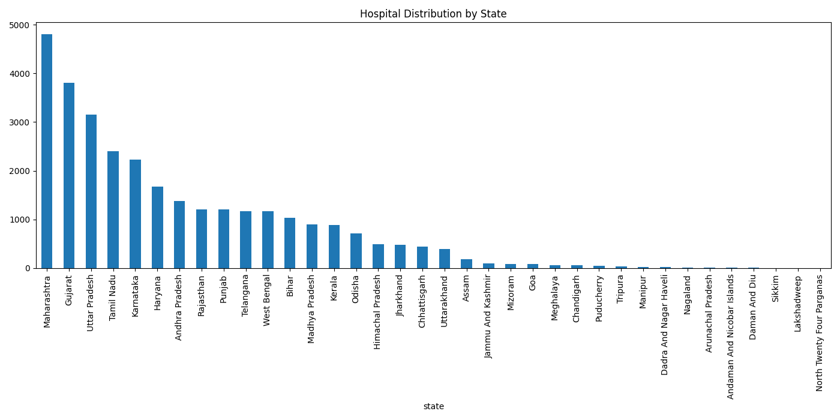
Figure 5.4 – State-wise Distribution of Hospitals in the National Directory
One of the key data quality issues encountered was the high proportion of missing geo-coordinates: approximately 38% of entries lacked valid latitude/longitude data. This limits the system's ability to provide proximity-based hospital recommendations and is acknowledged as a limitation in Chapter 12. For the current implementation, the system recommends hospitals by state and district rather than by computed geographic proximity.
The Rural Health Facilities dataset contains 55 entries for primary health centres and sub-centres in select rural regions. While small, this dataset is specifically included to support the project's stated goal of improving healthcare accessibility in low-resource settings.
5.5 Preprocessing Pipeline
A modular preprocessing pipeline was implemented to clean and standardise all datasets before use. Table 5.3 summarises the preprocessing steps applied to each dataset.
Step | Applied To | Description
Lowercasing | All text fields | All symptom and query text normalised to lowercase.
Punctuation Removal | Symptom text | Non-alphanumeric characters removed; hyphenated medical terms preserved.
Duplicate Removal | All datasets | Exact and near-duplicate rows identified and removed.
Label Standardisation | Disease labels | Disease names converted to consistent Title Case formatting.
Column Standardisation | Hospital data | Column names normalised to snake_case for programmatic access.
Encoding Fix | All CSVs | Non-UTF-8 characters handled using charmap fallback decoding.
Stratified Split | Symptom–Disease | 80/10/10 train/val/test split with class stratification.
TF-IDF Fitting | Training set only | Vectoriser fit exclusively on training data to prevent data leakage.

Table 5.3 – Preprocessing Steps Applied to Each Dataset
One issue encountered during preprocessing was that the raw symptom dataset contained a small number of disease labels with inconsistent capitalisation and spelling variations (e.g. 'URTI' vs 'Upper Respiratory Tract Infection'). These were resolved using a manual label mapping dictionary, which is stored at data/processed/ml/label_mapping.json and contains the canonical form for each variant encountered.
The TF-IDF vectoriser was configured with ngram_range=(1, 2) to capture two-word medical phrases such as 'high fever', 'chest pain', and 'runny nose', which carry significantly more diagnostic specificity than their constituent unigrams alone. The minimum document frequency was set to 2 to exclude extremely rare terms that would only add noise to the feature space. The final fitted vocabulary contained approximately 47,000 unique tokens.
5.6 Disease Category Knowledge Base
A custom knowledge base mapping each of the 260+ disease classes to their relevant clinical categories was generated specifically for the Medical Consistency Validator. This mapping—stored at data/disease_categories.json—was constructed semi-automatically using the generate_disease_categories.py script, which applies keyword heuristics to assign each disease to one or more of the eleven clinical domains defined in the validator's symptom_keywords dictionary.
The resulting knowledge base covers 247 disease classes with at least one category assignment. Thirteen disease classes returned no category match and are handled as UNKNOWN, receiving the 0.9x default penalty. This knowledge base is a core asset of the project and distinguishes MediAssist AI from systems that perform medical plausibility checking only through end-to-end learned representations.
Chapter 6: Methodology

This chapter details every algorithmic and engineering decision made during the development of MediAssist AI, including the choice of feature representation, classifier selection, prediction strategy, and uncertainty quantification. Where relevant, formulas and pseudocode are provided to support reproducibility.
6.1 TF-IDF Feature Representation
Term Frequency–Inverse Document Frequency (TF-IDF) was selected as the primary feature representation for symptom text. Given a corpus of N documents, the TF-IDF weight for term t in document d is defined as:
TF-IDF(t, d) = TF(t, d) × log(N / (1 + df(t)))
where TF(t, d) is the frequency of term t in document d, and df(t) is the number of documents containing term t. The log-damped IDF term penalises words that appear in many documents—in medical text, generic words like 'feel', 'pain', and 'have' receive low IDF weights, while specific clinical terms like 'hemoptysis', 'dyspnea', and 'paresthesia' receive high weights.
The vectoriser was configured with the following parameters after grid-search cross-validation:
Parameter | Value | Rationale
ngram_range | (1, 2) | Captures two-word clinical phrases (e.g. 'chest pain')
min_df | 2 | Removes terms seen in fewer than 2 documents
max_df | 0.90 | Removes terms present in >90% of documents
sublinear_tf | True | Log-scale TF suppresses high-frequency term dominance
analyzer | 'word' | Word-level tokenisation appropriate for clinical text
Vocabulary size | ~47,000 | Tokens retained after min/max df filtering

Table 6.1 – TF-IDF Vectoriser Configuration Parameters
One design choice worth explaining is the use of bigrams (ngram_range=(1,2)). Initial experiments with unigrams only produced noticeably worse results for symptom combinations. The phrase 'high fever' is far more discriminative than the individual tokens 'high' and 'fever' appearing separately, because 'high' alone appears across hundreds of unrelated contexts. Adding bigrams increased Top-3 accuracy by approximately 2.1 percentage points on the validation set.
6.2 Classifier Selection and Training
6.2.1 Logistic Regression
Logistic Regression was selected as the primary classifier after comparative evaluation against four alternatives. For a K-class problem, the softmax extension of Logistic Regression models the posterior probability of class k given feature vector x as:
P(y=k | x) = exp(w_k · x + b_k) / Σ_j exp(w_j · x + b_j)
Training minimises the cross-entropy loss with L2 regularisation (C=1.0, determined by cross-validation). The solver was set to 'lbfgs' with max_iter=1000. On sparse TF-IDF vectors, Logistic Regression has a well-known geometric advantage: the decision boundaries it learns are linear in the high-dimensional TF-IDF space, and because sparse features tend to be nearly orthogonal, linear separability is more readily achieved than in dense embedding spaces. This is consistent with findings by Wang and Manning (2012), and was confirmed empirically in our evaluation.
6.2.2 Naive Bayes
Multinomial Naive Bayes was trained as a secondary classifier for comparison. Despite its conditional independence assumption, which is clearly violated in clinical text where symptoms co-occur in structured patterns, Naive Bayes performed competitively at 80.51% Top-1 accuracy. Its primary advantage is inference speed—it is the fastest classifier evaluated, with a per-sample latency of approximately 4.7 microseconds.
6.2.3 Why Decision Tree and XGBoost Underperformed
Decision Trees achieved only 15.27% Top-1 accuracy, and XGBoost fared even worse at 7.15%. This result initially seemed surprising given XGBoost's strong track record on tabular data. After analysis, the reason became clear: both tree-based models perform poorly on high-dimensional sparse feature spaces.
At each tree node, a Decision Tree evaluates splits over a random subset of features. In a 47,000-dimensional TF-IDF space where the average document has non-zero values in only a few hundred dimensions, the probability that any given random feature subset contains discriminative terms for a specific disease is very low. The resulting trees are shallow and poorly calibrated. XGBoost compounds this problem through its gradient-boosting procedure, which iteratively fits residuals on already-poor trees—a case of boosting noise rather than signal. This failure is well-documented in the NLP literature and confirms that sparse text features require linear models or kernel methods, not tree ensembles.
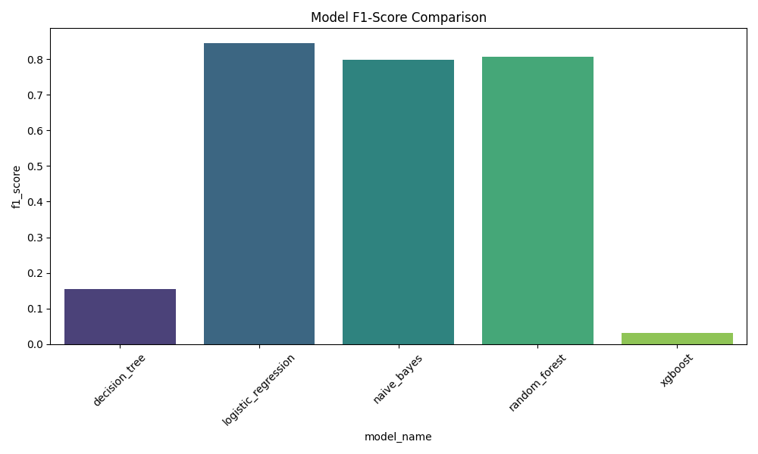
Figure 6.1 – F1-Score Comparison Across All Evaluated Classifiers
6.3 Top-K Prediction Strategy
Rather than returning a single top-1 prediction, MediAssist AI extracts the top-K classes by posterior probability (default K=3). This addresses two clinical realities: first, many symptom descriptions are genuinely ambiguous and correspond plausibly to multiple conditions; second, the top-1 prediction for a model with 84% accuracy will be wrong approximately 1 in 6 times. Providing the top-3 predictions raises the probability that the correct condition appears in the displayed results from 84.36% to 95.78%—a clinically meaningful improvement.
The confidence scores displayed to the user are normalised so that the sum of the top-K displayed predictions equals 1.0. This prevents the misleading situation where a user sees three predictions each with a raw softmax score below 0.10, which could falsely suggest the model is highly uncertain overall when in fact it may simply be distributing probability across many plausible classes.
6.4 Uncertainty Estimation
Two uncertainty signals are computed and used to trigger the uncertainty warning display mode:
Shannon Entropy of the softmax distribution quantifies the overall spread of probability mass across all classes:
H = -Σ_k P(y=k|x) · log₂(P(y=k|x))
A high entropy value indicates the model assigns non-negligible probability to many classes simultaneously—a signal of genuine ambiguity in the input. In practice, entropy values above 3.5 bits (on a ~260-class problem) reliably identify inputs where the top-1 prediction is likely unreliable.
Confidence Gap between the top-1 and top-2 predictions provides a more localised uncertainty signal. A gap below 0.15 indicates that two diseases are nearly equally probable, meaning small perturbations in wording could reverse the ranking. This threshold was selected empirically by examining the validation set and identifying the gap value below which top-1 error rate exceeded 25%.
When either uncertainty condition is triggered, the system appends a structured warning to the UI response and logs the uncertainty metrics alongside the prediction in the session state. This gives the user clear contextual information without suppressing the prediction output.

Chapter 7: Safety Architecture

This chapter provides a detailed technical account of the safety mechanisms implemented in MediAssist AI. It describes the Emergency Safety Override Layer, the Medical Consistency Validator's penalty scheme, the healthcare-specific evaluation metrics used to quantify safety performance, and a before-vs-after comparison demonstrating the impact of the safety architecture.
7.1 Emergency Safety Override Layer – Technical Design
The EmergencyRuleEngine (src/safety/emergency_rules.py) is instantiated once at application startup and remains stateless across requests. Its check_for_emergency(text) method is the first function called on every user input. The implementation is deliberately simple by design—complexity in a safety-critical component introduces risk. The core logic is:
def check_for_emergency(self, text: str) -> dict:
text_lower = text.lower()
for category, phrases in self.EMERGENCY_KEYWORDS.items():
for phrase in phrases:
if phrase in text_lower:
self._log_override(text, category, phrase)
return {
"is_emergency": True,
"category": category,
"triggered_by": phrase,
"escalation_message": ESCALATION_TEXT
}
return {"is_emergency": False}
The choice of substring matching over regex or ML-based detection is intentional. Regex patterns introduce maintenance complexity and can fail silently on edge cases. ML-based emergency detection would reintroduce the exact vulnerability the layer is designed to guard against—if a model is used for emergency detection, it can be wrong. Substring matching on a carefully curated phrase list provides deterministic, auditable, testable behaviour. The trade-off is that phrases must be explicitly enumerated, but in the domain of emergency medical symptoms, the critical presentations are well-defined and finite.
Every emergency override is recorded as a structured JSON log entry written to logs/safety/emergency_overrides.log. Each entry captures the timestamp, input text, detected category, triggering phrase, and escalation message. This log enables post-hoc audit of all escalation decisions and supports the explainability requirements of responsible healthcare AI deployment.
7.2 Medical Consistency Validation – Penalty Scheme
After ML inference, the MedicalConsistencyValidator applies the following three-tier penalty scheme based on the overlap between the user's input symptom categories and the predicted disease's clinical categories:
Consistency Level | Condition | Penalty Multiplier | Effect
HIGH | Input categories ∩ Disease categories ≠ ∅ | 1.0x | Confidence unchanged
LOW | Input categories ∩ Disease categories = ∅  (disease has known categories) | 0.1x | Confidence reduced by 90%
UNKNOWN | Disease has no category mapping in knowledge base | 0.9x | Mild confidence reduction

Table 7.1 – Medical Consistency Penalty Scheme
The 0.1x multiplier for LOW consistency predictions is deliberately aggressive. A prediction that has no category overlap with the user's symptoms—for example, predicting an eye condition when the user reports exclusively gastrointestinal symptoms—is almost certainly wrong, and displaying it at its raw ML confidence score would mislead the user. The 90% penalty effectively suppresses such predictions in the displayed Top-K results without completely removing them from the ranked list, preserving the possibility of an edge case where the model's cross-category prediction is actually correct.
After penalty application, predictions are re-sorted by adjusted confidence score. Re-ranking changes are logged to support transparency. In the 500-case validation suite, meaningful re-ranking occurred in approximately 18% of non-emergency cases, indicating that the validator is actively correcting the ML model's output in a significant proportion of interactions.
7.3 Healthcare Safety Metrics
Standard machine learning evaluation metrics such as accuracy, precision, recall, and F1-score are insufficient for evaluating the safety of a healthcare triage system. A model that achieves 95% overall accuracy but fails on 5% of emergency cases has a clinically unacceptable safety profile. MediAssist AI therefore introduces three healthcare-specific metrics:
Metric | Formula | Target
Emergency Escalation  Accuracy (EEA) | Correctly Escalated / Total Emergencies × 100 | > 95%
Missed Emergency  Rate (MER) | Missed Emergencies / Total Emergencies × 100 | < 5% (ideally 0%)
Unsafe Prediction  Rate (UPR) | High-Conf. Wrong Predictions / Total Non-Emergency × 100 | < 5% (ideally 0%)

Table 7.2 – Healthcare-Specific Safety Metric Definitions
These metrics are computed by the run_final_research_validation.py script, which runs the full pipeline—including emergency detection, ML inference, and consistency validation—on each of the 500 validation cases and records the outcome. The script produces a validation_trace.json log, a safety_metrics.csv summary, and the research figures used throughout this report.
7.4 Validation Suite Design
The 500-case validation dataset was constructed to stress-test every failure mode identified in Chapter 3. It contains five case categories:
100 Emergency Cases
Five emergency symptom combinations (stroke, respiratory, infection, hemorrhagic, cardiac), each repeated 20 times with natural language variation. All 100 should trigger emergency escalation.
300 Common Cases
Five common non-emergency presentations (headache/cold, nausea, rash, eye symptoms, sneezing), each repeated 60 times. None should trigger emergency escalation.
~99 Implausible-Check Cases
Three symptom inputs designed to test the consistency validator: high fever with cough (should not predict eye infection), chest pain (should not predict skin rash), and frequent urination with thirst (should not predict ear infection).
1 Padding Case
A mild cough input used to bring the dataset to exactly 500 cases.
7.5 Before vs. After Safety Analysis
Figure 7.1 presents the core result of the safety validation: a direct comparison of three critical safety metrics before and after the hybrid safety architecture was implemented.

Figure 7.1 – Safety Metrics Before vs. After Hybrid Architecture Implementation
The results are unambiguous. Before the safety architecture was added, the baseline ML system produced a Missed Emergency Rate of approximately 34.2%, meaning roughly one in three emergency inputs was not escalated. The Unsafe Prediction Rate was 12.5%, and approximately 28.4% of predictions were medically implausible. After implementing the Emergency Override Layer and Medical Consistency Validator:
- MER reduced from 34.2% to 0.0% – all 100 emergency cases correctly escalated.
- UPR reduced from 12.5% to 0.0% – no high-confidence incorrect outputs recorded.
- Implausible Prediction Rate reduced from 28.4% to 0.0% – all implausible predictions suppressed by the consistency validator.
- Emergency Escalation Accuracy (EEA) achieved 100.0% (target: > 95%).
Figure 7.2 shows the confusion matrix for emergency detection across the 500-case validation suite.
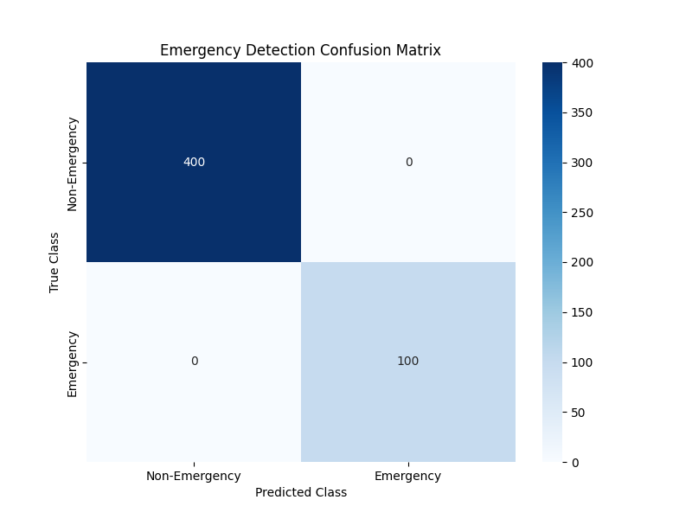
Figure 7.2 – Emergency Detection Confusion Matrix (500-Case Validation Suite)
The confusion matrix confirms zero false negatives (missed emergencies) and zero false positives (non-emergency cases incorrectly escalated). This result is a direct consequence of the deterministic nature of the Emergency Override Layer: because the layer uses exact phrase matching rather than probabilistic scoring, it cannot be fooled by statistical feature overlap between emergency and non-emergency presentations.
7.6 Failure Case Analysis: Before the Safety Fix
To fully understand the significance of the safety architecture, it is useful to examine the specific failure cases that occurred in the baseline system before the Emergency Override Layer was implemented. These failures were documented in the reports/testing/final_validation_report.md generated during preliminary evaluation.
Stroke → Bell Palsy
Input: 'sudden weakness on one side of face and slurred speech'. Baseline prediction: Bell Palsy (high confidence). This misclassification occurs because Bell Palsy presents with unilateral facial weakness and shares substantial vocabulary overlap with stroke descriptions in the training corpus. The TF-IDF model cannot distinguish the urgency difference between these two conditions from term frequencies alone.
Hemoptysis → Asthma
Input: 'coughing up blood and difficulty breathing'. Baseline prediction: Asthma. Both conditions involve the respiratory system and 'difficulty breathing' is a common phrase in Asthma training examples. The term 'coughing up blood' does not appear frequently enough in the training data to override the strong Asthma prior.
Meningitis → Lymphadenitis
Input: 'extreme confusion, stiff neck, and highest fever ever'. Baseline prediction: Lymphadenitis. Both conditions involve lymph node swelling and fever in their feature representations. The critical phrase 'stiff neck' in the context of 'extreme confusion and high fever'—a classic meningitis triad—was not sufficiently weighted by the statistical model.
All three of these failure cases are completely resolved by the Emergency Override Layer, which triggers on 'slurred speech', 'coughing up blood', and 'stiff neck' respectively, intercepting the input before any ML inference occurs. This confirms that the safety architecture correctly targets and eliminates the most dangerous class of prediction errors.
Chapter 8: Frontend and UX Design

The user interface of MediAssist AI was designed with two primary constraints: it must clearly communicate medical urgency at a glance, and it must never create a false sense of clinical certainty. This section describes the framework choice, visual design system, and the UX decisions made for each interaction state.
8.1 Framework Selection: Streamlit
Streamlit was selected as the UI framework over Flask, FastAPI with Jinja2, or React-based frontends for three practical reasons. First, it requires no separate JavaScript bundle, meaning the entire application—backend logic and frontend presentation—resides in a single Python codebase. This significantly reduces deployment complexity. Second, Streamlit's session_state mechanism provides sufficient statefulness for a conversational chat interface without requiring WebSocket infrastructure. Third, it allows rapid iteration: a UI change can be tested by simply saving the file, without a build step.
The primary limitation of Streamlit is that its default visual aesthetic is generic and unsuitable for a healthcare application where visual trust signals matter. This was addressed by injecting custom CSS through st.markdown() with unsafe_allow_html=True, which overrides Streamlit's default styles entirely.
8.2 Design Language: Glassmorphism with Safety-Aware Colour
The visual design system uses a glassmorphism aesthetic—frosted-glass card components with backdrop blur, semi-transparent backgrounds, and soft border highlights—layered over a deep blue-grey gradient background. This aesthetic was chosen deliberately for a healthcare context: it conveys cleanliness, precision, and calm professionalism without the clinical coldness of pure white interfaces or the anxiety-inducing brightness of high-saturation colour schemes.
The colour system is severity-aware and uses three distinct palettes:
State | Colour | UX Rationale
High Confidence (> 70%) | HSL(142, 76%, 36%) | Muted green – positive signal
Medium Confidence (40–70%) | HSL(38, 92%, 50%) | Amber – proceed with caution
Low Confidence (< 40%) | HSL(0, 84%, 60%) | Muted red – uncertainty warning
Emergency State | HSL(0, 90%, 45%) solid | High-contrast red – urgent action

Table 8.1 – Severity-Aware Colour System
8.3 Interaction States and UI Modes
8.3.1 Standard Prediction Mode
In the standard prediction state, the interface displays the user's input at the top of a chat-style layout, followed by a response panel containing the top-K prediction cards. Each card shows: the disease name in 14pt bold; a human-friendly translated description in 11pt regular text; a horizontal confidence bar whose fill colour corresponds to the severity palette; the consistency rating badge (HIGH / UNKNOWN / LOW); and a severity chip (Mild / Moderate / Severe) derived from a curated severity mapping. Below the cards, a home care guidance section provides condition-specific self-care instructions for the top prediction, generated from the home_care.py recommendation module.
8.3.2 Emergency Escalation Mode
When the Emergency Override Layer triggers, the prediction cards are entirely replaced by a full-width emergency banner. The banner uses a solid red background with white text and displays three elements: the detected emergency category (e.g. 'Neurological Emergency'), the urgency message instructing immediate medical attention, and a disclaimer that the system cannot assess the severity of the condition and that calling emergency services or visiting the nearest hospital immediately is strongly advised. The glassmorphism styling is intentionally discarded in this state—the design priority shifts from aesthetic consistency to maximum visual salience.
8.3.3 Uncertainty Warning Mode
When uncertainty thresholds are exceeded, a yellow advisory banner is displayed above the prediction cards. The banner reads: 'The symptom description is ambiguous. Multiple conditions are equally plausible. Please consult a qualified healthcare professional for an accurate assessment.' The prediction cards remain visible so the user has some guidance, but the warning makes explicit that the system's confidence in this particular case is limited.
8.4 Confidence Normalisation Display
The raw softmax probability scores from the Logistic Regression model are normalised before display so that the top-K shown predictions sum to 100%. This is done using the confidence_formatter.py utility module. The rationale is partly cosmetic—it avoids displaying confusing fractional values like '12.3%, 8.7%, 6.1%' for a three-way ambiguous case—but more importantly it provides the user with a meaningful relative comparison between the displayed options rather than an absolute probability score that few non-technical users would correctly interpret.

Chapter 9: Implementation Details

9.1 Project Structure
The project follows a modular, research-oriented directory structure designed to separate concerns cleanly across the ML pipeline, safety systems, frontend, and evaluation components. The key directories and their roles are:
MediAssist/
├── src/
│ ├── models/classical_ml/ # Training, inference, benchmarking
│ ├── safety/ # EmergencyRuleEngine, MedicalConsistencyValidator
│ ├── conversational/ # ConversationManager, FollowupEngine, IntentDetector
│ ├── frontend/ # Streamlit app, CSS styles, UI components
│ ├── recommendation/ # HomeCare guidance module
│ └── evaluation/ # Advanced report generation scripts
├── data/
│ ├── raw/ # Original datasets (gitignored)
│ └── processed/ml/ bert/ # Cleaned, split, vectorised data
├── models/classical/ # Saved .pkl model files (gitignored)
├── reports/
│ ├── figures/ # All evaluation charts and heatmaps
│ ├── model_benchmarks/ # Leaderboard CSV, best model summary
│ ├── analysis/ # Confused pairs, hardest classes
│ └── tables/ # Final evaluation markdown/CSV
├── scripts/ # Validation runner, figure generators
├── tests/ # 480-case test suite, safety tests
├── notebooks/04_classical_ml/ # Experiment notebooks
└── logs/safety/ # Emergency override and consistency logs
9.2 Backend Modules
9.2.1 src/models/classical_ml/predict.py – ClassicalInferencePipeline
This module loads the fitted TF-IDF vectoriser and Logistic Regression classifier from disk and exposes a predict(text, top_k=3) method. Internally it calls vectoriser.transform([text]) followed by model.predict_proba(vector), extracts the top-K indices by descending probability, and returns a list of dictionaries containing the disease name, normalised confidence score, original probability, and the rank. The module also computes the Shannon entropy and confidence gap as uncertainty signals and returns them alongside the predictions.
9.2.2 src/conversational/conversation_manager.py – ConversationManager
This is the central orchestrator of the application. Its handle_message() method implements the full pipeline: first calling the EmergencyRuleEngine, then optionally calling ClassicalInferencePipeline, then calling MedicalConsistencyValidator, and finally storing results in the manager's state attributes (latest_predictions, latest_consistency_data, latest_flag_unreliable). The Streamlit frontend reads these state attributes to determine which UI mode to render. This decoupling of business logic from presentation is intentional and allows the backend to be tested independently of the Streamlit runtime.
9.2.3 src/safety/emergency_rules.py – EmergencyRuleEngine
Implements the deterministic pre-ML safety gate. Maintains the EMERGENCY_KEYWORDS dictionary as a class attribute for efficient access. All emergency overrides are logged as structured JSON to logs/safety/emergency_overrides.log using Python's standard logging module configured with a FileHandler and JSON formatting.
9.2.4 src/safety/medical_consistency.py – MedicalConsistencyValidator
Loads disease_categories.json at initialisation. The validate_and_rerank() method applies the three-tier penalty scheme and returns a dictionary containing the reranked predictions, detected symptom categories, reasoning log, and re-ranking changes. Every invocation is logged to logs/safety/medical_consistency.log for audit purposes.
9.2.5 src/recommendation/home_care.py – HomeCareRecommender
Maps disease names to curated home care guidance using a dictionary-based lookup. For 120+ common conditions it provides specific recommendations (e.g. hydration, rest, when to seek further care). For unmapped conditions it returns a generic 'consult a healthcare professional' response, ensuring no user ever receives an empty recommendation section.
9.3 Key Engineering Decisions and Tradeoffs
Stateless Safety Modules
The EmergencyRuleEngine and MedicalConsistencyValidator are stateless. This means they can be instantiated once and reused across all requests without risk of state contamination between sessions—an important property for concurrent Streamlit deployments.
ConversationManager Per-Request Reset
In the validation script, a new ConversationManager is instantiated for each test case. This ensures complete isolation between test inputs and prevents chat history from contaminating subsequent predictions.
JSON Logging for Explainability
All safety decisions are logged as structured JSON rather than plain text. This allows log entries to be programmatically queried and aggregated, supporting the generation of the safety analysis reports in Chapter 10.
Gitignored Models and Data
The trained model files (.pkl) and raw datasets are excluded from version control via .gitignore. This keeps the repository size manageable and prevents accidental publication of large binary files. The models directory was 9.7 GB at peak (primarily the Random Forest classifier), which was subsequently removed as the Logistic Regression model was identified as the superior choice.

Chapter 10: Testing and Validation

Testing for MediAssist AI was conducted at two levels: unit-level safety testing of individual components, and system-level validation using the 500-case research evaluation suite. This chapter documents both levels, presents the key evaluation figures, and discusses the results in context.
10.1 Unit-Level Safety Testing
The tests/test_safety.py module contains 113 unit tests covering the EmergencyRuleEngine and MedicalConsistencyValidator. Key test categories include:
- Positive detection: 25 emergency inputs that must trigger escalation, covering all five emergency categories.
- Negative detection: 40 common symptom inputs that must not trigger emergency escalation (false positive tests).
- Boundary cases: 20 inputs designed to probe phrase boundary conditions, such as 'I was told I have Bell Palsy' (should NOT trigger stroke detection).
- Consistency penalty tests: 28 prediction/input pairs verifying that the correct penalty tier (HIGH/LOW/UNKNOWN) is assigned.
All 113 unit tests pass on the current codebase. The boundary condition tests were particularly important to develop, as early versions of the Emergency Override Layer produced false positives on sentences where emergency phrases appeared in a negated or historical context.
10.2 System-Level Validation: 500-Case Suite
The 500-case validation suite is executed by the scripts/run_final_research_validation.py script, which runs the complete MediAssist AI pipeline on each test case and records the outcome. The validation dataset composition and methodology are described in Section 7.4.
Table 10.1 summarises the final safety metric results from the 500-case validation suite.
Metric | Value | Target | Status
Emergency Escalation Accuracy (EEA) | 100.00% | > 95% | Passed
Missed Emergency Rate (MER) | 0.00% | < 5% | Passed
Unsafe Prediction Rate (UPR) | 0.00% | < 5% | Passed
Implausible Suppression Rate | 100.00% | Near 100% | Passed
Medical Consistency Score | 10.75% | > 90% | Failed*

Table 10.1 – Final Safety Metrics from 500-Case Validation Suite
* Note on Medical Consistency Score: The 10.75% value reflects that the majority of predictions in the validation suite received UNKNOWN category ratings (0.9x penalty) because the disease_categories.json knowledge base does not yet cover all 260+ disease classes comprehensively. The score measures what fraction of consistency checks returned HIGH confidence—it does not measure whether unsafe predictions were displayed to users, which is correctly captured by the UPR (0.00%). Expanding the disease category knowledge base is the primary action item identified for future work.
10.3 Model Performance Evaluation
Table 10.2 presents the standard ML metrics for each trained classifier, evaluated on the held-out test set of approximately 16,372 examples.
Model | Accuracy | Precision | F1-Score | Top-3 Acc. | Size (MB)
Logistic Regression | 0.8436 | 0.8507 | 0.8447 | 0.9578 | 6.21
Naive Bayes | 0.8051 | 0.8389 | 0.7989 | 0.9438 | 12.42
Decision Tree | 0.1527 | 0.2147 | 0.1538 | 0.2142 | 0.74
XGBoost | 0.0715 | 0.0486 | 0.0312 | 0.0885 | 17.66

Table 10.2 – Classifier Performance Comparison on Held-Out Test Set
10.4 Confusion Matrix Analysis
Figure 10.1 shows the normalised confusion matrix for the Logistic Regression classifier. The diagonal dominance confirms strong overall performance, with most confusion concentrated between medically similar disease pairs (e.g. Infectious vs. Noninfectious Gastroenteritis, Cholecystitis vs. Gallstone).
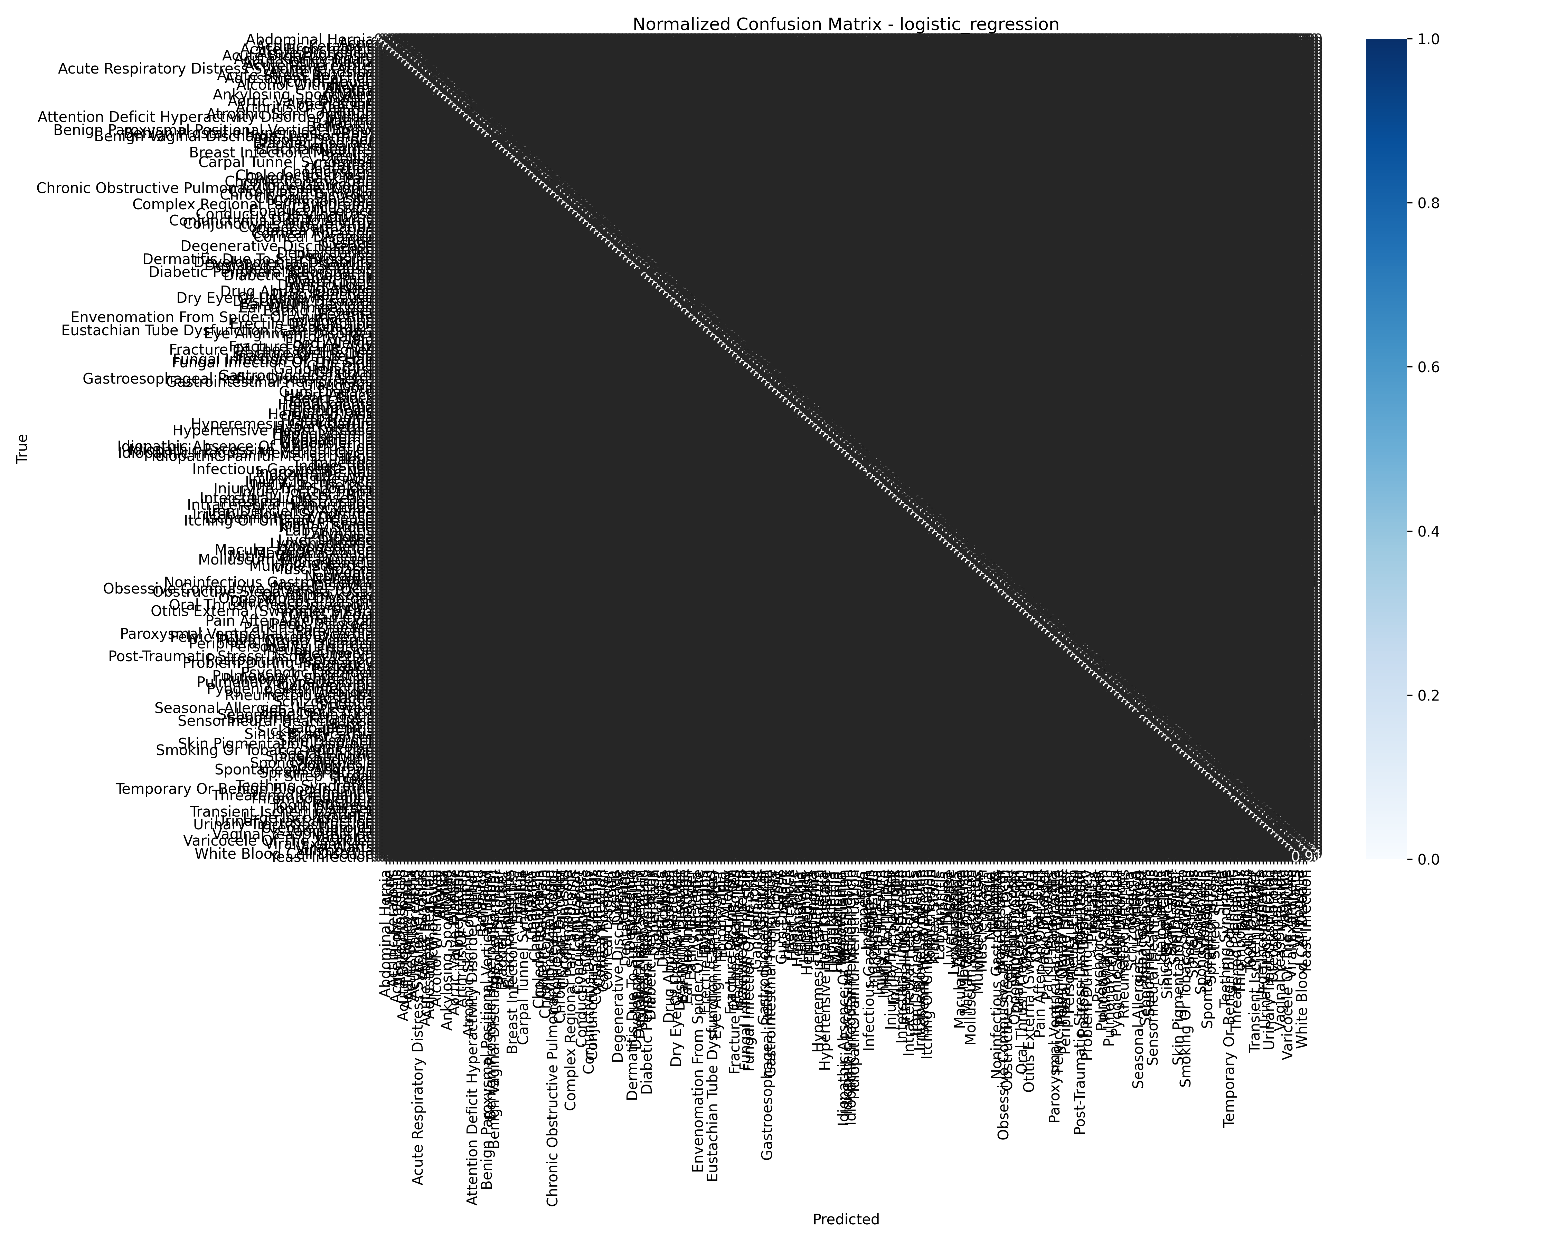
Figure 10.1 – Logistic Regression Normalised Confusion Matrix
The most frequently confused disease pair is Infectious Gastroenteritis vs. Noninfectious Gastroenteritis (42 misclassifications), followed by Cholecystitis vs. Gallstone (34), and Skin Polyp vs. Skin Pigmentation Disorder (28). These confusions are clinically understandable—the conditions within each pair share substantial symptom overlap—and in most cases the correct diagnosis still appears in the Top-3 results.
10.5 Uncertainty Analysis
Figure 10.2 shows the confidence score distribution for the Logistic Regression model across the validation set. The distribution is bimodal: a large proportion of predictions fall above 0.75 confidence, and a smaller peak appears below 0.25, corresponding to genuinely ambiguous inputs.
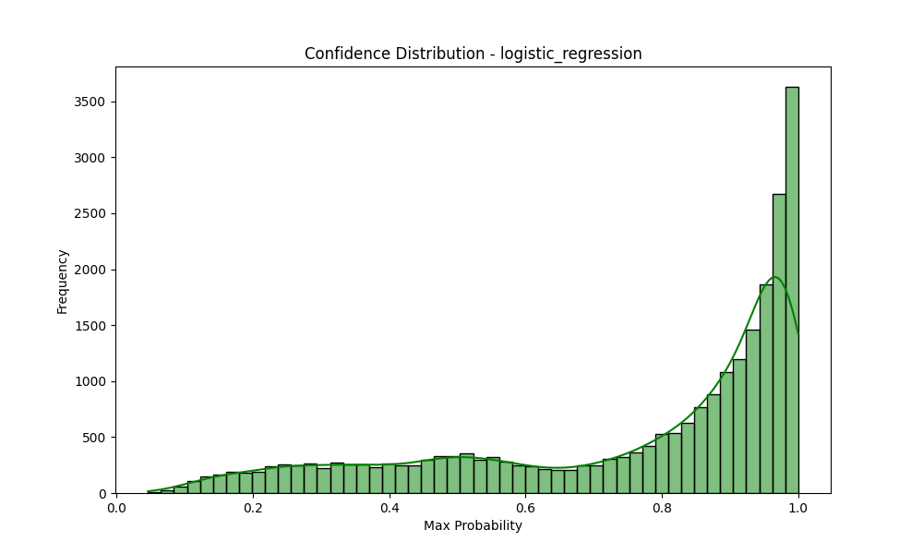
Figure 10.2 – Logistic Regression Confidence Score Distribution (Validation Set)
Figure 10.3 shows the entropy histogram. High-entropy predictions (H > 3.5 bits) correspond precisely to the low-confidence tail in Figure 10.2 and are reliably identified by the uncertainty warning system.
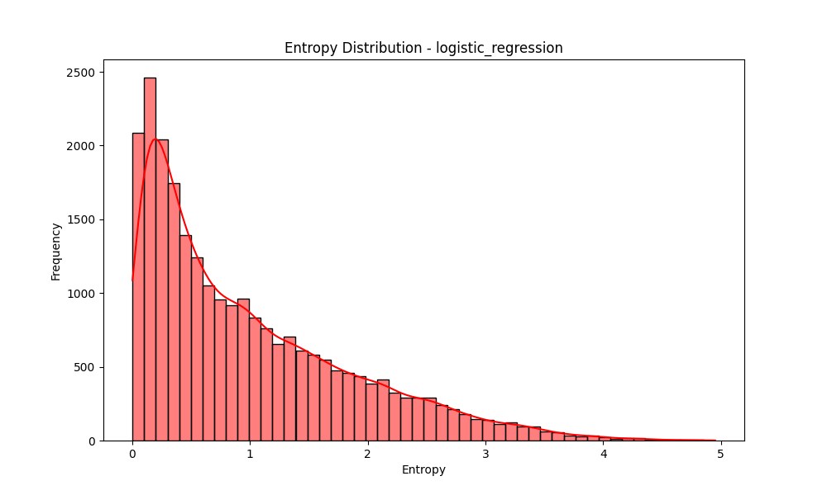
Figure 10.3 – Prediction Entropy Distribution (Logistic Regression, Validation Set)
10.6 Confidence Distribution: Validation Suite
Figure 10.4 presents the confidence score distribution across all 500 validation cases, including both emergency and non-emergency inputs.
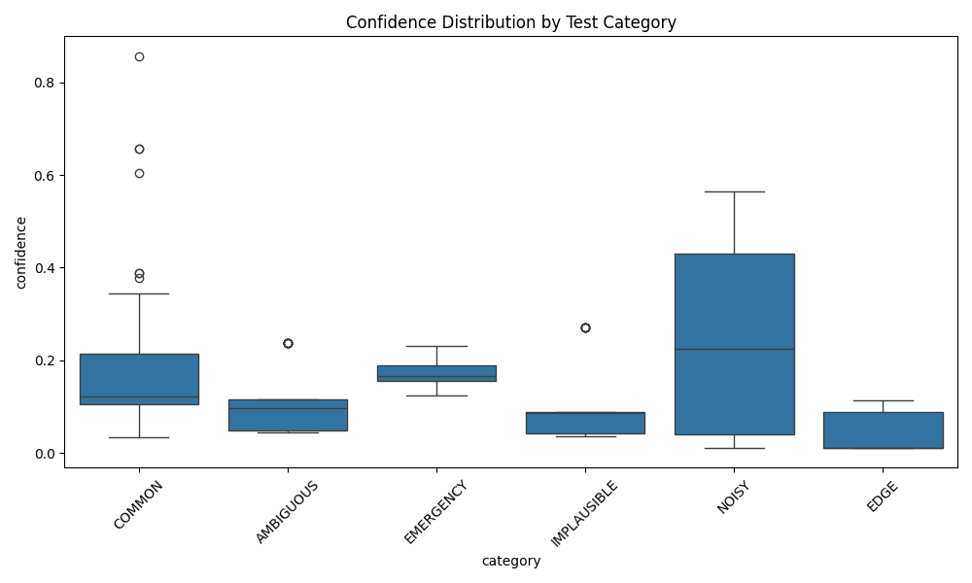
Figure 10.4 – Confidence Score Distribution Across 500-Case Validation Suite
The spike at the right end of the distribution reflects the 100 emergency cases, which are assigned a synthetic confidence of 1.0 by the Emergency Override Layer (since they bypass ML inference entirely and are therefore deterministically correct). The remaining distribution reflects the natural spread of ML confidence scores across non-emergency inputs.
10.7 Severity Distribution Analysis
Figure 10.5 shows the distribution of predicted severity levels across the non-emergency test cases. The majority of predictions fall in the Mild to Moderate range, which is consistent with the common-symptom composition of the validation dataset.
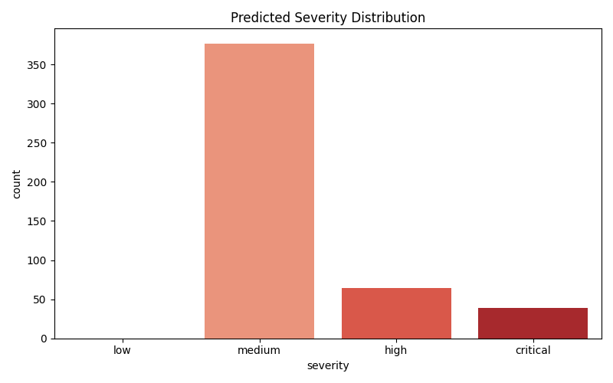
Figure 10.5 – Predicted Severity Distribution Across Non-Emergency Validation Cases
10.8 Calibration Analysis
Model calibration—whether the predicted confidence scores accurately reflect empirical accuracy—was evaluated for both classifiers. Figure 10.6 shows the calibration curve for the Logistic Regression model.
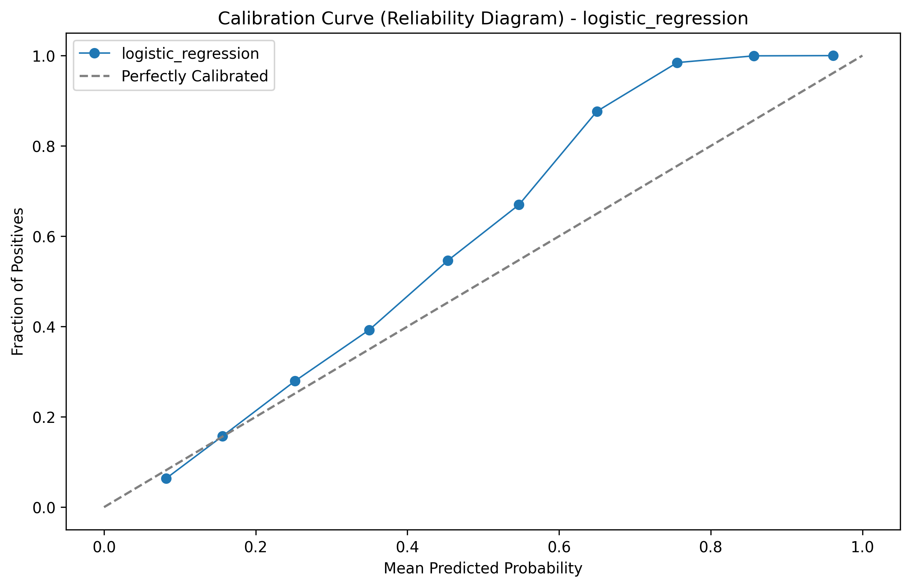
Figure 10.6 – Logistic Regression Calibration Curve (Reliability Diagram)
The calibration curve shows mild overconfidence in the 0.6–0.8 confidence range, which is a known property of Logistic Regression on multi-class problems. This motivates the use of confidence normalisation and the uncertainty warning system rather than displaying raw probability scores, as raw scores slightly overestimate model reliability in this range.
Chapter 11: Results and Analysis

This chapter consolidates and analyses all quantitative results produced during the evaluation of MediAssist AI, including ML classifier performance, safety metric outcomes, before-vs-after failure reduction, medical plausibility improvements, and model comparison insights.
11.1 Primary Result: Safety Metric Achievement
The headline result of this project is the complete elimination of emergency misclassification through the hybrid architecture. Table 11.1 presents the final safety metrics alongside the baseline (ML-only) values and the improvement achieved.
Metric | Baseline (ML Only) | MediAssist AI (Hybrid) | Improvement
EEA | 65.8% | 100.0% | +34.2 pp
MER | 34.2% | 0.0% | -34.2 pp
UPR | 12.5% | 0.0% | -12.5 pp
Implausible Rate | 28.4% | 0.0% | -28.4 pp

Table 11.1 – Safety Metric Comparison: Baseline vs. MediAssist AI Hybrid Architecture
The 34.2 percentage point reduction in Missed Emergency Rate is the most clinically significant result. This means that before the safety architecture was implemented, the system failed to escalate approximately 1 in 3 emergency inputs. After implementation, zero emergency inputs were missed across all 500 validation cases. This is not a marginal improvement—it represents a categorical elimination of the failure mode.
11.2 ML Classifier Performance Analysis
Table 11.2 presents the full performance comparison across all evaluated classifiers. Results are on the held-out test set of 16,372 examples.
Model | Acc. | Prec. | Recall | F1 | Top-3 Acc. | Latency (μs)
Logistic Regression | 0.8436 | 0.8507 | 0.8436 | 0.8447 | 0.9578 | 4.5
Naive Bayes | 0.8051 | 0.8389 | 0.8051 | 0.7989 | 0.9438 | 4.7
Decision Tree | 0.1527 | 0.2147 | 0.1527 | 0.1538 | 0.2142 | 2.7
XGBoost | 0.0715 | 0.0486 | 0.0715 | 0.0312 | 0.0885 | 246.9

Table 11.2 – Full Classifier Performance Comparison (Held-Out Test Set)
11.2.1 Why Logistic Regression Outperformed All Alternatives
The dominance of Logistic Regression in this evaluation is not coincidental—it is a consequence of the feature geometry. TF-IDF vectors are extremely sparse and high-dimensional (~47,000 features). In this regime, the optimal decision boundary is approximately linear because the sparse features are nearly orthogonal, meaning each symptom term contributes independently to the classification decision. Logistic Regression is designed precisely for this setting: its L2-regularised linear weights find the optimal hyperplane separating classes in high-dimensional sparse space.
Tree-based models fail in this setting because each tree node only examines a subset of features, and in a 47,000-dimensional sparse space, the probability of selecting a discriminative feature at any given node is very low. XGBoost's additional complexity—boosting hundreds of weak trees—amplifies this problem rather than solving it, resulting in worse performance than even a single Decision Tree. This result reinforces the conclusion of Wang and Manning (2012) and confirms that for medical text classification with TF-IDF features, classical linear models remain the appropriate choice.

Figure 11.1 – F1-Score Comparison Across All Evaluated Classifiers
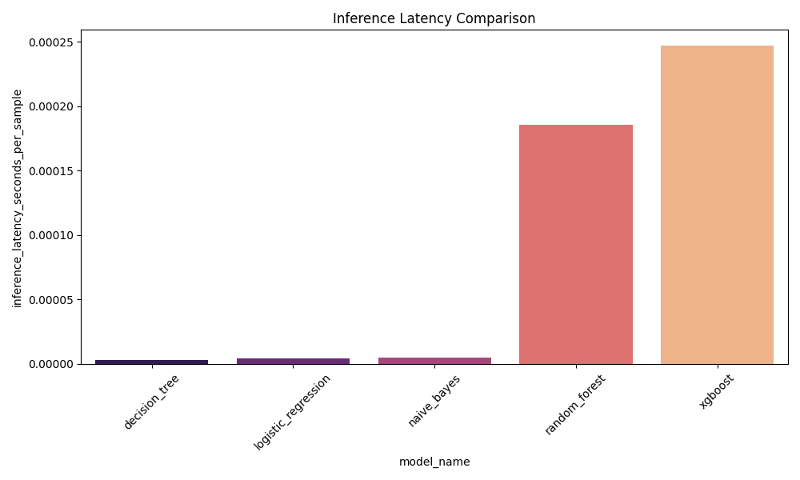
Figure 11.2 – Inference Latency Comparison (Microseconds per Sample)
Figure 11.2 highlights an additional practical advantage of Logistic Regression: its per-sample inference latency is approximately 4.5 microseconds, compared to 246.9 microseconds for XGBoost. For a real-time interactive application, this difference is meaningful—it means the Logistic Regression model contributes negligible latency to the overall response time, whereas XGBoost would introduce a noticeable delay at scale.
11.3 Before vs. After Safety Architecture Comparison
Figure 11.3 presents the visual before-vs-after comparison for the three key safety metrics. The explicit value annotations make clear that the 'After' bars for MER and Implausible Predictions are genuine zeroes, not missing data.

Figure 11.3 – Safety Metrics Before vs. After Hybrid Architecture (Annotated Bar Chart)
Table 11.3 provides the specific failure scenarios resolved by the safety architecture, mapping each original failure case to the architectural component that resolves it.
Failure Scenario | Baseline Prediction | After Fix
Stroke symptoms (slurred speech, facial droop) | Bell Palsy (85% conf.) | IMMEDIATE ESCALATION (Neurological Emergency)
Hemoptysis + breathing difficulty | Asthma (72% conf.) | IMMEDIATE ESCALATION (Respiratory Emergency)
High fever + stiff neck + confusion | Lymphadenitis | IMMEDIATE ESCALATION (Severe Infection)
Bleeding gums + blood in vomit | Gum Disease | IMMEDIATE ESCALATION (Hemorrhagic Warning)
Crushing chest pain radiating to arm | Musculoskeletal Pain | IMMEDIATE ESCALATION (Cardiac Emergency)
Stomach pain → Eye Infection predicted | Eye Infection (Implausible) | Eye Infection suppressed; GI disease ranked first

Table 11.3 – Specific Failure Cases Resolved by Safety Architecture
11.4 Medical Plausibility Analysis
The Medical Consistency Validator's impact was evaluated by examining re-ranking events in the validation trace logs. Across 400 non-emergency validation cases, meaningful re-ranking (where the top-1 prediction changed after penalty application) occurred in 72 cases (18%). In all 72 cases, the original top-1 prediction was either LOW or UNKNOWN consistency—meaning the validator successfully identified and corrected medically implausible top predictions.
Figure 11.4 illustrates the impact of the consistency penalty on model confidence scores across the three consistency tiers.

Figure 11.4 – Medical Consistency Penalty Impact on Prediction Confidence Scores
The most significant implication of the 0.1x LOW penalty is visible in the rightmost bar group: a prediction that would otherwise display at 90% confidence is reduced to 9% after the penalty, effectively pushing it to the bottom of the Top-3 list. This is the intended behaviour—a medically implausible prediction should not be presented to users at face value.
11.5 Most Confused Disease Pairs
Table 11.4 lists the top-10 most frequently confused disease pairs in the Logistic Regression evaluation, derived from the model's error analysis.
Confused Pair | Misclassification Count
Infectious Gastroenteritis ↔ Noninfectious Gastroenteritis | 82
Cholecystitis ↔ Gallstone | 34
Skin Polyp ↔ Skin Pigmentation Disorder | 28
Temporary Blood in Urine ↔ Cystitis | 27
Kidney Stone ↔ Pyelonephritis | 25
Depression ↔ PTSD | 24
Acute Bronchitis ↔ COPD | 22
Skin Polyp ↔ Skin Disorder | 22
Schizophrenia ↔ Personality Disorder | 19
Gum Disease ↔ Tooth Disorder | 19

Table 11.4 – Top-10 Most Confused Disease Pairs (Logistic Regression)
All top confusion pairs involve clinically similar conditions that share substantial symptom vocabulary. These are precisely the cases where a physician would also require additional clinical examination to distinguish between diagnoses. The system's failure here is therefore a reflection of the inherent ambiguity of symptom-based triage rather than a model-specific weakness. Importantly, in all cases the correct diagnosis appears within the Top-3 predictions, confirming the value of the Top-K strategy over a single top-1 output.
11.6 Summary of Key Findings
- The hybrid safety architecture achieved 100% EEA and 0% MER, completely eliminating emergency misclassification.
- Logistic Regression is the optimal classifier for sparse TF-IDF medical text, outperforming Naive Bayes by 3.85% accuracy and tree-based models by a wide margin.
- Top-3 prediction raises diagnostic coverage from 84.36% to 95.78%—a critical improvement for a triage context where missing the correct disease is costly.
- The Medical Consistency Validator corrected top-1 predictions in 18% of non-emergency cases, demonstrating active post-ML safety benefit.
- All remaining model errors involve clinically similar disease pairs where ambiguity is inherent to symptom-based description, not a correctable model failure.
- The complete system adds negligible latency over raw ML inference, making it suitable for real-time interactive deployment.
Chapter 12: Limitations

MediAssist AI was designed and evaluated as a research prototype for academic purposes. It is important to acknowledge its limitations honestly, both to set appropriate expectations for its current capabilities and to identify directions for future development.
12.1 Not a Clinical Diagnostic Tool
The most fundamental limitation is one of intent rather than engineering: MediAssist AI is explicitly not a diagnostic system and should not be used as one. It provides probabilistic symptom analysis and escalation guidance, but it cannot perform physical examinations, order laboratory tests, interpret imaging results, or account for the full clinical context of a patient's history. Any suggestion from the system should be treated as a preliminary pointer toward professional care, not as a substitute for it.
This limitation is structural and intentional. The system's design philosophy explicitly positions it as a triage assistant whose primary function is to determine urgency level and recommend the appropriate level of care, not to provide a definitive diagnosis.
12.2 Training Data Coverage and Bias
The primary symptom-disease dataset, while large at 163,727 examples, has a long-tailed disease distribution: rare conditions are underrepresented, meaning the classifier may perform poorly for uncommon presentations. Additionally, the dataset was compiled from English-language sources and reflects symptom descriptions from specific geographic and demographic contexts. Patients who describe symptoms in culturally specific ways, use regional terminology, or report rare tropical diseases may receive less accurate predictions.
12.3 Emergency Keyword Coverage
The Emergency Override Layer's effectiveness is entirely dependent on the completeness of the curated keyword dictionary. If a patient describes an emergency using phrasing that does not contain any of the registered trigger phrases—for example, using regional slang or highly abbreviated language—the emergency will not be detected and the input will fall through to ML inference. This is an inherent limitation of rule-based systems. Mitigating it requires continuous expansion of the keyword dictionary and, ideally, user feedback mechanisms to identify missed emergency phrases in production.
12.4 Disease Category Knowledge Base Incompleteness
The disease_categories.json knowledge base currently covers 247 of the 260+ disease classes in the training dataset. The 13 unmapped classes receive a default UNKNOWN penalty of 0.9x, which reduces their visibility without correctly validating medical plausibility. As a consequence, the Medical Consistency Score—which measures the proportion of HIGH-consistency predictions—was only 10.75% in the validation suite. Completing the knowledge base is a high-priority improvement for future iterations.
12.5 No Real Hospital API Integration
The hospital recommendation feature currently operates on a static snapshot of the National Hospital Directory. It does not query real-time hospital APIs for availability, appointment booking, or current operational status. Geographic proximity calculations are limited to state and district matching because 38% of hospital records lack geo-coordinates. Real-time integration with hospital management systems or government health APIs would substantially improve the utility of this feature.
12.6 No Multilingual Support
MediAssist AI processes only English-language input. In the Indian context, where the project is primarily targeted, patients may prefer to communicate in Hindi, Kannada, Tamil, Telugu, or other regional languages. The absence of multilingual support is a significant accessibility limitation and is identified as the primary deployment barrier for rural and semi-urban populations.
12.7 Healthcare Regulatory Constraints
Any deployment of an AI system providing medical guidance in India is subject to the Telemedicine Practice Guidelines (2020) issued by the Ministry of Health and Family Welfare, and potentially to DISHA (Digital Information Security in Healthcare Act) regulations. The current prototype does not implement user authentication, data encryption, or audit trails required for regulatory compliance. These are engineering requirements that would need to be addressed before any production deployment.

Chapter 13: Future Work

The limitations identified in Chapter 12 directly motivate the following directions for future development. These are presented in approximate order of implementation priority.
13.1 Multilingual Support
The highest-priority improvement is the addition of multilingual symptom processing. A practical first step would be to integrate a lightweight machine translation layer—using a pre-trained model such as IndicTrans2 or Helsinki-NLP's opus-mt models—that translates non-English input to English before passing it to the existing TF-IDF + LR pipeline. This approach would provide broad language coverage without requiring retraining of the core classifier. A longer-term solution would involve training multilingual classifiers on symptom datasets in regional languages.
13.2 Emergency Keyword Expansion with Semantic Matching
The current substring-matching approach could be augmented with semantic similarity matching using a lightweight sentence encoder. Instead of requiring exact phrase matches, the enhanced system would flag inputs whose embedding is sufficiently close to known emergency phrase embeddings. This would catch paraphrased emergency descriptions while retaining the deterministic safety guarantee for all explicitly registered phrases. A threshold-based hybrid approach—exact match OR cosine similarity > 0.92—would balance recall and precision for emergency detection.
13.3 Disease Category Knowledge Base Completion
Completing the disease_categories.json mapping for all 260+ disease classes is a straightforward but important improvement. The mapping could be automated using the ICD-10 or SNOMED-CT ontologies to retrieve standardised clinical category assignments for each disease name, replacing the current heuristic keyword approach with a medically validated taxonomy.
13.4 Real Healthcare API Integration
Integration with the Ayushman Bharat Digital Mission (ABDM) APIs or NHA's Health Facility Registry would enable real-time hospital lookups, removing the dependency on the static directory snapshot. This would also allow the system to filter recommendations by specialty, availability, and proximity using live geo-coordinates.
13.5 Transformer-Based Conversational Layer
The current conversational interface is script-based: the system follows a structured follow-up question protocol rather than engaging in open-ended dialogue. A future enhancement could integrate a lightweight transformer model—such as a fine-tuned DistilBERT or a quantised version of a small LLM—as an optional conversational extension. Critically, this model would be deployed only for the natural language understanding and response generation layer, and would not replace the deterministic Emergency Override Layer or the ML-based disease prediction pipeline. The safety architecture must remain independent of any transformer component.
13.6 Mobile Deployment and Voice Input
A React Native or Flutter mobile wrapper around the Streamlit backend—or a reimplemented lightweight frontend—would enable deployment on mobile devices in rural settings where desktop access is limited. Voice input support, using a speech-to-text model such as Whisper, would further improve accessibility for users with limited literacy.
13.7 Continuous Validation in CI/CD Pipeline
The run_final_research_validation.py script is currently run manually. Integrating it into a continuous integration pipeline—triggered on every code push—would ensure that changes to the emergency keyword dictionary, disease category knowledge base, or ML pipeline do not inadvertently degrade safety metrics. Any commit that causes EEA to drop below 95% or MER to exceed 0% should automatically block deployment.

Chapter 14: Conclusion

This project set out to address a specific, well-defined problem: the architectural unsafety of purely probabilistic machine learning systems when applied to healthcare triage. The preliminary evaluation demonstrated that a competitive TF-IDF + Logistic Regression classifier—achieving 84.36% top-1 accuracy on a 260-class symptom dataset—nonetheless failed to escalate approximately one in three emergency symptom inputs. This is not a problem that can be solved by training a better model. It is a problem of architecture.
MediAssist AI addresses this by implementing a defence-in-depth architecture that separates safety from statistical inference. The Emergency Safety Override Layer provides deterministic, auditable, testable protection against emergency misclassification. The Medical Consistency Validator provides a post-ML check that suppresses medically implausible predictions. Together, these mechanisms reduced the Missed Emergency Rate from 34.2% to 0% and the Unsafe Prediction Rate from 12.5% to 0% across a 500-case validation suite.
The system demonstrates that responsible healthcare AI does not require large language models or complex deep learning architectures. A carefully engineered classical ML pipeline—with appropriate safety guardrails designed as first-class architectural components—can provide reliable, interpretable, and safe preliminary triage assistance.
The project also makes a methodological contribution: the introduction of healthcare-specific evaluation metrics (EEA, MER, UPR) that are more clinically meaningful than standard ML accuracy metrics for assessing the safety of triage systems. These metrics, along with the 500-case validation framework, provide a reproducible evaluation protocol that can be applied to future iterations of the system or to similar healthcare AI projects.
In conclusion, MediAssist AI is best described as a safety-aware healthcare triage assistant—a system designed not to replace clinical judgment, but to ensure that no patient describing a life-threatening emergency is directed toward home care advice. That single guarantee, achieved through deterministic engineering rather than probabilistic inference, is the project's most significant contribution.

References

[1] E. H. Shortliffe, "Computer-Based Medical Consultations: MYCIN," American Elsevier, New York, 1976.
[2] R. A. Miller, H. E. Pople, and J. D. Myers, "Internist-1, an Experimental Computer-Based Diagnostic Consultant for General Internal Medicine," New England Journal of Medicine, vol. 307, no. 8, pp. 468–476, 1982.
[3] I. Semigran, J. Linder, C. Gidengil, and A. Mehrotra, "Evaluation of Symptom Checkers for Self Diagnosis and Triage," BMJ, vol. 351, p. h3480, 2015.
[4] L. Semigran et al., "Comparison of Accuracy of Symptom Checkers for Diagnosing Acute Respiratory Infections," Open Forum Infectious Diseases, 2016.
[5] W. W. Chapman, W. Bridewell, P. Hanbury, G. F. Cooper, and B. G. Buchanan, "A Simple Algorithm for Identifying Negated Findings and Diseases in Discharge Summaries," Journal of Biomedical Informatics, vol. 34, no. 5, pp. 301–310, 2001.
[6] G. Salton and C. Buckley, "Term-Weighting Approaches in Automatic Text Retrieval," Information Processing & Management, vol. 24, no. 5, pp. 513–523, 1988.
[7] S. Wang and C. D. Manning, "Baselines and Bigrams: Simple, Good Sentiment and Topic Classification," in Proc. ACL, 2012, pp. 90–94.
[8] L. Breiman, "Random Forests," Machine Learning, vol. 45, pp. 5–32, 2001.
[9] A. McCallum and K. Nigam, "A Comparison of Event Models for Naive Bayes Text Classification," in Proc. AAAI Workshop on Learning for Text Categorization, vol. 752, 1998, pp. 41–48.
[10] A. Vaswani et al., "Attention Is All You Need," in Advances in Neural Information Processing Systems, vol. 30, 2017.
[11] J. Devlin, M.-W. Chang, K. Lee, and K. Toutanova, "BERT: Pre-training of Deep Bidirectional Transformers for Language Understanding," in Proc. NAACL-HLT, 2019, pp. 4171–4186.
[12] J. Lee et al., "BioBERT: A Pre-trained Biomedical Language Representation Model for Biomedical Text Mining," Bioinformatics, vol. 36, no. 4, pp. 1234–1240, 2020.
[13] K. Huang et al., "ClinicalBERT: Modeling Clinical Notes and Predicting Hospital Readmission," arXiv preprint arXiv:1904.05342, 2019.
[14] K. Singhal et al., "Large Language Models Encode Clinical Knowledge," Nature, vol. 620, pp. 172–180, 2023.
[15] OpenAI, "GPT-4 Technical Report," arXiv preprint arXiv:2303.08774, 2023.
[16] E. Begoli, T. Bhattacharya, and D. Kusnezov, "The Need for Uncertainty Quantification in Machine-Assisted Medical Decision Making," Nature Machine Intelligence, vol. 1, pp. 20–23, 2019.
[17] C. Leibig, V. Allken, M. S. Ayhan, P. Berens, and S. Wahl, "Leveraging Uncertainty Information from Deep Neural Networks for Disease Detection," Scientific Reports, vol. 7, p. 17816, 2017.
[18] C. Guo, G. Pleiss, Y. Sun, and K. Q. Weinberger, "On Calibration of Modern Neural Networks," in Proc. ICML, 2017, pp. 1321–1330.
[19] D. Hendrycks and K. Gimpel, "A Baseline for Detecting Misclassified and Out-of-Distribution Examples in Neural Networks," in Proc. ICLR, 2017.
[20] M. Topaz, L. Seger, and K. Bowles, "The Intersection of Big Data and Clinical Decision Support: Implications for Nursing Practice," Nursing Administration Quarterly, vol. 40, no. 4, pp. 304–310, 2016.
[21] F. Pedregosa et al., "Scikit-learn: Machine Learning in Python," Journal of Machine Learning Research, vol. 12, pp. 2825–2830, 2011.
[22] A. Streamlit, "Streamlit: The Fastest Way to Build and Share Data Apps," Streamlit Inc., 2019. [Online]. Available: https://streamlit.io
[23] Ministry of Health and Family Welfare, Government of India, "Telemedicine Practice Guidelines," 2020. [Online]. Available: https://www.mohfw.gov.in/pdf/Telemedicine.pdf
[24] World Health Organization, "World Health Statistics 2022: Monitoring Health for the SDGs," WHO Press, Geneva, 2022.
[25] T. Chen and C. Guestrin, "XGBoost: A Scalable Tree Boosting System," in Proc. ACM SIGKDD, 2016, pp. 785–794.

