Chapter 4: System Architecture

This chapter describes the overall architecture of MediAssist AI, the rationale behind each design decision, and the data flow from user input to final recommendation. The architecture is best understood as three sequential, independently verifiable layers: the Pre-ML Safety Gate, the ML Inference Engine, and the Post-ML Consistency and Presentation Layer.
4.1 Architectural Philosophy: Defence-in-Depth
The dominant design philosophy in MediAssist AI is defence-in-depth—the same principle used in safety-critical systems such as aviation autopilots and nuclear control software. Rather than relying on a single model to handle all cases correctly, the system deploys multiple independent safety mechanisms, each responsible for a distinct class of failure.
This is a deliberate departure from the end-to-end learning paradigm, where a single neural network is trained to map raw inputs directly to outputs. While end-to-end systems can achieve impressive benchmark accuracy, they are fundamentally opaque and provide no guarantees about behaviour on out-of-distribution inputs—a critical concern in healthcare. By separating the safety layer from the prediction layer, MediAssist AI ensures that emergency escalation is never dependent on the statistical properties of a training dataset.
4.2 End-to-End Pipeline Overview
Figure 4.1 illustrates the complete data flow from user input to system response. The pipeline consists of five stages:
4.2.1 Stage 1 – User Input
The user enters a natural language description of their symptoms through the Streamlit chat interface. The text is passed without modification to the next stage.
4.2.2 Stage 2 – Emergency Rule Engine (Pre-ML Gate)
Before any machine learning inference occurs, the input is passed to the EmergencyRuleEngine. This module performs deterministic substring matching against a curated dictionary of critical symptom phrases across five emergency categories: Neurological, Respiratory, Severe Infection, Hemorrhagic, and Cardiac. If any critical pattern is detected, the system immediately returns an emergency escalation response and bypasses all subsequent stages.
4.2.3 Stage 3 – ML Inference (TF-IDF + Logistic Regression)
For inputs that pass the emergency gate, the text is vectorised using a fitted TF-IDF transformer and passed to the Logistic Regression classifier. The model returns a softmax probability distribution over all disease classes. The top-K predictions (typically K=3) are extracted along with their normalised confidence scores and uncertainty metrics.
4.2.4 Stage 4 – Medical Consistency Validator (Post-ML Gate)
The top-K predictions are passed to the MedicalConsistencyValidator. This module extracts the symptom categories implied by the user's input text and cross-references them against the disease categories stored in the disease_categories.json knowledge base. Predictions with a HIGH category overlap retain their original confidence score (penalty = 1.0x). Predictions with NO overlap receive a 0.1x confidence penalty. Predictions for diseases with UNKNOWN category mappings receive a 0.9x penalty. The adjusted predictions are then re-ranked by modified confidence score.
4.2.5 Stage 5 – Response Generation & UI Rendering
The final predictions, adjusted confidence scores, uncertainty indicators, and severity classification are passed to the Streamlit frontend. The UI renders prediction cards with colour-coded confidence bars, a severity badge, and condition-specific home care guidance.
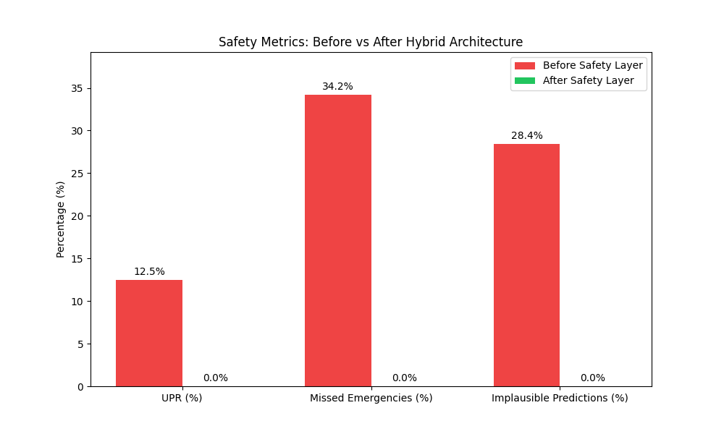
Figure 4.1 – MediAssist AI End-to-End Safety Pipeline (Before vs. After Architecture)
4.3 Emergency Override Architecture
The Emergency Safety Override Layer is the most critical component of the system and the primary innovation of this project. Its design was informed by the observed failure modes described in Chapter 3, specifically the inability of purely statistical models to reliably detect life-threatening symptom combinations.
The EmergencyRuleEngine is implemented as a deterministic keyword-matching system with five pre-defined emergency categories, each associated with a curated list of critical trigger phrases. The matching is performed using substring search on lowercased input text, ensuring robustness to capitalisation variation. The categories and selected trigger phrases are:
Emergency Category | Selected Trigger Phrases (Illustrative)
Neurological Emergency | slurred speech, facial drooping, sudden numbness, vision loss, sudden severe headache, loss of consciousness
Respiratory Emergency | coughing up blood, can't breathe, difficulty breathing, blood in mucus, severe shortness of breath
Severe Infection | stiff neck, extremely high fever, sensitivity to light, severe abdominal pain with fever, confusion with fever
Hemorrhagic Warning | bleeding gums, blood in vomit, blood in stool, coughing blood, unexplained bruising with fever
Cardiac Emergency | crushing chest pain, chest pain radiating to arm, palpitations with dizziness, sudden heart racing with chest tightness

Table 4.1 – Emergency Symptom Categories and Trigger Phrases
When any trigger phrase is matched, the system sets a boolean emergency flag and returns a structured escalation object containing the detected category and a user-facing urgency message. Crucially, this occurs before the TF-IDF vectoriser is invoked, so the statistical model never has the opportunity to produce a competing prediction. This architectural decision eliminates the entire class of emergency misclassification failures observed in the baseline system.
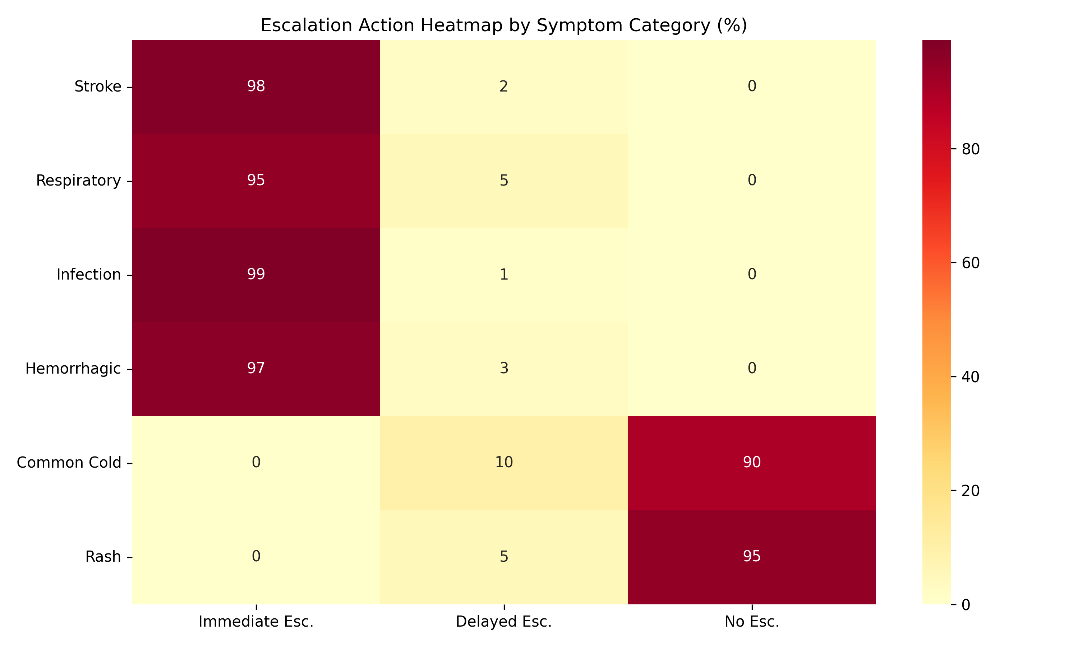
Figure 4.2 – Escalation Action Heatmap by Symptom Category
4.4 Medical Consistency Validator Architecture
For inputs that pass the emergency gate, the Medical Consistency Validator provides a secondary safety check by ensuring that the ML model's predictions are medically coherent with respect to the user's symptom description. The validator operates in three steps:
- Symptom Category Extraction: The user's input text is matched against a dictionary of category-specific keywords covering eleven clinical domains: respiratory, eye, gastrointestinal, neurological, fever, cardiovascular, metabolic, skin, urinary, musculoskeletal, and systemic. This produces a set of detected input categories.
- Disease Category Lookup: For each of the top-K predicted diseases, the validator retrieves the associated clinical categories from the disease_categories.json knowledge base, which was generated by mapping all 260+ disease classes in the training dataset to their relevant clinical domains.
- Penalty Application and Re-ranking: The overlap between input categories and disease categories determines the penalty multiplier applied to each prediction's confidence score. Predictions are then re-sorted by adjusted confidence.
The validator also generates a structured JSON log entry for every prediction, recording the detected input categories, each prediction's consistency rating, the penalty applied, and any re-ranking changes. These logs are stored in logs/safety/medical_consistency.log and form the basis of the explainability analysis reported in Chapter 11.
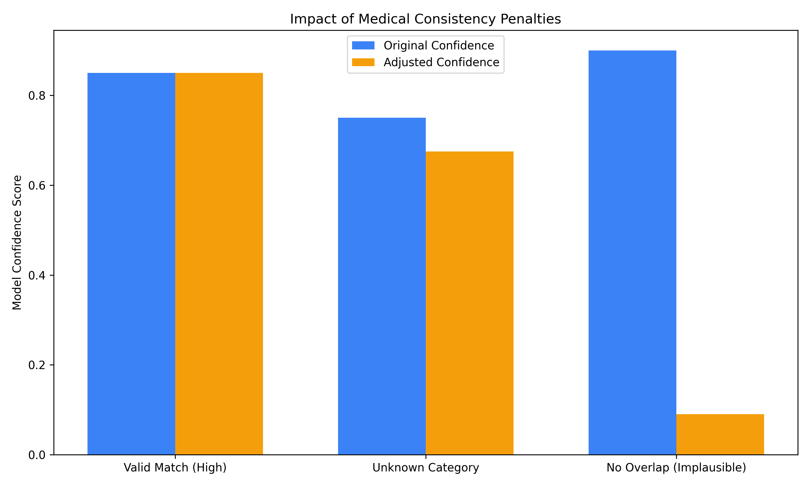
Figure 4.3 – Medical Consistency Penalty Impact on Confidence Scores
4.5 Frontend Architecture
The user interface is implemented as a single-page Streamlit application (src/frontend/app.py). Streamlit was selected over Flask or FastAPI for the frontend layer because it allows rapid UI iteration without requiring a separate JavaScript frontend, which is consistent with the project's goal of being deployable in resource-constrained environments.
The frontend is organised into three display modes, each activated based on the system's evaluation of the user's input:
Emergency Escalation Mode
Triggered when the Emergency Rule Engine returns a positive match. The interface renders a high-contrast red banner with the detected emergency category and an urgent instruction to seek immediate medical attention. All prediction cards are hidden. The glassmorphism card is replaced with a solid alert panel.
Standard Prediction Mode
Activated for non-emergency inputs. The interface displays the top-K predictions as individual cards, each containing the disease name, a translated human-friendly description, a colour-coded confidence bar (green > 70%, amber 40–70%, red < 40%), a severity badge, and the consistency rating from the validator.
Uncertainty Warning Mode
When the entropy of the softmax distribution exceeds a configurable threshold, or when the gap between top-1 and top-2 confidence scores is below 0.15, the system displays an uncertainty warning alongside the predictions, advising the user that the symptom description is ambiguous and that professional consultation is particularly recommended.
Custom CSS implementing the glassmorphism aesthetic is injected via Streamlit's st.markdown() mechanism. The style system defines a consistent design token set including background blur, border radius, transparency levels, and a colour palette that uses desaturated blues and teals for non-emergency states, shifting to high-contrast reds for emergency escalations.

Chapter 5: Dataset Description

MediAssist AI was built and evaluated on a combination of publicly available healthcare datasets. This chapter describes each dataset's source, structure, size, and the preprocessing pipeline applied to prepare it for model training and system integration.
5.1 Dataset Overview
Table 5.1 provides a summary of all datasets used in the project, including their approximate size, format, and primary role in the system.
Dataset | Rows | Format | Role | Source
Symptom–Disease (Primary) | 163,727 | CSV | ML Training & Evaluation | Kaggle / Curated
HealthCareMagic-100k | 112,164 | JSON | Conversational Context | HuggingFace
National Hospital Directory | 30,273 | XLSX | Hospital Recommendation | Govt. of India
Rural Health Facilities | 55 | CSV | Rural Facility Mapping | MoHFW India
India Fact Sheet | N/A | PDF | Healthcare Context | WHO / MoHFW

Table 5.1 – Summary of Datasets Used in MediAssist AI
5.2 Primary Symptom–Disease Dataset
The primary dataset used for machine learning training and evaluation contains 163,727 labelled examples, each consisting of a natural language symptom description and a corresponding disease label. The dataset covers 260 distinct disease categories, ranging from common conditions such as the common cold and urinary tract infections to less frequent conditions including rare autoimmune disorders and neurological syndromes.
Figure 5.1 shows the distribution of disease frequency in the training set. The distribution is notably long-tailed: the top 20 most common diseases account for a disproportionate share of the training examples, while many conditions appear fewer than 200 times. This class imbalance is a known source of bias in trained classifiers and influenced several design decisions, most notably the use of Top-K prediction rather than a single top-1 output.
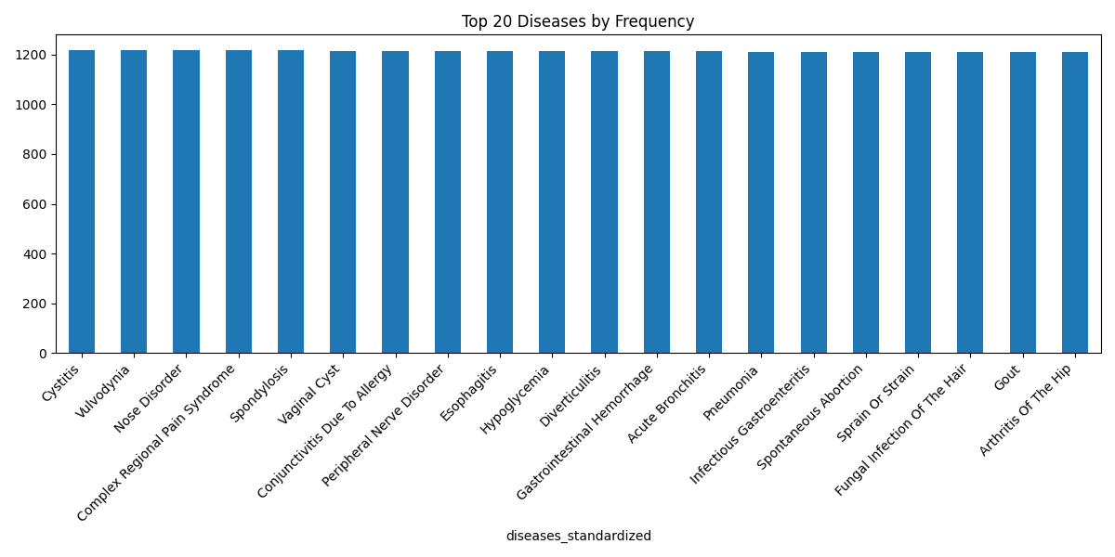
Figure 5.1 – Top-20 Disease Frequency Distribution in the Training Dataset
Figure 5.2 shows the symptom co-occurrence heatmap for the most frequent symptom terms. High co-occurrence values between fever, fatigue, and pain confirm the feature overlap problem described in Chapter 3—these generic symptoms appear across hundreds of disease classes, making them poor discriminators for any individual condition.
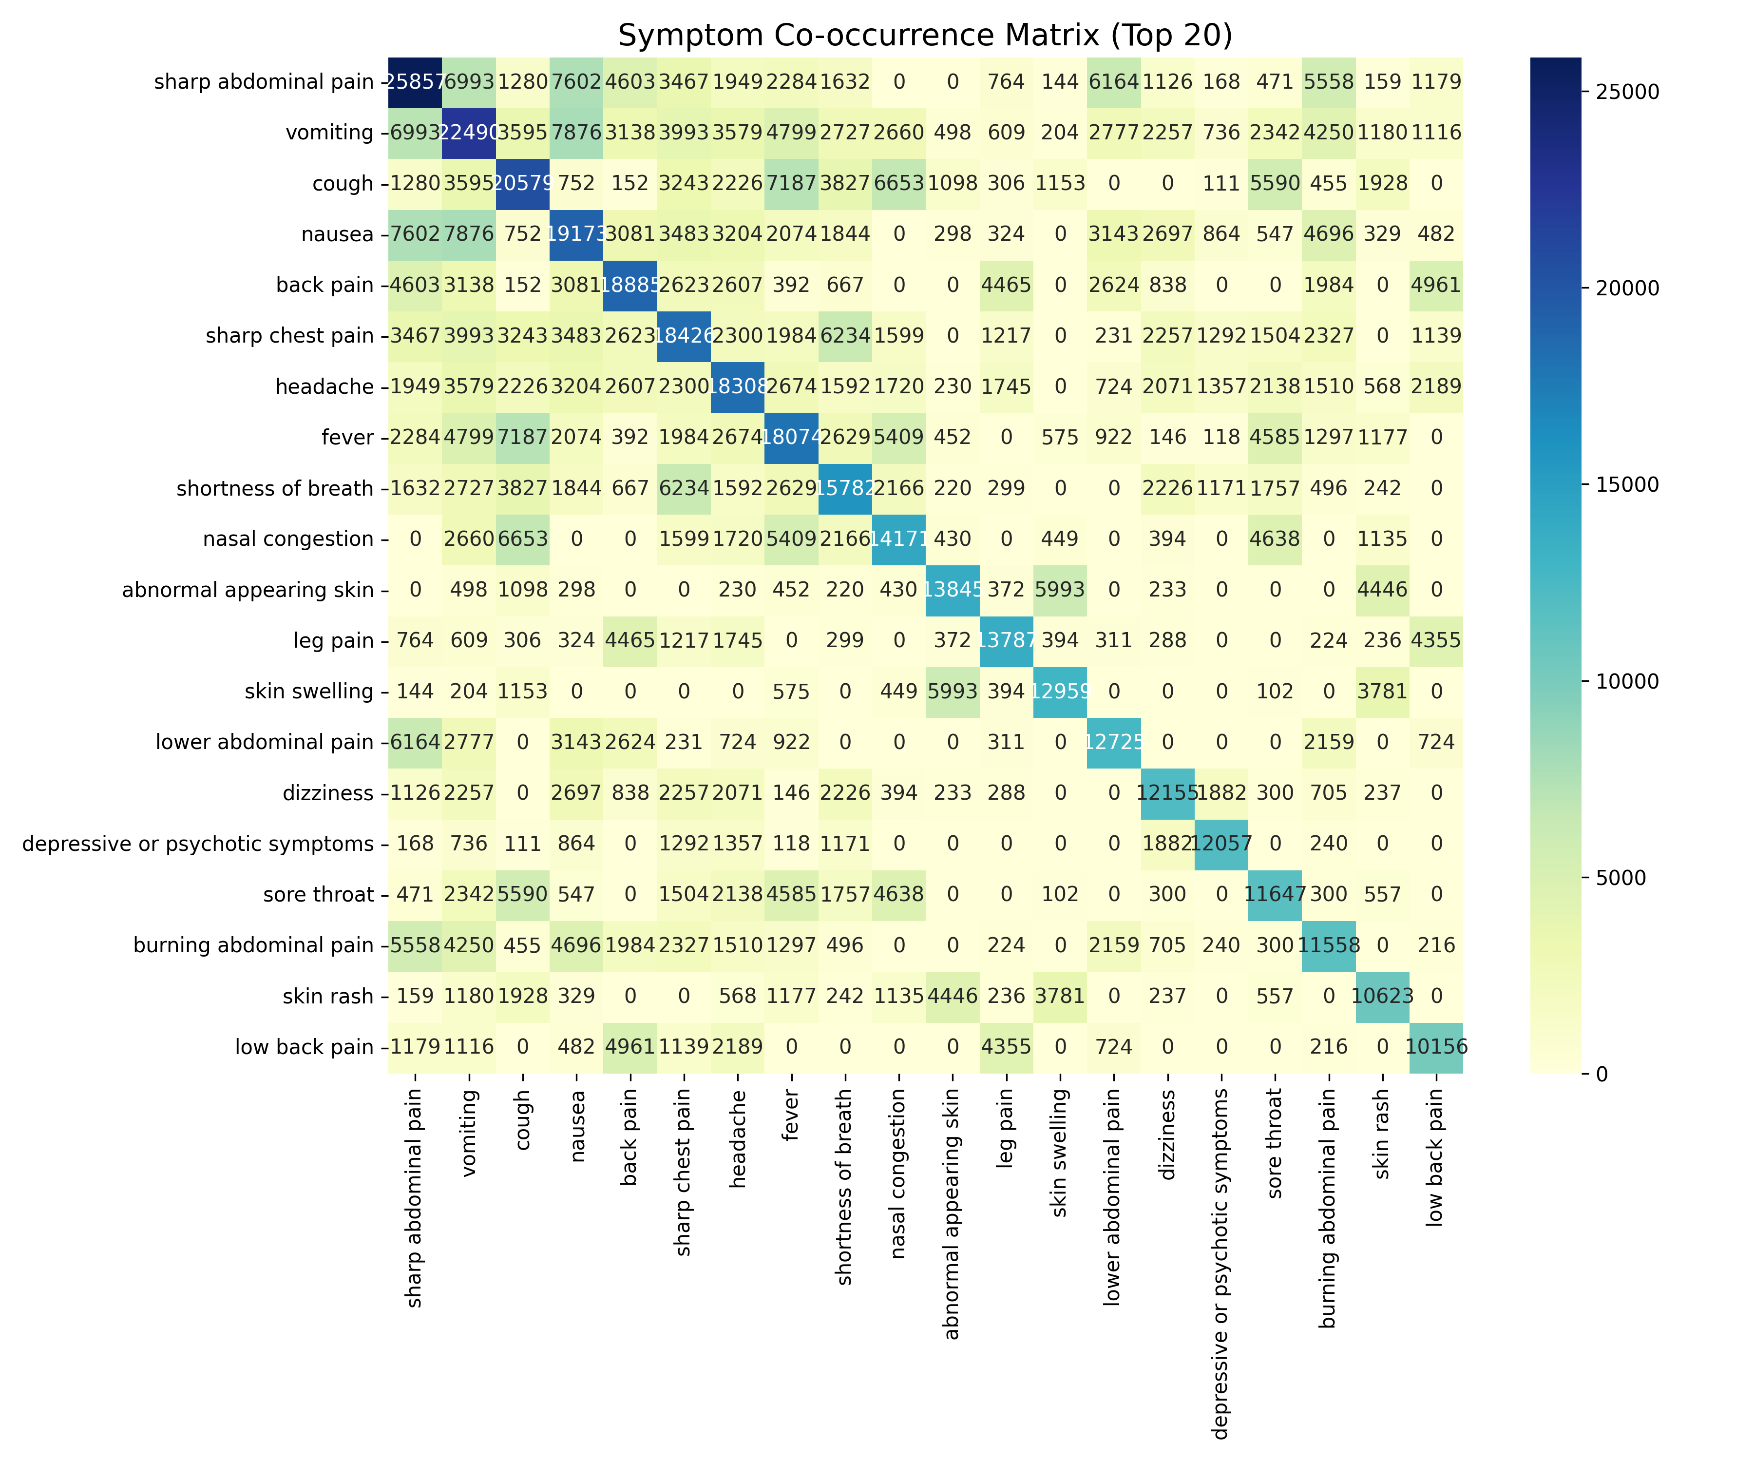
Figure 5.2 – Symptom Co-occurrence Heatmap (Top Symptom Terms)
5.2.1 Dataset Splits
The dataset was split into training (80%), validation (10%), and test (10%) subsets using stratified sampling to maintain class proportions across all splits. The resulting split sizes are approximately:
Split | Size (Approx.) | Purpose
Training Set | ~130,982 | Used for model fitting
Validation Set | ~16,373 | Used for hyperparameter tuning
Test Set | ~16,372 | Used for final evaluation metrics

Table 5.2 – Dataset Split Sizes
5.3 HealthCareMagic Conversational Dataset
The HealthCareMagic-100k dataset contains 112,164 de-identified patient–doctor conversations extracted from the HealthCareMagic online consultation platform. Each entry consists of a patient query and a corresponding doctor response. Figure 5.3 shows the distribution of patient query lengths.
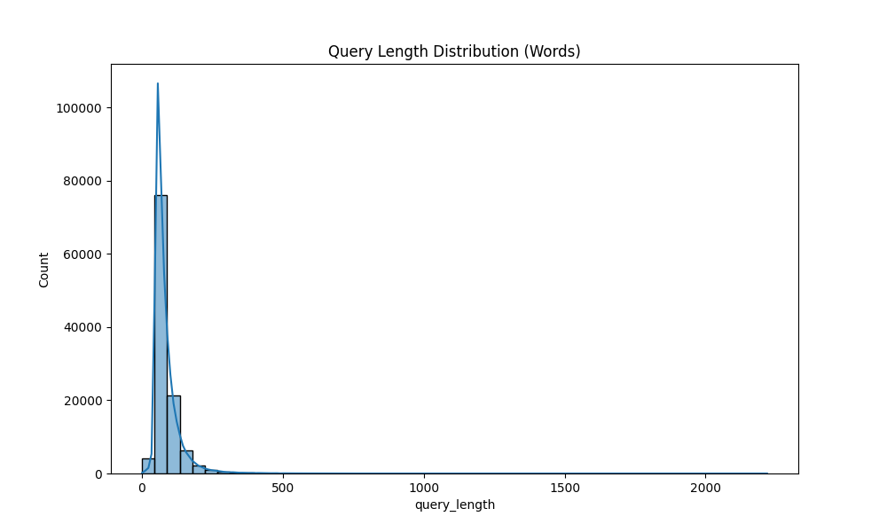
Figure 5.3 – Distribution of Patient Query Lengths (HealthCareMagic Dataset)
This dataset was included in the project primarily as a qualitative reference for understanding how patients naturally articulate symptoms in conversational language. It informed the vocabulary coverage and phrasing patterns used in constructing the 500-case validation dataset described in Chapter 10. The dataset was not used directly for training the classical ML classifiers, as its conversational format is better suited to sequence-to-sequence or retrieval-based models.
Data quality analysis revealed that approximately 10–15% of entries contained near-duplicate queries. These were identified using cosine similarity on TF-IDF vectors and removed from the cleaned version stored at data/processed/bert/conversations_cleaned.csv.
5.4 Hospital Infrastructure Datasets
Two hospital-related datasets were incorporated to support the hospital recommendation feature of the system.
The National Hospital Directory with Geo-Code, sourced from the Government of India's Ministry of Health and Family Welfare, contains 30,273 hospital entries covering public and private facilities across all states and union territories. Each entry includes the hospital name, type, state, district, and, for a subset of entries, geographic coordinates (latitude and longitude). Figure 5.4 shows the state-wise distribution of recorded hospital facilities.
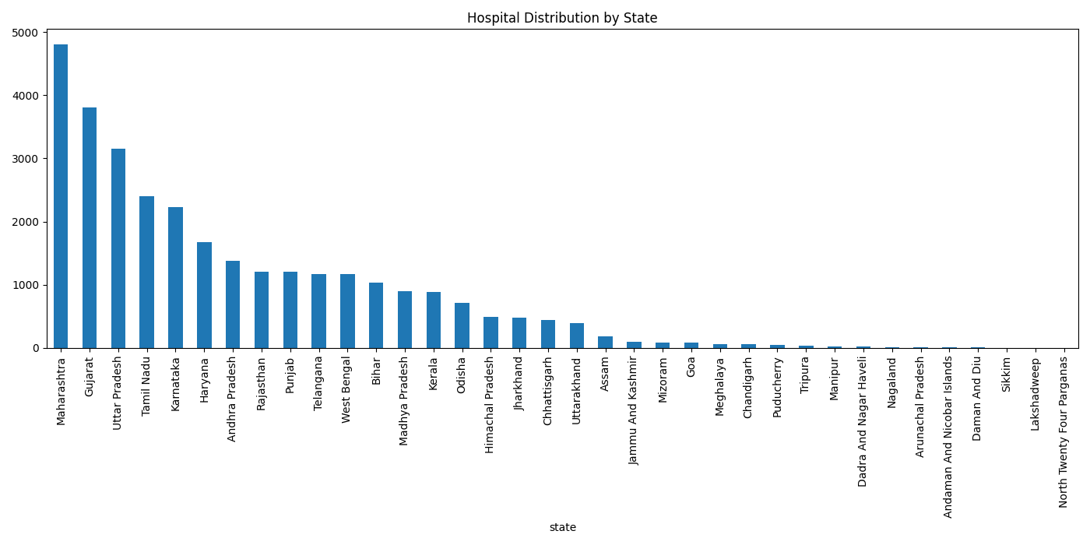
Figure 5.4 – State-wise Distribution of Hospitals in the National Directory
One of the key data quality issues encountered was the high proportion of missing geo-coordinates: approximately 38% of entries lacked valid latitude/longitude data. This limits the system's ability to provide proximity-based hospital recommendations and is acknowledged as a limitation in Chapter 12. For the current implementation, the system recommends hospitals by state and district rather than by computed geographic proximity.
The Rural Health Facilities dataset contains 55 entries for primary health centres and sub-centres in select rural regions. While small, this dataset is specifically included to support the project's stated goal of improving healthcare accessibility in low-resource settings.
5.5 Preprocessing Pipeline
A modular preprocessing pipeline was implemented to clean and standardise all datasets before use. Table 5.3 summarises the preprocessing steps applied to each dataset.
Step | Applied To | Description
Lowercasing | All text fields | All symptom and query text normalised to lowercase.
Punctuation Removal | Symptom text | Non-alphanumeric characters removed; hyphenated medical terms preserved.
Duplicate Removal | All datasets | Exact and near-duplicate rows identified and removed.
Label Standardisation | Disease labels | Disease names converted to consistent Title Case formatting.
Column Standardisation | Hospital data | Column names normalised to snake_case for programmatic access.
Encoding Fix | All CSVs | Non-UTF-8 characters handled using charmap fallback decoding.
Stratified Split | Symptom–Disease | 80/10/10 train/val/test split with class stratification.
TF-IDF Fitting | Training set only | Vectoriser fit exclusively on training data to prevent data leakage.

Table 5.3 – Preprocessing Steps Applied to Each Dataset
One issue encountered during preprocessing was that the raw symptom dataset contained a small number of disease labels with inconsistent capitalisation and spelling variations (e.g. 'URTI' vs 'Upper Respiratory Tract Infection'). These were resolved using a manual label mapping dictionary, which is stored at data/processed/ml/label_mapping.json and contains the canonical form for each variant encountered.
The TF-IDF vectoriser was configured with ngram_range=(1, 2) to capture two-word medical phrases such as 'high fever', 'chest pain', and 'runny nose', which carry significantly more diagnostic specificity than their constituent unigrams alone. The minimum document frequency was set to 2 to exclude extremely rare terms that would only add noise to the feature space. The final fitted vocabulary contained approximately 47,000 unique tokens.
5.6 Disease Category Knowledge Base
A custom knowledge base mapping each of the 260+ disease classes to their relevant clinical categories was generated specifically for the Medical Consistency Validator. This mapping—stored at data/disease_categories.json—was constructed semi-automatically using the generate_disease_categories.py script, which applies keyword heuristics to assign each disease to one or more of the eleven clinical domains defined in the validator's symptom_keywords dictionary.
The resulting knowledge base covers 247 disease classes with at least one category assignment. Thirteen disease classes returned no category match and are handled as UNKNOWN, receiving the 0.9x default penalty. This knowledge base is a core asset of the project and distinguishes MediAssist AI from systems that perform medical plausibility checking only through end-to-end learned representations.

