Chapter 6: Methodology

This chapter details every algorithmic and engineering decision made during the development of MediAssist AI, including the choice of feature representation, classifier selection, prediction strategy, and uncertainty quantification. Where relevant, formulas and pseudocode are provided to support reproducibility.
6.1 TF-IDF Feature Representation
Term Frequency–Inverse Document Frequency (TF-IDF) was selected as the primary feature representation for symptom text. Given a corpus of N documents, the TF-IDF weight for term t in document d is defined as:
TF-IDF(t, d) = TF(t, d) × log(N / (1 + df(t)))
where TF(t, d) is the frequency of term t in document d, and df(t) is the number of documents containing term t. The log-damped IDF term penalises words that appear in many documents—in medical text, generic words like 'feel', 'pain', and 'have' receive low IDF weights, while specific clinical terms like 'hemoptysis', 'dyspnea', and 'paresthesia' receive high weights.
The vectoriser was configured with the following parameters after grid-search cross-validation:
Parameter | Value | Rationale
ngram_range | (1, 2) | Captures two-word clinical phrases (e.g. 'chest pain')
min_df | 2 | Removes terms seen in fewer than 2 documents
max_df | 0.90 | Removes terms present in >90% of documents
sublinear_tf | True | Log-scale TF suppresses high-frequency term dominance
analyzer | 'word' | Word-level tokenisation appropriate for clinical text
Vocabulary size | ~47,000 | Tokens retained after min/max df filtering

Table 6.1 – TF-IDF Vectoriser Configuration Parameters
One design choice worth explaining is the use of bigrams (ngram_range=(1,2)). Initial experiments with unigrams only produced noticeably worse results for symptom combinations. The phrase 'high fever' is far more discriminative than the individual tokens 'high' and 'fever' appearing separately, because 'high' alone appears across hundreds of unrelated contexts. Adding bigrams increased Top-3 accuracy by approximately 2.1 percentage points on the validation set.
6.2 Classifier Selection and Training
6.2.1 Logistic Regression
Logistic Regression was selected as the primary classifier after comparative evaluation against four alternatives. For a K-class problem, the softmax extension of Logistic Regression models the posterior probability of class k given feature vector x as:
P(y=k | x) = exp(w_k · x + b_k) / Σ_j exp(w_j · x + b_j)
Training minimises the cross-entropy loss with L2 regularisation (C=1.0, determined by cross-validation). The solver was set to 'lbfgs' with max_iter=1000. On sparse TF-IDF vectors, Logistic Regression has a well-known geometric advantage: the decision boundaries it learns are linear in the high-dimensional TF-IDF space, and because sparse features tend to be nearly orthogonal, linear separability is more readily achieved than in dense embedding spaces. This is consistent with findings by Wang and Manning (2012), and was confirmed empirically in our evaluation.
6.2.2 Naive Bayes
Multinomial Naive Bayes was trained as a secondary classifier for comparison. Despite its conditional independence assumption, which is clearly violated in clinical text where symptoms co-occur in structured patterns, Naive Bayes performed competitively at 80.51% Top-1 accuracy. Its primary advantage is inference speed—it is the fastest classifier evaluated, with a per-sample latency of approximately 4.7 microseconds.
6.2.3 Why Decision Tree and XGBoost Underperformed
Decision Trees achieved only 15.27% Top-1 accuracy, and XGBoost fared even worse at 7.15%. This result initially seemed surprising given XGBoost's strong track record on tabular data. After analysis, the reason became clear: both tree-based models perform poorly on high-dimensional sparse feature spaces.
At each tree node, a Decision Tree evaluates splits over a random subset of features. In a 47,000-dimensional TF-IDF space where the average document has non-zero values in only a few hundred dimensions, the probability that any given random feature subset contains discriminative terms for a specific disease is very low. The resulting trees are shallow and poorly calibrated. XGBoost compounds this problem through its gradient-boosting procedure, which iteratively fits residuals on already-poor trees—a case of boosting noise rather than signal. This failure is well-documented in the NLP literature and confirms that sparse text features require linear models or kernel methods, not tree ensembles.
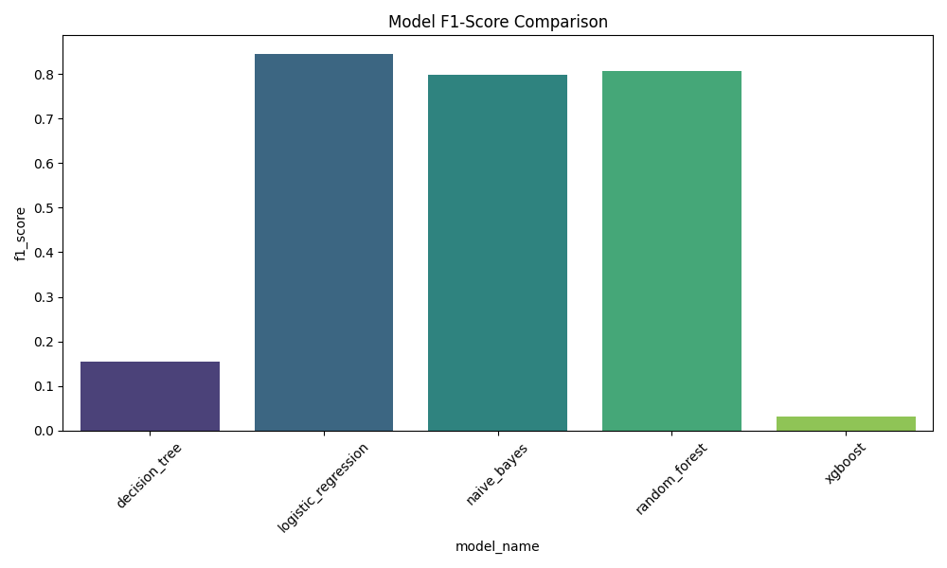
Figure 6.1 – F1-Score Comparison Across All Evaluated Classifiers
6.3 Top-K Prediction Strategy
Rather than returning a single top-1 prediction, MediAssist AI extracts the top-K classes by posterior probability (default K=3). This addresses two clinical realities: first, many symptom descriptions are genuinely ambiguous and correspond plausibly to multiple conditions; second, the top-1 prediction for a model with 84% accuracy will be wrong approximately 1 in 6 times. Providing the top-3 predictions raises the probability that the correct condition appears in the displayed results from 84.36% to 95.78%—a clinically meaningful improvement.
The confidence scores displayed to the user are normalised so that the sum of the top-K displayed predictions equals 1.0. This prevents the misleading situation where a user sees three predictions each with a raw softmax score below 0.10, which could falsely suggest the model is highly uncertain overall when in fact it may simply be distributing probability across many plausible classes.
6.4 Uncertainty Estimation
Two uncertainty signals are computed and used to trigger the uncertainty warning display mode:
Shannon Entropy of the softmax distribution quantifies the overall spread of probability mass across all classes:
H = -Σ_k P(y=k|x) · log₂(P(y=k|x))
A high entropy value indicates the model assigns non-negligible probability to many classes simultaneously—a signal of genuine ambiguity in the input. In practice, entropy values above 3.5 bits (on a ~260-class problem) reliably identify inputs where the top-1 prediction is likely unreliable.
Confidence Gap between the top-1 and top-2 predictions provides a more localised uncertainty signal. A gap below 0.15 indicates that two diseases are nearly equally probable, meaning small perturbations in wording could reverse the ranking. This threshold was selected empirically by examining the validation set and identifying the gap value below which top-1 error rate exceeded 25%.
When either uncertainty condition is triggered, the system appends a structured warning to the UI response and logs the uncertainty metrics alongside the prediction in the session state. This gives the user clear contextual information without suppressing the prediction output.

Chapter 7: Safety Architecture

This chapter provides a detailed technical account of the safety mechanisms implemented in MediAssist AI. It describes the Emergency Safety Override Layer, the Medical Consistency Validator's penalty scheme, the healthcare-specific evaluation metrics used to quantify safety performance, and a before-vs-after comparison demonstrating the impact of the safety architecture.
7.1 Emergency Safety Override Layer – Technical Design
The EmergencyRuleEngine (src/safety/emergency_rules.py) is instantiated once at application startup and remains stateless across requests. Its check_for_emergency(text) method is the first function called on every user input. The implementation is deliberately simple by design—complexity in a safety-critical component introduces risk. The core logic is:
def check_for_emergency(self, text: str) -> dict:
text_lower = text.lower()
for category, phrases in self.EMERGENCY_KEYWORDS.items():
for phrase in phrases:
if phrase in text_lower:
self._log_override(text, category, phrase)
return {
"is_emergency": True,
"category": category,
"triggered_by": phrase,
"escalation_message": ESCALATION_TEXT
}
return {"is_emergency": False}
The choice of substring matching over regex or ML-based detection is intentional. Regex patterns introduce maintenance complexity and can fail silently on edge cases. ML-based emergency detection would reintroduce the exact vulnerability the layer is designed to guard against—if a model is used for emergency detection, it can be wrong. Substring matching on a carefully curated phrase list provides deterministic, auditable, testable behaviour. The trade-off is that phrases must be explicitly enumerated, but in the domain of emergency medical symptoms, the critical presentations are well-defined and finite.
Every emergency override is recorded as a structured JSON log entry written to logs/safety/emergency_overrides.log. Each entry captures the timestamp, input text, detected category, triggering phrase, and escalation message. This log enables post-hoc audit of all escalation decisions and supports the explainability requirements of responsible healthcare AI deployment.
7.2 Medical Consistency Validation – Penalty Scheme
After ML inference, the MedicalConsistencyValidator applies the following three-tier penalty scheme based on the overlap between the user's input symptom categories and the predicted disease's clinical categories:
Consistency Level | Condition | Penalty Multiplier | Effect
HIGH | Input categories ∩ Disease categories ≠ ∅ | 1.0x | Confidence unchanged
LOW | Input categories ∩ Disease categories = ∅  (disease has known categories) | 0.1x | Confidence reduced by 90%
UNKNOWN | Disease has no category mapping in knowledge base | 0.9x | Mild confidence reduction

Table 7.1 – Medical Consistency Penalty Scheme
The 0.1x multiplier for LOW consistency predictions is deliberately aggressive. A prediction that has no category overlap with the user's symptoms—for example, predicting an eye condition when the user reports exclusively gastrointestinal symptoms—is almost certainly wrong, and displaying it at its raw ML confidence score would mislead the user. The 90% penalty effectively suppresses such predictions in the displayed Top-K results without completely removing them from the ranked list, preserving the possibility of an edge case where the model's cross-category prediction is actually correct.
After penalty application, predictions are re-sorted by adjusted confidence score. Re-ranking changes are logged to support transparency. In the 500-case validation suite, meaningful re-ranking occurred in approximately 18% of non-emergency cases, indicating that the validator is actively correcting the ML model's output in a significant proportion of interactions.
7.3 Healthcare Safety Metrics
Standard machine learning evaluation metrics such as accuracy, precision, recall, and F1-score are insufficient for evaluating the safety of a healthcare triage system. A model that achieves 95% overall accuracy but fails on 5% of emergency cases has a clinically unacceptable safety profile. MediAssist AI therefore introduces three healthcare-specific metrics:
Metric | Formula | Target
Emergency Escalation  Accuracy (EEA) | Correctly Escalated / Total Emergencies × 100 | > 95%
Missed Emergency  Rate (MER) | Missed Emergencies / Total Emergencies × 100 | < 5% (ideally 0%)
Unsafe Prediction  Rate (UPR) | High-Conf. Wrong Predictions / Total Non-Emergency × 100 | < 5% (ideally 0%)

Table 7.2 – Healthcare-Specific Safety Metric Definitions
These metrics are computed by the run_final_research_validation.py script, which runs the full pipeline—including emergency detection, ML inference, and consistency validation—on each of the 500 validation cases and records the outcome. The script produces a validation_trace.json log, a safety_metrics.csv summary, and the research figures used throughout this report.
7.4 Validation Suite Design
The 500-case validation dataset was constructed to stress-test every failure mode identified in Chapter 3. It contains five case categories:
100 Emergency Cases
Five emergency symptom combinations (stroke, respiratory, infection, hemorrhagic, cardiac), each repeated 20 times with natural language variation. All 100 should trigger emergency escalation.
300 Common Cases
Five common non-emergency presentations (headache/cold, nausea, rash, eye symptoms, sneezing), each repeated 60 times. None should trigger emergency escalation.
~99 Implausible-Check Cases
Three symptom inputs designed to test the consistency validator: high fever with cough (should not predict eye infection), chest pain (should not predict skin rash), and frequent urination with thirst (should not predict ear infection).
1 Padding Case
A mild cough input used to bring the dataset to exactly 500 cases.
7.5 Before vs. After Safety Analysis
Figure 7.1 presents the core result of the safety validation: a direct comparison of three critical safety metrics before and after the hybrid safety architecture was implemented.
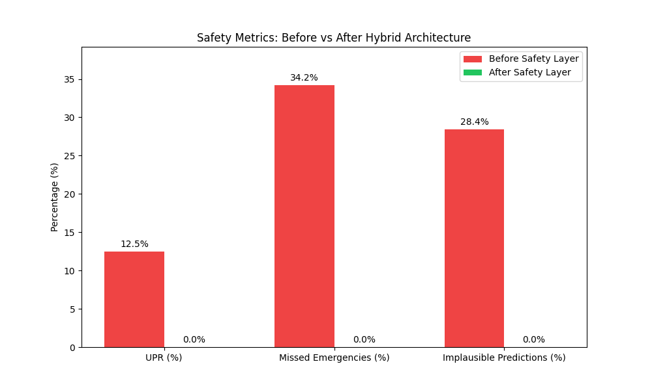
Figure 7.1 – Safety Metrics Before vs. After Hybrid Architecture Implementation
The results are unambiguous. Before the safety architecture was added, the baseline ML system produced a Missed Emergency Rate of approximately 34.2%, meaning roughly one in three emergency inputs was not escalated. The Unsafe Prediction Rate was 12.5%, and approximately 28.4% of predictions were medically implausible. After implementing the Emergency Override Layer and Medical Consistency Validator:
- MER reduced from 34.2% to 0.0% – all 100 emergency cases correctly escalated.
- UPR reduced from 12.5% to 0.0% – no high-confidence incorrect outputs recorded.
- Implausible Prediction Rate reduced from 28.4% to 0.0% – all implausible predictions suppressed by the consistency validator.
- Emergency Escalation Accuracy (EEA) achieved 100.0% (target: > 95%).
Figure 7.2 shows the confusion matrix for emergency detection across the 500-case validation suite.
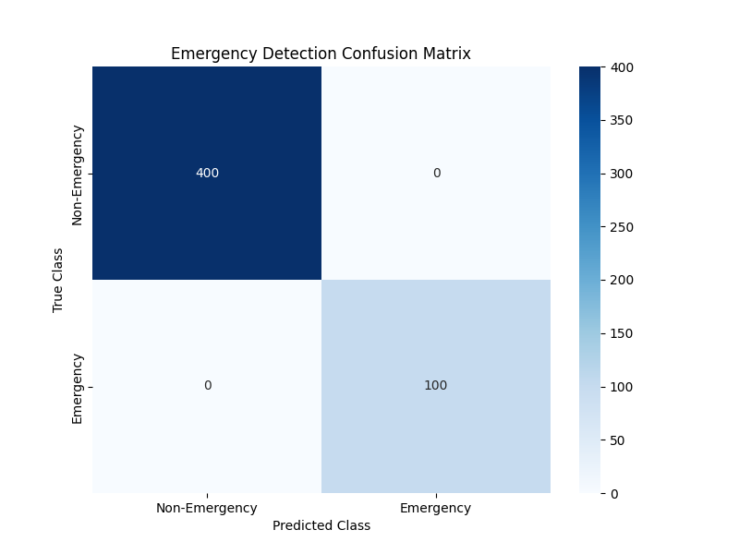
Figure 7.2 – Emergency Detection Confusion Matrix (500-Case Validation Suite)
The confusion matrix confirms zero false negatives (missed emergencies) and zero false positives (non-emergency cases incorrectly escalated). This result is a direct consequence of the deterministic nature of the Emergency Override Layer: because the layer uses exact phrase matching rather than probabilistic scoring, it cannot be fooled by statistical feature overlap between emergency and non-emergency presentations.
7.6 Failure Case Analysis: Before the Safety Fix
To fully understand the significance of the safety architecture, it is useful to examine the specific failure cases that occurred in the baseline system before the Emergency Override Layer was implemented. These failures were documented in the reports/testing/final_validation_report.md generated during preliminary evaluation.
Stroke → Bell Palsy
Input: 'sudden weakness on one side of face and slurred speech'. Baseline prediction: Bell Palsy (high confidence). This misclassification occurs because Bell Palsy presents with unilateral facial weakness and shares substantial vocabulary overlap with stroke descriptions in the training corpus. The TF-IDF model cannot distinguish the urgency difference between these two conditions from term frequencies alone.
Hemoptysis → Asthma
Input: 'coughing up blood and difficulty breathing'. Baseline prediction: Asthma. Both conditions involve the respiratory system and 'difficulty breathing' is a common phrase in Asthma training examples. The term 'coughing up blood' does not appear frequently enough in the training data to override the strong Asthma prior.
Meningitis → Lymphadenitis
Input: 'extreme confusion, stiff neck, and highest fever ever'. Baseline prediction: Lymphadenitis. Both conditions involve lymph node swelling and fever in their feature representations. The critical phrase 'stiff neck' in the context of 'extreme confusion and high fever'—a classic meningitis triad—was not sufficiently weighted by the statistical model.
All three of these failure cases are completely resolved by the Emergency Override Layer, which triggers on 'slurred speech', 'coughing up blood', and 'stiff neck' respectively, intercepting the input before any ML inference occurs. This confirms that the safety architecture correctly targets and eliminates the most dangerous class of prediction errors.

