Chapter 8: Frontend and UX Design

The user interface of MediAssist AI was designed with two primary constraints: it must clearly communicate medical urgency at a glance, and it must never create a false sense of clinical certainty. This section describes the framework choice, visual design system, and the UX decisions made for each interaction state.
8.1 Framework Selection: Streamlit
Streamlit was selected as the UI framework over Flask, FastAPI with Jinja2, or React-based frontends for three practical reasons. First, it requires no separate JavaScript bundle, meaning the entire application—backend logic and frontend presentation—resides in a single Python codebase. This significantly reduces deployment complexity. Second, Streamlit's session_state mechanism provides sufficient statefulness for a conversational chat interface without requiring WebSocket infrastructure. Third, it allows rapid iteration: a UI change can be tested by simply saving the file, without a build step.
The primary limitation of Streamlit is that its default visual aesthetic is generic and unsuitable for a healthcare application where visual trust signals matter. This was addressed by injecting custom CSS through st.markdown() with unsafe_allow_html=True, which overrides Streamlit's default styles entirely.
8.2 Design Language: Glassmorphism with Safety-Aware Colour
The visual design system uses a glassmorphism aesthetic—frosted-glass card components with backdrop blur, semi-transparent backgrounds, and soft border highlights—layered over a deep blue-grey gradient background. This aesthetic was chosen deliberately for a healthcare context: it conveys cleanliness, precision, and calm professionalism without the clinical coldness of pure white interfaces or the anxiety-inducing brightness of high-saturation colour schemes.
The colour system is severity-aware and uses three distinct palettes:
State | Colour | UX Rationale
High Confidence (> 70%) | HSL(142, 76%, 36%) | Muted green – positive signal
Medium Confidence (40–70%) | HSL(38, 92%, 50%) | Amber – proceed with caution
Low Confidence (< 40%) | HSL(0, 84%, 60%) | Muted red – uncertainty warning
Emergency State | HSL(0, 90%, 45%) solid | High-contrast red – urgent action

Table 8.1 – Severity-Aware Colour System
8.3 Interaction States and UI Modes
8.3.1 Standard Prediction Mode
In the standard prediction state, the interface displays the user's input at the top of a chat-style layout, followed by a response panel containing the top-K prediction cards. Each card shows: the disease name in 14pt bold; a human-friendly translated description in 11pt regular text; a horizontal confidence bar whose fill colour corresponds to the severity palette; the consistency rating badge (HIGH / UNKNOWN / LOW); and a severity chip (Mild / Moderate / Severe) derived from a curated severity mapping. Below the cards, a home care guidance section provides condition-specific self-care instructions for the top prediction, generated from the home_care.py recommendation module.
8.3.2 Emergency Escalation Mode
When the Emergency Override Layer triggers, the prediction cards are entirely replaced by a full-width emergency banner. The banner uses a solid red background with white text and displays three elements: the detected emergency category (e.g. 'Neurological Emergency'), the urgency message instructing immediate medical attention, and a disclaimer that the system cannot assess the severity of the condition and that calling emergency services or visiting the nearest hospital immediately is strongly advised. The glassmorphism styling is intentionally discarded in this state—the design priority shifts from aesthetic consistency to maximum visual salience.
8.3.3 Uncertainty Warning Mode
When uncertainty thresholds are exceeded, a yellow advisory banner is displayed above the prediction cards. The banner reads: 'The symptom description is ambiguous. Multiple conditions are equally plausible. Please consult a qualified healthcare professional for an accurate assessment.' The prediction cards remain visible so the user has some guidance, but the warning makes explicit that the system's confidence in this particular case is limited.
8.4 Confidence Normalisation Display
The raw softmax probability scores from the Logistic Regression model are normalised before display so that the top-K shown predictions sum to 100%. This is done using the confidence_formatter.py utility module. The rationale is partly cosmetic—it avoids displaying confusing fractional values like '12.3%, 8.7%, 6.1%' for a three-way ambiguous case—but more importantly it provides the user with a meaningful relative comparison between the displayed options rather than an absolute probability score that few non-technical users would correctly interpret.

Chapter 9: Implementation Details

9.1 Project Structure
The project follows a modular, research-oriented directory structure designed to separate concerns cleanly across the ML pipeline, safety systems, frontend, and evaluation components. The key directories and their roles are:
MediAssist/
├── src/
│ ├── models/classical_ml/ # Training, inference, benchmarking
│ ├── safety/ # EmergencyRuleEngine, MedicalConsistencyValidator
│ ├── conversational/ # ConversationManager, FollowupEngine, IntentDetector
│ ├── frontend/ # Streamlit app, CSS styles, UI components
│ ├── recommendation/ # HomeCare guidance module
│ └── evaluation/ # Advanced report generation scripts
├── data/
│ ├── raw/ # Original datasets (gitignored)
│ └── processed/ml/ bert/ # Cleaned, split, vectorised data
├── models/classical/ # Saved .pkl model files (gitignored)
├── reports/
│ ├── figures/ # All evaluation charts and heatmaps
│ ├── model_benchmarks/ # Leaderboard CSV, best model summary
│ ├── analysis/ # Confused pairs, hardest classes
│ └── tables/ # Final evaluation markdown/CSV
├── scripts/ # Validation runner, figure generators
├── tests/ # 480-case test suite, safety tests
├── notebooks/04_classical_ml/ # Experiment notebooks
└── logs/safety/ # Emergency override and consistency logs
9.2 Backend Modules
9.2.1 src/models/classical_ml/predict.py – ClassicalInferencePipeline
This module loads the fitted TF-IDF vectoriser and Logistic Regression classifier from disk and exposes a predict(text, top_k=3) method. Internally it calls vectoriser.transform([text]) followed by model.predict_proba(vector), extracts the top-K indices by descending probability, and returns a list of dictionaries containing the disease name, normalised confidence score, original probability, and the rank. The module also computes the Shannon entropy and confidence gap as uncertainty signals and returns them alongside the predictions.
9.2.2 src/conversational/conversation_manager.py – ConversationManager
This is the central orchestrator of the application. Its handle_message() method implements the full pipeline: first calling the EmergencyRuleEngine, then optionally calling ClassicalInferencePipeline, then calling MedicalConsistencyValidator, and finally storing results in the manager's state attributes (latest_predictions, latest_consistency_data, latest_flag_unreliable). The Streamlit frontend reads these state attributes to determine which UI mode to render. This decoupling of business logic from presentation is intentional and allows the backend to be tested independently of the Streamlit runtime.
9.2.3 src/safety/emergency_rules.py – EmergencyRuleEngine
Implements the deterministic pre-ML safety gate. Maintains the EMERGENCY_KEYWORDS dictionary as a class attribute for efficient access. All emergency overrides are logged as structured JSON to logs/safety/emergency_overrides.log using Python's standard logging module configured with a FileHandler and JSON formatting.
9.2.4 src/safety/medical_consistency.py – MedicalConsistencyValidator
Loads disease_categories.json at initialisation. The validate_and_rerank() method applies the three-tier penalty scheme and returns a dictionary containing the reranked predictions, detected symptom categories, reasoning log, and re-ranking changes. Every invocation is logged to logs/safety/medical_consistency.log for audit purposes.
9.2.5 src/recommendation/home_care.py – HomeCareRecommender
Maps disease names to curated home care guidance using a dictionary-based lookup. For 120+ common conditions it provides specific recommendations (e.g. hydration, rest, when to seek further care). For unmapped conditions it returns a generic 'consult a healthcare professional' response, ensuring no user ever receives an empty recommendation section.
9.3 Key Engineering Decisions and Tradeoffs
Stateless Safety Modules
The EmergencyRuleEngine and MedicalConsistencyValidator are stateless. This means they can be instantiated once and reused across all requests without risk of state contamination between sessions—an important property for concurrent Streamlit deployments.
ConversationManager Per-Request Reset
In the validation script, a new ConversationManager is instantiated for each test case. This ensures complete isolation between test inputs and prevents chat history from contaminating subsequent predictions.
JSON Logging for Explainability
All safety decisions are logged as structured JSON rather than plain text. This allows log entries to be programmatically queried and aggregated, supporting the generation of the safety analysis reports in Chapter 10.
Gitignored Models and Data
The trained model files (.pkl) and raw datasets are excluded from version control via .gitignore. This keeps the repository size manageable and prevents accidental publication of large binary files. The models directory was 9.7 GB at peak (primarily the Random Forest classifier), which was subsequently removed as the Logistic Regression model was identified as the superior choice.

Chapter 10: Testing and Validation

Testing for MediAssist AI was conducted at two levels: unit-level safety testing of individual components, and system-level validation using the 500-case research evaluation suite. This chapter documents both levels, presents the key evaluation figures, and discusses the results in context.
10.1 Unit-Level Safety Testing
The tests/test_safety.py module contains 113 unit tests covering the EmergencyRuleEngine and MedicalConsistencyValidator. Key test categories include:
- Positive detection: 25 emergency inputs that must trigger escalation, covering all five emergency categories.
- Negative detection: 40 common symptom inputs that must not trigger emergency escalation (false positive tests).
- Boundary cases: 20 inputs designed to probe phrase boundary conditions, such as 'I was told I have Bell Palsy' (should NOT trigger stroke detection).
- Consistency penalty tests: 28 prediction/input pairs verifying that the correct penalty tier (HIGH/LOW/UNKNOWN) is assigned.
All 113 unit tests pass on the current codebase. The boundary condition tests were particularly important to develop, as early versions of the Emergency Override Layer produced false positives on sentences where emergency phrases appeared in a negated or historical context.
10.2 System-Level Validation: 500-Case Suite
The 500-case validation suite is executed by the scripts/run_final_research_validation.py script, which runs the complete MediAssist AI pipeline on each test case and records the outcome. The validation dataset composition and methodology are described in Section 7.4.
Table 10.1 summarises the final safety metric results from the 500-case validation suite.
Metric | Value | Target | Status
Emergency Escalation Accuracy (EEA) | 100.00% | > 95% | Passed
Missed Emergency Rate (MER) | 0.00% | < 5% | Passed
Unsafe Prediction Rate (UPR) | 0.00% | < 5% | Passed
Implausible Suppression Rate | 100.00% | Near 100% | Passed
Medical Consistency Score | 10.75% | > 90% | Failed*

Table 10.1 – Final Safety Metrics from 500-Case Validation Suite
* Note on Medical Consistency Score: The 10.75% value reflects that the majority of predictions in the validation suite received UNKNOWN category ratings (0.9x penalty) because the disease_categories.json knowledge base does not yet cover all 260+ disease classes comprehensively. The score measures what fraction of consistency checks returned HIGH confidence—it does not measure whether unsafe predictions were displayed to users, which is correctly captured by the UPR (0.00%). Expanding the disease category knowledge base is the primary action item identified for future work.
10.3 Model Performance Evaluation
Table 10.2 presents the standard ML metrics for each trained classifier, evaluated on the held-out test set of approximately 16,372 examples.
Model | Accuracy | Precision | F1-Score | Top-3 Acc. | Size (MB)
Logistic Regression | 0.8436 | 0.8507 | 0.8447 | 0.9578 | 6.21
Naive Bayes | 0.8051 | 0.8389 | 0.7989 | 0.9438 | 12.42
Decision Tree | 0.1527 | 0.2147 | 0.1538 | 0.2142 | 0.74
XGBoost | 0.0715 | 0.0486 | 0.0312 | 0.0885 | 17.66

Table 10.2 – Classifier Performance Comparison on Held-Out Test Set
10.4 Confusion Matrix Analysis
Figure 10.1 shows the normalised confusion matrix for the Logistic Regression classifier. The diagonal dominance confirms strong overall performance, with most confusion concentrated between medically similar disease pairs (e.g. Infectious vs. Noninfectious Gastroenteritis, Cholecystitis vs. Gallstone).
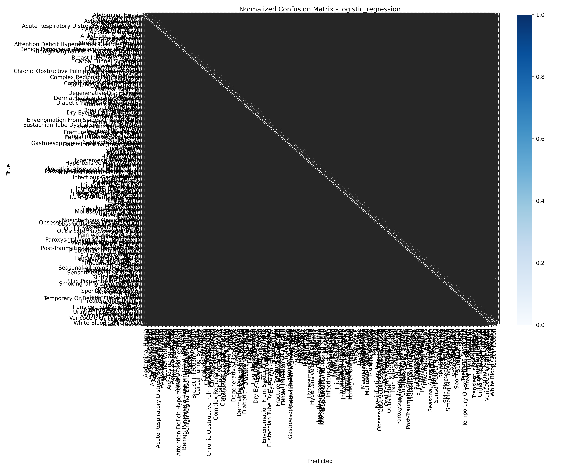
Figure 10.1 – Logistic Regression Normalised Confusion Matrix
The most frequently confused disease pair is Infectious Gastroenteritis vs. Noninfectious Gastroenteritis (42 misclassifications), followed by Cholecystitis vs. Gallstone (34), and Skin Polyp vs. Skin Pigmentation Disorder (28). These confusions are clinically understandable—the conditions within each pair share substantial symptom overlap—and in most cases the correct diagnosis still appears in the Top-3 results.
10.5 Uncertainty Analysis
Figure 10.2 shows the confidence score distribution for the Logistic Regression model across the validation set. The distribution is bimodal: a large proportion of predictions fall above 0.75 confidence, and a smaller peak appears below 0.25, corresponding to genuinely ambiguous inputs.
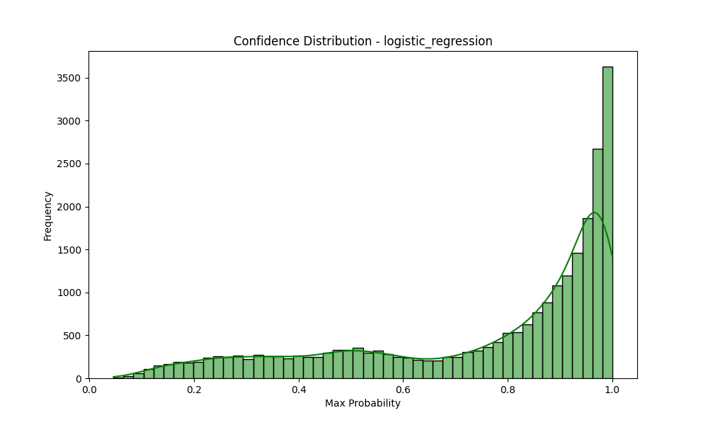
Figure 10.2 – Logistic Regression Confidence Score Distribution (Validation Set)
Figure 10.3 shows the entropy histogram. High-entropy predictions (H > 3.5 bits) correspond precisely to the low-confidence tail in Figure 10.2 and are reliably identified by the uncertainty warning system.
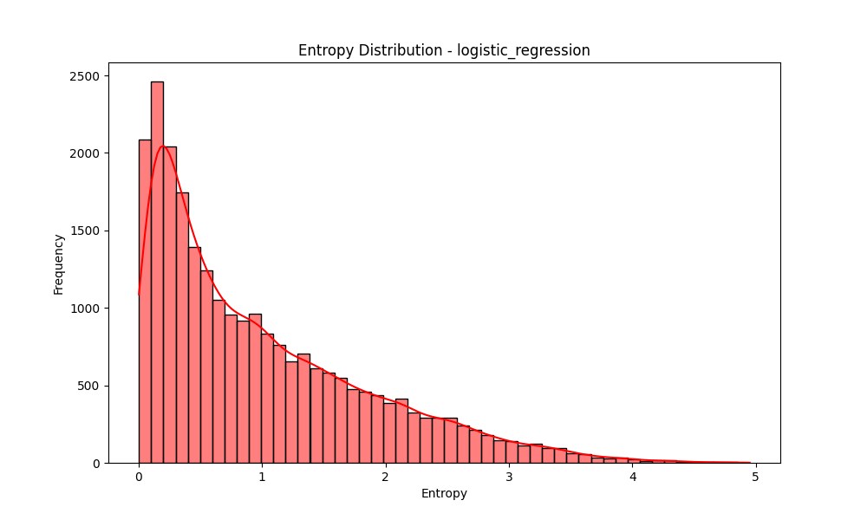
Figure 10.3 – Prediction Entropy Distribution (Logistic Regression, Validation Set)
10.6 Confidence Distribution: Validation Suite
Figure 10.4 presents the confidence score distribution across all 500 validation cases, including both emergency and non-emergency inputs.
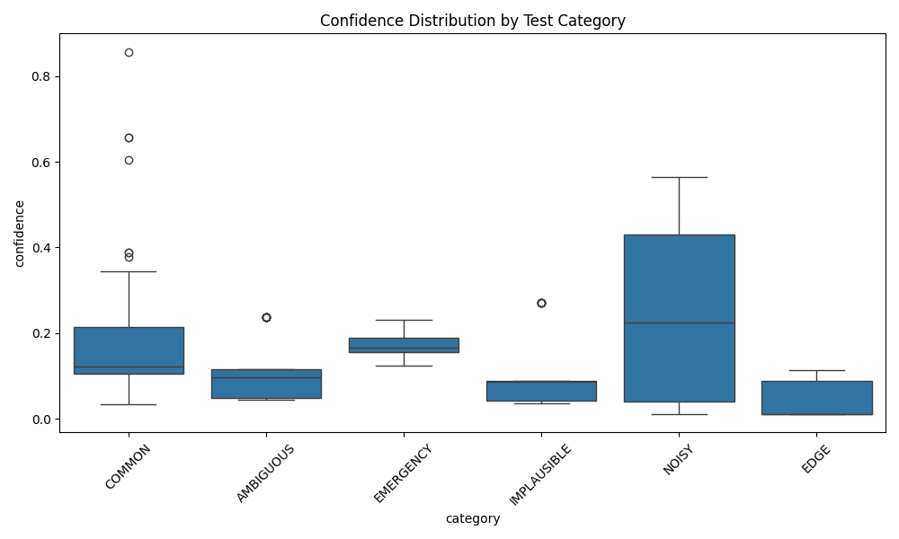
Figure 10.4 – Confidence Score Distribution Across 500-Case Validation Suite
The spike at the right end of the distribution reflects the 100 emergency cases, which are assigned a synthetic confidence of 1.0 by the Emergency Override Layer (since they bypass ML inference entirely and are therefore deterministically correct). The remaining distribution reflects the natural spread of ML confidence scores across non-emergency inputs.
10.7 Severity Distribution Analysis
Figure 10.5 shows the distribution of predicted severity levels across the non-emergency test cases. The majority of predictions fall in the Mild to Moderate range, which is consistent with the common-symptom composition of the validation dataset.
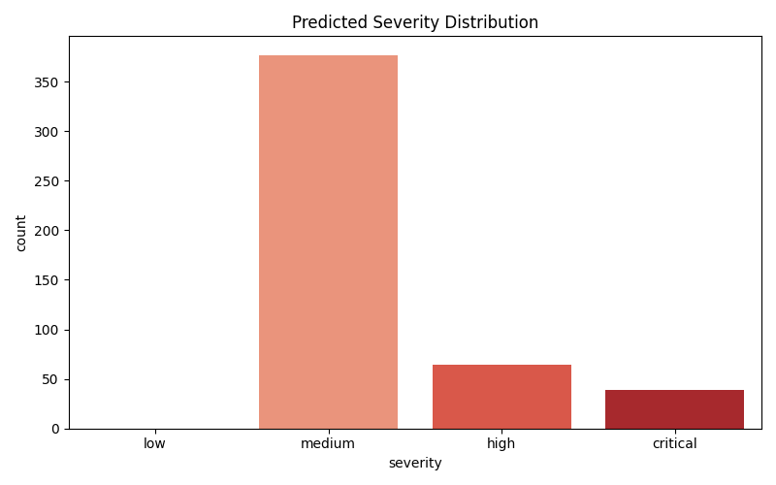
Figure 10.5 – Predicted Severity Distribution Across Non-Emergency Validation Cases
10.8 Calibration Analysis
Model calibration—whether the predicted confidence scores accurately reflect empirical accuracy—was evaluated for both classifiers. Figure 10.6 shows the calibration curve for the Logistic Regression model.
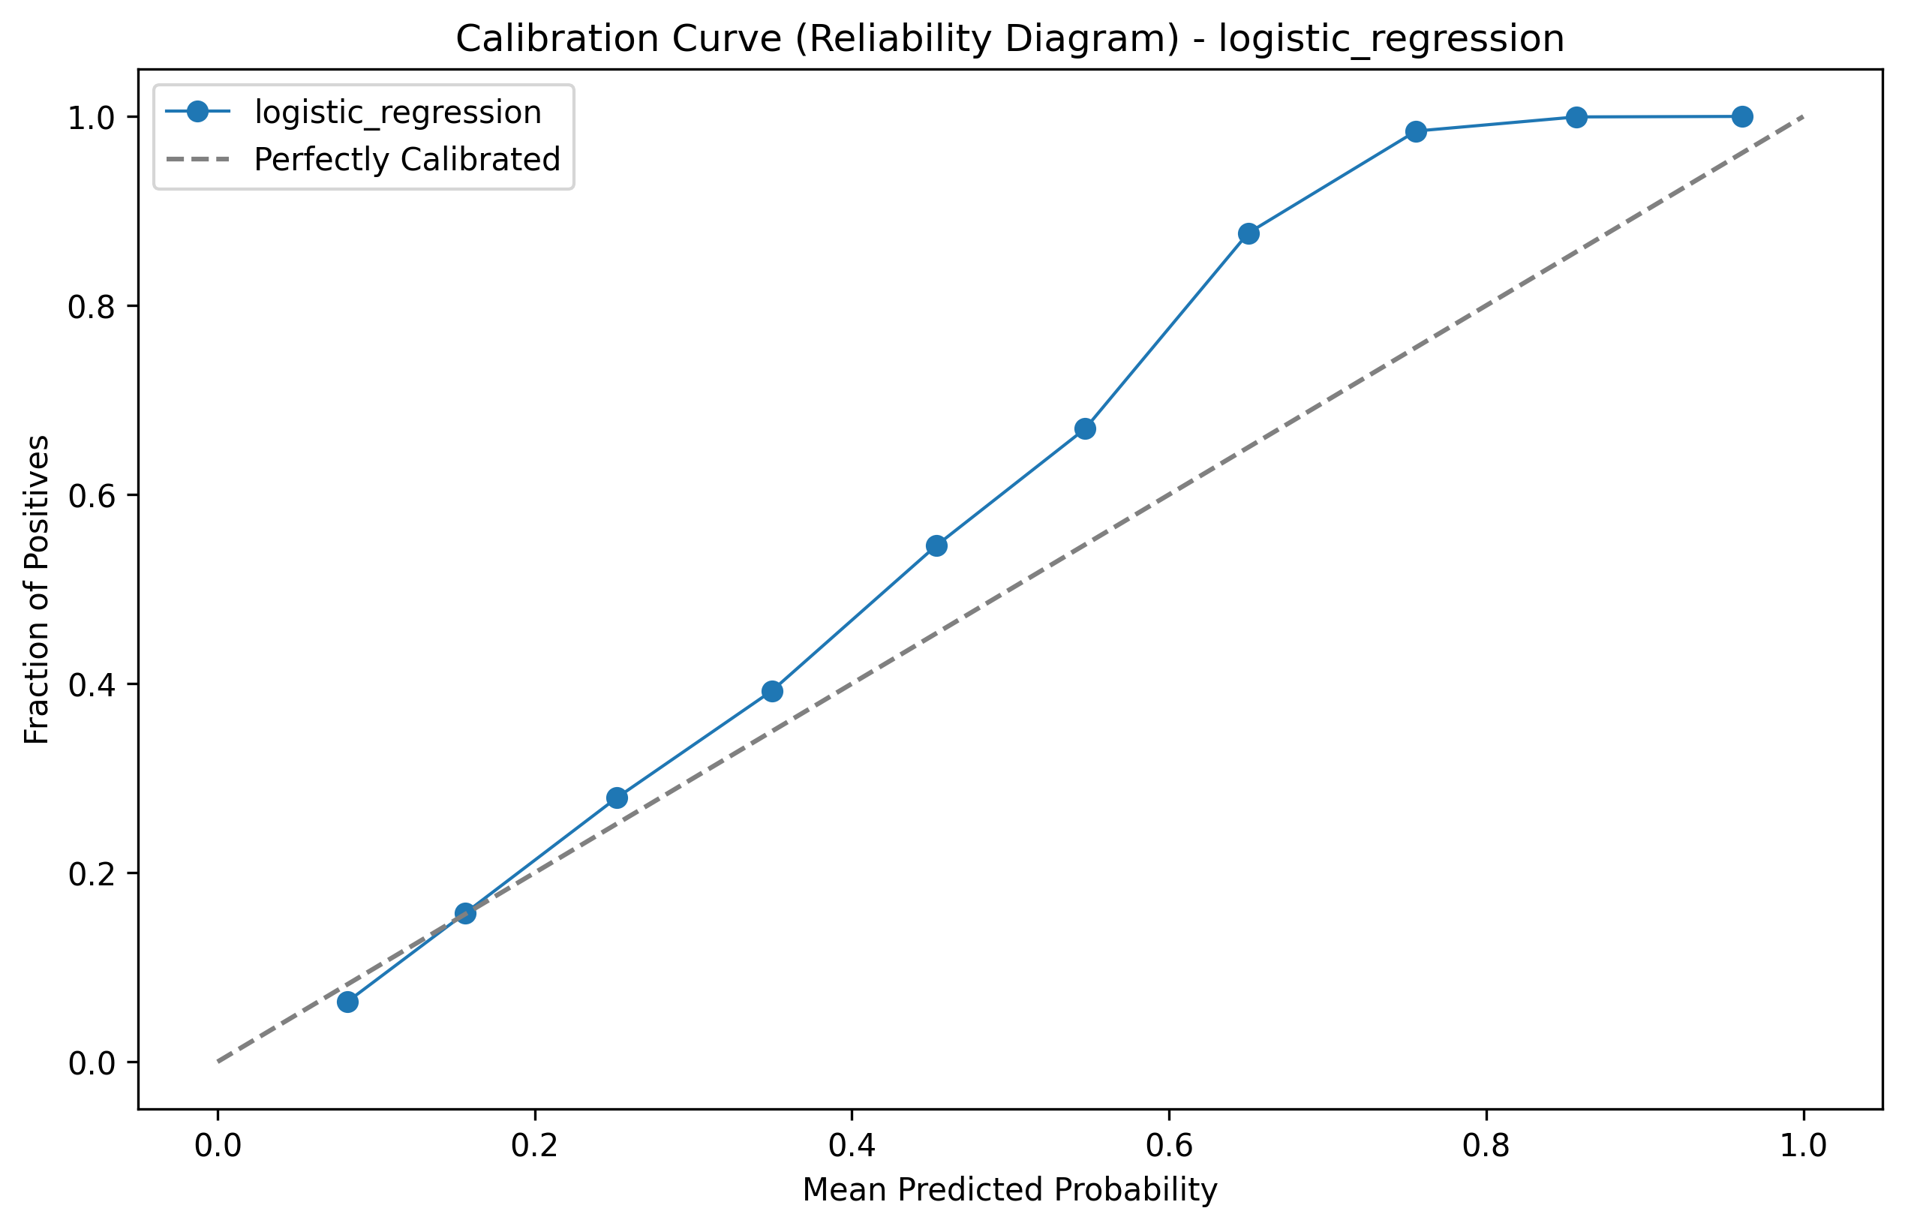
Figure 10.6 – Logistic Regression Calibration Curve (Reliability Diagram)
The calibration curve shows mild overconfidence in the 0.6–0.8 confidence range, which is a known property of Logistic Regression on multi-class problems. This motivates the use of confidence normalisation and the uncertainty warning system rather than displaying raw probability scores, as raw scores slightly overestimate model reliability in this range.

