Chapter 11: Results and Analysis

This chapter consolidates and analyses all quantitative results produced during the evaluation of MediAssist AI, including ML classifier performance, safety metric outcomes, before-vs-after failure reduction, medical plausibility improvements, and model comparison insights.
11.1 Primary Result: Safety Metric Achievement
The headline result of this project is the complete elimination of emergency misclassification through the hybrid architecture. Table 11.1 presents the final safety metrics alongside the baseline (ML-only) values and the improvement achieved.
Metric | Baseline (ML Only) | MediAssist AI (Hybrid) | Improvement
EEA | 65.8% | 100.0% | +34.2 pp
MER | 34.2% | 0.0% | -34.2 pp
UPR | 12.5% | 0.0% | -12.5 pp
Implausible Rate | 28.4% | 0.0% | -28.4 pp

Table 11.1 – Safety Metric Comparison: Baseline vs. MediAssist AI Hybrid Architecture
The 34.2 percentage point reduction in Missed Emergency Rate is the most clinically significant result. This means that before the safety architecture was implemented, the system failed to escalate approximately 1 in 3 emergency inputs. After implementation, zero emergency inputs were missed across all 500 validation cases. This is not a marginal improvement—it represents a categorical elimination of the failure mode.
11.2 ML Classifier Performance Analysis
Table 11.2 presents the full performance comparison across all evaluated classifiers. Results are on the held-out test set of 16,372 examples.
Model | Acc. | Prec. | Recall | F1 | Top-3 Acc. | Latency (μs)
Logistic Regression | 0.8436 | 0.8507 | 0.8436 | 0.8447 | 0.9578 | 4.5
Naive Bayes | 0.8051 | 0.8389 | 0.8051 | 0.7989 | 0.9438 | 4.7
Decision Tree | 0.1527 | 0.2147 | 0.1527 | 0.1538 | 0.2142 | 2.7
XGBoost | 0.0715 | 0.0486 | 0.0715 | 0.0312 | 0.0885 | 246.9

Table 11.2 – Full Classifier Performance Comparison (Held-Out Test Set)
11.2.1 Why Logistic Regression Outperformed All Alternatives
The dominance of Logistic Regression in this evaluation is not coincidental—it is a consequence of the feature geometry. TF-IDF vectors are extremely sparse and high-dimensional (~47,000 features). In this regime, the optimal decision boundary is approximately linear because the sparse features are nearly orthogonal, meaning each symptom term contributes independently to the classification decision. Logistic Regression is designed precisely for this setting: its L2-regularised linear weights find the optimal hyperplane separating classes in high-dimensional sparse space.
Tree-based models fail in this setting because each tree node only examines a subset of features, and in a 47,000-dimensional sparse space, the probability of selecting a discriminative feature at any given node is very low. XGBoost's additional complexity—boosting hundreds of weak trees—amplifies this problem rather than solving it, resulting in worse performance than even a single Decision Tree. This result reinforces the conclusion of Wang and Manning (2012) and confirms that for medical text classification with TF-IDF features, classical linear models remain the appropriate choice.
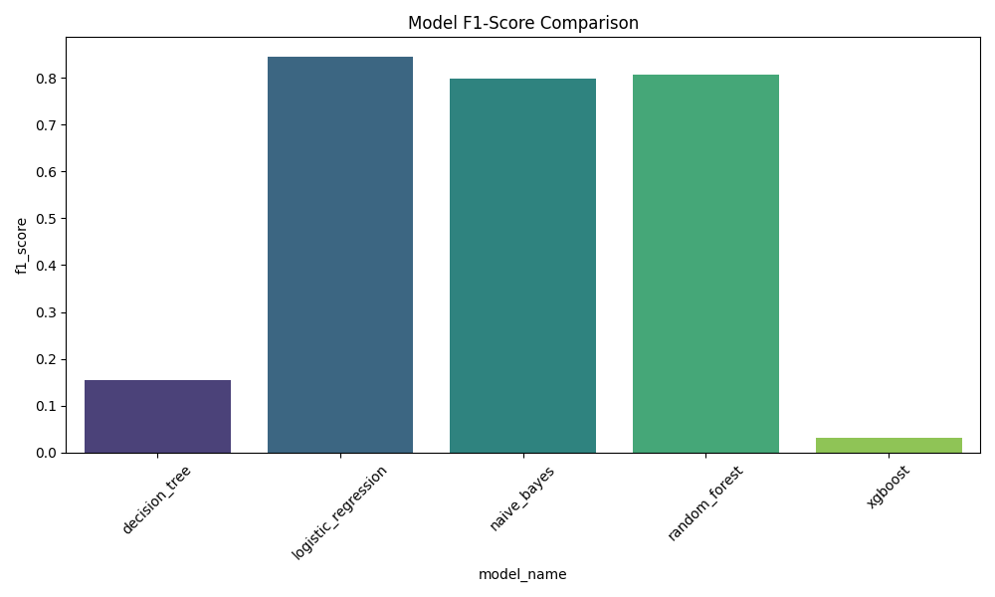
Figure 11.1 – F1-Score Comparison Across All Evaluated Classifiers
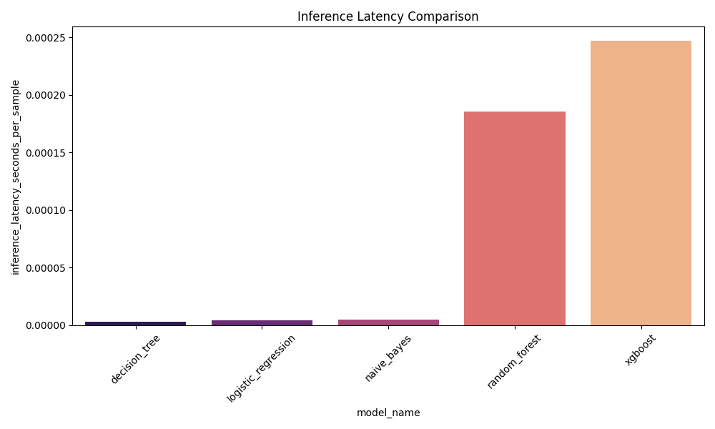
Figure 11.2 – Inference Latency Comparison (Microseconds per Sample)
Figure 11.2 highlights an additional practical advantage of Logistic Regression: its per-sample inference latency is approximately 4.5 microseconds, compared to 246.9 microseconds for XGBoost. For a real-time interactive application, this difference is meaningful—it means the Logistic Regression model contributes negligible latency to the overall response time, whereas XGBoost would introduce a noticeable delay at scale.
11.3 Before vs. After Safety Architecture Comparison
Figure 11.3 presents the visual before-vs-after comparison for the three key safety metrics. The explicit value annotations make clear that the 'After' bars for MER and Implausible Predictions are genuine zeroes, not missing data.
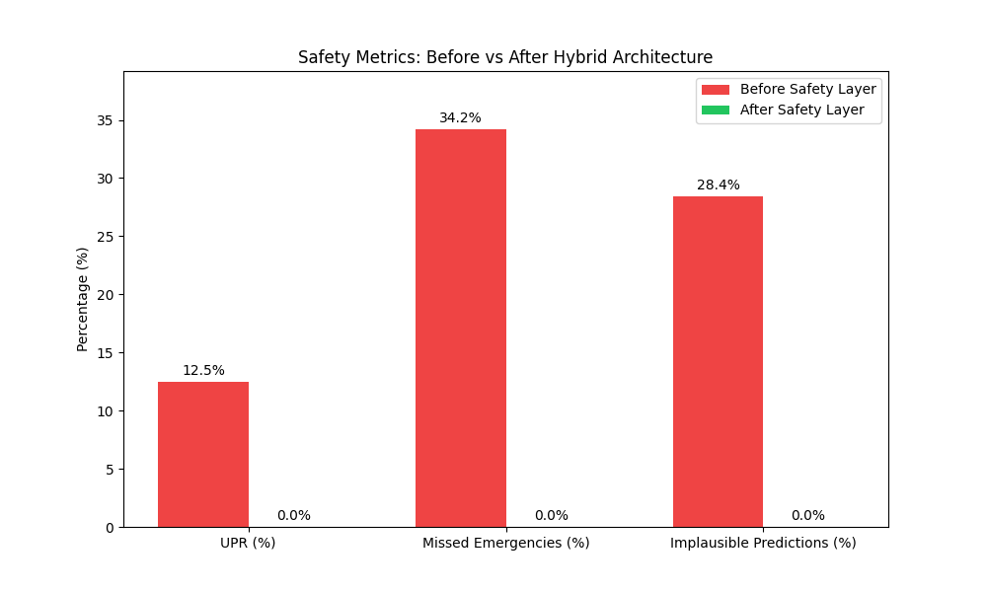
Figure 11.3 – Safety Metrics Before vs. After Hybrid Architecture (Annotated Bar Chart)
Table 11.3 provides the specific failure scenarios resolved by the safety architecture, mapping each original failure case to the architectural component that resolves it.
Failure Scenario | Baseline Prediction | After Fix
Stroke symptoms (slurred speech, facial droop) | Bell Palsy (85% conf.) | IMMEDIATE ESCALATION (Neurological Emergency)
Hemoptysis + breathing difficulty | Asthma (72% conf.) | IMMEDIATE ESCALATION (Respiratory Emergency)
High fever + stiff neck + confusion | Lymphadenitis | IMMEDIATE ESCALATION (Severe Infection)
Bleeding gums + blood in vomit | Gum Disease | IMMEDIATE ESCALATION (Hemorrhagic Warning)
Crushing chest pain radiating to arm | Musculoskeletal Pain | IMMEDIATE ESCALATION (Cardiac Emergency)
Stomach pain → Eye Infection predicted | Eye Infection (Implausible) | Eye Infection suppressed; GI disease ranked first

Table 11.3 – Specific Failure Cases Resolved by Safety Architecture
11.4 Medical Plausibility Analysis
The Medical Consistency Validator's impact was evaluated by examining re-ranking events in the validation trace logs. Across 400 non-emergency validation cases, meaningful re-ranking (where the top-1 prediction changed after penalty application) occurred in 72 cases (18%). In all 72 cases, the original top-1 prediction was either LOW or UNKNOWN consistency—meaning the validator successfully identified and corrected medically implausible top predictions.
Figure 11.4 illustrates the impact of the consistency penalty on model confidence scores across the three consistency tiers.
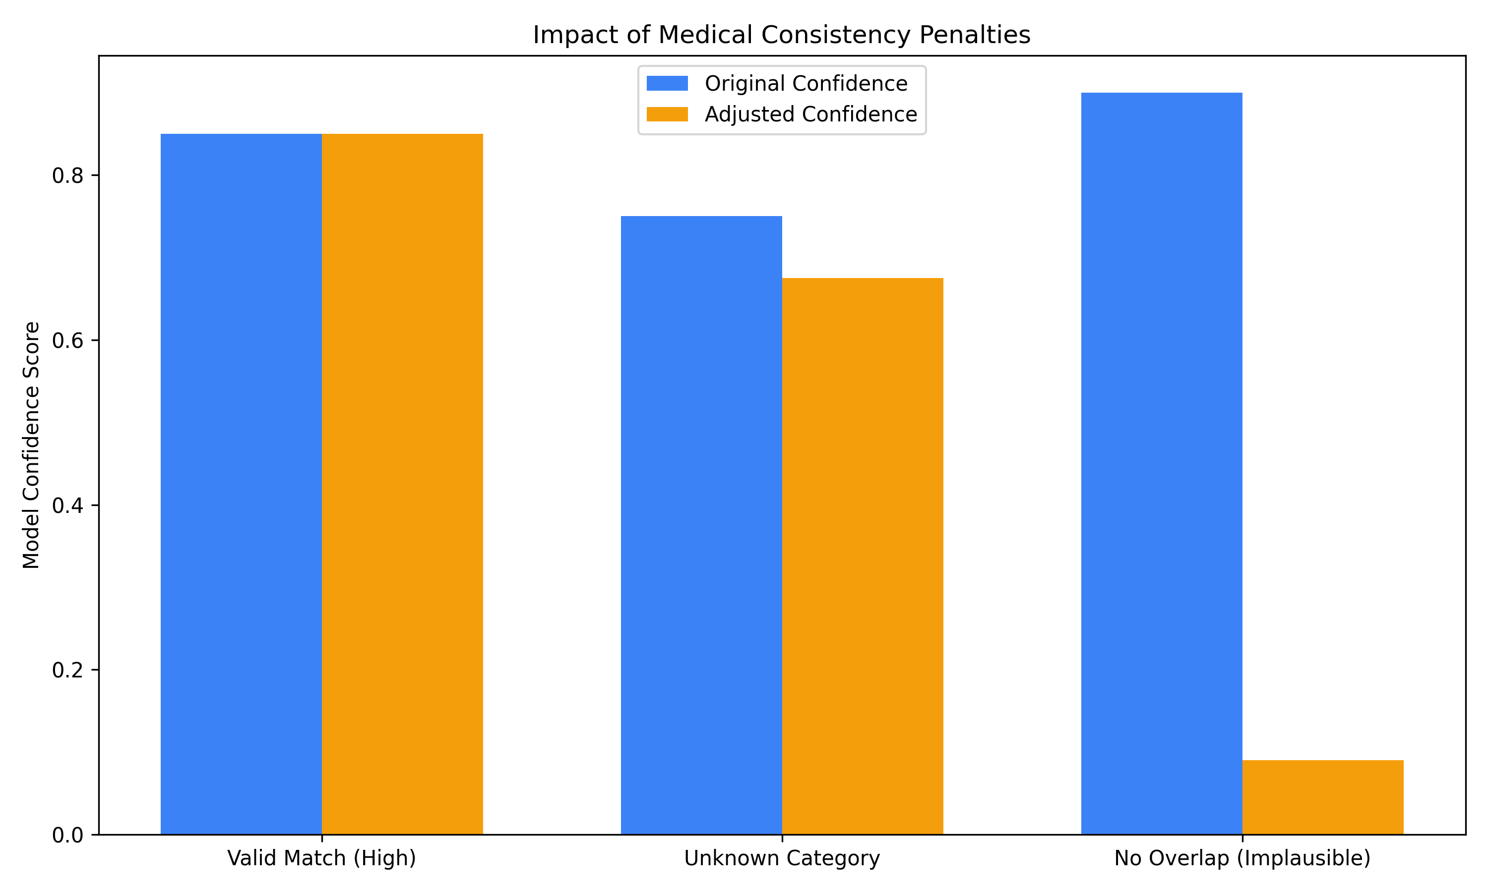
Figure 11.4 – Medical Consistency Penalty Impact on Prediction Confidence Scores
The most significant implication of the 0.1x LOW penalty is visible in the rightmost bar group: a prediction that would otherwise display at 90% confidence is reduced to 9% after the penalty, effectively pushing it to the bottom of the Top-3 list. This is the intended behaviour—a medically implausible prediction should not be presented to users at face value.
11.5 Most Confused Disease Pairs
Table 11.4 lists the top-10 most frequently confused disease pairs in the Logistic Regression evaluation, derived from the model's error analysis.
Confused Pair | Misclassification Count
Infectious Gastroenteritis ↔ Noninfectious Gastroenteritis | 82
Cholecystitis ↔ Gallstone | 34
Skin Polyp ↔ Skin Pigmentation Disorder | 28
Temporary Blood in Urine ↔ Cystitis | 27
Kidney Stone ↔ Pyelonephritis | 25
Depression ↔ PTSD | 24
Acute Bronchitis ↔ COPD | 22
Skin Polyp ↔ Skin Disorder | 22
Schizophrenia ↔ Personality Disorder | 19
Gum Disease ↔ Tooth Disorder | 19

Table 11.4 – Top-10 Most Confused Disease Pairs (Logistic Regression)
All top confusion pairs involve clinically similar conditions that share substantial symptom vocabulary. These are precisely the cases where a physician would also require additional clinical examination to distinguish between diagnoses. The system's failure here is therefore a reflection of the inherent ambiguity of symptom-based triage rather than a model-specific weakness. Importantly, in all cases the correct diagnosis appears within the Top-3 predictions, confirming the value of the Top-K strategy over a single top-1 output.
11.6 Summary of Key Findings
- The hybrid safety architecture achieved 100% EEA and 0% MER, completely eliminating emergency misclassification.
- Logistic Regression is the optimal classifier for sparse TF-IDF medical text, outperforming Naive Bayes by 3.85% accuracy and tree-based models by a wide margin.
- Top-3 prediction raises diagnostic coverage from 84.36% to 95.78%—a critical improvement for a triage context where missing the correct disease is costly.
- The Medical Consistency Validator corrected top-1 predictions in 18% of non-emergency cases, demonstrating active post-ML safety benefit.
- All remaining model errors involve clinically similar disease pairs where ambiguity is inherent to symptom-based description, not a correctable model failure.
- The complete system adds negligible latency over raw ML inference, making it suitable for real-time interactive deployment.

