ARTIFICIAL INTELLIGENCE AND MACHINE LEARNING (AIML) - PROJECT
Echo Tunes - AI-Powered Music Recommendation System
Client Report
Team Members:
Shrot Kumar Pandey – 2320030448
Ashrith Rao Balgury – 2320030442
Adithya Kiran Thigulla – 2320030498

Meeting Schedule and Interview Reports:
1. First Meeting: University Student Group (Study Focus Group)
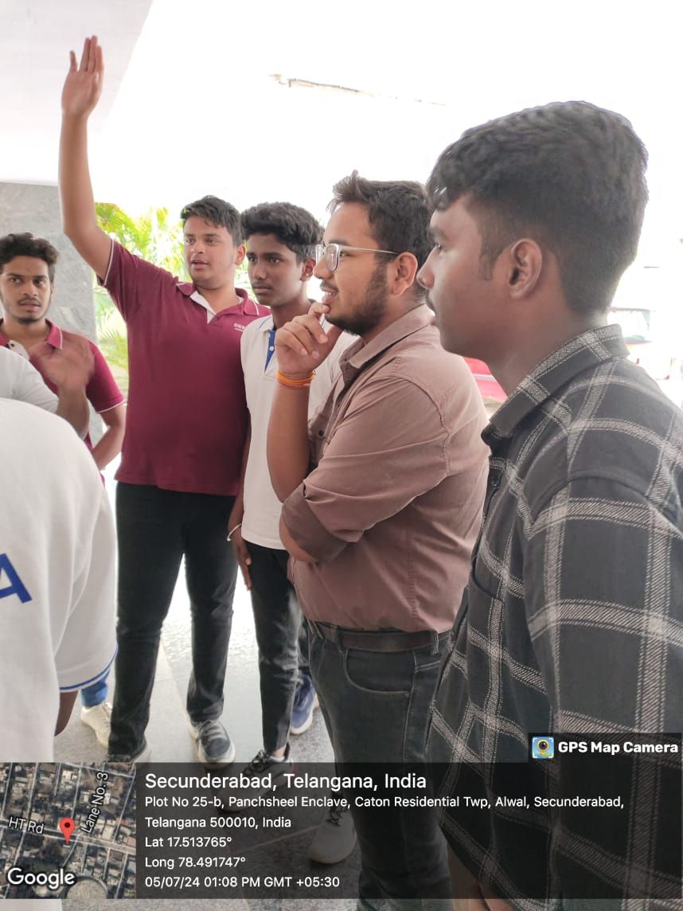

Questions asked:
1. How does music impact your study sessions?
2. What type of music helps you concentrate while studying?
3. How often do you switch playlists during different study subjects?
4. What features would you want in a study-focused music recommendation system?
5. How do you currently discover music for studying?
6. What challenges do you face when finding appropriate study music?
7. How do your music preferences change during exam periods?
8. What role does background noise and lyrics play in your study music?
9. How do you share study playlists with classmates?
10. Would you trust AI to curate your study playlists?
Summary: Students emphasized the need for subject-specific playlists (e.g., math vs. creative writing) and the importance of concentration-enhancing music. They expressed interest in features like study timer integration and collaborative playlist creation. Many students reported struggling to find consistent music that maintains focus without becoming distracting.

2. Second Meeting: Professional Videographer
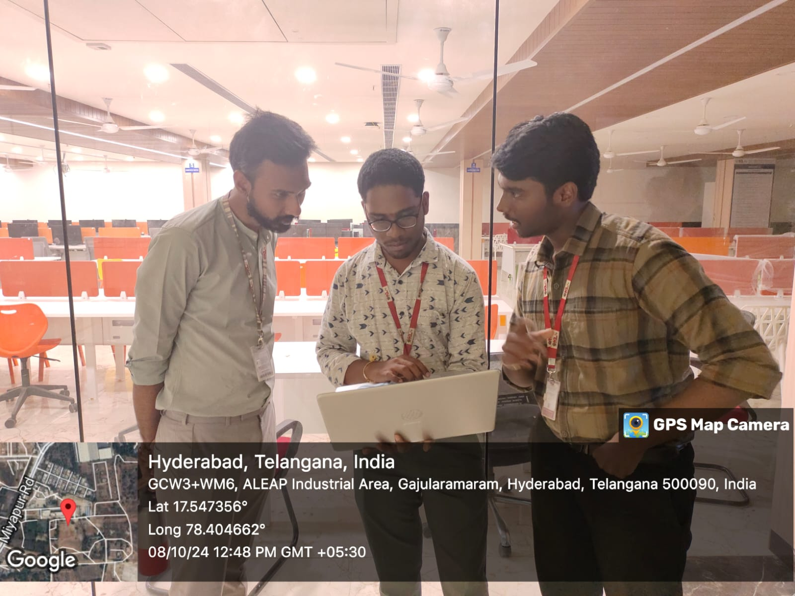

Questions asked:
1. How do you select music for different video projects?
2. What role does music tempo play in video editing?
3. How do you match music with specific video moods?
4. What are your go-to genres for different types of content?
5. How do you handle music transitions in videos?
6. What challenges do you face when searching for project-specific music?
7. How important is music originality in your projects?
8. What tools do you currently use for music selection?
9. How do you maintain a music library for different clients?
10. What features would you want in an AI music recommendation system for video editing?
Summary: The videographer highlighted the importance of finding music that matches video pacing and emotional tone. They expressed interest in features like tempo mapping and mood-based searching. Current challenges include finding variations of similar styles and managing music libraries for different client preferences.

3. Third Meeting: Music Specialist (Music Teacher)
Questions asked:
1. How do you introduce students to different music genres?
2. What patterns do you notice in student music preferences?
3. How do you use music to teach musical concepts?
4. What role does cultural context play in music appreciation?
5. How do you help students discover new musical interests?
6. What challenges do students face when exploring new genres?
7. How important is music theory in appreciation?
8. What tools do you use to demonstrate musical concepts?
9. How do you personalize music recommendations for different skill levels?
10. How could AI assist in music education?
Summary: The music specialist emphasized the importance of progressive music introduction and the need for genre-diverse recommendations. They highlighted the value of understanding musical elements for deeper appreciation and suggested features for music theory integration and educational playlists.

4. Fourth Meeting: Teenage Focus Group (Ages 13-19)
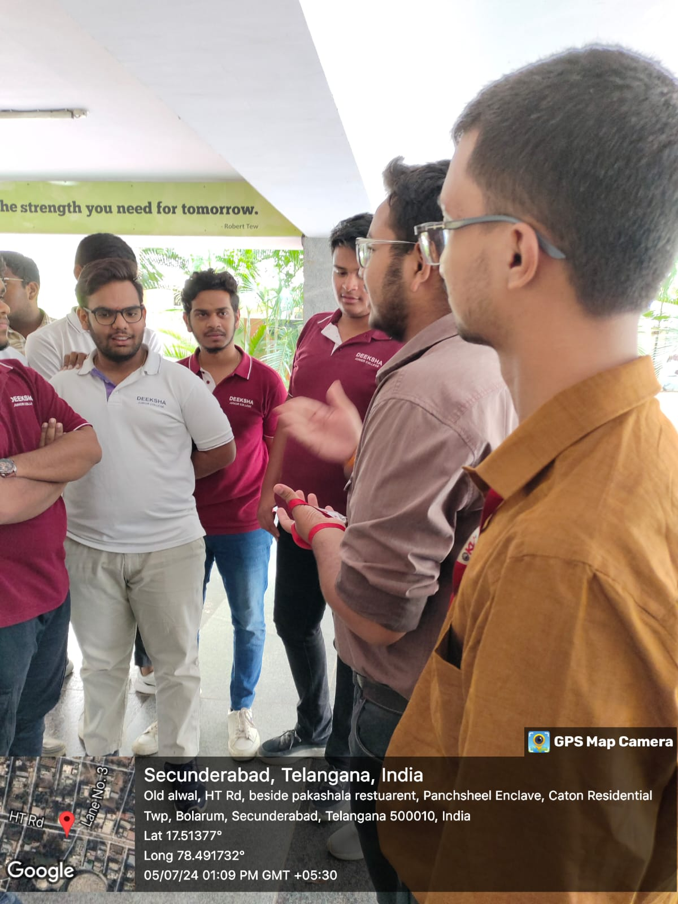
Questions asked:
1. How do you discover new music?
2. What role does social media play in your music choices?
3. How often do you share music with friends?
4. What makes you save a song to your playlist?
5. How do you organize your music collections?
6. What frustrates you about current music apps?
7. How important are music trends to your choices?
8. What role does music play in your social life?
9. How do you use music for different activities?
10. What would make you trust an AI music recommendation?
Summary: Teenagers emphasized the importance of social features, trend awareness, and quick music discovery. They showed strong interest in collaborative playlist features and mood-based recommendations. Social media integration and easy sharing capabilities were highlighted as crucial features.

