**Population and Agricultural land analysis**

**Adithya Othayoth**

Student ID: 21059393

Abstract

The number of people in the world has a major role in the agricultural area. If a country cannot produce its own crops and having large number of people living in the country, then it will lead to poverty. Here in the report, the data set is used to find out the agricultural area in each selected country and the effects. The data set is collected from the World Bank for the analysis. Here urbanisation, agricultural land area, arable land area and CO2 emission due to solid fuels and population growth are analysed.

Git Hub repository

<https://github.com/AdithyaOthayoth/Statistics-and-Trends>

Urbanization is a great way to achieve the development of infrastructure of the country, the facilities experienced by the people, and so on. But on the other side, it has a greater effect on the environment. One of them is the reduction in agricultural land area. Since the food is an essential thing, agriculture is important in human life. If the agricultural area decreases and if crops cannot be cultivated enough for the people then, there can be a chance of poverty or demand in essential food items. Firstly, Urban population is analysed.

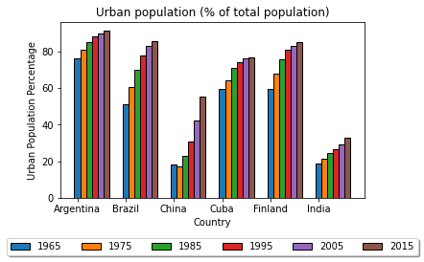

Figure 1: Urban Population bar graph

The bar graph (Figure 1) illustrates the total urban population in each country from 1965 to 2015. By using a bar graph, it is easy to understand the variation or growth in urban population over the period. From the bar graph, it is clear that urbanization has increased continuously in each country. It is majorly seen in Argentina, Brazil, and Finland. While India and china are having an urbanization percentage compared to the total population in a lesser amount. In India, it was around 20 percent in 1965 and increased to around 40 percent in 2015. China was having a tremendous change from 20 to nearly 60 percent from 1965 to 2015. In the case of Argentina, Brazil, and Finland, the peak point is above 80 percent which is in the year 2015.

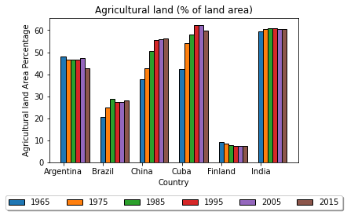

Figure 2: Agricultural land bar graph

The bar graph (Figure 2) illustrates the total agricultural land in each country during the period from 1965 to 2015. From the figure, it is clear that the countries which have higher urban populations have a less agricultural land area when compared to others. Here Argentina, Brazil, and Finland are having less agricultural area when compared to China and India. A great difference between urbanization and agricultural area can be seen in Finland and India. In India agricultural area is very much higher than the urban area. While in Finland it is the opposite. The urban area is higher than that of the agricultural area. The agricultural area is higher in Cuba and India around 60 percent. While in Finland, a decrementing trend can be seen. From the year 1965 to 2015, the agricultural land area decreased. This means, while increasing urbanization in Finland, the decrease in the agricultural area can be seen and this may cause demand.

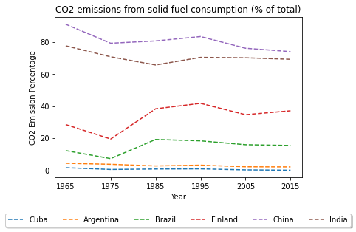

Figure 3: CO2 emissions Line graph

The line graph illustrates the CO2 emissions from solid fuel consumption in each country during the period from 1965 to 2015. By using a line graph the trends of each field can be represented in a single plot. From Figure 3, it is clear that the countries with lesser urban areas is having a high rate of CO2 emission, for example, China and India. The rate of CO2 emission in China and India has ups and downs. While in Brazil a drastic rise can be seen. So, the countries with fewer urban areas and with higher agricultural areas or rural areas is having a high level of CO2 emission from Solid Fuel consumption. Even though urbanization has problems like the destruction of agricultural land, it will not cause that much CO2 emissions from solid fuel consumption. Because solid fuels like wood, coal, etc. are seen more in rural areas, not in urban areas. Here India and China is having a higher rate around 80 percent.

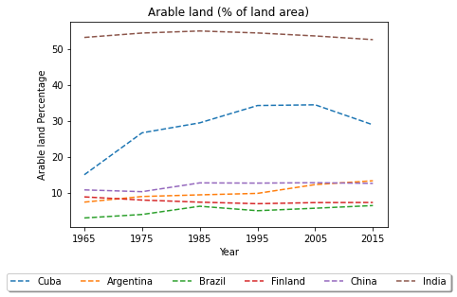

Figure 4: Arable land Line plot

From the previous bar graph, it is clear that Cuba, India, and China is having greater agricultural land. Temporary crops are also done greater in Cuba and India when compared to other countries. That is urbanization affects temporary crops also. By the use of this line graph, it was easy to understand the difference between the countries. By increasing the arable land areas, temporary crops can be cultivated. That is crop rotation can be done. By doing so, the fertility of the soil can be increased and weed control could be done. Here it is fewer in Brazil and Finland which is less than 10 percent. While India has more than 50 percent of arable land which will helps in soil nitrogen level raise and fertility of the soil. That will lead to a great agricultural environment in the country. But in Finland and Brazil the soil nitrogen, fertility, and other benefits of doing temporary crops will be reduced in large amount, which will affect the agriculture.

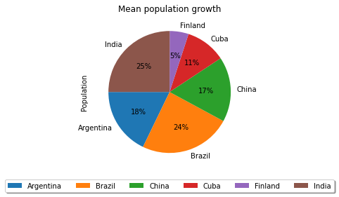

Figure 5: Mean Population Growth Pie chart

The pie chart represents the mean population growth in each country throughout the period from 1965 to 2015. By using the pie chart, it is easy to find out the value of population growth in each country. Here India is having highest population growth around 25% which is having larger agricultural area and lesser urban area. This means that even though the population is higher, the country is not urbanized majorly. While in the case of Brazil the population growth is 24% and urbanisation is higher in Brazil rather than doing agriculture. Finland is having only 5% of population growth and from the graphs, it is clear that Finland is more urbanized than having agricultural area.