AI Usage DISCLOSURE FORM

1. Team Details
Team Name: AICA
Project / Product Name: Janus
Organization / Institution (if any): Vellore Institute Of Technology, Vellore
Submission Date: 30th September 2026

2. AI Usage Declaration
Did your team use any Artificial Intelligence (AI) in developing this project? Yes / No
Yes

3. Purpose of AI Usage ( Brief Details)
Idea generation / brainstorming : Idea validation & better alternatives to current architecture
Code generation or assistance : Yes, Claude Code for efficient code generation
UI / UX design: N/A for the project
Content creation : NIL
Data analysis: Derive insights from the benchmark & evaluation kit outputs.
Testing / debugging : To run automated tests & debug
Other ________________________

4. Feature Origin Classification ( Please add/delete based on the number of the feature)
1. Feature Name: Single-Writer Event-Driven Kernel & Virtual Clock Scheduler
2. Self-Generated / AI-Generated / Both: Both
3. Description:
• AI tools/platform Used: Google Antigravity (Gemini 2.5 / 3.7 Pro & Flash
models)
• Prompt used: "Design a deterministic single-writer event loop for an
interruptible voice agent handling input/output queue batches, discrete
virtual-clock advancement, and non-blocking asynchronous worker task
orchestration."
• Output Summary: Produced the initial skeleton for batch event processing,
async task worker loops, and timestamped trace event logging.
• Modification: Hand-engineered strict deterministic batch ingestion,
custom tick step execution, error isolation, and integration with the
evaluation test harness.

1. Feature Name: Dual-Process Architecture & Fast-Path Floor Manager (<300ms)
2. Self-Generated / AI-Generated / Both: Both
3. Description:
• AI tools/platform Used: Google Antigravity (Gemini 2.5 Pro), Anthropic
Claude 3.5 Sonnet
• Prompt used: "Implement a dual-process voice agent architecture
separating sub-300ms fast-path acknowledgment/filler generation from
background slow-path LLM planning and tool execution."
• Output Summary: Generated conversational backchannel templates, filler
state machines, and background worker queue dispatchers.
• Modification: Added strict gating to eliminate false completion claims
(e.g., forbidding verbal "Done!" before slow-path tool verification), fine-
tuned response latency budgets, and added context-aware filler selection.

1. Feature Name: Transitive Invalidation Engine & Read-Set Dependency Tracking
2. Self-Generated / AI-Generated / Both: Both
3. Description:
• AI tools/platform Used: Google Antigravity (Gemini 3.7 Flash)
• Prompt used: "Create a dependency graph and fixpoint invalidation
algorithm where mid-utterance slot updates cascade through multi-step
chained tool calls and retract stale in-flight execution."
• Output Summary: Delivered a versioned FactStore, dependency index data
structures, and a fixed-point iteration loop (max 8 rounds) for cascading
invalidations.
• Modification: Implemented absence read-sets (PlanStep.absence_keys) for
unmentioned optional slots, added provenance tracking to derived facts, and
tied cancellation signals directly to active worker queues.

1. Feature Name: CommitGate Safety Layer & Settle Barrier (Zero-Duplicate Write
Control)
2. Self-Generated / AI-Generated / Both: Both
3. Description:
• AI tools/platform Used: Google Antigravity (Gemini 2.5 Pro), Claude
• Prompt used: "Construct an idempotency guard and commit gate enforcing
safety rules G1–G11 to block duplicate state-changing tool executions and
race conditions."
• Output Summary: Provided predicate filters validating schema schemas,
fingerprint matching, and in-flight deduplication.
• Modification: Designed and implemented the Settle Barrier (enforcing a
grace settling window after user end-of-turn to catch immediate self-
corrections before committing irreversible writes) and integrated
TimerWheel wake-up logic.

1. Feature Name: Fast Local Plan Rebinder & Disfluency Resolver
2. Self-Generated / AI-Generated / Both: Both
3. Description:
• AI tools/platform Used: Google Antigravity (Gemini 3.7 Pro), Claude
• Prompt used: "Write a fast-path local slot rebinder that updates existing
plan arguments without incurring a full LLM replan round-trip when the
execution structure remains unchanged."
• Output Summary: Provided slot substitution helpers and structural
dependency checkers for PlanStep definitions.
• Modification: Hardened the rebinder logic to handle spoken disfluencies
(hesitations, false starts, fillers) and bound parameter validation against
tool schemas with zero latency penalty.

1. Feature Name: Multimodal Perception & Visual Frame Grounding Pipeline
2. Self-Generated / AI-Generated / Both: Both,
3. Description:
• AI tools/platform Used: Google Antigravity (Gemini 2.5 Pro), Claude
• Prompt used: "Build a multimodal perception module that ingests video
frames/images in the background, extracts relevant context (OCR/object
attributes), and binds them to conversational slots."
• Output Summary: Generated image frame preprocessing, vision prompt
templates, and asynchronous perception result holders.
• Modification: Built evidence lease expiration logic (preventing stale
visual context from persisting across sessions) and integrated visual slot
grounding behind spoken audio acknowledgments.

1. Feature Name: Trace Checker & Invariant Conformance Test Suite (34 Safety
Rules)
2. Self-Generated / AI-Generated / Both: Both
3. Description:
• AI tools/platform Used: Google Antigravity (Gemini 2.5 Pro / 3.7 Flash), Claude
• Prompt used: "Create a comprehensive offline trace validator that checks
execution logs against 34 protocol, timing, cancellation, and safety
invariants."
• Output Summary: Generated automated verification scripts, timestamp delta
calculators, and rule violation reporters.
• Modification: Wrote custom adversarial scenario generators, timing-sweep
test harnesses, and strict regression checks to guarantee 100% test pass
rate across all public and synthetic scenarios.

5. Ethical & Compliance Confirmation
AI usage complies with guidelines and policies. Yes
No proprietary or copyrighted data misused. I Agree

6. Declaration & Sign-Off
Name of Team Representative: Eldo John Giby
Role: AI Engineering
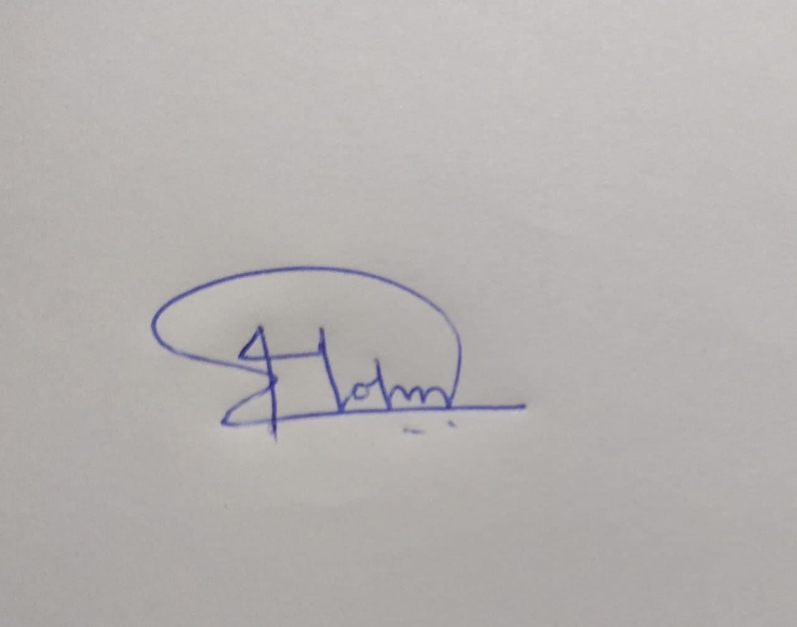
Signature:

Date: 30 September 2026

