**Week1_DesignPrinciplesAndPatterns_HandsOn**

**Exercise 1: Implementing the Singleton Pattern :**

**Code & Output :**

**class** Logger{

**private** **static** Logger *instance*;

**private** Logger()

{

System.***out***.println("Singleton Pattern is achieved");

}

**public** **static** Logger getinstance()

{

**if**(*instance*==**null**)

{

*instance*=**new** Logger();

}

**return** *instance*;

}

}

**public** **class** SingletonPatternExample

{

**public** **static** **void** main(String[] args) {

Logger obj1=Logger.*getinstance*();

Logger obj2=Logger.*getinstance*();

System.***out***.println(obj1==obj2);

}

}

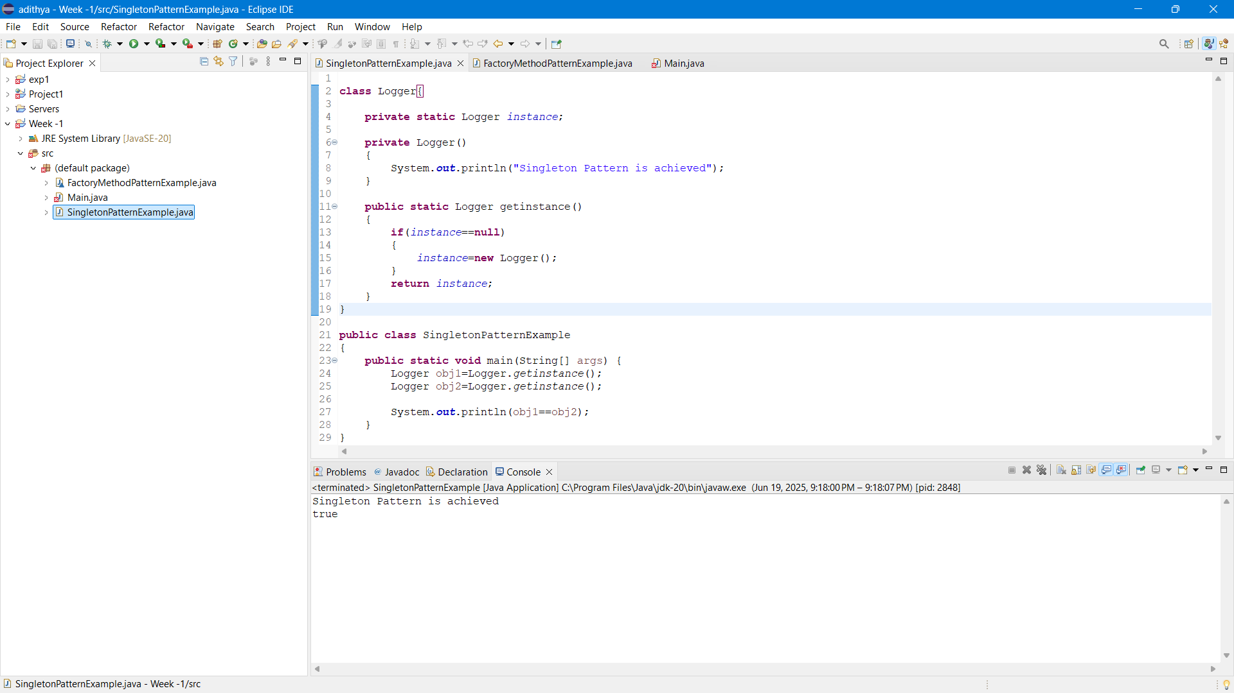

**Exercise 2: Implementing the Factory Method Pattern :**

**Code & Output :**

**interface** Document {

String create();

}

**class** Word **implements** Document {

**public** String create()

{

**return** "Word is created ";

}

}

**class** Pdf **implements** Document {

**public** String create()

{

**return** "Pdf is created ";

}

}

**class** Excel **implements** Document {

**public** String create()

{

**return** "Excel is created ";

}

}

**abstract** **class** DocumentFactory {

**abstract** Document createDocument();

}

**class** WordFactory **extends** DocumentFactory {

**public** Document createDocument()

{

**return** **new** Word();

}

}

**class** PdfFactory **extends** DocumentFactory {

**public** Document createDocument()

{

**return** **new** Pdf();

}

}

**class** ExcelFactory **extends** DocumentFactory {

**public** Document createDocument()

{

**return** **new** Excel();

}

}

**class** FactoryMethodPatternExample

{

**public** **static** **void** main(String[] args)

{

DocumentFactory factory=**new** WordFactory();

Document obj1=factory.createDocument();

System.***out***.println(obj1.create());

factory=**new** PdfFactory();

Document obj2=factory.createDocument();

System.***out***.println(obj2.create());

factory=**new** ExcelFactory();

Document obj3=factory.createDocument();

System.***out***.println(obj3.create());

}

}

