MASTER README — every folder, every subfolder
The two map files, and the difference between them
>
- MASTER README (this file) describes every folder and every subfolder, branch by
branch, all the way down. Read it to find a specific file.
- LOCAL README (`LOCAL_README.md`) describes **only the folders at
the top level**. One line each, no going inside them. Read it to find out which door to
open.
>
A third file, `PROJECT_OVERVIEW.md`, is not a map: it describes the
machine itself — what it is, the firmware, the bills of material, the DIC channel, and how
to get the software running.
**The final report is at
`Documentation/Final Report/UTM_DIC_Report.pdf`
— 99 pages, with the editable UTM_DIC_Report.docx beside it.
The project: a 1-D digital image correlation strain channel built onto the Department of
Product Development, Production and Design's desktop universal testing machine at Jönköping
University's School of Engineering, validated against a certified video extensometer and
applied to PLA, PETG and TPU. February – September 2026.

The folder tree
Drawn from the directory tree itself by Documentation/Scripts/master_readme_pdf.py, so it cannot drift from the repository. The number after each folder is how many files sit directly in it.
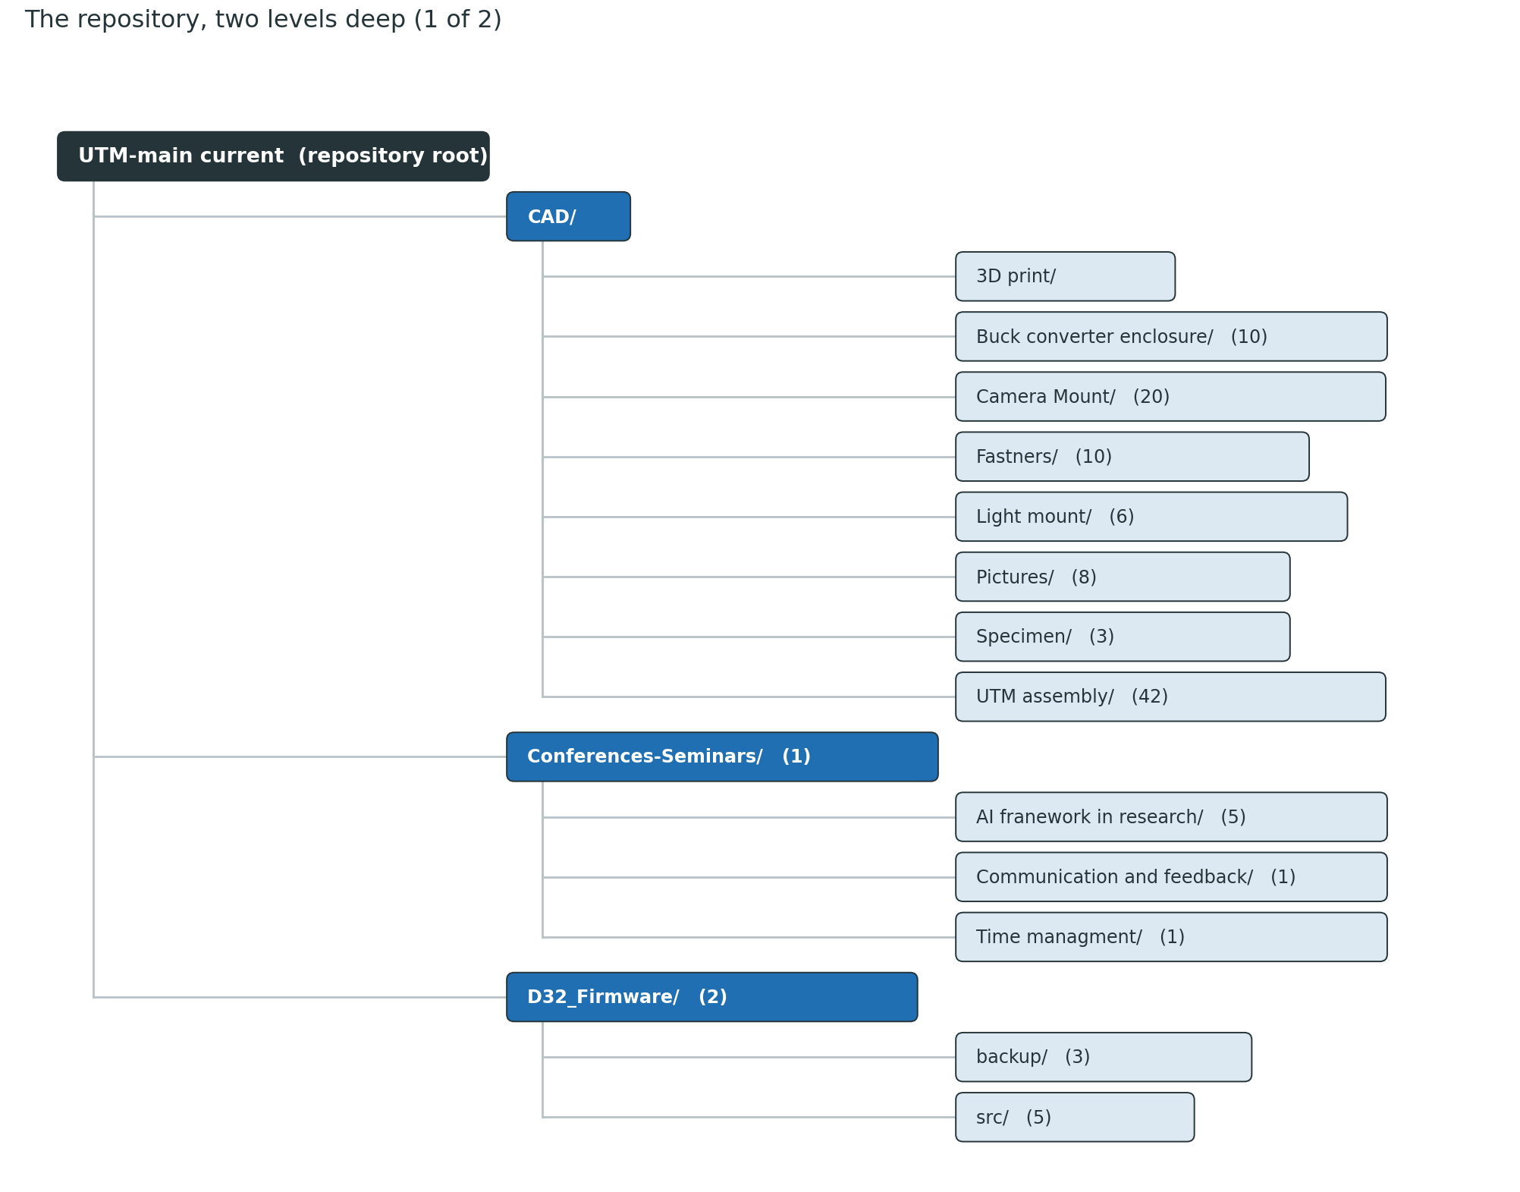
Figure 1 — The repository, two levels deep (1 of 2)
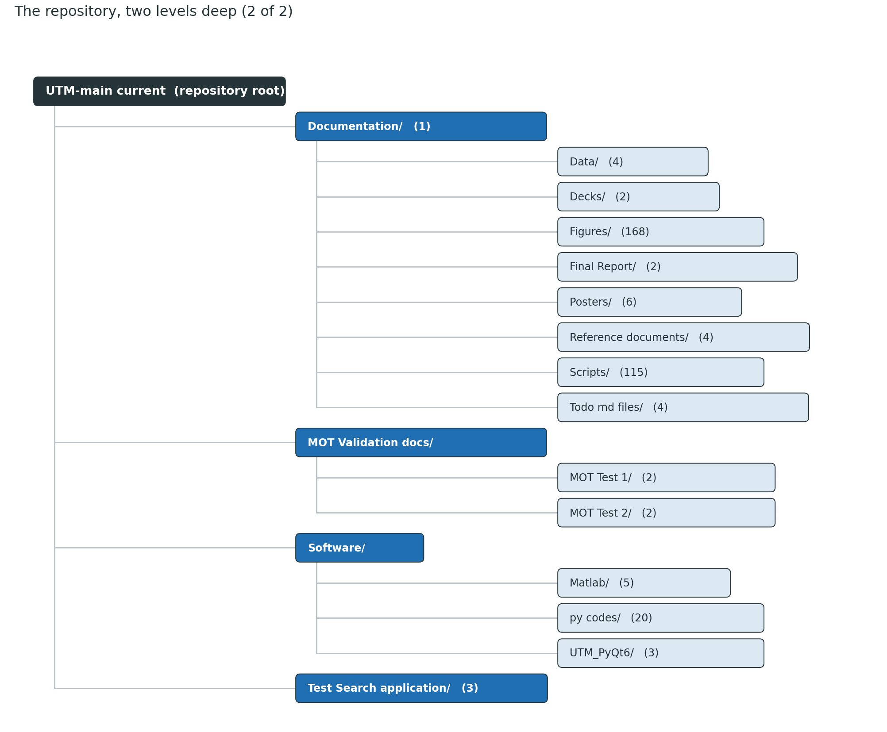
Figure 2 — The repository, two levels deep (2 of 2)
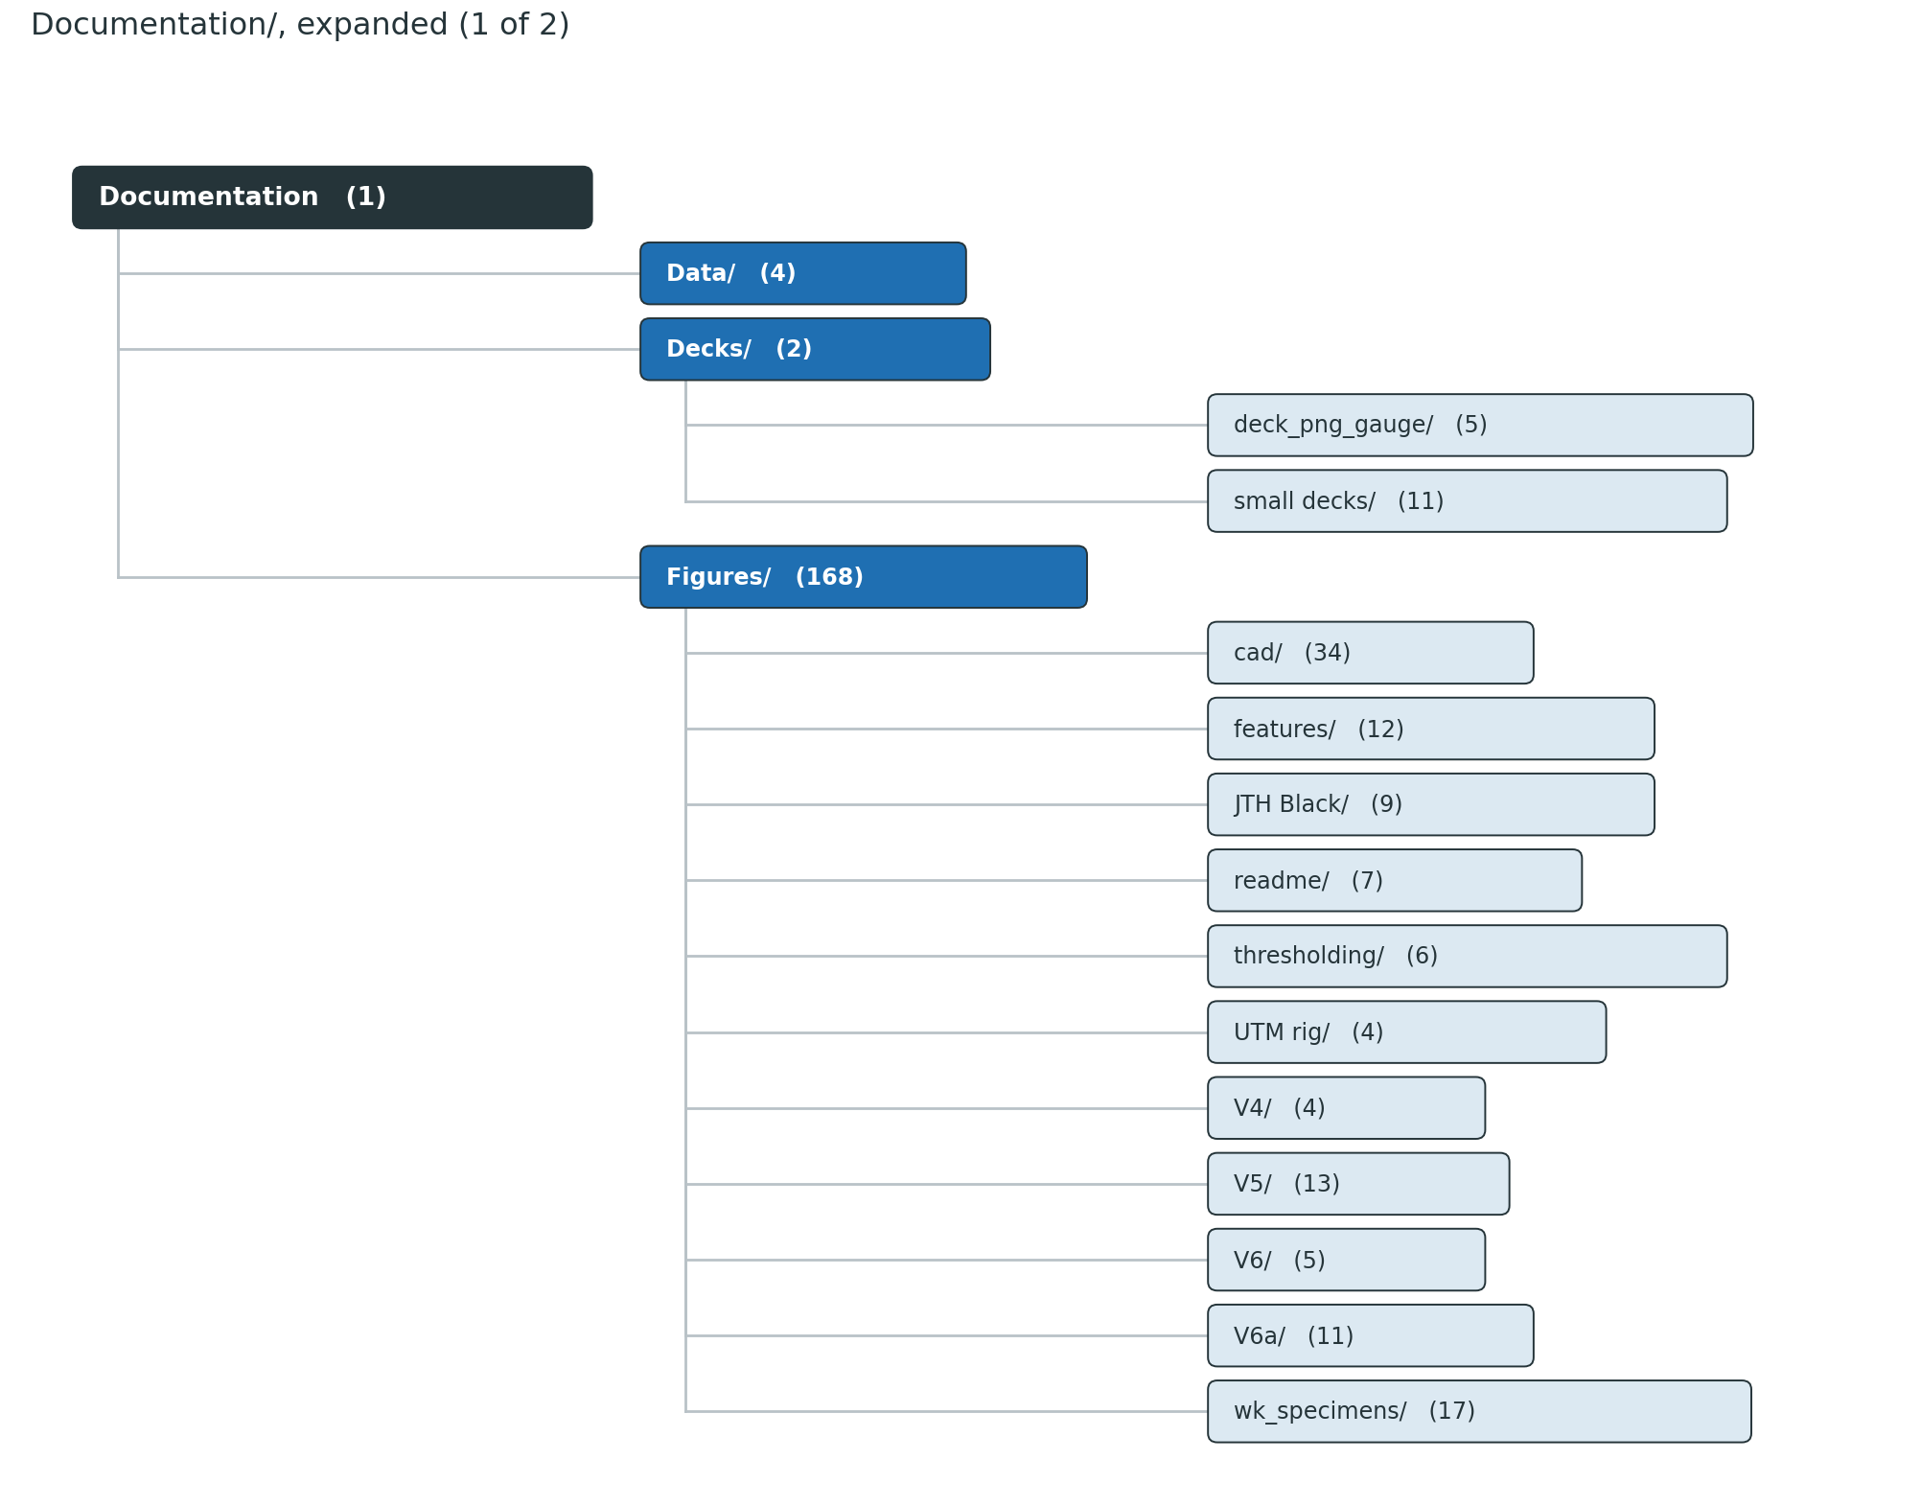
Figure 3 — Documentation/, expanded (1 of 2)
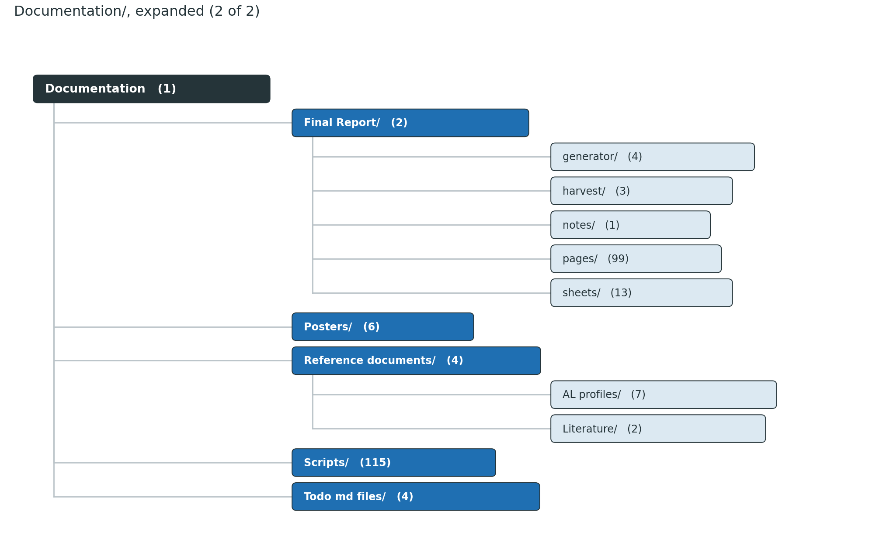
Figure 4 — Documentation/, expanded (2 of 2)
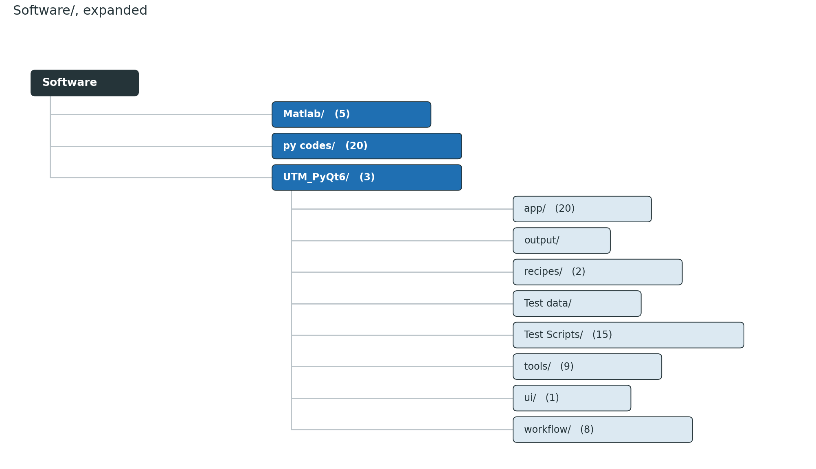
Figure 5 — Software/, expanded

CAD/ — everything designed for the rig
subfolder | what is in it
UTM assembly/ | The rig as a whole: SolidWorks parts and assemblies, STEP and STL exports. The largest folder here — the frame, grips, base and mounts.
Camera Mount/ | The camera carriage and its rail: parts, assemblies and DXF profiles. The rib and rail-profile studies in the report come from these.
Buck converter enclosure/ | The electronics box that holds the buck converter, with STEP exports.
Light mount/ | The printed uprights and diffuser mount for the LED strip.
Specimen/ | The tensile specimen models and the marker-template assemblies.
Fastners/ | Bought-in fasteners and inserts, kept as models so assemblies resolve.
Pictures/ | Photographs of the printed and assembled parts.
3D print/ | What was actually sent to the printer — Stl/, Gcode/, plus a Laptop stand/ side print.

Conferences-Seminars/ — seminars and department days
subfolder | what is in it
AI franework in research/ | Slides and notes from the AI-in-research seminar.
Communication and feedback/ | Seminar material on communication and feedback.
Time managment/ | Seminar material on time management.

A department-days PDF sits at the folder root. Nothing here feeds the rig or the report.

D32_Firmware/ — the ESP32 firmware
A PlatformIO project. platformio.ini at the root, and:
subfolder | what is in it
src/ | The firmware itself: C++ sources and headers — HX711 load-cell polling at 10 Hz, two TMC2160 drivers on one control signal, AS5600 encoders on the motor shafts.
backup/ | The previous Arduino-sketch version, kept for reference.
.vscode/ | Editor and build configuration for the firmware project.

Documentation/ — everything written or drawn about the project
README.md at the root of this folder is its own local map.
subfolder | what is in it
Final Report/ | The report. See the breakdown below.
Decks/ | The presentation decks. See the breakdown below.
Figures/ | Every figure any deck, poster or the report reads or writes. See the breakdown below.
Scripts/ | 110 Python files: the deck builders, the poster builder, the report-figure and deck-surgery scripts, and the data and plot modules they import. Run them from the repository root — every path inside is written relative to it.
Data/ | The computed caches the builders read: estimator_measurements.json, mot_postproc_compare.json, pxmm_reasoning.json, mot_matched_points.csv. Written by mot_postproc_compare.py, estimator_data.py and pxmm_data.py.
Posters/ | Smart_UTM_poster_A0, Smart_UTM_poster_A4 and Smart_UTM_progress_A4, each as .pptx and .pdf.
Reference documents/ | The literature read during the project: the iDICs *Good Practices Guide* Edition 2 (GPG_Ed2_251104.pdf), the predecessor thesis (FULLTEXT01.pdf), the individual design report, a DIC study guide, plus Literature/ (papers) and AL profiles/ (supplier photographs of the aluminium profile).
Todo md files/ | Project-level documents: TODO.md, Starting_TODO.md, PROJECT_REQUIREMENTS.md, VERSIONING.md.

Documentation/Final Report/
The two deliverables sit alone at the root — UTM_DIC_Report.docx and
UTM_DIC_Report.pdf (99 pages).
subfolder | what is in it
generator/ | The generator: build_report.py (two-pass compose, then Word COM for the PDF), rp.py (the document plumbing — headings, figures, tables, cross-references, citations), refs.py (the bibliography, 57 entries), harvest_refs.py (pulls the links out of the decks), and ch/ — one module per chapter plus the front matter and appendices. Rebuild with cd "Documentation/Final Report/generator" && python build_report.py.
pages/ | One PNG per page of the built PDF, for reviewing layout.
sheets/ | Contact sheets — the same pages tiled, for a whole-document glance.
harvest/ | Artifacts, not inputs: refs_harvest.json, refs_harvest.md, and registry_snapshot.json (the test registry as it stood when the report was built; the appendix's specimen register reads it).
notes/ | REPORT_PLAN.md — the plan the report was written against.

Documentation/Decks/
Weekly progress updated.pptx is the live progress diary (397 slides) and
PPD_Final_Presentation.pptx is the final departmental presentation.
subfolder | what is in it
small decks/ | The single-topic decks: Learnings.pptx (the pre-study digest of the DIC guide), the V4/V5/V5abc/V6a test-series decks, V2_capture_validation.pptx, UTM DIC Implementation.pptx, E_modulus_explained, and the MOT and S25/S26 reference packs.
deck_png_gauge/ | Slide renders kept for measuring text fit before a deck edit.

Documentation/Figures/
158 PNGs and 9 JPGs at the root — everything the report and the current decks read, written
by the scripts in Documentation/Scripts/. README.md here explains the naming.
subfolder | what is in it
cad/ | Design figures extracted from the deck for the report's CAD chapter.
V4/, V5/, V6/, V6a/ | The test-series plots, by series: staircase and linearity (V4), tensile-to-failure and the V5a/b/c set (V5), the V6 quintet (V6), and the 100 % infill series (V6a).
features/ | The feat_* proof figures for the twenty smart features, plus the UI screenshots.
UTM rig/ | Hardware and UI: the GUI, the rig schematic, the dimensioned drawing, the enclosure CAD render. Embedded in PROJECT_OVERVIEW.md and PROJECT_REQUIREMENTS.md.
wk_specimens/ | Specimen photographs used across the weekly deck.
thresholding/ | The binary_*.png threshold sweep — the same frame at six threshold values.
JTH Black/ | Jönköping University logos, in EPS, SVG, PNG and JPG.

MOT Validation docs/ — the external validation
The two sessions on the certified Zwick/Roell Z100 with the XT-205 video extensometer, on
which the whole validation chapter rests.
subfolder | what is in it
MOT Test 1/ | The first session (80 mm gauge). README.txt, registry.json, plus Videoextesometer MOT/ (the laboratory's own record and footage), DIC post processing data/ (what the rig's post-processor made of it) and PPD UTM DIC rig reference docs/ (the matching rig runs).
MOT Test 2/ | The second session (45 mm gauge) — the one Analysis 1 and Analysis 2 in the report use. Same structure.

Software/ — all the code
subfolder | what is in it
UTM_PyQt6/ | The application that runs the rig, its tests, its raw test data and its written record. Broken down below.
py codes/ | 19 standalone analysis scripts, one per test series or question. Broken down below.
Matlab/ | Where the project started — the original App Designer application. Broken down below.

Software/UTM_PyQt6/ — the application
README.md, registry.json (the test registry — every run the rig has recorded) and
requirements.txt sit at the root. Nothing else does: all Python lives in app/.

app/ — the 20 application modules
main.py is the entry point: python "Software/UTM_PyQt6/app/main.py" from the repository
root. The modules import each other by bare name, so they must stay together.
module | what it does
main.py | The main window and the whole live path: the state machine (idle → preload → running → fracture → release), the control loop, the live plots and HUD, CSV export, the guards, and the UI for all twenty smart features. By far the largest module.
camera_manager.py | The Basler camera: pylon integration, ROI, exposure and gain, the frame sink, and the latest-image strategy that keeps the loop from falling behind.
utm_dic.py | The DIC core — thresholding, marker segmentation, centroid, and the pixel-to-strain rule. Small and deliberately stable.
utm_analysis.py | The canonical analyser: fit window, yield, UTS, modulus, fracture detection, toughness. The app and every script import this one; nothing re-implements it.
serial_manager.py | The serial link to the ESP32 — force and position at the control period, and the command handler.
control_policies.py | The six closed-loop protocols (staircase, cyclic, creep, relaxation, progressive cyclic, staircase-to-fracture) as policy objects.
utm_postproc.py | The offline engine: re-measures a recorded video with the same DIC code the live path uses.
utm_postdlg.py | The post-processing dialog around that engine — the largest UI module after main.py.
utm_capture.py / utm_capdlg.py | Video recording alongside a test, and its settings dialog.
utm_camdlg.py | The camera settings dialog.
utm_autocal.py | Automatic pixels-per-millimetre calibration from a known marker separation.
utm_blobpick.py | Manual marker selection — the feature that closed the gap when automatic detection failed.
utm_noisedlg.py | The noise-floor measurement dialog.
utm_wizard.py | The guided setup wizard.
utm_recipes.py | Material recipes: load, save and apply a full acquisition setup.
utm_registry.py | The test registry — scans runs, adds rows, resolves paths. Also a CLI.
utm_report.py | The per-test PDF report, from the CSV. Also a CLI.
widgets.py / theme.py | The custom widgets (gauges, toggles) and the visual theme.

Test data/ — the raw runs
Every CSV, and therefore every number in the report, traces back here.
subfolder | what is in it
Fracture tests/ | 29 runs — the tensile-to-failure series across PLA, PETG and TPU (Specimen_S10… upward), each with its CSV, capture and index.
Smart Features - Advanced Test Modes data/ | 12 runs — one per closed-loop protocol: creep, relaxation, the cyclic modes, the staircases, progressive cyclic to fracture.
Trial for lateral strain/ | 2 runs, S38 and S39 — the Poisson's-ratio trial that the report's future work builds on.

Test Scripts/ — 15 test scripts
Five run offline with no hardware: test_threshold.py, test_postproc_guards.py,
test_scale_sidecar.py, test_multipair_postproc.py, test_plot_cursor.py. The rest need
the camera or the rig: test_camera.py through test_camera4.py, test_blob.py,
test_manual_blobs.py, test_reacquire.py, test_phase_8_6.py with its
validate_phase_8_6.py.

tools/ — developer tools beside the app
tool | what it does
control_sim.py | The simulation plant the closed-loop controllers were tuned on, without touching a specimen.
dic_replay.py | Replays a recorded video through the DIC code for debugging.
camera_setup.py | Interactive camera setup and exposure checking.
check_blobs.py / roi_tool.py | Marker-detection and ROI inspection on recorded frames.
analyze_hardware_tests.py | Batch analysis of the hardware test runs.
annotate_utm.py | Annotates rig photographs for the documentation.
generate_mode_help.py | Generates the per-protocol help images that ui/help/ holds.
build_exe.py | Packages the application as a standalone executable.

workflow/ — the written record
ROADMAP.md (start here — the living status of every feature: done, planned, blocked,
and what needs rig time), TESTING_TODO.md (the rig-test checklist the validations were run
against), TEST_FAILURES.md (what failed and why, S15's stall included),
PYTHON_WORKFLOW.md and its PDF (one page per module), RECALIBRATE_ROI.md (the procedure
after the camera moves), COMMANDS.txt (the serial command set) and
utm_code_summary.txt (a per-file summary by functional area).

ui/, recipes/, output/
subfolder | what is in it
ui/ | utm_mainwindow.ui, the Qt Designer layout main.py loads, and help/ — six PNGs, one per closed-loop protocol, shown in the app's own help.
recipes/ | Material recipes as plain JSON: Default.json and TPU.json. Readable, diffable, easy to hand-edit.
output/ | What the app writes at run time: captures/ (recorded video), diagnostics/ (threshold and blob dumps when something looks wrong), full_frame_output/, setup_output/, test_images/. Regenerable — nothing here is an input.

Software/py codes/ — the standalone analysis scripts
19 scripts, one per test series or question, with their own README.md. Run them **from the
repository root**. v4b_v4c_slope_plot.py and v4b_vs_v4c_compare.py (the staircase
linearity work), staircase_analysis.py and staircase_engaged_analysis.py,
stress_strain_8_6_19.py, tensile_failure_analysis.py, v5_full_analysis.py,
v5_v5b_compare.py, v5abc_compare.py, v6_compare.py, v6_quintet_plots.py,
v6_fracture_montage.py, the V6a set (v6a_analyze.py, v6a_plots.py,
v6a_epla_offset.py, v6a_offset_window.py), peak_strain_extraction.py,
preload_schedule.py and generate_report.py. Their figures land in
Documentation/Figures/.

Software/Matlab/ — where the project started
UTM.mlapp (the original App Designer application) with UTM_BAK.mlapp as its backup,
App.m — the exported source, kept for reference during the conversion to Python — and
GUI.png / MatlabApp.png, screenshots of that original interface.

Test Search application/ — a side utility
find_urls.py, check_urls.py and master_search.html: a small tool for collecting
reference URLs and checking that they still resolve. Unrelated to the rig.

Conventions that hold across the whole repository
- Run scripts from the repository root. Every data and figure path inside them is written
relative to it, not to the script.
- No number is typed by hand. Every figure and table in the report and the decks is
computed from a raw run by a committed script.
- `utm_analysis.py` is the single analyser. The app and every script import it; nothing
re-implements yield, modulus or fracture detection.
- A missing figure does not fail loudly. pic_or_ph() in the deck builders substitutes a
placeholder box, so a broken path yields a deck that builds cleanly and is quietly wrong —
check the picture count after moving anything.

